Katherine: Summary Statistisc

Henry Nanji

16/09/2021

PART I

Introduction:

The aim of this project was to do the follwing 1: summarise and visualise the data 2: Fit a linear mixed effect model to the data comparing simulated and unsimulated and adjust for age, bmi, gender and ethnicicty 3: perform correlation analysis on the other salivary parateters that were measured

# Data Pre-processing

The dataset was imported and prepared for analysis. there were missing values which weere not replaced as the numbers were small. Imputation is a possible consideration, that letwise deletion was allowed

# Summary statistics:

Mean of Salivary parameters for SS and US

|  |  |  |  |  |  |  |  |  |  |  |  |
| --- | --- | --- | --- | --- | --- | --- | --- | --- | --- | --- | --- |
| treatment | meanFR | sdFR | meanAge | sdAge | meanBMI | sdBMI | meanPro | sdPro | meanNa | sdNa | pop |
| US | 0.48 | 0.310 | 26.33 | 7.116 | 22.7 | 4.43 | 1.08 | 0.492 | 104.03 | 67.774 | 36 |
| SS | 1.20 | 0.588 | 26.33 | 7.116 | 22.7 | 4.43 | 0.96 | 0.367 | 193.58 | 147.028 | 36 |

Mean of Salivary parameters for SS and US con’t

|  |  |  |  |  |  |  |  |  |  |  |  |  |  |
| --- | --- | --- | --- | --- | --- | --- | --- | --- | --- | --- | --- | --- | --- |
| treatment | meanMg | sdMg | meanP | sdP | meanS | sdS | meanK | sdK | meanCa | sdCa | meanZn | sdZn | pop |
| US | 3.66 | 2.212 | 159.24 | 54.437 | 34.96 | 20.220 | 760.62 | 190.691 | 51.60 | 12.549 | 9.68 | 33.138 | 36 |
| SS | 2.60 | 1.099 | 143.75 | 48.934 | 28.69 | 20.042 | 809.67 | 195.693 | 43.48 | 8.809 | 14.48 | 95.227 | 36 |

Mean of Salivary parameters for SS and US, by visit

|  |  |  |  |  |  |  |  |  |  |  |  |  |
| --- | --- | --- | --- | --- | --- | --- | --- | --- | --- | --- | --- | --- |
| treatment | visit | meanFR | sdFR | meanAge | sdAge | meanBMI | sdBMI | meanPro | sdPro | meanNa | sdNa | pop |
| US | V1 | 0.47 | 0.304 | 26.33 | 7.183 | 22.7 | 4.473 | 1.08 | 0.433 | 94.58 | 50.136 | 36 |
| US | V2 | 0.46 | 0.287 | 26.33 | 7.183 | 22.7 | 4.473 | 1.15 | 0.583 | 115.78 | 85.190 | 36 |
| US | V3 | 0.52 | 0.342 | 26.33 | 7.183 | 22.7 | 4.473 | 1.02 | 0.452 | 101.47 | 63.039 | 36 |
| SS | V2 | 1.21 | 0.621 | 26.33 | 7.183 | 22.7 | 4.473 | 1.04 | 0.442 | 200.05 | 134.939 | 36 |
| SS | V3 | 1.30 | 0.635 | 26.33 | 7.183 | 22.7 | 4.473 | 0.90 | 0.353 | 196.31 | 171.462 | 36 |
| SS | V4 | 1.10 | 0.500 | 26.33 | 7.183 | 22.7 | 4.473 | 0.94 | 0.274 | 184.38 | 135.431 | 36 |

Mean of Salivary parameters for SS and US , by visit con’t

|  |  |  |  |  |  |  |  |  |  |  |  |  |  |  |
| --- | --- | --- | --- | --- | --- | --- | --- | --- | --- | --- | --- | --- | --- | --- |
| treatment | visit | meanMg | sdMg | meanP | sdP | meanS | sdS | meanK | sdK | meanCa | sdCa | meanZn | sdZn | pop |
| US | V1 | 4.10 | 2.989 | 151.61 | 59.856 | 32.12 | 20.211 | 742.31 | 223.134 | 50.06 | 11.886 | 4.69 | 15.105 | 36 |
| US | V2 | 3.61 | 1.913 | 168.57 | 53.964 | 37.80 | 21.933 | 792.59 | 177.521 | 55.24 | 12.497 | 24.25 | 52.829 | 36 |
| US | V3 | 3.26 | 1.414 | 157.55 | 49.116 | 34.96 | 18.542 | 746.95 | 168.154 | 49.50 | 12.779 | 0.11 | 0.085 | 36 |
| SS | V2 | 2.54 | 1.298 | 147.04 | 43.494 | 29.76 | 24.580 | 825.34 | 171.293 | 45.04 | 8.842 | 43.23 | 162.624 | 36 |
| SS | V3 | 2.45 | 1.126 | 147.92 | 61.405 | 29.11 | 21.722 | 832.75 | 257.291 | 43.67 | 10.675 | 0.08 | 0.059 | 36 |
| SS | V4 | 2.81 | 0.819 | 136.28 | 39.644 | 27.19 | 12.177 | 770.93 | 138.533 | 41.74 | 6.278 | 0.12 | 0.066 | 36 |

Mean of Salivary parameters by subjects

|  |  |  |  |  |  |  |  |  |  |  |  |
| --- | --- | --- | --- | --- | --- | --- | --- | --- | --- | --- | --- |
| patno | meanFR | sdFR | meanAge | sdAge | meanBMI | sdBMI | meanPro | sdPro | meanNa | sdNa | pop |
| 1 | 1.03 | 0.851 | 31 | 0 | 22.58 | 0 | 0.80 | 0.189 | 164.69 | 69.303 | 1 |
| 2 | 0.48 | 0.084 | 20 | 0 | 17.80 | 0 | 0.50 | 0.135 | 102.52 | 25.481 | 1 |
| 4 | 1.05 | 0.277 | 40 | 0 | 16.53 | 0 | 0.95 | 0.130 | 116.47 | 66.350 | 1 |
| 5 | 1.23 | 0.556 | 25 | 0 | 21.56 | 0 | 0.75 | 0.200 | 110.90 | 37.325 | 1 |
| 6 | 1.04 | 0.521 | 36 | 0 | 29.74 | 0 | 1.01 | 0.216 | 254.39 | 54.569 | 1 |
| 7 | 0.34 | 0.264 | 26 | 0 | NaN | NA | 0.74 | 0.216 | 131.14 | 24.736 | 1 |
| 8 | 0.96 | 0.843 | 29 | 0 | 21.76 | 0 | 1.37 | 0.326 | 92.92 | 51.963 | 1 |
| 9 | 1.19 | 0.250 | 21 | 0 | 23.13 | 0 | 0.84 | 0.211 | 59.70 | 9.127 | 1 |
| 10 | 0.59 | 0.367 | 23 | 0 | 19.21 | 0 | 0.75 | 0.240 | 130.31 | 96.062 | 1 |
| 11 | 1.69 | 0.706 | 26 | 0 | 22.18 | 0 | 1.46 | 0.379 | 152.31 | 74.603 | 1 |
| 13 | 1.01 | 0.422 | 28 | 0 | 26.26 | 0 | 1.01 | 0.155 | 72.47 | 23.156 | 1 |
| 14 | 0.44 | 0.302 | 25 | 0 | 23.89 | 0 | 0.99 | 0.148 | 191.96 | 41.800 | 1 |
| 15 | 0.81 | 0.489 | 30 | 0 | 21.95 | 0 | 0.97 | 0.202 | 68.60 | 37.508 | 1 |
| 16 | 0.82 | 0.172 | 47 | 0 | 22.60 | 0 | 1.07 | 0.092 | 84.33 | 21.118 | 1 |
| 19 | 1.05 | 0.502 | 37 | 0 | 21.80 | 0 | 1.01 | 0.455 | 91.72 | 42.267 | 1 |
| 20 | 0.52 | 0.351 | 29 | 0 | 20.31 | 0 | 1.00 | 0.347 | 97.98 | 75.743 | 1 |
| 21 | 0.77 | 0.451 | 33 | 0 | 23.51 | 0 | 0.71 | 0.284 | 117.13 | 67.829 | 1 |
| 22 | 0.45 | 0.312 | 26 | 0 | 22.14 | 0 | 1.37 | 0.724 | 108.84 | 57.290 | 1 |
| 24 | 0.48 | 0.259 | 42 | 0 | 44.20 | 0 | 1.87 | 0.429 | 104.96 | 21.642 | 1 |
| 26 | 0.44 | 0.228 | 26 | 0 | 21.62 | 0 | 1.29 | 0.325 | 76.08 | 29.323 | 1 |
| 27 | 0.96 | 0.562 | 22 | 0 | 21.36 | 0 | 0.66 | 0.127 | 213.43 | 84.282 | 1 |
| 29 | 0.54 | 0.248 | 27 | 0 | 19.57 | 0 | 0.96 | 0.225 | 464.80 | 333.298 | 1 |
| 30 | 0.81 | 0.381 | 22 | 0 | 20.91 | 0 | 0.78 | 0.181 | 206.15 | 55.245 | 1 |
| 33 | 1.03 | 0.780 | 22 | 0 | 21.68 | 0 | 1.35 | 0.499 | 114.72 | 59.689 | 1 |
| 35 | 1.48 | 0.699 | 23 | 0 | 22.94 | 0 | 0.81 | 0.305 | 222.76 | 90.923 | 1 |
| 36 | 1.68 | 0.609 | 19 | 0 | 21.51 | 0 | 0.71 | 0.137 | 120.04 | 30.473 | 1 |
| 38 | 0.43 | 0.236 | 21 | 0 | 23.31 | 0 | 0.76 | 0.168 | 166.89 | 24.790 | 1 |
| 41 | 1.22 | 0.675 | 20 | 0 | 20.31 | 0 | 0.63 | 0.069 | 104.79 | 23.175 | 1 |
| 42 | 0.61 | 0.495 | 19 | 0 | 21.86 | 0 | 1.37 | 0.375 | 80.69 | 49.290 | 1 |
| 45 | 1.05 | 0.810 | 21 | 0 | 24.20 | 0 | 0.99 | 0.379 | 405.85 | 275.035 | 1 |
| 46 | 0.99 | 0.498 | 20 | 0 | 22.56 | 0 | 0.66 | 0.092 | 183.31 | 114.175 | 1 |
| 47 | 0.52 | 0.416 | 20 | 0 | 21.26 | 0 | 1.54 | 0.402 | 240.04 | 117.402 | 1 |
| 49 | 0.11 | 0.046 | 20 | 0 | 21.64 | 0 | 1.81 | 0.663 | 70.30 | 20.234 | 1 |
| 50 | 1.38 | 0.758 | 19 | 0 | 18.29 | 0 | 1.28 | 0.801 | 239.86 | 127.102 | 1 |
| 51 | 0.37 | 0.218 | 19 | 0 | 27.06 | 0 | 1.41 | 0.295 | 111.50 | 44.823 | 1 |
| 52 | 0.68 | 0.430 | 34 | 0 | 23.42 | 0 | 1.08 | 0.184 | 83.66 | 10.392 | 1 |

Mean of Salivary parameters by subjects con’t

|  |  |  |  |  |  |  |  |  |  |  |  |  |  |
| --- | --- | --- | --- | --- | --- | --- | --- | --- | --- | --- | --- | --- | --- |
| patno | meanMg | sdMg | meanP | sdP | meanS | sdS | meanK | sdK | meanCa | sdCa | meanZn | sdZn | pop |
| 1 | 1.97 | 0.452 | 161.15 | 13.816 | 32.50 | 7.912 | 772.78 | 90.200 | 49.96 | 4.727 | 9.09 | 22.191 | 1 |
| 2 | 1.03 | 0.255 | 91.03 | 9.520 | 12.37 | 2.727 | 535.18 | 47.879 | 48.52 | 6.463 | 0.05 | 0.020 | 1 |
| 4 | 2.41 | 0.354 | 142.66 | 15.516 | 20.27 | 3.167 | 706.91 | 56.527 | 47.41 | 6.765 | 35.98 | 56.592 | 1 |
| 5 | 2.57 | 0.921 | 121.05 | 26.406 | 33.15 | 8.750 | 776.85 | 25.283 | 49.17 | 3.955 | 21.62 | 34.310 | 1 |
| 6 | 2.91 | 0.816 | 131.51 | 8.622 | 54.25 | 10.888 | 750.45 | 28.837 | 53.30 | 5.229 | 16.39 | 38.410 | 1 |
| 7 | 3.50 | 0.872 | 146.96 | 15.366 | 44.28 | 8.181 | 688.15 | 37.218 | 41.70 | 6.434 | 0.23 | 0.214 | 1 |
| 8 | 4.25 | 1.456 | 217.39 | 56.315 | 39.15 | 11.420 | 1044.46 | 133.193 | 55.51 | 9.186 | 0.14 | 0.056 | 1 |
| 9 | 1.77 | 0.279 | 145.36 | 7.376 | 15.44 | 2.886 | 779.78 | 49.845 | 45.34 | 4.519 | 19.43 | 30.032 | 1 |
| 10 | 1.63 | 0.640 | 108.38 | 14.397 | 19.85 | 3.504 | 712.27 | 89.320 | 37.68 | 3.049 | 0.08 | 0.057 | 1 |
| 11 | 1.74 | 0.602 | 112.91 | 11.163 | 10.33 | 4.247 | 684.95 | 47.741 | 52.91 | 7.814 | 15.11 | 20.105 | 1 |
| 13 | 4.66 | 3.097 | 135.49 | 27.440 | 27.68 | 5.699 | 718.52 | 121.339 | 48.45 | 7.332 | 0.06 | 0.062 | 1 |
| 14 | 3.25 | 0.586 | 100.52 | 22.144 | 20.63 | 4.358 | 625.42 | 139.538 | 33.58 | 6.707 | 7.71 | 12.846 | 1 |
| 15 | 2.89 | 0.713 | 203.80 | 37.644 | 42.26 | 10.527 | 904.30 | 73.664 | 48.69 | 6.687 | 8.51 | 20.729 | 1 |
| 16 | 2.55 | 0.561 | 159.23 | 21.576 | 35.71 | 9.968 | 799.71 | 41.703 | 33.03 | 4.727 | 0.08 | 0.050 | 1 |
| 19 | 3.28 | 0.857 | 103.07 | 12.574 | 18.81 | 4.839 | 693.42 | 98.825 | 73.46 | 13.211 | 202.03 | 389.043 | 1 |
| 20 | 3.02 | 0.326 | 142.38 | 15.669 | 30.24 | 3.351 | 683.57 | 60.829 | 50.72 | 13.028 | 0.10 | 0.075 | 1 |
| 21 | 5.79 | 4.499 | 163.16 | 63.022 | 39.62 | 19.635 | 736.58 | 212.313 | 59.72 | 13.878 | 0.06 | 0.051 | 1 |
| 22 | 3.28 | 0.833 | 254.21 | 48.708 | 25.22 | 4.668 | 1088.32 | 158.000 | 50.23 | 11.417 | 25.78 | 60.643 | 1 |
| 24 | 4.77 | 1.110 | 257.37 | 61.378 | 99.77 | 26.676 | 1342.62 | 204.234 | 51.23 | 6.929 | 0.17 | 0.098 | 1 |
| 26 | 2.87 | 0.470 | 221.86 | 42.007 | 42.94 | 6.605 | 884.63 | 173.756 | 44.12 | 10.100 | 0.06 | 0.040 | 1 |
| 27 | 4.67 | 2.881 | 137.93 | 38.893 | 30.72 | 11.191 | 817.76 | 113.448 | 47.56 | 5.438 | 0.10 | 0.060 | 1 |
| 29 | 2.95 | 1.133 | 146.28 | 18.548 | 47.39 | 14.357 | 684.06 | 62.596 | 36.00 | 3.873 | 0.06 | 0.046 | 1 |
| 30 | 2.29 | 0.605 | 113.80 | 7.418 | 18.96 | 8.437 | 786.96 | 24.657 | 33.69 | 8.414 | 12.13 | 29.474 | 1 |
| 33 | 3.79 | 1.332 | 150.48 | 31.335 | 43.96 | 9.721 | 878.09 | 91.504 | 60.87 | 12.401 | 4.21 | 10.153 | 1 |
| 35 | 2.72 | 1.190 | 103.84 | 9.467 | 18.05 | 6.765 | 577.23 | 51.995 | 51.91 | 5.443 | 0.10 | 0.067 | 1 |
| 36 | 1.93 | 0.256 | 102.43 | 13.294 | 10.66 | 1.779 | 610.51 | 78.606 | 46.87 | 5.654 | 0.08 | 0.047 | 1 |
| 38 | 2.71 | 0.995 | 188.29 | 97.930 | 38.93 | 24.174 | 910.88 | 488.600 | 46.18 | 17.422 | 0.06 | 0.056 | 1 |
| 41 | 3.92 | 2.509 | 134.91 | 24.888 | 23.20 | 7.039 | 693.07 | 134.209 | 53.77 | 10.517 | 0.09 | 0.043 | 1 |
| 42 | 3.36 | 0.728 | 154.29 | 27.456 | 24.88 | 2.192 | 775.38 | 156.484 | 44.16 | 6.614 | 0.10 | 0.078 | 1 |
| 45 | 3.27 | 1.625 | 174.86 | 46.744 | 27.60 | 13.419 | 838.01 | 76.205 | 49.42 | 8.735 | 0.10 | 0.123 | 1 |
| 46 | 1.22 | 0.181 | 115.50 | 14.817 | 13.80 | 2.442 | 673.41 | 58.574 | 46.16 | 4.135 | 0.11 | 0.080 | 1 |
| 47 | 6.87 | 3.274 | 157.30 | 18.233 | 71.14 | 25.342 | 957.81 | 147.780 | 47.18 | 11.669 | 0.16 | 0.109 | 1 |
| 49 | 3.51 | 0.805 | 202.82 | 34.991 | 44.45 | 7.648 | 854.29 | 56.368 | 40.32 | 5.657 | 29.12 | 49.083 | 1 |
| 50 | 2.32 | 0.704 | 119.18 | 18.466 | 16.01 | 6.060 | 684.43 | 34.360 | 44.70 | 2.593 | 25.57 | 47.441 | 1 |
| 51 | 4.38 | 1.631 | 172.10 | 50.332 | 34.12 | 12.130 | 802.67 | 183.104 | 54.81 | 19.549 | 0.08 | 0.047 | 1 |
| 52 | 2.59 | 1.065 | 160.31 | 40.093 | 17.28 | 5.181 | 791.83 | 113.561 | 33.17 | 4.591 | 0.06 | 0.040 | 1 |

## `summarise()` ungrouping output (override with `.groups` argument)

Repeated measurements by visit

|  |  |
| --- | --- |
| visit | count |
| V1 | 36 |
| V2 | 72 |
| V3 | 72 |
| V4 | 36 |

## `summarise()` regrouping output by 'treatment' (override with `.groups` argument)  
## `summarise()` regrouping output by 'treatment' (override with `.groups` argument)

Gender statistis

|  |  |  |  |  |
| --- | --- | --- | --- | --- |
| treatment | gender | N | freq | pct |
| SS | Female | 29 | 0.8055556 | 81 |
| SS | Male | 7 | 0.1944444 | 19 |
| US | Female | 29 | 0.8055556 | 81 |
| US | Male | 7 | 0.1944444 | 19 |

## `summarise()` regrouping output by 'treatment' (override with `.groups` argument)  
## `summarise()` regrouping output by 'treatment' (override with `.groups` argument)

Ethnicity statistis

|  |  |  |  |  |
| --- | --- | --- | --- | --- |
| treatment | ethnicity | N | freq | pct |
| SS | Asian | 9 | 0.2500000 | 25 |
| SS | Black | 1 | 0.0277778 | 3 |
| SS | Hispanic | 3 | 0.0833333 | 8 |
| SS | White | 23 | 0.6388889 | 64 |
| US | Asian | 9 | 0.2500000 | 25 |
| US | Black | 1 | 0.0277778 | 3 |
| US | Hispanic | 3 | 0.0833333 | 8 |
| US | White | 23 | 0.6388889 | 64 |

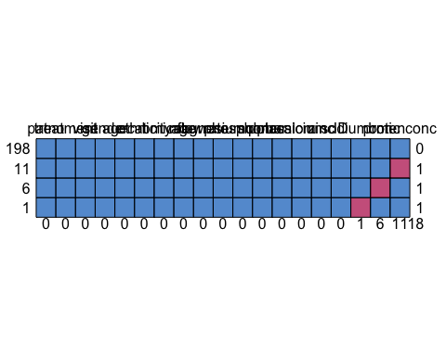

Variables with missing data

|  |  |  |  |  |  |  |  |  |  |  |  |  |  |  |  |  |  |  |  |  |
| --- | --- | --- | --- | --- | --- | --- | --- | --- | --- | --- | --- | --- | --- | --- | --- | --- | --- | --- | --- | --- |
|  | patno | treatment | visit | gender | agecat | ethnicity | bmicat | age | flowrate | magnesiumconc | phosphorus | sulphur | potassiom | calcium | zinc | ID | sodiumconc | bmi | protenconc | V20 |
| 198 | 1 | 1 | 1 | 1 | 1 | 1 | 1 | 1 | 1 | 1 | 1 | 1 | 1 | 1 | 1 | 1 | 1 | 1 | 1 | 0 |
| 11 | 1 | 1 | 1 | 1 | 1 | 1 | 1 | 1 | 1 | 1 | 1 | 1 | 1 | 1 | 1 | 1 | 1 | 1 | 0 | 1 |
| 6 | 1 | 1 | 1 | 1 | 1 | 1 | 1 | 1 | 1 | 1 | 1 | 1 | 1 | 1 | 1 | 1 | 1 | 0 | 1 | 1 |
| 1 | 1 | 1 | 1 | 1 | 1 | 1 | 1 | 1 | 1 | 1 | 1 | 1 | 1 | 1 | 1 | 1 | 0 | 1 | 1 | 1 |
|  | 0 | 0 | 0 | 0 | 0 | 0 | 0 | 0 | 0 | 0 | 0 | 0 | 0 | 0 | 0 | 0 | 1 | 6 | 11 | 18 |

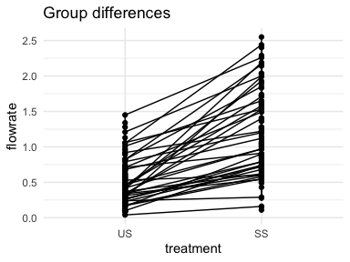

## Warning in arrows(x, li, x, pmax(y - gap, li), col = barcol, lwd = lwd, : zero-  
## length arrow is of indeterminate angle and so skipped  
  
## Warning in arrows(x, li, x, pmax(y - gap, li), col = barcol, lwd = lwd, : zero-  
## length arrow is of indeterminate angle and so skipped  
  
## Warning in arrows(x, li, x, pmax(y - gap, li), col = barcol, lwd = lwd, : zero-  
## length arrow is of indeterminate angle and so skipped  
  
## Warning in arrows(x, li, x, pmax(y - gap, li), col = barcol, lwd = lwd, : zero-  
## length arrow is of indeterminate angle and so skipped  
  
## Warning in arrows(x, li, x, pmax(y - gap, li), col = barcol, lwd = lwd, : zero-  
## length arrow is of indeterminate angle and so skipped  
  
## Warning in arrows(x, li, x, pmax(y - gap, li), col = barcol, lwd = lwd, : zero-  
## length arrow is of indeterminate angle and so skipped  
  
## Warning in arrows(x, li, x, pmax(y - gap, li), col = barcol, lwd = lwd, : zero-  
## length arrow is of indeterminate angle and so skipped  
  
## Warning in arrows(x, li, x, pmax(y - gap, li), col = barcol, lwd = lwd, : zero-  
## length arrow is of indeterminate angle and so skipped

## Warning in arrows(x, ui, x, pmin(y + gap, ui), col = barcol, lwd = lwd, : zero-  
## length arrow is of indeterminate angle and so skipped  
  
## Warning in arrows(x, ui, x, pmin(y + gap, ui), col = barcol, lwd = lwd, : zero-  
## length arrow is of indeterminate angle and so skipped  
  
## Warning in arrows(x, ui, x, pmin(y + gap, ui), col = barcol, lwd = lwd, : zero-  
## length arrow is of indeterminate angle and so skipped  
  
## Warning in arrows(x, ui, x, pmin(y + gap, ui), col = barcol, lwd = lwd, : zero-  
## length arrow is of indeterminate angle and so skipped  
  
## Warning in arrows(x, ui, x, pmin(y + gap, ui), col = barcol, lwd = lwd, : zero-  
## length arrow is of indeterminate angle and so skipped  
  
## Warning in arrows(x, ui, x, pmin(y + gap, ui), col = barcol, lwd = lwd, : zero-  
## length arrow is of indeterminate angle and so skipped  
  
## Warning in arrows(x, ui, x, pmin(y + gap, ui), col = barcol, lwd = lwd, : zero-  
## length arrow is of indeterminate angle and so skipped  
  
## Warning in arrows(x, ui, x, pmin(y + gap, ui), col = barcol, lwd = lwd, : zero-  
## length arrow is of indeterminate angle and so skipped

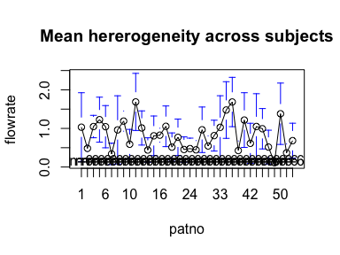

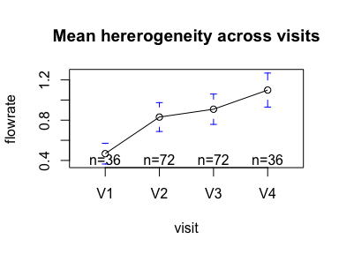

PART II: MIXED MODEL

The dataset has repeated measurements made on each subject,each subject had multiple SS and US measurements of the outcome which are likely to be correlated , ie for flowrate (outcome of interest) are likely to be similar if they come from the same subject. The ICC(Intra class correlation) is used to measure how similar the outcome(flowrate in this case) is if they come from the same subject. This model adds a random effect for each subject which allows a different baseline outcome measurement for each subject(accounting for individual differences) and also a random effect for visit(accounting for time differences)

Mixed Model for Flowrate

BMI, age, gendeder were not statistically significant Mean flow rate for SS was higher compared to US and this was statistically significant. ICC of patno = 59% means that 59% of variation in flow rate was explained by differences in participants and only 1% explained by differences over the different visits. Repeated measurements for each subject was highly correlated. There was hardly any correlation(similarity of flowrate measurements) over visit. Residuals were normally distributed and Shapiro-Wilk test also confirmed that(p >0.05)

Observations

216

Dependent variable

flowrate

Type

Mixed effects linear regression

AIC

180.65

BIC

197.53

Pseudo-R² (fixed effects)

0.39

Pseudo-R² (total)

0.76

Fixed Effects

Est.

2.5%

97.5%

t val.

d.f.

p

(Intercept)

0.46

0.32

0.60

6.29

27.28

0.00

treatmentSS

0.74

0.66

0.83

16.71

84.12

0.00

p values calculated using Satterthwaite d.f.

Random Effects

Group

Parameter

Std. Dev.

patno

(Intercept)

0.36

visit

(Intercept)

0.06

Residual

0.29

Grouping Variables

Group

# groups

ICC

patno

36

0.59

visit

4

0.01

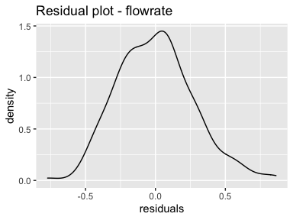

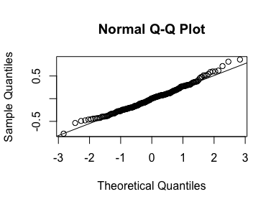

##   
## Shapiro-Wilk normality test  
##   
## data: flowsubset$resid  
## W = 0.98867, p-value = 0.08571

Mixed Model for Protein Concentration

Bmi, age, gender were not statistically significant Residual were not mormaly distributed. Outliers were detected and deleted and model refitted and model didn’t converge. Many consider using gammy distribution later

Observations

205

Dependent variable

protenconc

Type

Mixed effects linear regression

AIC

186.78

BIC

203.40

Pseudo-R² (fixed effects)

0.02

Pseudo-R² (total)

0.48

Fixed Effects

Est.

2.5%

97.5%

t val.

d.f.

p

(Intercept)

1.09

0.96

1.21

17.53

31.42

0.00

treatmentSS

-0.11

-0.21

-0.02

-2.43

79.85

0.02

p values calculated using Satterthwaite d.f.

Random Effects

Group

Parameter

Std. Dev.

patno

(Intercept)

0.30

visit

(Intercept)

0.04

Residual

0.32

Grouping Variables

Group

# groups

ICC

patno

36

0.46

visit

4

0.01

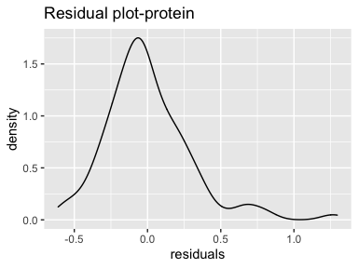

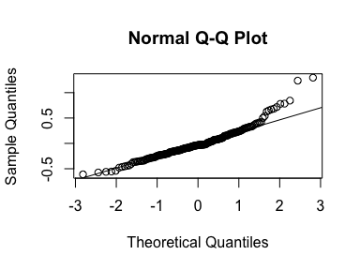

##   
## Shapiro-Wilk normality test  
##   
## data: proten_residuals$residuals.proteinmodel.  
## W = 0.93495, p-value = 6.283e-08

Model treatment

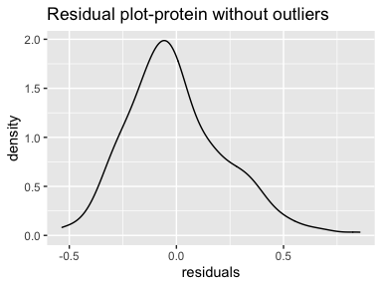

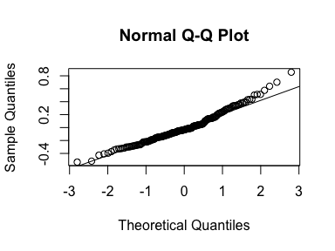

##   
## Shapiro-Wilk normality test  
##   
## data: proten_residualsM1$residuals.proteinM1.  
## W = 0.97259, p-value = 0.0007223