TeamNum:25

Data Warehouse Project

The dataset talks about the history of the weather, as it contains the date, temperature, humidity, a description of the weather, wind speed...etc. This data shows the weather conditions, as it is useful in alerting people to the temperature to know how the day will go. Will it rain or will the weather be nice? , Through existing data such as temperature and wind speed, people can know what to wear.

**Weather Dataset**

Data Warehouse Project

**Columns:**

1. Date 2. Summary 3. Precip Type
2. Temperature 5. Apparent Temperature 6. Humidity
3. Wind Speed 8. Wind Bearing 9. Visibility

10. Loud Cover 11. Pressure 12. Daily Summary

**component used in Alteryx:**

1. Input Data: Select the file to work on (file1).
2. Select: Choose the specific fields & Change type & size.
3. Filter: Put condition (T&F) to split the data you want, the condition is (Temperature > Wind Speed ).
4. Formula: Use to divide the columns (date) to (year & month &day), and replace white spaces with underscore.
5. Data Cleansing: Use to Uppercase the char (Modify Case ->Tile Case use to uppercase the first char only).
6. Output Data: Load data into DB.
7. Record ID: Put ID to record.
8. Tile: Divide the rows in file to two equal rows.
9. Sort: Sort the record by any column you choose

(Record ID).

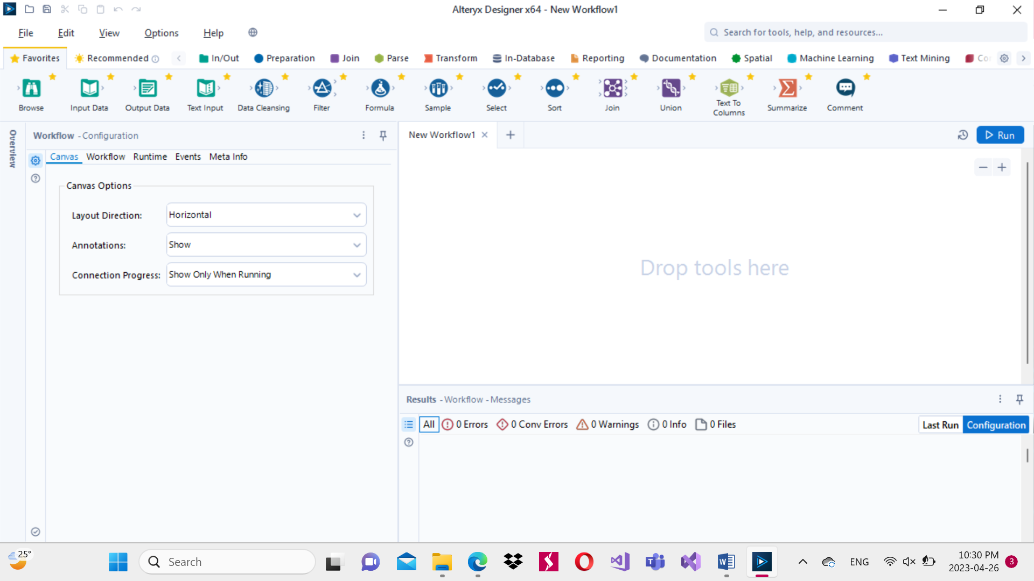 

**Component**

**used in Alteryx:**

 

  

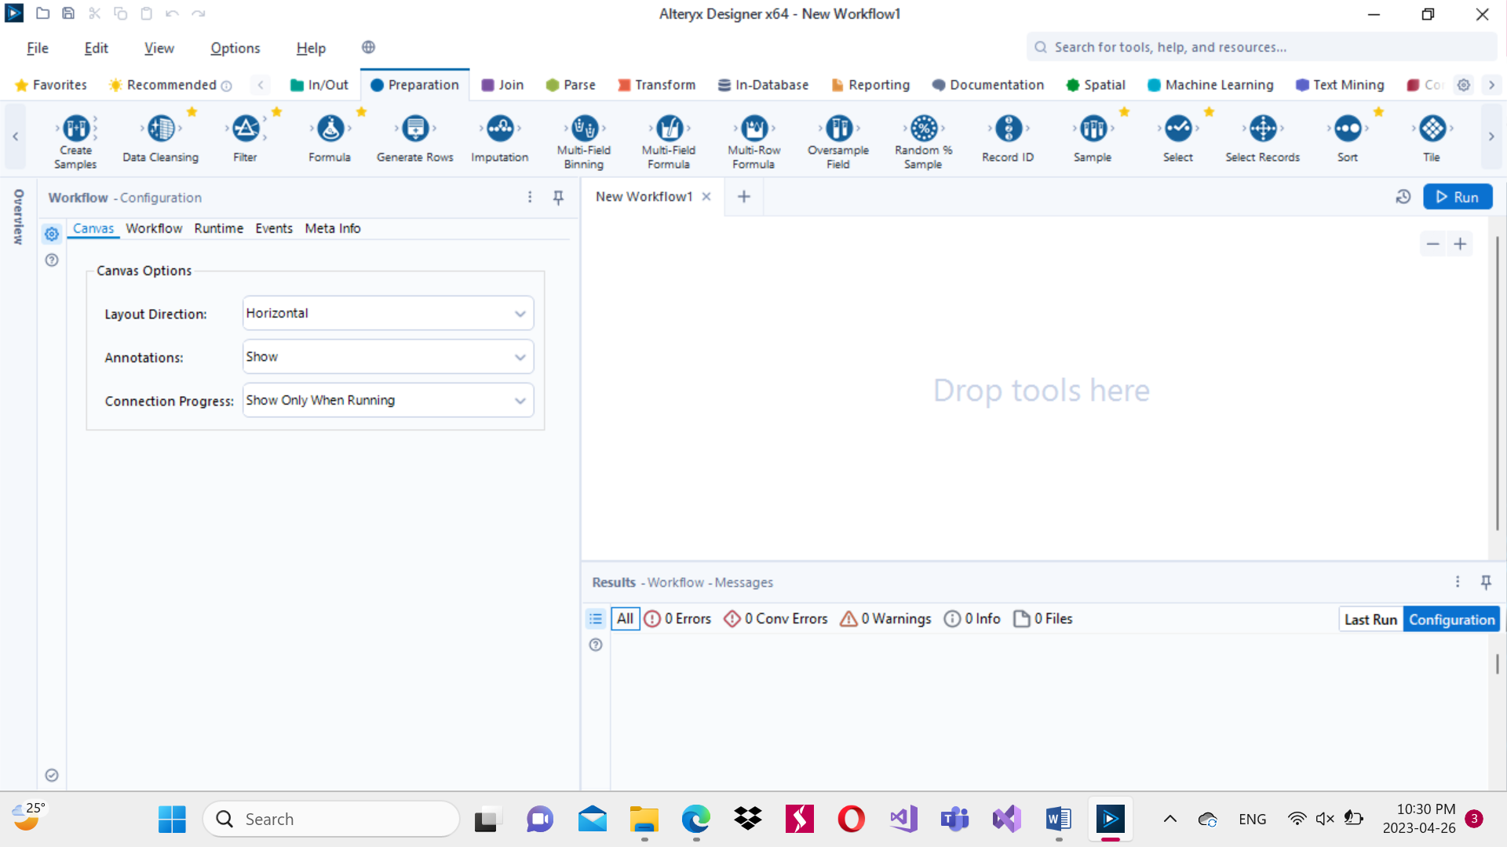 

**Divide the file Using Alteryx:**

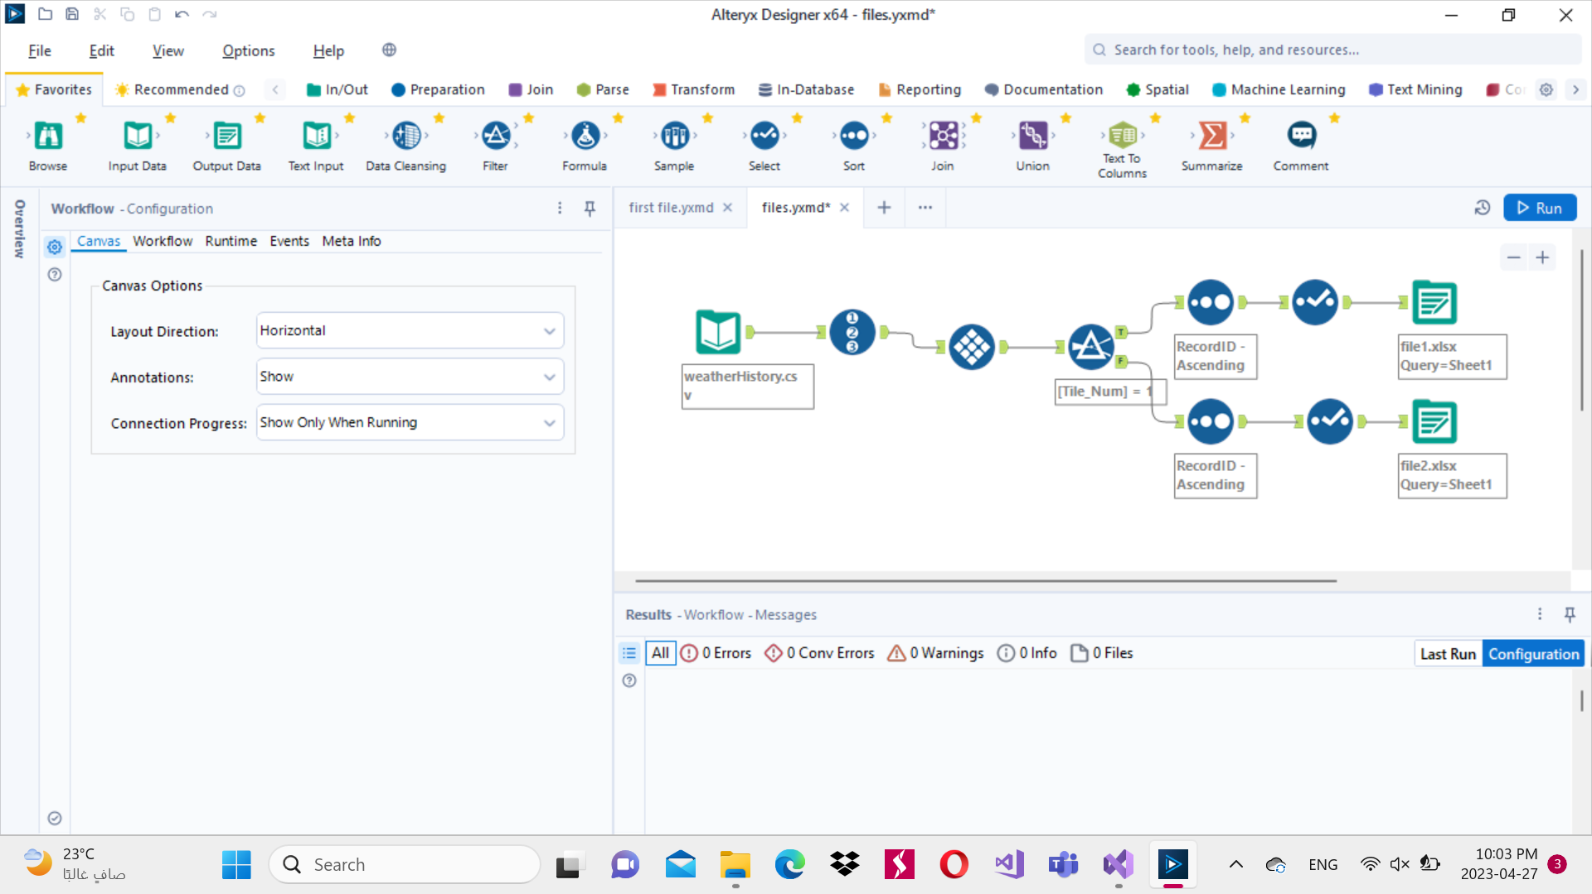

**Transform in the first file Using Alteryx:**

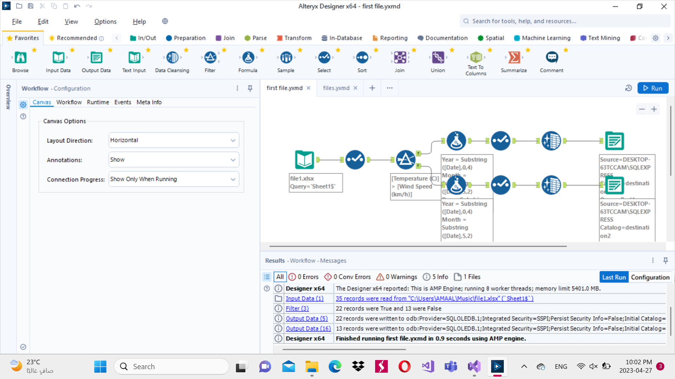

component used in SSIS:

1. Excel Source: Select the excel file to work on (file2).
2. Conditional Split: Put condition (T&F) to split the data you want, the condition is (Temperature > Wind Speed ).
3. Derived Column: Use to divide the columns (date) to (year & month &day), and replace white spaces with underscore, and use to Uppercase the char (upper the first char only & lower the other chars).
4. OLE DB Destination: Load data into DB.

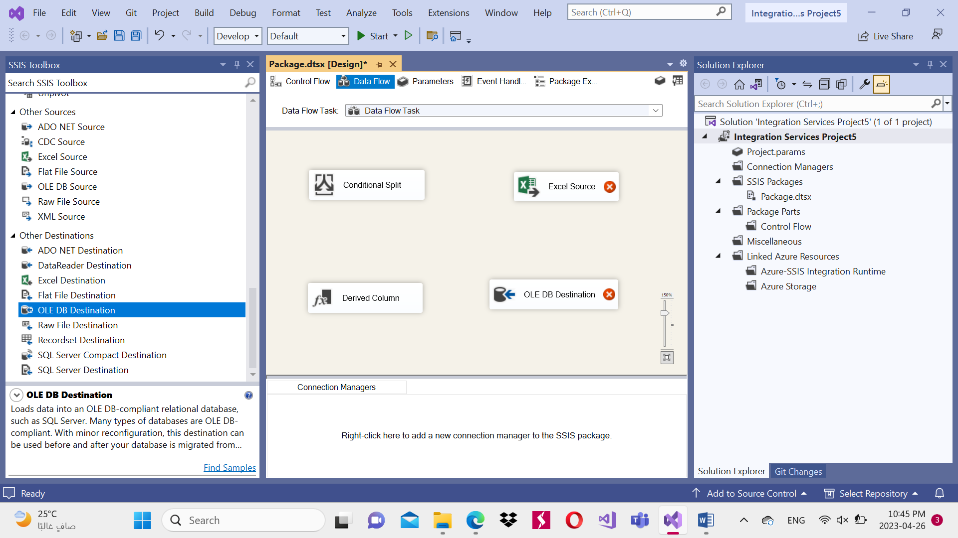

component used in SSIS:



 

**Transform in the second file Using SSIS:**

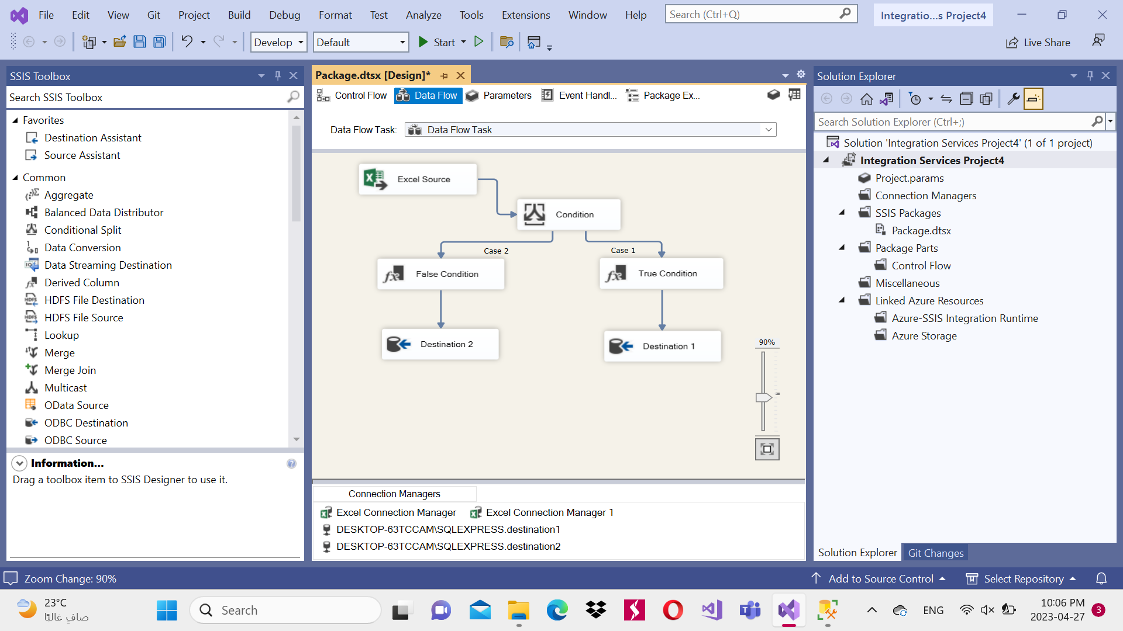

Pei Chart:

Charts

Results

* This chart shows how much the temperature will be depending on the weather details. Through the weather details and temperatures, people can know what can be worn in this weather.

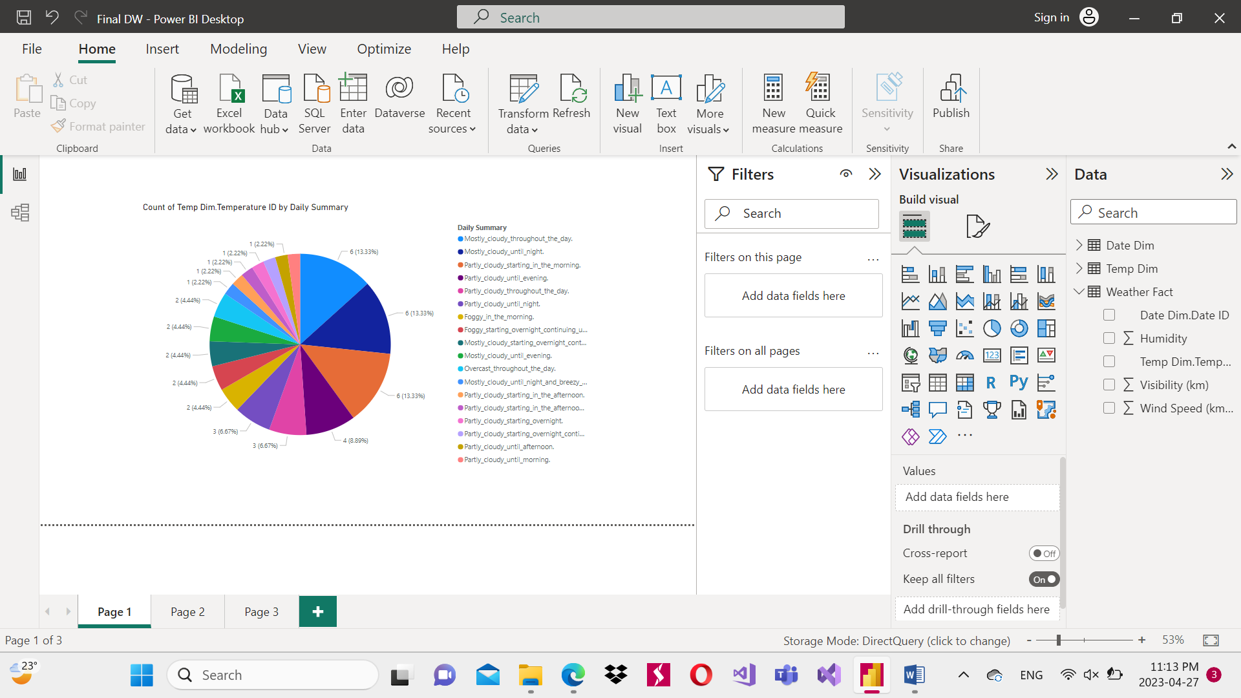

Column Chart:

* This chart shows how the visibility will be in each month, through which people can take caution in their movements.

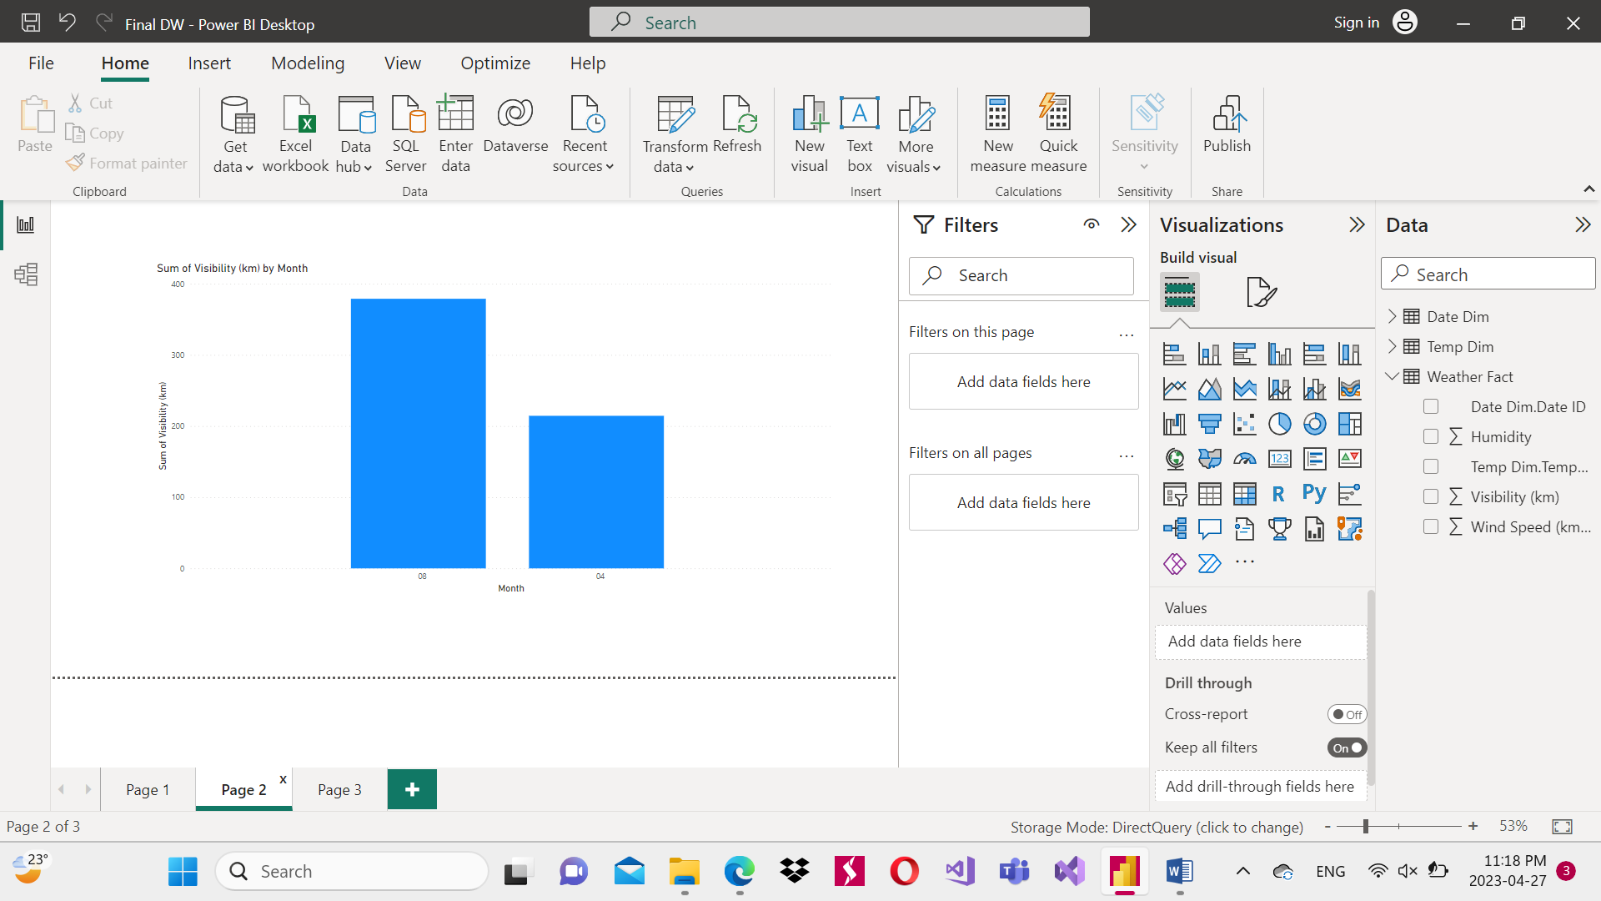

Line Chart:

* This diagram shows how the wind speed will be in relation to the humidity, through which people can decide if the weather will be bad or not, and whether there are fears of anything harmful happening, and it can also determine for patients whether they can leave their homes or not.

