The Role of K+ Currents in Human Articular Chondrocyte Electrophysiology: a Computational Perspective
Harish Narayanan1
Center for Biomedical Computing,
Simula Research Laboratory, Lysaker, Norway
Mary M. Maleckar,
Center for Biomedical Computing,
Simula Research Laboratory, Lysaker, Norway

Robert B. Clark,
Faculty of Kinesiology,
University of Calgary, Calgary, Canada
Wayne R. Giles,
Faculty of Kinesiology,
University of Calgary, Calgary, Canada

Abstract:
We have developed a computational model for studying the electrophysiology of the human articular chondrocyte based on experimental data which has identified novel K+ current expression. The utility of the model is illustrated by focusing on the role of a novel 2-pore K+ current in regulating the resting potential and therefore intracellular ion (e.g. Ca2+ homeostasis).

Key words: chondrocyte; electrophysiology; potassium channels; computational model

PLAN FOR 2nd Draft:
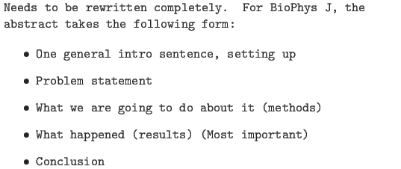

Introduction
Articular cartilage is aneural, avascular, alymphatic, flexible connective tissue that covers the articulating ends of diarthroidal joints (2,1) and permits stability and movement of the skeleton. This connective tissue consists of an extracellular matrix (ECM, composed primarily of collagen, elastin and proteoglycans, as detailed below) and one type of cell--the chondrocyte--which is responsible for synthesis and homeostasis of the matrix. Articular cartilage is regularly exposed to mechanical stresses, and this exposure is essential for the health of the tissue (3). Chondrocytes occupy only 1-10% of the total volume of articular cartilage in mammals (4,5) and play no direct mechanical role. Instead, mechanical support is provided by the ECM, which is composed of (a) collagen fibers, which gives the tissue the ability to resist tension, (b) negatively-charged gel-like proteoglycans (PGs) trapped within the collagen mesh, allowing the tissue to bear compression (6,1) and (c) synovial fluid within the articular capsule which acts as a lubricant, allowing for free movement of the bones (7). The chondrocyte thus resides in a physiologically atypical and dynamic environment. Its primary role is to maintain viable cartilage by balancing macromolecular synthesis and breakdown (see e.g. Wilkins et al. (8); Stockwell (3); Fassbender (9)).
Under abnormal conditions, chondrocyte damage may occur. As a result, the balance between matrix synthesis and degradation is lost, causing inflammation of the tissue and/or osteoarthritis: a thinning the cartilage layer which causes painful, bone-against-bone friction. It is generally known that the progression of osteoarthritis (Rush and Hall, 2003) and the ability of chondrocytes to respond to perturbations in the extracellular environment (Jones et al, 1999) is linked to poorly-regulated volume changes (10); physical damage to cartilage is more frequent in the context of reduced osmolarity (Bushet et al, 2005). In turn, there is indication that these volume changes are linked to an abnormal resting membrane potential in these cells (10). In abnormal chondrocytes, the response to challenging external stimuli may be altered (e.g. much larger changes in resting membrane potential) as compared to healthy cells (Lewis et al, 2011; Wilson, et al 2004; Tsuga 2002; Tirabashi 2010a). It is likely that such changes in the regulation of the resting membrane potential are due to altered ion channel function (Lewis et al, 2011; WIlson, et al 2004; Tsuga 2002; Tirabashi 2010a). Direct experimental investigation of the link between chondrocyte electrophysiology and chondrotoxicity is complicated, however, by small cell size and the associated limitations of in vitro electrophysiological studies. For the purpose of integrating available data and attempting to understand its functional significance, we have developed a detailed biophysical model of chondrocyte electrophysiology. This detailed model, the first of its kind, will facilitate investigation of questions related to chondrocyte electrophysiology, intra- and intercellular signaling, and biomechanical sensitivity and transduction. The role of the chondrocyte in articular pathophysiology can also be considered.
Osteoarthritic changes may develop in even young patients following orthopedic surgery (cite) via chondrolysis, a condition in which accelerated loss of articular cartilage occurs over a short time period (Webb editorial, 2009). Several clinical studies have suggested that this significant chondrotoxicity can occur as a result of postoperative administration of bupivacaine, a local anesthetic (Busfield and Romero, 2009; Bailie and Ellenbecker, 2009; Rapley et al, 2009; Wiater, et al, 2011). Experimental work has confirmed that bupivacaine can cause profound chondrotoxic effects in both cell (11) and animal studies (Gomoll et al, 2006; Chu et al, 2010). However, the cellular and subcellular mechanisms leading to chondrotoxicity remain unclear. The family of two-pore K+ channels, recently identified in human articular chondrocytes (Clark, et al, manuscript) can be inhibited by bupivacaine application (Clark et al, manuscript; Punke et al 2003). We therefore hypothesized that the blockade of the two-pore K+ channel in human articular chondrocytes by the local anesthetic bupivacaine leads to compensated regulation of the resting membrane potential in these cells. The main goals of our work are (1) to develop the first detailed mathematical model of chondrocyte electrophysiology and, (2) to use this model to investigate the potential role of bupivacaine in the homeostasis of the chondrocyte resting membrane potential.

Model and Methods
Our model assumes a single chondrocyte is an isolated cell residing in deep regions of cartilage. This extracellular environment can be modeled by specifying external concentrations [Na+]o , [K+]o , [Ca2+]o, [H+]o and [Cl-]o within physiologically-relevant, slightly hyperosmostic ranges (see Table 1). The chondrocyte cell membrane is known to express a number of voltage- and ligand-gated ion channels as well as pumps and exchangers (12). The channels under consideration in this model are illustrated in Figure 1 and described in the following section.

Ionic current formulations
Note (W. Giles): State which family.

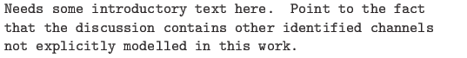

Potassium channels
Experimental results reported by Clark et al. (13) suggest that potassium channels play a dominant role in controlling the RMP of the human tibial joint articular chondrocyte. Motivated by this experimental work, our mathematical model incorporates the following three potassium channels.
Two-pore potassium channels. These are a set of widely-expressed K-selective channels. Their activation is largely independent of membrane potential. They play a vital role in determining the RMP of the human articular chondrocyte. Using the classic Hille-Goldman-Katz equation (ref) for voltage-gated, time-independent single-species ion channels, this current can be represented by:
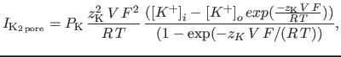 | (1)

and Figure 2a shows the current-voltage curve for this channel fit to experimental data (12)
Ca2+-activated K+ channels. In chondrocytes from a number of different mammals, the so-called large-conductance Ca2+-activated K+ channels have been identified. Such channels are hypothesized to act as ``osmolytic channels'’ and are responsible for decreasing intracellular osmotic strength by allowing efflux of potassium ions. This affects the ability of the chondrocyte to regulate its volume under rapid changes in the physiochemical environment (10). It has been suggested (12) that this type of K+ channel can be stretch-activated (stretch causes an increase in calcium influx, which results in markedly increased potassium current).
In the present formulation, we ignore the stretch dependence and model the (large) calcium-activated potassium channel using a functional form defined by Horrigan and Aldrich (15):

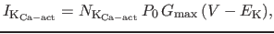 | (2)

where,
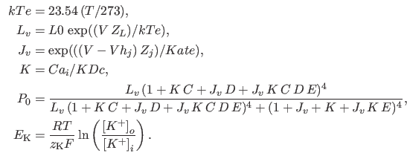

Figure 2b shows the current-voltage relationship for this channel fit to experimental data (13).
Delayed rectifier K+ Current. A markedly time- and voltage-dependent or delayed-rectifier has been identified in chondrocytes (17,18,16). These usually repolarize active cells following action potentials but their role in chondrocytes are not known because chondrocytes are far more depolarised. Previous studies have identified Kv 1.4 and 1.6 (18,19). In this work, the mathematical expression for the delayed rectifier is motivated by the ultra-rapidly rectifying potassium channel (20):
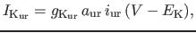 | (3)

where aur and iur are time-dependent channel activation and inactivation, and are defined in the model via the following expression:
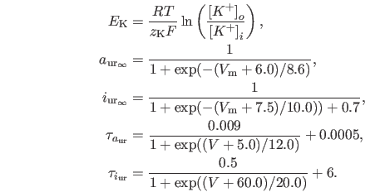

Figure 2c shows the voltage-current curve for this channel fit to experimental data (13) and Figure 2d shows the time-current curve over the same period.

Ion Pumps and Exchangers
Sodium-potassium pump
The effective expulsion of Na+ ions from the cell is achieved by the activity of the Na+-K+ - ATPase, and volume is maintained by altered balance of leaks and pumps to hold cell water constant..
In this model, we employ the following sodium-potassium pump formulation from Nygren et al. (22):
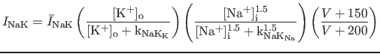 | (4)

Figure X shows a representative current-voltage curve for this electrogenic oump.
Sodium-calcium exchanger
As in many other cell types, the sodium-calcium exchanger plays a key role in Ca2+ homeostasis in articular chondrocytes (ref). Here, we model this channel using the following mathematical expression (22):
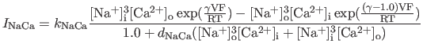 | (5)
Sodium-hydrogen exchanger
Chondrocytes possess a sodium-hydrogen antiporter (8,5) which allows the cell to sense extra-cellular pH. In order to model this channel, we use the following functional form described in Cha et al. (23):
 | (6)

where,
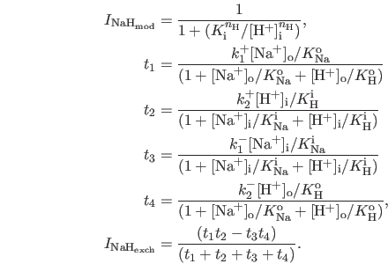 | (7)

Background Leakage Currents
The model accounts for background leakage of Na+ and K+ through the use of time-independent channels whose mathematical expressions are based on Hodgkin-Huxley formalism:
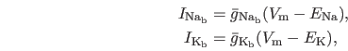 | (8)

The Nernst potentials for Na+ and K+ are computed based on their respective intra- and extracellular concentrations:
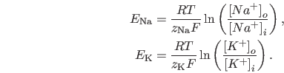

This model can account for chloride leakage using a similar mathematical formulation:

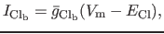 | (9)

where
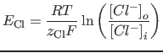

is the Nernst potential set up by the difference in Cl- concentration inside and outside the cell.

The atypical environment of the chondrocyte
As a result of being deep within cartilaginous tissue, the chondrocyte's extracellular environment is unique in comparison with other cell types. The high number of fixed negative charges on immediately adjacent proteoglycans attracts free cations (e.g. Na+ ) and excludes free anions from the matrix. As a results of this cation accumulation, water osmotically enters. The resulting ionic strength is in the range of XX osmoles. It is also known that the pH in this microenvironment is somewhat acidic in comparison with other extracellular environments (24,8).
As the tissue is avascular, synovial fluid supplies adult articular cartilage with small amounts of nutrients as well as oxygen, and byproducts are removed by diffusion (24,25). Due to the avascular nature of the resident tissue, chondrocytes generate ATP by substrate-level phosphorylation during anaerobic respiration. This generates H+ ions as a byproduct, which further lowers surrounding pH (24). Mechanical loading during activity also exposes chondrocytes to profound fluctuations in their physiochemical environment (27,26).
This atypical environment is reflected in measurements taken in tissue samples (see Table 1). Experimentally-reported values for the external concentrations of different species reveal some marked extremity in cation concentrations compared to e.g. cardiac tissue. We have utilized these extracellular concentrations in our model in concert with measured values from (13) to characterize the extracellular environment of the chondrocyte in our model.

Table 1: Consensus Values of Ion Concentrations for Chondrocyte Electrophysiology (8).
 | Cytoplasm | Matrix | Serum/Synovium
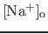 (mM) | 40 | 240-350 | 140
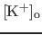 (mM) | 120-140 | 7-12 | 5
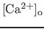 (mM) | 8.e-5 | 6-15 | 1.5
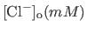 | 60-90 | 60-100 | 140
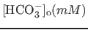 | 20 | 15 | 23
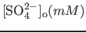 | 0.17 | 0.30 | 0.81
pH (mM) | 7.1 | 6.6-6.9 | 7.4
Osmolarity (mOsm) | -- | 350-450 | 300

Note from Wayne: Need a transition to next section.

Mathematical Model of Chondrocyte Electrophysiology
The individual currents above are defined by Equations 2-9, and the ODE system (10) is solved for the primary vector of unknowns: Vm, [Na+]i , [K+]i , [Ca2+]i , [H+]i , [Cl-]i , aur , and iur in the time period of the numerical experiment. The initial conditions are chosen from previous calculations run to steady state. The equation system is solved using LSODE (28), and the corresponding GNU Octave code is available free and open source for anyone to use and extend (12).

We assume that there are no spatial variations in quantities of interest, allowing us to model the chondrocyte as the following set of ordinary differential equations (ODEs) in time.

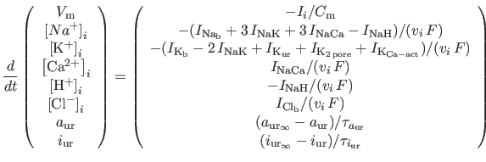 | (10)

where,
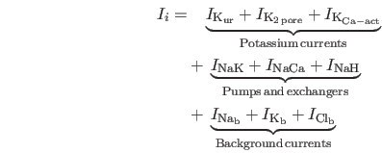

Results

Model characteristics
Experimental conditions described in Clark et al. (13) were first replicated in the simulations to fit significant potassium currents used in the model. For this, the exterior concentrations of the various species in the model were set to experimental values ( [K+]o = 5 mM, [Na+]o = 140 mM, [Ca2+]o = 2 mM, pH = 7.4 for IK,Ca-act and IKur ) and ( [K+]o = 5 mM, [Na+]o = 145 mM, [Ca2+]o = 2 mM, pH = 8.5 for IK2pore ), and the potential was linearly ramped over 1 s from -130 mV to +100 mV. The evolution of the concentrations and currents were tracked in this period, and multiple simulations of this nature were used to fit parameters for IK2pore , IK,Ca-act and IKur ). Figure 2 shows these individual currents and their fit to experimental values from Clark et al. (13). The other currents used in the model are significantly smaller in magnitude, and have not been specifically fit due to lack of experimental data. (Figure 3)
After this primary parameteristion, the overall model behaviour was studied under a linear voltage ramp from -130 mV to +90 mV under conditions matching experiments ( [K+]o = 5 mM, [Na+]o = 140 mM, [Ca2+]o = 2 mM, pH = 7.4) to reveal that the overall voltage-current behaviour of the chondrocyte model reproduces the experimental data quite closely (13). This comparison is shown in Figure 4 along with corresponding time evolution of the total current in the model.
The initial conditions used in the simulations were steady state values of the solution under same conditions used for the different numerical experiments. Figure 5 shows that, when starting from a steady state solution, the concentrations in the model do not evolve over a relatively long simulation period of 30 min. The initial conditions for the concentrations used in the computations were [Na+]i = 2.814 mM, [K+]i = 121.59 mM, [Ca2+]i = 2.371e-06 mM, [H+]i = 6.188e-10 mM, [Cl-]i = 13.209 mM. When the model is perturbed from these conditions, it returns to steady state values in a similar time frame.

/s is the molar volume of water. The surface area of the cell was related to the evolving volume by assuming a spherical geometry,

The interior and exterior osmolarities were computed by summing the (fixed) exterior concentrations of species and (evolving) interior concentrations of species respectively:

To ensure that the system does not evolve its volume at initial steady state, the initial difference between the osmolarities inside and outside the cell is subtracted from the osmolarity difference in Equation

Discussion

Limitations

TRP channels (TRPv4 in particular): These show little selectivity between cations Na+, Ca2+, Mg2+. Several have been identified in osteo-arthritic cartilage. Knocking out TRPv4 loss of Ca2+ response to hypo-osmotic challenge osteoarthritic changes. (Will cite.) Thus, membrane stretch calcium mobilisation via TRPv4 activation of Ca-act K, chondrogenesis and volume regulation.
Osteo-arthritic trip channel (12):
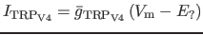 | (12)

Voltage-gated sodium channels: These have been found in some rabbit chondrocytes and some osteo-arthritic cartilage. They are likely constantly inactivated due to the voltages the chondrocyte. We instead model 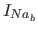 as a sort of constant background Na+ leak.
External stimulation (matching experiments, e.g. cyclic stimulation):
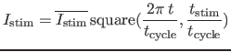 | (13)

Inwardly-rectifying IKATP : This channel is closed by intracellular ATP. It allows for physical coupling between metabolism and membrane excitability. It is observed to be open in the low-oxygen tension environment of chondrocytes (29,30).
Some mechanism for sensing external pH: ASIC channels (related to ENaC) are opened by extra-cellular protons (in the acidic environment of the chondrocytes ) and mediate an increase in Ca2+. There is also some other possible mechanism involving something called connexin-43.
Small calcium-activated Potassium ISK : A few reports suggest this might exist (14,5). Tiny magnitude, by definition and role unknown. So we ignore it.
Voltage-gated calcium channels: T, L-type VGCC found in some cartilage. Others refute. Supposedly, aggrecan and collagen synthesis induced by electrical stimulation relies on this channel. We will claim not important for RMP, just tissue growth, and thus we do not consider.
Epithelial sodium channels (EnaC): Not clear what role this plays in chondrocytes, though it has been identified. People speculate it has something to do with mechanotransduction contributes to RMP. It is perhaps defective during osteoarthritis. We will point out we do not look at this as it pertains to mechanics.
Aquaporin channels: AQP or some other mechanism for transport of water seems super important to the functioning of the cell. Studies show loss of volume regulation with inhibition of AQP. But we will point out that we do not model it because it pertains to mechanics.
NMDA channels: This is an excitatory neuro-transmitter receptor. It is possibly linked to mechanotransduction.

Bibliography
1
Poole, C. A., 1997.
Articular cartilage chondrons: form, function and failure.
J. Anat. 191:1-13.
2
Mankin, H. J., 1982.
The response of articular cartilage to mechanical injury.
J. Bone Joint Surg. Am. 64:460-466.
3
Stockwell, R. A., 1991.
Cartilage failure in osteoarthritis: Relevance of normal structure and function. A review.
Clin. Anat. 4:161-191.
4
Carney, S. L., and H. Muir, 1988.
The structure and function of cartilage proteoglycans.
Physiol. Rev. 68:858-910.
5
Hall, A. C., E. R. Horwitz, and R. J. Wilkins, 1996.
The cellular physiology of articular cartilage.
Exp. Physiol. 81:535-545.
6
Buckwalter, J. A., and H. J. Mankin, 1998.
Articular cartilage: Tissue design and chondrocyte-matrix interactions.
Instr. Course Lect. 47:477-486.
7
Edwards, J. C., L. S. Wilkinson, H. M. Jones, P. Soothill, K. J. Henderson, J. G. Worrall, and A. A. Pitsillides, 1994.
The formation of human synovial joint cavities: A possible role for hyaluronan and CD44 in altered interzone cohesion.
J. Anat. 185:355-367.
8
Wilkins, R. J., J. A. Browning, and J. C. Ellory, 2000.
Surviving in a Matrix: Membrane Transport in Articular Chondrocytes.
J. Membrane Biol. 177:95-108.
9
Fassbender, H. G., 1987.
Role of chondrocytes in the development of osteoarthritis.
Am. J. Med. 83:17-24.
10
Lewis, R., K. E. Asplin, G. Bruce, C. Dart, A. Mobasheri, and R. Barrett-Jolley, 2011.
The role of the membrane potential in chondrocyte volume regulation.
J. Cell. Physiol. xx:mm-nn.
11
Chu, C. R., N. J. Izzo, N. E. Papas, and F. H. Fu, 2006.
In Vitro Exposure to 0.5% Bupivacaine Is Cytotoxic to Bovine Articular Chondrocytes.
J. Arthroscopy 22:693-699.
12
Unknown, A., yyyy.
This is an unknown article.
J. Unknown xx:mm-nn.
13
Clark, R. B., C. Kondo, and W. R. Giles, 2011.
Two-pore K channels contribute to membrane potential of isolated human articular chondrocytes.
J. Physiol. xx:mm-nn.
14
Barrett-Jolley, R., R. Lewis, R. Fallman, and A. Mobasheri, 2010.
The emerging chondrocyte channelome.
Front. Physiol. 1:mm-nn.
15
Horrigan, F. T., and R. W. Aldrich, 2002.
Coupling between Voltage Sensor Activation, Ca Binding and Channel Opening in Large Conductance (BK) Potassium Channels.
J. Gen. Physiol. 120:267-305.
16
Walsh, K. B., S. D. Cannon, and R. E. Wuthier, 1992.
Characterization of a delayed rectifier potassium current in chicken growth plate chondrocytes.
Am. J. Physiol. 262:C1335-C1340.
17
Sugimoto, T., M. Yoshino, M. Nagao, S. Ishii, and H. Yabu, 1996.
Voltage-Gated Ionic Channels in Cultured Rabbit Articular Chondrocytes.
Comp. Biochem. Physiol. 115C:223-232.
18
Mobasheri, A., T. C. Gent, M. D. Womack, S. D. Carter, P. D. Clegg, and R. Barrett-Jolley, 2005.
Quantitative analysis of voltage-gated potassium currents from primary equine (Equus caballus) and elephant (Loxodonta africana) articular chondrocytes.
Am. J. Physiol. Regul. Integr. Comp. Physiol. 289:R172-R180.
19
Clark, R. B., N. Hatano, C. Kondo, D. D. Belke, B. S. Brown, S. Kumar, B. J. Votta, and W. R. Giles, 2010.
Voltage-gated K+ currents in mouse articular chondrocytes regulate membrane potential.
Channels 4:179-191.
20
Maleckar, M. M., J. L. Greenstein, W. R. Giles, and N. A. Trayanova, 2009.
K current changes account for the rate dependence of the action potential in the human atrial myocyte.
Am. J. Physiol Heart Circ. Physiol. 297:1398-1410.
21
Mobasheri, A., R. J. Errington, S. Golding, A. C. Hall, and J. P. Urban, 1997.
Characterization of the Na+, K+-ATPase in isolated bovine articular chondrocytes; molecular evidence for multiple alpha and beta isoforms.
Cell Biol. Int. 21:201-212.
22
Nygren, A., C. Fiset, L. Firek, J. W. Clark, D. S. Lindblad, R. B. Clark, and W. R. Giles, 1998.
Mathematical Model of an Adult Human Atrial Cell: The Role of K Currents in Repolarization.
Circ. Res. 82:63-81.
23
Cha, C. Y., C. Oka, Y. E. Earm, S. Wakabayashi, and A. Noma, 2009.
A Model of Na /H Exchanger and Its Central Role in Regulation of pH and Na in Cardiac Myocytes.
Biophys. J. 97:2674-2683.
24
Lee, R. B., and J. P. Urban, 1997.
Evidence for a negative Pasteur effect in articular cartilage.
Biochem. J. 321:95-102.
25
Otte, P., 1991.
Basic cell metabolism of articular cartilage. Manometric studies.
Z. Rheumatol. 50:304-312.
26
Mow, V. C., C. C. Wang, and C. T. Hung, 1999.
The extracellular matrix, interstitial fluid and ions as a mechanical signal transducer in articular cartilage.
Osteoarthr. Cartil. 7:41-58.
27
Urban, J. P., 1994.
The chondrocyte: A cell under pressure.
Br. J. Rheumatol. 33:901-908.
28
Radhakrishnan, K., and A. C. Hindmarsh, 1993.
Description and use of LSODE, the Livermore Solver for Ordinary Differential Equations.
Technical Report UCRL-ID-113855, Lawrence Livermore National Laboratory.
29
Dart, C., and N. B. Standen, 1994.
Hypoxia induces a potassium current in smooth muscle cells isolated from the porcine coronary artery.
J. Physiol. 477:P85-P86.
30
Mobasheri, A., T. C. Gent, A. I. Nash, M. D. Womack, C. A. Moskaluk, and R. Barrett-Jolley, 2007.
Evidence for functional ATP-sensitive (K(ATP)) potassium channels in human and equine articular chondrocytes.
Osteoarthr. Cartil. 15:1-8.

Figure Legends

Figure 1.
An illustration of the ion-selective channels included in the mathematical model of the chondrocyte.

Figure 2.
Potassium current-voltage relationships which have been fit to experimental values (in red) from Clark et al. (13). The external concentrations correspond to the experimental conditions: [K+]o = 5 mM, [Na+]o = 140 mM, [Ca2+]o = 2 mM, pH = 7.4, except for IK2pore , where [K+]o = 145 mM, pH = 8.5.

Figure 3.
I-V relations for the other currents. These are not fit to experimental data, but used to tune simulation results.

Figure 4.
Overall behaviour of the model when voltage is ramped from -130 mV to +90 mV in 1 s. The model output closely matches experimental data (red) from Clark et al. (13).

Figure 5.
Time-evolution of the concentrations over 1800 s to show that the initial conditions we have chosen for the model were at steady state. The initial conditions for the concentrations used in the computations were [Na+]i = 2.814 mM, [K+]i = 121.59 mM, [Ca2+]i = 2.371e-06 mM, [H+]i = 6.188e-10 mM, [Cl-]i = 13.209 mM.

Figure 6
Evolution of the resting membrane potential with varying external potassium concentration. Note that while it is slightly more positive than experiments, it matches the qualitative behaviour quite closely (13).

Figure 7.
When the amount of IK2pore is varied from 100% to 0% (by blocking with increasing amounts of BUP), the RMP increases. These simulations were carried out at two different values of external concentrations [K+]o = 5 mM and [K+]o = 25 mM and results compare favorably with experimental data (13, Fig. 8B).

Figure 1:
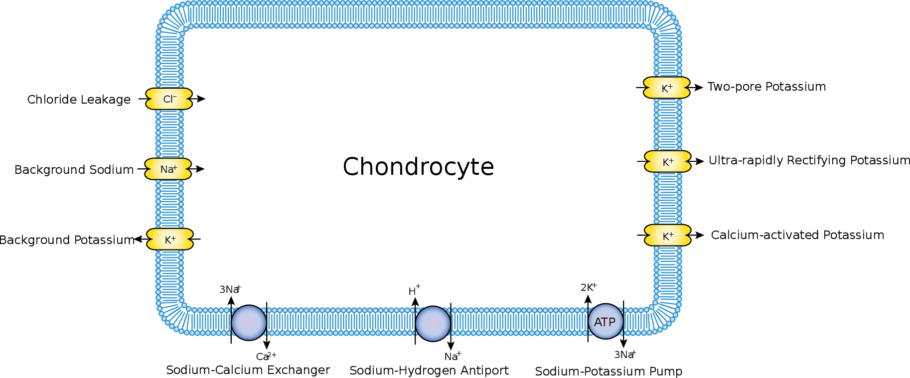

Figure 2:

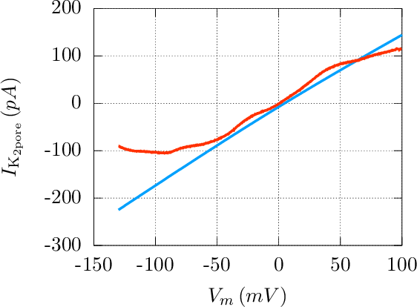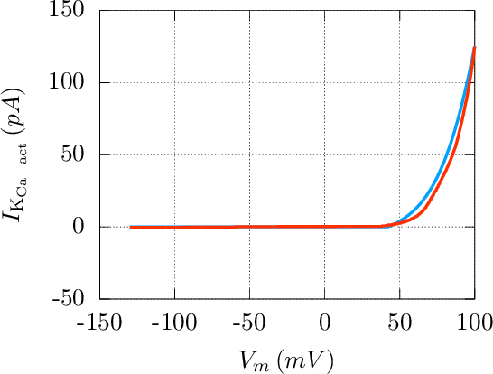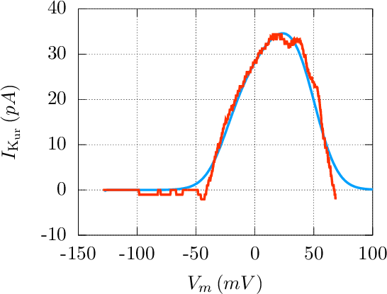

Figure 3:

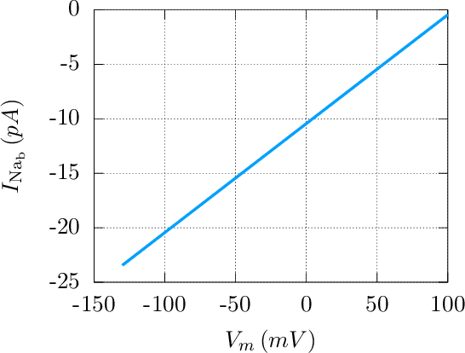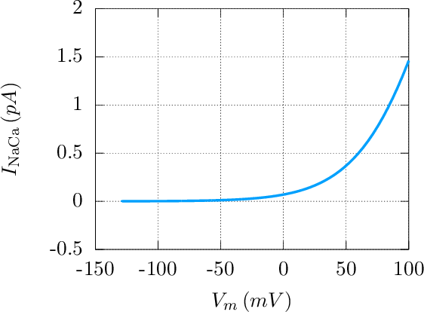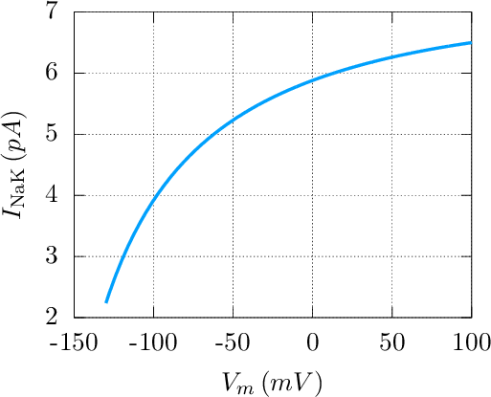

Figure 4:

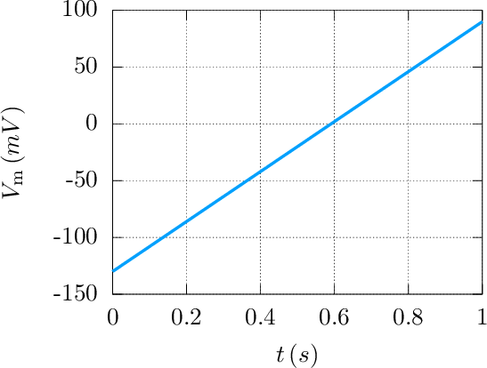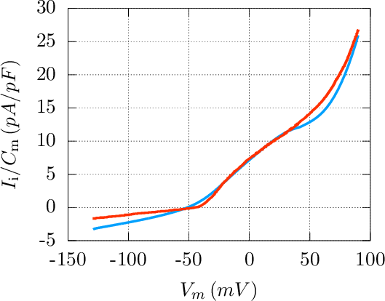

Figure 5:

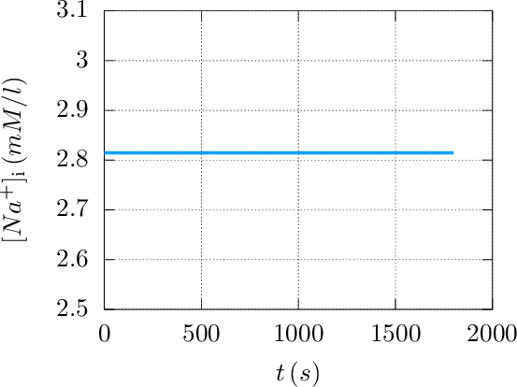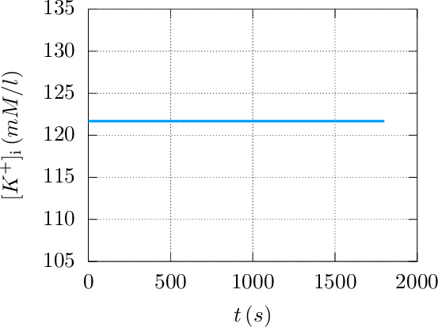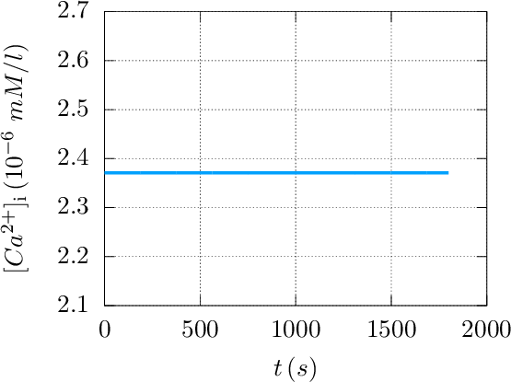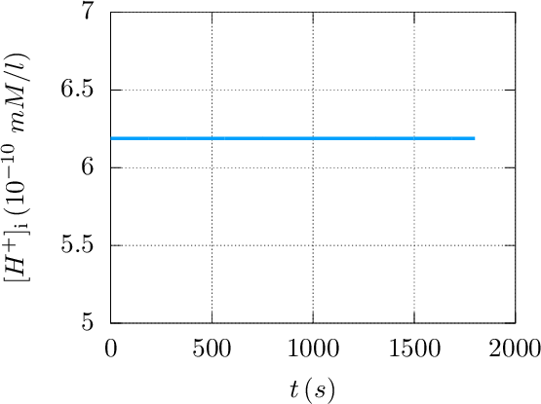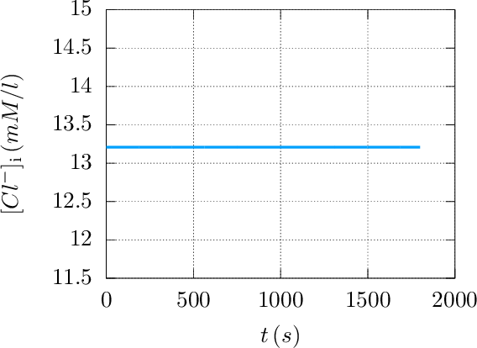

Figure 6:

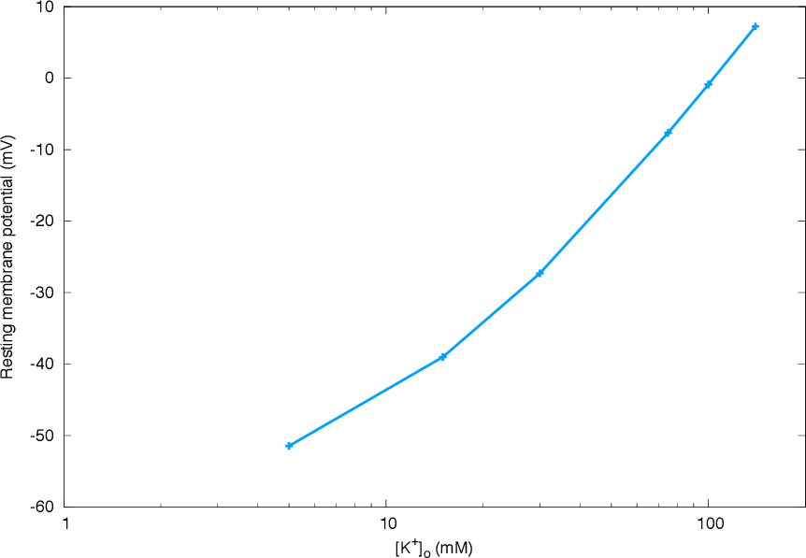
Figure 7:
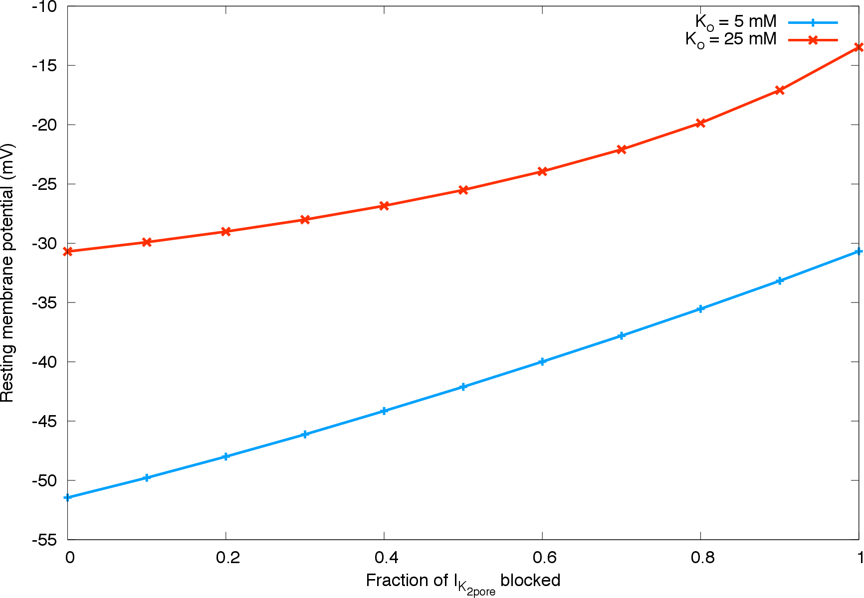

Footnotes
...Harish Narayanan1
Corresponding author. Address: Center for Biomedical Computing, Simula Research Laboratory, P.O. Box 134, 1325 Lysaker, Norway Tel.:+47 4003-4801, Fax: +47 6782-8201

Harish Narayanan 2012-10-05

