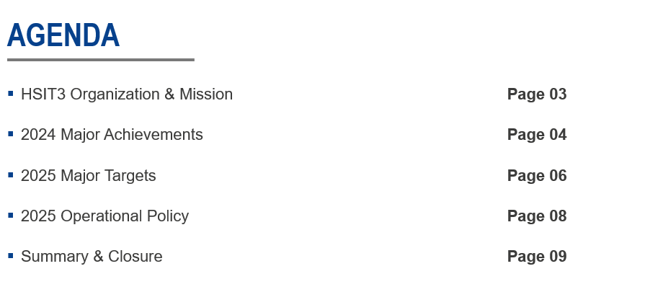
Slide 1: Agenda
Good morning, everyone, let me continue with the HSIT3 section. Let’s begin with today’s agenda. We’ll start with an overview of our organization and mission, then review our major achievements from 2024. Next, we’ll dive into our key targets for 2025, discuss our operational policy, and conclude with a summary and closing remarks. Let’s get started!

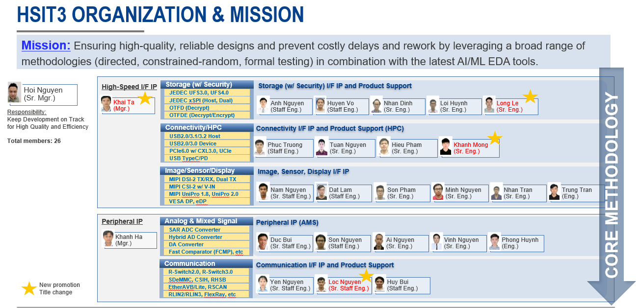
Slide 2: HSIT3 Organization & Mission
First, let’s take a moment to revisit the HSIT3 Organization and Mission. Despite a very challenging business situation, we’ve maintained the same headcount as last year. We have continued to support a range of core IPs, including Storage, Image, Analog & Mixed Signal, Connectivity, Communication IPs. Additionally, we have gradually expanded our scope to support some cutting-edge IPs like PCIe6, UCIe, UFS4, and for RCARGen5 in HPC. This growth is a strong sign that our team is steadily building trust and expanding our business scope with other organizations. I’d like to extend special thanks to the team and our newly promoted team members—Khai Ta, Long Le, and Khanh Mong. Congratulations on your well-deserved promotions!
Our mission remains clear: to ensure high-quality, reliable designs while preventing costly delays and rework by leveraging a broad range of methodologies—directed, constrained-random, and formal testing—combined with the latest AI and ML EDA tools. This mission is a guiding principle for everything we do.

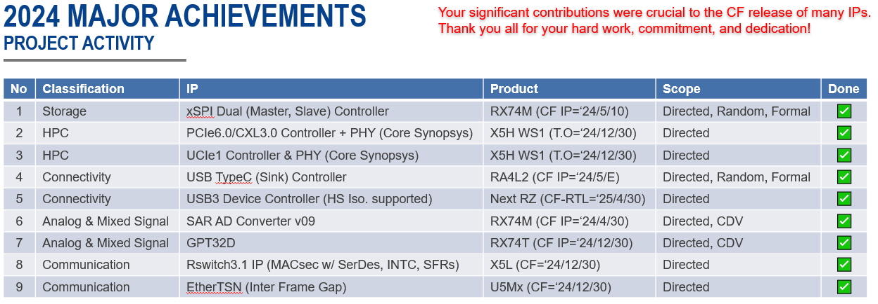
Slide 3: 2024 Major Achievements (Projects)
This year, we successfully supported multiple projects, contributing to the CF release of many IPs, from Storage IPs like the xSPI Dual Controller for RX74M, to High-Performance Computing IPs such as UCIe/PCIe6 for RCarGen5, Connectivity IPs like the USB3 Device Controller for Next RZ, as well as Analog & Mixed Signal IPs like ADC and GPT32, and Communication IPs like RSwitch and EtherTSN for U5Mx.
Each of these projects met its milestones. I want to sincerely thank every one of you for your hard work, commitment, and dedication. Your contributions were crucial to these releases, and I’m incredibly proud of what we’ve achieved together.

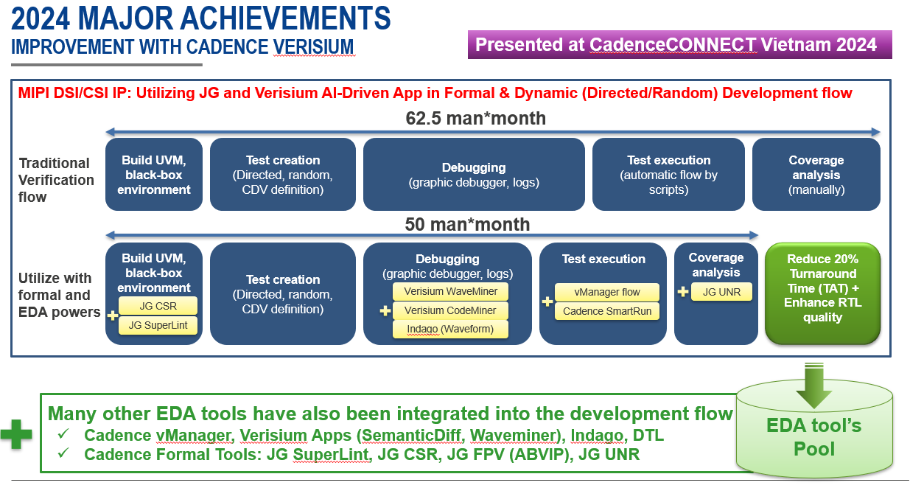
Slide 4: 2024 Major Achievements (Productivity with Cadence Verisium)
Beyond project delivery, we also made significant improvements in productivity. In 2024, we enhanced our workflow by integrating Cadence Verisium and JG tools into our MIPI DSI/CSI IP at every stage of the development flow, from initial debugging and simulation to regression and coverage closure. At the early stages of development, we use JG tools to catch initial bugs as early as possible. Verisium platform (WaveMiner, CodeMiner) supports root cause analysis. In the regression and coverage closure phase, the combination of vManager, Smart-Run, and JG UNR is powerful, speeding up regression and coverage analysis time.
The result? We reduced TAT by 20% and enhanced RTL quality. We have expanded our EDA tool pool, enabling us to work smarter and faster.

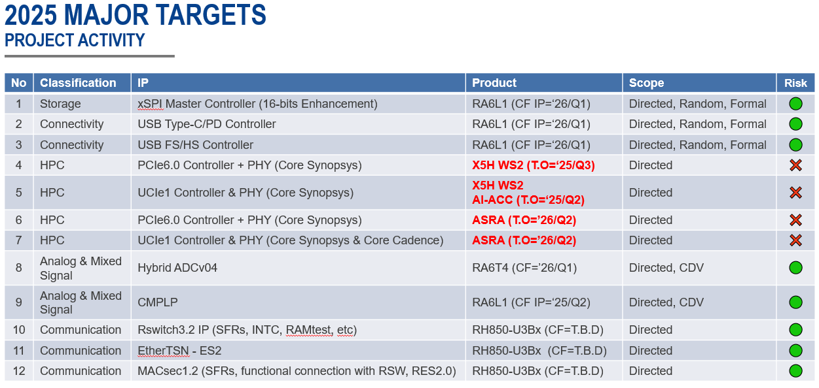
Slide 5: 2025 Major Targets (Projects)
Looking ahead to 2025, we have a lineup of many challenging projects. Our targets include IPs like the xSPI Master with 16-bits data enhancement and USB Type-C/PD Controller for RA6L1, PCIe6.0 and UCle1 Controllers for X5H WS2 and ASRA, and Analog & Mixed Signal IPs like Hybrid ADCV04 for RA6T4. We’re also focusing on Communication IPs such as RSwitch3.2 and EtherTSN-ES2 for RH850-U3Bx.
While most of these projects are low-risk, as indicated by the green circles, some—like the PCIe and UCle Controllers for X5H WS2 and ASRA—carry higher risks, marked in red. We’ll need to stay motivated and proactive to ensure success across all 12 projects.

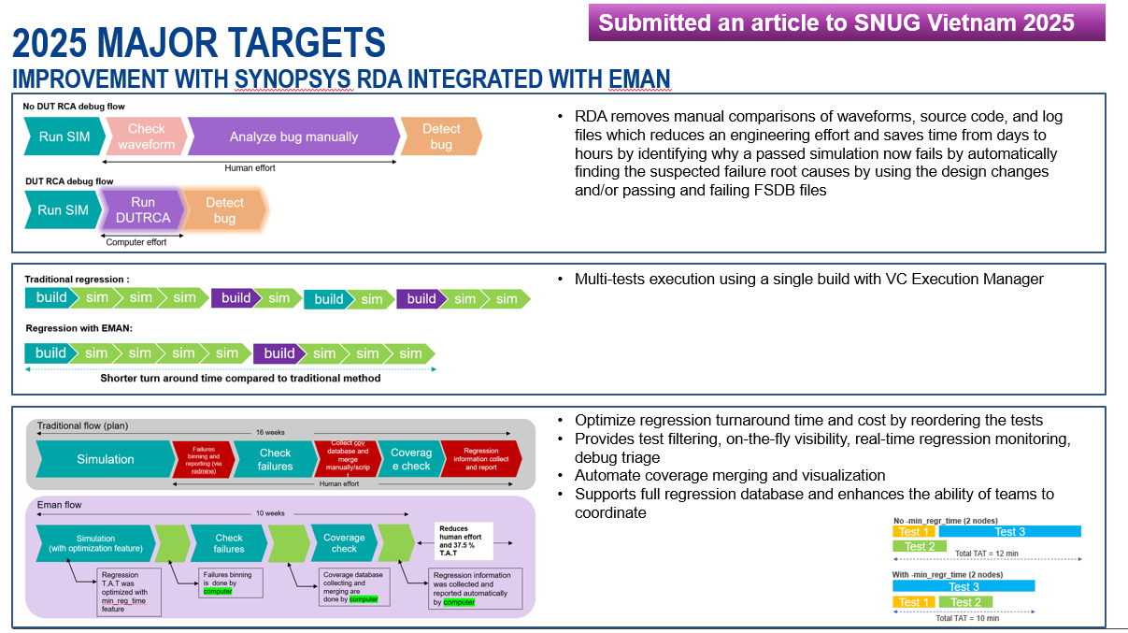
Slide 6: 2025 Major Targets (Productivity with Synopsys RDA Integrated with Eman)
In terms of productivity, we’re aiming to further optimize our processes by integrating Synopsys RDA with Eman. This will support our debugging flow, reducing manual effort in analyzing waveforms, source code, and log files. With Eman, we’ll automate failure detection, cutting debug time from days to hours.
We’re also introducing multi-test execution with VC Execution Manager, optimizing regression TAT with on-the-fly visibility and real-time monitoring. These improvements, which we’ve submitted as an article to SNUG Vietnam 2025, will help us work more efficiently and deliver even higher-quality results.

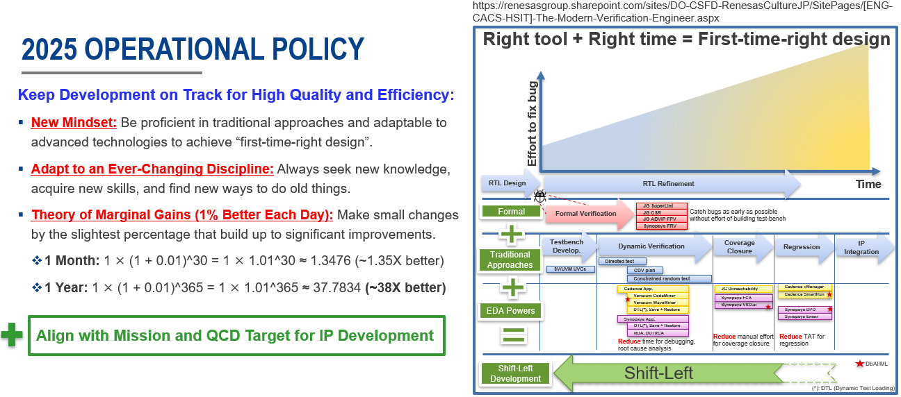
Slide 7: 2025 Operational Policy
Finally, let’s talk about our operational policy for 2025: ‘Right Tool + Right Time = First-Time-Right Design.’ To keep development on track for high quality and efficiency, we’ll adopt a new mindset—becoming proficient in traditional approaches while embracing advanced technologies. We must adapt to an ever-changing discipline, seeking new knowledge and skills to innovate.
We’ll also apply the Theory of Marginal Gains—small 1% improvements each day can lead to significant results. Over a month, this translates to a 1.35X improvement, and over a year, 38X better. By aligning with our mission and QCD targets, using formal verification, EDA tools, and a shift-left approach, we’ll reduce manual effort, catch bugs early, and ensure first-time-right designs. Let’s commit to this policy.

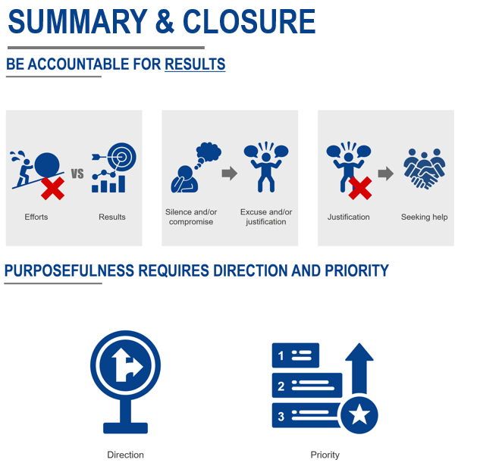
Slide 8: Summary & Closure
To sum up, I want to emphasize the importance of accountability as we step into 2025. As a team, we must avoid staying silent or compromising when having challenges—instead, we should focus on seeking help, prioritizing, and collaborating to overcome them. We need to shift our focus from just efforts to tangible results, because effort without results is not truly effective.
Purposefulness is key. We need clear direction and well-defined priorities to stay on track. By aligning our efforts with the mission and targets we’ve discussed today, we’ll maintain focus and drive impactful outcomes.
I’m confident we’ll achieve great things in 2025. Thank you all for your dedication - let’s make it happen!

