Business Hours Sample

Introduction
Business hours in Webex Contact Center allows centralized management of working hours, holidays, and emergency hours for a contact center. You can plan the contact center working and non-working hours in advance as well as take emergency actions for issues. Business hours comprises working hours, holidays, and overrides. Working hours configuration can optionally refer to holiday lists and overrides. Once you define working hours, these refer to flow scripts for appropriate routing behavior.

Within Webex Contact Center, you'll find a series of sample flows illustrating typical functions. These are crafted to guide you through the process of creating your own flows, mirroring their functionality.

Pre-requisites
- Create working hours, holiday lists, overrides from the Control Hub à Services-Contact Center Setup Business Hours.
- Upload required audio files from the sample provided or choose your own “Audio_BusinessHours".
- Import the sample json flow provided. Instructions Import Flow.

Sample Business Hours flow.
Image 1
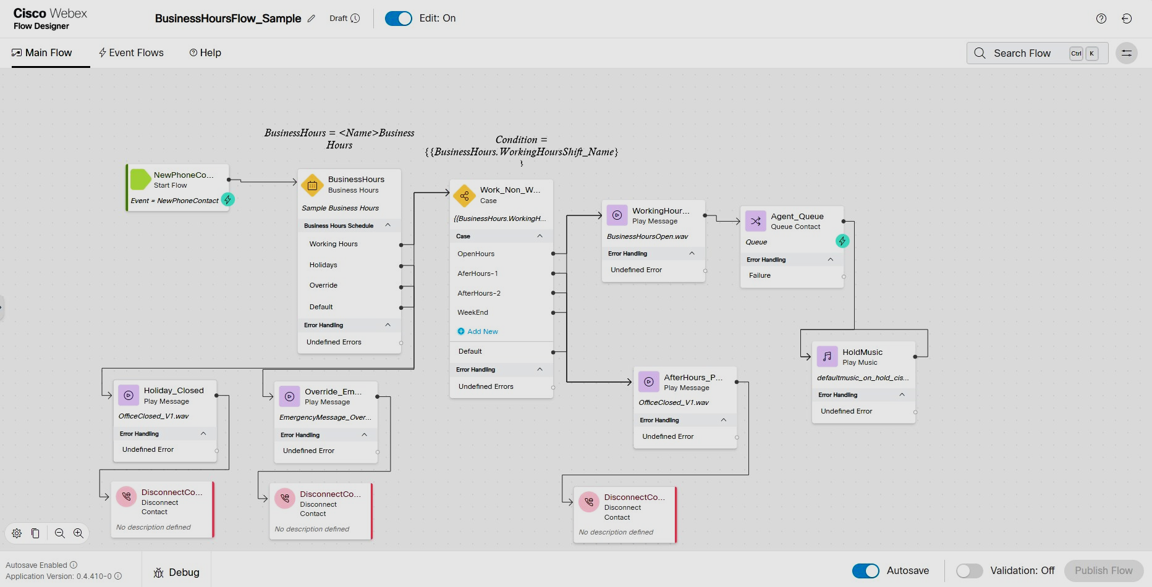

Image 2 (same)
