Contents

Environment : 1

Service Configuration: 1

DB Script 2

Test Results : 2

Eureka Service Registration : 2

API to create employee and store it in SQL 2

API to create department and store it in SQL 3

API to get all departments 4

API to get all employees 4

API to get employee details along with complete details of the department 5

API to get employees of any department 6

MY SQL Database 7

# Environment :

|  |  |
| --- | --- |
| IDE | Eclipse IDE |
| Database | MySQL 8  MY SQL Database  schemas = EMPLOYEE_DEPT_SERVICE  username = root  username = root |
| flyway | flyway.url = jdbc:mysql://localhost:3306/mysql  flyway.schemas = EMPLOYEE_DEPT_SERVICE  flyway.user = root  flyway.password = root |
| Build | Maven |
| ORM Framework | JPA (hibernate default) |
| spring-boot | 2.3.7.RELEASE |
| java.version | 11 |
| spring-cloud.version | Hoxton.SR9 |
| openfeign | For service invocation |

# Service Configuration:

|  |  |  |  |
| --- | --- | --- | --- |
| Service | Port | URLs | Description |
| netflix-eureka-naming-server | 8761 | [http://localhost:8761/](http://localhost:8761/eureka)  or  http://localhost:8761/eureka | Naming and Discovery Service |
| department-service | 8000 | POST : <http://localhost:8000/departments/>  GET: <http://localhost:8000/departments/> | Department service to capture department details |
| employee-service | 8001 | POST : <http://localhost:8001/employee/>  GET : <http://localhost:8001/employee/>  GET : <http://localhost:8001/employee/1>  GET : http://localhost:8001/employee/department/1 | Employee Service to capture Employee details.  Invokes Department service. |

# DB Script



# Test Results :

## Eureka Service Registration :

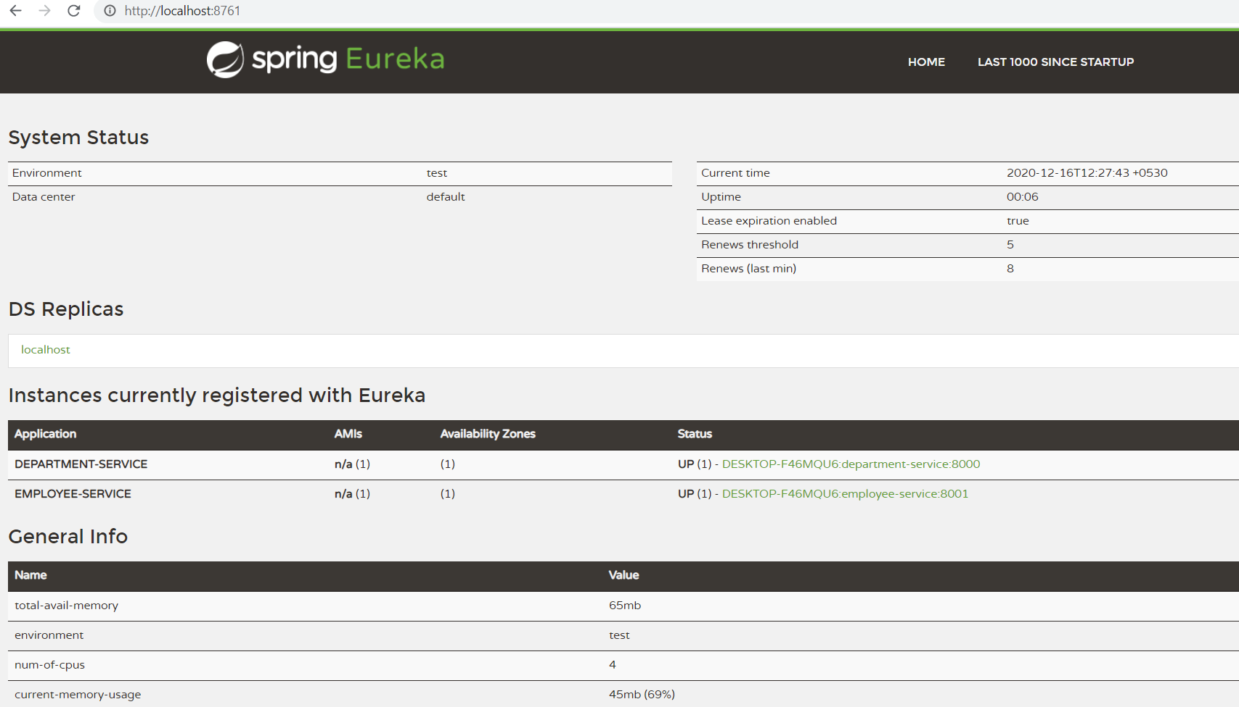

## API to create employee and store it in SQL

http://localhost:8001/employee/

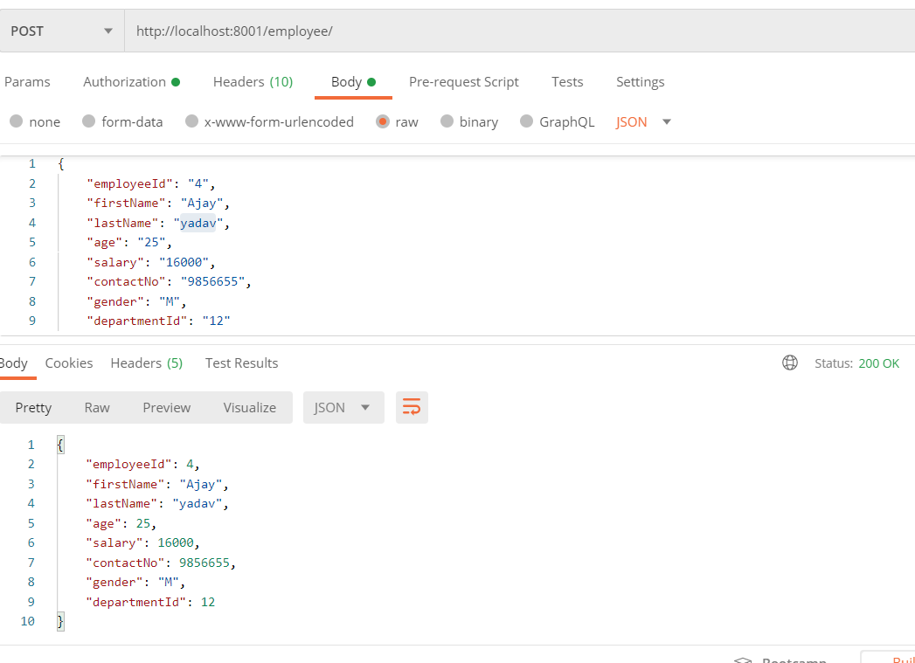

## API to create department and store it in SQL

http://localhost:8000/departments/

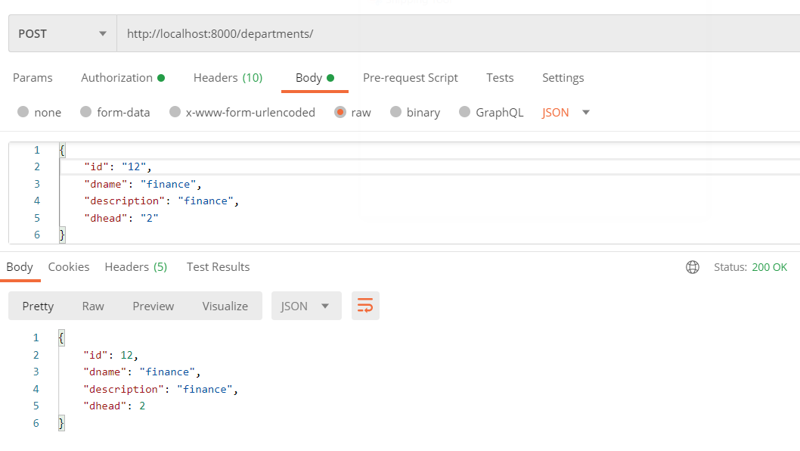

## API to get all departments

http://localhost:8000/departments/

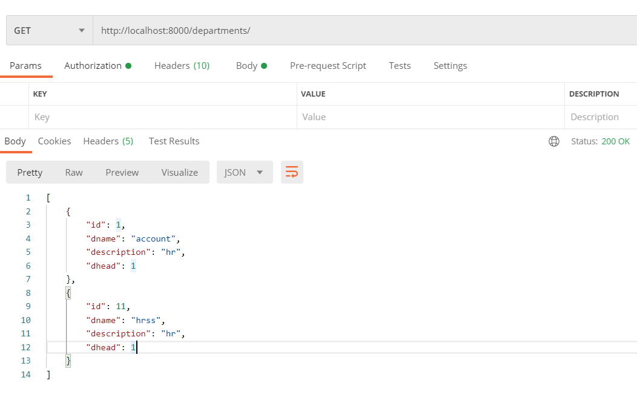

## API to get all employees

<http://localhost:8001/employee/>

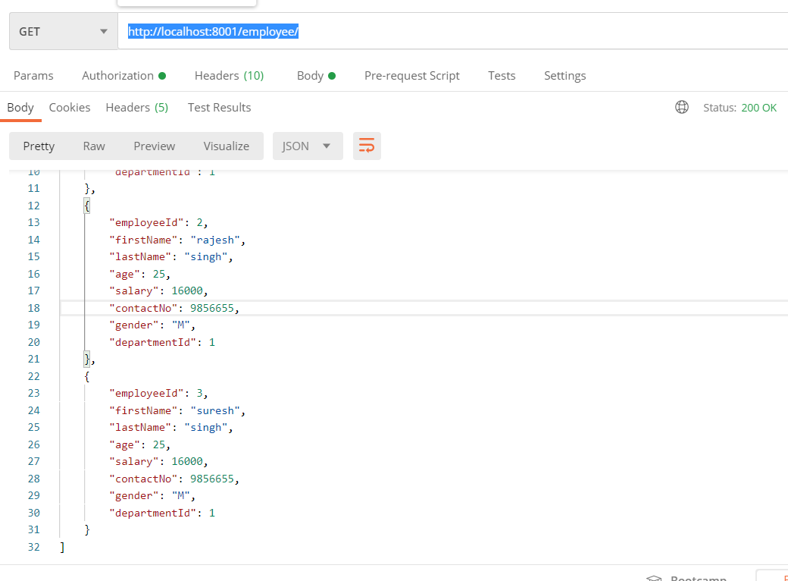

## API to get employee details along with complete details of the department

http://localhost:8001/employee/1

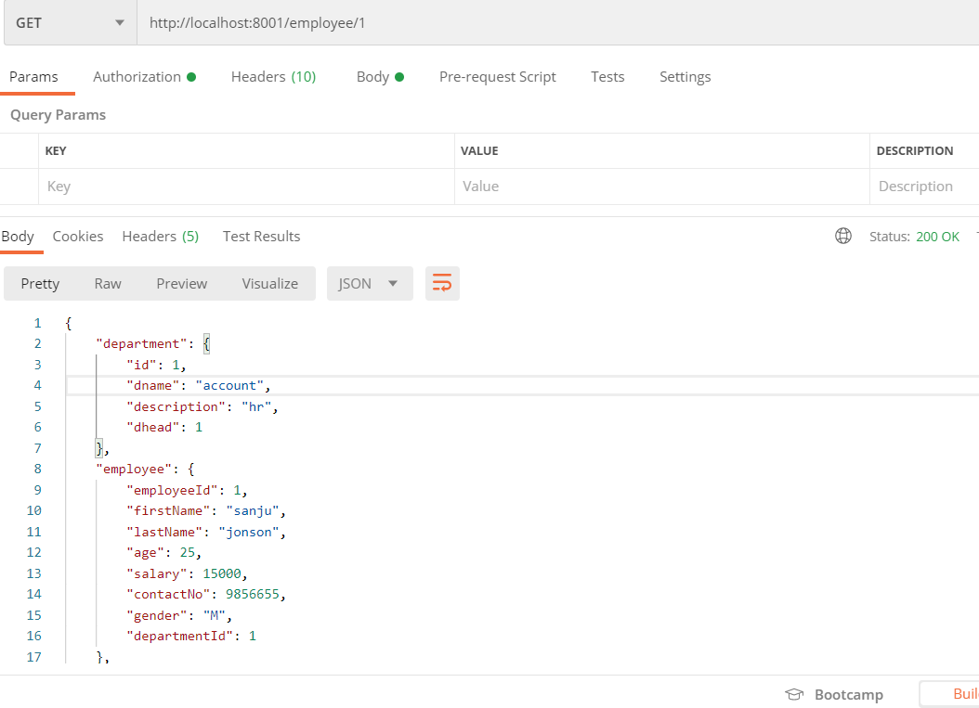

## API to get employees of any department

http://localhost:8001/employee/department/1

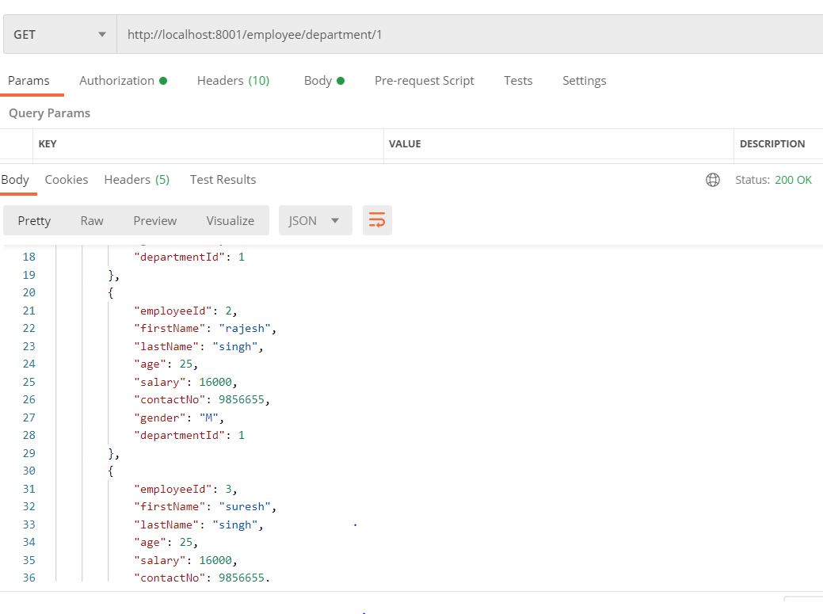

# MY SQL Database

schemas = EMPLOYEE_DEPT_SERVICE

username = root

username = root

