Ngoc Nguyen - Mimi

20188794

CISC 472 A1

Feb 3rd, 2023

Question 3: Linear filters

(b)

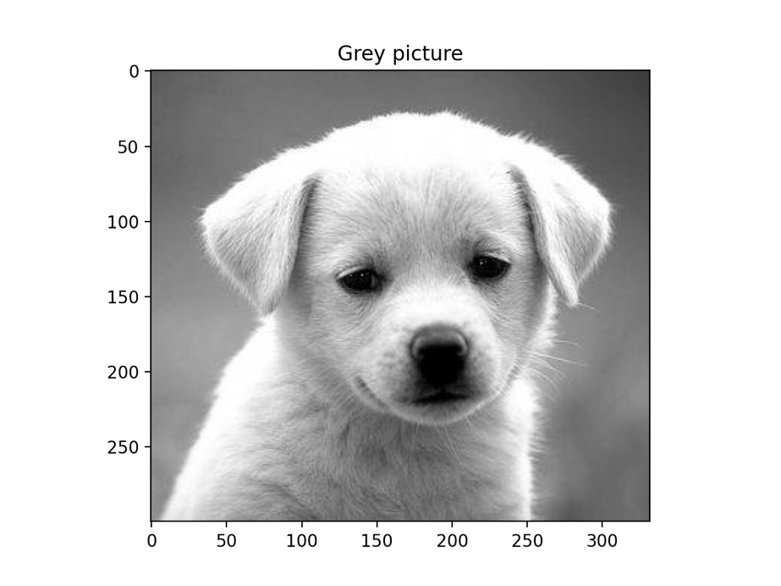

Figure 1: Original greyscale picture, greyscale picture with smoothing filter, greyscale picture with sharpening filter, greyscale picture with edge filter. (Order from left to right, up to down)

Observations:

In the smoothing filter, the details of the fur are blurred out as well as the highlights and shadows of the dog. In the sharpening filter, the sharpened picture looks really pixelated and exaggerated. The image looks grainy and unnatural. I tried smoothing the picture before sharpening it and the result is less drastic. Lastly, the edge filter can define discrete edges over the picture, which is especially observable with the dog’s fair.

Question 4: Non-linear filter (median)

(b)

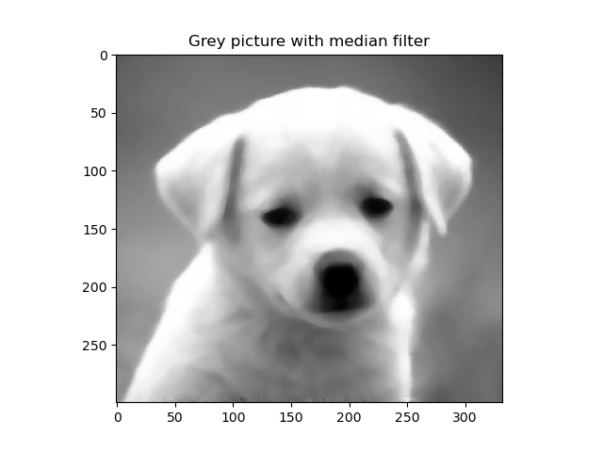

Figure 2: The original greyscale image and the image with median filter.

Observation: The median filter softens the edges and details of the original image far more than the smoothing filter in question 3. Details of the fur, eyelids, and nose of the dog are barely noticeable after applying the filter.

Question 5: Depth Modification

(b)

Figure 3: Original greyscale picture and image with modified depth to 12 bits.

Observation: The increase in depth shows a greater number of tones (in greyscale) represented in the image. There are seemingly more shares of grey being shown in the increased depth image.

(c)

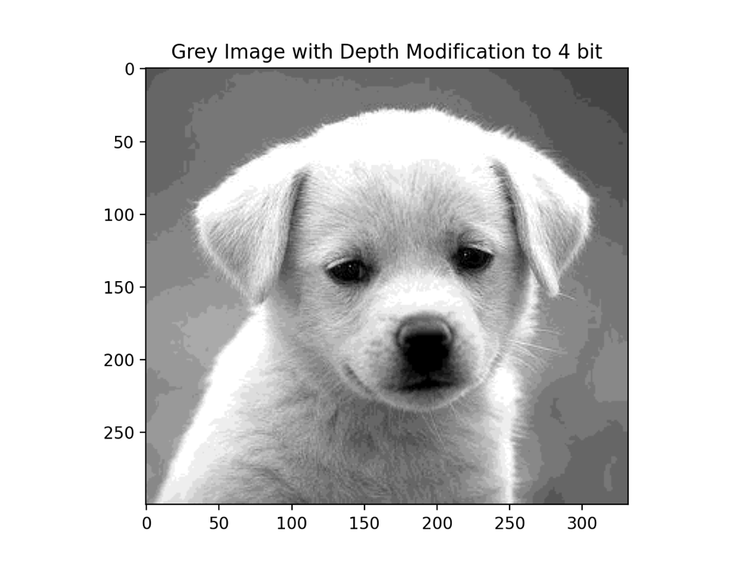

Figure 4: Greyscale image with modified depth to 2 bit and 4 bits.

Observation: The 2 bits depth image is the least dynamic and showing the least shades of grey out of all the modified depth images. The background of the 2 bits images breaks into different patches of grey color instead of the cohesive look in the original image. For the 4 bits depth image, the range of grey values are improved compared to the 2 bits, however, I can still notice the patchy background shading.

Question 6

(b)

Figure 5: Grey Image enhanced at different intensity range.

Observation:

* First case (L1: 0.25d, L2: 0.75): This image looks the most like the original one. This is because the range of intensity covers the middle half of the range, excluding the darkest and lightest pixels. Thus, most of the details are still retained in the image while the brightest areas are blown out white, and the darker details like the eyes are blacked out.
* Second case (L1: 0.45d, L2: 0.55): This image enhances the pixel values that falls right in the middle of the spectrum; thus, shading is retained while all other details are also either blown out white or blacked out.
* Third case (L1: 0.10d, L2: 0.60): This image enhances the rather lighter shade pixels; thus, the image appears bright and many details of the fur on the dog’s neck is visible.
* Fourth case (L1: 0.50d, L2: 0.80): This image retains most of the darker pixels, thus the image appears darker, showing more transition of the fur color to highlight spots.

Question 7

Figure 6: Generated image (original, median filter size 3, 7, 15)

Observation: With the kernel size increase, not much visible changes are made to the image. I’m assuming that since the image only has 2 values (0 and max), there isn’t much smoothing and transition the median filter could have done on the image.

(c)

Figure 7: Generated image (original, median filter size 5, median filter size 5 applied 10 times)

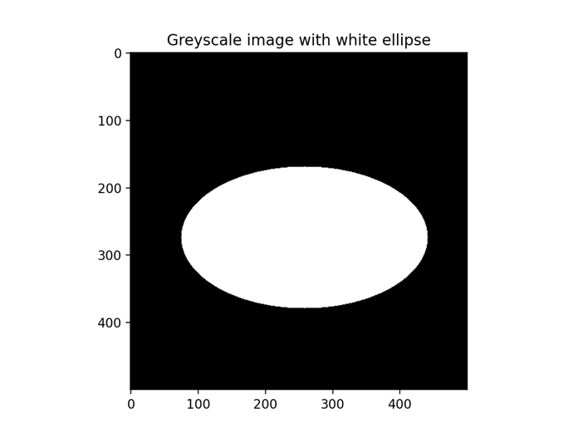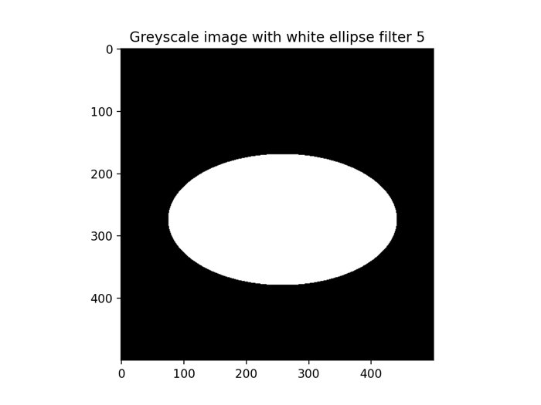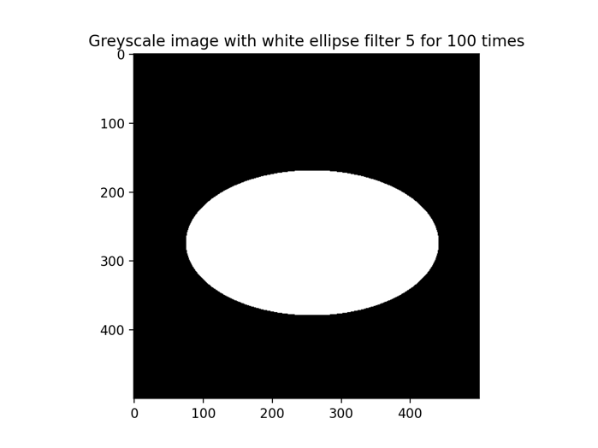

Figure 8: Generated image (original, median filter size 5, median filter size 5 applied 100 times)

Observation: Honestly, I expected to observe something different, but I see nothing visibly different here as well. I could be doing this question wrong.