Ngoc Bao Han, Nguyen

20188794

CISC 472 A2

Feb 17th, 2023

Assignment 2: Visualization and Segmentation

Question 2. Volume Reslicing

1. Axial, Sagittal, and Coronal image slices

1. Slicer Images

1. Volume Rendering

Question 3. Rendering

Maximum Intensity Projection Images: Axial, Sagittal, Coronal

Digitally Rendered Radiograph Images: Axial, Sagittal, Coronal

Question 4. Point-based segmentation

Question 5. Region based segmentation

Observations: The seed I choose for the object is pixel value of the center of the vessel [66, 55] (brightest spot), and the seed I choose for the background is [200, 200] (all black). As I adjust the threshold to be more lenient (increasing the threshold and the difference), the edge segmentation of the vessel becomes more forgiving and closer to the original slice image. Smaller threshold, such as 0 and 10, classify a lot of the outer edge area as the background because they are smoothed out pixels that doesn’t have the value 225 as the center of the vessel.

Question 6. Brain tumor segmentation

1. Cross section of the tumor: Axial, Sagittal, Coronal

1. Maximum Intensity Projection Images: Axial, Sagittal, Coronal

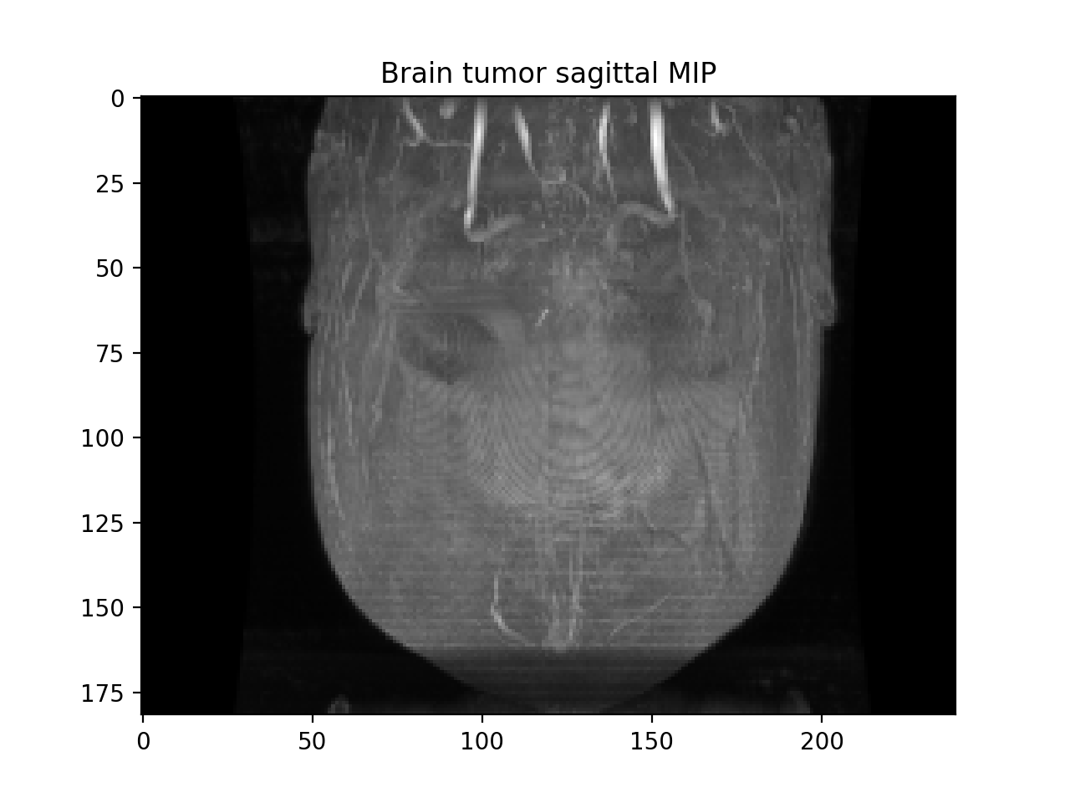

Digital Radiograph Images: Axial, Sagittal, Coronal

1. For point based segmentation, the range of pixel value within my region of interest (the tumor), oscillate between ~ 193 – 250, approximately. For my first test, I choose my threshold value to be from 205 to 255 to captures the brighter pixels in the image. After that, I gradually decrease the threshold lower bound and increase the upper bound in separate runs to see the results of the new boundaries on the image. The best result is within range [193, 255] even though it also segments the skull around the brain.

For Region based segmentation, I tried the seed value for the object as the center of the tumor and the background seed as the pixel around the tumor within the brain region.

(d)

To improve the segmentation result, I tried to smooth out the image and then apply a sharpen filter to see if the segmentation improves. I tried several times to apply the smoothing filter on the image (10, 20, 30, 50) the best result is around the middle with 35 times smoothing. This is when the segmentation doesn’t get anything else in the image besides the tumor. When smoothing out the pixel’s intensity, I believe that it creates a more homogenous intensity scheme. Since the tumor is thicker than the skull, the effect of smoothing is less drastic on the tumor than it is on the skull. Thus, the skull being blended to the dark background around it alters the intensity more dramatic than the tumor. After smoothing, the tumor remains the brightest pixels within the image and not the skull. When segmenting, the tumor remains the only item visible left. This same effect is not observed in the region-based segmentation technique. After smoothing, the image returned from region-based segmentation is only a black image with no segmentation.

I also tried the method of smoothing and then sharpening. The segmentation that follows still has the skull around the brain, but the segmentation of the tumor is also considerably sharper.

Sharpen and Edge filter when applied individually didn’t give any satisfactory results, thus I ruled them out as plausible filters when used without smoothing filter. I’m not so sure as to why but would love to ask this question in class after submission date.