CISC/CMPE 472 – Assignment 3

Ngoc Bao Han, Nguyen (Mimi)

Mar 17th, 2023

1. Data exploration

Upon segmenting the center slice from the axial, sagittal, and coronal view from Case00, I can observe and get a better understanding of where the prostate is in the original image. A visualization of these 2 volumes in Slicer is shown below:

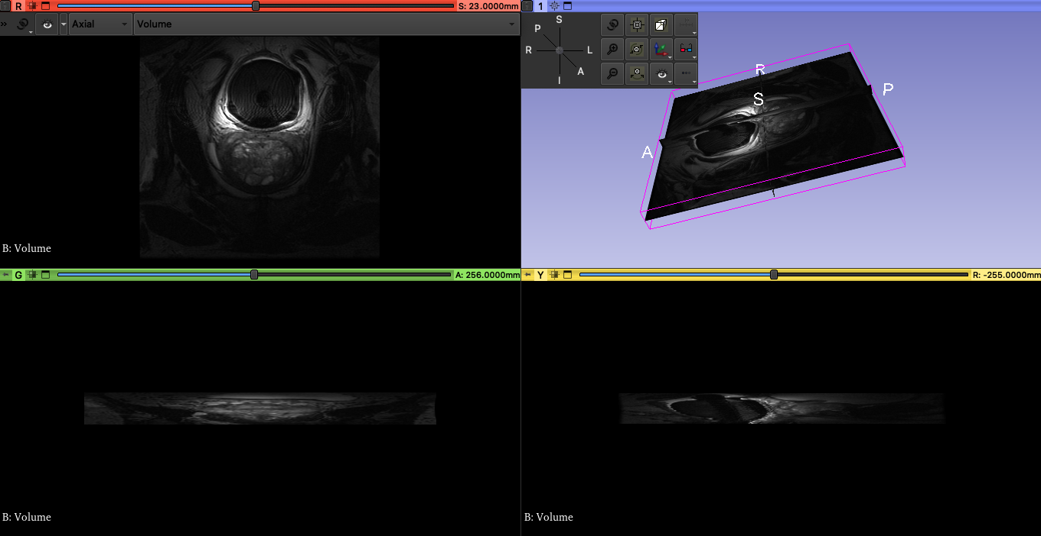

An immediate observation from viewing Case00 is that the Axial slice is wider and looks square compared to the Sagittal and Coronal views. I print out the dimension of the volume and I got (47, 512, 512).

I printed out a set of all different volume dimensions from the folder. This is the result of the set:

{(39, 512, 512), (15, 320, 320), (46, 512, 512), (34, 512, 512), (28, 384, 384), (28, 320, 320), (26, 512, 512), (18, 256, 256), (24, 320, 320), (20, 320, 320), (45, 512, 512), (29, 512, 512), (23, 512, 512), (47, 512, 512), (54, 512, 512), (17, 320, 320), (23, 256, 256), (42, 512, 512), (40, 512, 512)}

There is a good variation of:

* Axial depth: [15, 54]
* Sagittal depth: [256, 512]
* Coronal depth: [256, 512]

All volumes seem to have all 3 slice views.

1. Dataset creation

N/A

1. Data splitting

|  |  |  |  |  |  |
| --- | --- | --- | --- | --- | --- |
| Train data | | Validate data | | Test data | |
| Images | Segmentations | Images | Segmentations | Images | Segmentations |
| image_74.png  image_1.png  image_22.png  image_70.png  image_16.png  image_42.png  image_58.png  image_98.png  image_69.png  image_9.png  image_77.png  image_55.png  image_96.png  image_80.png  image_52.png  image_23.png  image_28.png  image_26.png  image_54.png  image_34.png  image_73.png  image_47.png  image_68.png  image_41.png  image_17.png  image_56.png  image_45.png  image_14.png  image_87.png  image_94.png  image_50.png  image_92.png  image_13.png  image_31.png  image_99.png  image_82.png  image_64.png  image_33.png  image_48.png  image_21.png  image_38.png  image_51.png  image_24.png  image_63.png  image_62.png  image_35.png  image_88.png  image_67.png  image_20.png  image_89.png  image_61.png  image_4.png  image_32.png  image_95.png  image_27.png  image_53.png  image_66.png  image_76.png  image_93.png  image_46.png | segmentation_74.png  segmentation_1.png  segmentation_22.png  segmentation_70.png  segmentation_16.png  segmentation_42.png  segmentation_58.png  segmentation_98.png  segmentation_69.png  segmenttation_9.png  segmentation_77.png  segmentation_55.png  segmentation_96.png  segmentation_80.png  segmentation_52.png  segmentation_23.png  segmentation_28.png  segmentation_26.png  segmentation_54.png  segmentation_34.png  segmentation_73.png  segmentation_47.png  segmentation_68.png  segmentation_41.png  segmentation_17.png  segmentation_56.png  segmentation_45.png  segmentation_14.png  segmentation_87.png  segmentation_94.png  segmentation_50.png  segmentation_92.png  segmentation_13.png  segmentation_31.png  segmentation_99.png  segmentation_82.png  segmentation_64.png  segmentation_33.png  segmentation_48.png  segmentation_21.png  segmentation_38.png  segmentation_51.png  segmentation_24.png  segmentation_63.png  segmentation_62.png  segmentation_35.png  segmentation_88.png  segmentation_67.png  segmentation_20.png  segmentation_89.png  segmentation_61.png  segmentation_4.png  segmentation_32.png  segmentation_95.png  segmentation_27.png  segmentation_53.png  segmentation_66.png  segmentation_76.png  segmentation_93.png  ation_46.png | image_30.png  image_59.png  image_15.png  image_11.png  image_40.png  image_65.png  image_19.png  image_91.png  image_71.png  image_86.png  image_97.png  image_43.png  image_10.png  image_8.png  image_3.png  image_7.png  image_83.png  image_85.png  image_60.png  image_6.png | segmentation_30.png  segmentation_59.png  segmentation_15.png  segmentation_11.png  segmentation_40.png  segmentation_65.png  segmentation_19.png  segmentation_91.png  segmentation_71.png  segmentation_86.png  segmentation_97.png  segmentation_43.png  segmentation_10.png  segmentation_8.png  segmentation_3.png  segmentation_7.png  segmentation_83.png  segmentation_85.png  segmentation_60.png  segmentation_6.png | image_84.png  image_57.png  image_72.png  image_5.png  image_49.png  image_44.png  image_29.png  image_81.png  image_18.png  image_0.png  image_25.png  image_36.png  image_75.png  image_39.png  image_90.png  image_12.png  image_78.png  image_79.png  image_2.png  image_37.png | segmentation_84.png  segmentation_57.png  segmentation_72.png  segmentation_5.png  segmentation_49.png  segmentation_44.png  segmentation_29.png  segmentation_81.png  segmentation_18.png  segmentation_0.png  segmentation_25.png  segmentation_36.png  segmentation_75.png  segmentation_39.png  segmentation_90.png  segmentation_12.png  segmentation_78.png  segmentation_79.png  segmentation_2.png  segmentation_37.png |

1. Initial preprocessing

Read image: Since I’m getting image shape as (128, 128, 3) back from the image I produce, the first thing that I have to do is to cast it back into (128, 128, 1) shape. Thus, I use numpy.mean to get the average of all three RGB channels and keep only one channel for the result image. I also threshold the circle value between (230, 255) so that it is not to noisy and hard for the model to detect the edge. That makes the image a bit cleaner and easier to define the circle edge. I didn’t use any edge filter or sharpening filter as I figure those make the circle looks distorted.

1. Cross-entropy loss
2. Experiment 1: 20 epochs + Early stopping

I set my model up to train for 20 epochs. I also coupled early stopping with model checkpoint. Wtih this approach, I’m able to help stop the training once no metric improvement is seen for several epochs. The early stopping will halt the training once it does not see the validation accuracy improve for 3 consecutive epochs (patience = 3).

1. Experiment 2: Trying other optimizers (SGD, Adagard, RMSprop)

Adam optimizer provides fast convergence rate and being robust to noise in the gradients, in this 2nd experiment, I tried to test out other popular optimizer as well!

* 1. SGD optimizer is a simple optimization algorithm that updates the parameters of the network based on the gradient of the loss function with respect to the parameters. It is computationally efficient and easy to implement, but can be slow to converge, as seen in the slow decrease in loss value over epochs, but with a simple task that we have. It achieves high accuracy still.

* 1. Adagard optimizer is an adaptive learning rate method that adapts the learning rate for each parameter based on the history of its gradients. It works well on sparse data. Thus, loss value decreases quickly through epochs and accuracy is well as good as Adam optimizer.

* 1. RMSprop optimizer is another adaptive learning rate method that uses a moving average of the squared gradients to adjust the learning rate for each parameter. It is designed to handle moving objects, but we will try it anyway for our task as it is a popular and well researched optimizer!

Optimizer experiment conclusion: In the context of our task, the choice of optimizer can have significant impact on the convergence rate and accuracy of the model. Adam optimizer will remain the optimizer we are moving forward with due to its ability to its performance on accuracy and loss convergence. However, it was interesting to experiment with other optimizers and hyperparameters.

1. IOU Loss

For IOU loss

The loss values drastically reduces within the first few epochs, showing quick adaptation to training process and the entire training takes 14 epochs to converge. While the accuracy bumps up and down for a good ~10 epochs, it also converges by the 14 and shows promisingly high numbers!

1. Additional metrics
2. For IOU loss (best weights prioritize loss, not accuracy)
3. For DICE loss (best weights prioritize loss, not accuracy)

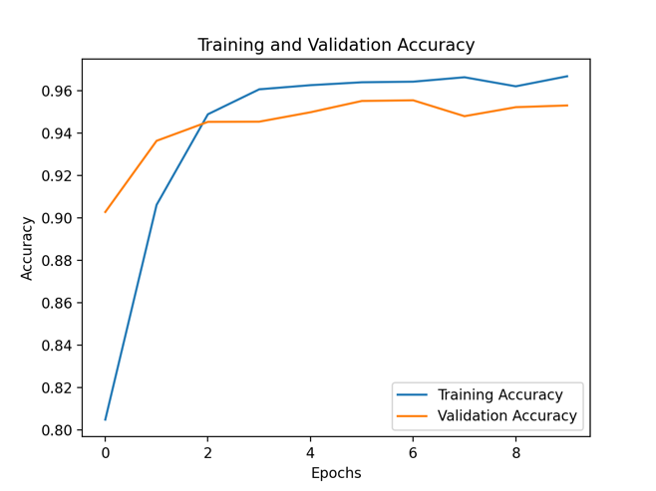

1. For Hausdoff

I couldn’t figure out hausdorff

1. Qualitative evaluation

|  |  |  |  |
| --- | --- | --- | --- |
| Original image | Cross_entropy loss predictions | IOU loss predictions | DICE loss predictions |
| image_84.png   |  |  |  |
| image_57.png |  |  |  |
| image_72.png   |  |  |  |
| image_5.png   |  |  |  |
| image_49.png   |  |  |  |
| image_44.png   |  |  |  |
| image_29.png   |  |  |  |
| image_81.png   |  |  |  |
| image_18.png   |  |  |  |
| image_0.png   |  |  |  |
| image_25.png   |  |  |  |
| image_36.png   |  |  |  |
| image_75.png   |  |  |  |
| image_39.png   |  |  |  |
| image_90.png   |  |  |  |
| image_12.png   |  |  |  |
| image_78.png   |  |  |  |
| image_79.png   |  |  |  |
| image_2.png   |  |  |  |
|  |  |  |  |

Speculation:

1. Cross Entropy loss: This loss function is sentitive to class imbalance, thus the circles produced are smaller than the other two loss function. The images also have a bit more of a fuzzy edge since the model may assign some pixels to the wrong class.
2. IOU loss: This loss function produces a slightly better result with clearer boundaries than cross entropy. It is more robust to class imbalance.
3. Dice loss: Dice loss is often preferred for imbalanced datasets, and it is more sensitive to small differences in overlap than IOU loss. The result circles can be slightly bigger than IOU loss, but in generally these two produces quiet similar segmentations.
4. Quantitative evaluation

|  |  |  |  |
| --- | --- | --- | --- |
| Metrics/ Loss function | Cross entropy loss function | IOU loss function | DICE loss function |
| F1 score | 0.9670 | 0.6337 | 0.9698 |
| Precision score | 0.9534 | 0.6290 | 0.9657 |
| Recall score | 0.8790 | 0.6313 | 0.9639 |

Speculations

1. Cross Entropy Loss function:

Inference: This loss function is commonly used in image segmentation tasks and works by penalizing the model for misclassifying pixels. High F1 score and precision score suggest that the model was able to accurately identify the white pixels that belong to the white circle. However, the lower recall score suggests that the black background may have made it harder for the model to distinguish between the circle and the background, leading to some false negatives.

1. IOU Loss functions:

Inference: IOU loss function works by computing the intersection over the union between the predicted segmentation mask and the ground truth mast. It aims to maximize the overlap between the predicted and true masks. The lower F1, precision, and recall score suggest that the model may have struggled to accurately segment the white circle. A possible explanation is that the IOU loss function may not take into the account the shape or size of the circle?

1. DICE Loss function:

Inference: This loss function is similar to IOU function, but it computers the harmonic mean between the precision and recall scores. The high F1 score, precision, and recall score obtained with the DICE loss function suggest that the model was able to accurately segment the white circle. One possible explanation for this is that the DICE loss function is more sensitive to small differences in overlap between the predicted and true masks.