Hannah Clayton

Dr. Abena Primo

COSC 2311_1

19 November 2020

**GUI ATM Application**

Part 1: Log In/ Register

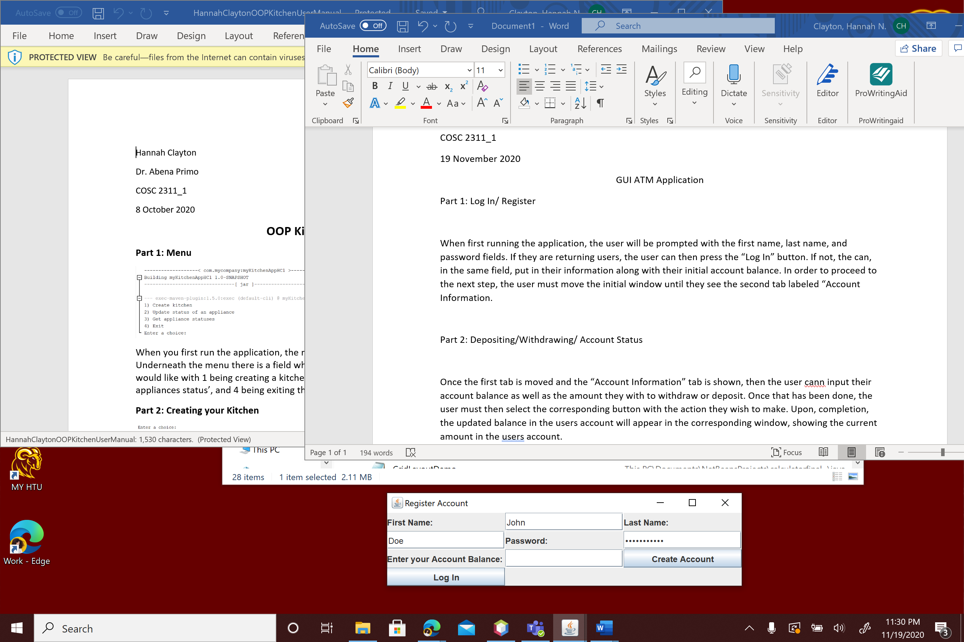

When first running the application, the user will be prompted with the first name, last name, and password fields. If they are returning users, the user can then press the “Log In” button. If not, the can, in the same field, put in their information along with their initial account balance. In order to proceed to the next step, the user must move the initial window until they see the second tab labeled “Account Information.

Part 2: Depositing/Withdrawing/ Account Status

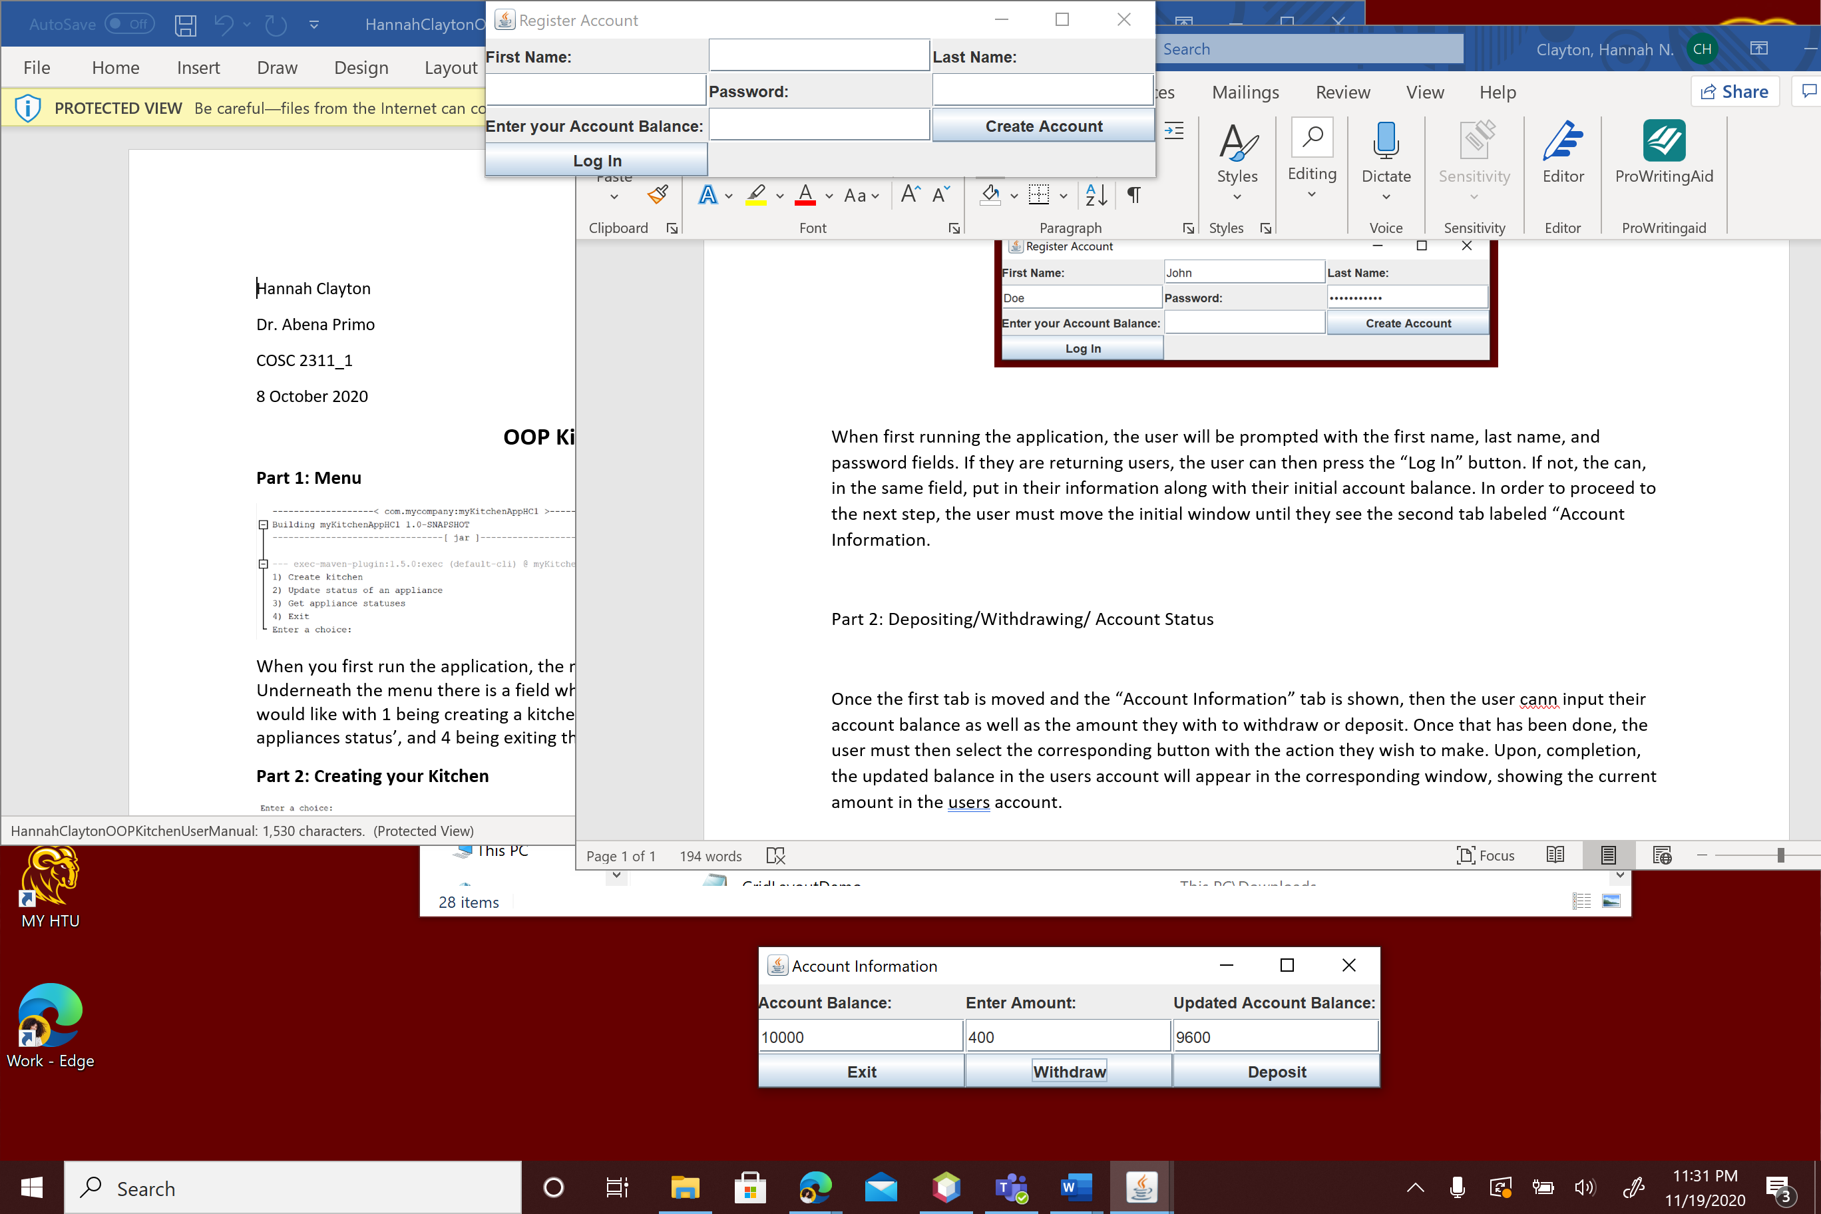

Once the first tab is moved and the “Account Information” tab is shown, then the user can input their account balance as well as the amount they with to withdraw or deposit. Once that has been done, the user must then select the corresponding button with the action they wish to make. Upon, completion, the updated balance in the users account will appear in the corresponding window, showing the current amount in the users’ account.

Part 3: Exit

In order to exit the application, the user will select the “Exit” button and the program with close