
UNIVERCITY TECHNOLOGY AND EDUCATION
FINALPROJECT DOCUMENT
Car sales website
Group 1
Group members | Hồ Ngọc Đình Châu – 17110008  Nguyễn Thị Bích Nhàn - 17110195
Supervisor | Nguyễn Đức Khoan
Final project | Car sales website
Thủ Đức, ngày 6 tháng 6 năm 2020

- Introduction
- Project Information
- Project name : Car sales website
- Programming Language : PHP
- Start Date : May 21st, 2020
- End Date : June 6th, 2010
- Introduction
  - Generality
The purpose of this application is interact with user. Help users choose products they like and buy products via the Internet. Friendly interface, easy to use helps users to manipulate a simple way. Also, help users avoid having to go to the store but they still buy what they need.
The programming languages for websites are HTML / CSS, JavaScript, and PHP.

2.2 Introduction
It is known globally that, in today’s market, it is extremely difficult to start a new small scale business and its sustenance with competition from the well-established and settled/brand owners. Most often, even if the quality of the product is really good, due to a lack of advertisement or business on a small scale, it just becomes another face in the sea, and the product does not reach a larger group of customers. In the fast-paced life of today when everyone is squeezed for time, the majority of people are finicky when it comes to doing physical shopping.
Logistically, a consumer finds a product more interesting and attractive when they find it on the website of a retailer directly and are able to see the item’s details online. The customers are not only attracted because online shopping is very convenient but also because they have broader selections, highly competitive prices, better information about the product and extremely simplified navigation for searching regarding the product.
Moreover, business owners often offer online shopping options at low rates because the overhead expenses in opening and running a physical store are higher. Further, with online shopping, their products have access to a worldwide market, which increases the number of customers from different ethnic groups, adds customer value, and overall sustainable in marketing.
Online web stores, such as Amazon and eBay, have gained huge popularity over the years because one can buy almost everything at these stores. These web stores also give an opportunity to a lot of small-scale companies and manufacture to reach the global market and to directly sell their products to people without involving different other companies or middlemen before their product can reach the shelves of a physical store. Further, instead of using the available platforms, manufacturers can bring a concept of designing their own web store to sell their products directly to the masses.

2.3 Statistical
E-Commerce has taken the world by storm in recent years, with an ever-increasing amount of American businesses adopting e-commerce platforms to pitch and sell their products.
While physical stores are still common, online retail stores are proliferating the retail landscape and American consumers are turning to online shopping. In fact, current retail trends show that 51% of Americans prefer online shopping, with e-commerce growing 23% year-on-year.
So a sales website will make it easier for people to exchange goods. Extremely convenient software for the 4.0 technology era.

2.4 Advantages and disadvantages
Advantages | Disadvantages
Convenience | Negative Environmental Impact of Packaging and Gas
Better Prices | Shipping Problems and Delays
More Variety | Risk of Fraud
Easy to Send Gifts | Less Contact With Your Community
More Control | Spending Too Much Time Online
Easy Price Comparisons | Returns Can Be Complicated
No Crowds | You Don't Know Exactly What You're Getting
No Sales Pressure | Unfriendly, Scammy, or Complicated Websites
Access to Used or Damaged Inventory | No Sales Assistance
Privacy for Discreet Purchases | No Support for Local Retailers
https://toughnickel.com/frugal-living/Online-shopping-sites-benefits
2.5 Best and Worst Things to Buy Online
Things You Should Buy Online | Things You Should Buy In a Store
Electronics (new or refurbished) | Anything you can haggle for to get a better price
Medicine (cheaper and easier, especially when you're sick) | Medicine (watch out for online scams and expired or fake meds)
Clothing (if you know exactly what color, style, and size you want) | Clothing (when you want to touch, try on, and inspect)
Baby supplies (diapers, formula, food) | Anything that should be experienced first (mattresses, furniture, blankets, etc.)
Pet food (cheaper and easier, especially in bulk) | Really heavy items (with pricey shipping costs)
Books (if you know exactly what you want) | Books (if you want to browse, talk to the bookseller, and support your local bookstore so they don't go out of business)
A used car (cheaper and easier without a dealer, unless you need financing) | Any product you haven't tried before (perfume, food items, cosmetics, etc.)
Groceries (if you don't have time) | Groceries (if you like to choose what you eat and support your local growers and grocers)
Holiday Gifts (the gift wrapping, shipping, and convenience can't be beat) | Any product you haven't tried before (perfume, food items, cosmetics, etc.)
Art (sites like Etsy list original, beautiful art direct from the artist) | A pet (of course!)
Prescription or reading glasses (always cheaper and cuter online) | Real estate (of course!)

- Role & Responsibility
No | full name | role | position | contact
1 | Nguyễn Đức Khoan | Project Manager | Supervisor | khoannd@gmail.com
2 | Hồ Ngọc Đình Châu | Developer | Leader | hndc9x@gmail.com
3 | Nguyễn Thị Bích Nhàn | Tester | Member | bichnhan3010@gmail.com

- Software Requirements
- Objectives
  - Introduction
The document is the one that describes the requirements along with interfaces for the system. It is meant for use by the developers and will be the basis for validating the final delivered system.
All the steps required in the software-analysis process related to this project (product function, user characteristics, functional and nonfunctional requirements, constraints, assumptions, and dependencies for the online shopping cart application) are described in the following sections.
  - Scope
This system allows the customers to maintain their cart for add or remove the product over the internet.
  - Definitions
- SRS - Software Requirement Specification
- GUI - Graphical User Interface
- ERD - Entity Relationship Diagram
- Stackholder- The person who will participate in system
Ex: Customer, Administrator, Visitor etc
  - References
- Software Requirement Specification ( SRS )
  - Overview
The system helps in buying goods, products, and services online by choosing the listed products from the website.
The Online Shopping System for Car sales shop web application is intended to provide complete solutions for vendors as well as customers through a single get way using the internet. It will enable vendors to set up online shops, customers to browse through the shop and purchase them online without having to visit the shop physically. The administration module will enable a system administrator to approve and reject requests for new shops and maintain various lists of shop categories.
  - Overall description
The Car Sales Website enables vendors to set up online shops, customers to browse through the shops, and a system administrator to approve and reject requests for new shops and maintain lists of shop categories. Also, the developer is designing an online shopping site to manage the items in the shop and also help customers to purchase them online without visiting the shop physically. The online shopping system will use the internet as the sole method for selling goods to its consumers.
    - Product Perspective
The system is a solution to carry out buying/selling products online.
This product aimed toward a person who doesn't want to visit the shop as he/she might don’t get time for that.
    - Product Functions
The system allows the user to buy/sell products online across internet connection globally.
The car sales website would have the following basic functions:
- Display new products and feature products on the main page of the system.
- Display all the categories available for shopping on the system’s product page.
- Display contact information on the contact page.
- Display products ordered on the order page.
- Display user information on the profile page.
- Allow users to compare products.
- Allow users to add to wishlist products.
- Allow users/administrator change password.
- Allow the administrator to add new items to the existing list of available items.

    - User Characteristics
There are 3 kinds of users for the proposed system :
Administrators are the who add, edit, delete products, product categories, and product brands :
- Assign or change the price of the items, update the items in the list, and delete the items.
- Assign sales tax for different states at the time of checkout.
- View the history of the customers who purchased the items.
The user will be the one who visits the website and buys products online :
- View, browse and select a category.
- View, add, and update items in the cart.
- Delete items from the cart.
- Check out the items from the application or continue shopping.
- Place the order by completing the order form.
Customer will be the one who visits the website and view products on the website.
- Sign-on/login using a username and password.
    - General Constraints
The main constraint here would be checking the genuineness of the buyer, which is not always possible. There can be security risks involved.
The developed system should run under any platform (Unix, Linux, Mac, Windows, etc.. ) that contains a web browser that supports PHP and JavaScript.
Hardware Limitations: The minimum hardware requirement for the system is 128 MB of Ram and a 32-MB hard-disc drive.
    - Assumptions and Dependencies
The details related to the product, customer, payment, and service transaction provided manually.
Roles and tasks are predefined.
We assume that system users adhere to the system’s minimum software and hardware requirements.
- Specific Requirements
  - External Interface Requirements
    - User Interfaces
Each part of the user interface intends to be as user friendly as possible. The fonts and buttons used will be intended to be very fast and easy to load on web pages.
GUI should be simple, clear, and have recognizable elements.
    - Hardware Interfaces
The Computer with the internet connection.
Processor : Pentium or Higher.
RAM : 312MB or Higher.
    - Software Interfaces
Operating System : Unix, Linux, Mac, Windows etc..
Development tool : PHP : Hypertext Preprocessor, JavaScript
Data Base : MySQL
Web application: browser Google Chrome (version 69 or higher) and Firefox (version 52 or higher), Internet Explorer (version 10 or higher) or with any web browser that supports HTML5 & CSS3.
    - Communication Interface
The Website Order system shall send an e-mail confirmation to the customer that the items they ordered will be delivered to the shipping address along with user identification.
  - System Overview Use Case
  - ERD Diagram
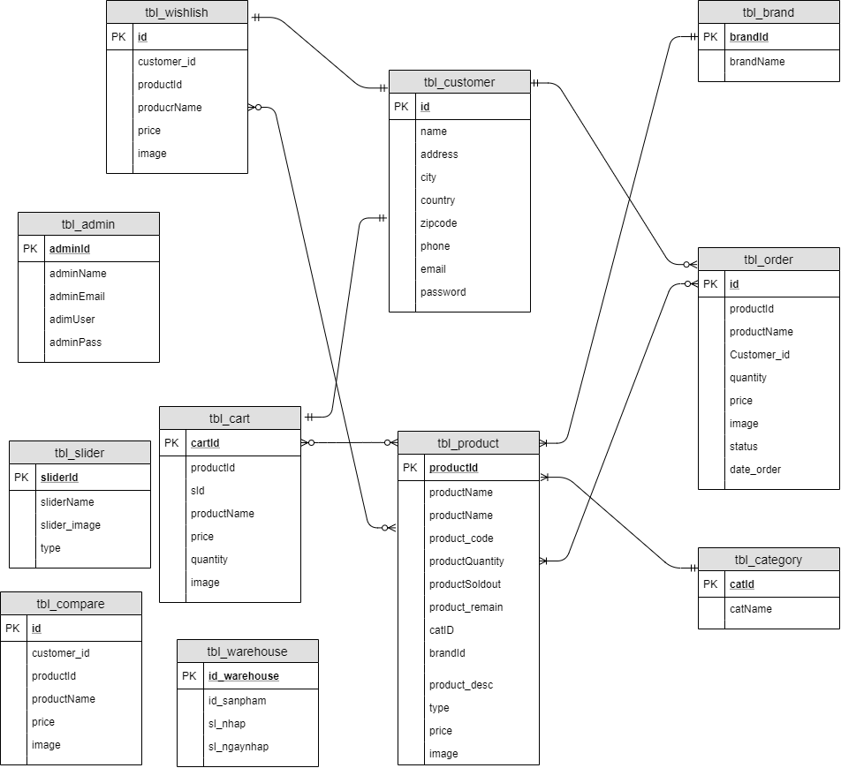
  - List of UseCase
    - <Customer> Overview UseCase
      - <Customer> Register
USE CASE - CUS_01
Use Case No. | CUS_01 | Use Case Version | 1.0
Use Case Name | Register
Author | BichNhan
Date | 01/06/2020 | Priority | Normal
Actor:
- Customer.
Summary:
- Allows customers to register an account.
Goal:
- Customer can create an account with USER role.
Triggers:
- Customer sends register command by click to the register button.
Preconditions:
- Customer is required to have a new email address.
Post Conditions:
- Success: A new account is created.
- Fail: The system shows error messages.
Main Success Scenario:
Step | Actor Action | System Reponse
1 | The guest goes to the website by URL. | System returns the login screen.
2 | Customer click to “Register” | The system redirects to the Register page.
3 | Customer input email, password and click to the Register button. | The system creates a new account with the input information with USER role.  The system redirects to the main view.
Alternative Scenario: N/A
Exceptions:
No | Cause | System Reponse
1 |  | The system shows the message "Please check your internet connection" when the internet is lost.
2 | Username is already used by  another user. | The system shows the message "Username is already used by another user. Please choose another username."
Relationships: N/A
Bussiness Rules:
- Email: must be unique
- Password: Password’s length is at least 6 characters and contains at least 1uppercase characters and at least one lower case character.
- The system must ensure that no one can read the user password.
- Attributes cannot be null.

      - <Customer> Login
USE CASE - CUS_02
Use Case No. | CUS_02 | Use Case Version | 1.0
Use Case Name | Login
Author | BichNhan
Date | 01/06/2020 | Priority | Normal
Actor:
- Customer.
Summary:
- Allows customers to log in to the system.
Goal:
- Customers can log in to the system.
Triggers:
- Customers can log in by clicking on the login button.
Preconditions:
- Customers enter the correct ID, Pass.
Post Conditions:
- Success: Successful access to the system.
- Fail: System show error messages.
Main Success Scenario:
Step | Actor Action | System Reponse
1 | Customer clicks login button in the menu. | The system redirect to login page.
2 |  | The system requires identity information from Customer:  - Email: text.  - Password: text.
3 | Customer inputs email , password.
4 | Customer clicks on “Login” button. | The system redirecet home page.Customer logins into the system with their specific role.
Alternative Scenario: N/A
Exceptions:
No | Cause | System Reponse
1 | Customer enter wrong identity information. | The system shows an error message”Wrong your email or password.Please try again.”
2 |  | The system shows the message "Please check your internet connection" when the internet is lost.
Relationships: N/A
Bussiness Rules:
- Email: must be not empty
- Password: must be not empty

      - <Customer> View Products
USE CASE - CUS_03
Use Case No. | CUS_03 | Use Case Version | 1.0
Use Case Name | View Product
Author | BichNhan
Date | 01/06/2020 | Priority | Normal
Actor:
- Customer.
Summary:
- Allows customers to view all products displayed on the website.
Goal:
- Customers can view new and featured products.
Triggers:
- Customer sends command by click to the Product button.
Preconditions:
- The customer has logged in successfully
Post Conditions:
- Success: The system switches to the product page.
- Fail: The system shows error messages.
Main Success Scenario:
Step | Actor Action | System Reponse
1 | Customer clicks the product button on the menu page. | The system goes to the product page.
Alternative Scenario: N/A
Exceptions:
No | Cause | System Reponse
1 |  | The system shows the message "Please check your internet connection" when the internet is lost.
Relationships: N/A
Bussiness Rules: N/A

      - <Customer> View Details Product
USE CASE - CUS_04
Use Case No. | CUS_04 | Use Case Version | 1.0
Use Case Name | View Details Product
Author | BichNhan
Date | 01/06/2020 | Priority | Normal
Actor:
- Customer.
Summary:
- Allows customers to view detail product displayed on the website.
Goal:
- Customers can see the product details.
Triggers:
- Customer sends command by click to the Details button.
Preconditions:
- The customer has logged in successfully
Post Conditions:
- Success: The system switches to the detail page.
- Fail: The system shows error messages.
Main Success Scenario:
Step | Actor Action | System Reponse
1 | Customer clicks the Details button or product image on the product page. | The system goes to the details page.
Alternative Scenario: N/A
Exceptions:
No | Cause | System Reponse
1 |  | The system shows the message "Please check your internet connection" when the internet is lost.
Relationships: N/A
Bussiness Rules: N/A

      - <Customer> Search Product
USE CASE - CUS_05
Use Case No. | CUS_05 | Use Case Version | 1.0
Use Case Name | Search Product
Author | BichNhan
Date | 01/06/2020 | Priority | Normal
Actor:
- Customer.
Summary:
- Allows customers to search for products by keyword.
Goal:
- Customers can search for the desired product.
Triggers:
- Customers type the keyword of the product to search into the textbox.
- Customers click the search button or press the enter key.
Preconditions:
- The customer has logged in successfully
Post Conditions:
- Success: The system finds the products.
- Fail: The system shows error messages.
Main Success Scenario:
Step | Actor Action | System Reponse
1 | Customers enter the keyword into the textbox on the header website. | The system displays the products containing the keyword.
Alternative Scenario: N/A
Exceptions:
No | Cause | System Reponse
1 |  | The system shows the message "Please check your internet connection" when the internet is lost.
2 | Keyword not found | The system shows the message " The system did not find related products”.
3 | Keyword invalid | The system shows the message " Do not enter symbol characters”.
Relationships: N/A
Bussiness Rules:
- Keyword no more than 10 characters.
- Keysword cannot contain special characters.
- Keyword must be in English.

      - <Customer> Add to Cart
USE CASE - CUS_06
Use Case No. | CUS_06 | Use Case Version | 1.0
Use Case Name | Add To Cart
Author | BichNhan
Date | 01/06/2020 | Priority | Normal
Actor:
- Customer.
Summary:
- Allow customers to add products to the cart.
Goal:
- Customers can put products to buy in the cart.
Triggers:
- Customers click on a product image or click the details button.
- Customers click the Add to cart button on the details page.
Preconditions:
- The customer has logged in successfully
Post Conditions:
- Success: Products are put into the cart.
- Fail: The system shows error messages.
Main Success Scenario:
Step | Actor Action | System Reponse
1 | Customers click the details button. | The system goes to the product detail page.
2 | Customer click the Add to cart button on the product detail page. | The system will put the product in the cart, and add up the price of all products in the cart.
Alternative Scenario: N/A
Exceptions:
No | Cause | System Reponse
1 |  | The system shows the message "Please check your internet connection" when the internet is lost.
2 | Out of stock. | The system shows message "Sorry, we are out of stock right now, please sympathize".
Relationships: N/A
Bussiness Rules: N/A

      - <Customer> Add to Wishlish
USE CASE - CUS_07
Use Case No. | CUS_07 | Use Case Version | 1.0
Use Case Name | Add To Wishlish
Author | BichNhan
Date | 01/06/2020 | Priority | Normal
Actor:
- Customer.
Summary:
- Allow customers to add products to the wishlish.
Goal:
- Customers can put products to buy in the wishlish.
Triggers:
- Customers click on a product image or click the details button.
- Customers click the Add to wishlish button.
Preconditions:
- The customer has logged in successfully
Post Conditions:
- Success: Products are put into the wishlish.
- Fail: The system shows error messages.
Main Success Scenario:
Step | Actor Action | System Reponse
1 | Customers click the details button. | The system goes to the product detail page.
2 | Customer click the Add to wishlish button on the product detail page. | The system will put the product in the wishlish.
Alternative Scenario: N/A
Exceptions:
No | Cause | System Reponse
1 |  | The system shows the message "Please check your internet connection" when the internet is lost.
Relationships: N/A
Bussiness Rules: N/A

    - <User> Orverview UseCase
      - <User> Logout
USE CASE - USER_01
Use Case No. | USER_01 | Use Case Version | 1.0
Use Case Name | Logout
Author | BichNhan
Date | 01/06/2020 | Priority | Normal
Actor:
- User.
Summary:
- Allow users logout from the system.
Goal:
- User logout successfully.
Triggers:
- User clicks to the logout button in the menu.
Preconditions:
- The user has logged in successfully.
Post Conditions:
- Success: System redirect to Login page.
- Fail: System show error messages.
Main Success Scenario:
Step | Actor Action | System Reponse
1 | User clicks button “Logout” in the menu. | System open logout popup with  the message “Are you sure you want to  logout now?”:  • Accept: button  • Cancel: button.
2 | User click “Accept” to confirm. | System redirect login page.
Alternative Scenario:
No | Actor Action | System Response
1 | User clicks on “cancel” button. | System close logout popup.

Exceptions:
No | Cause | System Reponse
1 |  | The system shows the message "Please check your internet connection" when the internet is lost.
Relationships: N/A
Bussiness Rules:
- After member sends logout request, system redirects to login page.
- After member sends logout request, system must clear user’s token.

      - <User> Compare Products
USE CASE - USER_02
Use Case No. | USER_02 | Use Case Version | 1.0
Use Case Name | Compare Products
Author | DinhChau
Date | 01/06/2020 | Priority | Normal
Actor:
- User.
Summary:
- Allows users to compare 2 or more products.
Goal:
- User can add information of a product to the comparison page
Triggers:
- User clicks to the compare products button on the details page.
- User clicks to the compare button on the menu.
Preconditions:
- The user has logged in successfully.
Post Conditions:
- Success: System redirect to Compare page and show all products to compare
- Fail: There are no products in the comparison page.
Main Success Scenario:
Step | Actor Action | System Reponse
1 | User clicks button “details” on the product page. | System redirect details page.
2 | User clicks button “Compare product” on the details page. | The system shows the message “Added to comparison list”.  The system insert product information to the database.
3 | User clicks button “Compare” on the menu. | System redirect compare page.  The system displays information that has just been inserted into the database
Alternative Scenario: N/A
Exceptions:
No | Cause | System Reponse
1 |  | The system shows the message "Please check your internet connection" when the internet is lost.
Relationships: N/A
Bussiness Rules: N/A

      - <User> Update Information
USE CASE - USER_03
Use Case No. | USER_03 | Use Case Version | 1.0
Use Case Name | Update Information
Author | DinhChau
Date | 01/06/2020 | Priority | Normal
Actor:
- User.
Summary:
- Allow users to edit profile.
Goal:
- User may change their personal information.
Triggers:
- User clicks to the profile button on the menu.
- User clicks to update profile button on the profile page.
Preconditions:
- The user has logged in successfully.
Post Conditions:
- Success: The system will update the latest information on the user's profile.
- Fail: System show error messages.
Main Success Scenario:
Step | Actor Action | System Reponse
1 | User clicks button “profile” on the menu | System redirect profile page.
2 | User clicks button “Update Profile” on the profile page. | The system enable the entry into the textbox
3 | User enter information into the textbox
4 | User clicks button “Save” on the profile page. | System redirect profile page and update user information
Alternative Scenario: N/A
Exceptions:
No | Cause | System Reponse
1 |  | The system shows the message "Please check your internet connection" when the internet is lost.
2 | The text box is empty | The system shows the message “Please fill in the information”
Relationships: N/A
Bussiness Rules: N/A

      - <User> Change Password
USE CASE - USER_04
Use Case No. | USER_04 | Use Case Version | 1.0
Use Case Name | Change password
Author | DinhChau
Date | 01/06/2020 | Priority | Normal
Actor:
- User.
Summary:
- Allow users to change password.
Goal:
- User may change password.
Triggers:
- User clicks to the change password button on the menu.
- User clicks to save button on the change password page.
Preconditions:
- The user has logged in successfully.
Post Conditions:
- Success: The system will update the latest information on the user's password.
- Fail: System show error messages.
Main Success Scenario:
Step | Actor Action | System Reponse
1 | User clicks button “Change Password” on the menu | System redirect changepassword page.
2 | The user enters the old password and the new password into the testbox
3 | User clicks button “Save” on the changepassword page. | System redirect changepassword page and update password.
Alternative Scenario: N/A
Exceptions:
No | Cause | System Reponse
1 |  | The system shows the message "Please check your internet connection" when the internet is lost.
2 | User entered the wrong old password | The system shows the message “Please enter the old password again”
3 | A new password containing special symbols. | The system shows the message “Invalid password”
Relationships: N/A
Bussiness Rules:
- The new password must not exceed 30 characters.
- The new password must not have special characters.
- The new password must not be empty.

      - <User> Payment
USE CASE - USER_05
Use Case No. | USER_05 | Use Case Version | 1.0
Use Case Name | Payment
Author | DinhChau
Date | 01/06/2020 | Priority | Normal
Actor:
- User.
Summary:
- Allows users to choose the method of product payment.
Goal:
- Users can pay for the product they want to buy.
Triggers:
- User clicks to the checkout button on the cart page.
- User clicks to payment button on the change password page.
Preconditions:
- The user has logged in successfully.
- Customer must add at least one product to the shopping cart.
Post Conditions:
- Success: System show success messages and send messages send notification to admin
- Fail: System show error messages.
Main Success Scenario:
Step | Actor Action | System Reponse
1 | User clicks button “Change Password” on the menu | System redirect changepassword page.
2 | The user enters the old password and the new password into the testbox
3 | User clicks button “Save” on the changepassword page. | System redirect changepassword page and update password.
Alternative Scenario: N/A
Exceptions:
No | Cause | System Reponse
1 |  | The system shows the message "Please check your internet connection" when the internet is lost.
2 | User entered the wrong old password | The system shows the message “Please enter the old password again”
3 | A new password containing special symbols. | The system shows the message “Invalid password”
Relationships: N/A
Bussiness Rules:
- The new password must not exceed 30 characters.
- The new password must not have special characters.
- The new password must not be empty.

      - <User> Order Product
    - <Admin> Orverview UseCase
      - <Admin>Login
      - <Admin>Logout
      - <Admin> Check Order
      - <Admin> Add Category
      - <Admin> Update Category
      - <Admin> Delete Category
      - <Admin> Add Brand
      - <Admin> Update Brand
      - <Admin> Delete Brand
      - <Admin> Add Product
      - <Admin> Update Product
      - <Admin> Delete Product
      - <Admin> Insert Slider
      - <Admin> Check WaveHose
    - <SubSystem> Orverview UseCase
  - Functional Requirements
    - Master Maintenance
This module consists of information about the products and services. This includes two sub-modules, Product master and Price master.
      - Product Master
Product master includes the information about particular product, such as product number, item, name, category, images of products, description, features, constraints of products, which are to be displayed on the website.
      - Price master
Price master deals with the cost of the product, discounts applicable for the particular product of a vendor/seller.
    - Housekeeping Module
This module deals with backing up of data for future references and hence to reduce the database size.
    - Funtional Requirements
      - User: View Categories and Items
The users shall be able to see the home page of the online shopping-cart application when they first run the program. The users shall be able to view the different categories, select categories, browse through the items in each category, and add items to the shopping cart. The users shall be able to view the shopping cart and more information about each item.
- FR01: The users shall be able to view the categories on the application’s home page.
- FR02: The users shall be able to view items in different categories.
- FR03: The users shall be able to add items to the cart.
- FR04: The users shall be able to view more information about an item before adding it to the cart.
- FR05: The users shall be able to able to view the shopping cart.
- FR06: The users shall be able to browse through the available items.
      - User: View Shopping Cart
After the first run of the application, the users shall be able to see their designated home page. After browsing through the items and adding items to the shopping cart, the users should be able to view the items in the shopping cart. The users shall be able to check out or continue shopping. The users shall be able to delete items from the cart.
- FR07: The users shall be able to view the items added to the cart.
- FR08: The users shall be able to check out with the current items in the cart.
- FR09: The users shall be able to continue shopping.
- FR10: The users shall be able to delete items from the cart.
      - User: Checkout Items
- FR11: The users shall be able to check out items only when there are items in the shopping cart.
      - Login/ User Authentication
- FR12: The users shall log in or register using the user authentication form.
- FR13: The users shall not log in or register if the information is incomplete or invalid.
      - User: Place Order
- FR14: The users shall place an order by completing the information in the order form
- FR15: The users shall not be able to place an order if the information in the order form is invalid or incomplete.
      - Admin: View User Information
- FR16: The administrator shall be able to view all the users’ information that completes the order form and the checkout process.
      - Admin: Add/Update/Delete Shopping Items.
- FR17: The administrator shall be able to add new items to the list of shopping items.
- FR18: The administrator shall be able to modify/update an item’s price and description.
- FR19: The administrator shall be able to delete items from the main page of the shopping-cart application.
      - Additional Functional Requirements
- FR20: The administrator shall be able to view the entire history of the checked-out items.
- FR21: The administrator shall be able to view the entire history for the users who successfully complete the checkout process.
  - Performance Requirements
This section lists the performance requirements expected from the online shopping-cart application.
- PR01: The users shall be able to add an item to the cart in fewer than 5 seconds.
- PR02: The users shall be able to view information about an item in fewer than 5 seconds.
- PR03: The users shall be able to check out the items in the shopping cart within 10 seconds after completing the order form.
- PR04: The navigation between pages shall take fewer than 5 seconds.
- PR05: The application shall be able to do a validation check on the information provided in the user-authentication form and the place-order form to avoid false or incomplete information.
  - Design Constraint
This section lists the design requirements for the online shopping-cart application.
- DC01: The user interface (UI) must have specific fonts and font sizes. The system shall match the fonts and font sizes used for all the pages of the application.
  - Software System Quality Attribute
    - Integrity
- QA01: The authorized user shall be allowed to access the online shopping-cart application.
- QA02: Based on the user type, the online shopping cart application shall provide a user specific interface.
    - Correctness
- QA03: The assigned task should be received by the specified user.
    - Availability
- QA04: The system shall be made available to the user/administrator year round
    - Robustness
- QA05: The system shall be able to save items to the shopping cart.

- Software Process
- Software process model
This project is developed using the Scrum model – part of an agile framework for Software development projects. Our team chooses the Scrum model because of the following reasons:
- Before our team only has 4 members, and tasks are assigned vertically, do all steps from design, coding, testing and implementation. Scrum is the most suitable model for small and medium size project team.
- After research about Proximity Ranking, Local Rank, Elastic search, we have defined problems. The risk of changing algorithm is high because proving accuracy of those algorithms is complicated. We need to use “try and test” method.
- In the project there are many new technologies that need to be learned. With the Scrum model, the team can learn and develop in parallel to meet deadlines.
- There is no leader, no hierarchy in team, so team members work cheerfully, stimulating the initiative and creativity of each member.
- Product owner can change requirements or extend scope. The team will adapt to be better.
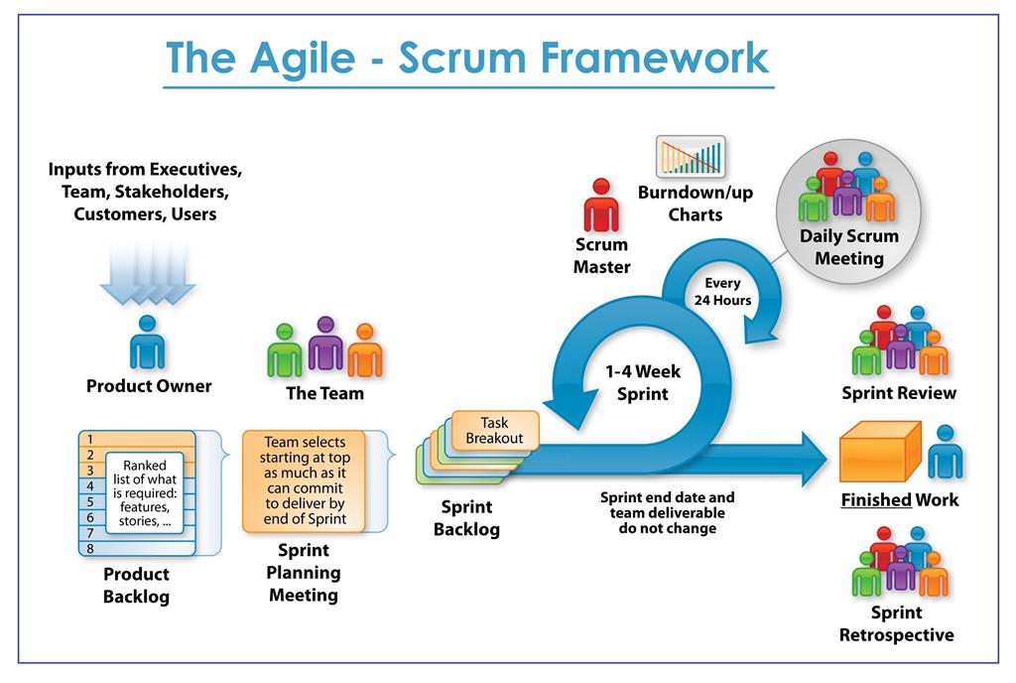
https://www.scrum.org/resources/what-is-scrum
- Role and responsibilities
No | Full Name | Role | Position | Responsibilities
1 | Hồ Ngọc Đình Châu | Scrum master | Leader | - Managing process  - Create Requirements  - Prepare documents  - Prepare data  - GUI Design  - Coding  - Testing  - Risk Management  - Create test plan  - Designing Test Case  - System architecture  - Class diagram  - Activity diagram  - Sequence diagram
2 | Nguyễn Thị Bích Nhàn | Srcum member | Member | - Designing database  - Designing Usecase  - Designing ERD  - Designing Test Case  - Use case specification  - Prepare documents  - GUI Design  - Coding  - Testing  - State machine diagram  - Sequence diagram

- System design
- System architecture
- Database diagram
- Class diagram
- Sequence diagram
- Activity diagram
- State machine diagram

