

**UNIVERCITY TECHNOLOGY AND EDUCATION**

**FINALPROJECT DOCUMENT**

**Car sales website**

|  |  |
| --- | --- |
| **Group 1** | |
| **Group members** | Hồ Ngọc Đình Châu – 17110008  Nguyễn Thị Bích Nhàn - 17110195 |
| **Supervisor** | Nguyễn Đức Khoan |
| **Final project** | Car sales website |

Thủ Đức, ngày 6 tháng 6 năm 2020

1. **Introduction**
2. **Project Information**

* Project name : Car sales website
* Programming Language : PHP
* Start Date : May 21st, 2020
* End Date : June 6th, 2010

1. **Introduction**
   1. **Generality**

The purpose of this application is interact with user. Help users choose products they like and buy products via the Internet. Friendly interface, easy to use helps users to manipulate a simple way. Also, help users avoid having to go to the store but they still buy what they need.

The programming languages for websites are HTML / CSS, JavaScript, and PHP.

**2.2 Introduction**

It is known globally that, in today’s market, it is extremely difficult to start a new small scale business and its sustenance with competition from the well-established and settled/brand owners. Most often, even if the quality of the product is really good, due to a lack of advertisement or business on a small scale, it just becomes another face in the sea, and the product does not reach a larger group of customers. In the fast-paced life of today when everyone is squeezed for time, the majority of people are finicky when it comes to doing physical shopping.

Logistically, a consumer finds a product more interesting and attractive when they find it on the website of a retailer directly and are able to see the item’s details online. The customers are not only attracted because online shopping is very convenient but also because they have broader selections, highly competitive prices, better information about the product and extremely simplified navigation for searching regarding the product.

Moreover, business owners often offer online shopping options at low rates because the overhead expenses in opening and running a physical store are higher. Further, with online shopping, their products have access to a worldwide market, which increases the number of customers from different ethnic groups, adds customer value, and overall sustainable in marketing.

Online web stores, such as Amazon and eBay, have gained huge popularity over the years because one can buy almost everything at these stores. These web stores also give an opportunity to a lot of small-scale companies and manufacture to reach the global market and to directly sell their products to people without involving different other companies or middlemen before their product can reach the shelves of a physical store. Further, instead of using the available platforms, manufacturers can bring a concept of designing their own web store to sell their products directly to the masses.

**2.3 Statistical**

E-Commerce has taken the world by storm in recent years, with an ever-increasing amount of American businesses adopting e-commerce platforms to pitch and sell their products.

While physical stores are still common, online retail stores are proliferating the retail landscape and American consumers are turning to online shopping. In fact, current retail trends show that 51% of Americans prefer online shopping, with e-commerce growing 23% year-on-year.

So a sales website will make it easier for people to exchange goods. Extremely convenient software for the 4.0 technology era.

**2.4 Advantages and disadvantages**

|  |  |
| --- | --- |
| **Advantages** | **Disadvantages** |
| Convenience | Negative Environmental Impact of Packaging and Gas |
| Better Prices | Shipping Problems and Delays |
| More Variety | Risk of Fraud |
| Easy to Send Gifts | Less Contact With Your Community |
| More Control | Spending Too Much Time Online |
| Easy Price Comparisons | Returns Can Be Complicated |
| No Crowds | You Don't Know Exactly What You're Getting |
| No Sales Pressure | Unfriendly, Scammy, or Complicated Websites |
| Access to Used or Damaged Inventory | No Sales Assistance |
| Privacy for Discreet Purchases | No Support for Local Retailers |

<https://toughnickel.com/frugal-living/Online-shopping-sites-benefits>

**2.5 Best and Worst Things to Buy Online**

|  |  |
| --- | --- |
| **Things You Should Buy Online** | **Things You Should Buy In a Store** |
| Electronics (new or refurbished) | Anything you can haggle for to get a better price |
| Medicine (cheaper and easier, especially when you're sick) | Medicine (watch out for online scams and expired or fake meds) |
| Clothing (if you know exactly what color, style, and size you want) | Clothing (when you want to touch, try on, and inspect) |
| Baby supplies (diapers, formula, food) | Anything that should be experienced first (mattresses, furniture, blankets, etc.) |
| Pet food (cheaper and easier, especially in bulk) | Really heavy items (with pricey shipping costs) |
| Books (if you know exactly what you want) | Books (if you want to browse, talk to the bookseller, and support your local bookstore so they don't go out of business) |
| A used car (cheaper and easier without a dealer, unless you need financing) | Any product you haven't tried before (perfume, food items, cosmetics, etc.) |
| Groceries (if you don't have time) | Groceries (if you like to choose what you eat and support your local growers and grocers) |
| Holiday Gifts (the gift wrapping, shipping, and convenience can't be beat) | Any product you haven't tried before (perfume, food items, cosmetics, etc.) |
| Art (sites like Etsy list original, beautiful art direct from the artist) | A pet (of course!) |
| Prescription or reading glasses (always cheaper and cuter online) | Real estate (of course!) |

1. **Role & Responsibility**

|  |  |  |  |  |
| --- | --- | --- | --- | --- |
| No | full name | role | position | contact |
| 1 | Nguyễn Đức Khoan | Project Manager | Supervisor | khoannd@gmail.com |
| 2 | Hồ Ngọc Đình Châu | Developer | Leader | hndc9x@gmail.com |
| 3 | Nguyễn Thị Bích Nhàn | Tester | Member | bichnhan3010@gmail.com |

1. **Software Requirements**
2. **Objectives**
   1. **Introduction**

The document is the one that describes the requirements along with interfaces for the system. It is meant for use by the developers and will be the basis for validating the final delivered system.

All the steps required in the software-analysis process related to this project (product function, user characteristics, functional and nonfunctional requirements, constraints, assumptions, and dependencies for the online shoppingcart application) are described in the following sections.

* 1. **Scope**

This system allows the customers to maintain their cart for add or remove the product over the internet.

* 1. **Definitions**
* SRS - Software Requirement Specification
* GUI - Graphical User Interface
* ERD - Entity Relationship Diagram
* Stackholder- The person who will participate in system

Ex: Customer, Administrator, Visitor etc

* 1. **References**

1. **Software Requirement Specification ( SRS )**
   1. **Overview**

The system helps in buying goods, products, and services online by choosing the listed products from the website.

The Online Shopping System for Car sales shop web application is intended to provide complete solutions for vendors as well as customers through a single get way using the internet. It will enable vendors to set up online shops, customers to browse through the shop and purchase them online without having to visit the shop physically. The administration module will enable a system administrator to approve and reject requests for new shops and maintain various lists of shop categories.

* 1. **Overall description**

The Car Sales Website enables vendors to set up online shops, customers to browse through the shops, and a system administrator to approve and reject requests for new shops and maintain lists of shop categories. Also, the developer is designing an online shopping site to manage the items in the shop and also help customers to purchase them online without visiting the shop physically. The online shopping system will use the internet as the sole method for selling goods to its consumers.

* + 1. **Product Perspective**

The system is a solution to carry out buying/selling products online.

This product aimed toward a person who doesn't want to visit the shop as he/she might don’t get time for that.

* + 1. **Product Functions**

The system allows the user to buy/sell products online across internet connection globally.

The car sales website would have the following basic functions:

* Display new products and feature products on the main page of the system.
* Display all the categories available for shopping on the system’s product page.
* Display contact information on the contact page.
* Display products ordered on the order page.
* Display user information on the profile page.
* Allow users to compare products.
* Allow users to add to wishlist products.
* Allow users/administrator change password.
* Allow the administrator to add new items to the existing list of available items.
  + 1. **User Characteristics**

There are 3 kinds of users for the proposed system :

**Administrators** are the who add, edit, delete products, product categories, and product brands :

* Assign or change the price of the items, update the items in the list, and delete the items.
* Assign sales tax for different states at the time of checkout.
* View the history of the customers who purchased the items.

**The user** will be the one who visits the website and buys products online :

* View, browse and select a category.
* View, add, and update items in the cart.
* Delete items from the cart.
* Check out the items from the application or continue shopping.
* Place the order by completing the order form.

**Customer** will be the one who visits the website and view products on the website.

* Sign-on/login using a username and password.
  + 1. **General Constraints**

The main constraint here would be checking the genuineness of the buyer, which is not always possible. There can be security risks involved.

The developed system should run under any platform (Unix, Linux, Mac, Windows, etc.. ) that contains a web browser that supports PHP and JavaScript.

Hardware Limitations: The minimum hardware requirement for the system is 128 MB of Ram and a 32-MB hard-disc drive.

* + 1. **Assumptions and Dependencies**

The details related to the product, customer, payment, and service transaction provided manually.

Roles and tasks are predefined.

We assume that system users adhere to the system’s minimum software and hardware requirements.

1. **Specific Requirements**
   1. **External Interface Requirements**
      1. **User Interfaces**

Each part of the user interface intends to be as user friendly as possible. The fonts and buttons used will be intended to be very fast and easy to load on web pages.

GUI should be simple, clear, and have recognizable elements.

* + 1. **Hardware Interfaces**

The Computer with the internet connection.

Processor : Pentium or Higher.

RAM : 312MB or Higher.

* + 1. **Software Interfaces**

Operating System : Unix, Linux, Mac, Windows etc..

Development tool : PHP : Hypertext Preprocessor, JavaScript

Data Base : MySQL

Web application: browser Google Chrome (version 69 or higher) and Firefox (version 52 or higher), Internet Explorer (version 10 or higher) or with any web browser that supports HTML5 & CSS3.

* + 1. **Communication Interface**

The Website Order system shall send an e-mail confirmation to the customer that the items they ordered will be delivered to the shipping address along with user identification.

* 1. **System Overview Use Case**



* 1. **ERD Diagram**

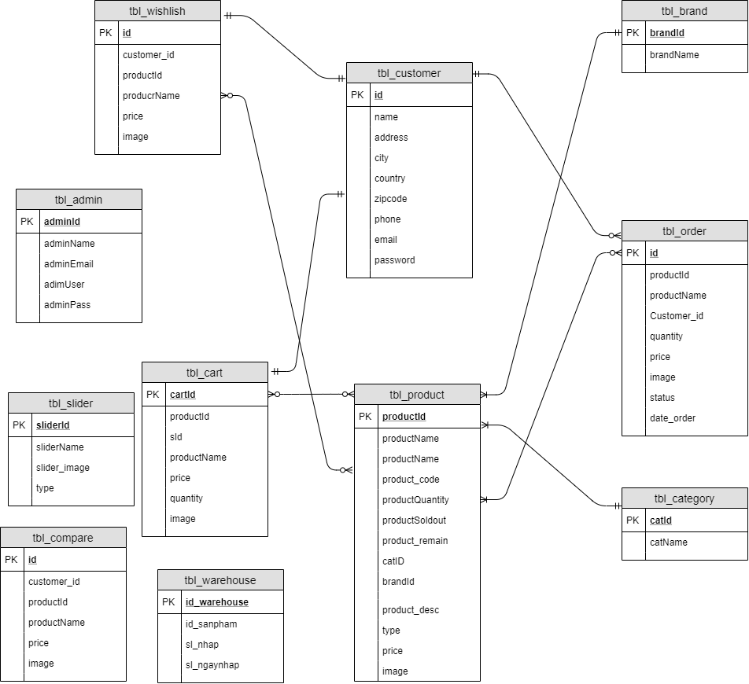

* 1. **List of UseCase**
     1. **<Customer> Overview UseCase**



* + - 1. **<Customer> Register**



|  |  |  |  |
| --- | --- | --- | --- |
| **USE CASE - CUS_01** | | | |
| **Use Case No.** | CUS_01 | **Use Case Version** | 1.0 |
| **Use Case Name** | Register | | |
| **Author** | BichNhan | | |
| **Date** | 01/06/2020 | **Priority** | Normal |
| **Actor:**   * Customer.   **Summary:**   * Allows customers to register an account.   **Goal:**   * Customer can create an account with USER role.   **Triggers:**   * Customer sends register command by click to the register button.   **Preconditions:**   * Customer is required to have a new email address.   **Post Conditions:**   * **Success:** A new account is created. * **Fail**: The system shows error messages.   **Main Success Scenario:**   |  |  |  | | --- | --- | --- | | **Step** | **Actor Action** | **System Reponse** | | 1 | The guest goes to the website by URL. | System returns the login screen. | | 2 | Customer click to “Register” | The system redirects to the Register page. | | 3 | Customer input email, password and click to the Register button. | The system creates a new account with the input information with USER role.  The system redirects to the main view. |   **Alternative Scenario:** N/A  **Exceptions:**   |  |  |  | | --- | --- | --- | | **No** | **Cause** | **System Reponse** | | 1 |  | The system shows the message "Please check your internet connection" when the internet is lost. | | 2 | Username is already used by  another user. | The system shows the message "Username is already used by another user. Please choose another username." |   **Relationships:** N/A  **Bussiness Rules:**   * Email: must be unique * Password: Password’s length is at least 6 characters and contains at least 1uppercase characters and at least one lower case character. * The system must ensure that no one can read the user password. * Attributes cannot be null. | | | |

* + - 1. **<Customer> Login**



|  |  |  |  |
| --- | --- | --- | --- |
| **USE CASE - CUS_02** | | | |
| **Use Case No.** | CUS_02 | **Use Case Version** | 1.0 |
| **Use Case Name** | Login | | |
| **Author** | BichNhan | | |
| **Date** | 01/06/2020 | **Priority** | Normal |
| **Actor:**   * Customer.   **Summary:**   * Allows customers to log in to the system.   **Goal:**   * Customers can log in to the system.   **Triggers:**   * Customers can log in by clicking on the login button.   **Preconditions:**   * Customers enter the correct ID, Pass.   **Post Conditions:**   * **Success:** Successful access to the system. * **Fail**: System show error messages.   **Main Success Scenario:**   |  |  |  | | --- | --- | --- | | **Step** | **Actor Action** | **System Reponse** | | 1 | Customer clicks login button in the menu. | The system redirect to login page. | | 2 |  | The system requires identity information from Customer:   * Email: text. * Password: text. | | 3 | Customer inputs email , password. |  | | 4 | Customer clicks on “Login” button. | The system redirecet home page.Customer logins into the system with their specific role. |   **Alternative Scenario:** N/A  **Exceptions:**   |  |  |  | | --- | --- | --- | | **No** | **Cause** | **System Reponse** | | 1 | Customer enter wrong identity information. | The system shows an error message”Wrong your email or password.Please try again.” | | 2 |  | The system shows the message "Please check your internet connection" when the internet is lost. |   **Relationships:** N/A  **Bussiness Rules:**   * Email: must be not empty * Password: must be not empty | | | |

* + - 1. **<Customer> View Products**



|  |  |  |  |
| --- | --- | --- | --- |
| **USE CASE - CUS_03** | | | |
| **Use Case No.** | CUS_03 | **Use Case Version** | 1.0 |
| **Use Case Name** | View Product | | |
| **Author** | BichNhan | | |
| **Date** | 01/06/2020 | **Priority** | Normal |
| **Actor:**   * Customer.   **Summary:**   * Allows customers to view all products displayed on the website.   **Goal:**   * Customers can view new and featured products.   **Triggers:**   * Customer sends command by click to the Product button.   **Preconditions:**   * The customer has logged in successfully   **Post Conditions:**   * **Success:** The system switches to the product page. * **Fail**: The system shows error messages.   **Main Success Scenario:**   |  |  |  | | --- | --- | --- | | **Step** | **Actor Action** | **System Reponse** | | 1 | Customer clicks the product button on the menu page. | The system goes to the product page. |   **Alternative Scenario:** N/A  **Exceptions:**   |  |  |  | | --- | --- | --- | | **No** | **Cause** | **System Reponse** | | 1 |  | The system shows the message "Please check your internet connection" when the internet is lost. |   **Relationships:** N/A  **Bussiness Rules:** N/A | | | |

* + - 1. **<Customer> View Details Product**



|  |  |  |  |
| --- | --- | --- | --- |
| **USE CASE - CUS_04** | | | |
| **Use Case No.** | CUS_04 | **Use Case Version** | 1.0 |
| **Use Case Name** | View Details Product | | |
| **Author** | BichNhan | | |
| **Date** | 01/06/2020 | **Priority** | Normal |
| **Actor:**   * Customer.   **Summary:**   * Allows customers to view detail product displayed on the website.   **Goal:**   * Customers can see the product details.   **Triggers:**   * Customer sends command by click to the Details button.   **Preconditions:**   * The customer has logged in successfully   **Post Conditions:**   * **Success:** The system switches to the detail page. * **Fail**: The system shows error messages.   **Main Success Scenario:**   |  |  |  | | --- | --- | --- | | **Step** | **Actor Action** | **System Reponse** | | 1 | Customer clicks the Details button or product image on the product page. | The system goes to the details page. |   **Alternative Scenario:** N/A  **Exceptions:**   |  |  |  | | --- | --- | --- | | **No** | **Cause** | **System Reponse** | | 1 |  | The system shows the message "Please check your internet connection" when the internet is lost. |   **Relationships:** N/A  **Bussiness Rules:** N/A | | | |

* + - 1. **<Customer> Search Product**



|  |  |  |  |
| --- | --- | --- | --- |
| **USE CASE - CUS_05** | | | |
| **Use Case No.** | CUS_05 | **Use Case Version** | 1.0 |
| **Use Case Name** | Search Product | | |
| **Author** | BichNhan | | |
| **Date** | 01/06/2020 | **Priority** | Normal |
| **Actor:**   * Customer.   **Summary:**   * Allows customers to search for products by keyword.   **Goal:**   * Customers can search for the desired product.   **Triggers:**   * Customers type the keyword of the product to search into the textbox. * Customers click the search button or press the enter key.   **Preconditions:**   * The customer has logged in successfully   **Post Conditions:**   * **Success:** The system finds the products. * **Fail**: The system shows error messages.   **Main Success Scenario:**   |  |  |  | | --- | --- | --- | | **Step** | **Actor Action** | **System Reponse** | | 1 | Customers enter the keyword into the textbox on the header website. | The system displays the products containing the keyword. |   **Alternative Scenario:** N/A  **Exceptions:**   |  |  |  | | --- | --- | --- | | **No** | **Cause** | **System Reponse** | | 1 |  | The system shows the message "Please check your internet connection" when the internet is lost. | | 2 | Keyword not found | The system shows the message " The system did not find related products”. | | 3 | Keyword invalid | The system shows the message " Do not enter symbol characters”. |   **Relationships:** N/A  **Bussiness Rules:**   * Keyword no more than 10 characters. * Keysword cannot contain special characters. * Keyword must be in English. | | | |

* + - 1. **<Customer> Add to Cart**



|  |  |  |  |
| --- | --- | --- | --- |
| **USE CASE - CUS_06** | | | |
| **Use Case No.** | CUS_06 | **Use Case Version** | 1.0 |
| **Use Case Name** | Add To Cart | | |
| **Author** | BichNhan | | |
| **Date** | 01/06/2020 | **Priority** | Normal |
| **Actor:**   * Customer.   **Summary:**   * Allow customers to add products to the cart.   **Goal:**   * Customers can put products to buy in the cart.   **Triggers:**   * Customers click on a product image or click the details button. * Customers click the Add to cart button on the details page.   **Preconditions:**   * The customer has logged in successfully   **Post Conditions:**   * **Success:** Products are put into the cart. * **Fail**: The system shows error messages.   **Main Success Scenario:**   |  |  |  | | --- | --- | --- | | **Step** | **Actor Action** | **System Reponse** | | 1 | Customers click the details button. | The system goes to the product detail page. | | 2 | Customer click the Add to cart button on the product detail page. | The system will put the product in the cart, and add up the price of all products in the cart. |   **Alternative Scenario:** N/A  **Exceptions:**   |  |  |  | | --- | --- | --- | | **No** | **Cause** | **System Reponse** | | 1 |  | The system shows the message "Please check your internet connection" when the internet is lost. | | 2 | Out of stock. | The system shows message "Sorry, we are out of stock right now, please sympathize". |   **Relationships:** N/A  **Bussiness Rules:** N/A | | | |

* + - 1. **<Customer> Add to Wishlish**



|  |  |  |  |
| --- | --- | --- | --- |
| **USE CASE - CUS_07** | | | |
| **Use Case No.** | CUS_07 | **Use Case Version** | 1.0 |
| **Use Case Name** | Add To Wishlish | | |
| **Author** | BichNhan | | |
| **Date** | 01/06/2020 | **Priority** | Normal |
| **Actor:**   * Customer.   **Summary:**   * Allow customers to add products to the wishlish.   **Goal:**   * Customers can put products to buy in the wishlish.   **Triggers:**   * Customers click on a product image or click the details button. * Customers click the Add to wishlish button.   **Preconditions:**   * The customer has logged in successfully   **Post Conditions:**   * **Success:** Products are put into the wishlish. * **Fail**: The system shows error messages.   **Main Success Scenario:**   |  |  |  | | --- | --- | --- | | **Step** | **Actor Action** | **System Reponse** | | 1 | Customers click the details button. | The system goes to the product detail page. | | 2 | Customer click the Add to wishlish button on the product detail page. | The system will put the product in the wishlish. |   **Alternative Scenario:** N/A  **Exceptions:**   |  |  |  | | --- | --- | --- | | **No** | **Cause** | **System Reponse** | | 1 |  | The system shows the message "Please check your internet connection" when the internet is lost. |   **Relationships:** N/A  **Bussiness Rules:** N/A | | | |

* + 1. **<User> Orverview UseCase**



* + - 1. **<User> Logout**



|  |  |  |  |
| --- | --- | --- | --- |
| **USE CASE - USER_01** | | | |
| **Use Case No.** | USER_01 | **Use Case Version** | 1.0 |
| **Use Case Name** | Logout | | |
| **Author** | BichNhan | | |
| **Date** | 01/06/2020 | **Priority** | Normal |
| **Actor:**   * User.   **Summary:**   * Allow users logout from the system.   **Goal:**   * User logout successfully.   **Triggers:**   * User clicks to the logout button in the menu.   **Preconditions:**   * The user has logged in successfully.   **Post Conditions:**   * **Success:** System redirect to Login page. * **Fail**: System show error messages.   **Main Success Scenario:**   |  |  |  | | --- | --- | --- | | **Step** | **Actor Action** | **System Reponse** | | 1 | User clicks button “Logout” in the menu. | System open logout popup with  the message “Are you sure you want to  logout now?”:  • Accept: button  • Cancel: button. | | 2 | User click “Accept” to confirm. | System redirect login page. |   **Alternative Scenario:**   |  |  |  | | --- | --- | --- | | **No** | **Actor Action** | **System Response** | | 1 | User clicks on “cancel” button. | System close logout popup. |   **Exceptions:**   |  |  |  | | --- | --- | --- | | **No** | **Cause** | **System Reponse** | | 1 |  | The system shows the message "Please check your internet connection" when the internet is lost. |   **Relationships:** N/A  **Bussiness Rules:**   * After member sends logout request, system redirects to login page. * After member sends logout request, system must clear user’s token. | | | |

* + - 1. **<User> Compare Products**



|  |  |  |  |
| --- | --- | --- | --- |
| **USE CASE - USER_02** | | | |
| **Use Case No.** | USER_02 | **Use Case Version** | 1.0 |
| **Use Case Name** | Compare Products | | |
| **Author** | DinhChau | | |
| **Date** | 01/06/2020 | **Priority** | Normal |
| **Actor:**   * User.   **Summary:**   * Allows users to compare 2 or more products.   **Goal:**   * User can add information of a product to the comparison page   **Triggers:**   * User clicks to the compare products button on the details page. * User clicks to the compare button on the menu.   **Preconditions:**   * The user has logged in successfully.   **Post Conditions:**   * **Success:** System redirect to Compare page and show all products to compare * **Fail**: There are no products in the comparison page.   **Main Success Scenario:**   |  |  |  | | --- | --- | --- | | **Step** | **Actor Action** | **System Reponse** | | 1 | User clicks button “details” on the product page. | System redirect details page. | | 2 | User clicks button “Compare product” on the details page. | The system shows the message “Added to comparison list”.  The system insert product information to the database. | | 3 | User clicks button “Compare” on the menu. | System redirect compare page.  The system displays information that has just been inserted into the database |   **Alternative Scenario:** N/A  **Exceptions:**   |  |  |  | | --- | --- | --- | | **No** | **Cause** | **System Reponse** | | 1 |  | The system shows the message "Please check your internet connection" when the internet is lost. |   **Relationships:** N/A  **Bussiness Rules:** N/A | | | |

* + - 1. **<User> Update Information**



|  |  |  |  |
| --- | --- | --- | --- |
| **USE CASE - USER_03** | | | |
| **Use Case No.** | USER_03 | **Use Case Version** | 1.0 |
| **Use Case Name** | Update Information | | |
| **Author** | DinhChau | | |
| **Date** | 01/06/2020 | **Priority** | Normal |
| **Actor:**   * User.   **Summary:**   * Allow users to edit profile.   **Goal:**   * User may change their personal information.   **Triggers:**   * User clicks to the profile button on the menu. * User clicks to update profile button on the profile page.   **Preconditions:**   * The user has logged in successfully.   **Post Conditions:**   * **Success:** The system will update the latest information on the user's profile. * **Fail**: System show error messages.   **Main Success Scenario:**   |  |  |  | | --- | --- | --- | | **Step** | **Actor Action** | **System Reponse** | | 1 | User clicks button “profile” on the menu | System redirect profile page. | | 2 | User clicks button “Update Profile” on the profile page. | The system enable the entry into the textbox | | 3 | User enter information into the textbox |  | | 4 | User clicks button “Save” on the profile page. | System redirect profile page and update user information |   **Alternative Scenario:** N/A  **Exceptions:**   |  |  |  | | --- | --- | --- | | **No** | **Cause** | **System Reponse** | | 1 |  | The system shows the message "Please check your internet connection" when the internet is lost. | | 2 | The text box is empty | The system shows the message “Please fill in the information” |   **Relationships:** N/A  **Bussiness Rules:** N/A | | | |

* + - 1. **<User> Change Password**



|  |  |  |  |
| --- | --- | --- | --- |
| **USE CASE - USER_04** | | | |
| **Use Case No.** | USER_04 | **Use Case Version** | 1.0 |
| **Use Case Name** | Change password | | |
| **Author** | DinhChau | | |
| **Date** | 01/06/2020 | **Priority** | Normal |
| **Actor:**   * User.   **Summary:**   * Allow users to change password.   **Goal:**   * User may change password.   **Triggers:**   * User clicks to the change password button on the menu. * User clicks to save button on the change password page.   **Preconditions:**   * The user has logged in successfully.   **Post Conditions:**   * **Success:** The system will update the latest information on the user's password. * **Fail**: System show error messages.   **Main Success Scenario:**   |  |  |  | | --- | --- | --- | | **Step** | **Actor Action** | **System Reponse** | | 1 | User clicks button “Change Password” on the menu | System redirect changepassword page. | | 2 | The user enters the old password and the new password into the testbox |  | | 3 | User clicks button “Save” on the changepassword page. | System redirect changepassword page and update password. |   **Alternative Scenario:** N/A  **Exceptions:**   |  |  |  | | --- | --- | --- | | **No** | **Cause** | **System Reponse** | | 1 |  | The system shows the message "Please check your internet connection" when the internet is lost. | | 2 | User entered the wrong old password | The system shows the message “Please enter the old password again” | | 3 | A new password containing special symbols. | The system shows the message “Invalid password” |   **Relationships:** N/A  **Bussiness Rules:**   * The new password must not exceed 30 characters. * The new password must not have special characters. * The new password must not be empty. | | | |

* + - 1. **<User> Payment**



|  |  |  |  |
| --- | --- | --- | --- |
| **USE CASE - USER_05** | | | |
| **Use Case No.** | USER_05 | **Use Case Version** | 1.0 |
| **Use Case Name** | Payment | | |
| **Author** | DinhChau | | |
| **Date** | 01/06/2020 | **Priority** | Normal |
| **Actor:**   * User.   **Summary:**   * Allows users to pay for the product they have purchased.   **Goal:**   * Admin can pay for the product they have purchased.   **Triggers:**   * Admin clicks to the “Checkout” button.   **Preconditions:**   * User has logged in successfully. * User must add at least one item to the shopping cart.   **Post Conditions:**   * **Success:**User payment successfully. * **Fail**: System show error messages.   **Main Success Scenario:**   |  |  |  | | --- | --- | --- | | **Step** | **Actor Action** | **System Reponse** | | 1 | User successfully added to the shopping cart. | System redirects to the cart page. | | 2 | Admin clicks button “ Checkout” on the cart page. | System redirects to the Payment page. | | 3 | Admin click button “Pay by credit” or button”Pay by cod” | System redirects to the pay page. | | 4 | Admin clicks button “Buy Now” | System shows message “Complete”. |   **Alternative Scenario:** N/A  **Exceptions:**   |  |  |  | | --- | --- | --- | | **No** | **Cause** | **System Reponse** | | 1 |  | The system shows the message "Please check your internet connection" when the internet is lost. | | 2 | Empty Cart. | The system shows the message “Your cart is empty, Please shopping now ”. |   **Relationships:** CUS_06 : Add To Cart.  **Bussiness Rules:**   * Cart is not empty. | | | |

* + - 1. **<User> Order Product**



|  |  |  |  |
| --- | --- | --- | --- |
| **USE CASE - USER_06** | | | |
| **Use Case No.** | USER_06 | **Use Case Version** | 1.0 |
| **Use Case Name** | Order Product | | |
| **Author** | DinhChau | | |
| **Date** | 01/06/2020 | **Priority** | Normal |
| **Actor:**   * User.   **Summary:**   * Allows users to view the items they have purchased.   **Goal:**   * Admin can view the items they have purchased.   **Triggers:**   * Admin clicks to the “Order” button on menu page.   **Preconditions:**   * Must successfully purchase at least one product.   **Post Conditions:**   * **Success:** The order page shows the products purchased. * **Fail**: System show error messages.   **Main Success Scenario:**   |  |  |  | | --- | --- | --- | | **Step** | **Actor Action** | **System Reponse** | | 1 | Admin clicks button “Order” on menu page. | System redirects to the order page. |   **Alternative Scenario:** N/A  **Exceptions:**   |  |  |  | | --- | --- | --- | | **No** | **Cause** | **System Reponse** | | 1 |  | The system shows the message "Please check your internet connection" when the internet is lost. |   **Relationships:** N/A.  **Bussiness Rules:**   * Must successfully purchase at least one product. | | | |

* + 1. **<Admin> Orverview UseCase**



* + - 1. **<Admin>Login**



|  |  |  |  |
| --- | --- | --- | --- |
| **USE CASE - ADMIN_01** | | | |
| **Use Case No.** | ADMIN_01 | **Use Case Version** | 1.0 |
| **Use Case Name** | Login | | |
| **Author** | BichNhan | | |
| **Date** | 01/06/2020 | **Priority** | Normal |
| **Actor:**   * Admin.   **Summary:**   * Allows admin to log in to the system.   **Goal:**   * Admin can log in to the system.   **Triggers:**   * Admin can log in by clicking on the login button.   **Preconditions:**   * Admin enter the correct ID, Pass.   **Post Conditions:**   * **Success:** Successful access to the system. * **Fail**: System show error messages.   **Main Success Scenario:**   |  |  |  | | --- | --- | --- | | **Step** | **Actor Action** | **System Reponse** | | 1 | Amin goes the website by URL. | System returns the login screen. | | 2 | Admin clicks login button in the menu. | The system redirect to login page. | | 3 |  | The system requires identity information from Customer:   * Email: text. * Password: text. | | 4 | Admin inputs email , password. |  | | 5 | Admin clicks on “Login” button. | The system redirecet home page.Admin logins into the system with their specific role. |   **Alternative Scenario:** N/A  **Exceptions:**   |  |  |  | | --- | --- | --- | | **No** | **Cause** | **System Reponse** | | 1 | Admin enter wrong identity information. | The system shows an error message”Wrong your email or password.Please try again.” | | 2 |  | The system shows the message "Please check your internet connection" when the internet is lost. |   **Relationships:** N/A  **Bussiness Rules:**   * Email: must be not empty * Password: must be not empty | | | |

* + - 1. **<Admin>Logout**



|  |  |  |  |
| --- | --- | --- | --- |
| **USE CASE - ADMIN_02** | | | |
| **Use Case No.** | ADMIN_02 | **Use Case Version** | 1.0 |
| **Use Case Name** | Logout | | |
| **Author** | BichNhan | | |
| **Date** | 01/06/2020 | **Priority** | Normal |
| **Actor:**   * Admin.   **Summary:**   * Allow Admin logout from the system.   **Goal:**   * Admin logout successfully.   **Triggers:**   * Admin clicks to the logout button in the menu.   **Preconditions:**   * Admin has logged in successfully.   **Post Conditions:**   * **Success:** System redirect to Login page. * **Fail**: System show error messages.   **Main Success Scenario:**   |  |  |  | | --- | --- | --- | | **Step** | **Actor Action** | **System Reponse** | | 1 | Admin clicks button “Logout” in the menu. | System open logout popup with  the message “Are you sure you want to  logout now?”:  • Accept: button  • Cancel: button. | | 2 | Admin click “Accept” to confirm. | System redirect login page. |   **Alternative Scenario:**   |  |  |  | | --- | --- | --- | | **No** | **Actor Action** | **System Response** | | 1 | Admin clicks on “cancel” button. | System close logout popup. |   **Exceptions:**   |  |  |  | | --- | --- | --- | | **No** | **Cause** | **System Reponse** | | 1 |  | The system shows the message "Please check your internet connection" when the internet is lost. |   **Relationships:** N/A  **Bussiness Rules:**   * After member sends logout request, system redirects to login page. * After member sends logout request, system must clear Admin token. | | | |

* + - 1. **<Admin> Check Order**



|  |  |  |  |
| --- | --- | --- | --- |
| **USE CASE - ADMIN_03** | | | |
| **Use Case No.** | ADMIN_03 | **Use Case Version** | 1.0 |
| **Use Case Name** | Check Oders | | |
| **Author** | BichNhan | | |
| **Date** | 01/06/2020 | **Priority** | Normal |
| **Actor:**   * Admin.   **Summary:**   * Allow admin to check orders placed.   **Goal:**   * Admin can browse orders placed   **Triggers:**   * Admin can check oders by clicking the Check Order button.   **Preconditions:**   * Admin has successfully logged in.   **Post Conditions:**   * **Success:** The system will redirect to the CheckOrders page and allow the admin to approve the order. * **Fail**: System show error messages.   **Main Success Scenario:**   |  |  |  | | --- | --- | --- | | **Step** | **Actor Action** | **System Reponse** | | 1 | Admin clicks the Check Orders button on the menu bar of the admin main page. | The system redirect to CheckOders page. | | 2 |  | The system will display all information on the order. | | 3 | Admin click the Accept button to accept and allow shipping orders. | The system will switch from accept to delivery. | | 4 |  | The system will send a confirmation message to the user. | | 5 | If User presses Confirm button on the orderdetails page. | The system switches from Delivery status to Complete at the admin page. |   **Alternative Scenario:** N/A  **Exceptions:**   |  |  |  | | --- | --- | --- | | **No** | **Cause** | **System Reponse** | | 1 | Admin who doesn't agree to sell the product will click the Reject button. | The system will notify customers that "Sorry, our system is out of stock, you come back later. I wish you a happy new day, thank you". | | 2 |  | The system shows the message "Please check your internet connection" when the internet is lost. |   **Relationships:** N/A  **Bussiness Rules:**   * Customers must oder from one product or more. | | | |

* + - 1. **<Admin> Add Category**



|  |  |  |  |
| --- | --- | --- | --- |
| **USE CASE - ADMIN_04** | | | |
| **Use Case No.** | ADMIN_04 | **Use Case Version** | 1.0 |
| **Use Case Name** | Add Category | | |
| **Author** | BichNhan | | |
| **Date** | 01/06/2020 | **Priority** | Normal |
| **Actor:**   * Admin.   **Summary:**   * Allow admin to add new product catalog.   **Goal:**   * Admin can add new categories on the website.   **Triggers:**   * Admin click the Add New Category button on the sidebar in the left corner of the admin page.   **Preconditions:**   * Admin has logged in successfully.   **Post Conditions:**   * **Success:** System will have new catalog. * **Fail**: System show error messages.   **Main Success Scenario:**   |  |  |  | | --- | --- | --- | | **Step** | **Actor Action** | **System Reponse** | | 1 | Admin clicks button “Add New Category ” in the menu. | The system redirects to the page to add a new category. | | 2 | Admin enters the name of the new category to be added to the textbox on the catadd page. |  | | 3 | Admin clicks the Save button at the bottom of the textbox. | The system will announce "Insert Category Successfully". |   **Alternative Scenario:**  **Exceptions:**   |  |  |  | | --- | --- | --- | | **No** | **Cause** | **System Reponse** | | 1 |  | The system shows the message "Please check your internet connection" when the internet is lost. |   **Relationships:** N/A  **Bussiness Rules:**   * Character length must not exceed 50 characters. | | | |

* + - 1. **<Admin> Update Category**



|  |  |  |  |
| --- | --- | --- | --- |
| **USE CASE - ADMIN_05** | | | |
| **Use Case No.** | ADMIN_05 | **Use Case Version** | 1.0 |
| **Use Case Name** | Update Category | | |
| **Author** | BichNhan | | |
| **Date** | 01/06/2020 | **Priority** | Normal |
| **Actor:**   * Admin.   **Summary:**   * Allows admin to update category name**.**   **Goal:**   * Admin can upate category new name on the website.   **Triggers:**   * Admin click the Edit button in the right corner of Category List page..   **Preconditions:**   * Admin has logged in successfully.   **Post Conditions:**   * **Success:** update category new name successful. * **Fail**: System show error messages.   **Main Success Scenario:**   |  |  |  | | --- | --- | --- | | **Step** | **Actor Action** | **System Reponse** | | 1 | Admin clicks button “Category” in the menu. |  | | 2 | Admin clicks button “Category List” in Category. | The system redirects to the Category List page | | 3 | Admin click the edit button of the category to fix | The system redirects to the catedit page. | | 4 | Admin enter a new name for that category. |  | | 5 | Admin clicks the Edit button at the bottom of the textbox. | The system will announce "Update Category Successfully". |   **Alternative Scenario:** N/A  **Exceptions:**   |  |  |  | | --- | --- | --- | | **No** | **Cause** | **System Reponse** | | 1 |  | The system shows the message "Please check your internet connection" when the internet is lost. |   **Relationships:** N/A  **Bussiness Rules:**   * Character length must not exceed 50 characters. | | | |

* + - 1. **<Admin> Delete Category**



|  |  |  |  |
| --- | --- | --- | --- |
| **USE CASE - ADMIN_06** | | | |
| **Use Case No.** | ADMIN_06 | **Use Case Version** | 1.0 |
| **Use Case Name** | Delete Category | | |
| **Author** | BichNhan | | |
| **Date** | 01/06/2020 | **Priority** | Normal |
| **Actor:**   * Admin.   **Summary:**   * Allow the admin to delete catalog on the website**.**   **Goal:**   * Admin can delete category on the website.   **Triggers:**   * Admin click the Delete button in the right corner of the Category List page.   **Preconditions:**   * Admin has logged in successfully.   **Post Conditions:**   * **Success:** Delete category successful. * **Fail**: System show error messages.   **Main Success Scenario:**   |  |  |  | | --- | --- | --- | | **Step** | **Actor Action** | **System Reponse** | | 1 | Admin clicks button “Category” in the menu. |  | | 2 | Admin clicks button “Category List” in Category. | The system redirects to the Category List page | | 3 | Admin click the delete button of the category to delete | The system shows the message”Are you want to delete?”  • Accept: button  • Cancel: button. | | 4 | Admin click “Accept” to delete. | System immediately removes the category from the list |   **Alternative Scenario:**   |  |  |  | | --- | --- | --- | | **No** | **Actor Action** | **System Response** | | 1 | Admin clicks on “cancel” button. | System close logout popup. |   **Exceptions:**   |  |  |  | | --- | --- | --- | | **No** | **Cause** | **System Reponse** | | 1 |  | The system shows the message "Please check your internet connection" when the internet is lost. |   **Relationships:** N/A  **Bussiness Rules:**   * Category List has at least 1 product. | | | |

* + - 1. **<Admin> Add Brand**



|  |  |  |  |
| --- | --- | --- | --- |
| **USE CASE - ADMIN_07** | | | |
| **Use Case No.** | ADMIN_07 | **Use Case Version** | 1.0 |
| **Use Case Name** | Add Brand | | |
| **Author** | BichNhan | | |
| **Date** | 01/06/2020 | **Priority** | Normal |
| **Actor:**   * Admin.   **Summary:**   * Allow admin to add new product brand.   **Goal:**   * Admin can add new brand on the website.   **Triggers:**   * Admin click the Add New Brand button on the sidebar in the left corner of the admin page.   **Preconditions:**   * Admin has logged in successfully.   **Post Conditions:**   * **Success:** System will have new brand. * **Fail**: System show error messages.   **Main Success Scenario:**   |  |  |  | | --- | --- | --- | | **Step** | **Actor Action** | **System Reponse** | | 1 | Admin clicks button “Add New Brand ” in the menu. | The system redirects to the page to add a new brand. | | 2 | Admin enters the name of the new brand to be added to the textbox on the brandadd page. |  | | 3 | Admin clicks the Save button at the bottom of the textbox. | The system will announce "Insert Brand Successfully". |   **Alternative Scenario:**  **Exceptions:** N/A   |  |  |  | | --- | --- | --- | | **No** | **Cause** | **System Reponse** | | 1 |  | The system shows the message "Please check your internet connection" when the internet is lost. |   **Relationships:** N/A  **Bussiness Rules:**   * Character length must not exceed 50 characters. | | | |

* + - 1. **<Admin> Update Brand**



|  |  |  |  |
| --- | --- | --- | --- |
| **USE CASE - ADMIN_08** | | | |
| **Use Case No.** | ADMIN_08 | **Use Case Version** | 1.0 |
| **Use Case Name** | Update Brand | | |
| **Author** | BichNhan | | |
| **Date** | 01/06/2020 | **Priority** | Normal |
| **Actor:**   * Admin.   **Summary:**   * Allows admin to update brand name   **Goal:**   * Admin can upate brand new name on the website.   **Triggers:**   * Admin click the Edit button in the right corner of Brand List page.   **Preconditions:**   * Admin has logged in successfully.   **Post Conditions:**   * **Success:** Update brand new name successfully * **Fail**: System show error messages.   **Main Success Scenario:**   |  |  |  | | --- | --- | --- | | **Step** | **Actor Action** | **System Reponse** | | 1 | Admin clicks button “Brand” in the menu. |  | | 2 | Admin clicks button “Brand List” in Category. | The system redirects to the Brand List page | | 3 | Admin click the edit button of the brand to fix | The system redirects to the brandedit page. | | 4 | Admin enter a new name for that brand. |  | | 5 | Admin clicks the Edit button at the bottom of the textbox. | The system will announce "Update Brand Successfully". |   **Alternative Scenario:** N/A  **Exceptions:**   |  |  |  | | --- | --- | --- | | **No** | **Cause** | **System Reponse** | | 1 |  | The system shows the message "Please check your internet connection" when the internet is lost. |   **Relationships:** N/A  **Bussiness Rules:**   * Character length must not exceed 50 characters. | | | |

* + - 1. **<Admin> Delete Brand**



|  |  |  |  |
| --- | --- | --- | --- |
| **USE CASE - ADMIN_09** | | | |
| **Use Case No.** | ADMIN_09 | **Use Case Version** | 1.0 |
| **Use Case Name** | Delete Brand | | |
| **Author** | BichNhan | | |
| **Date** | 01/06/2020 | **Priority** | Normal |
| **Actor:**   * Admin.   **Summary:**   * Allow the admin to delete brand on the website**.**   **Goal:**   * Admin can delete brand on the website.   **Triggers:**   * Admin click the Delete button in the right corner of the Brand List page.   **Preconditions:**   * Admin has logged in successfully.   **Post Conditions:**   * **Success:** Delete brand successful. * **Fail**: System show error messages.   **Main Success Scenario:**   |  |  |  | | --- | --- | --- | | **Step** | **Actor Action** | **System Reponse** | | 1 | Admin clicks button “Brand” in the menu. |  | | 2 | Admin clicks button “Brand List” in Product. | The system redirects to the Brand List page | | 3 | Admin click the delete button of the brand to delete | The system shows the message”Are you want to delete?”  • Accept: button  • Cancel: button. | | 4 | Admin click “Accept” to delete. | System immediately removes the brand from the list |   **Alternative Scenario:**   |  |  |  | | --- | --- | --- | | **No** | **Actor Action** | **System Response** | | 1 | Admin clicks on “cancel” button. | System close logout popup. |   **Exceptions:**   |  |  |  | | --- | --- | --- | | **No** | **Cause** | **System Reponse** | | 1 |  | The system shows the message "Please check your internet connection" when the internet is lost. |   **Relationships:** N/A  **Bussiness Rules:**   * Brand List has at least 1 product. | | | |

* + - 1. **<Admin> Add Product**



|  |  |  |  |
| --- | --- | --- | --- |
| **USE CASE - ADMIN_10** | | | |
| **Use Case No.** | ADMIN_10 | **Use Case Version** | 1.0 |
| **Use Case Name** | Add Product | | |
| **Author** | BichNhan | | |
| **Date** | 01/06/2020 | **Priority** | Normal |
| **Actor:**   * Admin.   **Summary:**   * Allow admin to add new product .   **Goal:**   * Admin can add new product on the website.   **Triggers:**   * Admin click the Add New Product button on the sidebar in the left corner of the admin page.   **Preconditions:**   * Admin has logged in successfully.   **Post Conditions:**   * **Success:** System will have new product. * **Fail**: System show error messages.   **Main Success Scenario:**   |  |  |  | | --- | --- | --- | | **Step** | **Actor Action** | **System Reponse** | | 1 | Admin clicks button “Add New product ” in the menu. | The system redirects to the page to add a new brand. | | 2 | Admin enters:   * Product Name * ZipCode * Amout * Category * Brand * Description * Price * Image * Type |  | | 3 | Admin clicks the Save button at the bottom of the textbox. | The system will announce "Insert Product Successfully". |   **Alternative Scenario:** N/A  **Exceptions:**   |  |  |  | | --- | --- | --- | | **No** | **Cause** | **System Reponse** | | 1 | Admin enter more than 50 characters | The system shows the message " Characters over 50”. | | 2 | Admin inputs characters in the list of amount and price. | The system shows the message " Please, enter the number of characters in the amount and price fields50”. | | 3 | Admin put the image file over 20MB | The system shows the message “Please insert a 20MB image file”. | | 4 |  | The system shows the message "Please check your internet connection" when the internet is lost. |   **Relationships:** N/A  **Bussiness Rules:**   * Character length must not exceed 50 characters. * The text box for amout and price items must be a number with no characters. * Image file size should not exceed 20MB. | | | |

* + - 1. **<Admin> Update Product**



|  |  |  |  |
| --- | --- | --- | --- |
| **USE CASE - ADMIN_11** | | | |
| **Use Case No.** | ADMIN_11 | **Use Case Version** | 1.0 |
| **Use Case Name** | Update Product | | |
| **Author** | BichNhan | | |
| **Date** | 01/06/2020 | **Priority** | Normal |
| **Actor:**   * Admin.   **Summary:**   * Allows admin to update product name.   **Goal:**   * Admin can upate product new name on the website.   **Triggers:**   * Admin click the Edit button in the right corner of product List page.   **Preconditions:**   * Admin has logged in successfully.   **Post Conditions:**   * **Success:** Update product new name successfully * **Fail**: System show error messages.   **Main Success Scenario:**   |  |  |  | | --- | --- | --- | | **Step** | **Actor Action** | **System Reponse** | | 1 | Admin clicks button “Product” in the menu. |  | | 2 | Admin clicks button “Product List” in Category. | The system redirects to the Product List page | | 3 | Admin click the edit button of the product to fix | The system redirects to the productedit page. | | 4 | Admin enter a new name for that product. |  | | 5 | Admin clicks the Edit button at the bottom of the textbox. | The system will announce "Update Brand Successfully". |   **Alternative Scenario:** N/A  **Exceptions:**   |  |  |  | | --- | --- | --- | | **No** | **Cause** | **System Reponse** | | 1 | Admin enter more than 50 characters | The system shows the message " Characters over 50”. | | 2 | Admin inputs characters in the list of amount and price. | The system shows the message " Please, enter the number of characters in the amount and price fields50”. | | 3 | Admin put the image file over 20MB | The system shows the message “Please insert a 20MB image file”. | | 4 |  | The system shows the message "Please check your internet connection" when the internet is lost. |   **Relationships:** N/A  **Bussiness Rules:**   * Character length must not exceed 50 characters. | | | |

* + - 1. **<Admin> Delete Product**



|  |  |  |  |
| --- | --- | --- | --- |
| **USE CASE - ADMIN_12** | | | |
| **Use Case No.** | ADMIN_12 | **Use Case Version** | 1.0 |
| **Use Case Name** | Delete product | | |
| **Author** | BichNhan | | |
| **Date** | 01/06/2020 | **Priority** | Normal |
| **Actor:**   * Admin.   **Summary:**   * Allow the admin to delete product on the website**.**   **Goal:**   * Admin can delete product on the website.   **Triggers:**   * Admin click the Delete button in the right corner of the Product List page.   **Preconditions:**   * Admin has logged in successfully.   **Post Conditions:**   * **Success:** Delete product successful. * **Fail**: System show error messages.   **Main Success Scenario:**   |  |  |  | | --- | --- | --- | | **Step** | **Actor Action** | **System Reponse** | | 1 | Admin clicks button “Product” in the menu. |  | | 2 | Admin clicks button “product List” in Product. | The system redirects to the Product List page | | 3 | Admin click the delete button of the product to delete | The system shows the message”Are you want to delete?”  • Accept: button  • Cancel: button. | | 4 | Admin click “Accept” to delete. | System immediately removes the product from the list |   **Alternative Scenario:**   |  |  |  | | --- | --- | --- | | **No** | **Actor Action** | **System Response** | | 1 | Admin clicks on “cancel” button. | System close logout popup. |   **Exceptions:**   |  |  |  | | --- | --- | --- | | **No** | **Cause** | **System Reponse** | | 1 |  | The system shows the message "Please check your internet connection" when the internet is lost. |   **Relationships:** N/A  **Bussiness Rules:**   * Product List has at least 1 product. | | | |

* + - 1. **<Admin> Insert Slider**



|  |  |  |  |
| --- | --- | --- | --- |
| **USE CASE - ADMIN_13** | | | |
| **Use Case No.** | ADMIN_13 | **Use Case Version** | 1.0 |
| **Use Case Name** | Insert Slider | | |
| **Author** | BichNhan | | |
| **Date** | 01/06/2020 | **Priority** | Normal |
| **Actor:**   * Admin.   **Summary:**   * Allow admin to insert image of slider on the website.   **Goal:**   * Admin can insert slider on the website.   **Triggers:**   * Admin clicks to the “Add slider” button on the menu.   **Preconditions:**   * Admin has logged in successfully.   **Post Conditions:**   * **Success:**Admin insert into slider successfully. * **Fail**: System show error messages.   **Main Success Scenario:**   |  |  |  | | --- | --- | --- | | **Step** | **Actor Action** | **System Reponse** | | 1 | Admin clicks button “Slider” on the sidebar. |  | | 2 | Admin clicks button “ Add Slider” in Slider. | System redirects to the slideradd page. | | 3 | Admin click the select file button. | System displays file explorer to select the image. | | 4 | Admin choose image. | System insert into image in database. | | 5 | Admin clicks “Save” button. | System shows message “Insert in to image successfully”. |   **Alternative Scenario:** N/A  **Exceptions:**   |  |  |  | | --- | --- | --- | | **No** | **Cause** | **System Reponse** | | 1 |  | The system shows the message "Please check your internet connection" when the internet is lost. | | 2 | Image size too 20MB. | The system shows the message “Please , Insert photos to the correct size”. |   **Relationships:** N/A  **Bussiness Rules:**   * Image size not exceeding 20MB. | | | |

* + - 1. **<Admin> Import of Product**



|  |  |  |  |
| --- | --- | --- | --- |
| **USE CASE - ADMIN_14** | | | |
| **Use Case No.** | ADMIN_14 | **Use Case Version** | 1.0 |
| **Use Case Name** | Import Of Product | | |
| **Author** | BichNhan | | |
| **Date** | 01/06/2020 | **Priority** | Normal |
| **Actor:**   * Admin.   **Summary:**   * Allow admin to import products into the warehouse.   **Goal:**   * Admin can import products into the warehouse .   **Triggers:**   * Admin clicks to the “Import” button on Product List page.   **Preconditions:**   * Admin has logged in successfully.   **Post Conditions:**   * **Success:**Admin import products successfully. * **Fail**: System show error messages.   **Main Success Scenario:**   |  |  |  | | --- | --- | --- | | **Step** | **Actor Action** | **System Reponse** | | 1 | Admin clicks button “Product” on the sidebar. |  | | 2 | Admin clicks button “ Product List” in Product. | System redirects to the Product List page. | | 3 | Admin click “Import” button |  | | 4 | Admin inputs in the Add Amount textbox. |  | | 5 | Admin clicks “Save” button. | System shows message “successfully”. |   **Alternative Scenario:** N/A  **Exceptions:**   |  |  |  | | --- | --- | --- | | **No** | **Cause** | **System Reponse** | | 1 |  | The system shows the message "Please check your internet connection" when the internet is lost. | | 2 | Admin inputs characters or blank at Add Amout textbox. | The system shows the message “inputs is a numer character”. |   **Relationships:** N/A  **Bussiness Rules:**   * Input is number character. | | | |

* + - 1. **<Admin> Change Password**



|  |  |  |  |
| --- | --- | --- | --- |
| **USE CASE - ADMIN_15** | | | |
| **Use Case No.** | ADMIN_15 | **Use Case Version** | 1.0 |
| **Use Case Name** | Change password | | |
| **Author** | BichNhan | | |
| **Date** | 01/06/2020 | **Priority** | Normal |
| **Actor:**   * Admin.   **Summary:**   * Allow admin to change password.   **Goal:**   * Admin can change password.   **Triggers:**   * Admin clicks to the change password button on the menu. * Admin clicks to save button on the change password page.   **Preconditions:**   * Admin has logged in successfully.   **Post Conditions:**   * **Success:** Admin update the latest information on the admin password. * **Fail**: System show error messages.   **Main Success Scenario:**   |  |  |  | | --- | --- | --- | | **Step** | **Actor Action** | **System Reponse** | | 1 | Admin clicks button “Change Password” on the menu | System redirect changepassword page. | | 2 | Admin enters the old password and the new password into the testbox |  | | 3 | Admin clicks button “Save” on the changepassword page. | System redirect changepassword page and update password. |   **Alternative Scenario:** N/A  **Exceptions:**   |  |  |  | | --- | --- | --- | | **No** | **Cause** | **System Reponse** | | 1 |  | The system shows the message "Please check your internet connection" when the internet is lost. | | 2 | Admin entered the wrong old password | The system shows the message “Please enter the old password again” | | 3 | A new password containing special symbols. | The system shows the message “Invalid password” |   **Relationships:** N/A  **Bussiness Rules:**   * The new password must not exceed 30 characters. * The new password must not have special characters. * The new password must not be empty. | | | |

* + 1. **<SubSystem> Orverview UseCase**
  1. **Functional Requirements** 
     1. **Master Maintenance**

This module consists of information about the products and services. This includes two sub-modules, Product master and Price master.

* + - 1. **Product Master**

Product master includes the information about particular product, such as product number, item, name, category, images of products, description, features, constraints of products, which are to be displayed on the website.

* + - 1. **Price master**

Price master deals with the cost of the product, discounts applicable for the particular product of a vendor/seller.

* + 1. **Housekeeping Module**

This module deals with backing up of data for future references and hence to reduce the database size.

* + 1. **Funtional Requirements**
       1. **User: View Categories and Items**

The users shall be able to see the home page of the online shopping-cart application when they first run the program. The users shall be able to view the different categories, select categories, browse through the items in each category, and add items to the shopping cart. The users shall be able to view the shopping cart and more information about each item.

* FR01: The users shall be able to view the categories on the application’s home page.
* FR02: The users shall be able to view items in different categories.
* FR03: The users shall be able to add items to the cart.
* FR04: The users shall be able to view more information about an item before adding it to the cart.
* FR05: The users shall be able to able to view the shopping cart.
* FR06: The users shall be able to browse through the available items.
  + - 1. **User: View Shopping Cart**

After the first run of the application, the users shall be able to see their designated home page. After browsing through the items and adding items to the shopping cart, the users should be able to view the items in the shopping cart. The users shall be able to check out or continue shopping. The users shall be able to delete items from the cart.

* FR07: The users shall be able to view the items added to the cart.
* FR08: The users shall be able to check out with the current items in the cart.
* FR09: The users shall be able to continue shopping.
* FR10: The users shall be able to delete items from the cart.
  + - 1. **User: Checkout Items**
* FR11: The users shall be able to check out items only when there are items in the shopping cart.
  + - 1. **Login/ User Authentication**
* FR12: The users shall log in or register using the user authentication form.
* FR13: The users shall not log in or register if the information is incomplete or invalid.
  + - 1. **User: Place Order**
* FR14: The users shall place an order by completing the information in the order form
* FR15: The users shall not be able to place an order if the information in the order form is invalid or incomplete.
  + - 1. **Admin: View User Information**
* FR16: The administrator shall be able to view all the users’ information that completes the order form and the checkout process.
  + - 1. **Admin: Add/Update/Delete Shopping Items.**
* FR17: The administrator shall be able to add new items to the list of shopping items.
* FR18: The administrator shall be able to modify/update an item’s price and description.
* FR19: The administrator shall be able to delete items from the main page of the shopping-cart application.
  + - 1. **Additional Functional Requirements**
* FR20: The administrator shall be able to view the entire history of the checked-out items.
* FR21: The administrator shall be able to view the entire history for the users who successfully complete the checkout process.
  1. **Non – Funtional Requirements**
     1. **Prefermance**
        1. **Fast Response Time for User Login**

The average response time for user login after entering the user name and password should be no more than 3 sec and the maximum response time should be 10 seconds.

* + - 1. **Fast Average Time for Rendering a Page**

After clicking on any link the result should be rendered within no more than 1 second on average and it should not take more than 10 seconds in maximum.

* + - 1. **Minimum number of concurrent users**

The application should be able to address at least 600 users concurrently.

* + 1. **Backup**

Backup is useful in recovering your data in the event of an electronic disaster like hardware failure or a break-in that changes or otherwise damages your data. It copies of all the important computer files kept in another location. So if the database is quite large that has to extract file first. That means, storage is the base of a backup system. System shall automatically make backups after every 4 months. This can be tuned according to company needs too.

* + 1. **Extensibility**

This project is planning to be applied in Kabul city and it should be applying able in another city in Afghanistan and also around the world. Scalability is so essential for any systems. The store is capable of growing with the different product, the system has been designed from the beginning to scale from a single server machine running all the components up to a system involving clustered components and distributed access from a worldwide basis. The implementation of a Web shop system takes into consideration future growth, the extensible of the new network system designed to adapt to the user the ability to future development of enterprises.

* + 1. **Usability**

Usability is crucial in website development. Because whether you are doing online store or online application, the page for users to make him easy and fun to use is a key; efficient to use, easy to use and consistent interface can help enhance usability.

* Efficient to use.
* Easy to use.
* Consistent interfaces
  + 1. **Reliability and availability**

The system shall provide for replication of databases to off-site storage locations. The system shall provide RAID V Disk Stripping on all database storage disks. The Web shop system needs to keep working for 24x7 with handling of capital flow.

* + 1. **Network security**
    2. **Information security**
    3. **Data security**
    4. **Security**
  1. **Performance Requirements**

This section lists the performance requirements expected from the online shopping-cart application.

* PR01: The users shall be able to add an item to the cart in fewer than 5 seconds.
* PR02: The users shall be able to view information about an item in fewer than 5 seconds.
* PR03: The users shall be able to check out the items in the shopping cart within 10 seconds after completing the order form.
* PR04: The navigation between pages shall take fewer than 5 seconds.
* PR05: The application shall be able to do a validation check on the information provided in the user-authentication form and the place-order form to avoid false or incomplete information.
  1. **Design Constraint**

This section lists the design requirements for the online shopping-cart application.

* DC01: The user interface (UI) must have specific fonts and font sizes. The system shall match the fonts and font sizes used for all the pages of the application.
  1. **Software System Quality Attribute**
     1. **Integrity**
* QA01: The authorized user shall be allowed to access the online shopping-cart application.
* QA02: Based on the user type, the online shopping cart application shall provide a user specific interface.
  + 1. **Correctness**
* QA03: The assigned task should be received by the specified user.
  + 1. **Availability**
* QA04: The system shall be made available to the user/administrator year round
  + 1. **Robustness**
* QA05: The system shall be able to save items to the shopping cart.

1. **Software Process**
2. **Software process model**

This project is developed using the Scrum model – part of an agile framework for Software development projects. Our team chooses the Scrum model because of the following reasons:

* Before our team only has 4 members, and tasks are assigned vertically, do all steps from design, coding, testing and implementation. Scrum is the most suitable model for small and medium size project team.
* After research about Proximity Ranking, Local Rank, Elastic search, we have defined problems. The risk of changing algorithm is high because proving accuracy of those algorithms is complicated. We need to use “try and test” method.
* In the project there are many new technologies that need to be learned. With the Scrum model, the team can learn and develop in parallel to meet deadlines.
* There is no leader, no hierarchy in team, so team members work cheerfully, stimulating the initiative and creativity of each member.
* Product owner can change requirements or extend scope. The team will adapt to be better.

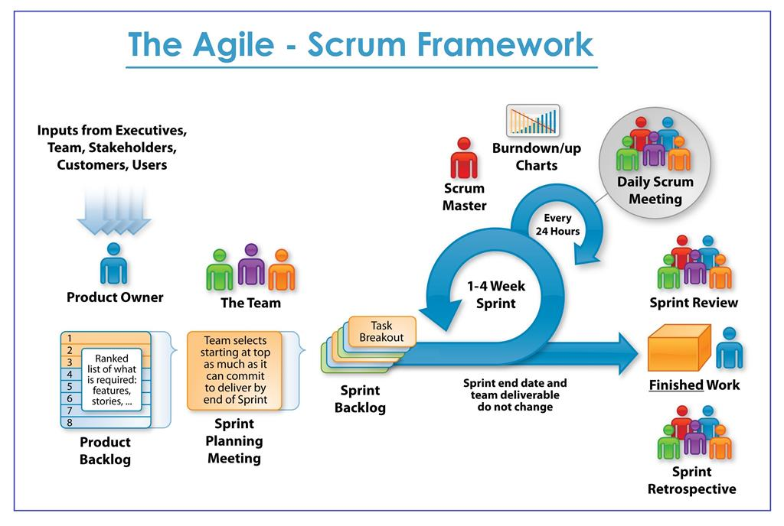

https://www.scrum.org/resources/what-is-scrum

1. **Role and responsibilities**

|  |  |  |  |  |
| --- | --- | --- | --- | --- |
| **No** | **Full Name** | **Role** | **Position** | **Responsibilities** |
| 1 | Hồ Ngọc Đình Châu | Scrum master | Leader | * Managing process * Create Requirements * Prepare documents * Prepare data * GUI Design * Coding * Testing * Risk Management * Create test plan * Designing Test Case * System architecture * Class diagram * Activity diagram * Sequence diagram * Component Diagram |
| 2 | Nguyễn Thị Bích Nhàn | Srcum member | Member | * Designing database * Designing Usecase * Designing ERD * Designing Test Case * Use case specification * Prepare documents * GUI Design * Coding * Testing * State machine diagram * Sequence diagram |

1. **System design**
2. **System architecture**

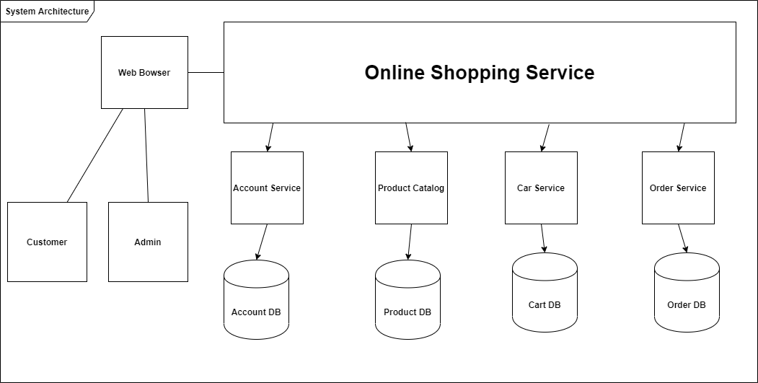

1. **Database diagram**

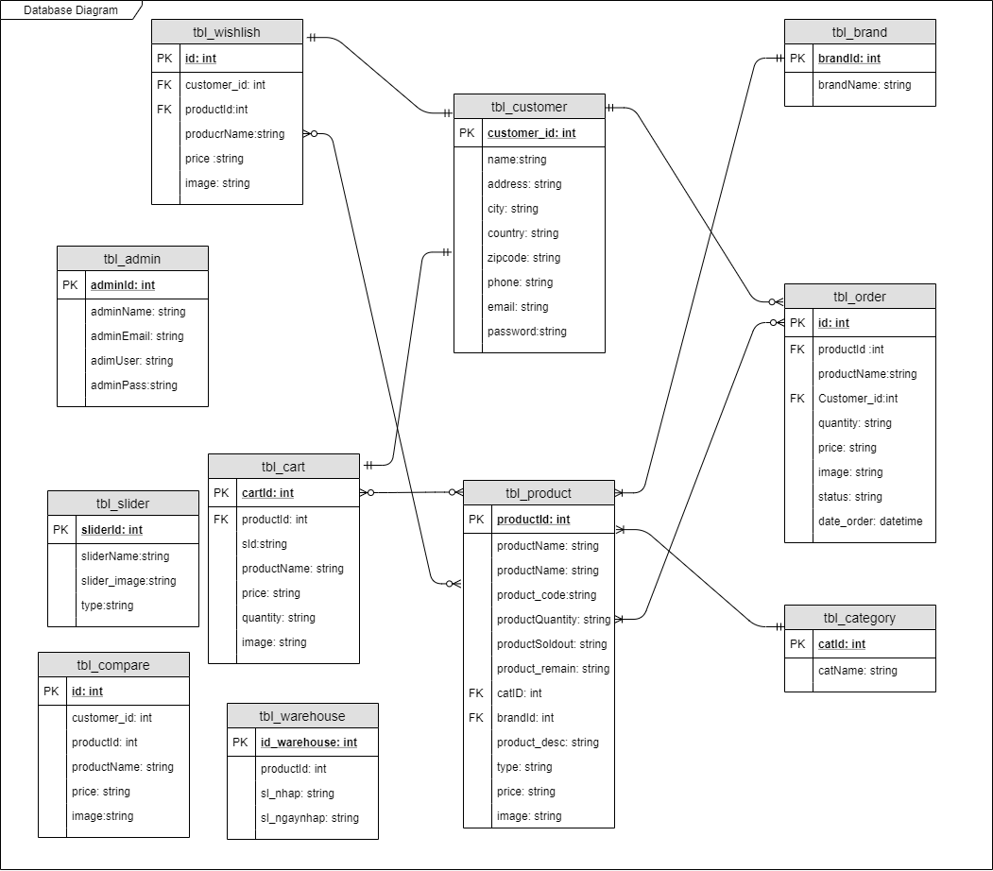

1. **Class diagram**
2. **Component Diagram**



1. **Sequence diagram**
   1. **Sequence Diagram Login**



* 1. **Sequence Diagram Purchase**



* 1. **Sequence Diagram Change Password**



* 1. **Sequece Diagram Registration**



1. **Activity diagram**
   1. **Activity Diagram Buy Product**



* 1. **Activity Check Order**



* 1. **Activity Add Product**



* 1. **Activity Update Product**



* 1. **Activity Delete Product**



1. **State machine diagram**
   1. **State Diagram Purchase Product.**



* 1. **State Diagram Login**



* 1. **State Diagram Shipping**



1. **System testing**

This chapter includes the methods that were used for testing, validating, and evaluating the system. The Conclusion and the Future Work for the software are also given.

1. **Testplan**

With this testing approach, all the specs were ready for a prototype, and a plan was already built to be shown; the tester started writing his or her code and saw if he or she could obtain the same results that the specs mentioned. This way, the specs were tested on each prototype, and continuous testing was applied. This also helped to minimize the testing that would have to be implemented at the end of the software lifecycle. In the process, all aspects of the software were tested. Steps to follow while implementing the methodology are as follows:

* Start with a base function that you want to implement.
* Create a document with the detailed requirement definition, an activity diagram with a description of the flow, database tables to be used, a component diagram, and a description of each component with the precondition and tables that would be affected by the component.
* Give the document to the tester, and work with the tester while he or she writes the code to check if the steps in the document can be implemented and if the result of each use case can be achieved
* If the tester finds a step difficult to implement or thinks he or she is missing additional information to implement the functionality, then go to step 2; otherwise, go to step 3.
* Ask the tester to log on all the errors and difficulties he or she encountered while working on the prototype implementation.
* Once the prototype is done and the results between the developer’s prototype and tester’s prototype match, work on the other requirement, and expand the prototype to final software.
* When the testing approach was implemented, the following pros and cons regarding the testing approach were realized.

**Pros of using the methodology**

* Helps give a better understanding about the requirements.
* Better design at the end of the cycle.
* Reduced testing to be performed at the end of the cycle
* Documents produced would be of higher quality.

**Cons of using the methodology**

* The person working on the document should be experienced.
* There are increased time and money involved with testing.
* Different viewpoints for the same problem can lead to varying results.

1. **Interface Testing**

This section lists the functional requirements used for creating the test-case table, the test cases that were used to verify the interface table, and the results for the test-cases table.

Table 1 lists the functional requirements for the interface built for the online shoppingcart application, along with a short description of each requirement

|  |  |
| --- | --- |
| **Functional Requirement Number** | **Functional Requirement Short Description** |
| FR01 | The online shopping-cart application shall have two types of authentication: User authentication and Admin authentication. |
| FR02 | The online shopping-cart application shall be accessible to all the users to browse all the categories and the items. |
| FR03 | The users shall be able to view the items they added to the shopping cart. |
| FR06 | The Admin shall be able to upload new/revised items as well as to add/modify the categories. |
| FR07 | The Admin shall be able to view all the users registered in the system |
| FR08 | The Admin shall be able to view all the information abour users who placed an order from the shopping cart. |
| FR09 | The users shall not be able to check out with an empty cart. |
| FR10 | The users shall not be able to place an order without providing valid information for all rows in the order form. |
| FR11 | The users shall not be able to place an order if any of the columns in the order form are left empty. |

1. **Test Cases**

Table 2 shows the functional requirements used to write the test cases along with the testcase numbers for each test case and a short description of the test cases.

|  |  |  |
| --- | --- | --- |
| **Functional Requirement No.** | **Test Case No. Test** | **Test-Case Short Description** |
| FR01 | TC01 | To test the Login/Authentication interface for the Admin |
|  | TC02 | To test the Login/Authentication interface for the users |
| FR03 | TC03 | To test, users can view the items they add in the shopping cart. |
| FR06 | TC04 | To test, Admin can upload new/revised categories. |
|  | TC05 | To test, Admin can upload new/revised items |
| FR07 | TC06 | To test, Admin can view all the users registered in the system |
| FR08 | TC07 | To test, Admin can view the information about all the users who successfully placed an order. |
| FR09 | TC08 | To test that users cannot check out with an empty shopping cart. |
| FR10 | TC09 | To test that users are not able to submit an order form if the information in any of the fields is not valid. |
| FR11 | TC10 | To test that users are not able to submit an order form if the information in any of the fields is left blank. |

The following list includes the steps that should be taken by the user, the conditions that should be met for the successful execution of the test case, and the end result that should be met for the test cases to pass.

|  |  |
| --- | --- |
| **TestCase_TC01 : To test the Login/Authentication interface** | |
| Input | Username and Password |
| Output | Valid Destination Page |
| Valid Range | User Name 🡪Alphanumeric, Password 🡪 Alphanumeric |
| Result | * If (User == Valid User), an order form appears to complete the checkout process. * If (User != Valid User), an error message is displayed on the Login interface. |

|  |  |
| --- | --- |
| **TestCase_TC02: To test, the users can view the items they add to the shopping cart.** | |
| Description of Purpose | The system shows all the saved items in shopping cart for a  particular user. The user can choose to check out the items or go back to continue  shopping. |
| Input | The user adds an item to the shopping cart from any of the available categories. |
| Output | The shopping-cart page pops up, showing the item that is added by the user. |
| Result | * If (Selection == Item and document == exists), the user is able to add that item to the cart, and the item shows up in the shopping cart, prompting user to delete the item, to continue shopping, or to check out the item. * If (Selection = Item and Selection = View Cart), an empty shopping cart pops up with buttons to check out or to continue shopping. |

|  |  |
| --- | --- |
| **TestCase_TC02: To test, the users can view the items they add to the shopping cart.** | |
| Description of Purpose | The system shows all the saved items in shopping cart for a  particular user. The user can choose to check out the items or go back to continue  shopping. |
| Input | The user adds an item to the shopping cart from any of the available categories. |
| Output | The shopping-cart page pops up, showing the item that is added by the user. |
| Result | * If (Selection == Item and document == exists), the user is able to add that item to the cart, and the item shows up in the shopping cart, prompting user to delete the item, to continue shopping, or to check out the item. * If (Selection = Item and Selection = View Cart), an empty shopping cart pops up with buttons to check out or to continue shopping. |

1. **Results**