|  |
| --- |
| Burford School – 62225 |
| Room Booking System |
| Keith Collister – 9164 |



|  |
| --- |
|  |

Contents

Analysis 2

Client 2

Background, Description of Current System 2

Identification of Users 2

Limitations 3

Data Sources/Destinations – Existing System 3

Data Sources/Destinations – Proposed Solution 4

Data Volumes 4

Data Dictionaries 5

Data Flow Diagram – Current System 6

Objectives 7

Potential Solutions 8

Appraisal of Potential Solutions 8

Justification of Chosen Solution (Client-Server) 9

Entity-Relationship Diagrams 9

System Flow Chart 9

Fact Finding Methods 10

Benefits of the proposed system 16

Design 17

Overall System Design 17

Solution Limitations 17

Description of Modular Structure 17

Processing and Algorithms 18

Storage Material and Format 19

Human-Computer Interface 19

Sample of Data Entry 19

Sample of Valid Output 19

Security & Integrity 20

System Security 20

Test Plan 20

Testing 21

Test Plan 21

Test Results - Evidence 28

Minimum Test Data 34

System Maintenance 40

Introduction 40

# Analysis

## Client

Client: Burford School

Client Liaisons:

* Mr Wilsdon (Network Manager), for technical information and access to existing system.

## Background, Description of Current System

At our school we have quite a few rooms that can be booked for classes – mostly computer rooms and engineering workshops, with a few special cases such as the Library, Gym and Main Hall. At the moment, this booking process is done through a web interface (accessible from any computer as it is hosted by an external company). This system is only accessible by teachers – students don’t have a logon.

This can produce some problems – students, in particular sixth-formers, often use such rooms for quiet work areas, and are frequently disturbed by booked classes arriving without warning and using the room. This can have large impacts on academic performance – for example, a student needing to use an engineering workshop to complete some urgent coursework may be forced to leave due to another class using the room, which could potentially damage the student’s grades.

In addition, as the website is hosted externally, were connection to be disrupted/the website to be shutdown, the school’s booking system would be rendered non-functional. Backups are taken and dealt with by the external company, but the school must pay a subscription fee.

The intended solution is therefore to create a system which introduces students into the booking system – not as “bookers”, but as viewers of the bookings. This will allow students to plan their studies around which facilities are available, hopefully assisting their academic lives.

The solution will also provide a replacement to the current (external) booking system – it would not be possible to provide student access without this. The act of replacement does present an opportunity to improve the system for teachers as well, however, so I intend to make full use of this by making improvements to their use of the booking system as well, hopefully by streamlining the booking process and making it easier to use. The replacement system will be hosted internally on the central school server, providing more reliable access compared to the external website.

## Identification of Users

At the moment there are 2 styles of access: one for teachers and one for administrators – teachers can use a slightly restricted version of CRUD: they can Read all bookings but only Create/Update /Delete their own bookings through the web interface. Administrators can view and edit all bookings. Students are unable to view any bookings, and in fact most are unaware that a booking system is currently used.

The current system doesn’t require much training, although this is recommended by the school so that mistakes aren’t made. Administrators do need training but it’s just so that they are aware of all the features – the system is clear enough to use without extensive training. The current administrators are the network managers who have a high degree of technical knowledge, while the teachers have varying knowledge from basic to advanced.

In the proposed solution, there will be 3 tiers of access: for teachers, administrators, and students. The abilities of teachers and administrators will be almost identical to the current system. Students will be able to view bookings for the current day and possibly the next few days. Administrators should also be able to revoke individual student’s room viewing rights, as a layer of control.

Ideally the solution will be intuitive and easy to understand, meaning most users won’t need training – this is almost necessary in a system with potentially over 1000 users. The students access to the system is very limited and simple, so likely won’t need any training. Teachers may need to be shown how to use the features, although they will be largely the same as those in the existing system. Administrators may need some extra instruction on the usage of more advanced features. Easily accessible help documentation should be included to assist all users.

## Limitations

* Technical
  + Hardware – the server will need to be able to handle connections to many computers around the school. As such it will need a large range of available ports for allocating as needed. High speed in this system isn’t required (although it is obviously desirable!), so the server doesn’t require any special hardware. The school logon server should be able to handle running the software process.  
    The client machines only need to run an application in the background, and it won’t be doing any significant processing, so they won’t need specialised hardware either.  
    Ideally, no money should be spent on buying new hardware specifically for this project.
  + Software – if I develop a computerised solution in a .NET language, all the machines running the resultant programs will require the .NET framework installed and updated to at least .NET version 4. This is installed on most computers already, but it would be need to be ensured to be present and updated as a prerequisite of this system.
* Economic – as the proposed systems don’t require any extra hardware the costs should be minimal. Similarly, none of the features of the system require funding. The server machine will need to do more processing so will use more power, but those costs are likely negligible.
* Legal – as my system will be handling data pertaining to living persons (teachers and students) such as names, email addresses, and their probable location at a given time, I need to make sure that all data is encrypted and stored securely (Data Protection Act, 1998).
* Operational – the current system has been used for many years and its uses are deeply ingrained in the minds of the staff; the new solution should therefore be easy to use and intuitive, reflecting the features of the current system, although without being averse to adding new features/streamlining existing ones.
* Scheduling – leading on from the previous limitation, with such a large application to develop I will no doubt be pushed for time. Changes to the user requirements will exacerbate this pressure, so I will need to be very careful in how frequently I check my progress with the client, in order to make sure I spend as little time as possible working “in the wrong direction”.

## Data Sources/Destinations – Existing System

|  |  |  |
| --- | --- | --- |
| Data | Source | Destination |
| List of teachers | Admin input | Website -> Database |
| List of students | Admin input | Website -> Database |
| List of bookable rooms | Admin input | Website -> Database |
| List of periods | Admin input | Website -> Database |
| List of bookings | Database | Website -> Database |
| New/edited booking | Teacher input | Website -> Database |

## Data Sources/Destinations – Proposed Solution

|  |  |  |
| --- | --- | --- |
| Data | Source | Destination |
| List of teachers | Admin input | Client -> Server -> Database |
| List of students | Admin input | Client -> Server -> Database |
| List of bookable rooms | Admin input | Client -> Server -> Database |
| List of periods | Admin input | Client -> Server -> Database |
| List of classes | Admin input | Client -> Server -> Database |
| List of departments | Admin input | Client -> Server -> Database |
| List of bookings | Admin input | Client -> Server -> Database |
| New/edited booking | Teacher/Admin input | Client -> Server -> Database |
| List of teachers | Database -> Server -> Client | Client (admin) interface |
| List of students | Database -> Server -> Client | Client (admin) interface |
| List of bookable rooms | Database -> Server -> Client | Client (admin) interface |
| List of periods | Database -> Server -> Client | Client (admin) interface |
| List of classes | Database -> Server -> Client | Client (admin) interface |
| List of departments | Database -> Server -> Client | Client (admin) interface |
| List of bookings | Database -> Server -> Client | Client (all) interface |

## Data Volumes

I intend to store the data in a database – there are quite a few references between records, such as a Booking having a list of Students. A serial access file like a binary file would need loading entirely into memory, and it would be difficult to follow the references. If the server crashed unexpectedly while the data was in memory before being saved to the file, it would be lost. A hierarchical file such as XML wouldn’t be able to represent all the relationships between data, and would also need to load into memory.  
A database allows random access and doesn’t need loading into memory, while also natively supporting references between records.  
The use of the Entity Framework will also allow me to access the data in a C# object-based manner, rather than directly through queries.  
  
An empty SQL database file is around 3MBs in size, and my records are unlikely to use more than 100bytes each. This means that for every 10,000 records the file will increase by 1MB, which is an acceptable scale factor. It’s safe to say that there will never be more than 100,000 records stored, but if there were the file size would still only be around 13MB.

## Data Dictionaries

Student

|  |  |  |  |  |  |
| --- | --- | --- | --- | --- | --- |
| Field Name | Field Purpose | Field Type | ≈Field Size (bytes/chars) | Example Data | Validation |
| First Name | Stores first name of the student | String | 50 | “Peter”, “Bill” | Not empty |
| Last Name | Stores last name of the student | String | 50 | “Smith”, “Brown” | Not empty |
| Logon Name | Stores the username of the student | String | 50 | “09135”, “caict10” | Not empty |
| Year | Stores the year group of the student | Integer (unsigned) | 4 | 7, 8, 9, 10, 11, 12, 13 | Nonnegative, maybe 7 ≤ Year ≤ 13? |
| Form | Stores the form group of the student | String | 20 | “WT”, “BR”, “CEB” | Not empty |

Teacher

|  |  |  |  |  |  |
| --- | --- | --- | --- | --- | --- |
| Field Name | Field Purpose | Field Type | ≈Field Size (bytes/chars) | Example Data | Validation |
| First Name | Stores first name of the teacher | String | 100 | “Peter”, “Bill” | Not empty |
| Last Name | Stores last name of the teacher | String | 100 | “Smith”, “Brown” | Not empty |
| Title | Stores the title of the teacher | String | 25 | “Mr”, “Ms”, “Mrs” | Not empty |
| Logon Name | Stores the username of the teacher | String | 50 | “ceb”, “mb” | Not empty |
| Email | Stores the email address of the teacher | String | 100 | “admin.4040 @burford.oxon .sch.uk” | Not empty, valid email format |

Room

|  |  |  |  |  |  |
| --- | --- | --- | --- | --- | --- |
| Field Name | Field Purpose | Field Type | ≈Field Size (bytes/chars) | Example Data | Validation |
| Room Name | Stores the name of the room | String | 50 | “D6”, “Library” | Not empty |
| Standard Seats | Stores the number of normal “desk-spaces” | Integer | 4 | 50, 20 | Nonnegative |
| Special Seats | Stores the number of non-desk spaces | Integer | 4 | 50, 20 | Nonnegative |
| Special Seats Type | A description the non-desk spaces | String | 50 | “Computer”, “Workbench” | Not empty if Special Seats ≠ 0 |

Class

|  |  |  |  |  |  |
| --- | --- | --- | --- | --- | --- |
| Field Name | Field Purpose | Field Type | ≈Field Size (bytes/chars) | Example Data | Validation |
| Class Name | Stores the name of the class | String | 100 | “Maths”, “Computing” | Not empty |

Department

|  |  |  |  |  |  |
| --- | --- | --- | --- | --- | --- |
| Field Name | Field Purpose | Field Type | ≈Field Size (bytes/chars) | Example Data | Validation |
| Name | Stores the name of the department | String | 100 | “Technology”, “MFL” | Not empty |

## Data Flow Diagram – Current System

This is a simplified model of the data processes and flow in the current system. It should provide a neat summary of the current system for me to refer to during the design stage. It should be noted that due to the tiered nature of access to the system for different users, colour coding has been used for clarity. Administrators retain access to the same features as Teachers.

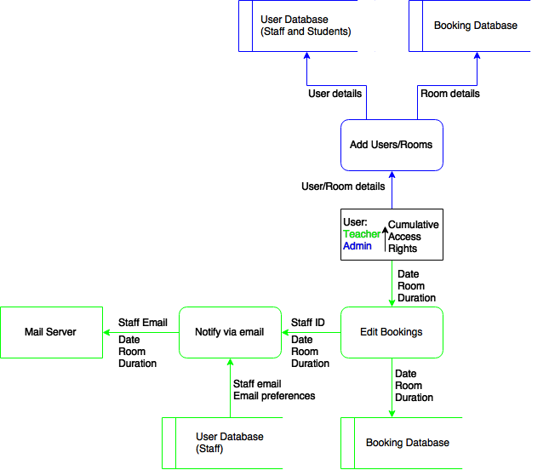

## Objectives

As well as observing the current system, I have released a number of surveys and questionnaires to students, teachers, and administrative staff. I feel that as they are the majority users, they will be far more able to identify problems in the current system than I will by observation. My research has yielded the following list of objectives, ranked very loosely from most important to least important, based off the results from the interviews and surveys:

1. Create a client that will allow 3 layers of access to the system for the 3 different users.
2. Allow users to view bookings over different days/months etc. (and possibly limit the scope of viewing for students).
3. Allow teachers to view and book specific rooms around the school site.
4. Allow students to view bookings for rooms around the school site.
5. Prevent unauthorised access to the system for non- students/teachers/admins.
6. Allow administrators to override bookings
7. Allow administrators to revoke student access to viewing bookings.
8. Provide an easy to use interface, so that students can use it without training, and teachers can use it with minimal training.
9. Provide clear and useful error messages that should give teachers an idea of what went wrong, not just that something did go wrong.
10. Allow teachers to set up recurring bookings on varying schemes (daily, weekly, monthly).
11. Provide checks to ensure users aren’t making mistakes when editing bookings.
12. Provide a warning to users when logging onto a computer in a room that’s been booked for that period.
13. Provide email notifications to teacher when they book/cancel a room and when a booking is authorised.
14. Provide useful statistics to teachers about room bookings, including per-teacher and per-department information.
15. Allow the clients to handle loss of connection to the server gracefully, and restore connection and services as soon as possible.
16. Allow students to view where their friends are logged on, provided their friends have marked that they want to be “visible” to that student.
17. Securely hold records of all bookings.
18. Allow the server to be turned on and off with minimal interruption to service (ie doesn’t “forget” bookings).
19. Allow new bookable rooms to be added (by administrators) with ease. Immediate availability of the new room for booking is not required, but is preferred.

## Potential Solutions

The current system was implemented to replace a highly inefficient paper-based system, so it doesn’t make much sense to regress back to a manual system. As such, I only consider electronic solutions.

1. A web-based system, which would allow teachers to book rooms from anywhere (not just school), and let students view the bookings without needing to log onto a computer. However, a website has no way of viewing where people are logged in, so this wouldn’t solve the main problems of students being “disconnected” from the system.
2. A Client-Server based system, where on logon an application starts that communicates with a server process running on the central school server and presents an interface to book/view the rooms. This would let the system know where people are logged on, but presents the problem of accessibility – users need to log onto a school computer to view bookings, which isn’t much use for checking where friends are.
3. A mobile app that provides the same level of interaction as the web-based solution, but is developed as an app (so a client-server system). This would provide the same amount of mobility as the website version, but would allow for a more complex UI.

## Appraisal of Potential Solutions

1. Web-based system: While this would provide an easily-accessible system, I have little experience in web-development, so don’t think I would be able to create a satisfactory solution using this approach. The existing system is also web-based, so I would likely be limited to the same design as the current one.
2. Client-Server system: I have the most experience developing solutions of this form, so I would feel comfortable using this design. However, this would need a lot of work as the communications between client-server would need to be designed as well. This has the most room for expansion though, as complex UI and logic can be added fairly easily.
3. Mobile App – I have some experience with mobile technology, but like the website solution not enough to create a satisfactory solution. The mobility factor is a positive feature, as people can browse the bookings without needing to log on, but if the overall solution is lacking, then the mobility doesn’t matter.

## Justification of Chosen Solution (Client-Server)

I have chosen to go with the Client-Server solution, as I believe I can make a more robust and effective system using this design rather than the other two possible designs.  
It does mean that mobility is reduced, as students and teachers need to log on to a school computer to see the system, but the application’s GUI can be more responsive and dynamic.

## Entity-Relationship Diagrams

The entities and their relationships are the same in both the existing and the proposed system – the differences are in how these entities are processed by the systems.  
The relationships between entities are fairly simple – there’s a roughly even split of one-to-many and many-to-many relationships.  
For example, a Booking can include multiple Students and take place in many Rooms, but can only use one Period and have one Teacher. At the same time, a Teacher or Student may have multiple Bookings, and so on.

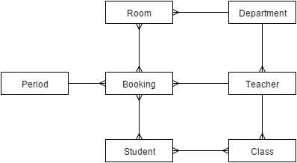

## System Flow Chart

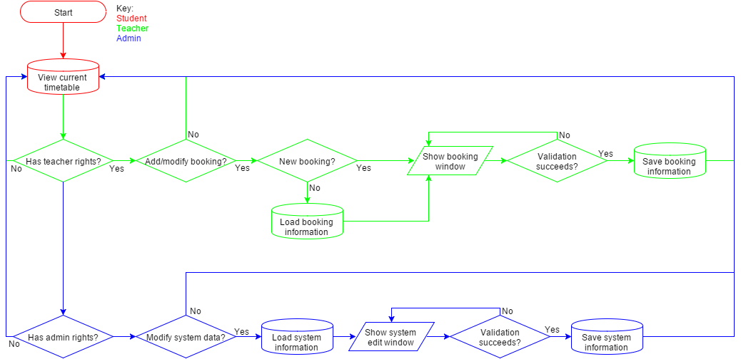

## Fact Finding Methods

Need to talk about observation, questionnaires, interview, and paperwork even if none was collected.

Interview with Mr Wilsdon, Client

What useful features are there in the current system that must to be carried across?

Teachers are emailed when they successfully book a room, cancel a room, or have a pending booking accepted. Multiple users can be imported into the system via CSV file which saves a lot of time, but individual users can be added too without bothering with a CSV. Some important rooms can have bookings requested, which are then approved by a set member of staff. New rooms can be added easily and appear instantly when staff try to book a new room. They can view rooms they’ve booked in timetable layout or as a list.

What features are there that should be carried across if possible?

The current system can show statistics about how many rooms each department or teacher booked over different months – that’s useful for our IT report to the headteacher. It would also be good if the system could handle bookings for all the different types of bookings we do – when students aren’t in school we offer caravan parking on the school fields, which the current system lets us treat as booking venues.

And what features would you like added?

At the moment you can’t have both “period scheduling”, where pre-defined blocks of time are booked, and “time scheduling”, where specific times chunks are booked, at the same time – this is problematic for when we book rooms after school for meetings, as we have to effectively book the 17 hour time chunk of 15:00 – 8:00. Also, some teachers “share” rooms – for example rooms D6 and D12 are next door to each other, so if we’ve got a large IT class in one room, and a much smaller A-level class in the other, sometimes the IT group will use some computers in the other class’s room. I guess that would be hard to implement, but it would certainly be useful.

How much overhead is there for running the system? What extra costs are incurred?

I pay a few hundred pounds a year subscription to the company who host this solution, and I have to buy an SSL certificate to make sure the data is transferred securely. I also need to back-up all the data into two locations to abide by school rules, which can be quite time-consuming.

How frequently would you need to add new rooms/teachers/users?

Obviously I’d need to add new users every year for the year 7’s. Adding teachers would be far less frequent, perhaps once a month maximum. Adding a new room would be very infrequent, once a year perhaps. Although having said that, I’ll need to add all the data to this system at the start anyway, so I will need a method of adding bulk data.

What different types of bookings do you have?

There are the standard bookings, like the computer rooms, and then there are the less used rooms like the conference room, library, gym. Finally we have some strange ones, like the mobile phone and the slots for caravan rallies during holiday times.

Paperwork from current system

As the current system is electronic, there is no paperwork – instead I have provided many print-screens in the subsequent section to show each main area of the system.

Observation of current system

Naturally as the current system is computerised there is no paperwork – in lieu of this I have taken screenshots of multiple views of the current system. The current solution has the following steps:

1. The user logs on. They can choose to log on as an administrator using the shown hyperlink (figure 1.0).

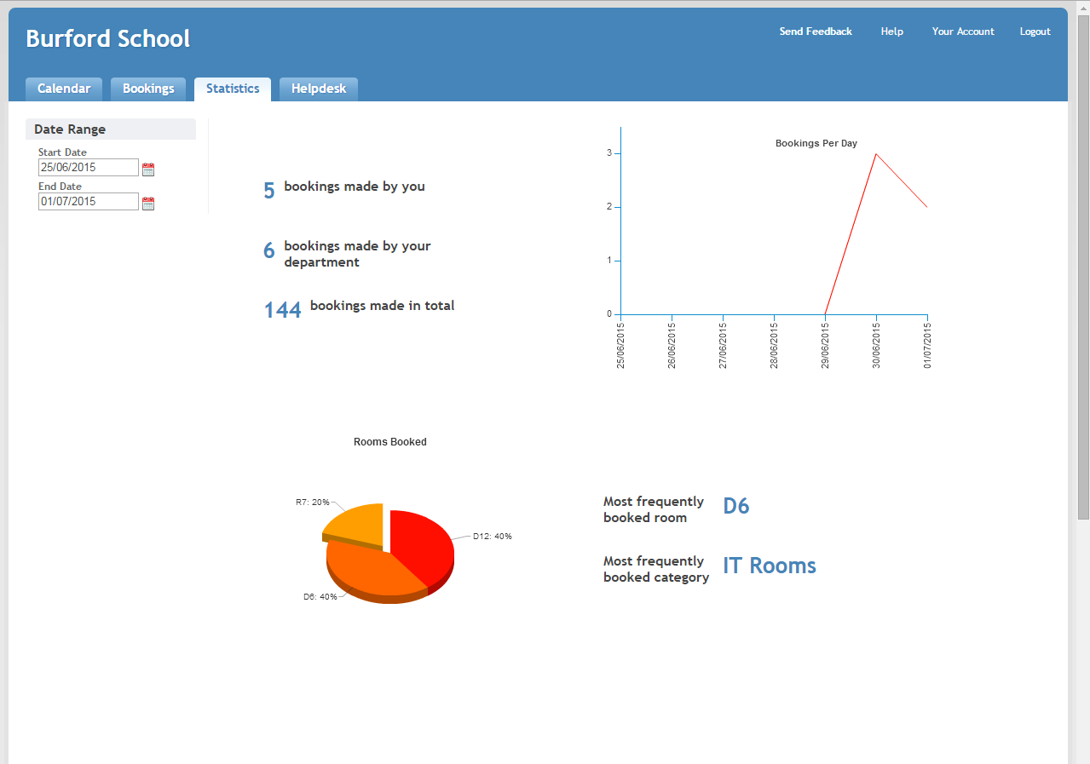

Figure 4.0

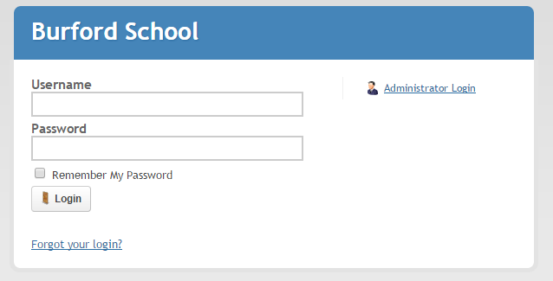

Figure 1.0

1. The user can view all the days’ bookings, and edit their bookings (figure 2.0).
   1. Clicking an empty timeslot will bring up a small dialog that enables the user to set some standard settings (figure 2.1), transfer to a page showing advanced settings (see 3.0), and confirm the booking.
   2. Selecting a category will change the shown timetable to the newly selected one (figure 2.2).
   3. Clicking “Week View” or “Category View” at the top switch to different viewing styles (a list of booked rooms or booked rooms by category).

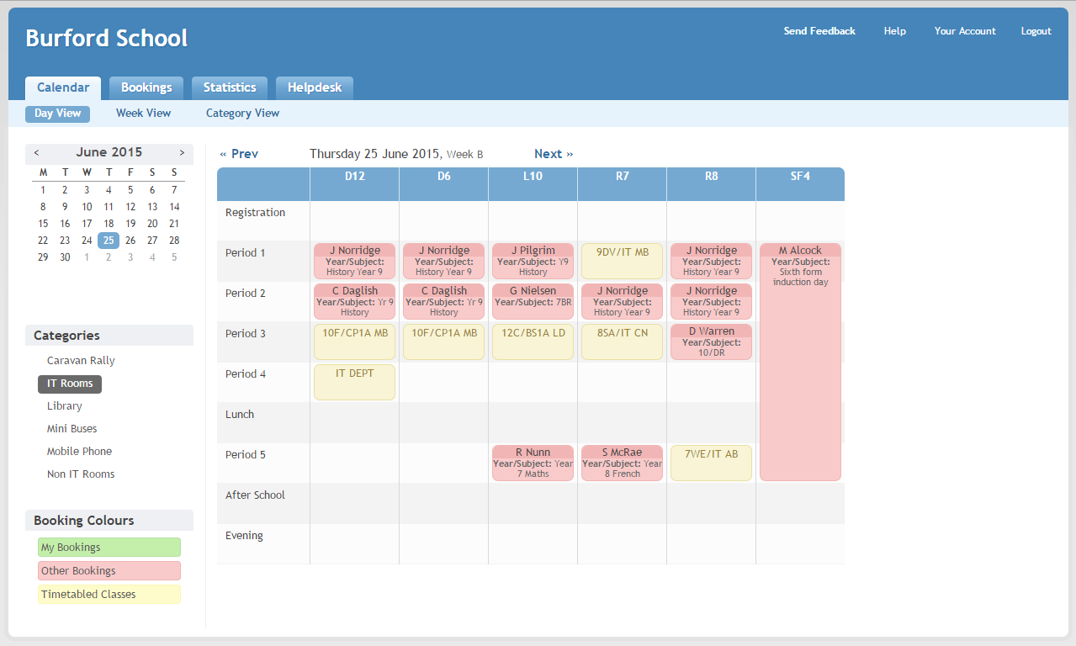

Figure 2.0

1. The “Bookings” tab links to a list of viewed rooms, similar to the “Week View”, but specific to the logged in teacher (figure 3.0).

Figure 2.2

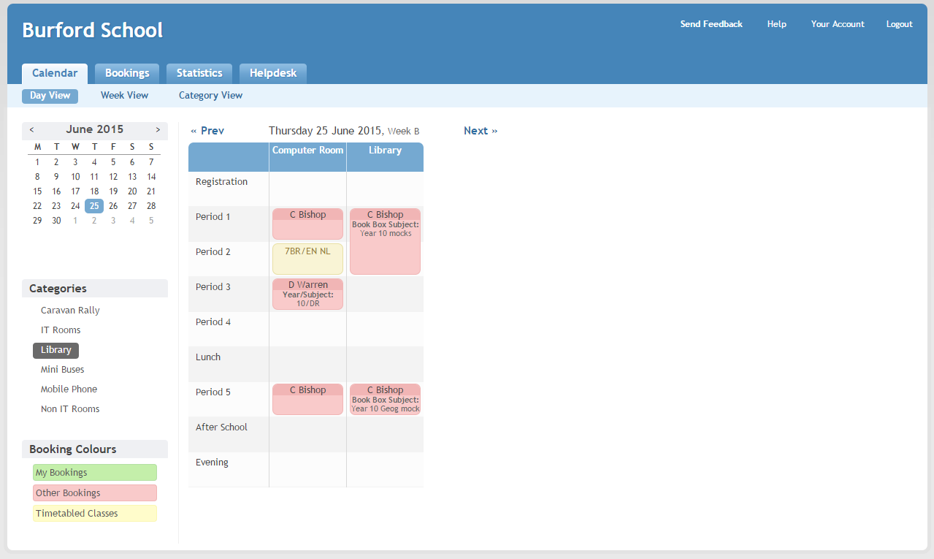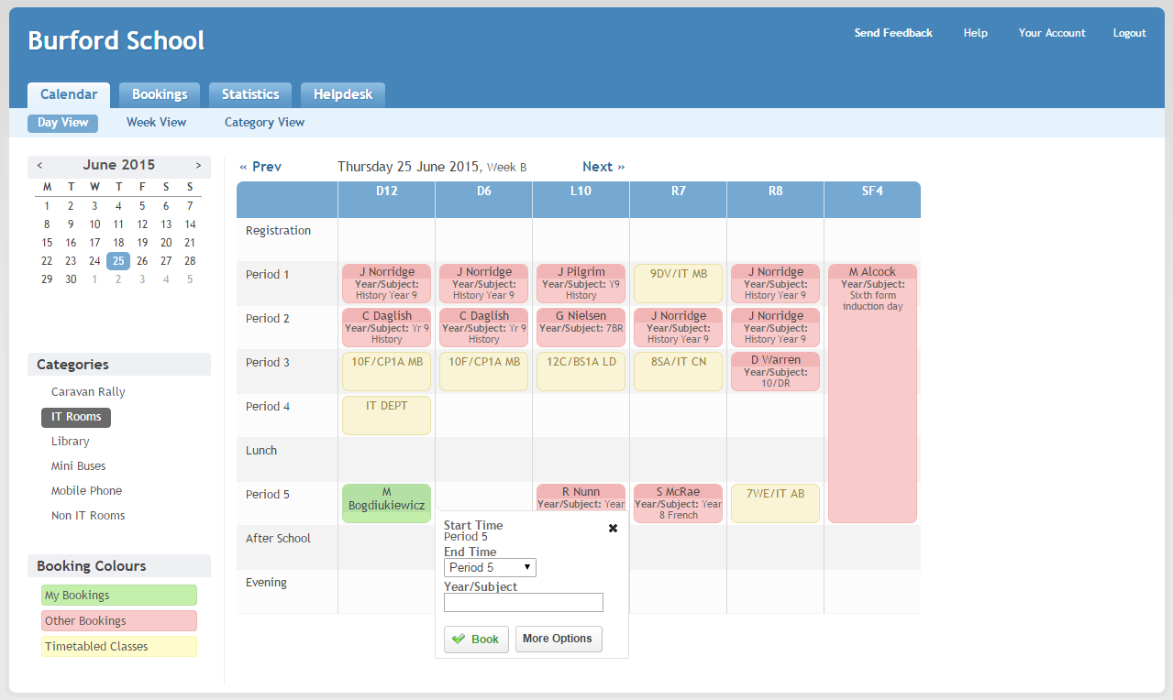

Figure 2.1

* 1. The “Add Booking” tab takes you to the same page as the “Advanced Options” choice on the calendar page did (see 2.1), with a choice of tabs to add extra detail to a booking.
     1. “Booking Notes” contains a textbox labelled “Year/Subject”, but most teachers write notes to the site team instead (figure 3.1.1).
     2. “Recurrence” provides detailed options for the teacher to set up automatic bookings, as well as a button to verify that the bookings don’t clash (figure 3.1.2).
     3. “Attendees” allows other teachers to be notified of a room booking along with the booker themselves (figure 3.1.3(a)). The address book button displays a list of all teachers in the system for easy adding (figure 3.1.3(b)).

1. The “Statistics” page instantly displays the number of bookings the logged-in teacher has made between the shown Start and End dates (defaults to the most recent week). It also displays some extra details as well as a pie chart of actual rooms booked, and a graph showing the number of bookings per day (figure 4.0).

Figure 3.0

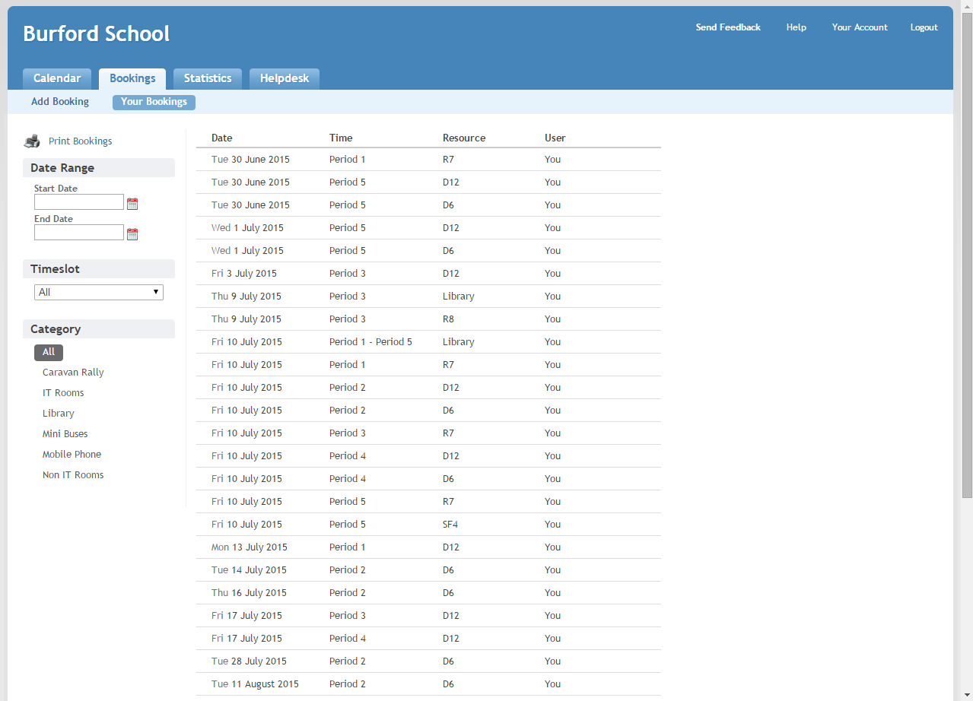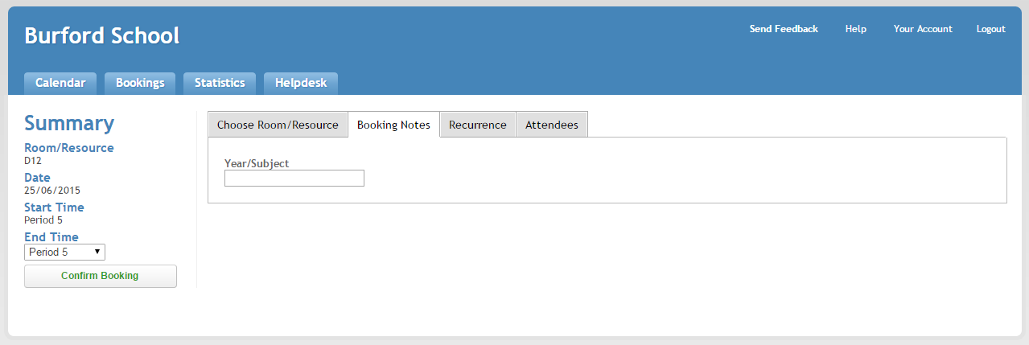

Figure 3.1.1

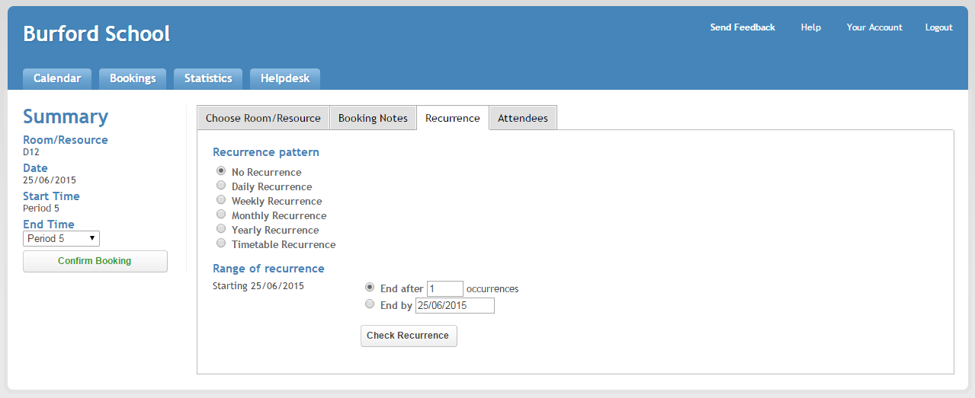

Figure 3.1.2

Figure 3.1.3(a)

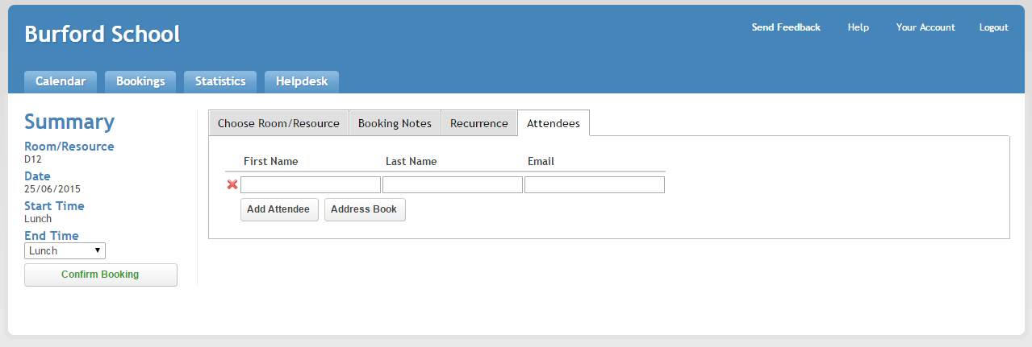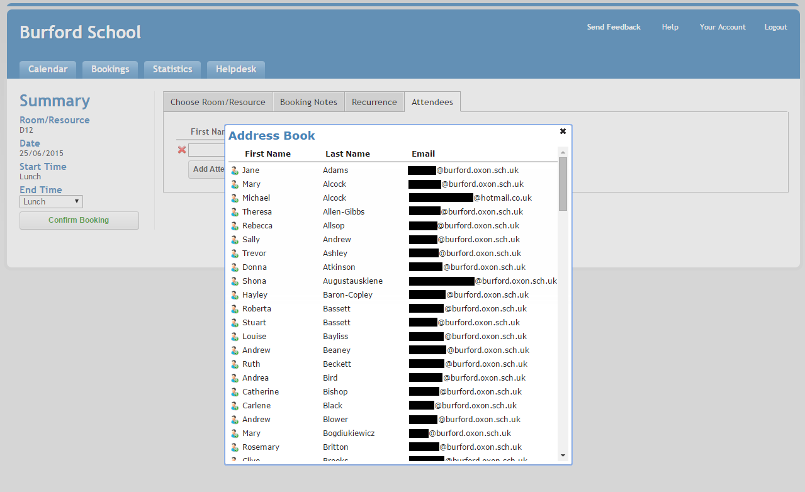

Figure 3.1.3(b)

Questionnaires

I have distributed questionnaires to students in years 13, 12, along with teachers; this constitutes the primary intended users of the system.  
  
TODO: Questionnaires

## Benefits of the proposed system

Many students (in particular sixth-formers) feel that being forced to leave bookable rooms is a major disruption to their work. This system will hopefully alleviate that problem, by making it easier to see which rooms are available when. Even if they don’t check on the booking system themselves, one of the most strongly supported features is an automated message on logon informing them that they’re in a booked room, ensuring they’re aware.

There are also a few other problems that have been identified in the current system, such as the inability of the website to support both block-based and time-based scheduling, and unclear error messages. These I hope to fix during the implementation the new system, as well as adding the new functionality.

# Design

## Overall System Design

A hybrid solution the web-based and the client-based proposed solutions – the main system will be accessible through an application available to computer users, which connect to a central server process running on the either an external server or more likely the internal school server. Upon logon, an application will start in the background which will present the current bookings. In the background, it will inform the server that the user has logged on, automatically sending relevant information such as the username and computer name. This will cause the server to update its internal model and distribute the change to all logged on clients, and send a copy of the current system state to the Client.

## Solution Limitations

The solution will be developed in C#, which I am comfortable with, but will have to use fairly advanced features of the language such as TCP/IP communications and multithreading, as well as producing a user-friendly interface using the Windows Presentation Foundation (WPF). I may also need to use multiple paradigms – primarily Imperative/Procedural, although the use of C# will naturally result in Object Oriented code, and in producing a responsive user interface I will use Event-driven programming. Also, as I will likely need to use multiple threads, I will need to use a blocking paradigm to ensure operations perform synchronously. As such I expect there will be lots of bugs in the development versions.

Also, students need to log on to a computer in order to see where other students are logged on – it’s not quite as easy to use as the website solution would be. However, I have little experience developing websites, and this solution allows for a far more powerful and responsive interface than that of a web UI.

## Description of Modular Structure

Client

A process running on each school computer; it runs on user logon and continues in the background. Presents a GUI to the logged in user that allows them to perform actions as allowed by their access rights (determined by a search of the database for the windows username). Also communicates with the server to send/receive updates to the booking model. No special hardware is needed for this constituent – it isn’t particularly demanding.

Server

A process running on the school server; it provides information about the bookings to clients as well as updating the database. This is the only constituent with access to the database – all other access is through the server, allowing a central mechanism of ensuring validity of inputs. The only special hardware required for this constituent is a machine that’s online all the time. The Server load won’t be massive as there will be fewer than 500 clients (machines) running, and if more are ever added, load will only increase roughly linearly.

NetCore

This assembly should be referenced by both the Client and the Server and will provide access to the networking framework. This will increase code reuse, saving time during development and making refactoring easier.

The networking framework will be developed as an event-oriented system, as it best matches the logic of the client-server relationship: A client will send a booking message to the server, which upon receiving it will update the database and distribute the change to the clients. Upon receiving these messages, the clients will update their UI.

Data

This assembly will be referenced only by the Server – I still intend to create it as a separate assembly however, as I feel that its logic is sufficiently different to that of the server to warrant the separation.

I intend to use the Entity Framework Code First framework to provide access to the database. This will let me design the model using C# code, and the database schema will then be generated and applied independently. Because the model is developed using C#, I can interact with it easily from the rest of my program logic without needing to perform queries within code – they are abstracted to properties within the model classes.

Shared

This assembly is the result of the need to abstract out even further from the NetCore and Data assemblies – the NetCore assembly must have access to the classes defined in the Data assembly in order to create messages that carry the database models, but at the same time the Data models need to specify how they should be serialised to the network. This would create a circular dependency, so I’ve been forced to create a separate assembly to provide interfaces (descriptions of the behaviour of a class, rather than the class itself) that remove the conflict.

## Processing and Algorithms

The following are high-level descriptions of some of the algorithms I intend to use – a lot is taken for granted, such as sending a message, which would require a significant amount of development in the background to work.  
  
I use the keyword “Upon” to introduce a function that is called upon an event occurring, to distinguish it from a normal procedure.

Client

// Called when the user tries to add a booking  
Upon BookingAdded(NewBooking) Do  
 If Invalid(NewBooking) Then  
 ShowErrorMessage()  
 EndIf  
 SendNewBookingMessage(Server, NewBooking)  
End.  
  
// Logic for when the server acknowledges the new booking  
Upon BookingAcknowledgementReceived(Message) Do  
 If BookingFailed(Message) Then  
 ShowErrorMessage(Message)  
 EndIf  
End.

// This is the logic for when a message containing a new booking layout is received  
Upon BookingChangeMessageReceived(Bookings) Do  
 If *User isn’t actively making a new booking* Then  
 UpdateBookingUI(Bookings)  
 EndIf  
End.

Server

// Called when a new booking message is received from a client  
Upon NewBookingMessageReceived(Sender, Booking) Do  
 If Invalid(Booking) Then  
 SendAcknowledgeMessageFailed(Sender)  
 Return  
 EndIf  
 ThreadLock(Database) Then  
 If *Booking clashes with existing database* Then  
 SendAcknowledgeMessageFailed(Sender)  
 Return  
 EndIf  
 EndLock  
 SendAcknowledgeMessageSuccess(Sender)  
  
 AddBookingToDatabase(Booking)  
 ForEach Client in ConnectedClients Do  
 SendBookingChangeMessage(*Bookings from database*)  
 End  
End.  
  
// Called when a new client connects  
Upon ClientConnectMessageReceived(Sender, Username, ComputerName) Do  
 ThreadLock(Database) Then  
 SendAccessLevelMessage(Sender, GetAccessLevel(Database, Username))  
 SetCurrentUser(Database, ComputerName, Username)  
 EndLock  
End.

## Storage Material and Format

The data will be stored in an SQL database on the server’s HDD. As covered in the Data Volumes section the analysis, the maximum file size of the database is under 15MB, so the existing hard drives can be used to save hardware expenses. An SSD could be used, but fast read speeds aren’t necessary.

The data stored isn’t entirely critical, so backups can be taken once a week, likely as part of the school server backup.

## Human-Computer Interface

## Sample of Data Entry

## Sample of Valid Output

## Security & Integrity

In order to access the application that provides access to the server, the user needs to log on – the application then sends the server the logged on username, and only if the username is registered in the database as an allowed username does the server provide the information about the bookings etc. This provides a fairly safe system. I intend to write a user manual to help people, and integrated help documentation in the form of UI tooltips and explanatory UI messages.  
  
All input will be validated to ensure it is correct. Ideally, the design of the UI will in fact prevent users from entering invalid data in the first place – for example, using a “ComboBox” to restrict user input to a selection of discrete values. Where such restrictions aren’t possible, such as when entering a teacher’s email address, standard validation will be used to ensure that sensible input is taken.

## System Security

As my system is dealing with personal information (names, ages of students, etc.), I do need to ensure that the security is up to scratch. I have the significant advantage that the whole system will be hosted inside the school’s network, which is already secured in accordance with regulations – it has firewalls and password-protected access. As such, many security requirements are already fulfilled by the school – the network is kept secure, and physical access to the servers is restricted. SQL provides integrated security as well, requiring authentication to access the database. The school server is in a dedicated room that has a smoke detector and burglar alarm installed.  
To prevent data loss from fires/burglary etc, backups of the database need to be taken frequently (this can happen along with the school server’s automated backups). Ideally a copy of the system data would also be stored off-site for a greater strength of fall-back backups.

## Test Plan

Due to the size of the solution I intend to use multiple test strategies on different parts of the system. For example, because the Data and NetCore assemblies are independent modules, I can test them using one technique, and then test the Client UI with another technique.

| Module | Test Method(s) | Description |
| --- | --- | --- |
| NetCore | Black Box | I intend to make a simple project to test this module, which sends various messages to the server and reports if any responses are incorrect. This will also allow me to stress test the server to see if it can handle high load, and check for memory leaks which are a major issue in servers. |
| Data | Black Box | As this module doesn’t have much built-in logic, it simply provides the classes for other projects to use, this won’t take much testing. |
| Client | Mixed-level, Integration | Some parts of this module will be fairly free of bugs, while others may be heavily affected. Using mixed-level testing I can dedicate more time to the high risk areas. This module integrates heavily with NetCore, so needs to be tested for bugs related to the interfacing. |
| Server | White Box, Integration | As perhaps the most important module, I will test this assembly thoroughly using White Box testing to make sure I can catch any obvious bugs. I will also use integration testing as this module references the NetCore and Data modules, so is the most likely to suffer from bugs caused by the interfacing. |
| Shared | Black Box | This assembly provides only very basic algorithms – the majority of the code is providing interfaces, which don’t specify any implementation and are used by other assemblies to increase code re-use. As such, this module will not need extensive testing, and I can infer that it works by seeing if the function calls by other modules return the correct value. |

# Testing

## Test Plan

I will test my application with a combination of typical, erroneous, and boundary data. For operations such as testing that pressing a button opens the correct window, it’s impossible to enter invalid data, so I won’t mark these inputs with their type. For tests where actual variable user input is entered, I will annotate the input with the type of data (Typical, Erroneous, Boundary) being entered, for clarity.

| Test No. | Description | Input | Expected Output | Actual Output |
| --- | --- | --- | --- | --- |
|  | As a student or teacher, the taskbar context menu has the correct items. | Right click on application’s taskbar icon. | One option, “View Bookings” | As expected (see evidence 1) |
|  | As an admin, the taskbar context menu has the correct items. | Right click on application’s taskbar icon. | Three options, “View Bookings”, “Customise system”, “Exit” | As expected (see evidence 2) |
|  | Clicking the taskbar icon opens the Timetable window. | Left click on the application’s taskbar icon | Timetable window opens | As expected (see evidence 3) |
|  | Clicking the menu item opens the Timetable window. | Right click on the taskbar icon, left click on the “Timetable” option. | Timetable window opens | As expected |
|  | Clicking the taskbar icon with the Timetable window already open brings it to the front. | Left click on the application’s taskbar icon | Timetable window gains focus. | As expected |
|  | Clicking the menu item with the Timetable window already open brings it to the front. | Right click on the taskbar icon, left click on the “Timetable” option. | Timetable window gains focus. | As expected |
|  | When the application starts in a room that’s been booked for the current period, a balloon is shown with a message. | Open the client on a matching room/time to a booking (edited the booking to match the time for ease of testing) | Balloon message appears displaying booking details. | As expected (see evidence 7) |
|  | When the application is open and a booking is made/is entered in the current room and time, a message is shown. | Wait for the time to enter a period. | Balloon message appears displaying booking details. | As expected |
|  | Timetable window displays bookings with the correct Subject colour and details. | Opening the Timetable window on a day with Bookings set. | Bookings have correct colour and details. | As expected (see evidence 9) |
|  | Bookings are displayed correctly if they recur (eg weekly) | Observing the timetable a long way in the future to check the recurrence still works. | Recurring bookings show up on the timetable. | As expected (see evidence 10) |
|  | Hovering over a booking tile in the Timetable Window darkens the colour. | Hover mouse over a booking on the timetable. | Tile colour darkens. | As expected (see evidence 11) |
|  | Hovering over a room on the timetable displays information | Hover mouse over a room on the timetable. | Tooltip shows the number of seats and special seats. | As expected (see evidence 12) |
|  | Closing the Timetable window doesn’t close the application, keeping the icon in the taskbar. | Closing the timetable window. | Window closes, taskbar icon remains. | As expected |
|  | The “Next Day/Previous Day” buttons work correctly. | Pressing the “Next Day/Previous Day” buttons on the Timetable window. | Timetable shows correct bookings, day and date of timetable are displayed. | As expected |
|  | Teachers can open the “EditBooking” window by clicking a tile. | Clicking a booking tile (when logged in as a teacher or admin). | “EditBooking” window appears. | As expected |
|  | Students cannot open the “EditBooking” window from the Timetable window. | Clicking a booking tile (when logged in as a student). | Nothing happens | As expected |
|  | Creating a new Booking with the “EditBooking” window has initial data set (Logged in teacher, selected room, selected period). | Opening the “EditBooking” window by clicking on an empty tile. | “EditBooking” window appears with some data fields already filled in. | As expected (see evidence 17) |
|  | Editing an existing Booking with the “EditBooking” window has the correct data from the Booking filled in. | Opening the “EditBooking” window by clicking on a tile with an existing booking. | “EditBooking” window appears with all data fields filled in correctly. | As expected (see evidence 18) |
|  | Cancelling creating/editing a booking doesn’t submit it by mistake. | Pressing the “Back” or “Close” button on the “EditBooking” window. | Window closes, no other action takes place. | As expected |
|  | Omitting details while trying to submit a Booking displays an informative error message. | Pressing the “Submit” button with incomplete data on the “EditBooking” window. | Message box with a useful message appears, Booking isn’t submitted. | As expected (see evidence 20) |
|  | The filter on the Students section of the Edit Booking window works correctly. (See evidence for a print screen of initial test data) | {“”, No Filter, “All Students”}  {“”, Checked, “All Students”} {“”, Unchecked, “All Students”} {“e”, First Name, “All Students”} {“or”, Last Name, “All Students”} {“m”, Form, “All Students”} {“11”, Year, “All Students”} {“a”, First Name, “Computing”} | {*List of all students*}  {*No students*} {*All students*} {*All students with an e in their name*} {Max Norman}  {Dan, Mia, Isobel} {Kaleb, Sam,Isobel} {Max, Dan} | All as expected (see evidence 21 for screenshots of test data 1, 6, and 8) |
|  | Pressing Delete on the EditBooking window causes the Server to delete the booking from the internal model and distribute it to all clients. | Pressing the “Delete” button on the EditWindow of an existing booking. | Window closes, server receives a delete booking message, clients remove the booking from their timetable. | As expected ( see evidence 22) |
|  | Submitting a booking that conflicts with other bookings (eg overlapping rooms), results in an error message being displayed. | Pressing the “Submit” button with some of the rooms selected clashing with other bookings in the same period. | Message box displayed showing an error message, Booking isn’t submitted. | As expected (see evidence 23) |
|  | Submitting a booking causes the server to receive the booking, add it to the database, and distribute it to all clients. | Pressing the “Submit” button on the “EditBooking” window. | Window closes, server receives booking message, clients update their timetable view to reflect the new Booking. | As expected (see evidence 24) |
|  | Making a change to a Booking sends an automated email to the teacher who made the Booking. | Pressing the Submit/Delete button on the “EditBooking” window, either creating, editing, or deleting a booking. | Email dispatched to teacher with useful information. | As expected (see output 25) |
|  | Clicking the “Customise System” option on the taskbar context menu opens the Admin Control window. | Click the “Customise System” option on the taskbar context menu. | Admin Control window appears. | As expected (see evidence 26) |
|  | Clicking the “Customise System” option on the taskbar context menu with the Admin Control window open brings it to the front. | Right click on the taskbar icon, left click on the “Customise System” option. | Admin window gains focus. | As expected |
|  | Clicking “Add Room” on the Rooms tab of the Admin Control window displays the right window. | Click “Add Room” on the Rooms tab on the Admin Control. | Edit Room window is displayed, fields blank. | As expected (see evidence 28) |
|  | Clicking “Edit Room” on the Rooms tab of the Admin Control displays the right window. | Click “Edit Room” on the Rooms tab on the Admin Control. | Edit Room window appears, fields prefilled. | As expected |
|  | Clicking “Delete Room” on the Rooms tab of the Admin Control checks for conflicts and deletes necessary Entities. | Click “Delete Room” on the Rooms tab on the Admin Control. | Confirmation dialog appears, selecting yes removes all dependent entities from the server. | As expected |
|  | Clicking “Add Period” on the Periods tab of the Admin Control window displays the right window. | Click “Add Period” on the Periods tab on the Admin Control. | Edit Period window appears, fields blank. | As expected (see evidence 31) |
|  | Clicking “Edit Period” on the Periods tab of the Admin Control displays the right window. | Click “Edit Period” on the Periods tab on the Admin Control. | Edit Period window appears, fields prefilled. | As expected |
|  | Clicking “Delete Period” on the Periods tab of the Admin Control checks for conflicts and deletes necessary Entities. | Click “Delete Period” on the Periods tab on the Admin Control. | Confirmation dialog appears, selecting yes removes all dependent entities from the server. | As expected |
|  | Clicking “Add Teacher” on the Teachers tab of the Admin Control window displays the right window. | Click “Add Teacher” on the Teachers tab on the Admin Control. | Edit Teacher window appears, fields blank. | As expected (see evidence 34) |
|  | Clicking “Edit Teacher” on the Teachers tab of the Admin Control displays the right window. | Click “Edit Teacher” on the Teachers tab on the Admin Control. | Edit Teacher window appears, fields prefilled. | As expected |
|  | Clicking “Delete Teacher” on the Teachers tab of the Admin Control checks for conflicts and deletes necessary Entities. | Click “Delete Teacher” on the Teachers tab on the Admin Control. | Confirmation dialog appears, selecting yes removes all dependent entities from the server. | As expected |
|  | Clicking “Add Student” on the Students tab of the Admin Control window displays the right window. | Click “Add Student” on the Students tab on the Admin Control. | Edit Student window appears, fields blank. | As expected (see evidence 37) |
|  | Clicking “Edit Student” on the Students tab of the Admin Control displays the right window. | Click “Edit Student” on the Students tab on the Admin Control. | Edit Student window appears, fields prefilled. | As expected |
|  | Clicking “Delete Student” on the Students tab of the Admin Control checks for conflicts and deletes necessary Entities. | Click “Delete Student” on the Students tab on the Admin Control. | Confirmation dialog appears, selecting yes removes all dependent entities from the server. | As expected |
|  | Clicking “Add Department” on the Departments tab of the Admin Control window displays the right window. | Click “Add Department” on the Departments tab on the Admin Control. | Edit Department window appears, fields blank. | As expected (see evidence 40) |
|  | Clicking “Edit Department” on the Departments tab of the Admin Control displays the right window. | Click “Edit Department” on the Departments tab on the Admin Control. | Edit Department window appears, fields prefilled. | As expected |
|  | Clicking “Delete Department” on the Departments tab of the Admin Control checks for conflicts and deletes necessary Entities. | Click “Delete Department” on the Students tab on the Admin Control. | Confirmation dialog appears, selecting yes removes all dependent entities from the server. | As expected |
|  | Clicking “Add Class” on the Classes tab of the Admin Control window displays the right window. | Click “Add Class” on the Classs tab on the Admin Control. | Edit Class window appears, fields blank. | As expected (see evidence 43) |
|  | Clicking “Edit Class” on the Classes tab of the Admin Control displays the right window. | Click “Edit Class” on the Classes tab on the Admin Control. | Edit Class window appears, fields prefilled. | As expected |
|  | Clicking “Delete Class” on the Classes tab of the Admin Control checks for conflicts and deletes necessary Entities. | Click “Delete Class” on the Classes tab on the Admin Control. | Confirmation dialog appears, selecting yes removes all dependent entities from the server. | As expected |
|  | Entering invalid input to the Standard/Special Seats fields on the Edit Room window is handled with an error message. | “20” [Typical] “-1” [Boundary] “5Ps#,” [Erroneous] | Accepted Error Error | All as expected (see evidence 46) |
|  | Entering invalid input to the Start/End time fields on the Edit Period window is handled with an error message. | “12:10” [Typical] “25:59” [Boundary] “1230” [Erroneous] “12:104” [Erroneous] “ab:13” [Erroneous] | Accepted  Error  Error  Error  Error | All as expected (see evidence 47) |
|  | Entering invalid input to the Email field on the Edit Teacher window is handled with an error message. | “test5@email.com” [Typical] “@email.com” [Erroneous] “mail@.com” [Erroneous] | Accepted Error Error | All as expected (see evidence 48) |
|  | Testing server capabilities under extreme load. | Open numerous clients on multiple computers and connect them all to the server, perform standard operations such as editing bookings/teachers. | System runs as normal, no crashes or exceptions thrown. | As expected (see evidence 49). |

## H:\Burford\Year 13\Computing\Project_Writeup\Resources\Testing\Screenshots\1.PNGTest Results - Evidence

1. As a student or teacher, the taskbar context menu displays the correct items when the icon is right clicked.
2. 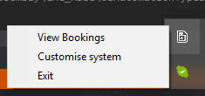As an admin, the taskbar context menu displays the correct items when the icon is clicked.
3. 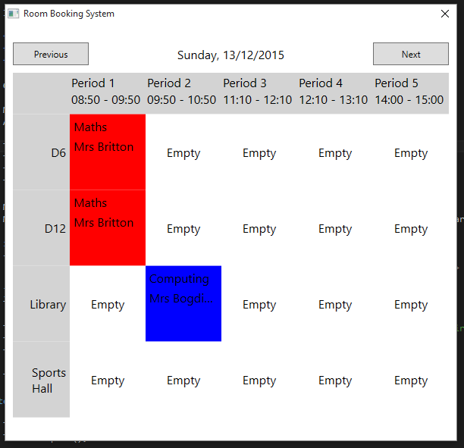Clicking the icon on the taskbar opens the Timetable window on the current date (also evidence of clicking the “Timetable” item on the right-click context menu shown before).

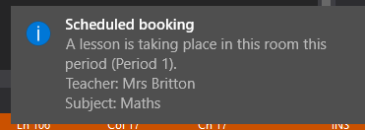

1. When the application starts in a room that’s been booked for the current period, a balloon is shown with a warning message.



1. The Timetable window displays bookings with the correct Subject colour and details, and in the correct Period/Room location.
2. Bookings are displayed correctly if they recur over multiple weeks/fortnights/months.

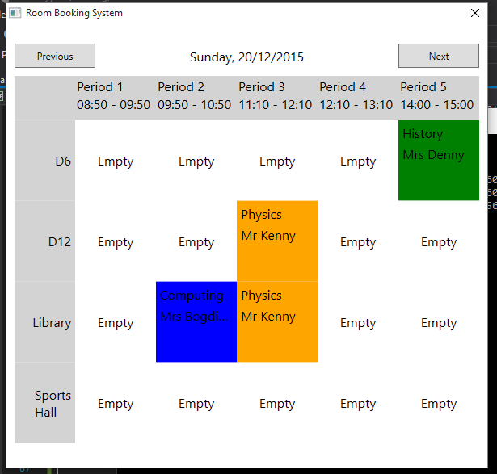 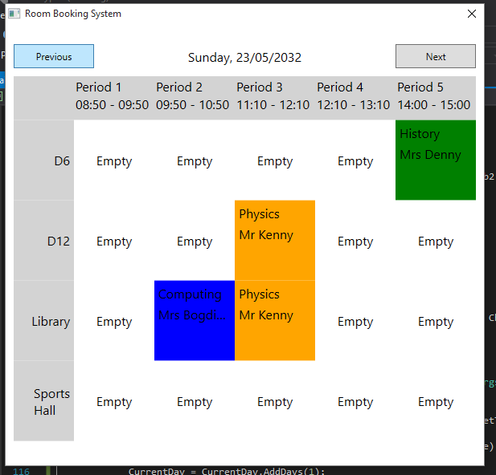

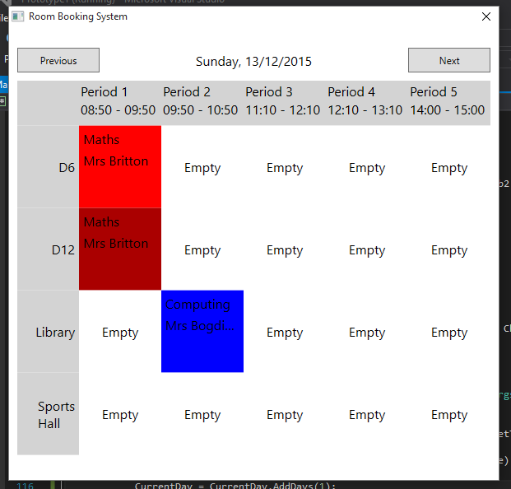

1. Hovering over a tile on the Timetable window darkens the colour.

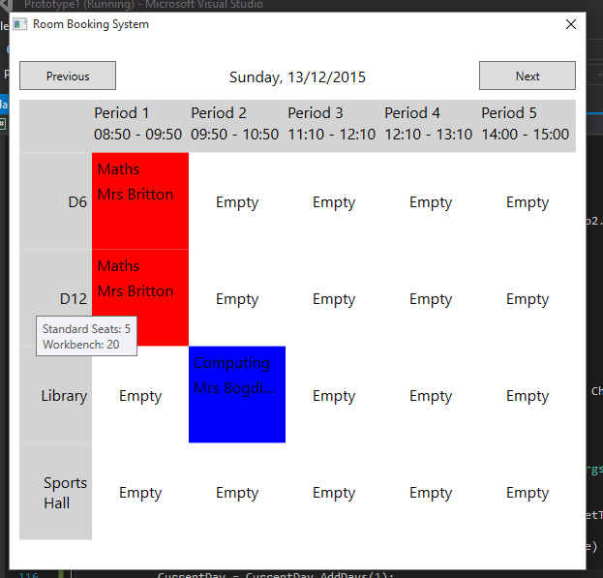

1. Hovering over a room tile on the timetable displays relevant information about the booking.

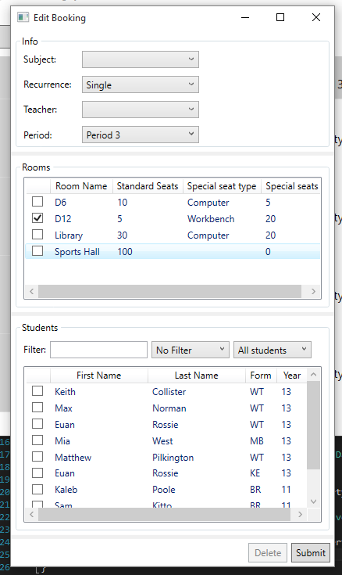

1. As a Teacher/Admin, creating a new Booking with the EditBooking window initialises the window with information that can be inferred from how the window was opened (eg. Room, period, teacher etc).
2. 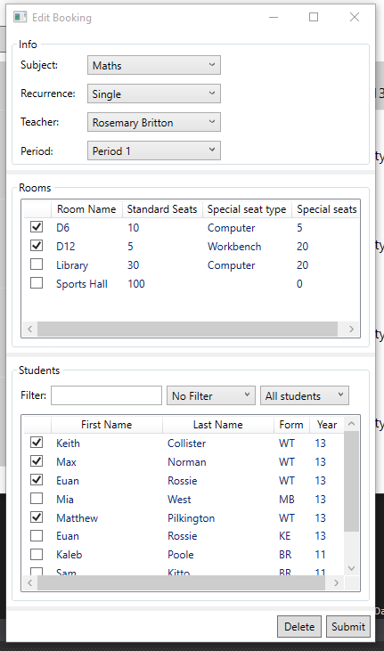Editing an existing Booking with the EditBooking window initialises the window with all the information of the existing booking.

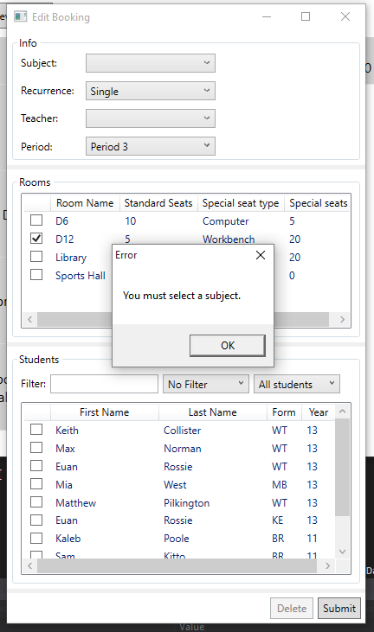

1. Omitting details while trying to submit a Booking displays an informative error message in a modal dialog box.
2. The filter on the Students section of the EditBooking window works correctly (a variety and combination of filters all function appropriately).

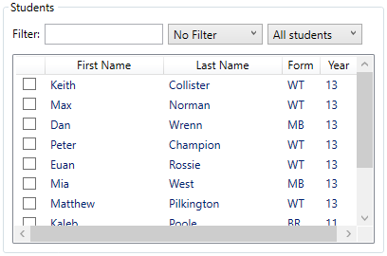

The initial set of students, with no filters applied.

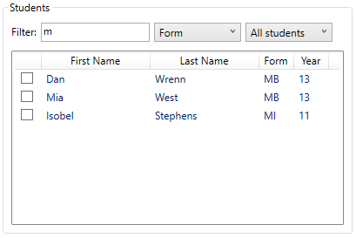

Filtering all students by form – using the letter “M” will perform a case-insensitive filter for any forms containing the letter “M”.

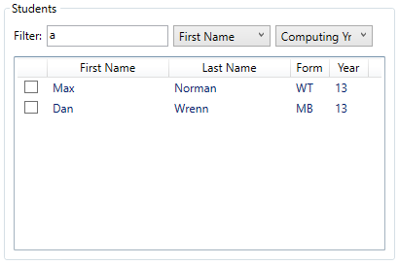

Filtering only the “Computing Yr 13” class (subset of all students), by “First Name” containing “A”. This shows that the aggregation of filters still works appropriately.

1. 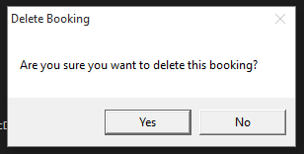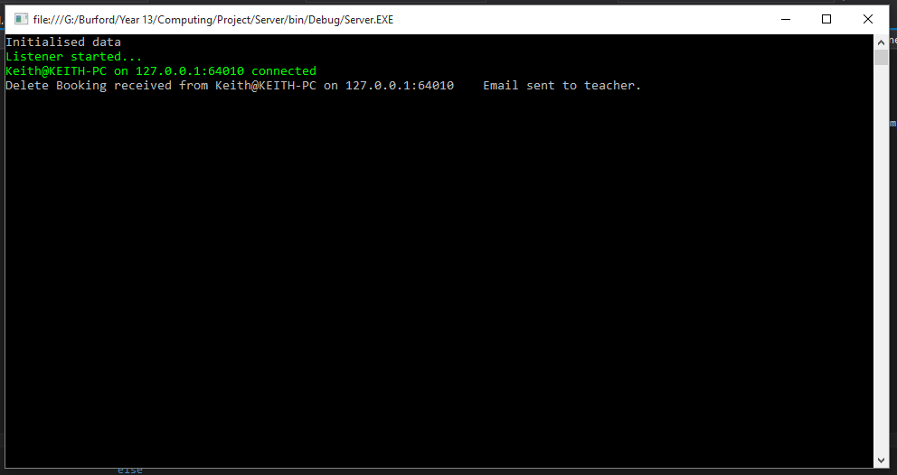Pressing delete on the EditBooking window displays a confirmation dialog, and causes the server to delete the Booking from the internal model, update the database, and distribute the changes to all connected clients. Clients connecting subsequent to the deletion are also given the correctly changed model.

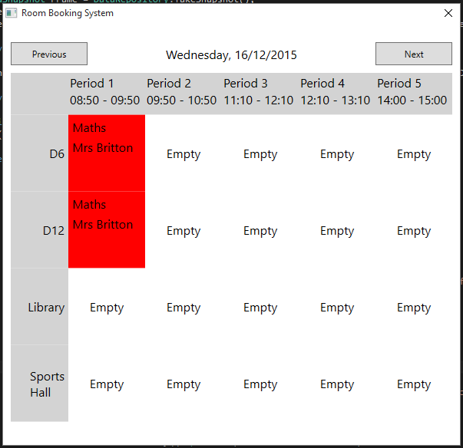

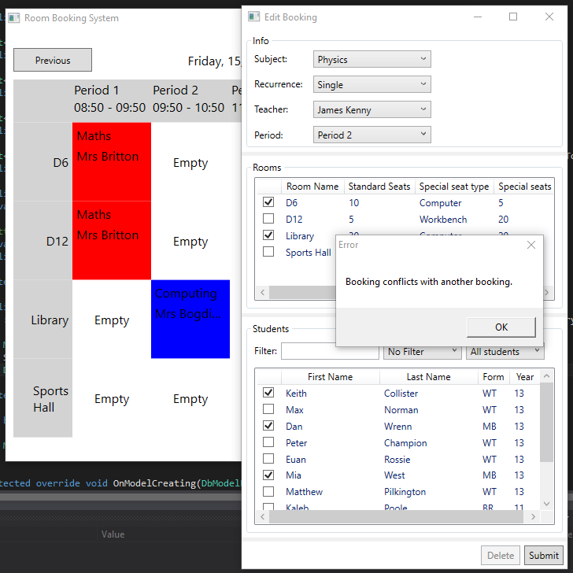

1. Submitting a booking that conflicts with other bookings (eg overlapping rooms/timeslots), results in an error message being displayed.

1. 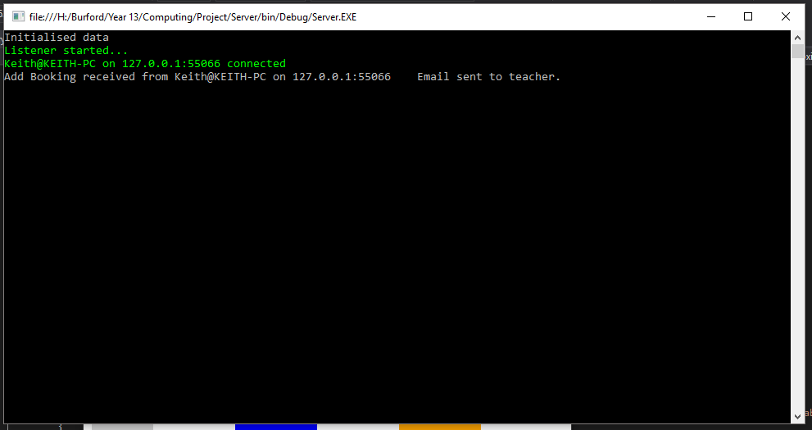Submitting a Booking causes the Server to receive and process the Booking, adding/editing the database records, and distributing it to all the connected clients. Again, due to the database updates, new clients connecting will receive the correct model as well.

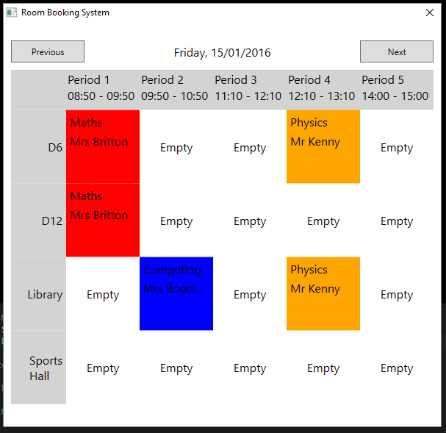

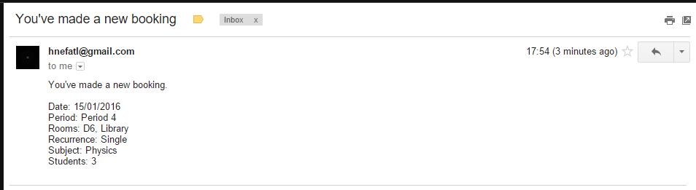

1. Making a change to a Booking sends an informative notification email to the relevant teacher.
2. 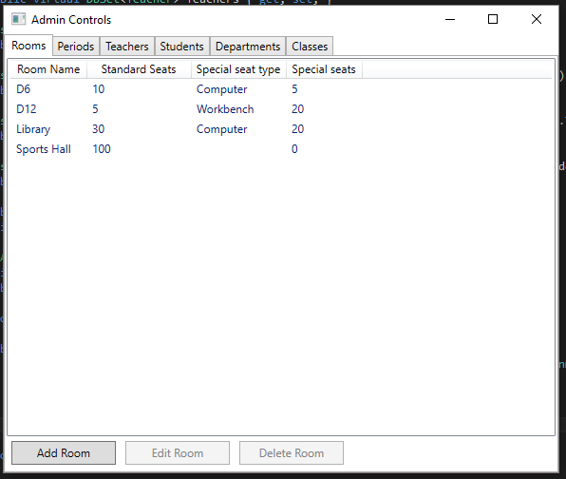Clicking the “Customise System” option on the taskbar context menu opens the Admin Control window.



1. Clicking “Add Room” on the Rooms tab of the Admin Control window displays the correct window.

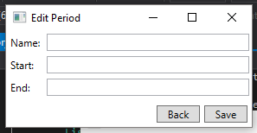

1. Clicking “Add Period” on the Periods tab of the Admin Control window displays the correct window.
2. 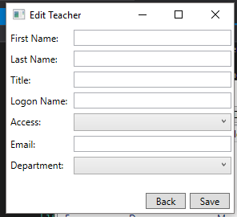Clicking “Add Teacher” on the Teachers tab of the Admin Control window displays the correct window.

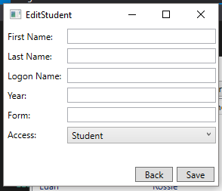

1. Clicking “Add Student” on the Students tab of the Admin Control window displays the correct window.

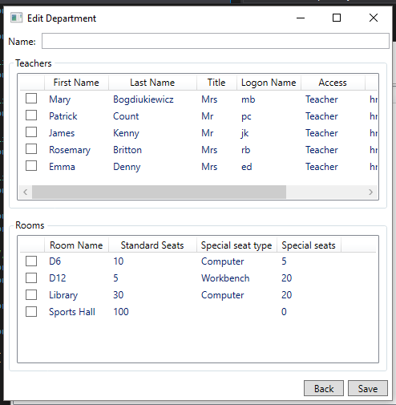

1. Clicking “Add Department” on the Departments tab of the Admin Control window displays the correct window.

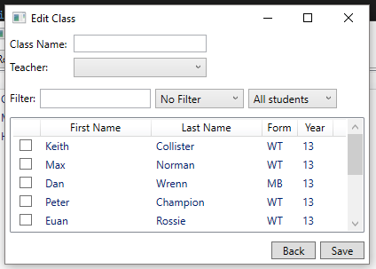

1. Clicking “Add Class” on the classes tab of the Admin Control window displays the correct window.
2. 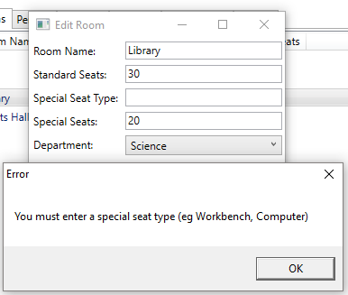Entering invalid input to the Standard/Special seats fields on the Edit Room window is handled with an informative error message.

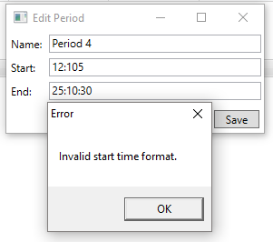

1. Entering invalid input to the Start/End time fields on the Edit Period window is handled with an informative error message.

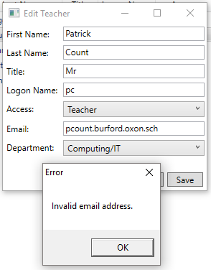

1. Entering invalid input to the Email field on the Edit Teacher window is handled with an informative error message.
2. Open numerous clients on multiple computers and connect them all to the server, perform standard operations such as editing Bookings/teachers

## Minimum Test Data

In order to test my application works in general usage, as opposed to under specific testing conditions, while running these tests I’ve loaded the system with number of sample data entries. For example, I have added “dummy” users, classes, rooms, etc. so that when testing the functionality of my system I can ensure that it scales correctly. Wherever a test involves data being sent across the network, I have set up multiple clients connected to the server at the same time, to ensure the server can deal with the load and be able to distribute data correctly.

# System Maintenance

## Introduction

The objective of the project, as stated in the Design section, was to provide a robust, scalable internal system enabling teachers to book rooms easily while giving students a degree of access to the system, providing notifications and information on bookings. It was decided to achieve this using a networked Client-Server system running inside the school network. The Client executables run on computer log-on, and connect to the Server running on a central host machine using a custom protocol on top of TCP/IP.

The Server keeps a database of Bookings (along with all other components of the system to allow customisability, such as Rooms and Periods) and updates it with necessary changes, and is responsible for receiving, updating, and distributing the changes. This is the workhorse of the system.

The Client is the front-end displayed to all users (Admin, Teacher, and Student roles). It sends data to the Server concerning changes to bookings etc, and displays the Timetable with bookings for the users. This is the “pretty front-end”.

There are 3 separate assemblies referenced by the two main applications – *Shared*, *Data*, and *NetCore*. These each provide some shared components, and are more or less independent logical structures. They’re described in more detail below.

Database interaction is done using the .NET Entity Framework (<http://www.asp.net/entity-framework>). The Server is the only application that interacts with the database – Clients receive a model of the internal model from the Server.

## Description of Modular System

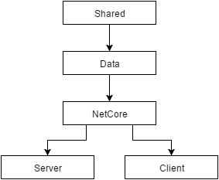The system has been designed to reuse as much code as possible, which coupled with the common tasks of networking from both the Server and the Client, has allowed for the creation of shared libraries of code referenced by the various other assemblies. The diagram on the right displays this structure, the arrows representing the references between different assemblies of code in the solution. These match up with the links as proposed in the Design section.

## Shared

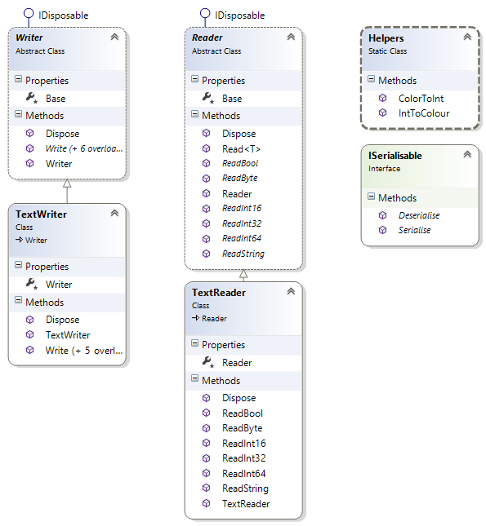The Shared library holds some classes which are usually the highest form of abstraction – for example, the *Writer* abstract class provides an abstraction for any classes that can write to a Stream. An initial implementation, *TextWriter* is given within the same assembly, and provides simple text output to a Stream. This is used in writing to the Settings file. The *Reader* class is the input analogue to the *Writer* class.

Another key class provided by this assembly is the *ISerialisable* interface – this is used by the Data and NetCore assemblies to provide a neatly abstracted way of serialising various objects (network messages, primarily).

The *Helpers* static class is used only for converting from a .NET *Color* object to an *Int32*, as databases cannot store most complex CLR types, only primitive types such as *Int32* etc.

using System;

The *Writer* class is an abstract superclass for the Stream IO derived classes.  
It provides the interface that all the subclasses must implement.

using System.IO;

namespace Shared

{

// Provides an abstract hierarchy for writing .NET objects to a Stream.

public abstract class Writer

: IDisposable

The member property *Base* (type *Stream*) inherits *IDisposable*, so must be disposed of appropriately – good practice dictates this class should thus be disposable as well, which makes it easier to deal with disposing of the member.

{

// The output stream to write to

protected Stream Base { get; set; }

public Writer(Stream Base)

{

this.Base = Base;

}

// Disposes of the output stream

public virtual void Dispose()

{

Base.Flush();

Base.Dispose();

}

These abstract functions dictate that all concrete subclasses of Writer must provide implementations for these standard outputs.

public abstract void Write(byte b);

public abstract void Write(bool b);

public abstract void Write(short s);

public abstract void Write(int i);

public abstract void Write(long l);

public abstract void Write(string s);

// Writes a loosely typed Object if it's of a supported type.

public virtual void Write(object Item)

{

Type t = Item.GetType();

if (t == typeof(byte))

This function allows an *Object* to be written without needing to know the type in advance, by testing it against different types to find a match.

Write((byte)Convert.ChangeType(Item, typeof(byte)));

else if (t == typeof(bool))

Write((bool)Convert.ChangeType(Item, typeof(bool)));

else if (t == typeof(short))

Write((short)Convert.ChangeType(Item, typeof(short)));

else if (t == typeof(int))

Write((int)Convert.ChangeType(Item, typeof(int)));

else if (t == typeof(long))

Write((long)Convert.ChangeType(Item, typeof(long)));

else if (t == typeof(string))

Write((string)Convert.ChangeType(Item, typeof(string)));

else

throw new ArgumentException("Cannot write values of the type specified.");

}

}

}

using System;

using System.IO;

namespace Shared

{

// Writes data to the output Stream using standard text encoding

public class TextWriter

This is a concrete implementation of the abstract *Writer* class designed to write using plain text. In essence, this is simply a wrapper over a *StreamWriter*, but inherits *Writer*.

: Writer

{

// Internal wrapper object

protected StreamWriter Writer { get; set; }

public TextWriter(Stream Base)

: base(Base)

{

Writer = new StreamWriter(Base);

}

public override void Dispose()

{

// Dispose the Writer, then dispose the base class

Writer.Dispose();

base.Dispose();

}

public override void Write(byte b)

{

Writer.WriteLine(b);

}

public override void Write(bool b)

{

Writer.WriteLine(b);

}

public override void Write(short s)

{

Writer.WriteLine(s);

}

public override void Write(int i)

{

Writer.WriteLine(i);

}

public override void Write(long l)

{

Writer.WriteLine(l);

}

public override void Write(string s)

{

Writer.WriteLine(s);

}

}

}

using System;

using System.Text;

This is a concrete implementation of the abstract *Writer* class designed to write using binary. *BinaryWriter* couldn’t be used as it outputs in host rather than network order.

using System.IO;

using System.Net;

namespace Shared

{

// Write data to a stream using bytes rather than text.

public class NetWriter

: Writer

{

public NetWriter(Stream Base)

:base(Base)

{

}

public virtual void Write(byte[] Data)

These overridden functions simply convert the input into bytes, ensuring they’re in network order (Big Endian), and writes them to the stream.

{

Base.Write(Data, 0, Data.Length);

}

public override void Write(byte b)

{

Write(new byte[] { b });

}

public override void Write(bool b)

{

Write(new byte[] { Convert.ToByte(b) });

}

public override void Write(short s)

{

// Writing to a network, so use Network order conversion

Write(BitConverter.GetBytes(IPAddress.HostToNetworkOrder(s)));

}

public override void Write(int i)

{

Write(BitConverter.GetBytes(IPAddress.HostToNetworkOrder(i)));

}

public override void Write(long l)

{

Write(BitConverter.GetBytes(IPAddress.HostToNetworkOrder(l)));

}

public override void Write(string s)

{

// Write the length of the string, then the actual string data

Write(Encoding.UTF8.GetByteCount(s));

Write(Encoding.UTF8.GetBytes(s));

To write a variable-length *String*, we first need to send its length so the receiver knows how many subsequent bytes to receive for the actual string contents.

}

}

}

using System;

Again, the member property *Base* inherits *IDisposable*, so this class inherits *IDisposable* in order to clean up.

This is a generic function to read an object of known type from the Stream. Provides strongly typed access to the Stream while maintaining a generic interface.

The abstract *Reader* class provides an input analogue to the *Writer* class, creating an interface for *Stream* IO.

using System.IO;

namespace Shared

{

// Abstract class providing a hierarchy for reading data from a stream.

public abstract class Reader

: IDisposable

{

// The stream to read from

protected Stream Base { get; set; }

public Reader(Stream Base)

{

this.Base = Base;

}

public virtual void Dispose()

{

Base.Dispose();

}

public abstract byte ReadByte();

public abstract bool ReadBool();

public abstract short ReadInt16();

public abstract int ReadInt32();

public abstract long ReadInt64();

public abstract string ReadString();

// Writes a generic type by checking the type against supported ones.

public virtual T Read<T>()

This generic function provides strongly typed access to the stream by checking the desired type against the allowed types and calling the desired function.

{

Type t = typeof(T);

if (t == typeof(byte))

return (T)Convert.ChangeType(ReadByte(), t);

else if (t == typeof(bool))

return (T)Convert.ChangeType(ReadBool(), t);

else if (t == typeof(short))

return (T)Convert.ChangeType(ReadInt16(), t);

else if (t == typeof(int))

return (T)Convert.ChangeType(ReadInt32(), t);

else if (t == typeof(long))

return (T)Convert.ChangeType(ReadInt64(), t);

else if (t == typeof(string))

return (T)Convert.ChangeType(ReadString(), t);

else

throw new ArgumentException("Cannot read values of the type specified.");

}

}

}

using System;

using System.Text;

*TextReader* is a concrete implementation of *Reader*, designed to be used with a *TextWriter*. Similarly, it’s a wrapper around *StreamReader*.

using System.IO;

namespace Shared

{

// Reads data from a stream using standard encoding.

public class TextReader

: Reader

{

// Internal wrapper object

protected StreamReader Reader { get; set; }

public TextReader(Stream Base)

:base(Base)

{

Reader = new StreamReader(Base);

}

public override void Dispose()

{

// Dispose of the wrapper first, then the base class.

Reader.Dispose();

base.Dispose();

}

public override byte ReadByte()

{

Reading non-string types is achieved by simply parsing each line as the type.

return (byte)Reader.Read();

}

public override bool ReadBool()

{

return bool.Parse(Reader.ReadLine());

}

public override short ReadInt16()

{

return short.Parse(Reader.ReadLine());

}

public override int ReadInt32()

{

return int.Parse(Reader.ReadLine());

}

public override long ReadInt64()

{

return long.Parse(Reader.ReadLine());

}

public override string ReadString()

{

return Reader.ReadLine();

}

}

}

using System;

*NetReader* is the largest class in this module. It provides the same style of access to the stream as *TextReader* does, but using binary. This class is also unique amongst the *Reader*/*Writer* hierarchy in that it provides asynchronous methods. These are extremely useful when implementing the network protocols in the *NetCore* assembly.

using System.Text;

using System.IO;

using System.Net;

namespace Shared

{

// Reads data from a stream using bytes rather than text.

public class NetReader

: Reader

{

public NetReader(Stream Base)

: base(Base)

{

}

// Read a specified number of bytes

public virtual byte[] ReadBytes(int Count)

{

if (Count <= 0)

return new byte[0];

byte[] Buffer = new byte[Count];

int Remaining = Count;

// Not guaranteed to read all bytes on first try - rety until all read

while (Remaining > 0)

Remaining -= Base.Read(Buffer, Buffer.Length - Remaining, Remaining);

if (Remaining != 0)

throw new Exception("Bad read (read " + (Buffer.Length - Remaining) + " of " + Buffer.Length + " bytes).");

return Buffer;

ReadBytes is a complicated function – it reads bytes into a buffer

}

public override byte ReadByte()

{

return ReadBytes(1)[0];

}

public override bool ReadBool()

{

return Convert.ToBoolean(ReadByte());

}

public override short ReadInt16()

{

return IPAddress.NetworkToHostOrder(BitConverter.ToInt16(ReadBytes(sizeof(short)), 0));

}

public override int ReadInt32()

{

return IPAddress.NetworkToHostOrder(BitConverter.ToInt32(ReadBytes(sizeof(int)), 0));

}

public override long ReadInt64()

{

return IPAddress.NetworkToHostOrder(BitConverter.ToInt64(ReadBytes(sizeof(long)), 0));

}

public override string ReadString()

{

int Length = ReadInt32(); // Read the length of the data first

return Encoding.UTF8.GetString(ReadBytes(Length));

}

// Asycnhronous methods using Begin-End paradigm

public virtual IAsyncResult BeginReadBytes(int Count, AsyncCallback Callback)

{

byte[] Buffer = new byte[Count]; // Allocate the memory to be used

// Delegate reading to the stream's async methods, passing the buffer as the state

return Base.BeginRead(Buffer, 0, Buffer.Length, Callback, Buffer);

}

public virtual byte[] EndReadBytes(IAsyncResult Handle)

{

// Retrieve the buffer as the state

byte[] Buffer = (byte[])Handle.AsyncState;

int Read = Base.EndRead(Handle);

// Check for a valid read (correct number of bytes)

if (Read != Buffer.Length)

throw new Exception("Bad read (read " + Read + " of " + Buffer.Length + " bytes).");

Handle.AsyncWaitHandle.Dispose(); // Cleanup

return Buffer;

}

public virtual IAsyncResult BeginReadByte(AsyncCallback Callback)

{

return BeginReadBytes(sizeof(byte), Callback);

}

public virtual byte EndReadByte(IAsyncResult Handle)

{

return EndReadBytes(Handle)[0];

}

public virtual IAsyncResult BeginReadBool(AsyncCallback Callback)

{

return BeginReadByte(Callback);

}

public virtual bool EndReadBool(IAsyncResult Handle)

{

return Convert.ToBoolean(EndReadByte(Handle));

}

public virtual IAsyncResult BeginReadInt16(AsyncCallback Callback)

{

return BeginReadBytes(sizeof(short), Callback);

}

public virtual short EndReadInt16(IAsyncResult Handle)

{

return IPAddress.NetworkToHostOrder(BitConverter.ToInt16(EndReadBytes(Handle), 0));

}

public virtual IAsyncResult BeginReadInt32(AsyncCallback Callback)

{

return BeginReadBytes(sizeof(int), Callback);

}

public virtual int EndReadInt32(IAsyncResult Handle)

{

return IPAddress.NetworkToHostOrder(BitConverter.ToInt32(EndReadBytes(Handle), 0));

}

public virtual IAsyncResult BeginReadInt64(AsyncCallback Callback)

{

return BeginReadBytes(sizeof(long), Callback);

}

public virtual long EndReadInt64(IAsyncResult Handle)

{

return IPAddress.NetworkToHostOrder(BitConverter.ToInt64(EndReadBytes(Handle), 0));

}

public virtual IAsyncResult BeginReadString(AsyncCallback Callback)

{

return BeginReadInt32(Callback);

}

public virtual string EndReadString(IAsyncResult Handle)

{

int Length = EndReadInt32(Handle);

return Encoding.UTF8.GetString(ReadBytes(Length));

}

// Static utility function to determine the number of bytes required to send a particular object.

public static int NetworkLength(object o)

{

if (o is short)

return sizeof(short);

else if (o is int)

return sizeof(int);

else if (o is long)

return sizeof(long);

else if (o is byte)

return sizeof(byte);

else if (o is string) // Sends size of contents + actual contents

return sizeof(int) + Encoding.UTF8.GetByteCount((string)o);

else

throw new NotSupportedException();

}

}

}

## Data

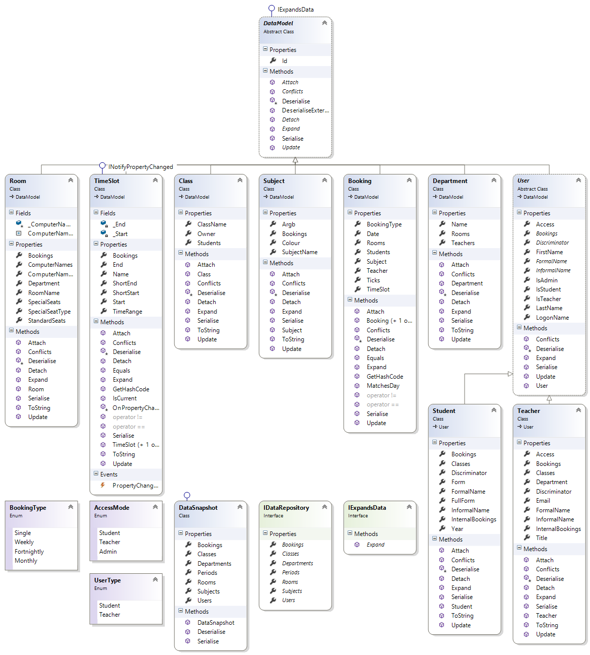

The Data assembly is one of the largest; it specifies the database objects that we want to work with using plain C# code, which Entity Framework then processes at compile-time to structure the database.

The most core class in this hierarchy is the *DataModel* class. It provides common subroutines for all the other database items.