# bamazon

Step 1: pull file from github then click on bamazonCustomer.js

Step 2: Open code, right click on screen

<img src = “screenshots/pic1.png” >

[<img src = “screenshots/pic1.png“ >]

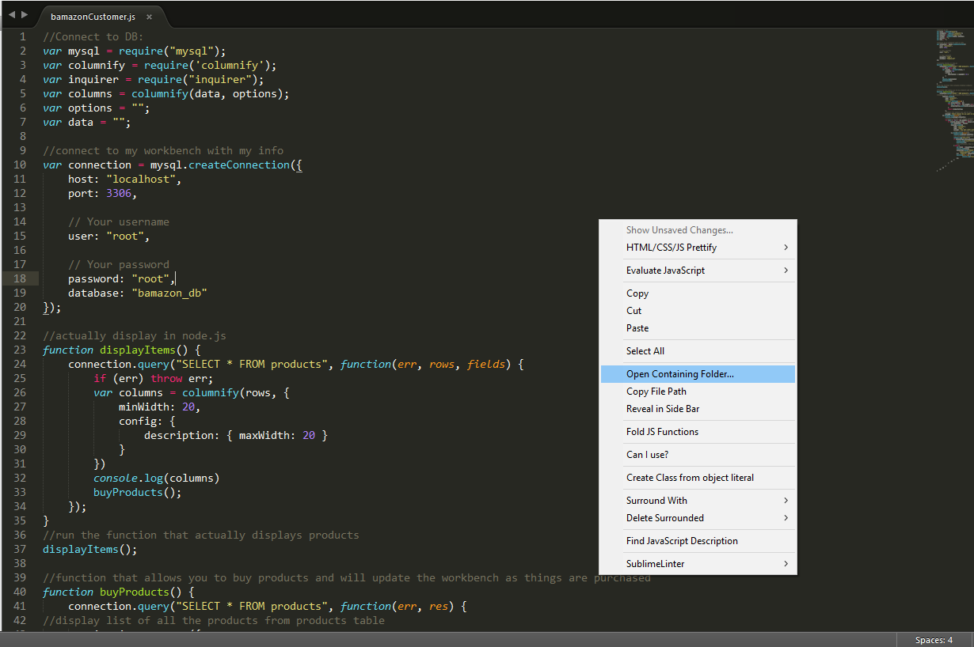

Step 3: click on “open containing folder”

<img src = “screenshots/pic2.png” >

[<img src = “screenshots/pic2.png“ >]

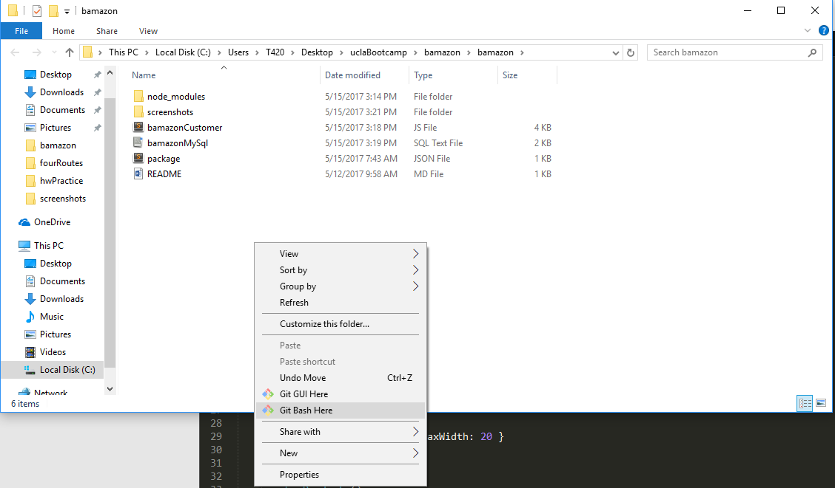

Step 4: right click and “git bash here”

Step 5: then type “npm install mysql columnify inquirer” so the code will run and be displayed cleanly

<img src = “screenshots/pic3.png” >

[<img src = “screenshots/pic3.png“ >]

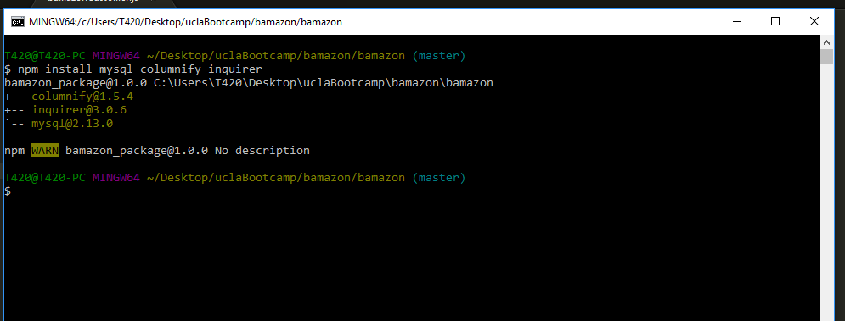

Step 6: open workbench type the exact text displayed below. Then, highlight line 1, hit the lightening bolt. Then highlight line 3, hit the lightening bold. Highlight the entire table(lines 5-12) then hit lightening bolt. Highlight 14-35 then hit lightening bolt.

<img src = “screenshots/pic4.png” >

<img src = “screenshots/pic5.png” >

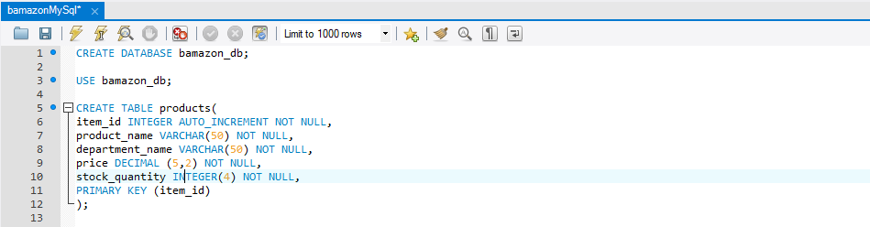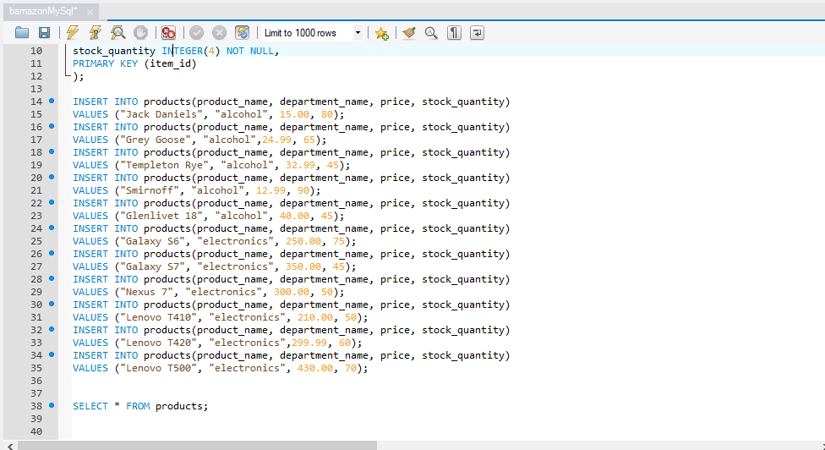

Step 7: go back to terminal, run bamazonCustomer.js, select what you want by moving up and down then hit the number for the quantity. When you hit enter, it will show if you purchased correctly then update the information.

<img src = “screenshots/pic6.png” >

<img src = “screenshots/pic7.png” >

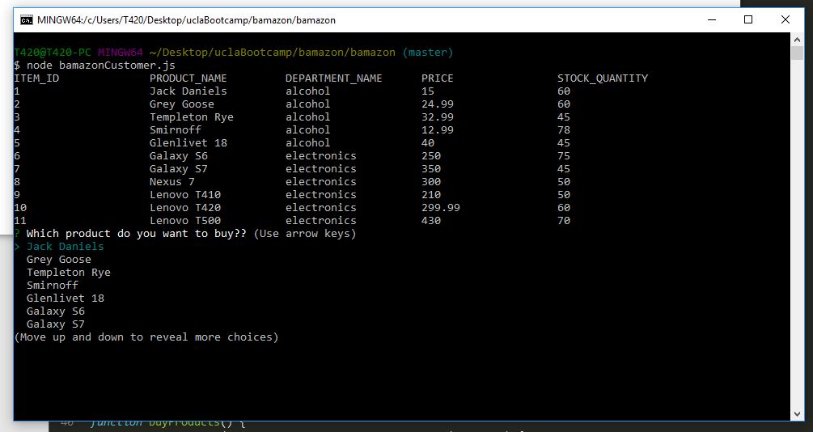

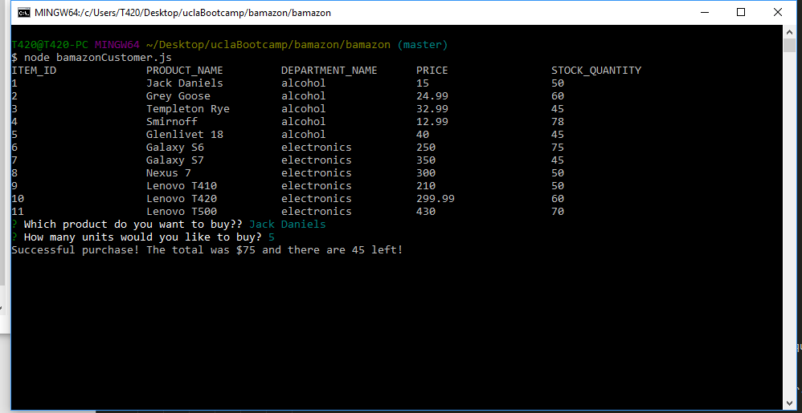

Hit “ctrl” + c to exit, then run again if you want.