|  |  |
| --- | --- |
| Hieu Nguyen : 7234520 | Professor: Jochen Lang |

CSI4130, Winter 2017 - Computer Graphics

**Assignment #4 - README**

Helicopter Control, with Skybox and Environment Mapping

horizontal line

# Installation Instructions

1. Create a new java project in eclipse importing all the files under “Assign4”
2. Open eclipse > right click on the project > Build Path > Configure Build Path

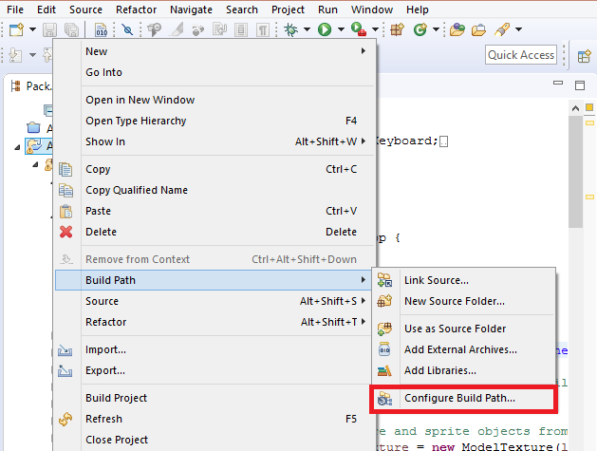

1. Click “Add JARs” > Assign4 >lib. And select all JARs in the folder.
2. Expand “JRE System Library” > Select “Native library location” > Click “Edit...”

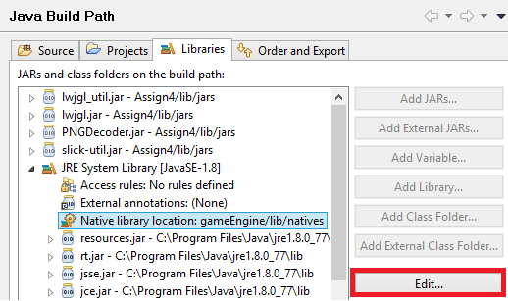

1. Click “Workspace...” > Expand to the “natives” folder which should include the dlls, and OK, OK, and Apply. (Note: these libraries are from the LWJGL package)

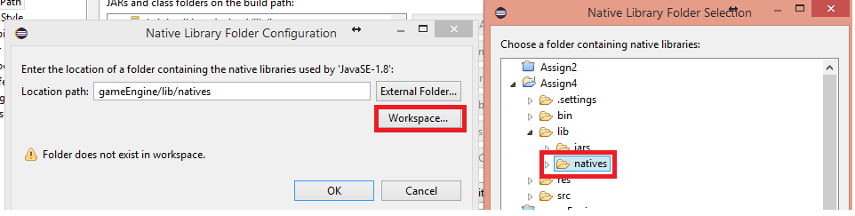

1. Compile and Run the program.

# Interaction Instructions

**“Left click and drag”** : to change camera view around the helicopter

**“Scroll Wheel”** : to change the distance between the camera and the helicopter

**“A”/”D”** : to change the “yaw” of the helicopter, left and right respectively

**“W”/”S”** : to move the helicopter forwards and backwards

**“Spacebar”** : to a make the helicopter ascend

## Version

Using LWJGL 2.9.3

## References

Referenced code from thinMatrix youtube LWJGL tutorials (commented where code was taken/adapted) : <https://www.youtube.com/playlist?list=PLRIWtICgwaX0u7Rf9zkZhLoLuZVfUksDP>

Skybox images: “Mp Sorbin” from <http://www.custommapmakers.org/skyboxes.php>

LWJGL 2.9.3: <http://legacy.lwjgl.org/download.php.html>

Billboarding Tutorial in Opengl: <http://www.lousodrome.net/opengl/#billboards>

Cube Mapping Tutorial in Opengl: <https://learnopengl.com/#!Advanced-OpenGL/Cubemaps>

Environment Mapping Tutorial: <http://antongerdelan.net/opengl/cubemaps.html>