github commits: https://github.com/hnguy130/CSE-464-2025-hnguy130/commits/refactor/

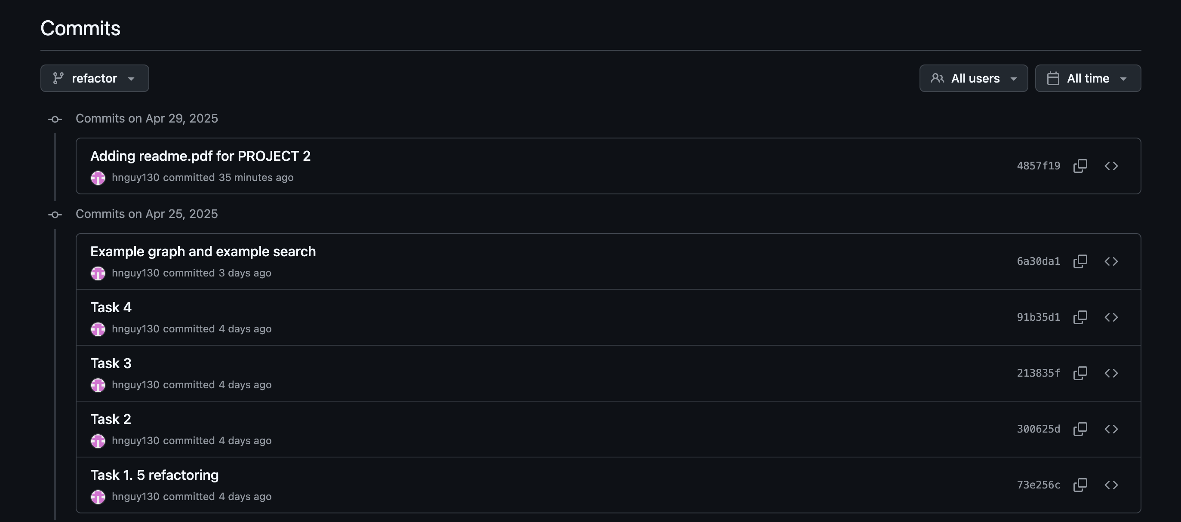
github workflow
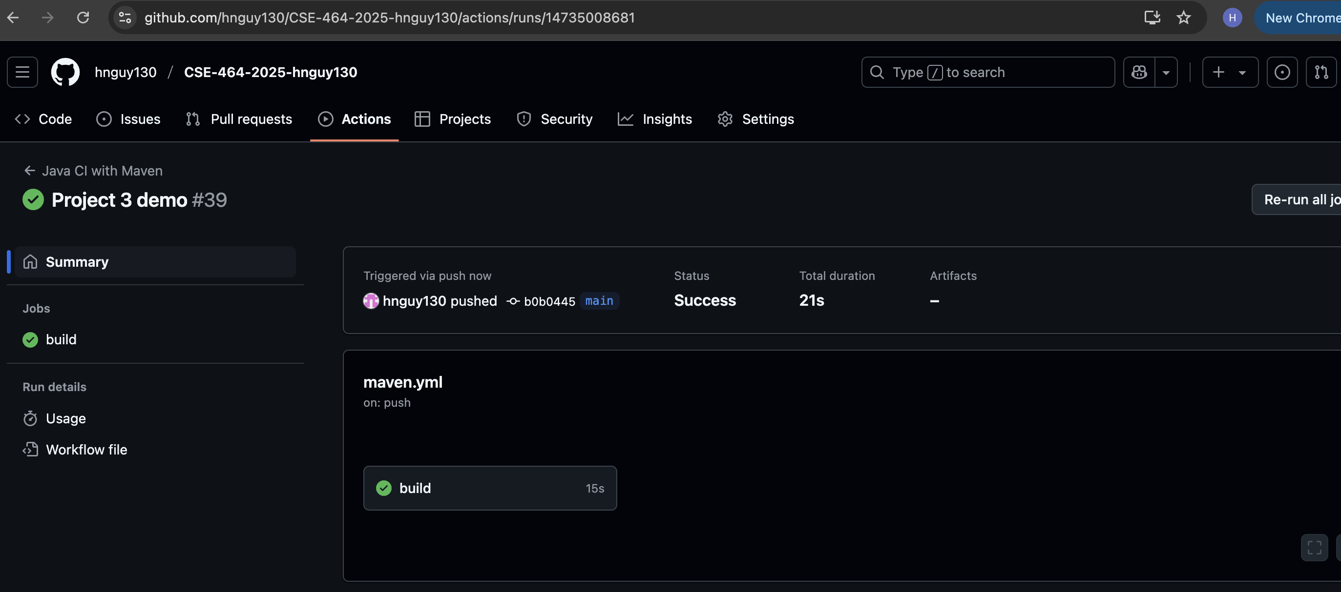
github merge (merge didn’t show as merge but as commits)
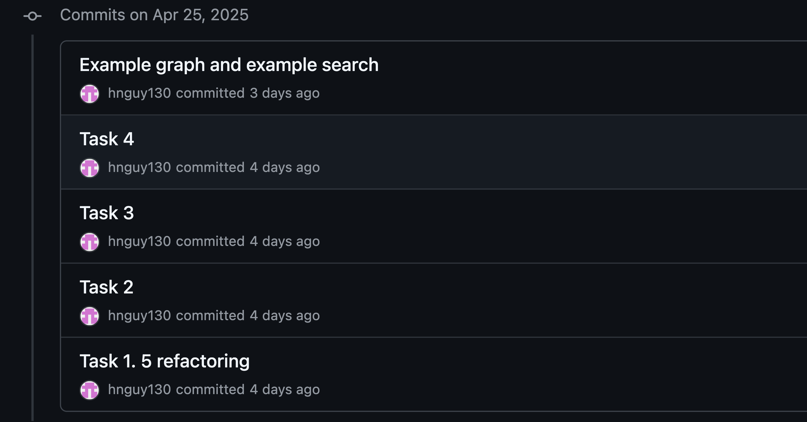

1.5 refactoring

github link:
https://github.com/hnguy130/CSE-464-2025-hnguy130/commit/73e256c10a17bcdcab2b0358e98ab340ce3206b5

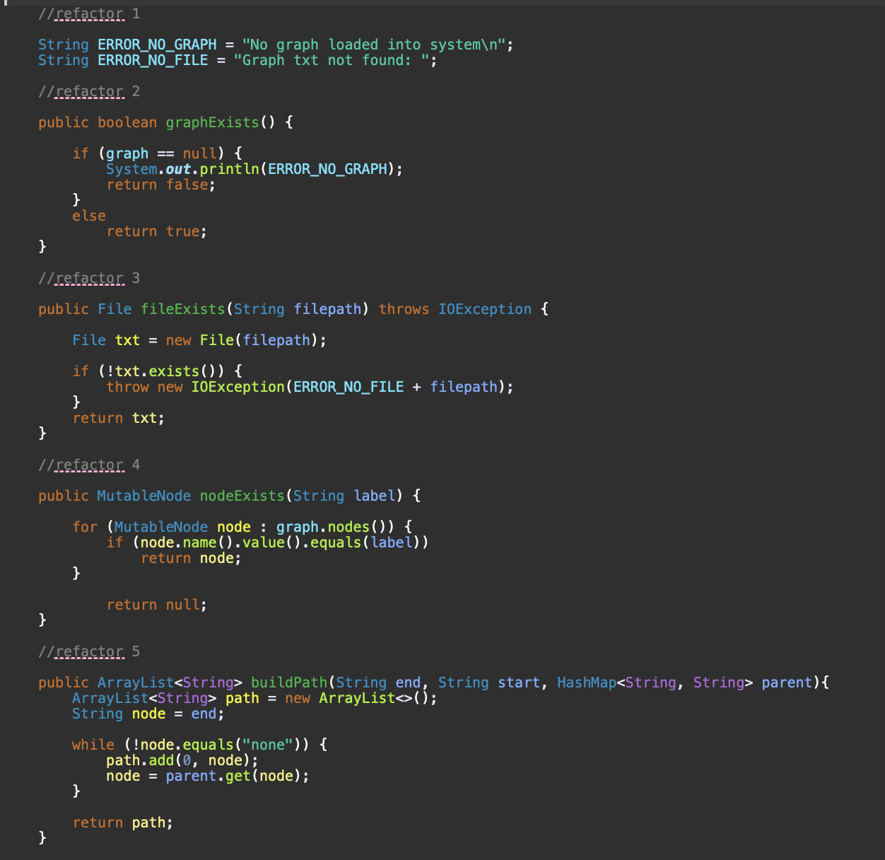

- refactoring 1: ERROR_NO_GRAPH, ERROR_NO_FILE
Type: Replace Magic Number with Symbolic Constant
Reason: To reduce typing the same string over again and avoid slight mistakes

- refactoring 2: graphExists()
Type: Extract method
Reason: To check if graph exists and print error if graph doesn’t exist, return Boolean for further processing

- refactoring 3: fileExists(String filepath)
Type: Extract method
Reason: To check if file exists in file system and print error if file doesn’t exist, return Boolean for further processing

- refactoring 4: nodeExists(String label)
Type: Extract method
Reason: To check through Graph’s list of nodes if a node is in that list of nodes, and return that node or null if node doesn’t exist

- refactoring 5: buildPath(String end, String start, HashMap<String, String> parent)
Type Extract method
Reason: To create an arraylist that contains path of nodes from child node to start node, and avoid redundancy and complexity

2.
github link:
https://github.com/hnguy130/CSE-464-2025-hnguy130/commit/300625d5dd7d059bf07c241df156c01e55e3d57d

- The class templateSearch is the template for subclasses that implement search types Breadth-first-search, Depth-first-search
+ Class templateSearch’s skeleton for algorithm processes is the method search(String from, String to). Method search(String from, String to) includes the common steps of the algorithms BFS, DFS
+ checking if there is a graph
+ checking if the start and the destination do exist in the graph, if not, return
+ Then, the skeleton method calls the abstract method searchHelper(String from, String to). This abstract method searchHelper(String from, String to) has to be implemented once for each subclass, with each subclass only able to contain one search algorithm, totaling 2 subclasses for BFS, DFS. The subclasses are: searchBFS and searchDFS
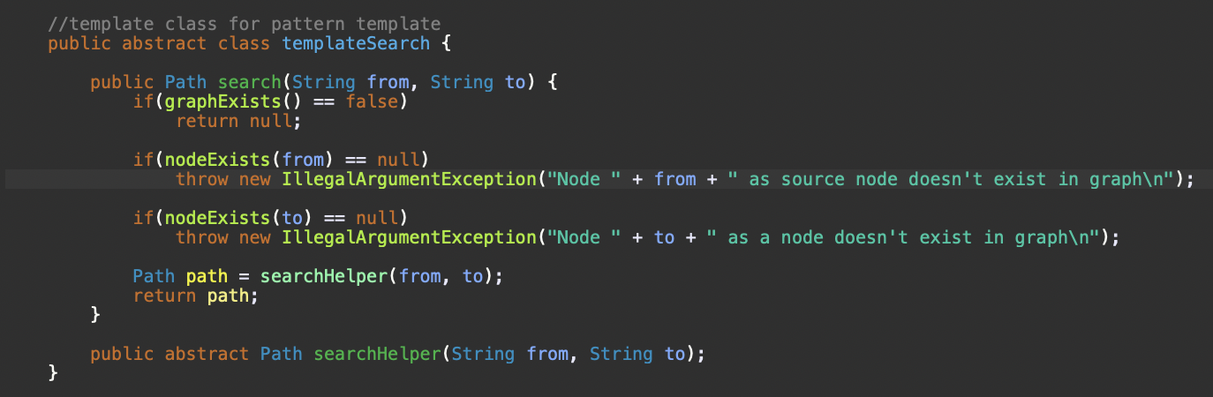

- Each subclass searchBFS, searchDFS, has the skeleton method search(String from, String to), but they need to implement their own searchHelper(String from, String to) separately for each subclass
+ searchHelper(String from, String to) in searchBFS subclass implements the search using Breath-first-search algorithm
+ searchHelper(String from, String to) in searchDFS subclass implements the search using Depth-first-search algorithm
- After implementing the different parts for each subclass about one search algorithm in DFS, BFS, their common skeleton method search(String from, String to):
+ processes all the common steps of all algorithms,
+ processes the specific algorithm’s separate parts in the abstract method searchHelper(String from, String to) differently
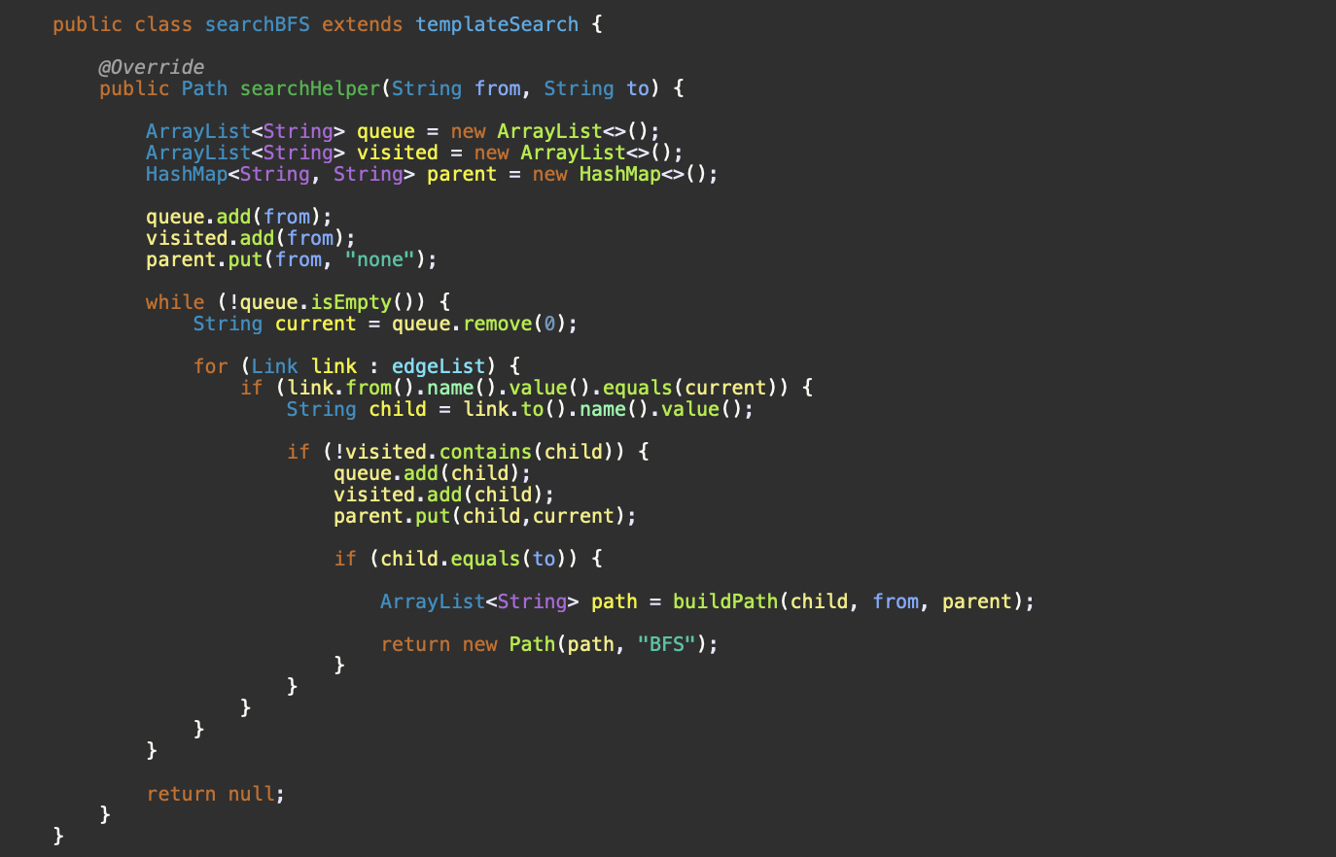
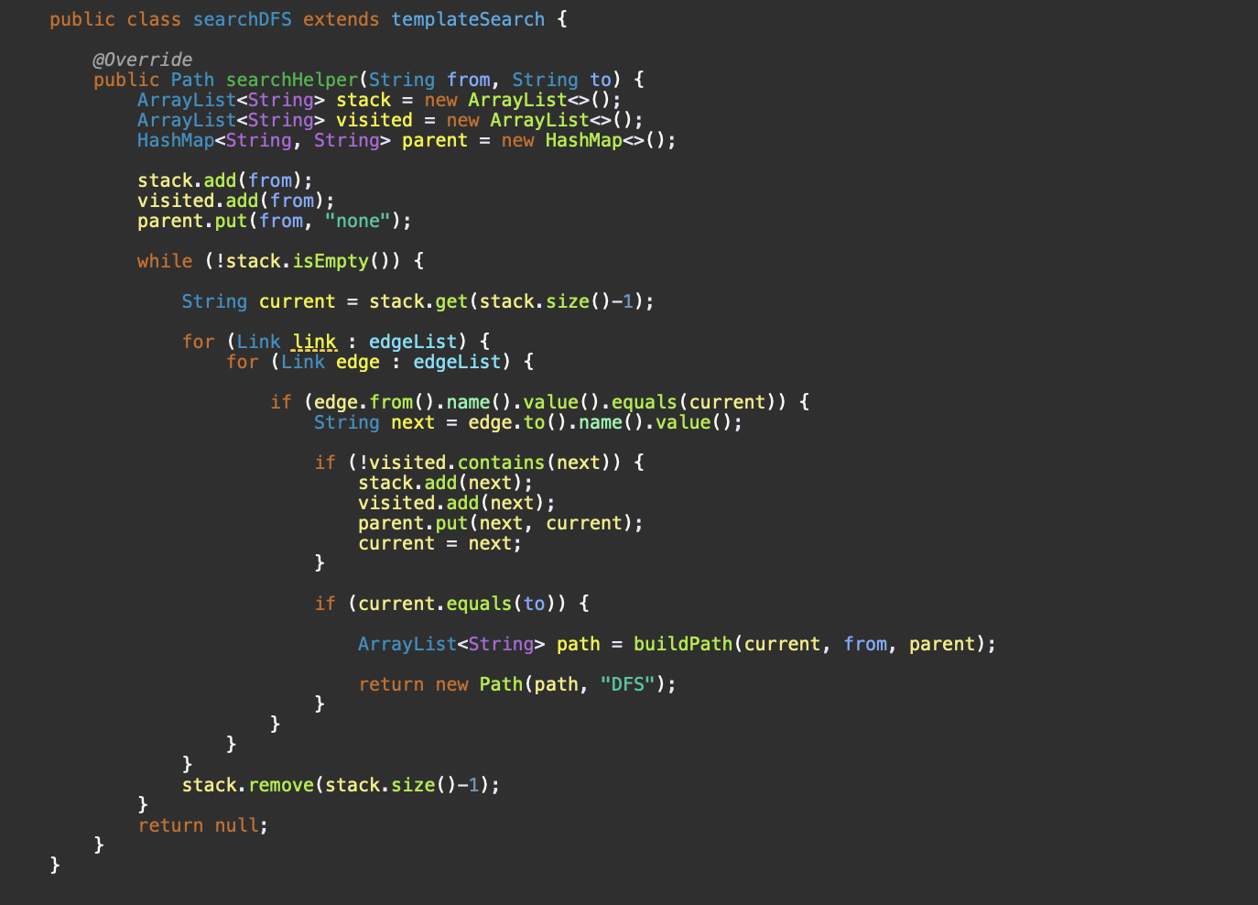
3.

github link:
https://github.com/hnguy130/CSE-464-2025-hnguy130/commit/213835f7f347262aa4a0f242c467a566e889d4d6

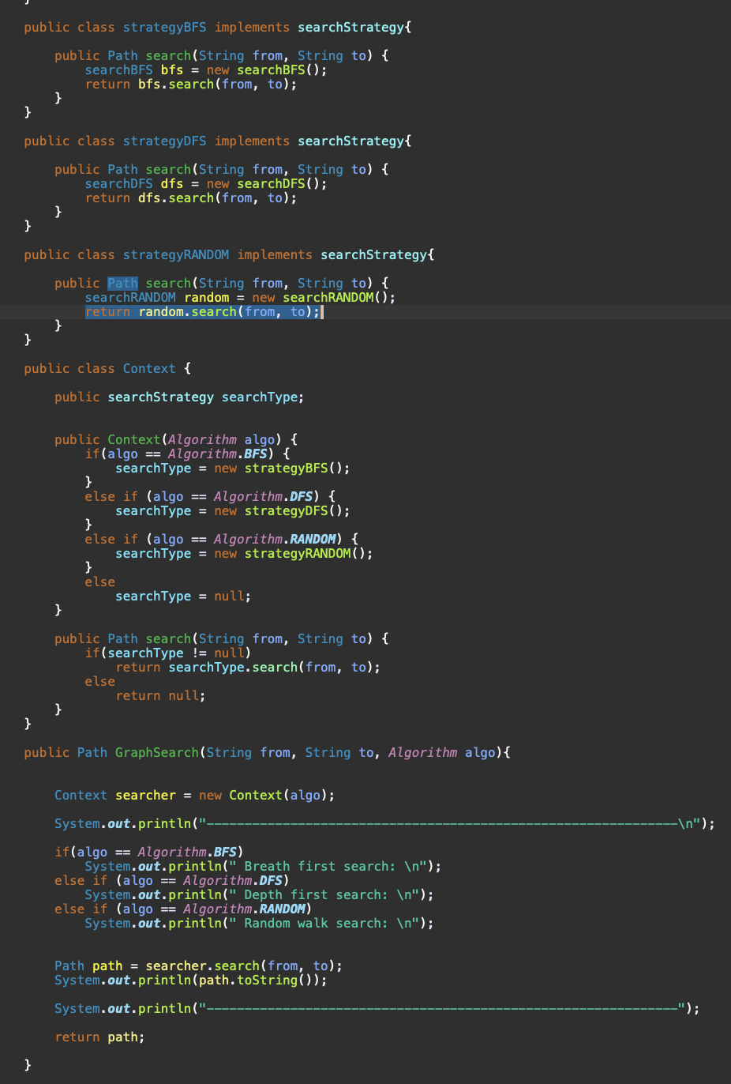

Reference:
method GraphSearch(String from, String to, Algorithm algo)
-> Context class
-> searchStrategy interface (strategy interface)
-> strategyBFS or strategyDFS class (classes for strategy)
-> searchBFS or searchDFS class (classes for algorithm)

- The class Context manages the input and selects the correct strategy to process. The structure of the class Context allows selecting the correct search algorithm BFS or DFS:

+Context class has the function search(String from, String to) which returns a path

+ A Context object is created, with a parameter for the specific algorithm, using
Context searcher = new Context(algo);
+ (point 1) After knowing the specific algorithm, the Context object creates the specific concrete strategy class’ object strategyBFS or strategyDFS, from interface searchStrategy:

+ (point 2) Then, strategyBFS or strategyDFS object’s custom function search(String from, String to) returns the specific algorithm class searchBFS or searchDFS’s abstract function search(String from, String to)

+ To search a path, use searcher.search(String from, String to). T

4.
github link:
https://github.com/hnguy130/CSE-464-2025-hnguy130/commit/91b35d10055db1fcef2d618f726d20953e1345d3
- You must implement this new random walk algorithm using both the strategy pattern and the
template pattern you implement for requirements 2 and 3 in this part.

+ Updated template pattern implementation
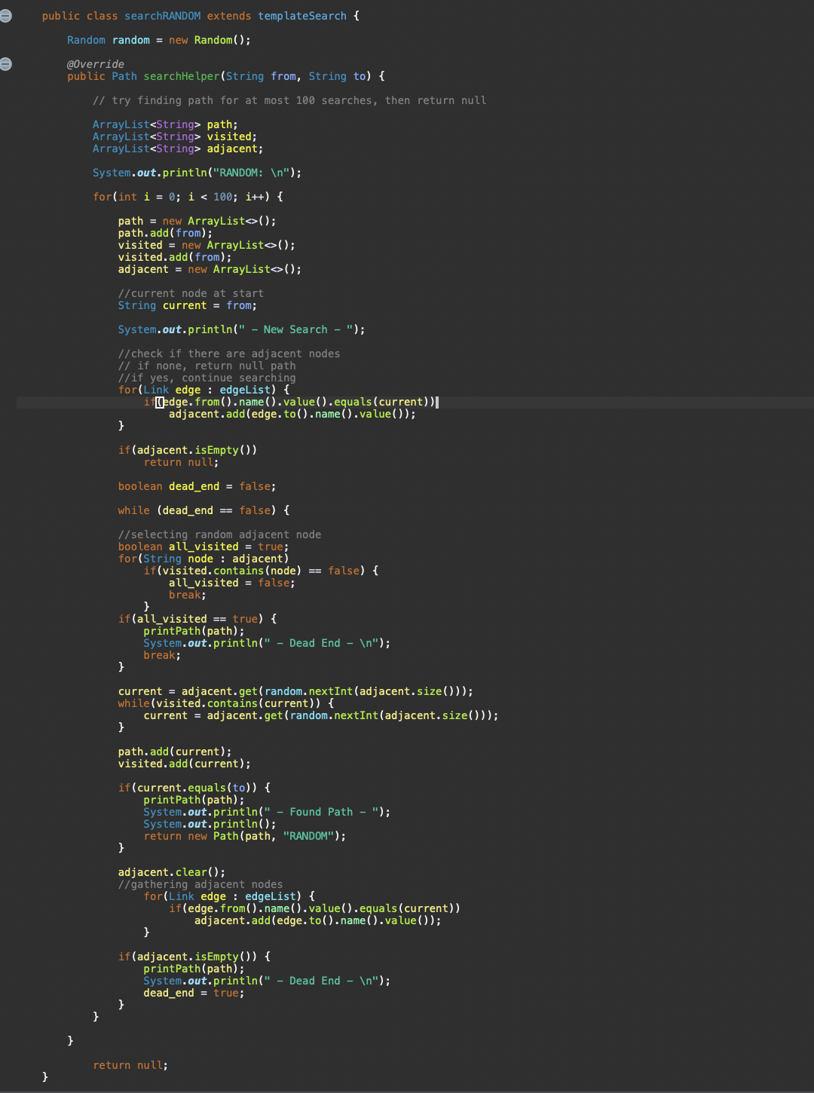

+ Updated strategy pattern implementation
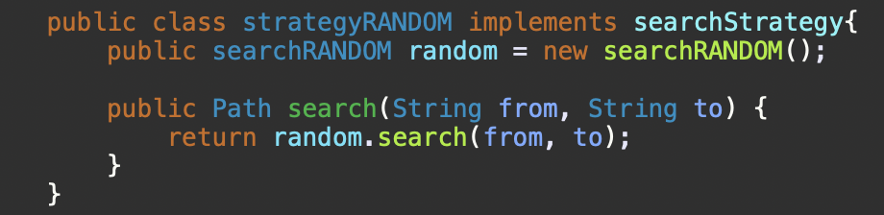
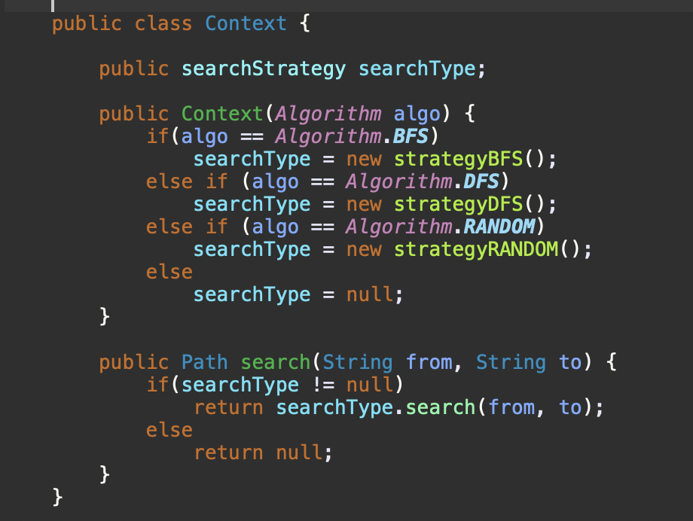

- You must provide an example graph and an example search to find a path in the example graph.
Sample graph:
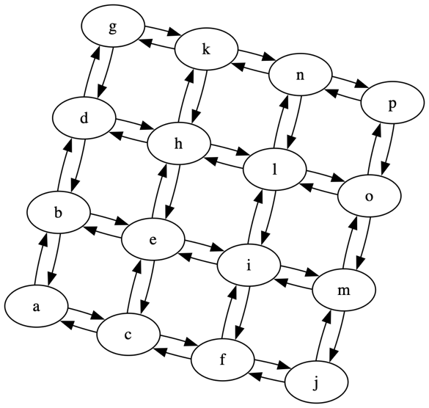
Example search
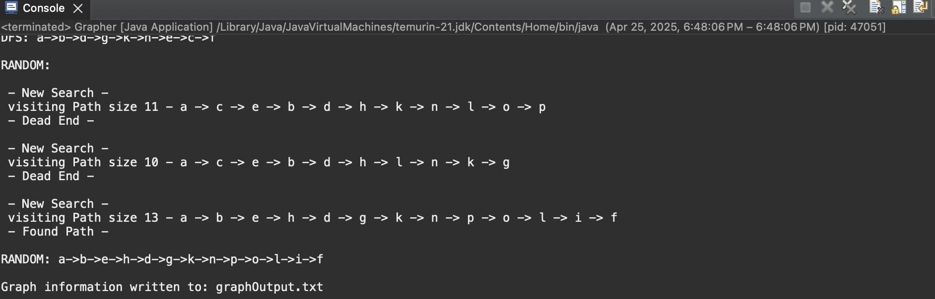

- You must make your code can search a path from a to c using the provided graph file at canvas
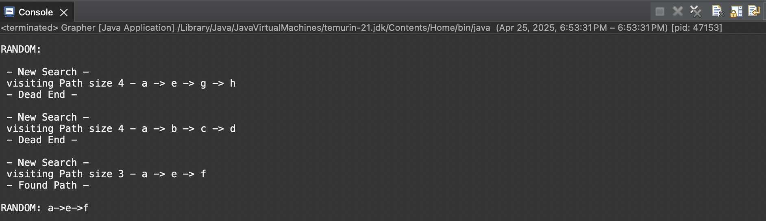
- You must run the search multiple times and output the search process to show the randomness of your search.

