Arithmetic means of crop and weed biomass (g/m $​^{−2}$) are in Figure 1.

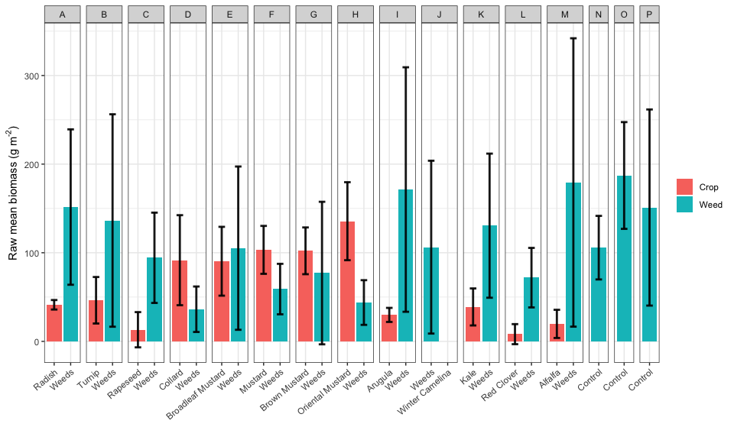

Figure 1: Arithmetic means of crop and weed biomass.

### Model diagnosis

Using ggResidpanel version 0.3.0 (Goode and Rey, 2019) for model diagnosis, no predictable pattern in the plots of residuals vs. predicted values suggests that the analysis models fit the data well (Figures 2 and 3).

### Crop biomass in response to treatment and weed biomass

fsb.crops <- fsb %>% filter(!treatment %in% c("N", "P", "O")) # Control treatments had no crop  
crops.lm <- lm(crop.biomass.g.per.sq.m ~ as.factor(block) + treatment + weed.biomass.g.per.sq.m, data = fsb.crops)  
resid_panel(crops.lm)

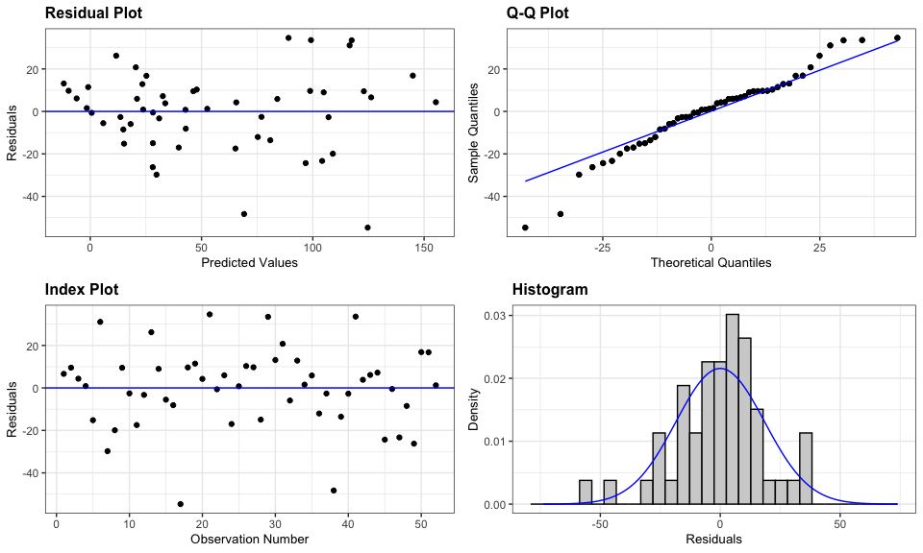

Figure 2: Diagnosis plot for the linear model of crop biomass responding to treatment and weed biomass

### Weed biomass in response to treatment and crop biomass

## Transforming crop.biomass.g.per.sq.m may be unnecessary because the Control treatment was mean to be zero for crop biomass   
# min(fsb$weed.biomass.g.per.sq.m[fsb$weed.biomass.g.per.sq.m > 0]) #9.24  
  
weeds.lm <- lm(log(weed.biomass.g.per.sq.m + 1) ~ as.factor(block) + treatment + crop.biomass.g.per.sq.m, data = fsb)  
  
resid_panel(weeds.lm)

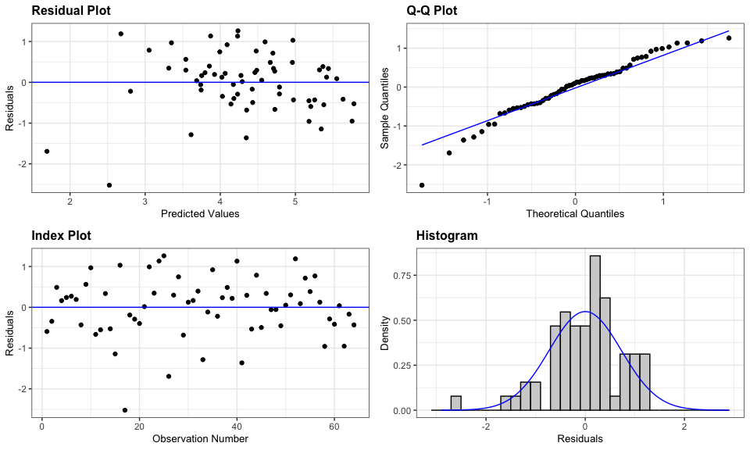

Figure 3: Diagnosis plot for the linear model of weed biomass responding to treatment and crop biomass

### Results

Weed suppression from different *Brassicacaea* species was comparable among each other and with the control treatments (Table 1), even though crop biomass differed by species (Table 2). Crop biomass was the strongest factor affecting weed biomass (Table 2).

Table 1: ANOVA for weed biomass response. Weed biomass was transformed with ln(x + 1) to maintain data normality.

| model term | df1 | df2 | F.ratio | p.value |
| --- | --- | --- | --- | --- |
| block | 3 | 44 | 7.846 | 0.0003 |
| treatment | 15 | 44 | 1.249 | 0.2744 |
| crop.biomass.g.per.sq.m | 1 | 44 | 11.055 | 0.0018 |

Table 2: ANOVA for crop biomass response. Crop biomass analyzed on the original scale.

| model term | df1 | df2 | F.ratio | p.value |
| --- | --- | --- | --- | --- |
| block | 3 | 35 | 7.086 | 0.0008 |
| treatment | 12 | 35 | 12.166 | <.0001 |
| weed.biomass.g.per.sq.m | 1 | 35 | 7.643 | 0.0090 |

Estimated marginal means of weed and crop biomass in each treatment are shown in Figures 4 and 5.

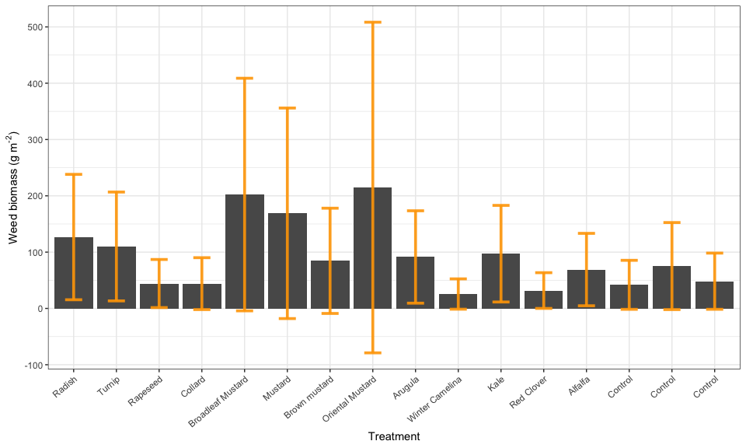

Figure 4: Estimated marginal means of weed biomass (back transformed from ln(x +1).

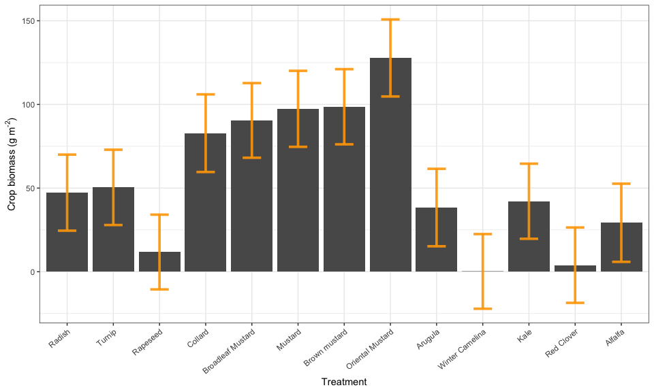

Figure 5: Estimated marginal means of crop biomass.

The arrow plots below (Figures 6 and 7) convey the same information with the bar charts, but quicker to make.

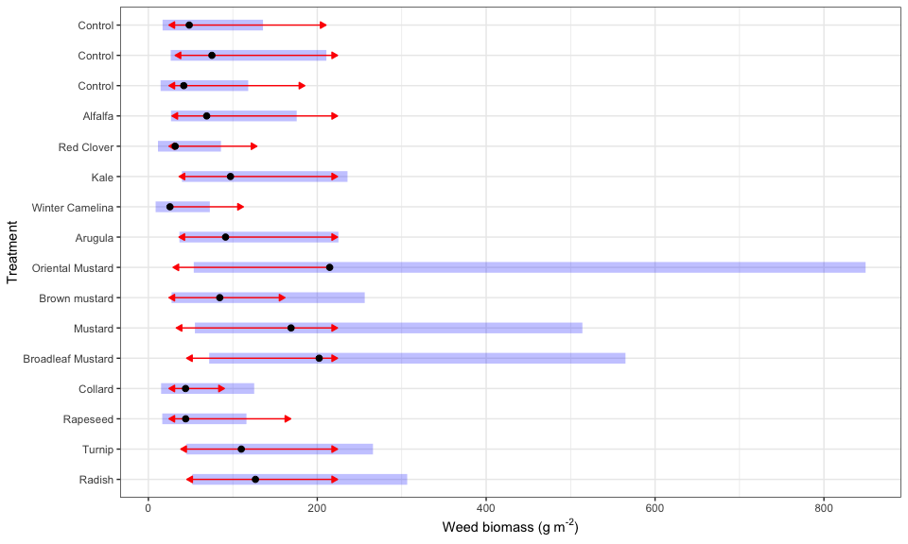

Figure 6: Estimated marginal means of weed biomass (back transformed from ln(x +1)). The black dots are the estimated marginal means. The blue bars indicate the estimated 95% confidence intervals. The arrows indicate whether two estimated means were significantly different. Overlapping arrows means non-significant difference.

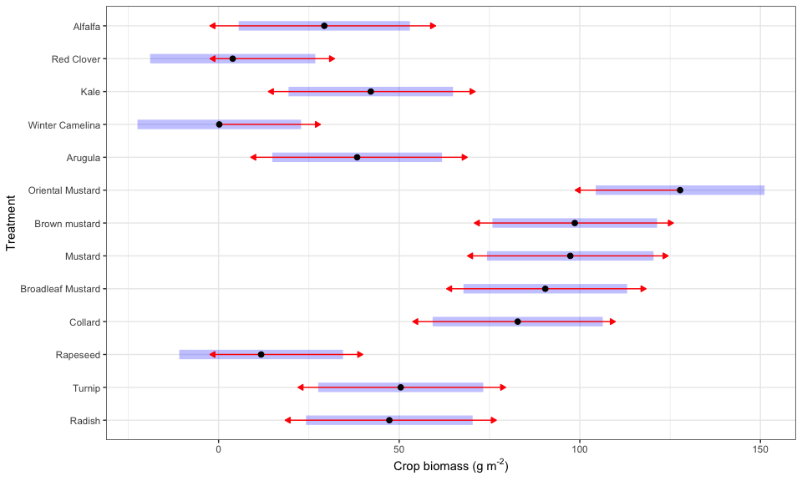

Figure 7: Estimated marginal means of crop biomass. The blue bars indicate the estimated 95% confidence intervals. The black dots are the estimated marginal means. The arrows indicate whether two estimated means were significantly different. Overlapping arrows means non-significant difference.