Arithmetic means of crop and weed biomass (g/m $​^{−2}$) are in Figure 1.  
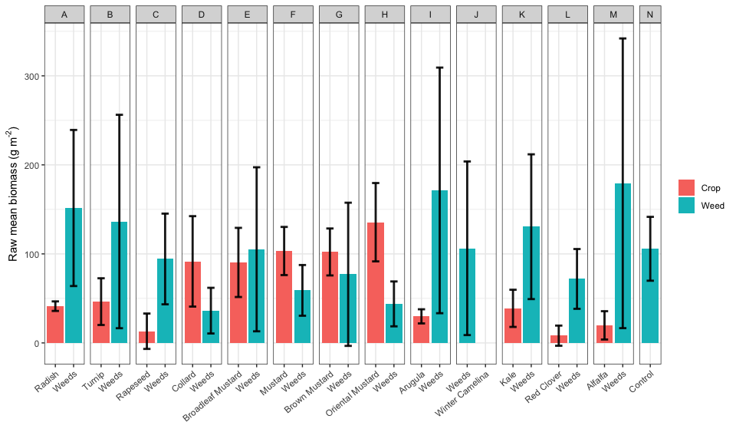

### Model diagnosis

Using ggResidpanel version 0.3.0 (Goode and Rey, 2019) for model diagnosis, no predictable pattern in the plots of residuals vs. predicted values suggests that the analysis models fit the data well (Figures ?? and 4), but AIC values of the ANCOVA models were lower than those of the ANOVA models: 486 vs. 494 for crop responses in ANCOVA vs. ANOVA; and 157 vs. 173 for weed biomass responses in ANCOVA vs ANOVA.

### Crop biomass in response to treatment and weed biomass

fsb.crops <- fsb %>% filter(!treatment %in% c("N", "P", "O")) # Control treatments had no crop  
crops.lm1 <- lm(crop.biomass.g.per.sq.m ~ as.factor(block) + treatment + weed.biomass.g.per.sq.m, data = fsb.crops)  
  
  
crops.lm2 <- lm(crop.biomass.g.per.sq.m ~ as.factor(block) + treatment , data = fsb.crops)  
resid_panel(crops.lm2)

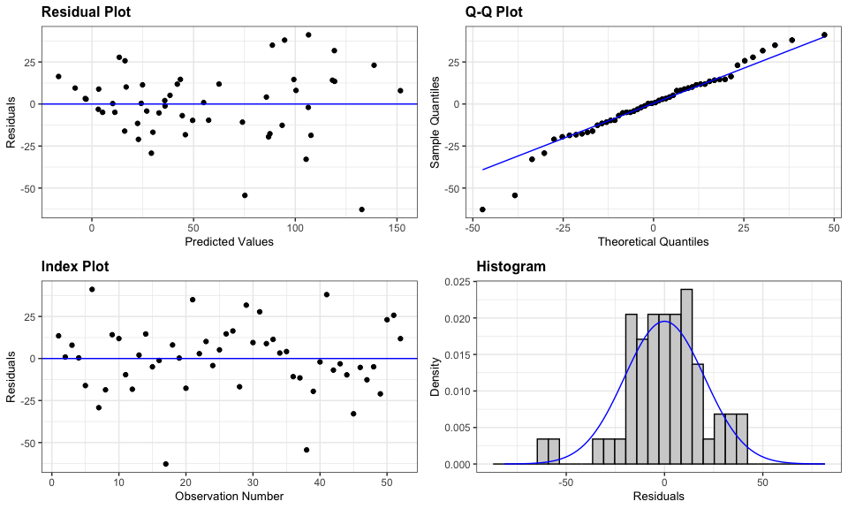

Figure 2: Diagnosis plot for the ANCOVA and ANOVA models of crop biomass responses

list(crops.lm1, crops.lm2) %>%   
 lapply(resid_panel, nrow = 2) %>%   
 wrap_plots() +  
 plot_annotation(tag_levels = "A")

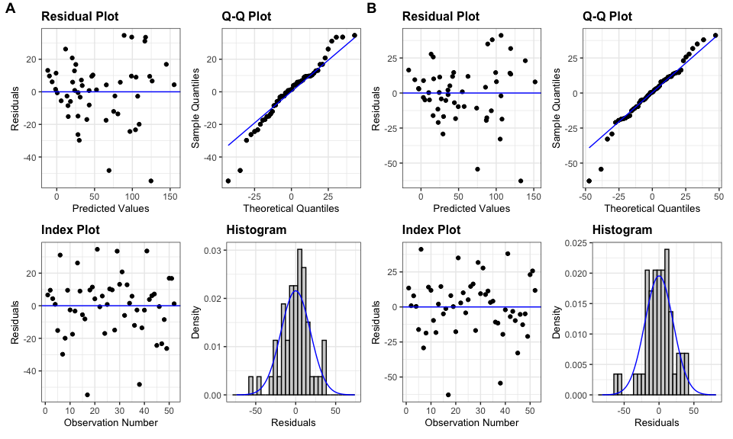

Figure 3: Diagnosis plot for the ANCOVA and ANOVA models of crop biomass responses

# AIC(crops.lm1, crops.lm2)

### Weed biomass in response to treatment and crop biomass - ANCOVA

fsb.weeds.N <- fsb %>% filter(!treatment %in% c("P", "O")) #retain the first control treatment only  
  
weeds.lm1 <- lm(log(weed.biomass.g.per.sq.m + 1) ~ as.factor(block) + treatment + crop.biomass.g.per.sq.m, data = fsb.weeds.N)  
  
  
weeds.lm2 <- lm(log(weed.biomass.g.per.sq.m + 1) ~ as.factor(block) + treatment , data = fsb.weeds.N)  
  
list(weeds.lm1, weeds.lm2) %>%   
 lapply(resid_panel, nrow = 2) %>%   
 wrap_plots() +  
 plot_annotation(tag_levels = "A")

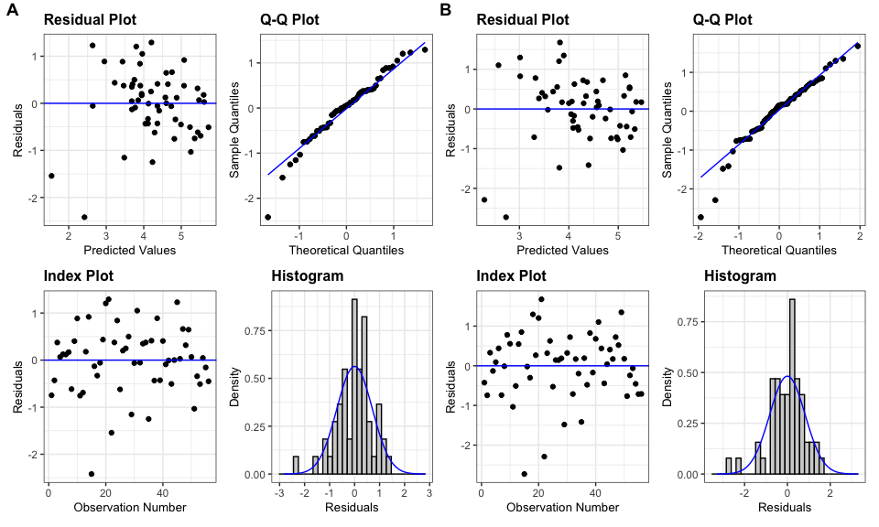

Figure 4: Diagnosis plot for the linear model of weed biomass responding to treatment and crop biomass

# AIC(weeds.lm1, weeds.lm2)

### Results

Weed suppression from different *Brassicacaea* species was comparable among each other and with the control treatments (Table 3), even though crop biomass differed by species (Table 4). Crop biomass was the strongest factor affecting weed biomass (Table 4).

Table 1: ANCOVA for weed biomass response. Weed biomass was transformed with ln(x + 1) to maintain data normality.

| model term | df1 | df2 | F.ratio | p.value |
| --- | --- | --- | --- | --- |
| block | 3 | 38 | 9.692 | 0.0001 |
| treatment | 13 | 38 | 1.533 | 0.1504 |
| crop.biomass.g.per.sq.m | 1 | 38 | 13.820 | 0.0006 |

Table 2: ANCOVA for crop biomass response. Crop biomass was analyzed on the original scale.

| model term | df1 | df2 | F.ratio | p.value |
| --- | --- | --- | --- | --- |
| block | 3 | 35 | 7.086 | 0.0008 |
| treatment | 12 | 35 | 12.166 | <.0001 |
| weed.biomass.g.per.sq.m | 1 | 35 | 7.643 | 0.0090 |

Table 3: ANOVA for weed biomass response. Weed biomass was transformed with ln(x + 1) to maintain data normality.

| model term | df1 | df2 | F.ratio | p.value |
| --- | --- | --- | --- | --- |
| block | 3 | 39 | 4.676 | 0.0069 |
| treatment | 13 | 39 | 1.483 | 0.1678 |

Table 4: ANOVA for crop biomass response. Crop biomass was analyzed on the original scale.

| model term | df1 | df2 | F.ratio | p.value |
| --- | --- | --- | --- | --- |
| block | 3 | 36 | 4.013 | 0.0146 |
| treatment | 12 | 36 | 13.005 | <.0001 |

Estimated marginal means of weed and crop biomass in each treatment are shown in Figures 5 and 6.

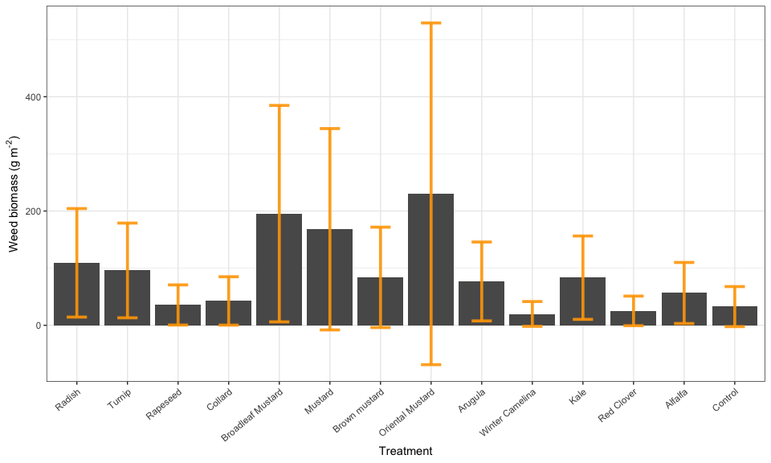

Figure 5: Estimated marginal means of weed biomass (back transformed from ln(x +1).

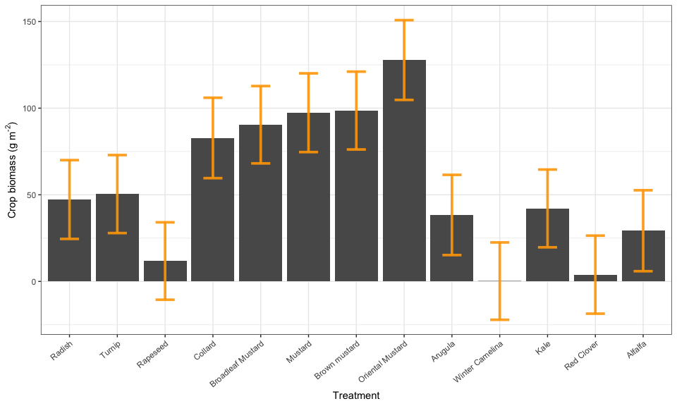

Figure 6: Estimated marginal means of crop biomass.

The arrow plots below (Figures 7 and 8) convey the same information with the bar charts, but are quicker to make.

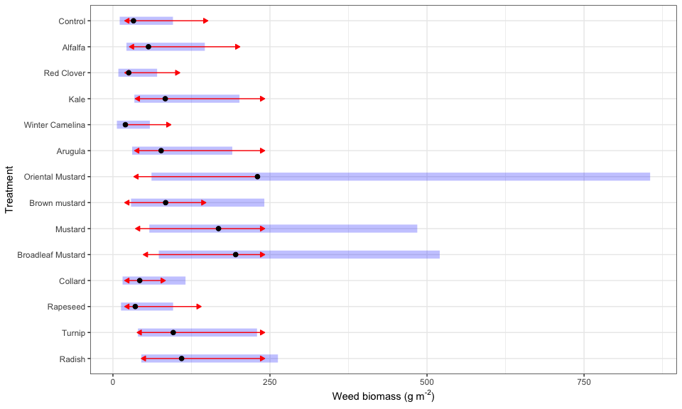

Figure 7: Estimated marginal means of weed biomass (back transformed from ln(x +1)). The black dots are the estimated marginal means. The blue bars indicate the estimated 95% confidence intervals. The arrows indicate whether two estimated means were significantly different. Overlapping arrows means non-significant difference.

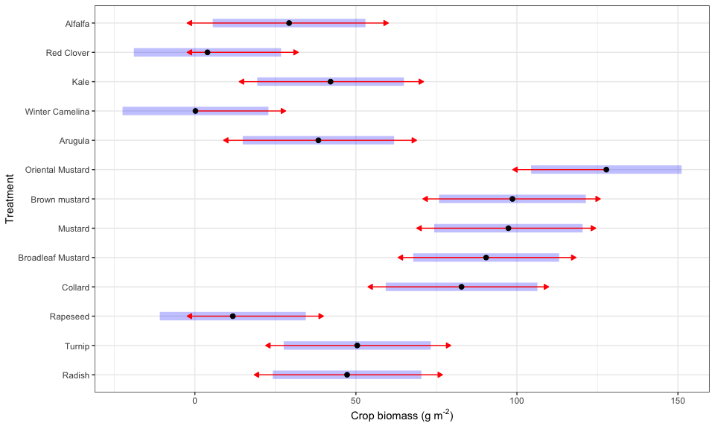

Figure 8: Estimated marginal means of crop biomass. The blue bars indicate the estimated 95% confidence intervals. The black dots are the estimated marginal means. The arrows indicate whether two estimated means were significantly different. Overlapping arrows means non-significant difference.