The data in the model projection was used in this simulation. 100 iterations of simulation were run per each rotation crossed with corn weed management regime, with non-manipulated seed production.

# event sequence: seed dropped - chisel - overwinter - field cultivator - emerge - survive - new seed  
  
# create a function   
# vec: starting seed column  
# poh: post-harvest tillage  
# ow: over winter seed survival  
# prt: pre-planting-tillage  
# em: emergence  
# sv: seed survival rate and seedling to maturity success rate  
# seed: fecundity  
  
rot_2year_conv <- function(vec, poh_C, ow_C, prt_C, em_C, sv_C, seed_C,  
 poh_S, ow_S, prt_S, em_S, sv_S, seed_S){  
  
 # corn phase dynamics   
 after_corn <- ow_C %*% poh_C %*% seed_C %*% sv_C %*% em_C %*% prt_C %*% vec   
# soybean phase dynamics  
  
 after_soy <- ow_S %*% poh_S %*% seed_S %*% sv_S %*% em_S %*% prt_S %*% after_corn   
  
 after_soy  
}  
  
rot_2year_low <- function(vec, poh_C, ow_C, prt_C, em_C, sv_C, seed_C,  
 poh_S, ow_S, prt_S, em_S, sv_S, seed_S){  
  
  
 # corn phase dynamics   
 after_corn <- ow_C %*% poh_C %*% seed_C %*% sv_C %*% em_C %*% prt_C %*% vec   
# soybean phase dynamics  
  
 after_soy <- ow_S %*% poh_S %*% seed_S %*% sv_S %*% em_S %*% prt_S %*% after_corn   
  
 after_soy  
}

##### with corn under conventional weed management {-}  
t <- 100  
N_2yr_conv <- list() # blank data frame to save loop output   
N_2yr_conv[[1]] <- starting_point   
  
for (i in 2:t) {   
 N_2yr_conv[[i]] = rot_2year_conv(vec = N_2yr_conv[[i-1]],  
 poh_C = fall_tillage$C2_conv,  
 ow_C = overwinter$C2_conv,  
 prt_C = spring_tillage$C2_conv,  
 em_C = emergence$C2_conv,  
 sv_C = summer_survival$C2_conv,  
 seed_C = fecundity18$C2_conv,  
   
 #soybean dynamics   
 poh_S = fall_tillage$S2_conv,  
 ow_S = overwinter$S2_conv,  
 prt_S = spring_tillage$S2_conv,  
 em_S = emergence$S2_conv,  
 sv_S = summer_survival$S2_conv,  
 seed_S = fecundity18$S2_conv)  
}  
  
N_2yr_conv_df <- N_2yr_conv %>%   
 unlist(recursive = FALSE) %>%  
 data.frame() %>%  
 dplyr::rename(counts = ".") %>%  
 dplyr::mutate(category = rep(c("top", "bottom", "cohort_1", "cohort_2", "cohort_3", "cohort_4", "cohort_5", "cohort_6"),t)) %>%  
 filter(category %in% c("top", "bottom")) %>%  
 unnest(cols = everything() ) %>%  
 mutate(cycle_no = rep(1:t, each = 2)) %>%  
 group_by(category) %>%  
 mutate(lambda_cycle = counts/lag(counts),  
 lambda_annualized = sqrt(lambda_cycle),  
 Rotation = "2-year",  
 Corn_weed_management = "conventional") %>%  
 na.omit()

##### with corn under low herbicide weed management {-}  
N_2yr_low <- list() # blank dataframe to save loop output   
  
N_2yr_low[[1]] <- starting_point   
for (i in 2:t) {   
 N_2yr_low[[i]] = rot_2year_low(vec = N_2yr_low[[i-1]],  
 poh_C = fall_tillage$C2_low,  
 ow_C = overwinter$C2_low,  
 prt_C = spring_tillage$C2_low,  
 em_C = emergence$C2_low,  
 sv_C = summer_survival$C2_low,  
 seed_C = fecundity18$C2_low,  
   
 #soybean dynamics   
 poh_S = fall_tillage$S2_low,  
 ow_S = overwinter$S2_low,  
 prt_S = spring_tillage$S2_low,  
 em_S = emergence$S2_low,  
 sv_S = summer_survival$S2_low,  
 seed_S = fecundity18$S2_low)  
}  
  
N_2yr_low_df <- N_2yr_low %>%   
 unlist(recursive = FALSE) %>%  
 data.frame() %>%  
 dplyr::rename(counts = ".") %>%  
 dplyr::mutate(category = rep(c("top", "bottom", "cohort_1", "cohort_2", "cohort_3", "cohort_4", "cohort_5", "cohort_6"),t)) %>%  
 filter(category %in% c("top", "bottom")) %>%  
 unnest(cols = everything() ) %>%  
 mutate(cycle_no = rep(1:t, each = 2)) %>%  
 group_by(category) %>%  
 mutate(lambda_cycle = counts/lag(counts),  
 lambda_annualized = sqrt(lambda_cycle),  
 Rotation = "2-year",  
 Corn_weed_management = "low") %>%  
 na.omit()

rot_3year_conv <- function(vec, poh_C, ow_C, prt_C, em_C, sv_C, seed_C,   
 poh_S, ow_S, prt_S, em_S, sv_S, seed_S ,  
 poh_O, ow_O, prt_O, em_O, sv_O, seed_O){  
   
  
  
  
# corn phase dynamics   
 after_corn <- ow_C %*% poh_C %*% seed_C %*% sv_C %*% em_C %*% prt_C %*% vec   
 # soybean phase dynamics  
 after_soy <- ow_S %*% poh_S %*% seed_S %*% sv_S %*% em_S %*% prt_S %*% after_corn  
# oat phase dynamics  
 after_oat <- ow_O %*% poh_O %*% seed_O %*% sv_O %*% em_O %*% prt_O %*% after_soy   
   
 after_oat  
}  
  
### low herbicide weed management  
## Manipulation note: if cohorts 1 through 3 were reduced to rlnorm(1, 2.65, 0.89), alphas are around 0.5 --> super "safe", but hard  
## cohorts 1 through 3 at rlnorm(1, 5.2, 0.51): more realistic  
rot_3year_low <- function(vec, poh_C, ow_C, prt_C, em_C, sv_C, seed_C,   
 poh_S, ow_S, prt_S, em_S, sv_S, seed_S ,  
 poh_O, ow_O, prt_O, em_O, sv_O, seed_O){  
   
  
  
# corn phase dynamics   
 after_corn <- ow_C %*% poh_C %*% seed_C %*% sv_C %*% em_C %*% prt_C %*% vec   
 # soybean phase dynamics  
 after_soy <- ow_S %*% poh_S %*% seed_S %*% sv_S %*% em_S %*% prt_S %*% after_corn  
# oat phase dynamics  
 after_oat <- ow_O %*% poh_O %*% seed_O %*% sv_O %*% em_O %*% prt_O %*% after_soy   
   
 after_oat  
}

##### with corn under conventional weed management {-}  
N_3yr_conv <- list() # blank dataframe to save loop output   
  
N_3yr_conv[[1]] <- starting_point   
  
  
for (i in 2:t) {   
 N_3yr_conv[[i]] = rot_3year_conv(vec = N_3yr_conv[[i-1]],  
 poh_C = fall_tillage$C3_conv,  
 ow_C = overwinter$C3_conv,  
 prt_C = spring_tillage$C3_conv,  
 em_C = emergence$C3_conv,  
 sv_C = summer_survival$C3_conv,  
 seed_C = fecundity18$C3_conv,  
   
 #soybean dynamics   
 poh_S = fall_tillage$S3_conv,  
 ow_S = overwinter$S3_conv,  
 prt_S = spring_tillage$S3_conv,  
 em_S = emergence$S3_conv,  
 sv_S = summer_survival$S3_conv,  
 seed_S = fecundity18$S3_conv,  
   
 #oat dynamics   
 poh_O = fall_tillage$O3_conv,  
 ow_O = overwinter$O3_conv,  
 prt_O = spring_tillage$O3_conv,  
 em_O = emergence$O3_conv,  
 sv_O = summer_survival$O3_conv,  
 seed_O = fecundity18$O3_conv)  
}  
  
N_3yr_conv_df <- N_3yr_conv %>%   
 unlist(recursive = FALSE) %>%  
 data.frame() %>%  
 dplyr::rename(counts = ".") %>%  
 dplyr::mutate(category = rep(c("top", "bottom", "cohort_1", "cohort_2", "cohort_3", "cohort_4", "cohort_5", "cohort_6"),t)) %>%  
 filter(category %in% c("top", "bottom")) %>%  
 unnest(cols = everything() ) %>%  
 mutate(cycle_no = rep(1:t, each = 2)) %>%  
 group_by(category) %>%  
 mutate(lambda_cycle = counts/lag(counts),  
 lambda_annualized = nthroot(lambda_cycle,3),  
 Rotation = "3-year",  
 Corn_weed_management = "conventional") %>%  
 na.omit()

##### with corn under low herbicide weed management {-}   
N_3yr_low <- list() # blank dataframe to save loop output   
  
N_3yr_low[[1]] <- starting_point   
  
  
for (i in 2:t) {   
 N_3yr_low[[i]] = rot_3year_low(vec = N_3yr_low[[i-1]],  
 poh_C = fall_tillage$C3_conv,  
 ow_C = overwinter$C3_low,  
 prt_C = spring_tillage$C3_low,  
 em_C = emergence$C3_low,  
 sv_C = summer_survival$C3_low,  
 seed_C = fecundity18$C3_low,  
   
 #soybean dynamics   
 poh_S = fall_tillage$S3_low,  
 ow_S = overwinter$S3_low,  
 prt_S = spring_tillage$S3_low,  
 em_S = emergence$S3_low,  
 sv_S = summer_survival$S3_low,  
 seed_S = fecundity18$S3_low,  
   
 #oat dynamics   
 poh_O = fall_tillage$O3_low,  
 ow_O = overwinter$O3_low,  
 prt_O = spring_tillage$O3_low,  
 em_O = emergence$O3_low,  
 sv_O = summer_survival$O3_low,  
 seed_O = fecundity18$O3_low)  
}  
  
N_3yr_low_df <- N_3yr_low %>%   
 unlist(recursive = FALSE) %>%  
 data.frame() %>%  
 dplyr::rename(counts = ".") %>%  
 dplyr::mutate(category = rep(c("top", "bottom", "cohort_1", "cohort_2", "cohort_3", "cohort_4", "cohort_5", "cohort_6"),t)) %>%  
 filter(category %in% c("top", "bottom")) %>%  
 unnest(cols = everything() ) %>%  
 mutate(cycle_no = rep(1:t, each = 2)) %>%  
 group_by(category) %>%  
 mutate(lambda_cycle = counts/lag(counts),  
 lambda_annualized = nthroot(lambda_cycle,3),  
 Rotation = "3-year",  
 Corn_weed_management = "low") %>%  
 na.omit()

### conventional weed management  
rot_4year_conv <- function(vec, poh_C, ow_C, prt_C, em_C, sv_C, seed_C,   
 poh_S, ow_S, prt_S, em_S, sv_S, seed_S ,  
 poh_O, ow_O, prt_O, em_O, sv_O, seed_O,  
 poh_A, ow_A, prt_A, em_A, sv_A, seed_A){  
   
  
# corn phase dynamics   
 after_corn <- ow_C %*% poh_C %*% seed_C %*% sv_C %*% em_C %*% prt_C %*% vec   
 # soybean phase dynamics  
 after_soy <- ow_S %*% poh_S %*% seed_S %*% sv_S %*% em_S %*% prt_S %*% after_corn  
# oat phase dynamics  
 after_oat <- ow_O %*% poh_O %*% seed_O %*% sv_O %*% em_O %*% prt_O %*% after_soy   
# alfalfa phase dynamics  
after_alfalfa <- ow_A %*% poh_A %*% seed_A %*% sv_A %*% em_A %*% prt_A %*% after_oat   
   
 after_alfalfa  
}  
  
### low herbicide weed management  
rot_4year_low <- function(vec, poh_C, ow_C, prt_C, em_C, sv_C, seed_C,   
 poh_S, ow_S, prt_S, em_S, sv_S, seed_S ,  
 poh_O, ow_O, prt_O, em_O, sv_O, seed_O,  
 poh_A, ow_A, prt_A, em_A, sv_A, seed_A){  
   
  
  
# corn phase dynamics   
 after_corn <- ow_C %*% poh_C %*% seed_C %*% sv_C %*% em_C %*% prt_C %*% vec   
 # soybean phase dynamics  
 after_soy <- ow_S %*% poh_S %*% seed_S %*% sv_S %*% em_S %*% prt_S %*% after_corn  
# oat phase dynamics  
 after_oat <- ow_O %*% poh_O %*% seed_O %*% sv_O %*% em_O %*% prt_O %*% after_soy   
# alfalfa phase dynamics  
 after_alfalfa <- ow_A %*% poh_A %*% seed_A %*% sv_A %*% em_A %*% prt_A %*% after_oat   
   
 after_alfalfa  
}

##### with corn under conventional weed management {-}  
N_4yr_conv <- list() # blank dataframe to save loop output   
  
N_4yr_conv[[1]] <- starting_point   
  
for (i in 2:t) {   
 N_4yr_conv[[i]] = rot_4year_conv(vec = N_4yr_conv[[i-1]],  
 poh_C = fall_tillage$C4_conv,  
 ow_C = overwinter$C4_conv,  
 prt_C = spring_tillage$C4_conv,  
 em_C = emergence$C4_conv,  
 sv_C = summer_survival$C4_conv,  
 seed_C = fecundity18$C4_conv,  
   
 #soybean dynamics   
 poh_S = fall_tillage$S4_conv,  
 ow_S = overwinter$S4_conv,  
 prt_S = spring_tillage$S4_conv,  
 em_S = emergence$S4_conv,  
 sv_S = summer_survival$S4_conv,  
 seed_S = fecundity18$S4_conv,  
   
 #oat dynamics   
 poh_O = fall_tillage$O4_conv,  
 ow_O = overwinter$O4_conv,  
 prt_O = spring_tillage$O4_conv,  
 em_O = emergence$O4_conv,  
 sv_O = summer_survival$O4_conv,  
 seed_O = fecundity18$O4_conv,  
   
 #alfalfa dynamics   
 poh_A = fall_tillage$A4_conv,  
 ow_A = overwinter$A4_conv,  
 prt_A = spring_tillage$A4_conv,  
 em_A = emergence$A4_conv,  
 sv_A = summer_survival$A4_conv,  
 seed_A = fecundity18$A4_conv)  
}  
  
N_4yr_conv_df <- N_4yr_conv %>%   
 unlist(recursive = FALSE) %>%  
 data.frame() %>%  
 dplyr::rename(counts = ".") %>%  
 dplyr::mutate(category = rep(c("top", "bottom", "cohort_1", "cohort_2", "cohort_3", "cohort_4", "cohort_5", "cohort_6"),t)) %>%  
 filter(category %in% c("top", "bottom")) %>%  
 unnest(cols = everything() ) %>%  
 mutate(cycle_no = rep(1:t, each = 2)) %>%  
 group_by(category) %>%  
 mutate(lambda_cycle = counts/lag(counts),  
 lambda_annualized = nthroot(lambda_cycle,4),  
 Rotation = "4-year",  
 Corn_weed_management = "conventional") %>%  
 na.omit()

##### with corn under low herbicide weed management {-}   
N_4yr_low <- list() # blank dataframe to save loop output   
  
N_4yr_low[[1]] <- starting_point   
  
for (i in 2:t) {   
 N_4yr_low[[i]] = rot_4year_low(vec = N_4yr_low[[i-1]],  
 poh_C = fall_tillage$C4_low,  
 ow_C = overwinter$C4_low,  
 prt_C = spring_tillage$C4_low,  
 em_C = emergence$C4_low,  
 sv_C = summer_survival$C4_low,  
 seed_C = fecundity18$C4_low,  
   
 #soybean dynamics   
 poh_S = fall_tillage$S4_low,  
 ow_S = overwinter$S4_low,  
 prt_S = spring_tillage$S4_low,  
 em_S = emergence$S4_low,  
 sv_S = summer_survival$S4_low,  
 seed_S = fecundity18$S4_low,  
   
 #oat dynamics   
 poh_O = fall_tillage$O4_low,  
 ow_O = overwinter$O4_low,  
 prt_O = spring_tillage$O4_low,  
 em_O = emergence$O4_low,  
 sv_O = summer_survival$O4_low,  
 seed_O = fecundity18$O4_low,  
   
 #alfalfa dynamics   
 poh_A = fall_tillage$A4_low,  
 ow_A = overwinter$A4_low,  
 prt_A = spring_tillage$A4_low,  
 em_A = emergence$A4_low,  
 sv_A = summer_survival$A4_low,  
 seed_A = fecundity18$A4_low)  
}  
  
N_4yr_low_df <- N_4yr_low %>%   
 unlist(recursive = FALSE) %>%  
 data.frame() %>%  
 dplyr::rename(counts = ".") %>%  
 dplyr::mutate(category = rep(c("top", "bottom", "cohort_1", "cohort_2", "cohort_3", "cohort_4", "cohort_5", "cohort_6"),t)) %>%  
 filter(category %in% c("top", "bottom")) %>%  
 unnest(cols = everything() ) %>%  
 mutate(cycle_no = rep(1:t, each = 2)) %>%  
 group_by(category) %>%  
 mutate(lambda_cycle = counts/lag(counts),  
 lambda_annualized = nthroot(lambda_cycle,4),  
 Rotation = "4-year",  
 Corn_weed_management = "low") %>%  
 na.omit()

## Warning: Removed 982 rows containing missing values (geom_point).

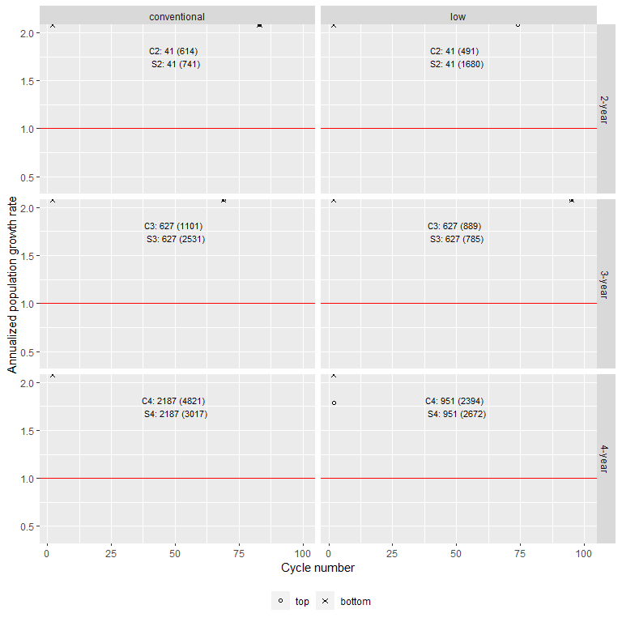

Figure 1: Population growth rates over 100 rotational cycles. All simulations started with a seed column of 10000 female seeds in the top 0 - 2 cm soil stratum and 0 female seed in the bottom 2 - 18 cm soil stratum. The simulation applied weed management on cohorts 1 through 3 in corn and soybean only. The relationships of aboveground mass and fecundity in Nguyen and Liebman (2022b) were used to estimate cohort-based fecundity. In corn and soybean, only the fecundity of cohorts 1 through 3 fecundity were manipulated to find the seed allowance in the corn and soybean environments, the fecundity of cohorts 4 and beyond were kept as they were measured from 2018. Each panel was annotated with the average fecundity allowance for the first three plant cohorts and the whole crop phase. The red horizontal line marks lambda = 1.

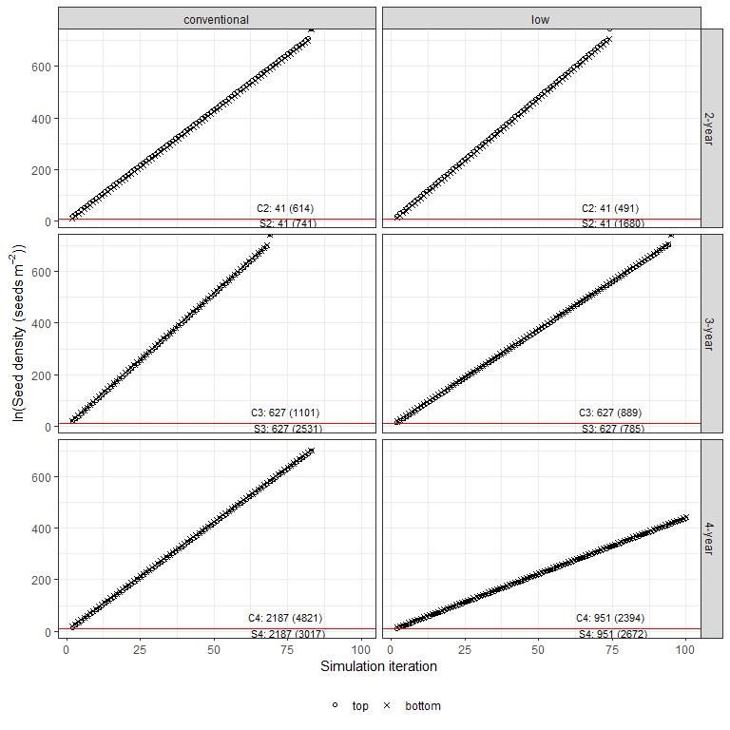

Figure 2: Population size at the end of a rotation cycle over 100 rotational cycles (the 2-year rotation ended at the soybean phase, the 3-year rotation ended at the oat phase, and the 4-year rotation ended at the alfalfa phase). All simulations started with a seed column of 10000 female seeds in the top 0 - 2 cm soil stratum and 0 female seed in the bottom 2 - 18 cm soil stratum. The simulation applied weed management on cohorts 1 through 3 in corn and soybean only. The relationships of aboveground mass and fecundity in Nguyen and Liebman (2022b) were used to estimate cohort-based fecundity. In corn and soybean, only the fecundity of cohorts 1 through 3 fecundity were manipulated to find the seed allowance in the corn and soybean environments, the fecundity of cohorts 4 and beyond were kept as they were measured from 2018. Each panel was annotated with the average fecundity thresholds for the first three waterhemp cohorts and the whole crop phase. The red horizontal line marks lambda = 1.