Effects of crop rotation on common waterhemp population dynamics: prospective and retrospective analyses

# Introduction

In arable land, a low-density weed seedbank is highly desired. A weed species’ seedbank persistence is often influenced by multiple factors, including burial depth, tillage regime, and crop environment (Steckel et al., 2007). Common waterhemp (*Amaranthus tuberculatus* (Moq.) J.D. Sauer) is an agronomically challenging weed species (Johnson et al., 2009; Prince et al., 2012) whose high fecundity, high relative growth rate (Heneghan and Johnson, 2017), rapid herbicide resistance development (Tranel, 2021), and extended emergence pattern (Buhler and Hartzler, 2001) can help maintain an abundant seedbank (Davis, 2008; Korres et al., 2018).

To increase labor use efficiency in waterhemp management, it is helpful to know possible choke points throughout the weed’s life cycle, where intervention can substantially reduce the population growth rate. Following the population in full life cycles in different crop environments can help identify the choke points where management could be focused (Caswell, 2001). Combining demographic parameters from multiple sources and organizing them in different scenarios can facilitate the evaluation of population responses without extensive field measurement (Caswell, 2001; Davis, 2002; Ullrich, 2000). In addition, retrospective perturbation analysis can be used to examine how a population would change if changes occurred at different points throughout the species’ life cycle (Caswell, 2001; Davis, 2002; Ullrich, 2000).

Interseeding red clover (*Trifolium pratense* L.) with wheat (*Triticum aestivum* L.) followed by spring tillage delayed and reduced giant foxtail (*Setaria faberi* Herrm ) seedling emergence as compared with three other interseeding and tillage timing combinations by fall tillage (Davis and Liebman, 2003). Cool-season crops, such as oat (*Avena sativa* L.), red clover can be planted in early spring, and alfalfa (*Medicago sativa* L.), can be planted in early spring or the fall and overwinter to limit waterhemp’s exposure to sunlight at the time of its emergence. Our search of the current literature did not return any information on waterhemp’s population dynamics in other cool-season crops, so we measured the following characteristics of waterhemp in cool-season crops environments: plant fecundity (Nguyen and Liebman, 2022a), soil seedbank density, the timing of seedling emergence and resultant densities, and plant survival.

Extending a conventional 2-year rotation of corn and soybean to contain oat, red clover, and alfalfa effectively maintained a weed community at an abundance level that did not coincide with a reduction in crop yields (Nguyen and Liebman, 2022b). The effects of cropping system diversification on common waterhemp abundance were not clearly defined (Nguyen and Liebman, 2022b), even though waterhemp’s reproductive potentials could be reduced without heavy reliance on herbicides (Nguyen and Liebman, 2022a). A heuristic model for waterhemp population dynamics in corn (*Zea mays* L.) and soybean (*Glycine max* (L.) Merr.) (two warm-season annual crops) with or without a rye (*Secale cereale* L.) cover crop in between the corn and soybean phases indicated that the cover crop would provide minimal suppression of waterhemp population densities. To explore other options for regulating waterhemp population dynamics, we conducted a prospective analysis using a population matrix approach (Caswell, 2001; Davis, 2002; Ullrich, 2000). In addition, we employed a retrospective perturbation analysis to examine how waterhemp population dynamics would change if life-history parameters at different points throughout the species’ life cycle were altered.

We employed a periodic matrix model (Caswell, 2001; Cousens and Mortimer, 1995) to study waterhemp population dynamics to accommodate the examination of the effect of various events, i.e., crop management activities, that occur throughout the life cycle of waterhemp on the population change rate, . We used the general equation of (Caswell, 2001) to study from one period to another. The waterhemp populations in our study were depth-structured for the soil seedbank and cohort-structured for plants to accommodate the variation in seed survival (Buhler and Hartzler, 2001; Yenish et al., 1992) and emergence rates (Werle et al., 2014) from different depths, plant survival rates, plant size, and fecundity of different cohorts (Hartzler et al., 2004; Nordby and Hartzler, 2004).

Elasticity analysis, which provides a closer look at how changes in () would respond to proportional perturbations in the lower-level demographic parameters (represented by the sub-annual matrix that described the sub-annual responses of the population to weed management practices), can help in evaluating to each sub-annual intervention. In addition, since elasticity analysis involves each element of a matrix , it is more convenient than sensitivity analysis in identifying the contribution of each to especially when a matrix involves more than one non-zero element.

This study examined how waterhemp population dynamics might change in cool-season crops suitable for the Midwestern USA climates, such as oat, red clover, and alfalfa. The modeling approach here combines demographic parameters from the literature and empirical data from our fieldwork. We hypothesized that extending a conventional 2-year rotation of corn and soybean with cool-season crops could accelerate the depletion of waterhemp seedbanks in the soil.

# Materials and methods

### Experiment design

To study how common waterhemp’s demography differs in three cropping systems suitable for the Midwestern USA, we used a factorial experiment design with nine crop identities crossed with two weed management regimes. Crop identity was assigned to main plots and comprised the combination of crop species name and rotation system. The different weed management regimes were assigned to split plots and comprised conventional versus low herbicide regimes applied to the corn phase of each of three rotation systems. The rotation systems used in this study included a 2-year (corn-soybean) rotation, a 3-year (corn - soybean - oat (*Avena sativa* L.)) intercropped with red clover (*Trifolium pratense* L.) rotation, and a 4-year (corn - soybean - oat intercropped with alfalfa (*Medicago sativa* L.) - alfalfa] rotation. There were four replications of each crop identity x herbicide regime combination. Field plots were located at the Iowa State University Agricultural Engineering and Agronomy Research Farm in Boone County, Iowa, USA.

The general experiment design and diagram were provided by Nguyen and Liebman (2022a), but an updated diagram (Figure 1) includes tillage regimes used for each treatment. Contrasting herbicide regimes were used for corn at the experiment site from 2008 through 2020; soybean plots in the contrasting weed management regimes were treated with different herbicides during 2008-2016 period but with the same herbicide regime during 2017-2020 period. During the period of the present study, data were collected in each experimental unit (eu) to accommodate the different weed management programs used in the corn phase of all crop rotations.

*Figure 1: Conceptual diagram of the three rotation systems compared within the experiment. A cycle of four calendar years is shown. Tillage regimes are symbolized with arrows: light, black ahead of crop sowing for field cultivator and medium, blue and bold orange after crop harvest for chisel and moldboard plowing, respectively. Crops are color-coded and displayed for the approximate months they were in the field. The emergence and establishment of common waterhemp plants are illustrated with black symbols. Grey plants shown in oat or alfalfa’s first year were physically controlled by crop harvest operations. Grey plants shown in alfalfa’s second year were physically suppressed three to four times by hay harvest. Alfalfa hay was harvested when approximately 5% of the plants flowered. Red clover in the O3 treatment and alfalfa in the A4 treatment were terminated in the winter before growing corn in the following year, so the dark green bar in the 3-year rotation represents volunteer red clover, and the light green bar in the 4-year rotation represents the living alfalfa residue in the C4 treatment.*

### Data collection and analysis

The current demographic information presented here is only for female waterhemp seeds and plants because 1) waterhemp is a dioecious species with a 1:1 sex ratio (Costea et al., 2005; Montgomery et al., 2021; Montgomery et al., 2019), 2) only female individuals are bearing seeds (Costea et al., 2005), and 3) pollen grains are abundantly available during reproduction (Liu et al., 2012). All plant characteristics were reported for each cohort, and seedbank densities were reported for two soil strata: 0 - 2 cm and 2 - 20 cm.

#### Seed densities and seed fates in the soil seedbank

Nine groups of four 20-cm deep soil cores arranged in a 3 x 3 grid were collected in the fall of 2019 from each experimental unit (eu). Each soil core was cut into two sections, the top 2 cm, and the bottom 18 cm. No deeper sampling was conducted because the tillage regimes applied at the experiment affected the top 0 - 20 cm of the soil. All the 0-2 cm sections in each (eu) were packed separately from all the 2-20 cm sections, so each eu yielded two data points, one for each of the two soil strata. Seeds were separated from the soil materials and plant residues using elutriation and floatation. Clean seeds were placed on germination paper imbibed with distilled water in Petri dishes and incubated in 28/18 degree Celsius light/dark - 18/8 hour night/day for five days. Proportions of dormant, readily germinable, and dead seeds were recorded: germinated as readily germinable; firm and unyielding to forceps pressure as dormant; and yielding to forceps pressure as dead (Borza et al., 2007). Readily germinable and dormant seeds were grouped as viable and used to calculate the emergence proportion (details on how the 2019 fall soil seedbank sample was used with data for 2020 seedling emergence to determine the emergence proportion is provided in the *Parameterization* section).

#### Seedling emergence pattern and timing

In the 2019 field season, non-destructive emergence surveys were conducted once every two to three weeks (weather permitting) in eight quadrats per eu. Seedlings were marked with color-coded toothpicks for cohort identification. Within an eu, seedlings in the same cohort were marked with the same toothpick color. Six cohorts of plants were followed from seedling to senescence.

In the 2020 field season, destructive emergence surveys were conducted in eight quadrats per eu. Seedlings were clipped at the base of the plant without disturbing the soil. With the intention of evaluating the proportion of seed germinated from the top 2 cm layer of the soil, eight to ten cohorts (depending on the crop environments) were recorded.

The number of seedlings in each cohort was converted to densities (seedlings/m). The dates of first emergence detection in a crop identity were noted as the date that cohort 1 emerged in that crop identity.

#### Statistical analysis of the measured parameters

All the response variables were analyzed with two-factorial mixed-effect models, in which crop identity (crop species in each rotation) was the main-plot effect, corn weed management was the split-plot effect, and cohort identity was the covariance. The response variables were transformed as needed to correct heteroscedasticity.  
For the emergence timing evaluation, a two-factorial model with crop species, instead of crop identity, being the main-plot factor and the corn weed management being the split-plot factor, was fitted on Julian’s dates of the first emergence because of small sample sizes in cohorts 2 and beyond. We feel that a slight modification of the statistical model was acceptable because we were interested in the difference in waterhemp emergence in different crop species environments.

### Model assumptions

The assumptions used in the modeling exercise in this manuscript are listed in Table 1.

Table 1: Female-only population dynamics model assumptions for common waterhemp (Amaranthus tuberculatus)

| Stage | Assumption | References or justification |
| --- | --- | --- |
| All | sex is stable throughout the life cycle | Montgomery et al., 2019 and 2021 |
|  | equal growth rate across individuals of the same size and shape under the same treatments (crop x rotation x herbicide | Chapter 8, Caswell, 2001 |
| Seed | equal germination probability across sexes | No evidence of sexually differentiated seed germination probability |
|  | the sex ratio is 1:1 | Costea et al., 2005 |
|  | sex is determined at seed formation | Montgomery et al., 2019 and 2021 |
|  | seedlings only emerge from the 0 - 2 cm | Mohler and Galford, 2008 |
|  | germination is most likely fatal from the 2 - 20 cm soil stratum | Davis and Renner, 2007 |
|  | equal decay rate across sexes | No evidence of sexually differentiated seed decay rate |
|  | different decay rates across all burial depths | Buhler et al., 2001, Steckel et al., 2007; Mohler and Galford, 2008; and Sosnoskie et al., 2013 |
|  | equal palatability to granivores across sexes | No evidence of sexually differentiated palatability |
|  | granivore activities are an important threat | van der Laat et al., 2015 |
| Young plant | female plants are more likely to survive under stressful conditions than male plants | deduced collectively from the general 1:1 sex ratio (Costea et al. 2005) and differentiated sex ratio at maturity across weed management systems at the experiment site in 2018 (Nguyen and Liebman 2022b) |
|  | competition with crops for resources was expressed in multiple periods | specific mortality or size reduction caused by crops was not measured |
|  | competition with other weed species is excluded | excluded for simplicity of the model |
|  | intraspecific competition is included in the survival rate from seedling through maturity | specific mortality or size reduction caused by other weed species was not measured |
|  | the weed control program catered to the specific crop is the main cause of mortality | Ryan et al., 2010 |
| Mature plant | pollen is abundantly available to all female plants at the reproductive stage | pollen grains can remain viable for five days after dispersal (Liu et al., 2012), and the populations at the experiment site were close to sexual parity with abundant plant densities (Nguyen and Liebman, 2022b) |
|  | 50% of the seeds produced by each female plant are female | Costea et al., 2005 |
|  | The male:female ratio can deviate from the 1:1 ratio under different conditions | Nguyen and Liebman 2022b and Montgomery et al., 2019 and 2021 |

### 

### Matrix form

Each rotation transition matrix () is the product of two, three, or four annual projection matrices, (r = 2, 3, or 4, corresponding to the number of crop phases in each rotation, and w = conventional (conv) or low, corresponding to the weed management regime applied in the corn phase). Each set of annual projection matrices, corresponding to a crop environment, , is the product of six sub-annual matrices, with . The six sub-annual matrices, in chronological order from spring to winter, are pre-planting tillage-induced seed vertical movement (), emergence (), summer seed and seedling survival (), fecundity (), post-harvest tillage induced vertical seed movement (), and overwinter seed survival ().

Any transition matrix (periodic sub-annual (), annual (), or rotational ()), is of eight rows by eight columns (8 x 8) and consists of four blocks using the format of matrix 4.8 in (Chapter 4, Caswell, 2001).

where,  
, 2 x 2, is the transition within the seedbank population (tillage-induced seed movement and summer and overwinter seed survival),  
, 6 x 6, is the transition within the plant population (seedling survival to maturity),  
, 6 x 2, is the transition from the seedbank to the plant population (emergence), and  
, 2 x 6, is the transition from the plant to the seedbank population (distribution of newly produced seeds to the soil seedbank)

The compilation of each matrix, from the published literature, empirical measurement, or both sources of parameters are detailed in the *Parameterization* section. In total, eighteen sets of six sub-annual periodic matrices were used. Each set of sub-annual matrices was constructed for every crop identity crossed with corn weed management combination. Population transition matrices were calculated using Wood’s quadratic programming method (Section 6.2, Caswell, 2001).

### Parameterization

Waterhemp plant size is highly variable; thus, the individual plant fecundity is highly variable. For example, the dried weight of the smallest recorded waterhemp in our experiment did not register on a four-digit scientific scale, whereas the dried weight of the largest plant was about 1 kilogram (data not shown). The control efficacy of the weed management programs on waterhemp is, therefore, more informatively reflected by fecundity (seeds/plant) or seed production (seeds/m) than plant density.

To accommodate the elasticity of plant size, two scenarios of population dynamics presented in this manuscript were distinguished by plant fecundity to examine the impact of different control efficacy on population dynamics (see *Plant fecundity* for details). In scenario 1, plant cohorts were recorded. In scenario 2, plant cohorts were assigned by their size because the emergence timing of the sampled plants was not included under the assumption that plant size decreases as emergence is delayed (Table 1). All the parameters were calculated for a female-only population because only female plants bear seeds. Consequently, the modeled population size reflected half of the population size in reality. The seedbank densities of the whole population (male and female) from 2014 through 2019 are shown in Figure 8.

The lower-level demographic parameters are demographic parameters at each sub-annual period () filling elements at positions that describe seed and plant dynamics. From left to right, the eight columns of a matrix are named as s_t, s_b, pt_co_1, …, p_co_6. The columns s_t and s_b represent two strata of the soil seedbank: the top 0-2 cm and the bottom 2-20 cm. The columns p_co_1 through p_co_6 represent the plant cohorts 1 through 6. The same order is applied down eight rows of .

The examined lower-level demographic parameters can be grouped based on their impacts on preserving and producing new seeds, hereafter referred to as seed production, seed preservation, and neutral parameters. The seed preserving parameters are the probability of seeds not emerging (). The seed-producing parameters are the emergence probabilities (), the survival rates of seeds () and seedlings () during summer, the fecundity rate (), and the survival rate over winter (). Even though emergence reduces the seedbank, the number of seeds that are produced from an emerged seedling that succeeds until seed production is substantial, so emergence is considered positively impacting new seed production (Davis, 2008). The neutral parameters for both seed preservation and seed production are tillage-induced seed movement across soil strata at the pre-planting () and post-harvest ) periods. The tillage-induced seed vertical movement rates are considered neutral parameters because the seeds that are kept at or moved to the 0-2 cm soil layer can be exposed to emergence stimulants or granivores, while the seeds that are kept at or moved to the 2-20 cm soil layer can germinate without reaching the soil surface (fatal germination), are exposed to decaying stimuli; or preserved at optimal conditions (Burnside et al., 1996; Davis et al., 2005; Davis and Renner, 2007).

Details of how each matrix was formed are in the Appendix, but a summary of each parameter's range is provided below.

Table 2: Female-only population dynamics model parameters for common waterhemp (Amaranthus tuberculatus)

| Parameter | Denomination | Unit | Corn | Soybean | Oat | Alfalfa |
| --- | --- | --- | --- | --- | --- | --- |
| Top seeds stay at top stratum | t_11,s or t_11,f | seeds/seeds | pre-planting: 0.59;  post-harvest: 0.59 | pre-planting: 0.59;  post-harvest: 1 | pre-planting: 0.59; post-harvest: 0.02 - 1 | pre-planting: 1;  post-harvest: 0.02 |
| Top seeds move to the bottom | t_12,s or t_12,f | seeds/seeds | pre-planting: 0.15;  post-harvest: 0.1 | pre-planting: 0.15;  post-harvest: 0 | pre-planting: 0.15; post-harvest: 0 - 0.07 | pre-planting: 0;  post-harvest: 0.07 |
| Bottom seeds move to the top stratum | t_21,s or t_21,f | seeds/seeds | pre-planting: 0.41;  post-harvest: 0.41 | pre-planting: 0.41;  post-harvest: 0 | pre-planting: 0.41; post-harvest: 0 - 0.98 | pre-planting: 0;  post-harvest: 0.98 |
| Bottom seeds stay at bottom stratum | t_22,s or t_22,f | seeds/seeds | pre-planting: 0.85;  post-harvest: 0.9 | pre-planting: 0.85;  post-harvest: 1 | pre-planting: 0.85; post-harvest: 0.93 - 1 | pre-planting: 1;  post-harvest: 0.93 |
| Emergence rate | e_1 through e_6 | plants/seeds | 1.7 x 10^-6 - 0.07 | 1.8 x 10^-6 - 0.02 | 3.3 x 10^-6 - 0.0006 | 0.0008 - 0.1 |
| Plant survival rate | s_1,p through s_6,p | plants/plants | 0.01 - 0.84 | 0 - 0.89 | 0.1 - 0.9 | 0.1 - 0.5 |
| Seed survival rate | s_11,s, s_22,s, o_11,s o_22,s | seeds/seeds | summer: 0.66 - 0.74;  overwinter: 0.66 - 0.74 | summer: 0.66 - 0.74;  overwinter: 0.66 - 0.74 | summer: 0.66 - 0.74; overwinter: 0.66 - 0.74 | summer: 0.66 - 0.74;  overwinter: 0.66 - 0.74 |
| Plant fecundity | f_1 through f_6 | seeds/plant | Scenario 1: 1.0 - 3518.6;  scenario 2: 4.3 - 9003620 | scenario 1: 0 - 35.5;  scenario 2: 0.5 - 4453381.0 | scenario 1: 3.9 - 964.0;  scenario 2: 3.9 - 4115522.0 | scenario 1: 0.64 - 11.8;  scenario 2: 0.2 - 14478.1 |

### 

### Modeling

Within a year, the waterhemp population projection from the sub-annual period to was reflected by the changes in the number of seeds and plants and calculated as follows (Chapters 2, 3, and 4, Caswell, 2001).

where,  
 is the square transition matrix from time to time , and  
 is the population vector (in column matrix form) of eight rows and one column.  
Waterhemp population transition in one crop phase, from pre-planting tillage to winter seed dormancy, is calculated with

where,  
 is the index for the crop phase in a particular rotation,  
 is the Leslie population matrix (Leslie, 1945) in the crop phase corn weed management , and  
 is the population transition matrix during summer

The main factors that contribute to the success of the control practices used for waterhemp are tillage regime, herbicides, cultivation practice, and crops’ competitiveness. Among those four factors, crop competitiveness is reflected in waterhemp emergence proportion, mature plant size (intermediate value to calculate fecundity), and fecundity because this factor could not be measured independently.

Matrix calculation in this study was performed in R version 4.2.0 (R Development Core Team, 2022).

#### Population growth rate

The eigen.analysis function in the popbio package version 2.7 (Stubben et al., 2020) was applied on the matrices , , and to obtain the population growth rate () in each crop phase crossed with the corn weed management regime during the full crop cycle.

The rotation-wise population growth rates (, ) were extracted from the $lambda element in the comprehensive output of eigen.analysis for each of , , and . The annualized population growth rates for each rotation crossed with corn weed management regime (, , and ) were obtained by taking the square root, cubic root, and fourth root of , , and .

#### Sensitivity of population growth rate on each lower-level parameter

In all the Life Table Retrospective Experiment (LTRE) procedures performed here, the conventional corn weed management treatment is the reference treatment, and the low herbicide regime is the treatment of interest, following Caswell and Trevisan's (1994) notions.

The sensitivities of rotation-wise population growth rate (, to changes in sub-annual demographic parameters are not presented in this manuscript, but were used as intermediate parameters to calculate the elasticity of to each element of a sub-annual projection matrix. The sensitivity of to each element of each sub-annual periodic matrix is calculated with

where,

is the periodic projection matrix for sub-annual period h; ,

is the transpose of the matrix product of all the , and

is the sensitivity of to each element of (the average annual projection matrix between the reference treatment and the treatment of interest). was calculated by applying the sensitivity function from the popbio package on the .

In general, each , except for - sensitivity of to summer survival, is a 8 x 2 matrix. In all , only the first column was used in calculating the variance of population growth rate because the first column contains sensitivity values that concern the population dynamics from changes in eight categories of interest, namely, seed density in the 0-2 cm soil stratum, seed density in the 2-20 cm soil stratum, and plant cohort one through six. The second through eighth columns are irrelevant under this manuscript’s scope because those columns explain theoretical changes to if other patterns occurred in the population dynamics, such as if seeds from the 2-20 cm emerged and contributed (column two), or if plant cohort one “becomes” cohort two (column three), and so on.

#### Elasticity of population growth rate on each lower-level parameter

The elasticity of to each element of a sub-annual projection matrix is calculated with

where,

is the entry at row i column j of a matrix , and other elements as defined in Equation (2).

# Results and discussion

All the multi-year variables failed Levene’s test for equal variance, so those data were analyzed by year.

## Waterhemp sub-annual demographic parameters from empirical measurement

### Seedling emergence pattern and timing

Within the same calendar year, cumulative whole-season and cohort-based seedling densities were lower in the warm-season crops than in the cool-season crops (Figure 2). Seedling emergence was delayed in the cool-season crops compared to warm-season crops (Tables 3 and 4). Waterhemp emergence was delayed by two weeks to a month in the alfalfa crop environment compared to the corn and soybean environments. Waterhemp emergence was nine to sixteen days earlier in oat than in alfalfa.

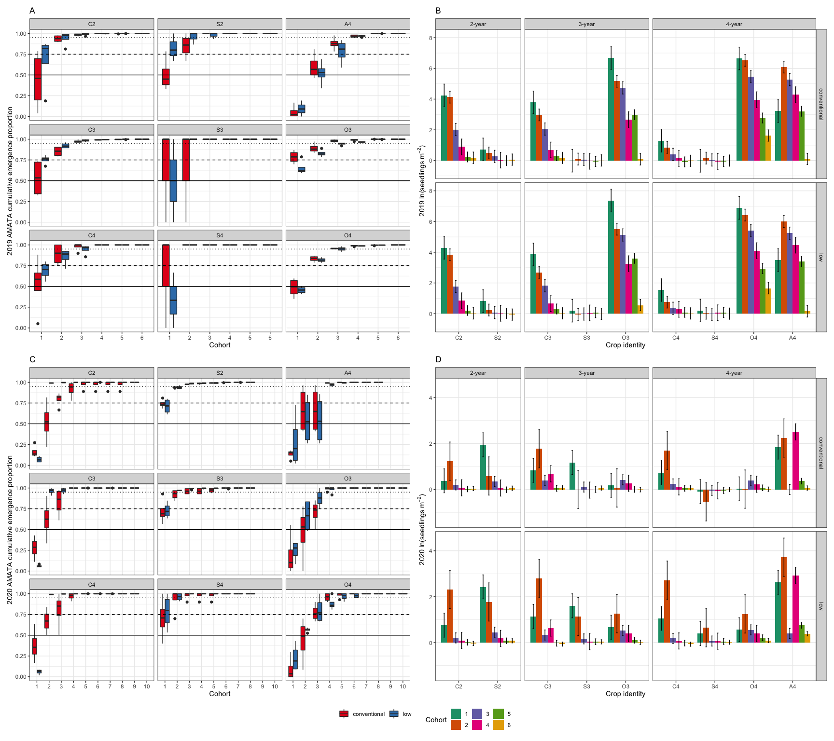

Figure 2: Cumulative emergence proportion of waterhemp in 2019 (A) and 2020 (C) and effects of crop identity on female waterhemp seedling density by cohort in 2019 (B) and 2020 (D). Panel A and C represent data-based means. Panels B and D represent model-based outputs. In panels A and C: the solid, dashed, and dotted lines indicate 50%, 75%, and 95% of total season emergence. In panels B and D, the error bars' upper and lower limits show the means' lower and upper limits. The abbreviations on each section of panels A and C or on the x-axis of panels B and D are crop identities, which are the combinations of the first letter in crop species names and the rotation in which it occurred (C2 - corn in the 2-year rotation, C3 - corn in the 3-year rotation, C4 - corn in the 4-year rotation, S2 - soybean in the 2-year rotation, S3 - soybean in the 3-year rotation, S4 - soybean in the 4-year rotation, O3 - oat in the 3-year rotation, O4 - oat in the 4-year rotation, and A4 - alfalfa in the 4-year rotation). In 2020, panel D, only the first six cohorts were included in the statistical model because the small sample sizes of cohorts 7 and beyond were insufficient for the model to run.

Table 3: 2019 and 2020 seedling emergence initiation in four crop environments (Julian’s date). Only the first seedling cohort was used as the response variable due to small sample sizes in the subsequent cohorts.

|  | 2019 | | | 2020 | | |
| --- | --- | --- | --- | --- | --- | --- |
| Crop | estimate | SE | df | estimate | SE | df |
| alfalfa | 154.0 | 1.3 | 61 | 163.0 | 0.1 | 61 |
| corn | 176.7 | 0.7 | 61 | 139.3 | 0.0 | 61 |
| oat | 150.0 | 0.9 | 61 | 141.0 | 0.1 | 61 |
| soybean | 189.0 | 0.7 | 61 | 163.0 | 0.0 | 61 |

Table 4: 2019 and 2020 seedling emergence timing (days) in four crop environments

|  | 2019 | | | | 2020 | | | |
| --- | --- | --- | --- | --- | --- | --- | --- | --- |
| Contrast | difference | SE | df | p | difference | SE | df | p |
| alfalfa - corn | -22.7 | 1.5 | 61 | <.0001 | 23.8 | 0.1 | 61 | <.0001 |
| alfalfa - oat | 4.0 | 1.6 | 61 | 0.0596 | 22.0 | 0.1 | 61 | <.0001 |
| alfalfa - soybean | -35.0 | 1.5 | 61 | <.0001 | 0.0 | 0.1 | 61 | 1.0000 |
| corn - oat | 26.7 | 1.2 | 61 | <.0001 | -1.8 | 0.1 | 61 | <.0001 |
| corn - soybean | -12.3 | 1.0 | 61 | <.0001 | -23.8 | 0.1 | 61 | <.0001 |
| oat - soybean | -39.0 | 1.2 | 61 | <.0001 | -22.0 | 0.1 | 61 | <.0001 |

### 2019 soil seedbank and emergence proportion

In 2019, the waterhemp soil seedbank densities estimated between crop harvest and post-harvest tillage in the cool-season crop environments (O3, O4, and A4) were substantially higher than those of the warm-season crops. The waterhemp soil seedbank densities in the soybean environments were the lowest among all the crop environments (Table 5).

Table 5: 2019 seedbank densities (seeds per meter squared) at the top and bottom soil strata

|  |  |  |  | Top stratum density | | Bottom stratum density | |
| --- | --- | --- | --- | --- | --- | --- | --- |
| Rotation | Crop ID | Corn weed management | df | mean | SE | mean | SE |
| 2-year | C2 | conventional | 51 | 8,231.9 | 5,655.5 | 5,422.1 | 1,679.3 |
| 2-year | C2 | low | 51 | 4,811.6 | 3,306.0 | 3,938.9 | 1,220.0 |
| 2-year | S2 | conventional | 51 | 604.6 | 416.0 | 1,297.9 | 402.2 |
| 2-year | S2 | low | 51 | 1,451.2 | 997.6 | 1,612.6 | 499.6 |
| 3-year | C3 | conventional | 51 | 1,851.6 | 1,272.6 | 6,361.6 | 1,970.2 |
| 3-year | C3 | low | 51 | 1,781.0 | 1,224.1 | 8,922.5 | 2,763.2 |
| 3-year | S3 | conventional | 51 | 73.8 | 51.4 | 1,615.5 | 500.5 |
| 3-year | S3 | low | 51 | 303.6 | 209.2 | 1,831.5 | 567.5 |
| 3-year | O3 | conventional | 51 | 6,682.3 | 4,591.0 | 5,921.9 | 1,834.1 |
| 3-year | O3 | low | 51 | 8,513.1 | 5,848.7 | 5,292.1 | 1,639.1 |
| 4-year | C4 | conventional | 51 | 90.0 | 62.5 | 1,052.1 | 326.1 |
| 4-year | C4 | low | 51 | 77.9 | 54.2 | 1,300.8 | 403.1 |
| 4-year | S4 | conventional | 51 | 231.8 | 159.9 | 2,554.0 | 791.2 |
| 4-year | S4 | low | 51 | 375.6 | 258.7 | 3,717.3 | 1,151.4 |
| 4-year | O4 | conventional | 51 | 10,201.1 | 7,008.2 | 5,209.5 | 1,613.5 |
| 4-year | O4 | low | 51 | 13,770.2 | 9,460.0 | 4,590.4 | 1,421.8 |
| 4-year | A4 | conventional | 51 | 5,777.9 | 3,969.8 | 2,790.2 | 864.3 |
| 4-year | A4 | low | 51 | 8,022.3 | 5,511.5 | 3,415.9 | 1,058.1 |

## Waterhemp population growth rates

All the data sets for the empirically estimated sub-annual parameters were measured once. In 2019, individual plant size at maturity was measured for six cohorts in each quadrat of each eu, and two strata of soil seedbank were estimated between crop harvest and post-harvest tillage. In 2018, a different number of cohorts were followed in different crop environments because of limited labor availability and adverse weather conditions. 2019 data was used as scenario 1.

### Scenario 1

Using 2019 fecundity rates that were estimated from individual plant sizes using eighteen equations from Nguyen and Liebman (2022a), waterhemp population densities were projected to decrease in all rotations, except in the 4-year rotation with low herbicide corn weed management ( = 1.14). The population was projected to decrease most quickly in the 2-year rotation under low herbicide corn weed management and the 3-year rotation under both corn weed management programs (Figure 3). ’s decreased right after the first phase of the 2-year (C2) and 3-year (C3) rotations, but increased in the first phase of the 4-year rotation ( = 6.12, = 28.34) fold. The steady decrease of population density in the soybean, oat, and alfalfa phases (’s = 0.5) of the 4-year rotation under conventional corn weed management was sufficient to keep the rotation-wise populations decreasing within a four-year cycle even if increased again when the cropping system returned to the corn phase. Most of the seedbank in the 4-year rotation were in the 2-20 cm stratum, limiting the seed pool density for seedling emergence.

### Scenario 2

Using 2018 fecundity rates, waterhemp population densities would increase rapidly in all rotations, but most quickly in the 2-year rotation (Figure 5). The population increase in the 3-year rotation under low herbicide corn weed management was similar to that of the 4-year rotation. Even though were all increasing, the partition of seedbanks differed between rotations. Within the same rotation, a consistent pattern of top:bottom ratio of seed densities was observed between two corn weed management regimes. In the 2-year rotation, a large portion of the seedbanks were in the 0-2 cm soil stratum; in the 3-year rotation, the top and bottom soil strata were fairly evenly populated; and in the 4-year rotation, the majority of the seedbanks were at the bottom stratum.

The oat phase of the 3-year rotation (O3) and the alfalfa phase of the 4-year rotation (A4) offered opportunities for decreasing , which was not possible in any other crop phases in the three examined rotations. However, the declines in ’s in O3 ( = 0.60 and = 0.56) and A4 ( = 0.70 and = 0.54) were not strong enough to deplete the replenishment from the corn ( = 5.56, = 1.20, = 172.81, and = 87.14) and soybean phases ( = 13360.78, = 4361.91, = 80.51, and = 10.18).

## Elasticities of population growth rates to lower-level demographic parameters

The relative ranking of elasticity of ’s to the lower-level demographic parameters was consistent between corn weed management regimes (Figures 4 and 6). However, the overall population change rate can be reflected by the relative importance of each element on the elasticity of .

Even though all the matrices, but , were identical across scenarios, the ranking of each element contribution to the elasticity of might be slightly different across scenarios. For example, the the -decreasing case, the relative ranks of (the probability that seed in the 2-20 cm stratum stay at that stratum) was higher than those of other , whereas in the population-growing case was the lowest among all . Similarly, was more important than in the elasticity of in the population-shrinking versus population-growing case. Consistent patterns in the importance of to the elasticity of were observed in the two scenarios.

Because seed emergence and seedling survival rate contributed minimally to the elasticity of , this pattern suggests that even if weed control programs are of high or even total efficacy, very few surviving plants prolifically producing new seeds can sustain the population. The low relative importance of and can be attributed to the low emergence rate in weeds, the high weed control efficacy, and the high relative importance of of to the elasticity of can be explained by the high individual fecundity.

In both scenarios, the patterns of contribution to elasticity of in the 3-year rotation was slightly different from the 2-year and 4-year rotations. The contribution of plant survival rate to the elasticity of was non-existent in C2, S2, C4, S4, and O4 (absolute zeroes) but minimal in C3, S3, and O4 (very small positive values). The difference in the contribution of plant survival rate on O3 and O4 might be attributed to the different companion crops to oat (red clover in O3 and alfalfa in O4).

### Scenario 1

The ranking of parameters or individual parameters to the elasticity of differed by rotation and crop phase (Figure 4). The seed preserving parameters were ranked higher in the corn phase of the 3-year rotation (C3) under both weed management regimes, the soybean phase of the 3-year rotation (S3) that followed corn under low herbicide weed management, the oat phases of the 3-year and 4-year rotations (O3 and O4) regardless of the preceding corn phase’s weed management regime, and the alfalfa phase of the 4-year rotation (A4) regardless of the preceding corn phase’s weed management regime. The seed-producing parameters were ranked higher in the other crop environments (crop species in each rotation).

The elasticity of to fecundity rate, as a group, were ranked first in the corn phase of the 2-year rotation (C2) (43.13 and 3.15), the soybean phase of the 2-year rotation (S2) (0.75 and 4.18), the soybean phase of the 3-year rotation (S3) that followed corn under low herbicide weed management program (0.91), the corn phase of the 4-year rotation (C4) (305.24 and 323.07), and the alfalfa in the 4-year rotation (A4) (36.78 and 14.49) under both weed management regimes. The rate of pre-planting tillage induced seed movement to the 2-20 cm soil stratum was the first-ranked individual parameter to the elasticity of ’s in the corn phase of the 3-year rotation (C3) (1.1 and 1.1), the soybean in the 3-year rotation that followed corn under low herbicide weed management (0.89), the oat phase of the 3-year rotation (O3) (0.87 and 0.88), and the oat phase of the 4-year rotation (5.49 and 3.98). The overwinter survival rate of the seeds in the 0-2 cm soil stratum was the first-ranked individual parameter to the elasticity of ’s in the soybean phase of the 4-year rotation (S4) (3.32 and 2.41).

As s declined in this scenario, with some opportunity of increasing in the C4 phase, focusing on reducing plant fecundity in C4 would sufficiently stabilize , provided that the weed control efficacy in the subsequent three crop phases remained adequate.

### Scenario 2

Unlike Scenario 1’s dynamics, the differences in the absolute value of the elasticity of to the first-ranked and second-ranked groups of parameters were multiple orders of magnitude. The seed-producing parameters were ranked higher in all crop environments (crop species in each rotation).

The elasticity of ’s to fecundity rates, as a group, were ranked first in all crop phases (Figure 6). The elasticity of ’s to cohort one fecundity was the highest in C2 (4.02 x and 3.44 x ), S3 (1.33 x and 1.61 x ), and O4 (682.28 and 1531.97) phases. The elasticity of ’s elasticity to cohort two fecundity was the highest in S2 (1.82 x and 1.39 x ), C3 (2.22 x and 5.69 x ), O3 (76673.94 and  
62845.84), C4 (5.84 x and 1.01 x ), S4 (5.74 x and 2.17 x ), and A4 (1850.3 and 156.54) phases.

The second-ranked group of demographic parameters to differed by rotation and crop phase. In the 2-year rotation, the second-ranked group of parameters in contribution to the elasticity of were both pre-planting tillage-induced seed movement and overwinter seed survival. In the 3-year rotation, no clear pattern of the second-ranked group of parameters in contribution to the elasticity of was observed: overwinter survival rate of the top stratum seeds in C3, non-germinating seeds in the top stratum in S3, and overwinter survival rate of the bottom stratum seeds in O3. In the 4-year rotation, the second-ranked group of parameters in contribution to the elasticity of was overwinter seed survival in the warm-season crop phase and non-germinating seeds in the top stratum in the cool-season crop phases.

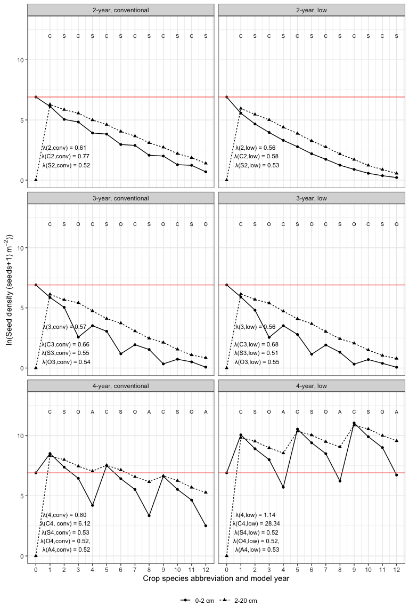

Figure 3: Scenario 1: Changes of seed densities in two soil strata after 12 model years in three rotations (2-year, 3-year, and 4-year) crossed with two corn weed management programs (conventional and low herbicide). The model started at year 0 with 1000 and 0 seeds per meter squared in the top (0-2 cm) and bottom (2-20 cm) strata, respectively. The red horizontal line shows the number of seeds in the top stratum at the beginning of the model clock. The annualized population growth rates are followed by their variances in brackets. The model years’ are labeled with the main crop species names’ abbreviations: C - corn, S - soybean, O - oat, and A - alfalfa.

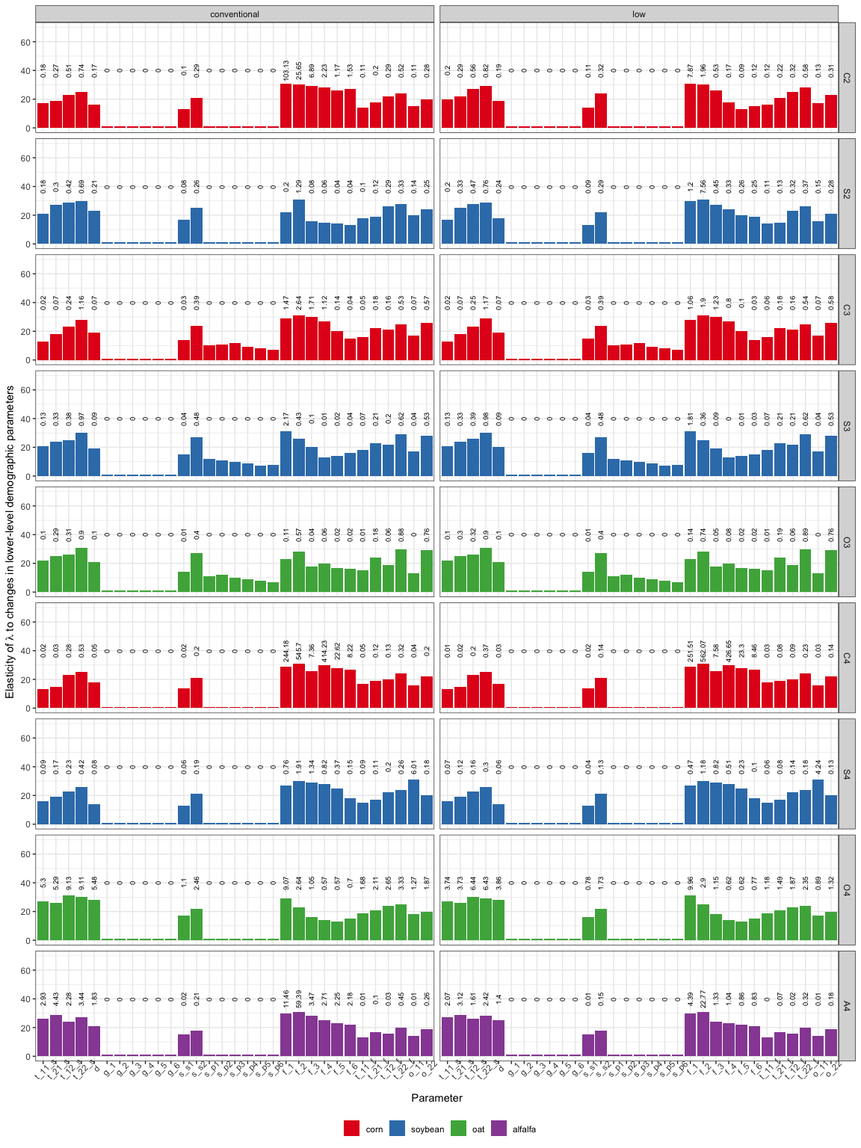

Figure 4: Scenario 1: Elasticity of annualized population growth rates to changes in lower-level demographic parameters. Bar height represents the parameter’s ranking. Each bar is labeled with the absolute value of the contribution of the parameter to the elasticity of annualized population growth rates (zeros from s_s1 through s_p6 in C3, S3, and O3 were due to rounding). Crop identities are color-coded by crop species. From left to right of the x-axis, the sub-annual demographic parameters are: t_11_s - probability that a seed in the 0-2 cm soil stratum stay at that statum after pre-planting tillage; t_21_s - probability that a seed in the 2-20 cm soil stratum move to the 0-2 cm soil stratum after pre-planting tillage; t_12_s - probability that a seed in the 0-2 cm soil stratum move to the 2-20 cm stratum after pre-planting tillage; and t_22_s - probability that a seed in the 2-20 cm soil stratum stay at that statum after pre-planting tillage; d - the probability that a seed is not germinating; g_1 through g_6: the probabiblites that a seed emerge to seedling cohorts 1 through 6; s_s1 and s_s2 - the survival rate of seeds in the 0-2 cm and 2-20 cm soil strata in the cropped season; s_p1 through s_p6: the probability that seedling cohorts 1 through 6 reach reproductive maturity; f_1 through f_6 - the fecundity rates of mature plant cohorts 1 through 6; t_11_f - probability that a seed in the 0-2 cm soil stratum stay at that statum after post-harvest tillage; t_21_f - probability that a seed in the 2-20 cm soil stratum move to the 0-2 cm soil stratum after post-harvest tillage; t_12_f - probability that a seed in the 0-2 cm soil stratum move to the 2-20 cm stratum after post-harvest tillage; and t_22_f - probability that a seed in the 2-20 cm soil stratum stay at that statum after post-harvest tillage; o_11 and o_12 - overwiter survival rates in the 0-2 cm and 2-20 cm soil strata.

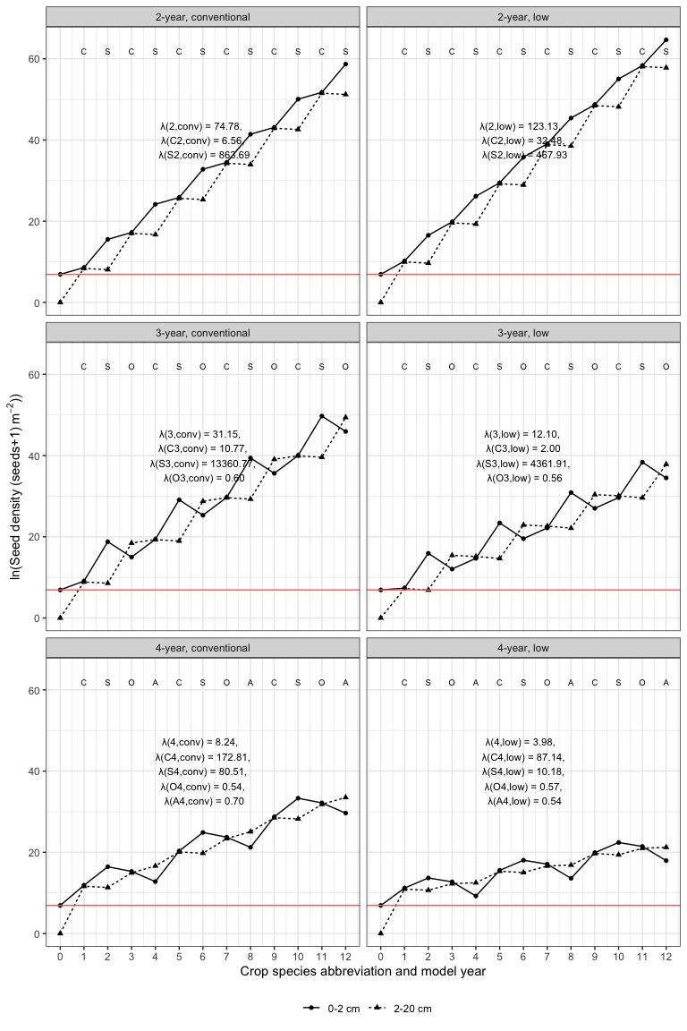

Figure 5: Scenario 1: Changes of natural-logarithm of seed densities in two soil strata after 12 model years in three rotations (2-year, 3-year, and 4-year) crossed with two corn weed management programs (conventional and low herbicide). Seed densities were natural-logarithm transformed because of scales. The model started at year 0 with 1000 and 0 seeds per meter squared in the top (0 - 2 cm) and bottom (2 - 20 cm) strata, respectively. The red horizontal line shows the number of seeds at the top stratum at the beginning of the model clock. The annualized population growth rates are followed by their variances in brackets. The model years’ are labeled with the main crop species names’ abbreviations: C - corn, S - soybean, O - oat, and A - alfalfa.

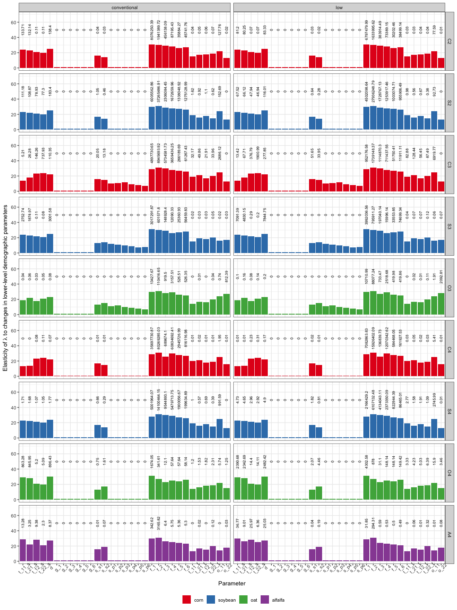

Figure 6: Scenario 2: Elasticity of annualized population growth rates to changes in lower-level demographic parameters. Bar height represents the parameter’s ranking. Each bar is labeled with the absolute value of the contribution of the parameter to the elasticity of annualized population growth rates (zeros on top of some of the medium height bars were due to rounding). Crop identities are color-coded by crop species. From left to right of the x-axis, the sub-annual demographic parameters are: t_11_s - probability that a seed at the 0-2 cm soil stratum stay at that statum after pre-planting tillage; t_21_s - probability that a seed at the 2-20 cm soil stratum move to the 0-2 cm soil stratum after pre-planting tillage; t_12_s - probability that a seed at the 0-2 cm soil stratum move to the 2-20 cm stratum after pre-planting tillage; and t_22_s - probability that a seed in the 2-20 cm soil stratum stay at that statum after pre-planting tillage; d - the probability that a seed is not germinating; g_1 through g_6: the probabiblites that a seed emerge to seedling cohorts 1 through 6; s_s1 and s_s2 - the survival rate of seeds in the 0-2 cm and 2-20 cm soil strata in the cropped season; s_p1 through s_p6: the probability that seedling cohorts 1 through 6 reach reproductive maturity; f_1 through f_6 - the fecundity rates of mature plant cohorts 1 through 6; t_11_f - probability that a seed in the 0-2 cm soil stratum stay at that statum after post-harvest tillage; t_21_f - probability that a seed in the 2-20 cm soil stratum move to the 0-2 cm soil stratum after post-harvest tillage; t_12_f - probability that a seed in the 0-2 cm soil stratum move to the 2-20 cm stratum after post-harvest tillage; and t_22_f - probability that a seed in the 2-20 cm soil stratum stay at that statum after post-harvest tillage; o_11 and o_12 - overwiter survival rates in the 0-2 cm and 2-20 cm soil strata.

## Conclusion

Delayed but steady emergence (Tables 3 and 4), Figure 2) in the cool-season crop environments decreased population fecundity in the oat and alfalfa phases, and thus, accelerated seedbank size reduction in scenario 1 and slowed seedbank size increment in scenario 2.

The cohort-based female survival rates at the experiment site were not realistically estimated due to the small sample size in a high-efficacy weed management program (Table 6. Future experiments should focus on assessing cohort-based female survival rates in cool-season crop environments.

The hypothesis that “extending a conventional 2-year rotation of corn and soybean with cool-season crops can accelerate soil seedbank depletion” was supported. Unlike giant foxtail, whose bottleneck point in the life cycle was overwinter seed survival rate (Davis, 2002), waterhemp’s bottleneck point in its life cycle was seedling emergence rate and seedling to maturity success rate. However, if the early emerged plants were unaffected by weed control programs, either through herbicide resistance or escaped from cultivation, and completed their life cycle, a small number of large, prolific female plants would sufficiently replenish the soil seedbank.

Since the elasticity of was the least affected by seedling emergence in both the population-increasing and population-declining scenarios, it would be helpful to focus on disrupting seed production by reducing individual plant size by delaying emergence or applying multiple stress factors to successfully established plants and by limiting seed deposit to the soil. Under the current 4-year rotation’s crop sequence, oat (O4) and alfalfa (A4) provided valuable opportunities to reduce plant size (Nguyen and Liebman, 2022b, 2022a).

A reduction in the mass of applied herbicide active ingredients (Nguyen and Liebman, 2022b) was not coincident with the population decline in Scenario 1 () but did coincide with population increases in scenario 2 (). Considering Scenario 2, population-increasing, it would be useful to examine how many years of continuous overwinter crops would be necessary and which cool-season crop species would be most efficient in decreasing waterhemp after steady seedbank replenishment. Such an investigation is needed because even if the increased abundance of waterhemp and other weed species has not been observed at the experiment site (Nguyen and Liebman, 2022b), an abundant seedbank of a highly competitive weed species harbors risks of weed outbreaks.

## Appendix

### Seed densities at the top and bottom soil strata

## ANOVA of Crop ID x Corn weed management effects on AMATA seedbank density at the 0-2 cm soil stratum  
AMATA_female_top_lm <- lm(log(AMATA_total_viable_density + 1) ~ Block +   
 Crop_ID * Corn_weed_management,   
 data = top_stratum_female)  
  
  
## ANOVA table of female seedbank density at the 0-2 cm soil stratum  
AMATA_female_top_emm_log <- emmeans(AMATA_female_top_lm,   
 c("Crop_ID" , "Corn_weed_management"))  
  
joint_tests(AMATA_female_top_emm_log )

## model term df1 df2 F.ratio p.value  
## Crop_ID 8 51 14.638 <.0001  
## Corn_weed_management 1 51 0.998 0.3225  
## Crop_ID:Corn_weed_management 8 51 0.343 0.9445

## ANOVA of Crop ID x Corn weed management effects on AMATA seedbank density at the 2-20 cm soil stratum  
AMATA_female_bottom_lm <- lm(log(AMATA_total_viable_density + 1) ~ Block +   
 Crop_ID * Corn_weed_management,   
 data = bottom_stratum_female)  
   
  
## ANOVA table of female seedbank density at the 2-20 cm soil stratum  
AMATA_female_bottom_emm_log <- emmeans(AMATA_female_bottom_lm, c("Crop_ID" , "Corn_weed_management"))  
  
joint_tests(AMATA_female_bottom_emm_log)

## model term df1 df2 F.ratio p.value  
## Crop_ID 8 51 8.812 <.0001  
## Corn_weed_management 1 51 0.482 0.4908  
## Crop_ID:Corn_weed_management 8 51 0.288 0.9669

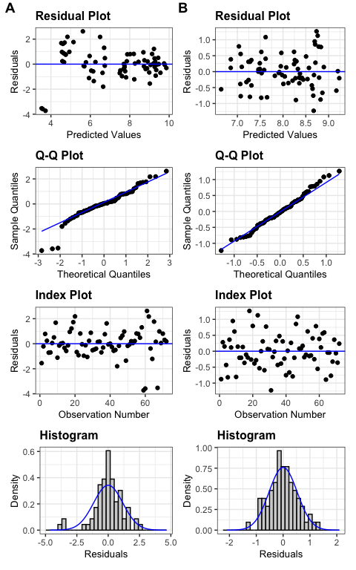

Figure 7: Diagnosis plots for the effects of crop identity and crop weed management on the seedbank densities at the top (A) and bottom (B) soil strata

### Seedbank density from 2014 through 2019

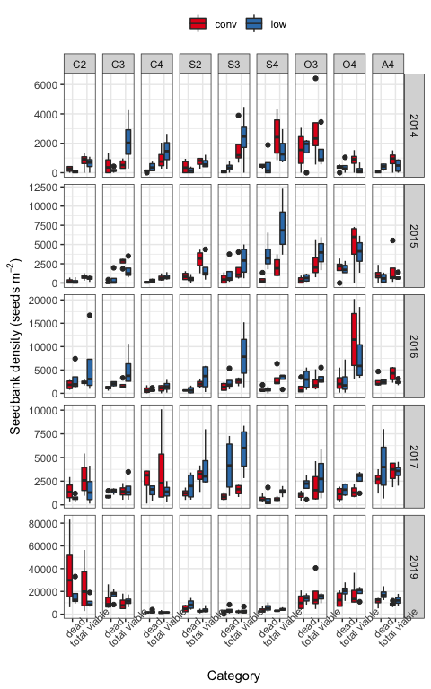

Figure 8: Dead and viable seedbank density from 2014 through 2019. 2018 seedbank density was not evaluated due to weather adversity.

### Emergence pattern and timing in different crop environments

## Did crop identity and corn weed management affect waterhemp's emergence pattern in 2019?  
emerge_cohort_19_gls <- gls(log(eu_female_cohort_Density_begin+1) ~ Block +   
 Crop_ID*Corn_weed_management + Cohort +  
 Crop_ID:Cohort + Corn_weed_management:Cohort,  
 correlation=corCompSymm(form=~1 | bt),  
 weights=varIdent(form= ~1 | Cohort),  
data = density_emerge_19)  
  
 joint_tests(emerge_cohort_19_gls)

## model term df1 df2 F.ratio p.value  
## Block 3 68.42 2.793 0.0468  
## Crop_ID 8 54.23 222.641 <.0001  
## Corn_weed_management 1 54.23 0.518 0.4749  
## Cohort 5 75.61 438.355 <.0001  
## Crop_ID:Corn_weed_management 8 68.42 0.956 0.4772  
## Crop_ID:Cohort 40 75.61 46.683 <.0001  
## Corn_weed_management:Cohort 5 75.61 1.569 0.1790

## Did crop identity and corn weed management affect waterhemp's emergence pattern in 2020?  
#   
emerge_cohort_20_gls <- gls(log(cohort_female_Seedling_density +1) ~ Block +   
 Crop_ID*Corn_weed_management + Cohort +  
 Crop_ID:Cohort + Corn_weed_management:Cohort,  
 correlation=corCompSymm(form=~1 | bt),  
 weights=varIdent(form= ~1 | Cohort),  
data=cohort_emerge_20_first_six )  
  
 joint_tests(emerge_cohort_20_gls)

## model term df1 df2 F.ratio p.value  
## Block 3 65.97 2.376 0.0779  
## Crop_ID 8 57.25 9.890 <.0001  
## Corn_weed_management 1 57.25 13.732 0.0005  
## Cohort 5 66.34 40.266 <.0001  
## Crop_ID:Corn_weed_management 8 65.97 5.920 <.0001  
## Crop_ID:Cohort 40 66.34 11.498 <.0001  
## Corn_weed_management:Cohort 5 66.34 5.185 0.0004

## Did crop identity and corn weed management affect waterhemp's first emergence timing in 2019?  
Julian_cohort1_19_lm <- lm(Julian_day ~ Block +   
 Crop * Corn_weed_management,  
data = cohort1_2019)   
  
joint_tests(Julian_cohort1_19_lm)

## model term df1 df2 F.ratio p.value  
## Block 3 61 0.000 1.0000  
## Crop 3 61 458.187 <.0001  
## Corn_weed_management 1 61 0.000 1.0000  
## Crop:Corn_weed_management 3 61 0.000 1.0000

## Did crop identity and corn weed management affect waterhemp's first emergence timing in 2020?  
Julian_cohort1_20_lm <- lm(Julian_day ~ Block +   
 Crop*Corn_weed_management,  
 data=cohort1_2020)  
  
joint_tests(Julian_cohort1_20_lm )

## model term df1 df2 F.ratio p.value  
## Block 3 61 10.170 <.0001  
## Crop 3 61 64217.940 <.0001  
## Corn_weed_management 1 61 0.000 1.0000  
## Crop:Corn_weed_management 3 61 0.000 1.0000

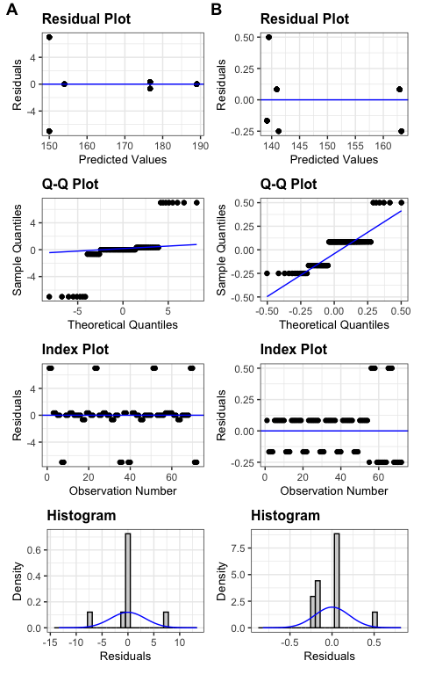

Figure 9: Diagnosis plots for the effects of crop identity and corn weed management on the seedbank densities at the top (A) and bottom (B) soil strata

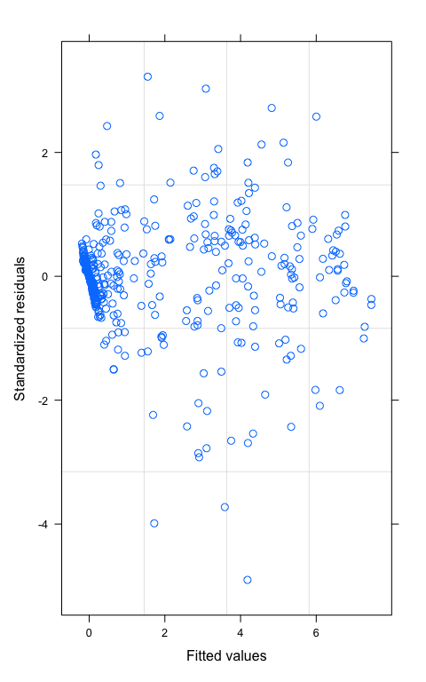

Figure 10: Diagnosis plot for the effects of crop identity, corn weed management, and cohort on seedling densities in 2019

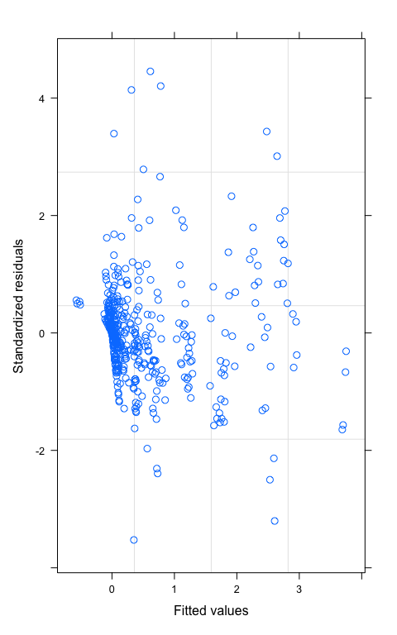

Figure 11: Diagnosis plot for the effects of crop identity, corn weed management, and cohort on seedling densities in 2020

### 2019 female survival rate by cohort

Table 6: Point-estimates of 2019 seedling to maturity survival rates by cohort. Some zeroes are due to rounding.

|  |  | Cohort | | | | | |
| --- | --- | --- | --- | --- | --- | --- | --- |
| Crop ID | Corn weed management | 1 | 2 | 3 | 4 | 5 | 6 |
| C2 | conventional | 0.17 | 0.10 | 0.19 | 0.46 | 0.50 | 0.50 |
| C2 | low | 0.00 | 0.15 | 0.32 | 0.43 | 0.17 | 0.00 |
| S2 | conventional | 0.00 | 0.00 | 0.00 | 0.00 | 0.00 | 0.00 |
| S2 | low | 0.00 | 0.00 | 0.00 | 0.00 | 0.00 | 0.00 |
| C3 | conventional | 0.15 | 0.25 | 0.34 | 0.53 | 0.00 | 0.67 |
| C3 | low | 0.02 | 0.20 | 0.33 | 0.23 | 0.00 | 1.00 |
| S3 | conventional | 0.00 | 0.00 | 0.00 | 0.00 | 0.00 | 0.00 |
| S3 | low | 0.00 | 0.00 | 0.00 | 0.00 | 0.00 | 0.00 |
| O3 | conventional | 0.04 | 0.08 | 0.01 | 0.39 | 0.00 | 0.00 |
| O3 | low | 0.03 | 0.02 | 0.03 | 0.07 | 0.04 | 0.00 |
| C4 | conventional | 0.38 | 0.26 | 0.42 | 0.50 | 0.00 | 0.00 |
| C4 | low | 0.02 | 0.24 | 0.37 | 0.30 | 0.00 | 0.00 |
| S4 | conventional | 0.00 | 0.00 | 0.00 | 0.00 | 0.00 | 0.00 |
| S4 | low | 0.00 | 0.00 | 0.00 | 0.00 | 0.00 | 0.00 |
| O4 | conventional | 0.15 | 0.10 | 0.28 | 0.22 | 0.33 | 0.22 |
| O4 | low | 0.07 | 0.04 | 0.09 | 0.13 | 0.29 | 0.08 |
| A4 | conventional | 0.06 | 0.06 | 0.17 | 0.02 | 0.06 | 0.00 |
| A4 | low | 0.08 | 0.06 | 0.10 | 0.14 | 0.25 | 0.00 |

### Matrix assembly

The structure of all periodic matrices used in the two different scenarios is listed below. All numbers are female-only. Each theoretical matrix for a sub-annual period is followed by the set of matrices used in that sub-annual period. The abbreviate row and column names are:  
- s_t: seed at the top stratum (0 - 2 cm),  
- s_b: seed at the bottom stratum (2 - 20 cm),  
- p_co_1 through p_co_6: plant cohort 1 through 6.

#### Published literature data

##### Pre-planting tillage induced vertical redistribution of seeds

The only non-zeroes section of the pre-planting tillage induced vertical redistribution of seeds is . ’s were resized from the raw data of Seed Chaser (Spokas et al., 2007), a simulation program that estimates vertical seed movement after various types of tillage: the proportion of seeds staying at its original soil stratum, and , or move to another stratum, and . The original matrices in Spokas et al. (2007) were resized to 2 x 2 by summing over all the elements within each of the four sections, i.e., top left 2 x 2, bottom left 18 x 2, top right 2 x 18, and 18x18, and divide each of the i x 2 summations by the summation of the 20 x 2 left section, and each of the i x 18 summations by the summation of the 20 x 2 right section.

No-till is represented by an identical matrix, , after Cousens and Moss (1990). A field cultivator was applied before planting corn (C2, C3, and C4), soybean (S2, S3, and S4), and oat (O3 and O4). No tillage was applied before alfalfa (A4) because alfalfa that was intercropped with oat in the 4-year rotation (O4) was kept overwinter and grown as a sole crop in the following year.

The same pre-planting tillage regimes were applied in 2018 and 2019.

## $A4_conv  
## s_t s_b p_co_1 p_co_2 p_co_3 p_co_4 p_co_5 p_co_6  
## s_t 1 0 0 0 0 0 0 0  
## s_b 0 1 0 0 0 0 0 0  
## p_co_1 0 0 0 0 0 0 0 0  
## p_co_2 0 0 0 0 0 0 0 0  
## p_co_3 0 0 0 0 0 0 0 0  
## p_co_4 0 0 0 0 0 0 0 0  
## p_co_5 0 0 0 0 0 0 0 0  
## p_co_6 0 0 0 0 0 0 0 0  
##   
## $A4_low  
## s_t s_b p_co_1 p_co_2 p_co_3 p_co_4 p_co_5 p_co_6  
## s_t 1 0 0 0 0 0 0 0  
## s_b 0 1 0 0 0 0 0 0  
## p_co_1 0 0 0 0 0 0 0 0  
## p_co_2 0 0 0 0 0 0 0 0  
## p_co_3 0 0 0 0 0 0 0 0  
## p_co_4 0 0 0 0 0 0 0 0  
## p_co_5 0 0 0 0 0 0 0 0  
## p_co_6 0 0 0 0 0 0 0 0  
##   
## $C2_conv  
## s_t s_b p_co_1 p_co_2 p_co_3 p_co_4 p_co_5 p_co_6  
## s_t 0.59 0.15 0 0 0 0 0 0  
## s_b 0.41 0.85 0 0 0 0 0 0  
## p_co_1 0.00 0.00 0 0 0 0 0 0  
## p_co_2 0.00 0.00 0 0 0 0 0 0  
## p_co_3 0.00 0.00 0 0 0 0 0 0  
## p_co_4 0.00 0.00 0 0 0 0 0 0  
## p_co_5 0.00 0.00 0 0 0 0 0 0  
## p_co_6 0.00 0.00 0 0 0 0 0 0  
##   
## $C2_low  
## s_t s_b p_co_1 p_co_2 p_co_3 p_co_4 p_co_5 p_co_6  
## s_t 0.59 0.15 0 0 0 0 0 0  
## s_b 0.41 0.85 0 0 0 0 0 0  
## p_co_1 0.00 0.00 0 0 0 0 0 0  
## p_co_2 0.00 0.00 0 0 0 0 0 0  
## p_co_3 0.00 0.00 0 0 0 0 0 0  
## p_co_4 0.00 0.00 0 0 0 0 0 0  
## p_co_5 0.00 0.00 0 0 0 0 0 0  
## p_co_6 0.00 0.00 0 0 0 0 0 0  
##   
## $C3_conv  
## s_t s_b p_co_1 p_co_2 p_co_3 p_co_4 p_co_5 p_co_6  
## s_t 0.59 0.15 0 0 0 0 0 0  
## s_b 0.41 0.85 0 0 0 0 0 0  
## p_co_1 0.00 0.00 0 0 0 0 0 0  
## p_co_2 0.00 0.00 0 0 0 0 0 0  
## p_co_3 0.00 0.00 0 0 0 0 0 0  
## p_co_4 0.00 0.00 0 0 0 0 0 0  
## p_co_5 0.00 0.00 0 0 0 0 0 0  
## p_co_6 0.00 0.00 0 0 0 0 0 0  
##   
## $C3_low  
## s_t s_b p_co_1 p_co_2 p_co_3 p_co_4 p_co_5 p_co_6  
## s_t 0.59 0.15 0 0 0 0 0 0  
## s_b 0.41 0.85 0 0 0 0 0 0  
## p_co_1 0.00 0.00 0 0 0 0 0 0  
## p_co_2 0.00 0.00 0 0 0 0 0 0  
## p_co_3 0.00 0.00 0 0 0 0 0 0  
## p_co_4 0.00 0.00 0 0 0 0 0 0  
## p_co_5 0.00 0.00 0 0 0 0 0 0  
## p_co_6 0.00 0.00 0 0 0 0 0 0  
##   
## $C4_conv  
## s_t s_b p_co_1 p_co_2 p_co_3 p_co_4 p_co_5 p_co_6  
## s_t 0.59 0.15 0 0 0 0 0 0  
## s_b 0.41 0.85 0 0 0 0 0 0  
## p_co_1 0.00 0.00 0 0 0 0 0 0  
## p_co_2 0.00 0.00 0 0 0 0 0 0  
## p_co_3 0.00 0.00 0 0 0 0 0 0  
## p_co_4 0.00 0.00 0 0 0 0 0 0  
## p_co_5 0.00 0.00 0 0 0 0 0 0  
## p_co_6 0.00 0.00 0 0 0 0 0 0  
##   
## $C4_low  
## s_t s_b p_co_1 p_co_2 p_co_3 p_co_4 p_co_5 p_co_6  
## s_t 0.59 0.15 0 0 0 0 0 0  
## s_b 0.41 0.85 0 0 0 0 0 0  
## p_co_1 0.00 0.00 0 0 0 0 0 0  
## p_co_2 0.00 0.00 0 0 0 0 0 0  
## p_co_3 0.00 0.00 0 0 0 0 0 0  
## p_co_4 0.00 0.00 0 0 0 0 0 0  
## p_co_5 0.00 0.00 0 0 0 0 0 0  
## p_co_6 0.00 0.00 0 0 0 0 0 0  
##   
## $O3_conv  
## s_t s_b p_co_1 p_co_2 p_co_3 p_co_4 p_co_5 p_co_6  
## s_t 0.59 0.15 0 0 0 0 0 0  
## s_b 0.41 0.85 0 0 0 0 0 0  
## p_co_1 0.00 0.00 0 0 0 0 0 0  
## p_co_2 0.00 0.00 0 0 0 0 0 0  
## p_co_3 0.00 0.00 0 0 0 0 0 0  
## p_co_4 0.00 0.00 0 0 0 0 0 0  
## p_co_5 0.00 0.00 0 0 0 0 0 0  
## p_co_6 0.00 0.00 0 0 0 0 0 0  
##   
## $O3_low  
## s_t s_b p_co_1 p_co_2 p_co_3 p_co_4 p_co_5 p_co_6  
## s_t 0.59 0.15 0 0 0 0 0 0  
## s_b 0.41 0.85 0 0 0 0 0 0  
## p_co_1 0.00 0.00 0 0 0 0 0 0  
## p_co_2 0.00 0.00 0 0 0 0 0 0  
## p_co_3 0.00 0.00 0 0 0 0 0 0  
## p_co_4 0.00 0.00 0 0 0 0 0 0  
## p_co_5 0.00 0.00 0 0 0 0 0 0  
## p_co_6 0.00 0.00 0 0 0 0 0 0  
##   
## $O4_conv  
## s_t s_b p_co_1 p_co_2 p_co_3 p_co_4 p_co_5 p_co_6  
## s_t 0.59 0.15 0 0 0 0 0 0  
## s_b 0.41 0.85 0 0 0 0 0 0  
## p_co_1 0.00 0.00 0 0 0 0 0 0  
## p_co_2 0.00 0.00 0 0 0 0 0 0  
## p_co_3 0.00 0.00 0 0 0 0 0 0  
## p_co_4 0.00 0.00 0 0 0 0 0 0  
## p_co_5 0.00 0.00 0 0 0 0 0 0  
## p_co_6 0.00 0.00 0 0 0 0 0 0  
##   
## $O4_low  
## s_t s_b p_co_1 p_co_2 p_co_3 p_co_4 p_co_5 p_co_6  
## s_t 0.59 0.15 0 0 0 0 0 0  
## s_b 0.41 0.85 0 0 0 0 0 0  
## p_co_1 0.00 0.00 0 0 0 0 0 0  
## p_co_2 0.00 0.00 0 0 0 0 0 0  
## p_co_3 0.00 0.00 0 0 0 0 0 0  
## p_co_4 0.00 0.00 0 0 0 0 0 0  
## p_co_5 0.00 0.00 0 0 0 0 0 0  
## p_co_6 0.00 0.00 0 0 0 0 0 0  
##   
## $S2_conv  
## s_t s_b p_co_1 p_co_2 p_co_3 p_co_4 p_co_5 p_co_6  
## s_t 0.59 0.15 0 0 0 0 0 0  
## s_b 0.41 0.85 0 0 0 0 0 0  
## p_co_1 0.00 0.00 0 0 0 0 0 0  
## p_co_2 0.00 0.00 0 0 0 0 0 0  
## p_co_3 0.00 0.00 0 0 0 0 0 0  
## p_co_4 0.00 0.00 0 0 0 0 0 0  
## p_co_5 0.00 0.00 0 0 0 0 0 0  
## p_co_6 0.00 0.00 0 0 0 0 0 0  
##   
## $S2_low  
## s_t s_b p_co_1 p_co_2 p_co_3 p_co_4 p_co_5 p_co_6  
## s_t 0.59 0.15 0 0 0 0 0 0  
## s_b 0.41 0.85 0 0 0 0 0 0  
## p_co_1 0.00 0.00 0 0 0 0 0 0  
## p_co_2 0.00 0.00 0 0 0 0 0 0  
## p_co_3 0.00 0.00 0 0 0 0 0 0  
## p_co_4 0.00 0.00 0 0 0 0 0 0  
## p_co_5 0.00 0.00 0 0 0 0 0 0  
## p_co_6 0.00 0.00 0 0 0 0 0 0  
##   
## $S3_conv  
## s_t s_b p_co_1 p_co_2 p_co_3 p_co_4 p_co_5 p_co_6  
## s_t 0.59 0.15 0 0 0 0 0 0  
## s_b 0.41 0.85 0 0 0 0 0 0  
## p_co_1 0.00 0.00 0 0 0 0 0 0  
## p_co_2 0.00 0.00 0 0 0 0 0 0  
## p_co_3 0.00 0.00 0 0 0 0 0 0  
## p_co_4 0.00 0.00 0 0 0 0 0 0  
## p_co_5 0.00 0.00 0 0 0 0 0 0  
## p_co_6 0.00 0.00 0 0 0 0 0 0  
##   
## $S3_low  
## s_t s_b p_co_1 p_co_2 p_co_3 p_co_4 p_co_5 p_co_6  
## s_t 0.59 0.15 0 0 0 0 0 0  
## s_b 0.41 0.85 0 0 0 0 0 0  
## p_co_1 0.00 0.00 0 0 0 0 0 0  
## p_co_2 0.00 0.00 0 0 0 0 0 0  
## p_co_3 0.00 0.00 0 0 0 0 0 0  
## p_co_4 0.00 0.00 0 0 0 0 0 0  
## p_co_5 0.00 0.00 0 0 0 0 0 0  
## p_co_6 0.00 0.00 0 0 0 0 0 0  
##   
## $S4_conv  
## s_t s_b p_co_1 p_co_2 p_co_3 p_co_4 p_co_5 p_co_6  
## s_t 0.59 0.15 0 0 0 0 0 0  
## s_b 0.41 0.85 0 0 0 0 0 0  
## p_co_1 0.00 0.00 0 0 0 0 0 0  
## p_co_2 0.00 0.00 0 0 0 0 0 0  
## p_co_3 0.00 0.00 0 0 0 0 0 0  
## p_co_4 0.00 0.00 0 0 0 0 0 0  
## p_co_5 0.00 0.00 0 0 0 0 0 0  
## p_co_6 0.00 0.00 0 0 0 0 0 0  
##   
## $S4_low  
## s_t s_b p_co_1 p_co_2 p_co_3 p_co_4 p_co_5 p_co_6  
## s_t 0.59 0.15 0 0 0 0 0 0  
## s_b 0.41 0.85 0 0 0 0 0 0  
## p_co_1 0.00 0.00 0 0 0 0 0 0  
## p_co_2 0.00 0.00 0 0 0 0 0 0  
## p_co_3 0.00 0.00 0 0 0 0 0 0  
## p_co_4 0.00 0.00 0 0 0 0 0 0  
## p_co_5 0.00 0.00 0 0 0 0 0 0  
## p_co_6 0.00 0.00 0 0 0 0 0 0

##### In-season survival of seeds and seedlings

The matrix is comprised of seed survival rates at the and plant survival rates at the sections, respectively.

The section’s diagonal ( and ) were filled with survival rates adapted from equations and (Figures 1 and 3, Sosnoskie et al., 2013) for the top and bottom layers. The values of x were assigned at 6 months for all crop environments. We settled at 6 months despite the complexity in tillage timing and method, light and humidity conditions, and granivores’ activities at individual crop environments for simplicity. In reality, the burial length can interact with any crop management activity and deliver different germination and emergence results.

The empirically measured data for seedling survival were deemed unrealistically (Appendix) low as compared to the literature, so Nordby and Hartzler's (2004) results were used for corn, and Hartzler et al. (2004)’s results were used for soybean crop environments. The seedling survival rates by cohort () were assigned such that the earlier cohorts had a lower survival rate in the oat crop environment; and those in the alfalfa crop environment were evenly low in all cohorts. These estimated numbers were based on a suggestion that cool-season crop environments can inhibit warm-season weed species growth (Nguyen and Liebman, 2022b and citations given there).

The same summer survival rates were used in 2018 and 2019.

## $A4_conv  
## s_t s_b p_co_1 p_co_2 p_co_3 p_co_4 p_co_5 p_co_6  
## s_t 0.66 0.00 0.0 0.0 0.0 0.0 0.0 0.0  
## s_b 0.00 0.74 0.0 0.0 0.0 0.0 0.0 0.0  
## p_co_1 0.00 0.00 0.1 0.0 0.0 0.0 0.0 0.0  
## p_co_2 0.00 0.00 0.0 0.1 0.0 0.0 0.0 0.0  
## p_co_3 0.00 0.00 0.0 0.0 0.1 0.0 0.0 0.0  
## p_co_4 0.00 0.00 0.0 0.0 0.0 0.1 0.0 0.0  
## p_co_5 0.00 0.00 0.0 0.0 0.0 0.0 0.5 0.0  
## p_co_6 0.00 0.00 0.0 0.0 0.0 0.0 0.0 0.5  
##   
## $A4_low  
## s_t s_b p_co_1 p_co_2 p_co_3 p_co_4 p_co_5 p_co_6  
## s_t 0.66 0.00 0.0 0.0 0.0 0.0 0.0 0.0  
## s_b 0.00 0.74 0.0 0.0 0.0 0.0 0.0 0.0  
## p_co_1 0.00 0.00 0.1 0.0 0.0 0.0 0.0 0.0  
## p_co_2 0.00 0.00 0.0 0.1 0.0 0.0 0.0 0.0  
## p_co_3 0.00 0.00 0.0 0.0 0.1 0.0 0.0 0.0  
## p_co_4 0.00 0.00 0.0 0.0 0.0 0.1 0.0 0.0  
## p_co_5 0.00 0.00 0.0 0.0 0.0 0.0 0.5 0.0  
## p_co_6 0.00 0.00 0.0 0.0 0.0 0.0 0.0 0.5  
##   
## $C2_conv  
## s_t s_b p_co_1 p_co_2 p_co_3 p_co_4 p_co_5 p_co_6  
## s_t 0.66 0.00 0.00 0.00 0.00 0.00 0.00 0.00  
## s_b 0.00 0.74 0.00 0.00 0.00 0.00 0.00 0.00  
## p_co_1 0.00 0.00 0.84 0.00 0.00 0.00 0.00 0.00  
## p_co_2 0.00 0.00 0.00 0.48 0.00 0.00 0.00 0.00  
## p_co_3 0.00 0.00 0.00 0.00 0.48 0.00 0.00 0.00  
## p_co_4 0.00 0.00 0.00 0.00 0.00 0.04 0.00 0.00  
## p_co_5 0.00 0.00 0.00 0.00 0.00 0.00 0.04 0.00  
## p_co_6 0.00 0.00 0.00 0.00 0.00 0.00 0.00 0.01  
##   
## $C2_low  
## s_t s_b p_co_1 p_co_2 p_co_3 p_co_4 p_co_5 p_co_6  
## s_t 0.66 0.00 0.00 0.00 0.00 0.00 0.00 0.00  
## s_b 0.00 0.74 0.00 0.00 0.00 0.00 0.00 0.00  
## p_co_1 0.00 0.00 0.84 0.00 0.00 0.00 0.00 0.00  
## p_co_2 0.00 0.00 0.00 0.48 0.00 0.00 0.00 0.00  
## p_co_3 0.00 0.00 0.00 0.00 0.48 0.00 0.00 0.00  
## p_co_4 0.00 0.00 0.00 0.00 0.00 0.04 0.00 0.00  
## p_co_5 0.00 0.00 0.00 0.00 0.00 0.00 0.04 0.00  
## p_co_6 0.00 0.00 0.00 0.00 0.00 0.00 0.00 0.01  
##   
## $C3_conv  
## s_t s_b p_co_1 p_co_2 p_co_3 p_co_4 p_co_5 p_co_6  
## s_t 0.66 0.00 0.00 0.00 0.00 0.00 0.00 0.00  
## s_b 0.00 0.74 0.00 0.00 0.00 0.00 0.00 0.00  
## p_co_1 0.00 0.00 0.84 0.00 0.00 0.00 0.00 0.00  
## p_co_2 0.00 0.00 0.00 0.48 0.00 0.00 0.00 0.00  
## p_co_3 0.00 0.00 0.00 0.00 0.48 0.00 0.00 0.00  
## p_co_4 0.00 0.00 0.00 0.00 0.00 0.04 0.00 0.00  
## p_co_5 0.00 0.00 0.00 0.00 0.00 0.00 0.04 0.00  
## p_co_6 0.00 0.00 0.00 0.00 0.00 0.00 0.00 0.01  
##   
## $C3_low  
## s_t s_b p_co_1 p_co_2 p_co_3 p_co_4 p_co_5 p_co_6  
## s_t 0.66 0.00 0.00 0.00 0.00 0.00 0.00 0.00  
## s_b 0.00 0.74 0.00 0.00 0.00 0.00 0.00 0.00  
## p_co_1 0.00 0.00 0.84 0.00 0.00 0.00 0.00 0.00  
## p_co_2 0.00 0.00 0.00 0.48 0.00 0.00 0.00 0.00  
## p_co_3 0.00 0.00 0.00 0.00 0.48 0.00 0.00 0.00  
## p_co_4 0.00 0.00 0.00 0.00 0.00 0.04 0.00 0.00  
## p_co_5 0.00 0.00 0.00 0.00 0.00 0.00 0.04 0.00  
## p_co_6 0.00 0.00 0.00 0.00 0.00 0.00 0.00 0.01  
##   
## $C4_conv  
## s_t s_b p_co_1 p_co_2 p_co_3 p_co_4 p_co_5 p_co_6  
## s_t 0.66 0.00 0.00 0.00 0.00 0.00 0.00 0.00  
## s_b 0.00 0.74 0.00 0.00 0.00 0.00 0.00 0.00  
## p_co_1 0.00 0.00 0.84 0.00 0.00 0.00 0.00 0.00  
## p_co_2 0.00 0.00 0.00 0.48 0.00 0.00 0.00 0.00  
## p_co_3 0.00 0.00 0.00 0.00 0.48 0.00 0.00 0.00  
## p_co_4 0.00 0.00 0.00 0.00 0.00 0.04 0.00 0.00  
## p_co_5 0.00 0.00 0.00 0.00 0.00 0.00 0.04 0.00  
## p_co_6 0.00 0.00 0.00 0.00 0.00 0.00 0.00 0.01  
##   
## $C4_low  
## s_t s_b p_co_1 p_co_2 p_co_3 p_co_4 p_co_5 p_co_6  
## s_t 0.66 0.00 0.00 0.00 0.00 0.00 0.00 0.00  
## s_b 0.00 0.74 0.00 0.00 0.00 0.00 0.00 0.00  
## p_co_1 0.00 0.00 0.84 0.00 0.00 0.00 0.00 0.00  
## p_co_2 0.00 0.00 0.00 0.48 0.00 0.00 0.00 0.00  
## p_co_3 0.00 0.00 0.00 0.00 0.48 0.00 0.00 0.00  
## p_co_4 0.00 0.00 0.00 0.00 0.00 0.04 0.00 0.00  
## p_co_5 0.00 0.00 0.00 0.00 0.00 0.00 0.04 0.00  
## p_co_6 0.00 0.00 0.00 0.00 0.00 0.00 0.00 0.01  
##   
## $O3_conv  
## s_t s_b p_co_1 p_co_2 p_co_3 p_co_4 p_co_5 p_co_6  
## s_t 0.66 0.00 0.0 0.0 0.0 0.0 0.0 0.0  
## s_b 0.00 0.74 0.0 0.0 0.0 0.0 0.0 0.0  
## p_co_1 0.00 0.00 0.1 0.0 0.0 0.0 0.0 0.0  
## p_co_2 0.00 0.00 0.0 0.1 0.0 0.0 0.0 0.0  
## p_co_3 0.00 0.00 0.0 0.0 0.5 0.0 0.0 0.0  
## p_co_4 0.00 0.00 0.0 0.0 0.0 0.5 0.0 0.0  
## p_co_5 0.00 0.00 0.0 0.0 0.0 0.0 0.9 0.0  
## p_co_6 0.00 0.00 0.0 0.0 0.0 0.0 0.0 0.9  
##   
## $O3_low  
## s_t s_b p_co_1 p_co_2 p_co_3 p_co_4 p_co_5 p_co_6  
## s_t 0.66 0.00 0.0 0.0 0.0 0.0 0.0 0.0  
## s_b 0.00 0.74 0.0 0.0 0.0 0.0 0.0 0.0  
## p_co_1 0.00 0.00 0.1 0.0 0.0 0.0 0.0 0.0  
## p_co_2 0.00 0.00 0.0 0.1 0.0 0.0 0.0 0.0  
## p_co_3 0.00 0.00 0.0 0.0 0.5 0.0 0.0 0.0  
## p_co_4 0.00 0.00 0.0 0.0 0.0 0.5 0.0 0.0  
## p_co_5 0.00 0.00 0.0 0.0 0.0 0.0 0.9 0.0  
## p_co_6 0.00 0.00 0.0 0.0 0.0 0.0 0.0 0.9  
##   
## $O4_conv  
## s_t s_b p_co_1 p_co_2 p_co_3 p_co_4 p_co_5 p_co_6  
## s_t 0.66 0.00 0.0 0.0 0.0 0.0 0.0 0.0  
## s_b 0.00 0.74 0.0 0.0 0.0 0.0 0.0 0.0  
## p_co_1 0.00 0.00 0.1 0.0 0.0 0.0 0.0 0.0  
## p_co_2 0.00 0.00 0.0 0.1 0.0 0.0 0.0 0.0  
## p_co_3 0.00 0.00 0.0 0.0 0.5 0.0 0.0 0.0  
## p_co_4 0.00 0.00 0.0 0.0 0.0 0.5 0.0 0.0  
## p_co_5 0.00 0.00 0.0 0.0 0.0 0.0 0.9 0.0  
## p_co_6 0.00 0.00 0.0 0.0 0.0 0.0 0.0 0.9  
##   
## $O4_low  
## s_t s_b p_co_1 p_co_2 p_co_3 p_co_4 p_co_5 p_co_6  
## s_t 0.66 0.00 0.0 0.0 0.0 0.0 0.0 0.0  
## s_b 0.00 0.74 0.0 0.0 0.0 0.0 0.0 0.0  
## p_co_1 0.00 0.00 0.1 0.0 0.0 0.0 0.0 0.0  
## p_co_2 0.00 0.00 0.0 0.1 0.0 0.0 0.0 0.0  
## p_co_3 0.00 0.00 0.0 0.0 0.5 0.0 0.0 0.0  
## p_co_4 0.00 0.00 0.0 0.0 0.0 0.5 0.0 0.0  
## p_co_5 0.00 0.00 0.0 0.0 0.0 0.0 0.9 0.0  
## p_co_6 0.00 0.00 0.0 0.0 0.0 0.0 0.0 0.9  
##   
## $S2_conv  
## s_t s_b p_co_1 p_co_2 p_co_3 p_co_4 p_co_5 p_co_6  
## s_t 0.66 0.00 0.00 0.00 0.00 0.00 0.00 0.00  
## s_b 0.00 0.74 0.00 0.00 0.00 0.00 0.00 0.00  
## p_co_1 0.00 0.00 0.84 0.00 0.00 0.00 0.00 0.00  
## p_co_2 0.00 0.00 0.00 0.84 0.00 0.00 0.00 0.00  
## p_co_3 0.00 0.00 0.00 0.00 0.26 0.00 0.00 0.00  
## p_co_4 0.00 0.00 0.00 0.00 0.00 0.26 0.00 0.00  
## p_co_5 0.00 0.00 0.00 0.00 0.00 0.00 0.01 0.00  
## p_co_6 0.00 0.00 0.00 0.00 0.00 0.00 0.00 0.01  
##   
## $S2_low  
## s_t s_b p_co_1 p_co_2 p_co_3 p_co_4 p_co_5 p_co_6  
## s_t 0.66 0.00 0.00 0.00 0.00 0.00 0.00 0.00  
## s_b 0.00 0.74 0.00 0.00 0.00 0.00 0.00 0.00  
## p_co_1 0.00 0.00 0.84 0.00 0.00 0.00 0.00 0.00  
## p_co_2 0.00 0.00 0.00 0.84 0.00 0.00 0.00 0.00  
## p_co_3 0.00 0.00 0.00 0.00 0.26 0.00 0.00 0.00  
## p_co_4 0.00 0.00 0.00 0.00 0.00 0.26 0.00 0.00  
## p_co_5 0.00 0.00 0.00 0.00 0.00 0.00 0.01 0.00  
## p_co_6 0.00 0.00 0.00 0.00 0.00 0.00 0.00 0.01  
##   
## $S3_conv  
## s_t s_b p_co_1 p_co_2 p_co_3 p_co_4 p_co_5 p_co_6  
## s_t 0.66 0.00 0.00 0.00 0.00 0.00 0.00 0.00  
## s_b 0.00 0.74 0.00 0.00 0.00 0.00 0.00 0.00  
## p_co_1 0.00 0.00 0.84 0.00 0.00 0.00 0.00 0.00  
## p_co_2 0.00 0.00 0.00 0.84 0.00 0.00 0.00 0.00  
## p_co_3 0.00 0.00 0.00 0.00 0.26 0.00 0.00 0.00  
## p_co_4 0.00 0.00 0.00 0.00 0.00 0.26 0.00 0.00  
## p_co_5 0.00 0.00 0.00 0.00 0.00 0.00 0.01 0.00  
## p_co_6 0.00 0.00 0.00 0.00 0.00 0.00 0.00 0.01  
##   
## $S3_low  
## s_t s_b p_co_1 p_co_2 p_co_3 p_co_4 p_co_5 p_co_6  
## s_t 0.66 0.00 0.00 0.00 0.00 0.00 0.00 0.00  
## s_b 0.00 0.74 0.00 0.00 0.00 0.00 0.00 0.00  
## p_co_1 0.00 0.00 0.84 0.00 0.00 0.00 0.00 0.00  
## p_co_2 0.00 0.00 0.00 0.84 0.00 0.00 0.00 0.00  
## p_co_3 0.00 0.00 0.00 0.00 0.26 0.00 0.00 0.00  
## p_co_4 0.00 0.00 0.00 0.00 0.00 0.26 0.00 0.00  
## p_co_5 0.00 0.00 0.00 0.00 0.00 0.00 0.01 0.00  
## p_co_6 0.00 0.00 0.00 0.00 0.00 0.00 0.00 0.01  
##   
## $S4_conv  
## s_t s_b p_co_1 p_co_2 p_co_3 p_co_4 p_co_5 p_co_6  
## s_t 0.66 0.00 0.00 0.00 0.00 0.00 0.00 0.00  
## s_b 0.00 0.74 0.00 0.00 0.00 0.00 0.00 0.00  
## p_co_1 0.00 0.00 0.84 0.00 0.00 0.00 0.00 0.00  
## p_co_2 0.00 0.00 0.00 0.84 0.00 0.00 0.00 0.00  
## p_co_3 0.00 0.00 0.00 0.00 0.26 0.00 0.00 0.00  
## p_co_4 0.00 0.00 0.00 0.00 0.00 0.26 0.00 0.00  
## p_co_5 0.00 0.00 0.00 0.00 0.00 0.00 0.01 0.00  
## p_co_6 0.00 0.00 0.00 0.00 0.00 0.00 0.00 0.01  
##   
## $S4_low  
## s_t s_b p_co_1 p_co_2 p_co_3 p_co_4 p_co_5 p_co_6  
## s_t 0.66 0.00 0.00 0.00 0.00 0.00 0.00 0.00  
## s_b 0.00 0.74 0.00 0.00 0.00 0.00 0.00 0.00  
## p_co_1 0.00 0.00 0.84 0.00 0.00 0.00 0.00 0.00  
## p_co_2 0.00 0.00 0.00 0.84 0.00 0.00 0.00 0.00  
## p_co_3 0.00 0.00 0.00 0.00 0.26 0.00 0.00 0.00  
## p_co_4 0.00 0.00 0.00 0.00 0.00 0.26 0.00 0.00  
## p_co_5 0.00 0.00 0.00 0.00 0.00 0.00 0.01 0.00  
## p_co_6 0.00 0.00 0.00 0.00 0.00 0.00 0.00 0.01

##### Post-harvest tillage induced vertical redistribution of seeds post-harvest tillage

The compilation of was similar to that of . Chisel plowing was applied after corn was harvested in the C2, C3, and C4 treatments, no-till was applied after harvests in the S2, S3, S4, and O4 treatments, and moldboard plowing was applied at the end of the O3 and A4 phases.

The same post-harvest tillage regimes were applied in 2018 and 2019.

## $A4_conv  
## s_t s_b p_co_1 p_co_2 p_co_3 p_co_4 p_co_5 p_co_6  
## s_t 0.02 0.07 0 0 0 0 0 0  
## s_b 0.98 0.93 0 0 0 0 0 0  
## p_co_1 0.00 0.00 0 0 0 0 0 0  
## p_co_2 0.00 0.00 0 0 0 0 0 0  
## p_co_3 0.00 0.00 0 0 0 0 0 0  
## p_co_4 0.00 0.00 0 0 0 0 0 0  
## p_co_5 0.00 0.00 0 0 0 0 0 0  
## p_co_6 0.00 0.00 0 0 0 0 0 0  
##   
## $A4_low  
## s_t s_b p_co_1 p_co_2 p_co_3 p_co_4 p_co_5 p_co_6  
## s_t 0.02 0.07 0 0 0 0 0 0  
## s_b 0.98 0.93 0 0 0 0 0 0  
## p_co_1 0.00 0.00 0 0 0 0 0 0  
## p_co_2 0.00 0.00 0 0 0 0 0 0  
## p_co_3 0.00 0.00 0 0 0 0 0 0  
## p_co_4 0.00 0.00 0 0 0 0 0 0  
## p_co_5 0.00 0.00 0 0 0 0 0 0  
## p_co_6 0.00 0.00 0 0 0 0 0 0  
##   
## $C2_conv  
## s_t s_b p_co_1 p_co_2 p_co_3 p_co_4 p_co_5 p_co_6  
## s_t 0.59 0.1 0 0 0 0 0 0  
## s_b 0.41 0.9 0 0 0 0 0 0  
## p_co_1 0.00 0.0 0 0 0 0 0 0  
## p_co_2 0.00 0.0 0 0 0 0 0 0  
## p_co_3 0.00 0.0 0 0 0 0 0 0  
## p_co_4 0.00 0.0 0 0 0 0 0 0  
## p_co_5 0.00 0.0 0 0 0 0 0 0  
## p_co_6 0.00 0.0 0 0 0 0 0 0  
##   
## $C2_low  
## s_t s_b p_co_1 p_co_2 p_co_3 p_co_4 p_co_5 p_co_6  
## s_t 0.59 0.1 0 0 0 0 0 0  
## s_b 0.41 0.9 0 0 0 0 0 0  
## p_co_1 0.00 0.0 0 0 0 0 0 0  
## p_co_2 0.00 0.0 0 0 0 0 0 0  
## p_co_3 0.00 0.0 0 0 0 0 0 0  
## p_co_4 0.00 0.0 0 0 0 0 0 0  
## p_co_5 0.00 0.0 0 0 0 0 0 0  
## p_co_6 0.00 0.0 0 0 0 0 0 0  
##   
## $C3_conv  
## s_t s_b p_co_1 p_co_2 p_co_3 p_co_4 p_co_5 p_co_6  
## s_t 0.59 0.1 0 0 0 0 0 0  
## s_b 0.41 0.9 0 0 0 0 0 0  
## p_co_1 0.00 0.0 0 0 0 0 0 0  
## p_co_2 0.00 0.0 0 0 0 0 0 0  
## p_co_3 0.00 0.0 0 0 0 0 0 0  
## p_co_4 0.00 0.0 0 0 0 0 0 0  
## p_co_5 0.00 0.0 0 0 0 0 0 0  
## p_co_6 0.00 0.0 0 0 0 0 0 0  
##   
## $C3_low  
## s_t s_b p_co_1 p_co_2 p_co_3 p_co_4 p_co_5 p_co_6  
## s_t 0.59 0.1 0 0 0 0 0 0  
## s_b 0.41 0.9 0 0 0 0 0 0  
## p_co_1 0.00 0.0 0 0 0 0 0 0  
## p_co_2 0.00 0.0 0 0 0 0 0 0  
## p_co_3 0.00 0.0 0 0 0 0 0 0  
## p_co_4 0.00 0.0 0 0 0 0 0 0  
## p_co_5 0.00 0.0 0 0 0 0 0 0  
## p_co_6 0.00 0.0 0 0 0 0 0 0  
##   
## $C4_conv  
## s_t s_b p_co_1 p_co_2 p_co_3 p_co_4 p_co_5 p_co_6  
## s_t 0.59 0.1 0 0 0 0 0 0  
## s_b 0.41 0.9 0 0 0 0 0 0  
## p_co_1 0.00 0.0 0 0 0 0 0 0  
## p_co_2 0.00 0.0 0 0 0 0 0 0  
## p_co_3 0.00 0.0 0 0 0 0 0 0  
## p_co_4 0.00 0.0 0 0 0 0 0 0  
## p_co_5 0.00 0.0 0 0 0 0 0 0  
## p_co_6 0.00 0.0 0 0 0 0 0 0  
##   
## $C4_low  
## s_t s_b p_co_1 p_co_2 p_co_3 p_co_4 p_co_5 p_co_6  
## s_t 0.59 0.1 0 0 0 0 0 0  
## s_b 0.41 0.9 0 0 0 0 0 0  
## p_co_1 0.00 0.0 0 0 0 0 0 0  
## p_co_2 0.00 0.0 0 0 0 0 0 0  
## p_co_3 0.00 0.0 0 0 0 0 0 0  
## p_co_4 0.00 0.0 0 0 0 0 0 0  
## p_co_5 0.00 0.0 0 0 0 0 0 0  
## p_co_6 0.00 0.0 0 0 0 0 0 0  
##   
## $O3_conv  
## s_t s_b p_co_1 p_co_2 p_co_3 p_co_4 p_co_5 p_co_6  
## s_t 0.02 0.07 0 0 0 0 0 0  
## s_b 0.98 0.93 0 0 0 0 0 0  
## p_co_1 0.00 0.00 0 0 0 0 0 0  
## p_co_2 0.00 0.00 0 0 0 0 0 0  
## p_co_3 0.00 0.00 0 0 0 0 0 0  
## p_co_4 0.00 0.00 0 0 0 0 0 0  
## p_co_5 0.00 0.00 0 0 0 0 0 0  
## p_co_6 0.00 0.00 0 0 0 0 0 0  
##   
## $O3_low  
## s_t s_b p_co_1 p_co_2 p_co_3 p_co_4 p_co_5 p_co_6  
## s_t 0.02 0.07 0 0 0 0 0 0  
## s_b 0.98 0.93 0 0 0 0 0 0  
## p_co_1 0.00 0.00 0 0 0 0 0 0  
## p_co_2 0.00 0.00 0 0 0 0 0 0  
## p_co_3 0.00 0.00 0 0 0 0 0 0  
## p_co_4 0.00 0.00 0 0 0 0 0 0  
## p_co_5 0.00 0.00 0 0 0 0 0 0  
## p_co_6 0.00 0.00 0 0 0 0 0 0  
##   
## $O4_conv  
## s_t s_b p_co_1 p_co_2 p_co_3 p_co_4 p_co_5 p_co_6  
## s_t 1 0 0 0 0 0 0 0  
## s_b 0 1 0 0 0 0 0 0  
## p_co_1 0 0 0 0 0 0 0 0  
## p_co_2 0 0 0 0 0 0 0 0  
## p_co_3 0 0 0 0 0 0 0 0  
## p_co_4 0 0 0 0 0 0 0 0  
## p_co_5 0 0 0 0 0 0 0 0  
## p_co_6 0 0 0 0 0 0 0 0  
##   
## $O4_low  
## s_t s_b p_co_1 p_co_2 p_co_3 p_co_4 p_co_5 p_co_6  
## s_t 1 0 0 0 0 0 0 0  
## s_b 0 1 0 0 0 0 0 0  
## p_co_1 0 0 0 0 0 0 0 0  
## p_co_2 0 0 0 0 0 0 0 0  
## p_co_3 0 0 0 0 0 0 0 0  
## p_co_4 0 0 0 0 0 0 0 0  
## p_co_5 0 0 0 0 0 0 0 0  
## p_co_6 0 0 0 0 0 0 0 0  
##   
## $S2_conv  
## s_t s_b p_co_1 p_co_2 p_co_3 p_co_4 p_co_5 p_co_6  
## s_t 1 0 0 0 0 0 0 0  
## s_b 0 1 0 0 0 0 0 0  
## p_co_1 0 0 0 0 0 0 0 0  
## p_co_2 0 0 0 0 0 0 0 0  
## p_co_3 0 0 0 0 0 0 0 0  
## p_co_4 0 0 0 0 0 0 0 0  
## p_co_5 0 0 0 0 0 0 0 0  
## p_co_6 0 0 0 0 0 0 0 0  
##   
## $S2_low  
## s_t s_b p_co_1 p_co_2 p_co_3 p_co_4 p_co_5 p_co_6  
## s_t 1 0 0 0 0 0 0 0  
## s_b 0 1 0 0 0 0 0 0  
## p_co_1 0 0 0 0 0 0 0 0  
## p_co_2 0 0 0 0 0 0 0 0  
## p_co_3 0 0 0 0 0 0 0 0  
## p_co_4 0 0 0 0 0 0 0 0  
## p_co_5 0 0 0 0 0 0 0 0  
## p_co_6 0 0 0 0 0 0 0 0  
##   
## $S3_conv  
## s_t s_b p_co_1 p_co_2 p_co_3 p_co_4 p_co_5 p_co_6  
## s_t 1 0 0 0 0 0 0 0  
## s_b 0 1 0 0 0 0 0 0  
## p_co_1 0 0 0 0 0 0 0 0  
## p_co_2 0 0 0 0 0 0 0 0  
## p_co_3 0 0 0 0 0 0 0 0  
## p_co_4 0 0 0 0 0 0 0 0  
## p_co_5 0 0 0 0 0 0 0 0  
## p_co_6 0 0 0 0 0 0 0 0  
##   
## $S3_low  
## s_t s_b p_co_1 p_co_2 p_co_3 p_co_4 p_co_5 p_co_6  
## s_t 1 0 0 0 0 0 0 0  
## s_b 0 1 0 0 0 0 0 0  
## p_co_1 0 0 0 0 0 0 0 0  
## p_co_2 0 0 0 0 0 0 0 0  
## p_co_3 0 0 0 0 0 0 0 0  
## p_co_4 0 0 0 0 0 0 0 0  
## p_co_5 0 0 0 0 0 0 0 0  
## p_co_6 0 0 0 0 0 0 0 0  
##   
## $S4_conv  
## s_t s_b p_co_1 p_co_2 p_co_3 p_co_4 p_co_5 p_co_6  
## s_t 1 0 0 0 0 0 0 0  
## s_b 0 1 0 0 0 0 0 0  
## p_co_1 0 0 0 0 0 0 0 0  
## p_co_2 0 0 0 0 0 0 0 0  
## p_co_3 0 0 0 0 0 0 0 0  
## p_co_4 0 0 0 0 0 0 0 0  
## p_co_5 0 0 0 0 0 0 0 0  
## p_co_6 0 0 0 0 0 0 0 0  
##   
## $S4_low  
## s_t s_b p_co_1 p_co_2 p_co_3 p_co_4 p_co_5 p_co_6  
## s_t 1 0 0 0 0 0 0 0  
## s_b 0 1 0 0 0 0 0 0  
## p_co_1 0 0 0 0 0 0 0 0  
## p_co_2 0 0 0 0 0 0 0 0  
## p_co_3 0 0 0 0 0 0 0 0  
## p_co_4 0 0 0 0 0 0 0 0  
## p_co_5 0 0 0 0 0 0 0 0  
## p_co_6 0 0 0 0 0 0 0 0

##### Overwinter survival

The compilation of matrix was similar to that of , using equations and (Figures 1 and 3, Sosnoskie et al., 2013).

The same overwinter survival rates were used in 2018 and 2019. Some zero values were due to rounding.

## $A4_conv  
## s_t s_b p_co_1 p_co_2 p_co_3 p_co_4 p_co_5 p_co_6  
## s_t 0.66 0.00 0 0 0 0 0 0  
## s_b 0.00 0.74 0 0 0 0 0 0  
## p_co_1 0.00 0.00 0 0 0 0 0 0  
## p_co_2 0.00 0.00 0 0 0 0 0 0  
## p_co_3 0.00 0.00 0 0 0 0 0 0  
## p_co_4 0.00 0.00 0 0 0 0 0 0  
## p_co_5 0.00 0.00 0 0 0 0 0 0  
## p_co_6 0.00 0.00 0 0 0 0 0 0  
##   
## $A4_low  
## s_t s_b p_co_1 p_co_2 p_co_3 p_co_4 p_co_5 p_co_6  
## s_t 0.66 0.00 0 0 0 0 0 0  
## s_b 0.00 0.74 0 0 0 0 0 0  
## p_co_1 0.00 0.00 0 0 0 0 0 0  
## p_co_2 0.00 0.00 0 0 0 0 0 0  
## p_co_3 0.00 0.00 0 0 0 0 0 0  
## p_co_4 0.00 0.00 0 0 0 0 0 0  
## p_co_5 0.00 0.00 0 0 0 0 0 0  
## p_co_6 0.00 0.00 0 0 0 0 0 0  
##   
## $C2_conv  
## s_t s_b p_co_1 p_co_2 p_co_3 p_co_4 p_co_5 p_co_6  
## s_t 0.66 0.00 0 0 0 0 0 0  
## s_b 0.00 0.74 0 0 0 0 0 0  
## p_co_1 0.00 0.00 0 0 0 0 0 0  
## p_co_2 0.00 0.00 0 0 0 0 0 0  
## p_co_3 0.00 0.00 0 0 0 0 0 0  
## p_co_4 0.00 0.00 0 0 0 0 0 0  
## p_co_5 0.00 0.00 0 0 0 0 0 0  
## p_co_6 0.00 0.00 0 0 0 0 0 0  
##   
## $C2_low  
## s_t s_b p_co_1 p_co_2 p_co_3 p_co_4 p_co_5 p_co_6  
## s_t 0.66 0.00 0 0 0 0 0 0  
## s_b 0.00 0.74 0 0 0 0 0 0  
## p_co_1 0.00 0.00 0 0 0 0 0 0  
## p_co_2 0.00 0.00 0 0 0 0 0 0  
## p_co_3 0.00 0.00 0 0 0 0 0 0  
## p_co_4 0.00 0.00 0 0 0 0 0 0  
## p_co_5 0.00 0.00 0 0 0 0 0 0  
## p_co_6 0.00 0.00 0 0 0 0 0 0  
##   
## $C3_conv  
## s_t s_b p_co_1 p_co_2 p_co_3 p_co_4 p_co_5 p_co_6  
## s_t 0.66 0.00 0 0 0 0 0 0  
## s_b 0.00 0.74 0 0 0 0 0 0  
## p_co_1 0.00 0.00 0 0 0 0 0 0  
## p_co_2 0.00 0.00 0 0 0 0 0 0  
## p_co_3 0.00 0.00 0 0 0 0 0 0  
## p_co_4 0.00 0.00 0 0 0 0 0 0  
## p_co_5 0.00 0.00 0 0 0 0 0 0  
## p_co_6 0.00 0.00 0 0 0 0 0 0  
##   
## $C3_low  
## s_t s_b p_co_1 p_co_2 p_co_3 p_co_4 p_co_5 p_co_6  
## s_t 0.66 0.00 0 0 0 0 0 0  
## s_b 0.00 0.74 0 0 0 0 0 0  
## p_co_1 0.00 0.00 0 0 0 0 0 0  
## p_co_2 0.00 0.00 0 0 0 0 0 0  
## p_co_3 0.00 0.00 0 0 0 0 0 0  
## p_co_4 0.00 0.00 0 0 0 0 0 0  
## p_co_5 0.00 0.00 0 0 0 0 0 0  
## p_co_6 0.00 0.00 0 0 0 0 0 0  
##   
## $C4_conv  
## s_t s_b p_co_1 p_co_2 p_co_3 p_co_4 p_co_5 p_co_6  
## s_t 0.66 0.00 0 0 0 0 0 0  
## s_b 0.00 0.74 0 0 0 0 0 0  
## p_co_1 0.00 0.00 0 0 0 0 0 0  
## p_co_2 0.00 0.00 0 0 0 0 0 0  
## p_co_3 0.00 0.00 0 0 0 0 0 0  
## p_co_4 0.00 0.00 0 0 0 0 0 0  
## p_co_5 0.00 0.00 0 0 0 0 0 0  
## p_co_6 0.00 0.00 0 0 0 0 0 0  
##   
## $C4_low  
## s_t s_b p_co_1 p_co_2 p_co_3 p_co_4 p_co_5 p_co_6  
## s_t 0.66 0.00 0 0 0 0 0 0  
## s_b 0.00 0.74 0 0 0 0 0 0  
## p_co_1 0.00 0.00 0 0 0 0 0 0  
## p_co_2 0.00 0.00 0 0 0 0 0 0  
## p_co_3 0.00 0.00 0 0 0 0 0 0  
## p_co_4 0.00 0.00 0 0 0 0 0 0  
## p_co_5 0.00 0.00 0 0 0 0 0 0  
## p_co_6 0.00 0.00 0 0 0 0 0 0  
##   
## $O3_conv  
## s_t s_b p_co_1 p_co_2 p_co_3 p_co_4 p_co_5 p_co_6  
## s_t 0.66 0.00 0 0 0 0 0 0  
## s_b 0.00 0.74 0 0 0 0 0 0  
## p_co_1 0.00 0.00 0 0 0 0 0 0  
## p_co_2 0.00 0.00 0 0 0 0 0 0  
## p_co_3 0.00 0.00 0 0 0 0 0 0  
## p_co_4 0.00 0.00 0 0 0 0 0 0  
## p_co_5 0.00 0.00 0 0 0 0 0 0  
## p_co_6 0.00 0.00 0 0 0 0 0 0  
##   
## $O3_low  
## s_t s_b p_co_1 p_co_2 p_co_3 p_co_4 p_co_5 p_co_6  
## s_t 0.66 0.00 0 0 0 0 0 0  
## s_b 0.00 0.74 0 0 0 0 0 0  
## p_co_1 0.00 0.00 0 0 0 0 0 0  
## p_co_2 0.00 0.00 0 0 0 0 0 0  
## p_co_3 0.00 0.00 0 0 0 0 0 0  
## p_co_4 0.00 0.00 0 0 0 0 0 0  
## p_co_5 0.00 0.00 0 0 0 0 0 0  
## p_co_6 0.00 0.00 0 0 0 0 0 0  
##   
## $O4_conv  
## s_t s_b p_co_1 p_co_2 p_co_3 p_co_4 p_co_5 p_co_6  
## s_t 0.66 0.00 0 0 0 0 0 0  
## s_b 0.00 0.74 0 0 0 0 0 0  
## p_co_1 0.00 0.00 0 0 0 0 0 0  
## p_co_2 0.00 0.00 0 0 0 0 0 0  
## p_co_3 0.00 0.00 0 0 0 0 0 0  
## p_co_4 0.00 0.00 0 0 0 0 0 0  
## p_co_5 0.00 0.00 0 0 0 0 0 0  
## p_co_6 0.00 0.00 0 0 0 0 0 0  
##   
## $O4_low  
## s_t s_b p_co_1 p_co_2 p_co_3 p_co_4 p_co_5 p_co_6  
## s_t 0.66 0.00 0 0 0 0 0 0  
## s_b 0.00 0.74 0 0 0 0 0 0  
## p_co_1 0.00 0.00 0 0 0 0 0 0  
## p_co_2 0.00 0.00 0 0 0 0 0 0  
## p_co_3 0.00 0.00 0 0 0 0 0 0  
## p_co_4 0.00 0.00 0 0 0 0 0 0  
## p_co_5 0.00 0.00 0 0 0 0 0 0  
## p_co_6 0.00 0.00 0 0 0 0 0 0  
##   
## $S2_conv  
## s_t s_b p_co_1 p_co_2 p_co_3 p_co_4 p_co_5 p_co_6  
## s_t 0.66 0.00 0 0 0 0 0 0  
## s_b 0.00 0.74 0 0 0 0 0 0  
## p_co_1 0.00 0.00 0 0 0 0 0 0  
## p_co_2 0.00 0.00 0 0 0 0 0 0  
## p_co_3 0.00 0.00 0 0 0 0 0 0  
## p_co_4 0.00 0.00 0 0 0 0 0 0  
## p_co_5 0.00 0.00 0 0 0 0 0 0  
## p_co_6 0.00 0.00 0 0 0 0 0 0  
##   
## $S2_low  
## s_t s_b p_co_1 p_co_2 p_co_3 p_co_4 p_co_5 p_co_6  
## s_t 0.66 0.00 0 0 0 0 0 0  
## s_b 0.00 0.74 0 0 0 0 0 0  
## p_co_1 0.00 0.00 0 0 0 0 0 0  
## p_co_2 0.00 0.00 0 0 0 0 0 0  
## p_co_3 0.00 0.00 0 0 0 0 0 0  
## p_co_4 0.00 0.00 0 0 0 0 0 0  
## p_co_5 0.00 0.00 0 0 0 0 0 0  
## p_co_6 0.00 0.00 0 0 0 0 0 0  
##   
## $S3_conv  
## s_t s_b p_co_1 p_co_2 p_co_3 p_co_4 p_co_5 p_co_6  
## s_t 0.66 0.00 0 0 0 0 0 0  
## s_b 0.00 0.74 0 0 0 0 0 0  
## p_co_1 0.00 0.00 0 0 0 0 0 0  
## p_co_2 0.00 0.00 0 0 0 0 0 0  
## p_co_3 0.00 0.00 0 0 0 0 0 0  
## p_co_4 0.00 0.00 0 0 0 0 0 0  
## p_co_5 0.00 0.00 0 0 0 0 0 0  
## p_co_6 0.00 0.00 0 0 0 0 0 0  
##   
## $S3_low  
## s_t s_b p_co_1 p_co_2 p_co_3 p_co_4 p_co_5 p_co_6  
## s_t 0.66 0.00 0 0 0 0 0 0  
## s_b 0.00 0.74 0 0 0 0 0 0  
## p_co_1 0.00 0.00 0 0 0 0 0 0  
## p_co_2 0.00 0.00 0 0 0 0 0 0  
## p_co_3 0.00 0.00 0 0 0 0 0 0  
## p_co_4 0.00 0.00 0 0 0 0 0 0  
## p_co_5 0.00 0.00 0 0 0 0 0 0  
## p_co_6 0.00 0.00 0 0 0 0 0 0  
##   
## $S4_conv  
## s_t s_b p_co_1 p_co_2 p_co_3 p_co_4 p_co_5 p_co_6  
## s_t 0.66 0.00 0 0 0 0 0 0  
## s_b 0.00 0.74 0 0 0 0 0 0  
## p_co_1 0.00 0.00 0 0 0 0 0 0  
## p_co_2 0.00 0.00 0 0 0 0 0 0  
## p_co_3 0.00 0.00 0 0 0 0 0 0  
## p_co_4 0.00 0.00 0 0 0 0 0 0  
## p_co_5 0.00 0.00 0 0 0 0 0 0  
## p_co_6 0.00 0.00 0 0 0 0 0 0  
##   
## $S4_low  
## s_t s_b p_co_1 p_co_2 p_co_3 p_co_4 p_co_5 p_co_6  
## s_t 0.66 0.00 0 0 0 0 0 0  
## s_b 0.00 0.74 0 0 0 0 0 0  
## p_co_1 0.00 0.00 0 0 0 0 0 0  
## p_co_2 0.00 0.00 0 0 0 0 0 0  
## p_co_3 0.00 0.00 0 0 0 0 0 0  
## p_co_4 0.00 0.00 0 0 0 0 0 0  
## p_co_5 0.00 0.00 0 0 0 0 0 0  
## p_co_6 0.00 0.00 0 0 0 0 0 0

#### Empirically measured data

##### Seedling recruitment

The emergence proportions calculated from step 5 here are positioned on the first column of block in the matrix . represents the proportion of non-emerging seeds.

The proportion of seedling emergence from the top 0-2 cm soil seedbank stratum in each crop identity crossed with the corn weed management regime was calculated with the following steps:

1 - Estimate the 0-2 cm and 2-20 cm seedbank densities with the soil seedbank samples collected before post-harvest tillage. A seed column at a particular sub-annual period is comprised of the 0-2 cm and 2-20 cm soil stratum seed densities, .

From steps 2 through 4, the seed column in sub-period h, , was transitioned from one period to the next with the general matrix multiplication of by Caswell (2001).

2 - Estimate post-harvest tillage induced vertical seed redistribution with resized Seed Chaser (Spokas et al., 2007) chisel and moldboard plowing matrices, as detailed in the *Post-harvest tillage induced vertical seed movement*, to yield

3 - Adapt overwinter survival rates as previously explained in thee *Overwinter survival section* and apply it on to yield . Corn weed management did not affect waterhemp’s first cohort emergence in the same crop environment (Appendix), so the same value of was used for the same crop identity.

4 - Estimate pre-planting tillage-induced seed vertical redistribution with resized Seed Chaser (Spokas et al., 2007) field cultivator matrix, similar to step 2 to yield .

5 - Divide the seedling density in each cohort, , by , the top soil stratum seed density to yield .

The same emergence rates were used in 2018 and 2019. Some zero values in the first column were due to rounding.

## $A4_conv  
## s_t s_b p_co_1 p_co_2 p_co_3 p_co_4 p_co_5 p_co_6  
## s_t 0.56527 0 0 0 0 0 0 0  
## s_b 0.00000 1 0 0 0 0 0 0  
## p_co_1 0.08562 0 0 0 0 0 0 0  
## p_co_2 0.19256 0 0 0 0 0 0 0  
## p_co_3 0.00164 0 0 0 0 0 0 0  
## p_co_4 0.14593 0 0 0 0 0 0 0  
## p_co_5 0.00705 0 0 0 0 0 0 0  
## p_co_6 0.00194 0 0 0 0 0 0 0  
##   
## $A4_low  
## s_t s_b p_co_1 p_co_2 p_co_3 p_co_4 p_co_5 p_co_6  
## s_t 0.61054 0 0 0 0 0 0 0  
## s_b 0.00000 1 0 0 0 0 0 0  
## p_co_1 0.07651 0 0 0 0 0 0 0  
## p_co_2 0.17070 0 0 0 0 0 0 0  
## p_co_3 0.00253 0 0 0 0 0 0 0  
## p_co_4 0.12963 0 0 0 0 0 0 0  
## p_co_5 0.00730 0 0 0 0 0 0 0  
## p_co_6 0.00280 0 0 0 0 0 0 0  
##   
## $C2_conv  
## s_t s_b p_co_1 p_co_2 p_co_3 p_co_4 p_co_5 p_co_6  
## s_t 0.99758 0 0 0 0 0 0 0  
## s_b 0.00000 1 0 0 0 0 0 0  
## p_co_1 0.00020 0 0 0 0 0 0 0  
## p_co_2 0.00221 0 0 0 0 0 0 0  
## p_co_3 0.00000 0 0 0 0 0 0 0  
## p_co_4 0.00000 0 0 0 0 0 0 0  
## p_co_5 0.00000 0 0 0 0 0 0 0  
## p_co_6 0.00000 0 0 0 0 0 0 0  
##   
## $C2_low  
## s_t s_b p_co_1 p_co_2 p_co_3 p_co_4 p_co_5 p_co_6  
## s_t 0.98906 0 0 0 0 0 0 0  
## s_b 0.00000 1 0 0 0 0 0 0  
## p_co_1 0.00149 0 0 0 0 0 0 0  
## p_co_2 0.00746 0 0 0 0 0 0 0  
## p_co_3 0.00070 0 0 0 0 0 0 0  
## p_co_4 0.00051 0 0 0 0 0 0 0  
## p_co_5 0.00040 0 0 0 0 0 0 0  
## p_co_6 0.00039 0 0 0 0 0 0 0  
##   
## $C3_conv  
## s_t s_b p_co_1 p_co_2 p_co_3 p_co_4 p_co_5 p_co_6  
## s_t 0.99269 0 0 0 0 0 0 0  
## s_b 0.00000 1 0 0 0 0 0 0  
## p_co_1 0.00073 0 0 0 0 0 0 0  
## p_co_2 0.00644 0 0 0 0 0 0 0  
## p_co_3 0.00001 0 0 0 0 0 0 0  
## p_co_4 0.00012 0 0 0 0 0 0 0  
## p_co_5 0.00001 0 0 0 0 0 0 0  
## p_co_6 0.00001 0 0 0 0 0 0 0  
##   
## $C3_low  
## s_t s_b p_co_1 p_co_2 p_co_3 p_co_4 p_co_5 p_co_6  
## s_t 0.97022 0 0 0 0 0 0 0  
## s_b 0.00000 1 0 0 0 0 0 0  
## p_co_1 0.00436 0 0 0 0 0 0 0  
## p_co_2 0.01897 0 0 0 0 0 0 0  
## p_co_3 0.00180 0 0 0 0 0 0 0  
## p_co_4 0.00281 0 0 0 0 0 0 0  
## p_co_5 0.00092 0 0 0 0 0 0 0  
## p_co_6 0.00092 0 0 0 0 0 0 0  
##   
## $C4_conv  
## s_t s_b p_co_1 p_co_2 p_co_3 p_co_4 p_co_5 p_co_6  
## s_t 0.94130 0 0 0 0 0 0 0  
## s_b 0.00000 1 0 0 0 0 0 0  
## p_co_1 0.00564 0 0 0 0 0 0 0  
## p_co_2 0.05282 0 0 0 0 0 0 0  
## p_co_3 0.00006 0 0 0 0 0 0 0  
## p_co_4 0.00006 0 0 0 0 0 0 0  
## p_co_5 0.00006 0 0 0 0 0 0 0  
## p_co_6 0.00006 0 0 0 0 0 0 0  
##   
## $C4_low  
## s_t s_b p_co_1 p_co_2 p_co_3 p_co_4 p_co_5 p_co_6  
## s_t 0.80031 0 0 0 0 0 0 0  
## s_b 0.00000 1 0 0 0 0 0 0  
## p_co_1 0.02995 0 0 0 0 0 0 0  
## p_co_2 0.13850 0 0 0 0 0 0 0  
## p_co_3 0.01023 0 0 0 0 0 0 0  
## p_co_4 0.00798 0 0 0 0 0 0 0  
## p_co_5 0.00662 0 0 0 0 0 0 0  
## p_co_6 0.00640 0 0 0 0 0 0 0  
##   
## $O3_conv  
## s_t s_b p_co_1 p_co_2 p_co_3 p_co_4 p_co_5 p_co_6  
## s_t 0.99691 0 0 0 0 0 0 0  
## s_b 0.00000 1 0 0 0 0 0 0  
## p_co_1 0.00064 0 0 0 0 0 0 0  
## p_co_2 0.00118 0 0 0 0 0 0 0  
## p_co_3 0.00075 0 0 0 0 0 0 0  
## p_co_4 0.00048 0 0 0 0 0 0 0  
## p_co_5 0.00003 0 0 0 0 0 0 0  
## p_co_6 0.00001 0 0 0 0 0 0 0  
##   
## $O3_low  
## s_t s_b p_co_1 p_co_2 p_co_3 p_co_4 p_co_5 p_co_6  
## s_t 0.99662 0 0 0 0 0 0 0  
## s_b 0.00000 1 0 0 0 0 0 0  
## p_co_1 0.00069 0 0 0 0 0 0 0  
## p_co_2 0.00122 0 0 0 0 0 0 0  
## p_co_3 0.00080 0 0 0 0 0 0 0  
## p_co_4 0.00054 0 0 0 0 0 0 0  
## p_co_5 0.00010 0 0 0 0 0 0 0  
## p_co_6 0.00003 0 0 0 0 0 0 0  
##   
## $O4_conv  
## s_t s_b p_co_1 p_co_2 p_co_3 p_co_4 p_co_5 p_co_6  
## s_t 0.99906 0 0 0 0 0 0 0  
## s_b 0.00000 1 0 0 0 0 0 0  
## p_co_1 0.00013 0 0 0 0 0 0 0  
## p_co_2 0.00037 0 0 0 0 0 0 0  
## p_co_3 0.00025 0 0 0 0 0 0 0  
## p_co_4 0.00014 0 0 0 0 0 0 0  
## p_co_5 0.00005 0 0 0 0 0 0 0  
## p_co_6 0.00000 0 0 0 0 0 0 0  
##   
## $O4_low  
## s_t s_b p_co_1 p_co_2 p_co_3 p_co_4 p_co_5 p_co_6  
## s_t 0.99904 0 0 0 0 0 0 0  
## s_b 0.00000 1 0 0 0 0 0 0  
## p_co_1 0.00014 0 0 0 0 0 0 0  
## p_co_2 0.00034 0 0 0 0 0 0 0  
## p_co_3 0.00024 0 0 0 0 0 0 0  
## p_co_4 0.00015 0 0 0 0 0 0 0  
## p_co_5 0.00007 0 0 0 0 0 0 0  
## p_co_6 0.00003 0 0 0 0 0 0 0  
##   
## $S2_conv  
## s_t s_b p_co_1 p_co_2 p_co_3 p_co_4 p_co_5 p_co_6  
## s_t 0.93632 0 0 0 0 0 0 0  
## s_b 0.00000 1 0 0 0 0 0 0  
## p_co_1 0.04595 0 0 0 0 0 0 0  
## p_co_2 0.01162 0 0 0 0 0 0 0  
## p_co_3 0.00331 0 0 0 0 0 0 0  
## p_co_4 0.00124 0 0 0 0 0 0 0  
## p_co_5 0.00068 0 0 0 0 0 0 0  
## p_co_6 0.00089 0 0 0 0 0 0 0  
##   
## $S2_low  
## s_t s_b p_co_1 p_co_2 p_co_3 p_co_4 p_co_5 p_co_6  
## s_t 0.97522 0 0 0 0 0 0 0  
## s_b 0.00000 1 0 0 0 0 0 0  
## p_co_1 0.01917 0 0 0 0 0 0 0  
## p_co_2 0.00452 0 0 0 0 0 0 0  
## p_co_3 0.00097 0 0 0 0 0 0 0  
## p_co_4 0.00009 0 0 0 0 0 0 0  
## p_co_5 0.00001 0 0 0 0 0 0 0  
## p_co_6 0.00001 0 0 0 0 0 0 0  
##   
## $S3_conv  
## s_t s_b p_co_1 p_co_2 p_co_3 p_co_4 p_co_5 p_co_6  
## s_t 0.96263 0 0 0 0 0 0 0  
## s_b 0.00000 1 0 0 0 0 0 0  
## p_co_1 0.02918 0 0 0 0 0 0 0  
## p_co_2 0.00582 0 0 0 0 0 0 0  
## p_co_3 0.00145 0 0 0 0 0 0 0  
## p_co_4 0.00012 0 0 0 0 0 0 0  
## p_co_5 0.00025 0 0 0 0 0 0 0  
## p_co_6 0.00055 0 0 0 0 0 0 0  
##   
## $S3_low  
## s_t s_b p_co_1 p_co_2 p_co_3 p_co_4 p_co_5 p_co_6  
## s_t 0.97661 0 0 0 0 0 0 0  
## s_b 0.00000 1 0 0 0 0 0 0  
## p_co_1 0.01854 0 0 0 0 0 0 0  
## p_co_2 0.00364 0 0 0 0 0 0 0  
## p_co_3 0.00085 0 0 0 0 0 0 0  
## p_co_4 0.00000 0 0 0 0 0 0 0  
## p_co_5 0.00009 0 0 0 0 0 0 0  
## p_co_6 0.00028 0 0 0 0 0 0 0  
##   
## $S4_conv  
## s_t s_b p_co_1 p_co_2 p_co_3 p_co_4 p_co_5 p_co_6  
## s_t 0.99896 0 0 0 0 0 0 0  
## s_b 0.00000 1 0 0 0 0 0 0  
## p_co_1 0.00079 0 0 0 0 0 0 0  
## p_co_2 0.00016 0 0 0 0 0 0 0  
## p_co_3 0.00000 0 0 0 0 0 0 0  
## p_co_4 0.00003 0 0 0 0 0 0 0  
## p_co_5 0.00003 0 0 0 0 0 0 0  
## p_co_6 0.00003 0 0 0 0 0 0 0  
##   
## $S4_low  
## s_t s_b p_co_1 p_co_2 p_co_3 p_co_4 p_co_5 p_co_6  
## s_t 0.99893 0 0 0 0 0 0 0  
## s_b 0.00000 1 0 0 0 0 0 0  
## p_co_1 0.00063 0 0 0 0 0 0 0  
## p_co_2 0.00020 0 0 0 0 0 0 0  
## p_co_3 0.00009 0 0 0 0 0 0 0  
## p_co_4 0.00005 0 0 0 0 0 0 0  
## p_co_5 0.00005 0 0 0 0 0 0 0  
## p_co_6 0.00006 0 0 0 0 0 0 0

##### Plant fecundity

The plant fecundity matrix () had the block’s diagonal filled with 1’s and the first row of the filled with . The 1’s in the block’s diagonal are placeholders to carry the product from the previous matrices over.

Two scenarios of plant fecundity were used. In scenario 1, plant fecundity () in each crop identity crossed with corn weed management was estimated from plant aboveground mass using eighteen equations from Nguyen and Liebman (2022a). In scenario 2, the plants were partitioned into six size-based bins, and their fecundity was summarized as and filled in their relevant positions in the matrix by partitioning. Both practices in scenarios 1 and 2 were based on the assumption that plant size and fecundity decreased as emergence was delayed (Hartzler et al., 2004; Nordby and Hartzler, 2004).

Scenario 1: 2019

## $A4_conv  
## s_t s_b p_co_1 p_co_2 p_co_3 p_co_4 p_co_5 p_co_6  
## s_t 1 0 11.8 5.36 3.4 2.13 1.3 0.64  
## s_b 0 1 0.0 0.00 0.0 0.00 0.0 0.00  
## p_co_1 0 0 0.0 0.00 0.0 0.00 0.0 0.00  
## p_co_2 0 0 0.0 0.00 0.0 0.00 0.0 0.00  
## p_co_3 0 0 0.0 0.00 0.0 0.00 0.0 0.00  
## p_co_4 0 0 0.0 0.00 0.0 0.00 0.0 0.00  
## p_co_5 0 0 0.0 0.00 0.0 0.00 0.0 0.00  
## p_co_6 0 0 0.0 0.00 0.0 0.00 0.0 0.00  
##   
## $A4_low  
## s_t s_b p_co_1 p_co_2 p_co_3 p_co_4 p_co_5 p_co_6  
## s_t 1 0 6.22 3.21 2.26 1.65 1.3 0.88  
## s_b 0 1 0.00 0.00 0.00 0.00 0.0 0.00  
## p_co_1 0 0 0.00 0.00 0.00 0.00 0.0 0.00  
## p_co_2 0 0 0.00 0.00 0.00 0.00 0.0 0.00  
## p_co_3 0 0 0.00 0.00 0.00 0.00 0.0 0.00  
## p_co_4 0 0 0.00 0.00 0.00 0.00 0.0 0.00  
## p_co_5 0 0 0.00 0.00 0.00 0.00 0.0 0.00  
## p_co_6 0 0 0.00 0.00 0.00 0.00 0.0 0.00  
##   
## $C2_conv  
## s_t s_b p_co_1 p_co_2 p_co_3 p_co_4 p_co_5 p_co_6  
## s_t 1 0 3518.59 615.17 231.49 99.53 29.99 7.69  
## s_b 0 1 0.00 0.00 0.00 0.00 0.00 0.00  
## p_co_1 0 0 0.00 0.00 0.00 0.00 0.00 0.00  
## p_co_2 0 0 0.00 0.00 0.00 0.00 0.00 0.00  
## p_co_3 0 0 0.00 0.00 0.00 0.00 0.00 0.00  
## p_co_4 0 0 0.00 0.00 0.00 0.00 0.00 0.00  
## p_co_5 0 0 0.00 0.00 0.00 0.00 0.00 0.00  
## p_co_6 0 0 0.00 0.00 0.00 0.00 0.00 0.00  
##   
## $C2_low  
## s_t s_b p_co_1 p_co_2 p_co_3 p_co_4 p_co_5 p_co_6  
## s_t 1 0 242.93 22.54 12.03 6.81 3.9 2  
## s_b 0 1 0.00 0.00 0.00 0.00 0.0 0  
## p_co_1 0 0 0.00 0.00 0.00 0.00 0.0 0  
## p_co_2 0 0 0.00 0.00 0.00 0.00 0.0 0  
## p_co_3 0 0 0.00 0.00 0.00 0.00 0.0 0  
## p_co_4 0 0 0.00 0.00 0.00 0.00 0.0 0  
## p_co_5 0 0 0.00 0.00 0.00 0.00 0.0 0  
## p_co_6 0 0 0.00 0.00 0.00 0.00 0.0 0  
##   
## $C3_conv  
## s_t s_b p_co_1 p_co_2 p_co_3 p_co_4 p_co_5 p_co_6  
## s_t 1 0 685.16 120.67 37.61 19.81 7.85 2.39  
## s_b 0 1 0.00 0.00 0.00 0.00 0.00 0.00  
## p_co_1 0 0 0.00 0.00 0.00 0.00 0.00 0.00  
## p_co_2 0 0 0.00 0.00 0.00 0.00 0.00 0.00  
## p_co_3 0 0 0.00 0.00 0.00 0.00 0.00 0.00  
## p_co_4 0 0 0.00 0.00 0.00 0.00 0.00 0.00  
## p_co_5 0 0 0.00 0.00 0.00 0.00 0.00 0.00  
## p_co_6 0 0 0.00 0.00 0.00 0.00 0.00 0.00  
##   
## $C3_low  
## s_t s_b p_co_1 p_co_2 p_co_3 p_co_4 p_co_5 p_co_6  
## s_t 1 0 105.88 48.51 31.41 24.87 20.11 15.01  
## s_b 0 1 0.00 0.00 0.00 0.00 0.00 0.00  
## p_co_1 0 0 0.00 0.00 0.00 0.00 0.00 0.00  
## p_co_2 0 0 0.00 0.00 0.00 0.00 0.00 0.00  
## p_co_3 0 0 0.00 0.00 0.00 0.00 0.00 0.00  
## p_co_4 0 0 0.00 0.00 0.00 0.00 0.00 0.00  
## p_co_5 0 0 0.00 0.00 0.00 0.00 0.00 0.00  
## p_co_6 0 0 0.00 0.00 0.00 0.00 0.00 0.00  
##   
## $C4_conv  
## s_t s_b p_co_1 p_co_2 p_co_3 p_co_4 p_co_5 p_co_6  
## s_t 1 0 980.71 643.78 70.33 48.66 6.55 3.09  
## s_b 0 1 0.00 0.00 0.00 0.00 0.00 0.00  
## p_co_1 0 0 0.00 0.00 0.00 0.00 0.00 0.00  
## p_co_2 0 0 0.00 0.00 0.00 0.00 0.00 0.00  
## p_co_3 0 0 0.00 0.00 0.00 0.00 0.00 0.00  
## p_co_4 0 0 0.00 0.00 0.00 0.00 0.00 0.00  
## p_co_5 0 0 0.00 0.00 0.00 0.00 0.00 0.00  
## p_co_6 0 0 0.00 0.00 0.00 0.00 0.00 0.00  
##   
## $C4_low  
## s_t s_b p_co_1 p_co_2 p_co_3 p_co_4 p_co_5 p_co_6  
## s_t 1 0 1431.88 969.28 227.07 123.04 38.59 0.98  
## s_b 0 1 0.00 0.00 0.00 0.00 0.00 0.00  
## p_co_1 0 0 0.00 0.00 0.00 0.00 0.00 0.00  
## p_co_2 0 0 0.00 0.00 0.00 0.00 0.00 0.00  
## p_co_3 0 0 0.00 0.00 0.00 0.00 0.00 0.00  
## p_co_4 0 0 0.00 0.00 0.00 0.00 0.00 0.00  
## p_co_5 0 0 0.00 0.00 0.00 0.00 0.00 0.00  
## p_co_6 0 0 0.00 0.00 0.00 0.00 0.00 0.00  
##   
## $O3_conv  
## s_t s_b p_co_1 p_co_2 p_co_3 p_co_4 p_co_5 p_co_6  
## s_t 1 0 385.14 110.44 57.49 29.61 14.7 3.94  
## s_b 0 1 0.00 0.00 0.00 0.00 0.0 0.00  
## p_co_1 0 0 0.00 0.00 0.00 0.00 0.0 0.00  
## p_co_2 0 0 0.00 0.00 0.00 0.00 0.0 0.00  
## p_co_3 0 0 0.00 0.00 0.00 0.00 0.0 0.00  
## p_co_4 0 0 0.00 0.00 0.00 0.00 0.0 0.00  
## p_co_5 0 0 0.00 0.00 0.00 0.00 0.0 0.00  
## p_co_6 0 0 0.00 0.00 0.00 0.00 0.0 0.00  
##   
## $O3_low  
## s_t s_b p_co_1 p_co_2 p_co_3 p_co_4 p_co_5 p_co_6  
## s_t 1 0 334.33 202.25 147.01 116.24 86.41 52.36  
## s_b 0 1 0.00 0.00 0.00 0.00 0.00 0.00  
## p_co_1 0 0 0.00 0.00 0.00 0.00 0.00 0.00  
## p_co_2 0 0 0.00 0.00 0.00 0.00 0.00 0.00  
## p_co_3 0 0 0.00 0.00 0.00 0.00 0.00 0.00  
## p_co_4 0 0 0.00 0.00 0.00 0.00 0.00 0.00  
## p_co_5 0 0 0.00 0.00 0.00 0.00 0.00 0.00  
## p_co_6 0 0 0.00 0.00 0.00 0.00 0.00 0.00  
##   
## $O4_conv  
## s_t s_b p_co_1 p_co_2 p_co_3 p_co_4 p_co_5 p_co_6  
## s_t 1 0 606.39 163.51 81.36 47.65 23.06 8.76  
## s_b 0 1 0.00 0.00 0.00 0.00 0.00 0.00  
## p_co_1 0 0 0.00 0.00 0.00 0.00 0.00 0.00  
## p_co_2 0 0 0.00 0.00 0.00 0.00 0.00 0.00  
## p_co_3 0 0 0.00 0.00 0.00 0.00 0.00 0.00  
## p_co_4 0 0 0.00 0.00 0.00 0.00 0.00 0.00  
## p_co_5 0 0 0.00 0.00 0.00 0.00 0.00 0.00  
## p_co_6 0 0 0.00 0.00 0.00 0.00 0.00 0.00  
##   
## $O4_low  
## s_t s_b p_co_1 p_co_2 p_co_3 p_co_4 p_co_5 p_co_6  
## s_t 1 0 963.95 223.23 120.21 69.43 29.84 13.56  
## s_b 0 1 0.00 0.00 0.00 0.00 0.00 0.00  
## p_co_1 0 0 0.00 0.00 0.00 0.00 0.00 0.00  
## p_co_2 0 0 0.00 0.00 0.00 0.00 0.00 0.00  
## p_co_3 0 0 0.00 0.00 0.00 0.00 0.00 0.00  
## p_co_4 0 0 0.00 0.00 0.00 0.00 0.00 0.00  
## p_co_5 0 0 0.00 0.00 0.00 0.00 0.00 0.00  
## p_co_6 0 0 0.00 0.00 0.00 0.00 0.00 0.00  
##   
## $S2_conv  
## s_t s_b p_co_1 p_co_2 p_co_3 p_co_4 p_co_5 p_co_6  
## s_t 1 0 1.32 0 0 0 0 0  
## s_b 0 1 0.00 0 0 0 0 0  
## p_co_1 0 0 0.00 0 0 0 0 0  
## p_co_2 0 0 0.00 0 0 0 0 0  
## p_co_3 0 0 0.00 0 0 0 0 0  
## p_co_4 0 0 0.00 0 0 0 0 0  
## p_co_5 0 0 0.00 0 0 0 0 0  
## p_co_6 0 0 0.00 0 0 0 0 0  
##   
## $S2_low  
## s_t s_b p_co_1 p_co_2 p_co_3 p_co_4 p_co_5 p_co_6  
## s_t 1 0 6.99 0 0 0 0 0  
## s_b 0 1 0.00 0 0 0 0 0  
## p_co_1 0 0 0.00 0 0 0 0 0  
## p_co_2 0 0 0.00 0 0 0 0 0  
## p_co_3 0 0 0.00 0 0 0 0 0  
## p_co_4 0 0 0.00 0 0 0 0 0  
## p_co_5 0 0 0.00 0 0 0 0 0  
## p_co_6 0 0 0.00 0 0 0 0 0  
##   
## $S3_conv  
## s_t s_b p_co_1 p_co_2 p_co_3 p_co_4 p_co_5 p_co_6  
## s_t 1 0 8.5 0 0 0 0 0  
## s_b 0 1 0.0 0 0 0 0 0  
## p_co_1 0 0 0.0 0 0 0 0 0  
## p_co_2 0 0 0.0 0 0 0 0 0  
## p_co_3 0 0 0.0 0 0 0 0 0  
## p_co_4 0 0 0.0 0 0 0 0 0  
## p_co_5 0 0 0.0 0 0 0 0 0  
## p_co_6 0 0 0.0 0 0 0 0 0  
##   
## $S3_low  
## s_t s_b p_co_1 p_co_2 p_co_3 p_co_4 p_co_5 p_co_6  
## s_t 1 0 0.06 0 0 0 0 0  
## s_b 0 1 0.00 0 0 0 0 0  
## p_co_1 0 0 0.00 0 0 0 0 0  
## p_co_2 0 0 0.00 0 0 0 0 0  
## p_co_3 0 0 0.00 0 0 0 0 0  
## p_co_4 0 0 0.00 0 0 0 0 0  
## p_co_5 0 0 0.00 0 0 0 0 0  
## p_co_6 0 0 0.00 0 0 0 0 0  
##   
## $S4_conv  
## s_t s_b p_co_1 p_co_2 p_co_3 p_co_4 p_co_5 p_co_6  
## s_t 1 0 35.45 0 0 0 0 0  
## s_b 0 1 0.00 0 0 0 0 0  
## p_co_1 0 0 0.00 0 0 0 0 0  
## p_co_2 0 0 0.00 0 0 0 0 0  
## p_co_3 0 0 0.00 0 0 0 0 0  
## p_co_4 0 0 0.00 0 0 0 0 0  
## p_co_5 0 0 0.00 0 0 0 0 0  
## p_co_6 0 0 0.00 0 0 0 0 0  
##   
## $S4_low  
## s_t s_b p_co_1 p_co_2 p_co_3 p_co_4 p_co_5 p_co_6  
## s_t 1 0 30.96 0 0 0 0 0  
## s_b 0 1 0.00 0 0 0 0 0  
## p_co_1 0 0 0.00 0 0 0 0 0  
## p_co_2 0 0 0.00 0 0 0 0 0  
## p_co_3 0 0 0.00 0 0 0 0 0  
## p_co_4 0 0 0.00 0 0 0 0 0  
## p_co_5 0 0 0.00 0 0 0 0 0  
## p_co_6 0 0 0.00 0 0 0 0 0

Scenario 2: 2018

## $A4_conv  
## s_t s_b p_co_1 p_co_2 p_co_3 p_co_4 p_co_5 p_co_6  
## s_t 1 0 460.33 14.67 1 13.25 1.25 4.25  
## s_b 0 1 0.00 0.00 0 0.00 0.00 0.00  
## p_co_1 0 0 0.00 0.00 0 0.00 0.00 0.00  
## p_co_2 0 0 0.00 0.00 0 0.00 0.00 0.00  
## p_co_3 0 0 0.00 0.00 0 0.00 0.00 0.00  
## p_co_4 0 0 0.00 0.00 0 0.00 0.00 0.00  
## p_co_5 0 0 0.00 0.00 0 0.00 0.00 0.00  
## p_co_6 0 0 0.00 0.00 0 0.00 0.00 0.00  
##   
## $A4_low  
## s_t s_b p_co_1 p_co_2 p_co_3 p_co_4 p_co_5 p_co_6  
## s_t 1 0 10.67 8.25 9.25 2.5 0.5 1.25  
## s_b 0 1 0.00 0.00 0.00 0.0 0.0 0.00  
## p_co_1 0 0 0.00 0.00 0.00 0.0 0.0 0.00  
## p_co_2 0 0 0.00 0.00 0.00 0.0 0.0 0.00  
## p_co_3 0 0 0.00 0.00 0.00 0.0 0.0 0.00  
## p_co_4 0 0 0.00 0.00 0.00 0.0 0.0 0.00  
## p_co_5 0 0 0.00 0.00 0.00 0.0 0.0 0.00  
## p_co_6 0 0 0.00 0.00 0.00 0.0 0.0 0.00  
##   
## $C2_conv  
## s_t s_b p_co_1 p_co_2 p_co_3 p_co_4 p_co_5 p_co_6  
## s_t 1 0 36077.33 15592.33 6958.8 6298.6 2192.13 272  
## s_b 0 1 0.00 0.00 0.0 0.0 0.00 0  
## p_co_1 0 0 0.00 0.00 0.0 0.0 0.00 0  
## p_co_2 0 0 0.00 0.00 0.0 0.0 0.00 0  
## p_co_3 0 0 0.00 0.00 0.0 0.0 0.00 0  
## p_co_4 0 0 0.00 0.00 0.0 0.0 0.00 0  
## p_co_5 0 0 0.00 0.00 0.0 0.0 0.00 0  
## p_co_6 0 0 0.00 0.00 0.0 0.0 0.00 0  
##   
## $C2_low  
## s_t s_b p_co_1 p_co_2 p_co_3 p_co_4 p_co_5 p_co_6  
## s_t 1 0 84140.39 3127.22 897.67 506.33 224.17 34.83  
## s_b 0 1 0.00 0.00 0.00 0.00 0.00 0.00  
## p_co_1 0 0 0.00 0.00 0.00 0.00 0.00 0.00  
## p_co_2 0 0 0.00 0.00 0.00 0.00 0.00 0.00  
## p_co_3 0 0 0.00 0.00 0.00 0.00 0.00 0.00  
## p_co_4 0 0 0.00 0.00 0.00 0.00 0.00 0.00  
## p_co_5 0 0 0.00 0.00 0.00 0.00 0.00 0.00  
## p_co_6 0 0 0.00 0.00 0.00 0.00 0.00 0.00  
##   
## $C3_conv  
## s_t s_b p_co_1 p_co_2 p_co_3 p_co_4 p_co_5 p_co_6  
## s_t 1 0 21662.67 7965.78 3138.78 166.33 271.33 75.25  
## s_b 0 1 0.00 0.00 0.00 0.00 0.00 0.00  
## p_co_1 0 0 0.00 0.00 0.00 0.00 0.00 0.00  
## p_co_2 0 0 0.00 0.00 0.00 0.00 0.00 0.00  
## p_co_3 0 0 0.00 0.00 0.00 0.00 0.00 0.00  
## p_co_4 0 0 0.00 0.00 0.00 0.00 0.00 0.00  
## p_co_5 0 0 0.00 0.00 0.00 0.00 0.00 0.00  
## p_co_6 0 0 0.00 0.00 0.00 0.00 0.00 0.00  
##   
## $C3_low  
## s_t s_b p_co_1 p_co_2 p_co_3 p_co_4 p_co_5 p_co_6  
## s_t 1 0 292.33 517.33 207.25 144 35.5 51.25  
## s_b 0 1 0.00 0.00 0.00 0 0.0 0.00  
## p_co_1 0 0 0.00 0.00 0.00 0 0.0 0.00  
## p_co_2 0 0 0.00 0.00 0.00 0 0.0 0.00  
## p_co_3 0 0 0.00 0.00 0.00 0 0.0 0.00  
## p_co_4 0 0 0.00 0.00 0.00 0 0.0 0.00  
## p_co_5 0 0 0.00 0.00 0.00 0 0.0 0.00  
## p_co_6 0 0 0.00 0.00 0.00 0 0.0 0.00  
##   
## $C4_conv  
## s_t s_b p_co_1 p_co_2 p_co_3 p_co_4 p_co_5 p_co_6  
## s_t 1 0 93672.33 7124 18026.33 722 500.67 272.67  
## s_b 0 1 0.00 0 0.00 0 0.00 0.00  
## p_co_1 0 0 0.00 0 0.00 0 0.00 0.00  
## p_co_2 0 0 0.00 0 0.00 0 0.00 0.00  
## p_co_3 0 0 0.00 0 0.00 0 0.00 0.00  
## p_co_4 0 0 0.00 0 0.00 0 0.00 0.00  
## p_co_5 0 0 0.00 0 0.00 0 0.00 0.00  
## p_co_6 0 0 0.00 0 0.00 0 0.00 0.00  
##   
## $C4_low  
## s_t s_b p_co_1 p_co_2 p_co_3 p_co_4 p_co_5 p_co_6  
## s_t 1 0 6139.56 2349 830.5 164.75 52.25 18.75  
## s_b 0 1 0.00 0 0.0 0.00 0.00 0.00  
## p_co_1 0 0 0.00 0 0.0 0.00 0.00 0.00  
## p_co_2 0 0 0.00 0 0.0 0.00 0.00 0.00  
## p_co_3 0 0 0.00 0 0.0 0.00 0.00 0.00  
## p_co_4 0 0 0.00 0 0.0 0.00 0.00 0.00  
## p_co_5 0 0 0.00 0 0.0 0.00 0.00 0.00  
## p_co_6 0 0 0.00 0 0.0 0.00 0.00 0.00  
##   
## $O3_conv  
## s_t s_b p_co_1 p_co_2 p_co_3 p_co_4 p_co_5 p_co_6  
## s_t 1 0 3353.67 849.25 424.75 218 123.25 79.6  
## s_b 0 1 0.00 0.00 0.00 0 0.00 0.0  
## p_co_1 0 0 0.00 0.00 0.00 0 0.00 0.0  
## p_co_2 0 0 0.00 0.00 0.00 0 0.00 0.0  
## p_co_3 0 0 0.00 0.00 0.00 0 0.00 0.0  
## p_co_4 0 0 0.00 0.00 0.00 0 0.00 0.0  
## p_co_5 0 0 0.00 0.00 0.00 0 0.00 0.0  
## p_co_6 0 0 0.00 0.00 0.00 0 0.00 0.0  
##   
## $O3_low  
## s_t s_b p_co_1 p_co_2 p_co_3 p_co_4 p_co_5 p_co_6  
## s_t 1 0 658 236.6 307.8 205.6 161.2 105  
## s_b 0 1 0 0.0 0.0 0.0 0.0 0  
## p_co_1 0 0 0 0.0 0.0 0.0 0.0 0  
## p_co_2 0 0 0 0.0 0.0 0.0 0.0 0  
## p_co_3 0 0 0 0.0 0.0 0.0 0.0 0  
## p_co_4 0 0 0 0.0 0.0 0.0 0.0 0  
## p_co_5 0 0 0 0.0 0.0 0.0 0.0 0  
## p_co_6 0 0 0 0.0 0.0 0.0 0.0 0  
##   
## $O4_conv  
## s_t s_b p_co_1 p_co_2 p_co_3 p_co_4 p_co_5 p_co_6  
## s_t 1 0 3696.56 1021 267 227 363 65.25  
## s_b 0 1 0.00 0 0 0 0 0.00  
## p_co_1 0 0 0.00 0 0 0 0 0.00  
## p_co_2 0 0 0.00 0 0 0 0 0.00  
## p_co_3 0 0 0.00 0 0 0 0 0.00  
## p_co_4 0 0 0.00 0 0 0 0 0.00  
## p_co_5 0 0 0.00 0 0 0 0 0.00  
## p_co_6 0 0 0.00 0 0 0 0 0.00  
##   
## $O4_low  
## s_t s_b p_co_1 p_co_2 p_co_3 p_co_4 p_co_5 p_co_6  
## s_t 1 0 3361.56 2109.44 891.5 722.5 432.25 154.75  
## s_b 0 1 0.00 0.00 0.0 0.0 0.00 0.00  
## p_co_1 0 0 0.00 0.00 0.0 0.0 0.00 0.00  
## p_co_2 0 0 0.00 0.00 0.0 0.0 0.00 0.00  
## p_co_3 0 0 0.00 0.00 0.0 0.0 0.00 0.00  
## p_co_4 0 0 0.00 0.00 0.0 0.0 0.00 0.00  
## p_co_5 0 0 0.00 0.00 0.0 0.0 0.00 0.00  
## p_co_6 0 0 0.00 0.00 0.0 0.0 0.00 0.00  
##   
## $S2_conv  
## s_t s_b p_co_1 p_co_2 p_co_3 p_co_4 p_co_5 p_co_6  
## s_t 1 0 47226.33 36547 24963.5 18982.89 6499.89 1756.22  
## s_b 0 1 0.00 0 0.0 0.00 0.00 0.00  
## p_co_1 0 0 0.00 0 0.0 0.00 0.00 0.00  
## p_co_2 0 0 0.00 0 0.0 0.00 0.00 0.00  
## p_co_3 0 0 0.00 0 0.0 0.00 0.00 0.00  
## p_co_4 0 0 0.00 0 0.0 0.00 0.00 0.00  
## p_co_5 0 0 0.00 0 0.0 0.00 0.00 0.00  
## p_co_6 0 0 0.00 0 0.0 0.00 0.00 0.00  
##   
## $S2_low  
## s_t s_b p_co_1 p_co_2 p_co_3 p_co_4 p_co_5 p_co_6  
## s_t 1 0 54736.67 78894 55179.33 21709.5 5373.67 1397.67  
## s_b 0 1 0.00 0 0.00 0.0 0.00 0.00  
## p_co_1 0 0 0.00 0 0.00 0.0 0.00 0.00  
## p_co_2 0 0 0.00 0 0.00 0.0 0.00 0.00  
## p_co_3 0 0 0.00 0 0.00 0.0 0.00 0.00  
## p_co_4 0 0 0.00 0 0.00 0.0 0.00 0.00  
## p_co_5 0 0 0.00 0 0.00 0.0 0.00 0.00  
## p_co_6 0 0 0.00 0 0.00 0.0 0.00 0.00  
##   
## $S3_conv  
## s_t s_b p_co_1 p_co_2 p_co_3 p_co_4 p_co_5 p_co_6  
## s_t 1 0 1249255 702469.2 251112.9 62278.67 52229.92 63615.4  
## s_b 0 1 0 0.0 0.0 0.00 0.00 0.0  
## p_co_1 0 0 0 0.0 0.0 0.00 0.00 0.0  
## p_co_2 0 0 0 0.0 0.0 0.00 0.00 0.0  
## p_co_3 0 0 0 0.0 0.0 0.00 0.00 0.0  
## p_co_4 0 0 0 0.0 0.0 0.00 0.00 0.0  
## p_co_5 0 0 0 0.0 0.0 0.00 0.00 0.0  
## p_co_6 0 0 0 0.0 0.0 0.00 0.00 0.0  
##   
## $S3_low  
## s_t s_b p_co_1 p_co_2 p_co_3 p_co_4 p_co_5 p_co_6  
## s_t 1 0 682268.7 163529.3 111944.6 31397.89 27976.67 5621.89  
## s_b 0 1 0.0 0.0 0.0 0.00 0.00 0.00  
## p_co_1 0 0 0.0 0.0 0.0 0.00 0.00 0.00  
## p_co_2 0 0 0.0 0.0 0.0 0.00 0.00 0.00  
## p_co_3 0 0 0.0 0.0 0.0 0.00 0.00 0.00  
## p_co_4 0 0 0.0 0.0 0.0 0.00 0.00 0.00  
## p_co_5 0 0 0.0 0.0 0.0 0.00 0.00 0.00  
## p_co_6 0 0 0.0 0.0 0.0 0.00 0.00 0.00  
##   
## $S4_conv  
## s_t s_b p_co_1 p_co_2 p_co_3 p_co_4 p_co_5 p_co_6  
## s_t 1 0 287288.8 101940.4 38300.5 7487.5 5401.83 18928.92  
## s_b 0 1 0.0 0.0 0.0 0.0 0.00 0.00  
## p_co_1 0 0 0.0 0.0 0.0 0.0 0.00 0.00  
## p_co_2 0 0 0.0 0.0 0.0 0.0 0.00 0.00  
## p_co_3 0 0 0.0 0.0 0.0 0.0 0.00 0.00  
## p_co_4 0 0 0.0 0.0 0.0 0.0 0.00 0.00  
## p_co_5 0 0 0.0 0.0 0.0 0.0 0.00 0.00  
## p_co_6 0 0 0.0 0.0 0.0 0.0 0.00 0.00  
##   
## $S4_low  
## s_t s_b p_co_1 p_co_2 p_co_3 p_co_4 p_co_5 p_co_6  
## s_t 1 0 41160 14720 25259 18228 6427.83 4673.56  
## s_b 0 1 0 0 0 0 0.00 0.00  
## p_co_1 0 0 0 0 0 0 0.00 0.00  
## p_co_2 0 0 0 0 0 0 0.00 0.00  
## p_co_3 0 0 0 0 0 0 0.00 0.00  
## p_co_4 0 0 0 0 0 0 0.00 0.00  
## p_co_5 0 0 0 0 0 0 0.00 0.00  
## p_co_6 0 0 0 0 0 0 0.00 0.00

# References

Buhler, D. D., and Hartzler, R. G. (2001). Emergence and persistence of seed of velvetleaf, common waterhemp, woolly cupgrass, and giant foxtail. *Weed Science*, *49*(2), 230–235. <https://doi.org/dmnt6f>

Burnside, O. C., Wilson, R. G., Weisberg, S., and Hubbard, K. G. (1996). Seed longevity of 41 weed species buried 17 years in eastern and western Nebraska. *Weed Science*, *44*(1), 74–86.

Caswell, H. (2001). *Matrix population models: Construction, analysis, and interpretation* (Second). Sunderland, Mass. : Sinauer Associates.

Caswell, H., and Trevisan, M. C. (1994). Sensitivity analysis of periodic matrix models. *Ecology*, *75*(5), 1299–1303. <https://doi.org/cbjqq5>

Costea, M., Weaver, S. E., and Tardif, F. J. (2005). The biology of invasive alien plants in Canada. 3. *Amaranthus tuberculatus* (Moq.) Sauer var. *rudis* (Sauer) Costea & Tardif. *Can. J. Plant Sci.*, *85*(2), 507–522. <https://doi.org/b75t54>

Cousens, R., and Mortimer, M. (1995). *Dynamics of weed populations*. Cambridge University Press. <https://doi.org/10.1017/CBO9780511608629>

Cousens, R., and Moss, S. R. (1990). A model of the effects of cultivation on the vertical distribution of weed seeds within the soil. *Weed Research*, *30*(1), 61–70. <https://doi.org/d824tt>

Davis, A. S. (2008). Weed seed pools concurrent with corn and soybean harvest in Illinois. *Weed Science*, *56*(4), 503–508. <https://doi.org/bmncpf>

Davis, A. S. (2002). *Cropping system effects on giant foxtail demography* [Doctor of {{Philosophy}}, Iowa State University, Digital Repository]. <https://doi.org/10.31274/rtd-180814-161>

Davis, A. S., Cardina, J., Forcella, F., Johnson, G. A., Kegode, G., Lindquist, J. L., Luschei, E. C., Renner, K. A., Sprague, C. L., and Williams, M. M. (2005). Environmental factors affecting seed persistence of annual weeds across the U.S. Corn Belt. *Weed Science*, *53*(6), 860–868. <https://doi.org/dmvcdf>

Davis, A. S., and Liebman, M. (2003). Cropping system effects on giant foxtail (*Setaria faberi*) demography: I. Green manure and tillage timing. *Weed Science*, *51*(6), 919–929. <https://doi.org/bxq7q8>

Davis, A. S., and Renner, K. A. (2007). Influence of seed depth and pathogens on fatal germination of velvetleaf (Abutilon theophrasti) and giant foxtail (Setaria faberi). *Weed Sci.*, *55*(1), 30–35. <https://doi.org/cdzbdn>

Hartzler, R. G., Battles, B. A., and Nordby, D. (2004). Effect of common waterhemp (*Amaranthus rudis*) emergence date on growth and fecundity in soybean. *Weed Science*, *52*(2), 242–245. <https://doi.org/cmhpxk>

Heneghan, J. M., and Johnson, W. G. (2017). The growth and development of five waterhemp (*Amaranthus tuberculatus*) populations in a common garden. *Weed Science*, *65*(2), 247–255. <https://doi.org/f93hz9>

Johnson, W. G., Davis, V. M., Kruger, G. R., and Weller, S. C. (2009). Influence of glyphosate-resistant cropping systems on weed species shifts and glyphosate-resistant weed populations. *European Journal of Agronomy*, *31*(3), 162–172. <https://doi.org/dxmb34>

Korres, N. E., Norsworthy, J. K., Young, B. G., Reynolds, D. B., Johnson, W. G., Conley, S. P., Smeda, R. J., Mueller, T. C., Spaunhorst, D. J., Gage, K. L., Loux, M., Kruger, G. R., and Bagavathiannan, M. V. (2018). Seedbank persistence of Palmer amaranth (Amaranthus palmeri) and waterhemp (*Amaranthus* *Tuberculatus*)across diverse geographical regions in the United States. *Weed Science*, *66*(4), 446–456. <https://doi.org/gd2hgf>

Leslie, P. H. (1945). On the use of matrices in certain population mathematics. *Biometrika*, *33*(3), 183–212. <https://doi.org/bskdps>

Liu, J., Davis, A. S., and Tranel, P. J. (2012). Pollen biology and dispersal dynamics in waterhemp (*Amaranthus* *Tuberculatus*). *Weed Science*, *60*(3), 416–422. <https://doi.org/f35xbv>

Montgomery, J. S., Giacomini, D. A., Weigel, D., and Tranel, P. J. (2021). Male-specific Y-chromosomal regions in waterhemp (*Amaranthus* *Tuberculatus*) and Palmer amaranth (*Amaranthus* *Palmeri*). *New Phytol*, *229*(6), 3522–3533. <https://doi.org/gjpz5c>

Montgomery, J. S., Sadeque, A., Giacomini, D. A., Brown, P. J., and Tranel, P. J. (2019). Sex-specific markers for waterhemp (*Amaranthus* *Tuberculatus*) and Palmer amaranth (*Amaranthus* *Palmeri*). *Weed Science*, *67*(4), 412–418. <https://doi.org/gf5pdq>

Nguyen, H. T. X., and Liebman, M. (2022a). Impact of cropping system diversification on vegetative and reproductive characteristics of waterhemp (*A. tuberculatus*). *Frontiers in Agronomy*, *4*. <https://doi.org/gpsrmj>

Nguyen, H. T. X., and Liebman, M. (2022b). Weed community composition in simple and more diverse cropping systems. *Front. Agron.* <https://doi.org/gpsrmk>

Nordby, D. E., and Hartzler, R. G. (2004). Influence of corn on common waterhemp (*Amaranthus rudis*) growth and fecundity. *Weed Science*, *52*(2), 255–259. <https://doi.org/10.1614/WS-03-060R>

Prince, J. M., Shaw, D. R., Givens, W. A., Owen, M. D. K., Weller, S. C., Young, B. G., Wilson, R. G., and Jordan, D. L. (2012). Benchmark study: IV. Survey of grower practices for managing glyphosate-resistant weed populations. *Weed Technology*, *26*(3), 543–548. <https://doi.org/f37vn9>

R Development Core Team. (2022). *R: A language and environment for statistical computing*. R Foundation for Statistical Computing.

Sosnoskie, L. M., Webster, T. M., and Culpepper, A. S. (2013). Glyphosate resistance does not affect Palmer amaranth (Amaranthus palmeri) seedbank longevity. *Weed Science*, *61*(2), 283–288. <https://doi.org/f4vgfs>

Spokas, K., Forcella, F., Archer, D., and Reicosky, D. (2007). SeedChaser: Vertical soil tillage distribution model. *Computers and Electronics in Agriculture*, *57*(1), 62–73. <https://doi.org/dzh845>

Steckel, L. E., Sprague, C. L., Stoller, E. W., Wax, L. M., and Simmons, F. W. (2007). Tillage, cropping system, and soil depth effects on common waterhemp (Amaranthus rudis) seed-bank persistence. *Weed Science*, *55*(3), 235–239. <https://doi.org/bhs6vt>

Stubben, C., Milligan, B., and Nantel, P. (2020). *Popbio: Construction and analyse and of matrix models*.

Tranel, P. J. (2021). Herbicide resistance in *Amaranthus tuberculatus*. *Pest Manag Sci*, *77*(1), 43–54. <https://doi.org/gjpz5w>

Ullrich, S. (2000). *Weed population dynamics in potato cropping systems as affected by rotation crop, cultivation, and primary tillage* [PhD thesis]. The University of Maine.

Werle, R., Sandell, L. D., Buhler, D. D., Hartzler, R. G., and Lindquist, J. L. (2014). Predicting emergence of 23 summer annual weed species. *Weed Science*, *62*(2), 267–279. <https://doi.org/f5z7zc>

Yenish, J. P., Doll, J. D., and Buhler, D. D. (1992). Effects of tillage on vertical distribution and viability of weed seed in soil. *Weed Science*, *40*(3), 429–433.