Effects of crop rotation on common waterhemp population dynamics: A prospective and retrospective analysis

# Introduction

In arable land, a low-density seedbank is highly desired. A weed species’ seedbank persistence is often influenced by multiple factors, including burial depth, tillage regime, and crop environment (Steckel et al., 2007). Common waterhemp (*Amaranthus tuberculatus* (Moq.) J.D. Sauer) is an agronomically challenging weed species (Johnson et al., 2009; Prince et al., 2012) whose high fecundity, high relative growth rate [heneghanGrowthDevelopmentFive2017], rapid herbicide resistance development (Tranel, 2021), and extended emergence pattern (Buhler and Hartzler, 2001) can help maintain an abundant seedbank (Davis, 2008; Korres et al., 2018).

To increase labor use efficiency in waterhemp management, it is helpful to know possible choke points throughout the weed’s life cycle, where intervention can substantially reduce the population growth rate. Following the population in full life cycles in different crop environments can help identify the choke points where management could be focused (Caswell, 2001). Combining demographic parameters from multiple sources and organizing them in different scenarios can facilitate the evaluation of population responses without extensive field measurement (Caswell, 2001; Davis, 2002; Ullrich, 2000). In addition, retrospective perturbation analysis can be used to examine how a population would change if changes occurred at different points throughout the species’ life cycle (Caswell, 2001; Davis, 2002; Ullrich, 2000).

Interseeding red clover (*Trifolium pratense* L.) with wheat (*Triticum aestivum* L.) followed by spring tillage delayed and reduced giant foxtail (*Setaria faberi* Herrm ) seedling emergence as compared with three other interseeding and tillage timing combinations by fall tillage (Davis and Liebman, 2003). Cool-season crops, such as oat (*Avena sativa* L.), red clover can be planted early spring, and alfalfa (*Medicago sativa* L.), can be planted early spring or in the fall and overwinter to limit waterhemp’s exposure to sunlight at the time of its emergence. Our search of the current literature did not return any information on waterhemp’s population dynamics in other cool-season crops so we measured the following characteristics of waterhemp in cool-season crops environments: plant fecundity (Nguyen and Liebman, 2022a), soil seedbank density, seedling emergence and timing, and plant survival.

Extending a conventional 2-year rotation of corn and soybean to contain oat, red clover, and alfalfa effectively maintain weed community at a level of abundance that did not coincidence with crop yield decline (Nguyen and Liebman, 2022b). The effects of cropping system diversification on common waterhemp abundance was not clearly defined (Nguyen and Liebman, 2022b), even though waterhemp’s reproductive potentials could be reduced without heavy reliance on herbicides (Nguyen and Liebman, 2022a). A heuristic model for waterhemp population dynamics in corn (*Zea mays* L.) and soybean (*Glycine max* (L.) Merr.) (two warm-season annual crops) with or without a rye (*Secale cereale* L.) cover crop in between the corn and soybean phases indicated that the cover crop would provide minimal suppression of waterhemp population densities. To explore other options for regulating waterhemp population dynamcs, we conducted a prospective analysis using a population matrix approach (Caswell, 2001; Davis, 2002; Ullrich, 2000). In addition, we employed a retrospective perturbation analysis to examine how waterhemp population dynamics if life history parameters at different points throughout the species’ life cycle were altered.

We employed a periodic matrix model (Caswell, 2001; Cousens and Mortimer, 1995) to study waterhemp population dynamics to accommodate the examination of the effect of various events, i.e., crop management activities, that occur throughout the life cycle of waterhemp on the population change rate, . We used the general equation of (Caswell, 2001) to study from one period to another. The waterhemp populations in our study were depth-structured for the soil seedbank and cohort-structured for plants to accommodate the variation in seed survival (Buhler and Hartzler, 2001; Yenish et al., 1992) and emergence rates (Werle et al., 2014) from different depths, plant survival rates, plant size, and fecundity of different cohorts (Hartzler et al., 2004; Nordby and Hartzler, 2004).

Elasticity analysis, which provides a closer look at how changes in () would response to proportional perturbations in the lower-level demographic parameters (represented by the sub-annual matrix that described the sub-annual responses of the population to weed management practices), can help evaluating to each sub-annual intervention. In addition, since elasticity analysis involves each element of matrix , it is more convenient than sensitivity analysis in identifying the contribution of each to especially when a matrix involves more than one non-zero element.

This study examined how waterhemp population dynamics might changes in cool-season crops suitable for the Midwestern USA climates, such as oat, red clover, and alfalfa. The modeling approach here combines demographic parameters from the literature as well as from our own empirical field work. We hypothesized that extending a conventional 2-year rotation of corn and soybean with cool-season crops could accelerate depletion of waterhemp seedbanks in the soil.

# Materials and methods

### Experiment design

To study how common waterhemp’s demography differs in three cropping systems suitable for the Midwestern USA, we used a factorial design with nine crop identities crossed with two weed management regimes. Crop identity was assigned to main plots and comprised the combination of crop species name and rotation system. The different weed management regimes were assigned to split plots and comprised conventional versus low herbicide regimes applied to the corn phase of each of three rotation systems The rotation systems used in this study included a 2-year (corn-soybean) rotation, a 3-year (corn - soybean - oat (Avena sativa L.)) intercropped with red clover (Trifolium pratense L.) rotation, and a 4-year (corn - soybean - oat intercropped with alfalfa (Medicago sativa L.) - alfalfa] rotation. There were four replications of each crop identity x herbicide regime combination. Field plots were located at the Iowa State University Agricultural Engineering and Agronomy Research Farm in Boone County, Iowa, USA.

The general experiment design and diagram were provided by Nguyen and Liebman (2022a), but an updated diagram (Figure 1) includes tillage regimes used for each treatment. Contrasting herbicide regimes were used for both corn and soybean at the experiment site from 2008 through 2020, and soybean plots were managed by conventional herbicide starting in 2017. Data were collected in each experimental unit (eu) to accommodate the different weed management programs in the corn phase of all crop rotations.

Figure 1: Conceptual diagram of the three rotation systems compared within the experiment. A cycle of four calendar years is shown. Tillage regimes are symbolized with arrows: light, black ahead of crop sowing for field cultivator and medium, blue and bold orange after crop harvest for chisel and moldboard plowing, respectively. Crops are color-coded and displayed for the approximate months that they were present in the field. Emergence and establishment of common waterhemp plants are illustrated with black symbols. Grey plants shown in oat or alfalfa’s first year were physically controlled by crop harvest operations. Grey plants shown in alfalfa’s second year were physically suppressed three to four times by hay harvest. Alfalfa hay was harvested when approximately 5% of the plants flowered. Red clover in O3, and A4 treatments were terminated in the winter before growing corn in the following year, so the dark green bar in the 3-year rotation represents volunteer red clover and the light green bar in the 4-year rotation represents the living alfalfa residue in the C4 treatment.

### Data collection and analysis

The current demographic information presented here is only for female waterhemp seeds and plants because: 1) waterhemp is a dioecious species with 1:1 sex ratio (Costea et al., 2005; Montgomery et al., 2021; Montgomery et al., 2019), 2) only female individuals are bearing seeds (Costea et al., 2005), and 3) pollen grains are abundantly available during reproduction (Liu et al., 2012). All plant characteristics were reported for each cohort and seedbank densities were reported for two soil strata: 0 - 2 cm and 2 - 20 cm.

#### Seed densities and seed fates in the soil seedbank

Nine groups of four soil cores arranged in a 3 x 3 grid were collected in the fall of 2019 from each experimental unit (eu). Each soil core was cut into two sections, the top 2 cm and the bottom 18 cm. No deeper sampling was conducted because the tillage regimes applied at the experiment were affecting the top 0 - 20 cm of the soil. All the 0-2 cm sections in each (eu) were packed separately from all the 2-20 sections, so each eu yield two data points, one for each of the two soil strata. Seeds were separated from the soil materials and plant residues using elutriation and floatation. Clean seeds were placed on germination paper imbibed with distilled water in Petri dishes and incubated in 28/18 degree Celsius light/dark - 18/8 hour night/day for five days. Proportions of seeds that are dormant, readily germinable, and dead were recorded: germinated as readily germinable, firm and unyielding to forceps pressure as dormant; and yielding to forceps pressure as dead (Borza et al., 2007). Readily germinable and dormant seeds were grouped as viable and used to calculate emergence proportion (Details on how the 2019 fall soil seedbank sample was used with 2020 destructive emergence record keeping for emergence proportion calculation is provided in *Parameterization*).

#### Emergence pattern and timing

In the 2019 field season, non-destructive emergence survey was recorded once every two to three weeks (weather permitting) in eight quadrats per eu. Seedlings were marked with color-coded toothpicks for cohort identification. Within an eu, seedlings that were in the same cohort were marked with the same toothpick color. Six cohorts of plants were followed from seedling to senescence.

In the 2020 field season, destructive emergence survey was recorded in eight quadrats per eu. Seedlings were clipped at the base of the plant without disturbing the soil. With the intention to evaluate the proportion of seed germinated from the top 2 cm layer of the soil, eight to ten cohorts (depending on the crop environments) were recorded.

The number of seedlings at each cohort was converted to densities (seedlings/m). The dates of first emergence detection in each crop identity were noted.

#### Statistical analysis of the measured parameters

All the response variables were analyzed with two-factorial mix-effect models, in which crop identity (crop species in each rotation) was the main-plot effect, corn weed management was the split-plot effect, and cohort identity was the covariance. The response variables were transformed as needed to correct heteroscedasticity.

### Model assumptions

The assumptions used in the modeling exercise in this manuscript are listed in Table 1.

Table 1: Female-only population dynamics model assumptions for common waterhemp (Amaranthus tuberculatus)

| Stage | Assumption | References.or.justification |
| --- | --- | --- |
| All | sex is stable throughout the life cycle | Montgomery et al., 2019 and 2021 |
|  | equal growth rate across indivudals of the same size and shape under the same treatments (crop x rotation x herbicide | Chapter 8, Caswell, 2001 |
| Seed | euqal germination probability across sexes | No evidence of sexually differentiated seed germination probability |
|  | the sex ratio is 1:1 | Costea et al., 2005 |
|  | sex is determined at seed formation | Montgomery et al., 2019 and 2021 |
|  | seedlings only emerge from the 0 - 2 cm | Chapter 3, FAO, 1989 and ??? |
|  | germination is fatal from the 2 - 20 cm soil stratum | i |
|  | equal decay rate across sexes | No evidence of sexually differentiated seed decay rate |
|  | different decay rate across all burial depths | Buhler et al., 2001, Steckel et al., 2007 and Sosnoskie et al., 2013 |
|  | equal palatability to granivores across sexes | No evidence of sexually differentiated palatability |
|  | granivore activities are an important thread | van der Laat et al., 2015 |
| Young plant | female plants are more likely to survive under stressful conditions than male plants | deduced collectively from the general 1:1 sex ratio (Costea et al. 2005) and differentiated sex ratio at maturity across weed management systems at the experiment site in 2018 (Nguyen and Liebman 2022b) |
|  | competition with crops for resources were expressed in multiple periods | specific mortality or size reduction causes by crops were not measured |
|  | competition with other weed species is excluded | excluded for simplicity of the model |
|  | intraspecific competition is included in the survival rate from seedling through maturity | specific mortality or size reduction causes by other weed species were not measured |
|  | the weed control program catered to the specific crop is the main cause of mortality | Ryan et al., 2010 |
| Mature plant | pollen is abundantly available to all female plants at reproductive stage | pollen grains can remain viable for five days after dispersal (Liu et al., 2012) and the populations at the expriment site were close to sexual parity with abundant plant densities (Nguyen and Liebman, 2022b) |
|  | 50% of the seeds produced by each female plant are female | Costea et al., 2005 |
|  | male:female ratio can deviate from the 1:1 ratio under different conditions | Nguyen and Liebman 2022b and Montgomery et al., 2019 and 2021 |

### Matrix form

Each rotation transition matrix, , is the product of two, three or four annual projection matrices, (c = 2, 3, or 4, corresponding to the number of crop phases in each rotation). Each set of annual projection matrices, corresponding to a crop environment, , is the product of six sub-annual matrices, with $h = \{t(s), g, s, f, t(f), o}$. The six sub-annual matrices, in chronological order from spring to winter, are pre-planting tillage induced seed vertical movement (), emergence (), summer seed and seedling survival (), fecundity (), post-harvest tillage induced seed vertical movement (), and overwinter seed survival ().

Any transition matrix (periodic sub-annual, (), annual, (), or rotational, ()), is of eight rows by eight columns (8 x 8) consists of four blocks using the format of matrix 4.8 in (Chapter 4, Caswell, 2001).

where,  
, 2 x 2, is the transition within the seedbank population (tillage-induced seed movement and summer and overwinter seed survival),  
, 6 x 6, is the transition within the plant population (seedling survival to maturity),  
, 6 x 2, is the transition from the seedbank to the plant population (emergence), and  
, 2 x 6, is the transition from the plant to the seedbank population (distribution of newly produced seeds to the soil seedbank)

The compilation of each matrix, from the published literature, empirical measurement, or both parameters are detailed in the *Parameterization* section. In total, eighteen sets of six sub-annual periodic matrices were used. Each set of sub-annual matrices was constructed for every crop identity crossed with corn weed management combination. Population transition matrices were calculated using Wood’s quadratic programming method (Section 6.2, Caswell, 2001).

### Parameterization

Two scenarios of population dynamics presented in this manuscript were distinguished by plant fecundity (see *Plant fecundity* for details). In scenario 1, plant cohorts were recorded. In scenario 2, plant cohorts were assigned by their size because the emergence timing of the sampled plants were not included under the assumption that plant size decreases as emergence is delayed (Table 1). All the parameters were calculated for a female-only population.

The lower-level demographic parameters are demographic parameters at each sub-annual periods, , filling elements at positions that describe seed and plant dynamics. From left to right, the eight columns of a matrix are named as seed_top, seed_bottom, plant_cohort_1, …, plant_cohort_6. seed_top and seed_bottom represents two stratum of the soil seedbank. The same order is applied down eight rows of .  
The examined lower-level demographic parameters can be grouped based on their impacts to preserving and producing new seeds, hereafter referred to as seed production, seed preservation, and neutral parameters. The seed preserving parameters are the probability of seeds not emerging (). The seed producing parameters are the emergence probabilities (), the survival rates of seeds () and seedlings () during summer, the fecundity rate (), and the survival rate overwinter (). Even though emergence reduces the seedbank, the number of seeds that are produced from an emerged seedling that succeeds until seed production are substantial, so emergence is considered positively impacting new seed production (Davis, 2008). The neutral parameters to both seed preservation and seed production are tillage-induced seed movement across soil strata at the pre-planting () and post-harvest ) periods. The tillage-induced seed vertical movement rates are considered neutral parameters because the seeds that are kept at or moved to the 0-2 cm soil layer can be exposed to emergence stimulants or granivors while the seeds that are kept at or moved to the 2-20 cm soil layer can germinate without reaching the soil surface (fatal germination), are exposed to decaying stimuli; or preserved at optimal conditions (Burnside et al., 1996; Davis et al., 2005; Davis and Renner, 2007).

#### Published literature data

##### Pre-planting tillage induced vertical redistribution of seeds

The only non-zeroes section of the pre-planting tillage induced vertical redistribution of seeds is . ’s were resized from the raw data of Seed Chaser (Spokas et al., 2007), a simulation program that estimate vertical seed movement after tillage: the proportion of seeds staying at its original soil stratum, and , or move to another stratum, and . The original matrices in Spokas et al. (2007) were resized to 2 x 2 by summing over all the elements within each of the four sections, i.e., top left 2 x 2, bottom left 18 x 2, top right 2 x 18, and 18x18, and divide each of the i x 2 summations by the summation of the 20 x 2 left section, and each of the i x 18 summations by the summation of the 20 x 2 right section.

No-till is represented by an identical matrix, , after Cousens and Moss (1990). A field cultivator was applied before planting corn (C2, C3, and C4), soybean (S2, S3, and S4), and oat (O3 and O4). No tillage was applied before alfalfa (A4) because alfalfa that was intercropped with oat in the 4-year rotation (O4) was kept overwinter and grown as a sole crop in the following year.

##### In-season survival of seeds and seedlings

The matrix is comprised of seed survival rates at the and plant survival rates at the sections, respectively.

The section’s diagonal ( and ) were filled with survival rates adapted from equations and (Figures 1 and 3, Sosnoskie et al., 2013) for the top and bottom layers. The values of x, denoted as , the burial length since emergence until new seed production, were assigned at 6 for corn and soybean, *6.5 for oat, and 7 for alfalfa* crop environments (Table ??).

The empirically measured data for seedling survival was deemed unrealistically (Appendix) low as compared to the literature, so Nordby and Hartzler (2004)’s results were used for corn and Hartzler et al. (2004)’s results were used for soybean crop environments. The seedling survival rates by cohort () were assigned such that the earlier cohorts had lower survival rate in the oat crop environment; and those in the alfalfa crop environment were evenly low in all cohorts. These estimated numbers were based on a suggestion that cool-season crop environments can inhibit warm-season weed species growth (Nguyen and Liebman, 2022b and citations given there).

##### Plant fecundity

The plant fecundity matrix, , had the block’s diagonal filled with 1’s and the first row of the filled with . The 1’s in the block’s diagonal are placeholders to carry the product from the previous matrices over.

Two scenarios of plant fecundity were used. In scenario 1, plant fecundity () in each crop identity crossed with corn weed management was estimated from plant aboveground mass using eighteen equations from Nguyen and Liebman (2022a). In scenario 2, the plants were partitioned into six size-based bins and their fecundity was summarized as and filled in their relevant positions in the matrix by partitioning. Both practices in scenarios 1 and 2 were based on the assumption that plant size and fecundity decreased as emergence delayed (Hartzler et al., 2004; Nordby and Hartzler, 2004).

##### Post-harvest tillage induced vertical redistribution of seeds post-harvest tillage

The compilation of was the similar to that of . Chisel plowing was applied after corn was harvested in the C2, C3, and C4 treatments, no-till was applied after harvests in the S2, S3, S4, and O4 treatments, and moldboard was applied at the end of the O3 and A4 phases.

##### Overwinter survival

The compilation of matrix was similar to that of , using equations and (Figures 1 and 3, Sosnoskie et al., 2013). was calculated with different values of x, denoted as the burial length after post-harvest tillage application until emergence initiation, were assigned at 6 for corn and soybean, *5.5 for oat, and 5 for alfalfa* crop environments (Table ??), equivalent to in the summer seed survival in matrix .

#### Empirically measured data

##### Seedling recruitment

The emergence proportions calculated from step 5 here are positioned on the first column of block in matrix . represents the non-emerging seeds proportion.

The proportion of seedling emergence from the top 0-2 cm soil seedbank stratum in each crop identity crossed with corn weed management was calculated with the following steps:

1 - Estimate the 0-2 cm and 2-20 cm seedbank densities with the soil seedbank samples collected before post-harvest tillage. A seed column at a particular sub-annual period is comprised of the 0-2 cm and 2-20 cm soil stratum seed densities, .

From steps 2 through 4, the seed column in sub-period h, , was transitioned from one period to the next with the general matrix multiplication of by Caswell (2001).

2 - Estimate post-harvest tillage induced seed vertical redistribution with resized Seed Chaser (Spokas et al., 2007) chisel and moldboard plowing matrices, as detailed in the *Post-harvest tillage induced seed vertical movement*, to yield

3 - Adapt overwinter survival rates as previously explain in he *Overwinter survival section* and apply it on to yield . Corn weed management did not affect waterhemp’s first cohort emergence in the same crop environment (Appendix), so the same value of was used for the same crop identity.

4 - Estimate pre-planting tillage induced seed vertical redistribution with resized Seed Chaser (Spokas et al., 2007) field cultivator matrix, similar to step 2 to yield .

5 - Divide the seedling density in each cohort, , by , the top soil stratum seed density to yield .

### Variance of the lower-level parameters

The variance-covariance matrix of each matrix , , was used to calculate the variance of . dimension depended on the dimension of the non-zero block in the relevant matrix. All the matrices, but and , are diagonal. Variance of zero is assumed to be zero.

#### Pre-planting and post-harvest tillage induced seed movement

The variance-covariance matrix of matrices and are 2 x 2 because these periods involved seed dynamics only. and , where is the column summation of all the seeds in the relevant matrix.

and

#### Seedling emergence

The diagonals of were filled with and other elements, where , were filled with . is the proportion of seedling emerge at cohort k. The off-diagonal of the and the second column of the are zeros because we assumed no emergence from the 2-20 cm soil stratum and that the seedling emergence from the 0-2 cm soil stratum is independent of the 2-20 stratum soil seedbank density.

#### Summer seedling and plant survival

and elements were visually estimated from Figures 1 and 3, in Sosnoskie et al. (2013) because the raw data was not available. All other elements are 0 because we assumed seed survival in different strata and plant survival in different cohorts are independent of one another.

#### Plant fecundity

The variance-covariance matrix of , , is 6 x 6 because this period involved plant dynamics only. , where is the fecundity of plant z in cohort k, is the mean fecundity of the cohort k, and is the number of plants in cohort k. Variance of a cohort that had only one sample was assigned zero. Fecundity of plants in different cohorts were assumed independent, so .

#### Overwinter survival

Similar to , the variance-covariance matrix of , , is 2x2 because this stage involved seed dynamics only. The $v_o_{11}}$ and elements were visually estimated from Figures 1 and 3, in Sosnoskie et al. (2013) because the raw data was not available. Survival rates of seeds in different strata were assumed independent, so

### Modeling

Within a year, waterhemp population projection from time to was reflected by the changes in number of seeds and plants and calculated as follow (Chapters 2, 3 and 4, Caswell, 2001).

where,  
 is the square transition matrix from time to time , and  
 is the population vector (in column matrix form) of eight rows and one column.  
Waterhemp population transition in one crop phase, from pre-planting tillage to winter seed dormancy is calculated with

where,  
 is the index for the crop phase in a particular rotation,  
 is the Leslie population matrix in crop phase corn weed management , and (Leslie, 1945)  
 is the population transition matrix during summer

*The main factors that contribute to the success of the control practices used for waterhemp are tillage regime, herbicides, cultivation practice, and crops’ competitiveness. Among those four factors, crop competitiveness is reflected in emergence proportion, mature plant size (intermediate value to calculate fecundity), and fecundity because this factor could not be measured independently.*

Matrix calculation in this study was performed in R version 4.2.0 (R Development Core Team, 2022). The population growth rate () sensitivity and elasticity were calculated with eigen.analysis function in the popbio package version 2.7 (Stubben et al., 2020).

#### Sensitivity of population growth rate on each lower-level parameter

In all the Life Table Retrospective Experiment (LTRE) procedures performed here, the conventional corn weed management treatment is the reference treatment and low herbicide regime is the treatment of interest, following Caswell and Trevisan (1994)’s notions.

The sensitivities of to changes in sub-annual demographic parameters are not presented in this manuscript, but were used as intermediate parameters to calculate the elasticity of to each element of a sub-annual projection matrix *and variance of* . The sensitivity of to each element of each sub-annual periodic matrix is calculated with

where, is the periodic projection matrix for sub-annual period h; , is the transpose of the matrix product of all the , and is the sensitivity of to each element of (the average annual projection matrix between the reference treatment and the treatment of interest).

In general, each , except for - sensitivity of to summer survival, is a 8 x 2 matrix. In all , only the first column was used in calculating the variance of population growth rate because the first column contains sensitivity values that concerns the population dynamics from changes in eight categories of interest, namely, seed density at the 0-2 cm soil stratum, seed density at the 2-20 cm soil stratum, and plant cohort one through six. The second through eighth columns are irrelevant under this manuscript’s scope because those columns explain theoretical changes to if other patterns occurred in the population dynamics, such as if seeds from the 2-20 cm emerged and contributed (column two), or if plant cohort one “becomes” cohort two (column three), and so on.

#### Population growth rate and its variance

The variance of population growth rate in each rotation was calculated with where is the variance-covariance matrix of each matrix. The variance of annualized population growth rates (, , and ) were calculated with Taylor series expansion using the general formula: , in which is the nth-root function used to annualize the rotation-wise growth rates. For example, the variance of annualized population growth rate in the 2-year rotation was , where .

### Elasticity of population growth rate on each lower-level parameter

The elasticity of to each element of a sub-annual projection matrix is calculated with

where,

is the entry at row i column j of matrix , and other elements as defined in Equation (2).

# Results and discussion

All the multi-year variables failed the Levene’s test for equal variance so those data was analyzed by year.

## Waterhemp sub-annual demographic parameters from empirical measurement

### Seedling emergence pattern and timing

Within the same calendar year, whole-season and cohort-based seedling densities were lower in the warm-season crops than in the cool-season crops (Tables 2 and ??). Seedling emergence was delayed in the cool-season crops as compared to that in the warm-season crops (Tables 2 and 3). Waterhemp emergence was delayed by two weeks to a month in alfalfa crop environment as compared to corn and soybean environments. Waterhemp emergence was nine to sixteen days earlier in oat than that in alfalfa.

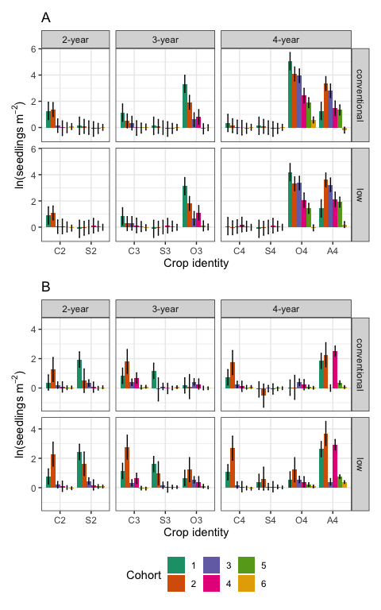

Figure 2: Effects of crop identity on female waterhemp seedling density by cohort in 2019 (A) and 2020 (B). The upper and lower limits of the error bars show the lower and upper limits of the means. The abbreviations on the x-axis are crop identities, which are the combinations of the first letter in crop species names and the rotation in which it occurred (C2 - corn in the 2-year rotation, C3 - corn in the 3-year rotation, C4 - corn in the 4-year rotation, S2 - soybean in the 2-year rotation, S3 - soybean in the 3-year rotation, S4 - soybean in the 4-year rotation, O3 - oat in the 3-year rotation, O4 - oat in the 4-year rotation, and A4 - alfalfa in the 4-year rotation). In 2020, only the first six cohorts were included in the statistical model because the small sample size of cohorts 7 and beyond were not appreciated by the model., fig.height = 16, fig.width = 12

Table 2: 2019 and 2020 seedling emergence initiation in four crop environments

|  | 2019 | | | 2020 | | |
| --- | --- | --- | --- | --- | --- | --- |
| Crop | difference | SE | df | difference | SE | df |
| oat | 173.000 | 0.000000000000006138086 | 51 | 141.00 | 0.061 | 51 |
| soybean | 180.667 | 0.000000000000005011726 | 51 | 163.00 | 0.050 | 51 |
| corn | 158.000 | 0.000000000000005011726 | 51 | 139.25 | 0.050 | 51 |
| alfalfa | 189.000 | 0.000000000000008680565 | 51 | 163.00 | 0.086 | 51 |

Table 3: 2019 and 2020 seedling emergence timing in four crop environments

|  | 2019 | | | | 2020 | | | |
| --- | --- | --- | --- | --- | --- | --- | --- | --- |
| Contrast | difference | SE | df | p | difference | SE | df | p |
| oat - soybean | -7.67 | 7.92e-15 | 51 | <.0001 | -22.00 | 0.0783 | 51 | <.0001 |
| oat - corn | 15.00 | 7.92e-15 | 51 | <.0001 | 1.75 | 0.0783 | 51 | <.0001 |
| oat - alfalfa | -16.00 | 1.06e-14 | 51 | <.0001 | -22.00 | 0.1050 | 51 | <.0001 |
| soybean - corn | 22.67 | 7.09e-15 | 51 | <.0001 | 23.75 | 0.0700 | 51 | <.0001 |
| soybean - alfalfa | -8.33 | 1.00e-14 | 51 | <.0001 | 0.00 | 0.0990 | 51 | 1.0000 |
| corn - alfalfa | -31.00 | 1.00e-14 | 51 | <.0001 | -23.75 | 0.0990 | 51 | <.0001 |

### 2019 soil seedbank and emergence proportion

In 2019, the waterhemp soil seedbanks in the cool-season crop environments (O3, O4, and A4) were substantially higher than those of the warm-season crops. The waterhemp soil seedbanks in the soybean environments were the lowest among all the crop environments (Table 4).

Table 4: 2019 seedbank densities at the top and bottom soil strata

|  |  |  |  | Top stratum desity | | Bottom stratum density | |
| --- | --- | --- | --- | --- | --- | --- | --- |
| Rotation | Crop ID | Corn weed management | df | mean | SE | mean | SE |
| 2-year | C2 | conventional | 51 | 8,231.86 | 5,655.50 | 5,422.06 | 1,679.28 |
| 2-year | C2 | low | 51 | 4,811.59 | 3,305.97 | 3,938.95 | 1,220.03 |
| 2-year | S2 | conventional | 51 | 604.65 | 416.04 | 1,297.91 | 402.22 |
| 2-year | S2 | low | 51 | 1,451.23 | 997.60 | 1,612.56 | 499.65 |
| 3-year | C3 | conventional | 51 | 1,851.61 | 1,272.63 | 6,361.60 | 1,970.22 |
| 3-year | C3 | low | 51 | 1,780.96 | 1,224.10 | 8,922.47 | 2,763.21 |
| 3-year | S3 | conventional | 51 | 73.77 | 51.36 | 1,615.47 | 500.55 |
| 3-year | S3 | low | 51 | 303.58 | 209.23 | 1,831.55 | 567.46 |
| 3-year | O3 | conventional | 51 | 6,682.30 | 4,591.04 | 5,921.90 | 1,834.06 |
| 3-year | O3 | low | 51 | 8,513.14 | 5,848.72 | 5,292.15 | 1,639.06 |
| 4-year | C4 | conventional | 51 | 89.98 | 62.50 | 1,052.11 | 326.10 |
| 4-year | C4 | low | 51 | 77.88 | 54.19 | 1,300.81 | 403.11 |
| 4-year | S4 | conventional | 51 | 231.80 | 159.92 | 2,554.02 | 791.18 |
| 4-year | S4 | low | 51 | 375.59 | 258.70 | 3,717.29 | 1,151.39 |
| 4-year | O4 | conventional | 51 | 10,201.07 | 7,008.23 | 5,209.54 | 1,613.48 |
| 4-year | O4 | low | 51 | 13,770.16 | 9,459.99 | 4,590.44 | 1,421.77 |
| 4-year | A4 | conventional | 51 | 5,777.88 | 3,969.76 | 2,790.16 | 864.30 |
| 4-year | A4 | low | 51 | 8,022.25 | 5,511.51 | 3,415.89 | 1,058.06 |

## Waterhemp population growth rates

### Scenario 1

Using 2019 fecundity rates that were estimated from individual plant size using eighteen equations from Nguyen and Liebman (2022a), waterhemp population densities were projected to decrease in all rotations, most quickly in the 2-year rotation under low herbicide corn weed management and the 3-year rotation under both corn weed management programs (Figure 3). ’s decreased right after the first phase of the 2-year (C2) and 3-year (C3) rotations, but increased in the first phase of the 4-year rotation (C4) by three ( = 3.24) to fourteen ( = 14.34) fold. The steady decrease of population density in the soybean, oat, and alfalfa phases (’s = 0.5) of the 4-year rotation were sufficient to keep the rotation-wise populations decreasing within a four year cycle even if increased again when the cropping system returned to the corn phase. The majority of the seedbank in the 4-year rotation was in the 2-20 cm stratum, limiting the seed pool density for seedling emergence.

### Scenario 2

Using 2018 fecundity rates, waterhemp population densities would increase rapidly in all rotations, but most quickly in the 2-year rotation (Figure 5). The population increase in the 3-year rotation under low herbicide corn weed management was similar to that of the 4-year rotation. Even though were all increasing, the partition of seedbanks differed between rotations. Within the same rotation, a consistent pattern of top:bottom ratios of seed densities was observed between two corn weed management regimes. In the 2-year rotation, a large portion of the seedbanks were at the 0-2 cm soil stratum; in the 3-year rotation, the top and bottom soil strata were fairly evenly populated; and in the 4-year rotation, the majority of the seedbanks were at the bottom stratum.

The oat phase of the 3-year rotation (O3) and the alfalfa phase of the 4-year rotation (A4) offered opportunities for decreasing , which was not possible in any other crop phases in the three examined rotations. However, the declines in ’s in O3 ( = 0.68) and A4 ( = 0.60) were not strong enough to deplete the replenishment from the corn ( = 2553 and = 35676.54) and soybean phases ( = 14567.90 and = 30.20).

## Elasticities of popilation growth rates to lower-level demographic parameters

All the relative ranking of elasticity of to the lower-level demographic parameters was consistent between corn weed management regimes (Figures 4 and 6). However, the overall population change rate can be reflected by the relative importance of each element on the elasticity of .

Even though all the matrices, but , were identical across scenarios, the ranking of each element contribution to the elasticity of might be slightly different across scenarios. For example, the the -decreasing case, the relative ranks of (the probability that a seed in the 2-20 cm stratum stay at that stratum) was higher that those of other , whereas in the population-growing case was the lowest among all . Similarly, was more important than in the elasticity of in the population-shrinking versus population-growing case. Consistent patterns in the importance of to elasticity of was observed in the two scenarios.

Because seed emergence and seedling survival rate contributed minimally to the elasticity of , this pattern suggests that even if weed control programs are of high, or even total efficacy, very few survived plants prolifically producing new seeds, can sustain the population. The low relative importance of and can be attributed to the low emergence rate in weeds, the high weed control efficacy, while the high relative importance of of to elasticity of can be explained by the high individual fecundity.

In both scenarios, the patterns of contribution to elasticity of in the 3-year rotation was slightly different from the 2-year and 4-year rotations. The contribution of plant survival rate to elasticity of was non-existent in C2, S2, C4, S4, and O4 (absolute zeros) but minimal in C3, S3, and O4 (very small positive values). The difference in contribution of plant survival rate on O3 and O4 might be attributed to the different companion crops to oat (red clover in O3 and alfalfa in O4).

### Scenario 1

The ranking of parameters or individual parameters to the elasticity of differed by rotation and crop phase. The seed preserving parameters were ranked higher in the corn phase of the 3-year rotation (C3) under both weed management regimes, the soybean phase of the 3-year rotation (S3) that followed corn under low herbicide weed management, the oat phases of the 3-year and 4-year rotations (O3 and O4) regardless of the preceding corn phase’s weed management regime, and the alfalfa phase of the 4-year rotation (A4) regardless of the preceding corn phase’s weed management regime. The seed producing parameters were ranked higher in the other crop environments (crop species in each rotation).

The elasticity of to fecundity rate, as a group, were ranked first in the corn phase of the 2-year rotation (C2) (43.13 and 3.15), the soybean phase of the 2-year rotation (S2) (0.75 and 4.18), the soybean phase of the 3-year rotation (S3) that followed corn under low herbicide weed management program (0.91), the corn phase of the 4-year rotation (C4) (305.24 and 323.07), and the alfalfa in the 4-year rotation (A4) (36.78 and 14.49) under both weed management regimes. The rate of pre-planting tillage induced seed movement to the 2-20 cm soil stratum was the first-ranked individual parameter to the elasticity of ’s in the corn phase of the 3-year rotation (C3) (1.1 and 1.1), the soybean in the 3-year rotation that followed corn under low herbicide weed management (0.89), the oat phase of the 3-year rotation (O3) (0.87 and 0.88), and the oat phase of the 4-year rotation (5.49 and 3.98). The overwinter survival rate of the seeds in the 0-2 cm soil stratum was the first-ranked individual parameter to the elasticity of ’s in the soybean phase of the 4-year rotation (S4) (3.32 and 2.41).

As s declined in this scenario, with some opportunity of increasing in the C4 phase, focusing on reducing plant fecundity in C4 would sufficiently stabilize , provided that the weed control efficacy in the subsequent three crop phases remained adequate.

### Scenario 2

Unlike Scenario 1’s dynamics, the differences in the absolute value of the elasticity of to the first-ranked and second-ranked groups of parameters were multiple orders of magnitude. The seed producing parameters were ranked higher in all crop environments (crop species in each rotation).

The elasticity of ’s to fecundity rates, as a group, were ranked first in all crop phases. The elasticity of ’s to cohort one fecundity were the highest in C2 (4.1 x and 2.8 x ), S3 (4.4 x and 9.7 x ), and O4 (8.3 x and 6.5 x ) phases. The elasticity of ’s elasticity to cohort two fecundity were the highest in S2 (1.4 x and 8.4 x ), C3 (1 x and 1 x ), O3 (3 x and 2.5 x ), C4 (1.6 x and 1 x ), S4 (8.4 x and 8.8 x ), and A4 (1.1 x and 3 x ) phases.

The second-ranked group of demographic parameters to differed by rotation and crop phase. In the 2-year rotation, the second-ranked group of parameters in contribution to the elasticity of were both pre-planting tillage-induced seed movement and overwinter seed survival. In the 3-year rotation, the second-ranked group of parameters in contribution to elasticity of was pre-planting tillage-induced seed movement in the warm-season crop phases; and overwinter seed survival in the cool-season crop phase. In the 4-year rotation, the second-ranked group of parameters in contribution to elasticity of was overwinter seed survival in the cool-season crop phase and pre-planting tillage-induced seed movement in the warm-season crop phases; a reverse trend as compared to the 3-year rotation’s dynamics.

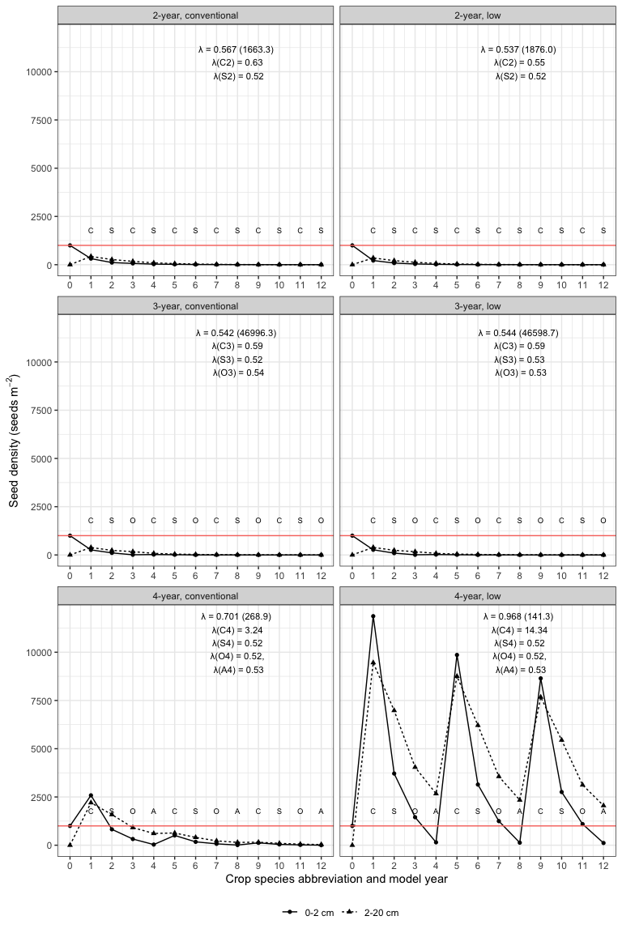

Figure 3: Scenario 1: Changes of a seed column after twelve model years in three rotations (2-year, 3-year, and 4-year) crossed with two corn weed management programs (conventional and low herbicide). The model started at year 0 with 1000 and 0 seeds per squared meter at the top (0-2 cm) and bottom (2-20 cm) strata, respectively. The red horizontal line shows the number of seeds at the top stratum at the begining of the model clock. The annualized population growth rates are followed by their variances in brackets. The models years are followed by the main crop species names’ abbreviations: C - corn, S - soybean, O - oat, and A - alfalfa.

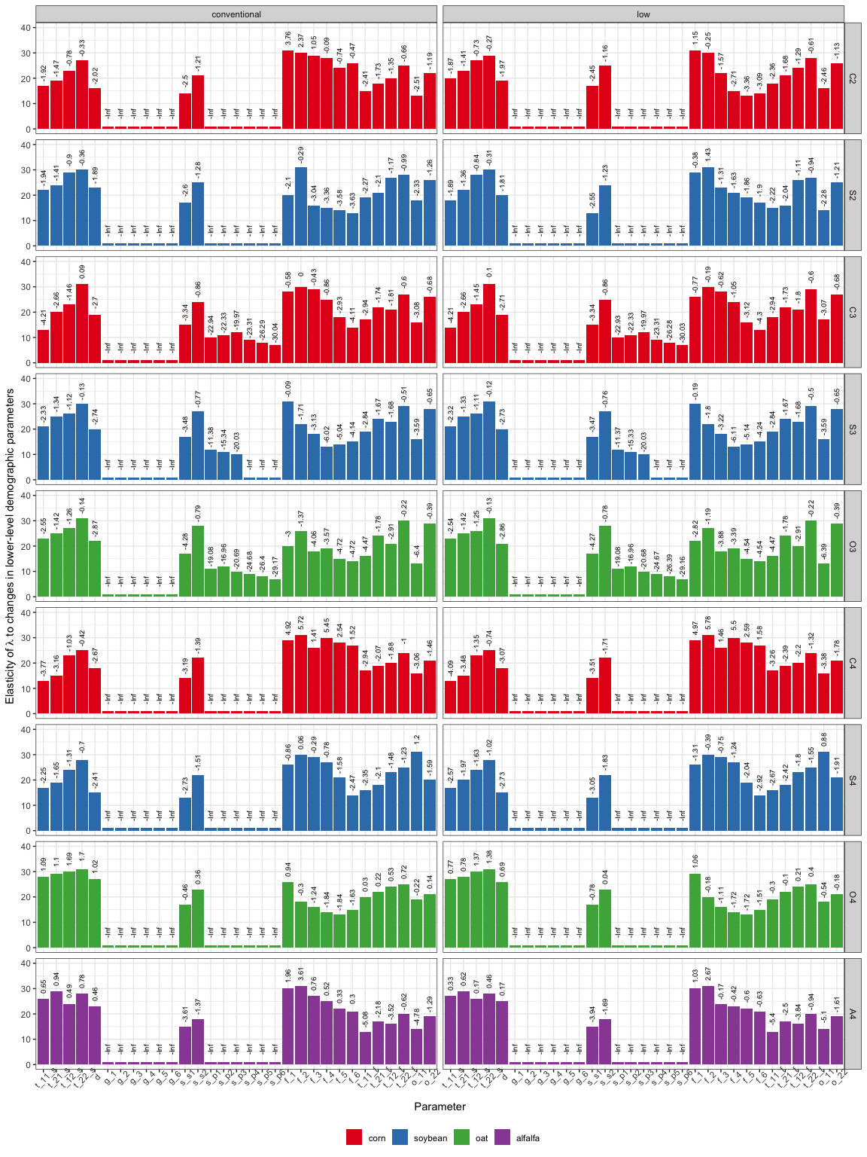

Figure 4: Scenario 1: Elasticity of annualized population growth rates to changes in lower-level demographic parameters. Bar height represents parameter’s ranking. Each bar is labeled with the natural lograrithm of absolute value of the contribution of the parameter to elasticity of annualized population growth rates (-Inf labels indicates the parameters whose contribution to elasticity of lambda were zero). Crop identities are color-coded by crop species. From left to right of the x-axis, the sub-annual demographic parameters are: t_11_s - probability that a seed at the 0-2 cm soil stratum stay at that statum; t_21_s - probability that a seed at the 2-20 cm soil stratum move to the 0-2 cm soil stratum; t_12_s - probability that a seed at the 0-2 cm soil stratum move to the 2-20 cm stratum; and t_22_s - probability that a seed at the 2-20 cm soil stratum stay at that statum; d - the probability that a seed is not germinating; g_1 through g_6: the probabiblites that a seed emerge to seedling cohorts 1 through 6; s_s1 and s_s2: the survival rate of seeds at the 0-2 cm and 2-20 cm soil strata in the cropped season; s_p1 through s_p6: the probability that seedling cohorts 1 through 6 reach reproductive maturity; f_1 through f_6: the fecundity rates of mature plant cohorts 1 through 6; t_11_f through t_22_f: the vertical seed movement probability induced by post-harvest tillage; o_11 and o_12: overwiter survival rates in the 0-2 cm and 2-20 cm soil strata.

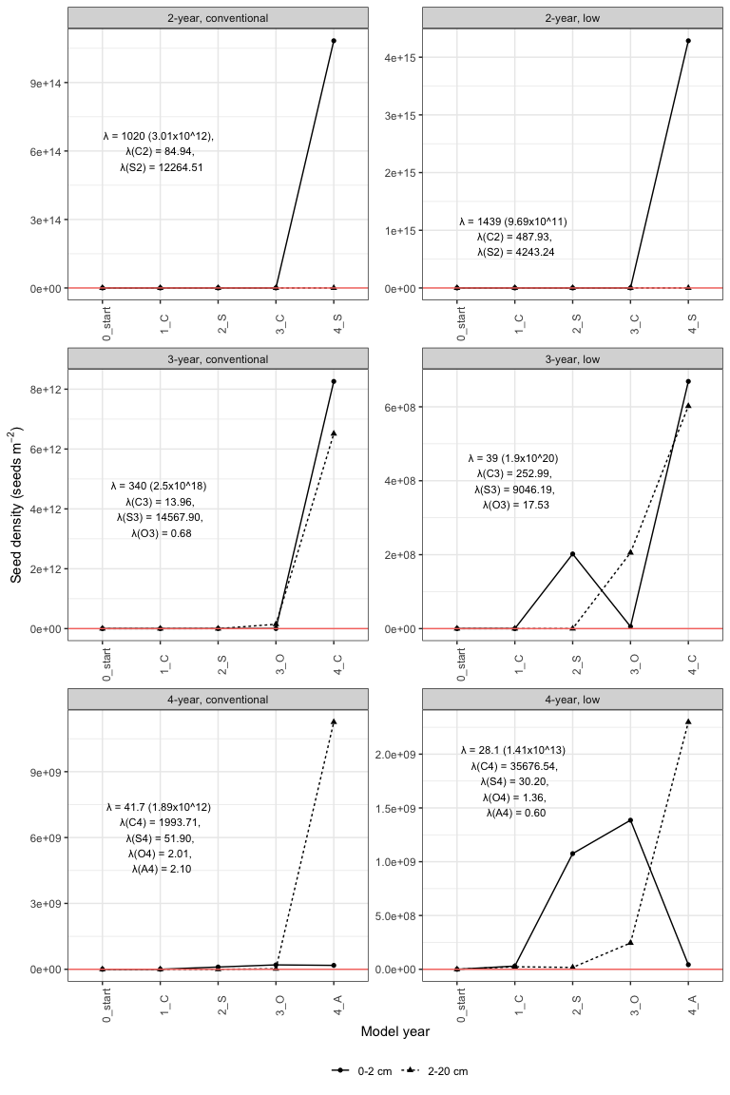

Figure 5: Scenario 1: Changes of seed densities in two soil strata after four model years (only four years are illustrated because of scales) in three rotations (2-year, 3-year, and 4-year) crossed with two corn weed management programs (conventional and low herbicide). The model started at year 0 with 1000 and 0 seeds per squared meter at the top (0-2 cm) and bottom (2-20 cm) strata, respectively. The red horizontal line shows the number of seeds at the top stratum at the beginning of the model clock. The annualized population growth rates are followed by their variances in brackets. The model years’ are labelled with the main crop species names’ abbreviations: C - corn, S - soybean, O - oat, and A - alfalfa.

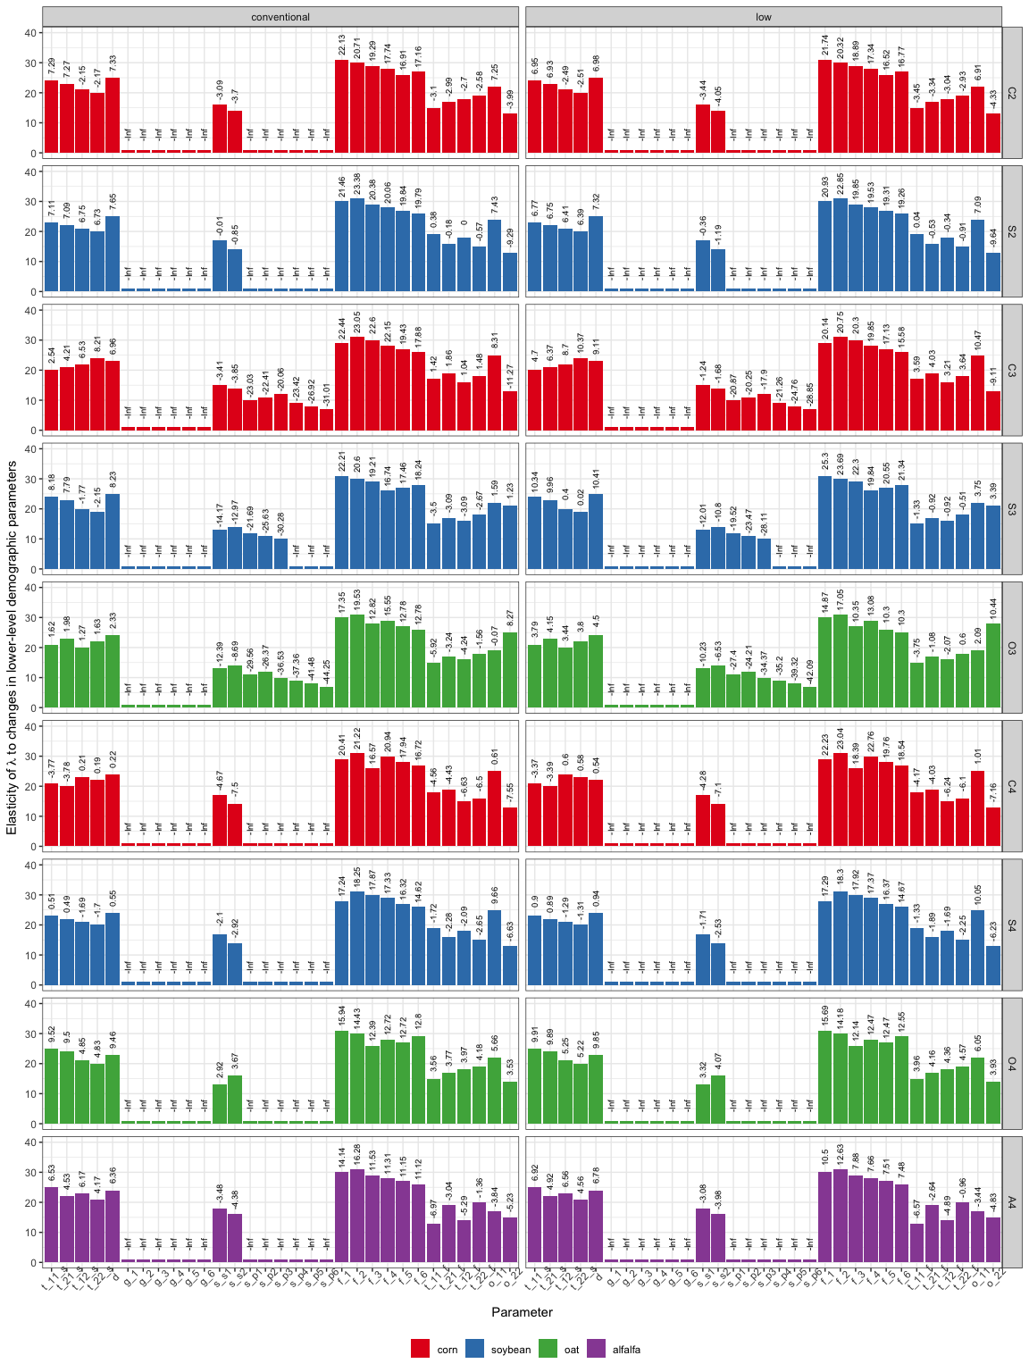

Figure 6: Scenario 2: Elasticity of annualized population growth rates to changes in lower-level demographic parameters. Bar height represents parameter’s ranking. Each bar is labeled with the natural lograrithm of absolute value of the contribution of the parameter to elasticity of annualized population growth rates (-Inf labels indicates the parameters whose contribution to elasticity of lambda were zero). Crop identities are color-coded by crop species. From left to right of the x-axis, the sub-annual demographic parameters are: t_11_s - probability that a seed at the 0-2 cm soil stratum stay at that statum; t_21_s - probability that a seed at the 2-20 cm soil stratum move to the 0-2 cm soil stratum; t_12_s - probability that a seed at the 0-2 cm soil stratum move to the 2-20 cm stratum; and t_22_s - probability that a seed at the 2-20 cm soil stratum stay at that statum; d - the probability that a seed is not germinating; g_1 through g_6: the probabiblites that a seed emerge to seedling cohorts 1 through 6; s_s1 and s_s2: the survival rate of seeds at the 0-2 cm and 2-20 cm soil strata in the cropped season; s_p1 through s_p6: the probability that seedling cohorts 1 through 6 reach reproductive maturity; f_1 through f_6: the fecundity rates of mature plant cohorts 1 through 6; t_11_f through t_22_f: the vertical seed movement probability induced by post-harvest tillage; o_11 and o_12: overwiter survival rates in the 0-2 cm and 2-20 cm soil strata.

## Conclusion

Delayed (Table ??) but steady emergence ?? in the cool-season crop environments decreased population fecundity in the oat and alfalfa phases, and thus, accelerated seedbank size reduction in scenario 1 and slowed seedbank size increment in scenario 2.

The cohort-based female survival rates at the experiment site were not realistically estimated due to small sample size in a high-efficacy weed management program. Future experiments should focus on assessing cohort-based female survival rates in cool-season crop environments.

The hypothesis that “extending a conventional 2-year rotation of corn and soybean with cool-season crops can accelerate soil seedbank depletion” was supported. The findings here illustrated that employing the “many little hammers” concept could provide effective control of common waterhemp (Liebman and Gallandt, 1997). Unlike giant foxtail whose bottle neck point in the life cycle was overwinter seed survival rate (Davis, 2002), waterhemp’s bottle neck point in its life cycle was seedling emergence rate and seedling to maturity success rate. However, if the early emerged plants were unaffected by weed control programs, either through herbicide resistance or escape from cultivation, and successfully complete their life cycle, a small number of large, prolific female plants would sufficiently replenish the soil seedbank.

Since the elasticity of was the least affected by seedling emergence in both the population-growing and population-shrinking scenarios, it would be helpful to focus on disrupting seed production by reducing individual plant size with delaying emergence or applying multiple stress factors to successfully establishing plants, and by limiting seed deposit to the soil. Under the current 4-year rotation’s crop sequence, oat (O4) and alfalfa (A4) provided valuable opportunities to reduce plant size (Nguyen and Liebman, 2022b, 2022a).

A reduction in the mass of applied herbicide active ingredients (Nguyen and Liebman, 2022b) was not coincident with population growing in the Scenario 1 () but did coincide with population growing in scenario 2 (). In consideration of Scenario 2, population-growing, it would be useful to examine how many years of continuous overwinter cover crops would be necessary and which cool-season crop species would be most efficient in decreasing waterhemp after steady seedbank replenishment. Such an investigation is needed because even if the increased abundance of waterhemp and other weed species has not been observed at the experiment site (Nguyen and Liebman, 2022b), an abundant seedbank of a highly competitive weed species harbors risks of weed outbreaks.

## Appendix

### Seed densities at the top and bottom soil strata

## ANOVA of Crop ID x Corn weed management effects on AMATA seedbank density at the 0-2 cm soil stratum  
AMATA_female_top_lm <- lm(log(AMATA_total_viable_density + 1) ~ Block +   
 Crop_ID * Corn_weed_management,   
 data = top_stratum_female)  
  
  
## ANOVA table of female seedbank density at the 0-2 cm soil stratum  
AMATA_female_top_emm_log <- emmeans(AMATA_female_top_lm,   
 c("Crop_ID" , "Corn_weed_management"))  
  
joint_tests(AMATA_female_top_emm_log )

## model term df1 df2 F.ratio p.value  
## Crop_ID 8 51 14.638 <.0001  
## Corn_weed_management 1 51 0.998 0.3225  
## Crop_ID:Corn_weed_management 8 51 0.343 0.9445

## ANOVA of Crop ID x Corn weed management effects on AMATA seedbank density at the 2-20 cm soil stratum  
AMATA_female_bottom_lm <- lm(log(AMATA_total_viable_density + 1) ~ Block +   
 Crop_ID * Corn_weed_management,   
 data = bottom_stratum_female)  
   
  
## ANOVA table of female seedbank density at the 2-20 cm soil stratum  
AMATA_female_bottom_emm_log <- emmeans(AMATA_female_bottom_lm, c("Crop_ID" , "Corn_weed_management"))  
  
joint_tests(AMATA_female_bottom_emm_log)

## model term df1 df2 F.ratio p.value  
## Crop_ID 8 51 8.812 <.0001  
## Corn_weed_management 1 51 0.482 0.4908  
## Crop_ID:Corn_weed_management 8 51 0.288 0.9669

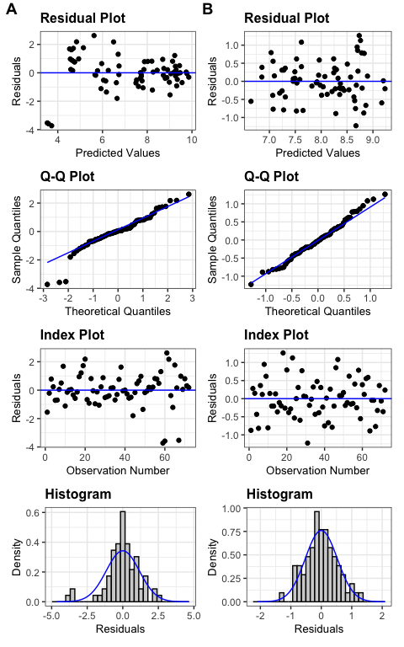

Figure 7: Diagnosis plots for the effects of crop identity and crop weed managennt on the seedbank densities at the top (A) and bottom (B) soil strata

### Emergence pattern and timing in different crop environments

## Did crop identity and corn weed management affect waterhemp's emergence pattern in 2019?  
emerge_cohort_19_gls <- gls(log(Density_end_female_eu_cohort+1) ~ Block +   
 Crop_ID*Corn_weed_management + Cohort +  
 Crop_ID:Cohort + Corn_weed_management:Cohort,  
 correlation=corCompSymm(form=~1 | bt),  
 weights=varIdent(form= ~1 | Cohort),  
data=cohort_emergence_female_19)  
  
 joint_tests(emerge_cohort_19_gls)

## model term df1 df2 F.ratio p.value  
## Block 3 56.93 0.477 0.6998  
## Crop_ID 8 56.53 117.230 <.0001  
## Corn_weed_management 1 56.53 0.602 0.4411  
## Cohort 5 69.94 70.175 <.0001  
## Crop_ID:Corn_weed_management 8 56.93 4.015 0.0008  
## Crop_ID:Cohort 40 69.94 15.739 <.0001  
## Corn_weed_management:Cohort 5 69.94 1.206 0.3153

## Did crop identity and corn weed management affect waterhemp's emergence pattern in 2020?  
#   
emerge_cohort_20_gls <- gls(log(cohort_female_Seedling_density +1) ~ Block +   
 Crop_ID*Corn_weed_management + Cohort +  
 Crop_ID:Cohort + Corn_weed_management:Cohort,  
 correlation=corCompSymm(form=~1 | bt),  
 weights=varIdent(form= ~1 | Cohort),  
data=cohort_emerge_20_first_six )  
  
 joint_tests(emerge_cohort_20_gls)

## model term df1 df2 F.ratio p.value  
## Block 3 53.88 2.441 0.0742  
## Crop_ID 8 98.25 9.916 <.0001  
## Corn_weed_management 1 88.66 12.907 0.0005  
## Cohort 5 83.86 39.802 <.0001  
## Crop_ID:Corn_weed_management 8 58.17 6.045 <.0001  
## Crop_ID:Cohort 40 97.25 11.675 <.0001  
## Corn_weed_management:Cohort 5 80.71 4.963 0.0005

## Did crop identity and corn weed management affect waterhemp's first emergence timing in 2019?  
Julian_cohort1_19_lm <- lm(Julian_day ~ Block +   
 Crop_ID*Corn_weed_management,  
data = cohort1_2019_eu )   
  
joint_tests(Julian_cohort1_19_lm)

## model term df1 df2 F.ratio  
## Block 3 51 2.000  
## Crop_ID 8 51 3851911191786461636489811853312.000  
## Corn_weed_management 1 51 0.000  
## Crop_ID:Corn_weed_management 8 51 1.000  
## p.value  
## 0.2023  
## <.0001  
## 0.6656  
## 0.3385

## Did crop identity and corn weed management affect waterhemp's first emergence timing in 2020?  
Julian_cohort1_20_lm <- lm(Julian_day ~ Block +   
 Crop_ID*Corn_weed_management,  
 data=cohort1_2020)  
  
joint_tests(Julian_cohort1_20_lm )

## model term df1 df2 F.ratio p.value  
## Block 3 51 8.500 0.0001  
## Crop_ID 8 51 20133.903 <.0001  
## Corn_weed_management 1 51 0.000 1.0000  
## Crop_ID:Corn_weed_management 8 51 0.000 1.0000

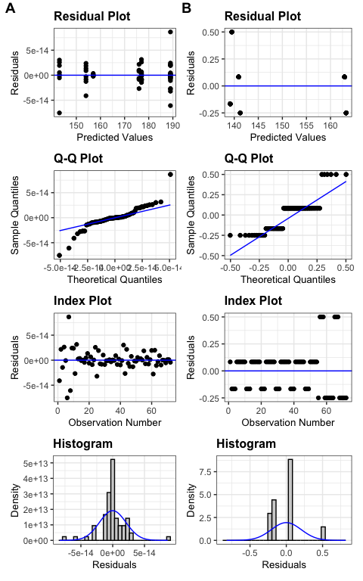

Figure 8: Diagnosis plots for the effects of crop identity and corn weed management on the seedbank densities at the top (A) and bottom (B) soil strata

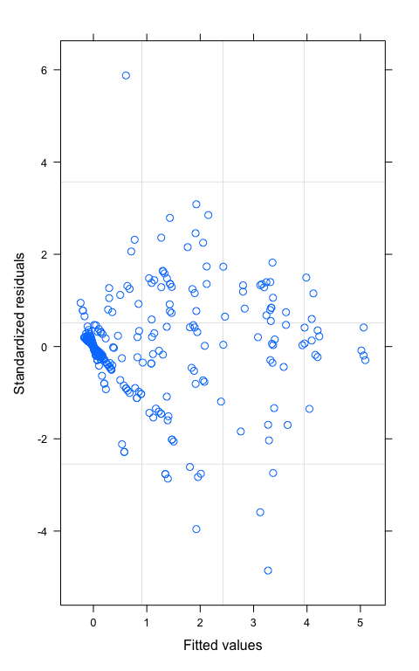

Figure 9: Diagnosis plot for the effects of crop identity, corn weed management, and cohort on seedling densities in 2019

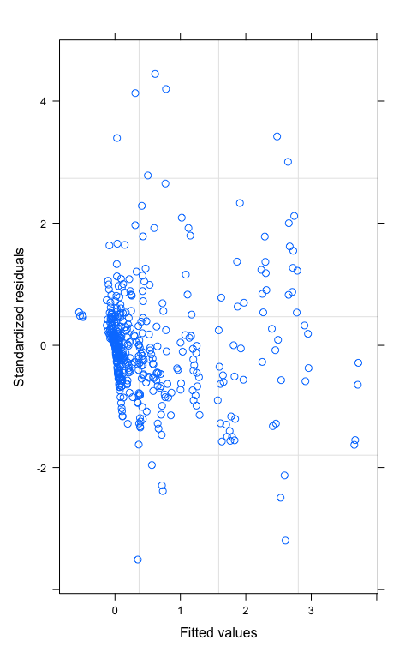

Figure 10: Diagnosis plot for the effects of crop identity, corn weed management, and cohort on seedling densities in 2020

### 2019 female survival rate by cohort

Table 5: 2019 seedbank densities at the top and bottom soil strata

|  |  | Cohort | | | | | |
| --- | --- | --- | --- | --- | --- | --- | --- |
| Crop ID | Corn weed management | 1 | 2 | 3 | 4 | 5 | 6 |
| C2 | conventional | 0.17 | 0.10 | 0.19 | 0.46 | 0.50 | 0.50 |
| C2 | low | 0.00 | 0.15 | 0.32 | 0.43 | 0.17 | 0.00 |
| S2 | conventional | 0.00 | 0.00 | 0.00 | 0.00 | 0.00 | 0.00 |
| S2 | low | 0.00 | 0.00 | 0.00 | 0.00 | 0.00 | 0.00 |
| C3 | conventional | 0.15 | 0.25 | 0.34 | 0.53 | 0.00 | 0.67 |
| C3 | low | 0.02 | 0.20 | 0.33 | 0.23 | 0.00 | 1.00 |
| S3 | conventional | 0.00 | 0.00 | 0.00 | 0.00 | 0.00 | 0.00 |
| S3 | low | 0.00 | 0.00 | 0.00 | 0.00 | 0.00 | 0.00 |
| O3 | conventional | 0.04 | 0.08 | 0.01 | 0.39 | 0.00 | 0.00 |
| O3 | low | 0.03 | 0.02 | 0.03 | 0.07 | 0.04 | 0.00 |
| C4 | conventional | 0.38 | 0.26 | 0.42 | 0.50 | 0.00 | 0.00 |
| C4 | low | 0.02 | 0.24 | 0.37 | 0.30 | 0.00 | 0.00 |
| S4 | conventional | 0.00 | 0.00 | 0.00 | 0.00 | 0.00 | 0.00 |
| S4 | low | 0.00 | 0.00 | 0.00 | 0.00 | 0.00 | 0.00 |
| O4 | conventional | 0.15 | 0.10 | 0.28 | 0.22 | 0.33 | 0.22 |
| O4 | low | 0.07 | 0.04 | 0.09 | 0.13 | 0.29 | 0.08 |
| A4 | conventional | 0.06 | 0.06 | 0.17 | 0.02 | 0.06 | 0.00 |
| A4 | low | 0.08 | 0.06 | 0.10 | 0.14 | 0.25 | 0.00 |

# References

Borza, J. K., Westerman, P. R., and Liebman, M. (2007). Comparing estimates of seed viability in three foxtail (setaria) species using the imbibed seed crush test with and without additional tetrazolium testing. *Weed Technology*, *21*(2), 518–522. <https://doi.org/d8wnfq>

Buhler, D. D., and Hartzler, R. G. (2001). Emergence and persistence of seed of velvetleaf, common waterhemp, woolly cupgrass, and giant foxtail. *Weed Science*, *49*(2), 230–235. <https://doi.org/dmnt6f>

Burnside, O. C., Wilson, R. G., Weisberg, S., and Hubbard, K. G. (1996). Seed longevity of 41 weed species buried 17 years in eastern and western Nebraska. *Weed Science*, *44*(1), 74–86.

Caswell, H. (2001). *Matrix population models: Construction, analysis, and interpretation* (Second). Sunderland, Mass. : Sinauer Associates.

Caswell, H., and Trevisan, M. C. (1994). Sensitivity analysis of periodic matrix models. *Ecology*, *75*(5), 1299–1303. <https://doi.org/cbjqq5>

Costea, M., Weaver, S. E., and Tardif, F. J. (2005). The biology of invasive alien plants in Canada. 3. *Amaranthus tuberculatus* (Moq.) Sauer var. *rudis* (Sauer) Costea & Tardif. *Can. J. Plant Sci.*, *85*(2), 507–522. <https://doi.org/b75t54>

Cousens, R., and Mortimer, M. (1995). *Dynamics of weed populations*. Cambridge University Press. <https://doi.org/10.1017/CBO9780511608629>

Cousens, R., and Moss, S. R. (1990). A model of the effects of cultivation on the vertical distribution of weed seeds within the soil. *Weed Research*, *30*(1), 61–70. <https://doi.org/d824tt>

Davis, A. S. (2008). Weed seed pools concurrent with corn and soybean harvest in Illinois. *Weed Science*, *56*(4), 503–508. <https://doi.org/bmncpf>

Davis, A. S. (2002). *Cropping system effects on giant foxtail demography* [Doctor of {{Philosophy}}, Iowa State University, Digital Repository]. <https://doi.org/10.31274/rtd-180814-161>

Davis, A. S., Cardina, J., Forcella, F., Johnson, G. A., Kegode, G., Lindquist, J. L., Luschei, E. C., Renner, K. A., Sprague, C. L., and Williams, M. M. (2005). Environmental factors affecting seed persistence of annual weeds across the U.S. Corn Belt. *Weed Science*, *53*(6), 860–868. <https://doi.org/dmvcdf>

Davis, A. S., and Liebman, M. (2003). Cropping system effects on giant foxtail (*Setaria faberi*) demography: I. Green manure and tillage timing. *Weed Science*, *51*(6), 919–929. <https://doi.org/bxq7q8>

Davis, A. S., and Renner, K. A. (2007). Influence of seed depth and pathogens on fatal germination of velvetleaf (Abutilon theophrasti) and giant foxtail (Setaria faberi). *Weed Sci.*, *55*(1), 30–35. <https://doi.org/cdzbdn>

Hartzler, R. G., Battles, B. A., and Nordby, D. (2004). Effect of common waterhemp (*Amaranthus rudis*) emergence date on growth and fecundity in soybean. *Weed Science*, *52*(2), 242–245. <https://doi.org/cmhpxk>

Johnson, W. G., Davis, V. M., Kruger, G. R., and Weller, S. C. (2009). Influence of glyphosate-resistant cropping systems on weed species shifts and glyphosate-resistant weed populations. *European Journal of Agronomy*, *31*(3), 162–172. <https://doi.org/dxmb34>

Korres, N. E., Norsworthy, J. K., Young, B. G., Reynolds, D. B., Johnson, W. G., Conley, S. P., Smeda, R. J., Mueller, T. C., Spaunhorst, D. J., Gage, K. L., Loux, M., Kruger, G. R., and Bagavathiannan, M. V. (2018). Seedbank persistence of Palmer amaranth (Amaranthus palmeri) and waterhemp (*Amaranthus* *Tuberculatus*)across diverse geographical regions in the United States. *Weed Science*, *66*(4), 446–456. <https://doi.org/gd2hgf>

Leslie, P. H. (1945). On the use of matrices in certain population mathematics. *Biometrika*, *33*(3), 183–212. <https://doi.org/bskdps>

Liebman, M., and Gallandt, E. R. (1997). Many little hammers: Ecological management of crop-weed interactions. In L. E. Jackson (Ed.), *Ecology in Agriculture* (pp. 291–343). Academic Press. <https://doi.org/10.1016/B978-012378260-1/50010-5>

Liu, J., Davis, A. S., and Tranel, P. J. (2012). Pollen biology and dispersal dynamics in waterhemp (*Amaranthus* *Tuberculatus*). *Weed Science*, *60*(3), 416–422. <https://doi.org/f35xbv>

Montgomery, J. S., Giacomini, D. A., Weigel, D., and Tranel, P. J. (2021). Male-specific Y-chromosomal regions in waterhemp (*Amaranthus* *Tuberculatus*) and Palmer amaranth (*Amaranthus* *Palmeri*). *New Phytol*, *229*(6), 3522–3533. <https://doi.org/gjpz5c>

Montgomery, J. S., Sadeque, A., Giacomini, D. A., Brown, P. J., and Tranel, P. J. (2019). Sex-specific markers for waterhemp (*Amaranthus* *Tuberculatus*) and Palmer amaranth (*Amaranthus* *Palmeri*). *Weed Science*, *67*(4), 412–418. <https://doi.org/gf5pdq>

Nguyen, H. T. X., and Liebman, M. (2022a). Impact of cropping system diversification on vegetative and reproductive characteristics of waterhemp (*A. tuberculatus*). *Frontiers in Agronomy*, *4*. <https://doi.org/gpsrmj>

Nguyen, H. T. X., and Liebman, M. (2022b). Weed community composition in simple and more diverse cropping systems. *Front. Agron.* <https://doi.org/gpsrmk>

Nordby, D. E., and Hartzler, R. G. (2004). Influence of corn on common waterhemp (*Amaranthus rudis*) growth and fecundity. *Weed Science*, *52*(2), 255–259. <https://doi.org/10.1614/WS-03-060R>

Prince, J. M., Shaw, D. R., Givens, W. A., Owen, M. D. K., Weller, S. C., Young, B. G., Wilson, R. G., and Jordan, D. L. (2012). Benchmark study: IV. Survey of grower practices for managing glyphosate-resistant weed populations. *Weed Technology*, *26*(3), 543–548. <https://doi.org/f37vn9>

R Development Core Team. (2022). *R: A language and environment for statistical computing*. R Foundation for Statistical Computing.

Sosnoskie, L. M., Webster, T. M., and Culpepper, A. S. (2013). Glyphosate resistance does not affect Palmer amaranth (Amaranthus palmeri) seedbank longevity. *Weed Science*, *61*(2), 283–288. <https://doi.org/f4vgfs>

Spokas, K., Forcella, F., Archer, D., and Reicosky, D. (2007). SeedChaser: Vertical soil tillage distribution model. *Computers and Electronics in Agriculture*, *57*(1), 62–73. <https://doi.org/dzh845>

Steckel, L. E., Sprague, C. L., Stoller, E. W., Wax, L. M., and Simmons, F. W. (2007). Tillage, cropping system, and soil depth effects on common waterhemp (Amaranthus rudis) seed-bank persistence. *Weed Science*, *55*(3), 235–239. <https://doi.org/bhs6vt>

Stubben, C., Milligan, B., and Nantel, P. (2020). *Popbio: Construction and analyse and of matrix models*.

Tranel, P. J. (2021). Herbicide resistance in *Amaranthus tuberculatus*. *Pest Manag Sci*, *77*(1), 43–54. <https://doi.org/gjpz5w>

Ullrich, S. (2000). *Weed population dynamics in potato cropping systems as affected by rotation crop, cultivation, and primary tillage* [PhD thesis]. The University of Maine.

Werle, R., Sandell, L. D., Buhler, D. D., Hartzler, R. G., and Lindquist, J. L. (2014). Predicting emergence of 23 summer annual weed species. *Weed Science*, *62*(2), 267–279. <https://doi.org/f5z7zc>

Yenish, J. P., Doll, J. D., and Buhler, D. D. (1992). Effects of tillage on vertical distribution and viability of weed seed in soil. *Weed Science*, *40*(3), 429–433.