The sensitivity and elasticity patterns were consistent between weed management regimes, but graphs are separated by weed management regimes for ease of view. In scenario one, using the 2019 fecundity rates, the probability that a seed in the soil successfully establish had the greatest effects on waterhemp population growth (Figures 1 and 2. The absolute change in waterhemp’s population growth rates influenced by successful establishment in the cool-season crops were at a smaller magnitude than that of the warm-season crops. The number of seeds contributed to the soil seedbank intermediately affected the absolute change in waterhemp’s population growth in the cool-season crops but minimally so in the warm-season crops.

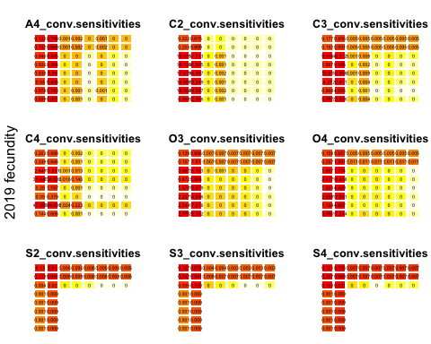

Figure 1: Sensitivities of eigen values to changes in each element of the population projection matrix. Each panel presents the sensitivities in each crop phase under or follow conventional weed management.

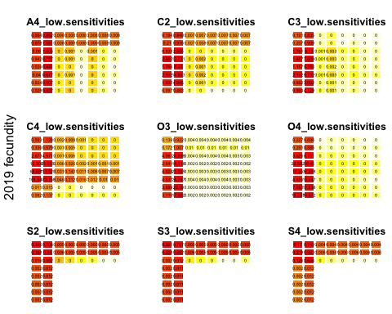

Figure 2: Sensitivities of eigen values to changes in each element of the population projection matrix. Each panel presents the sensitivities in each crop phase under or follow low herbicide weed management.

Also using the 2019 fecundity rates, the seedbank had the greatest proportional effects on waterhemp population growth in all crop phases. The influence of seedbank states on waterhemp population growth was consistent between weed management regimes (Figures 3 and 4. In general, the probability that a plant successfully contribute seeds to the soil surface was more influential to waterhemp population proportional change in warm-season crops than in cool-season crops. Noticeably, waterhemp population proportional changes in the 2-year rotation (C2 and S2) were only influenced by the seedbank dynamics.

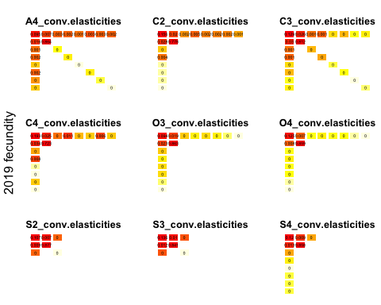

Figure 3: Elasticities of eigen values to changes in each element of the population projection matrix, using 2019 fecundity rate. Each panel presents the elasticities in each crop phase under or follow conventional weed management.

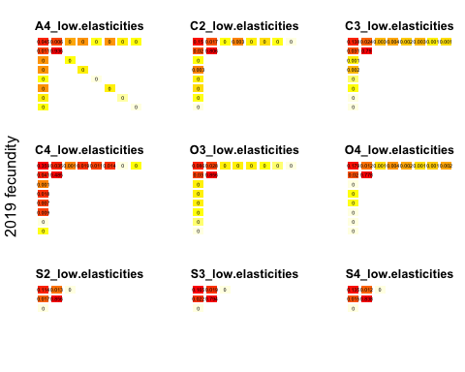

Figure 4: Elasticities of eigen values to changes in each element of the population projection matrix, using 2019 fecundity rate. Each panel presents the elasticities in each crop phase under or follow low herbicide weed management.

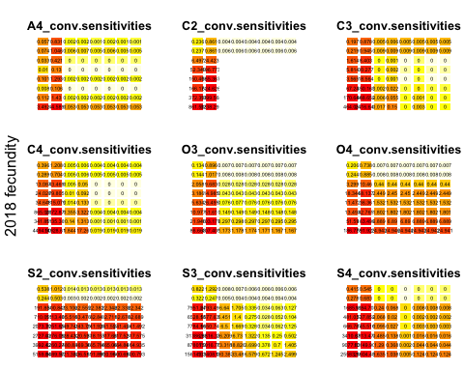 In scenario two, the patterns in sensitivities and elasticities of waterhemp proportional population changes to proportional changes in projection matrices’ elements using 2018 fecundity rate were consistent with those in scenarios one ((Figures 7 and 8).

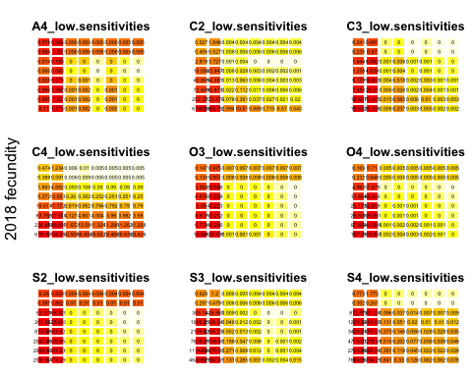

Figure 6: Sensitivities of eigen values to changes in each element of the population projection matrix, using 2018 fecundity rate. Each panel presents the sensitivities in each crop phase under or follow low herbicide weed management.

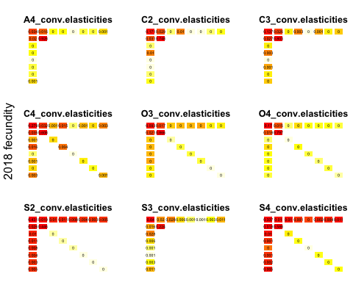

Figure 7: Elasticities of eigen values to changes in each element of the population projection matrix, using 2018 fecundity rate. Each panel presents the elasticities in each crop phase under or follow conventional weed management.

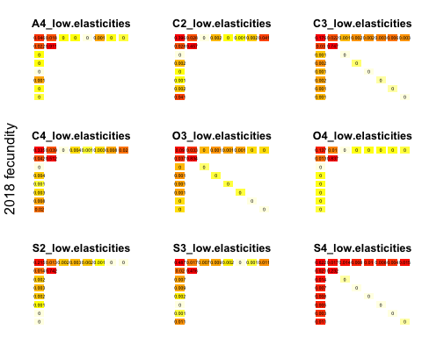

Figure 8: Elasticities of eigen values to changes in each element of the population projection matrix, using 2018 fecundity rate. Each panel presents the elasticities in each crop phase under or follow low herbicide weed management.