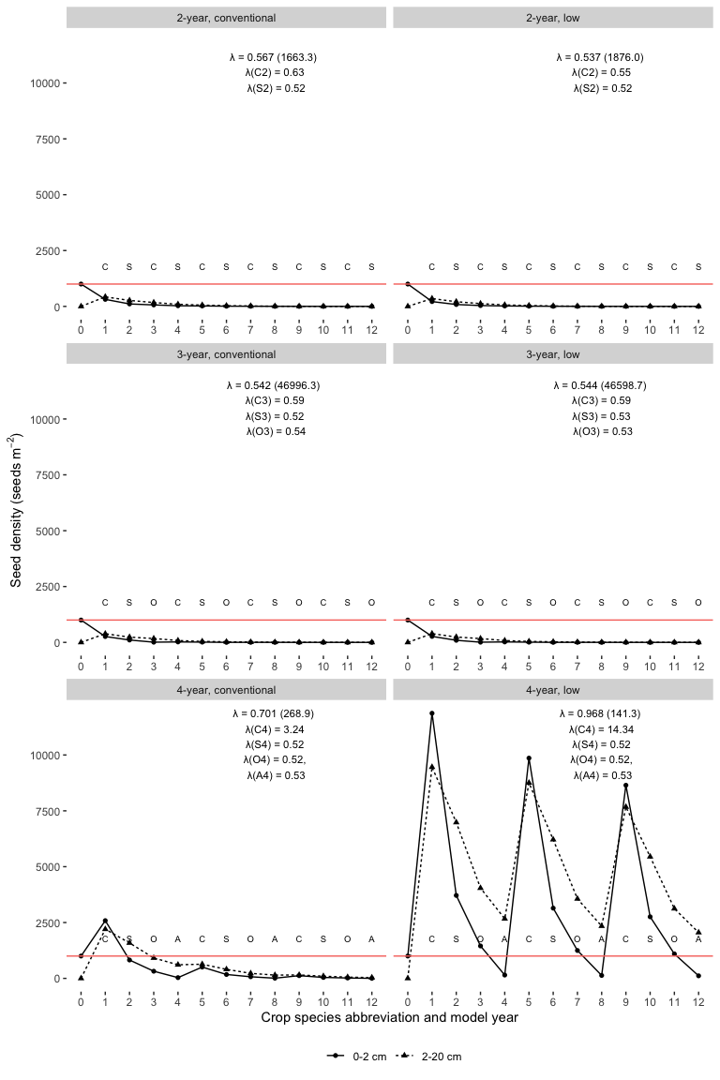

Figure 1: Scenario 1: Changes of a seed column after twelve model years in three rotations (2-year, 3-year, and 4-year) crossed with two corn weed management programs (conventional and low herbicide). The model started at year 0 with 1000 and 0 seeds per squared meter at the top (0-2 cm) and bottom (2-20 cm) strata, respectively. The red horizontal line shows the number of seeds at the top stratum at the begining of the model clock. The annualized population growth rates are followed by their variances in brackets. The models years are followed by the main crop species names’ abbreviations: C - corn, S - soybean, O - oat, and A - alfalfa.

## Joining, by = c("Rotation", "Crop_ID", "Corn_weed_management", "Crop",  
## "Parameter")

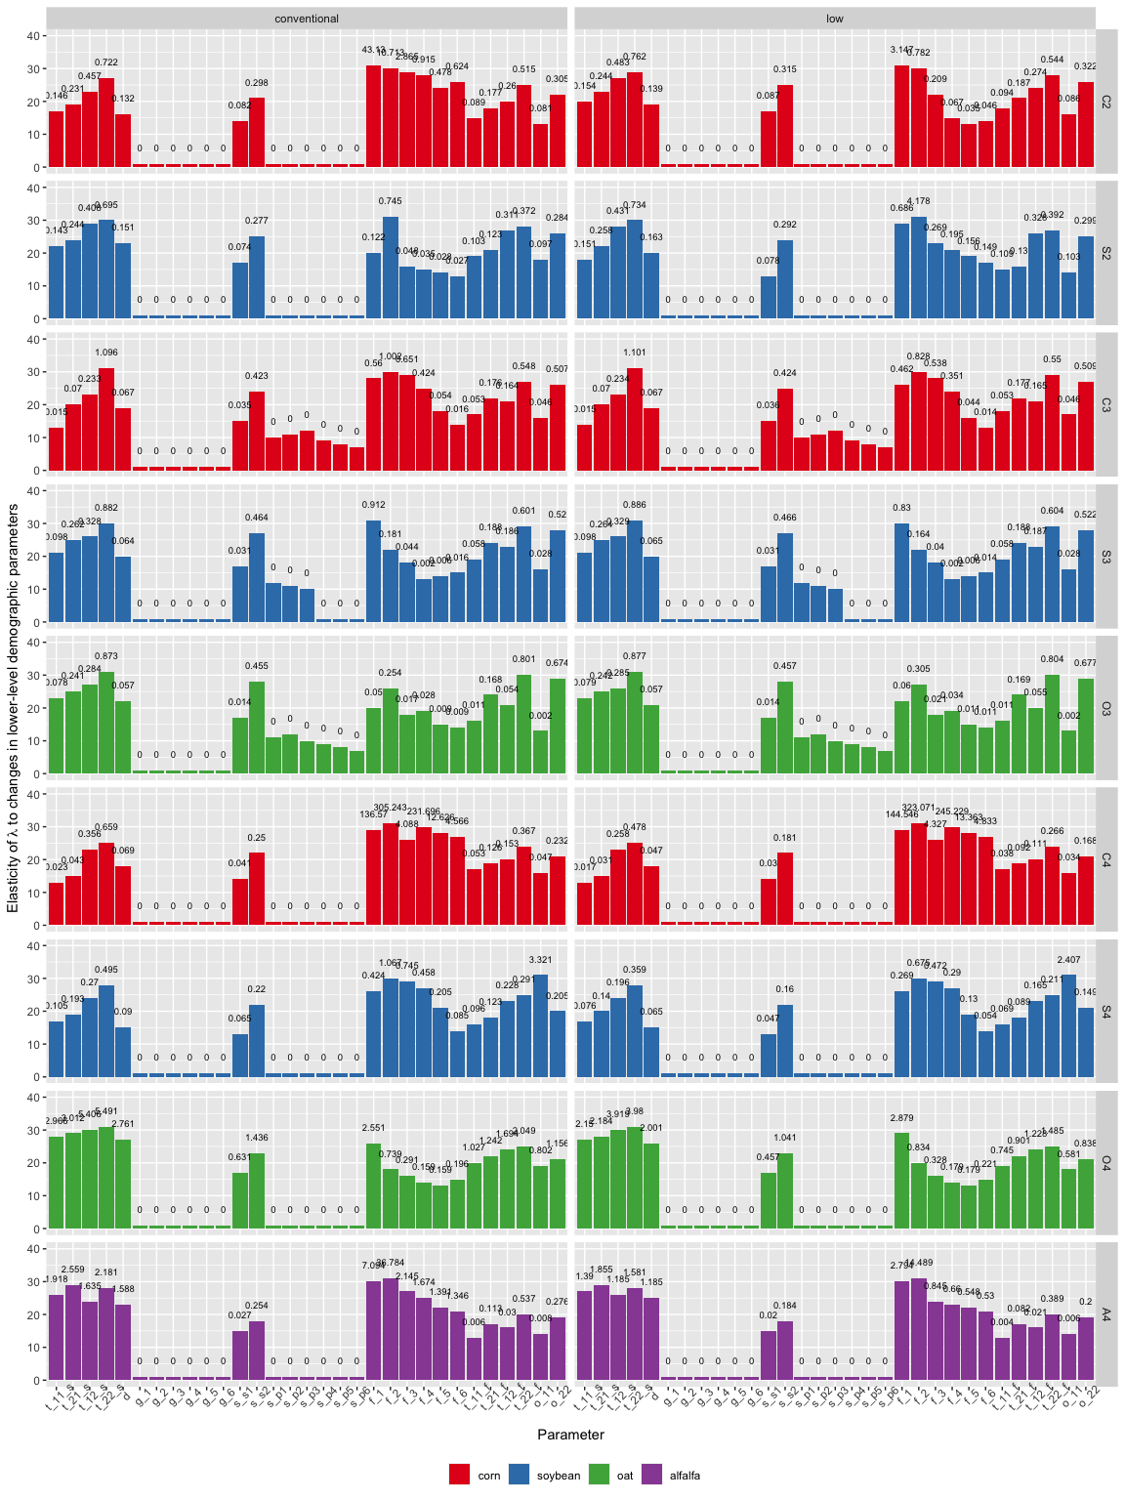

Figure 2: Scenario 1: Elasticity of annualized population growth rates to changes in lower-level demographic parameters. Bar height represents parameter’s ranking. Each bar is labeled with the natural lograrithm of absolute value of the contribution of the parameter to elasticity of annualized population growth rates (-Inf labels indicates the parameters whose contribution to elasticity of lambda were zero). Crop identities are color-coded by crop species. From left to right of the x-axis, the sub-annual demographic parameters are: t_11_s - probability that a seed at the 0-2 cm soil stratum stay at that statum; t_21_s - probability that a seed at the 2-20 cm soil stratum move to the 0-2 cm soil stratum; t_12_s - probability that a seed at the 0-2 cm soil stratum move to the 2-20 cm stratum; and t_22_s - probability that a seed at the 2-20 cm soil stratum stay at that statum; d - the probability that a seed is not germinating; g_1 through g_6: the probabiblites that a seed emerge to seedling cohorts 1 through 6; s_s1 and s_s2: the survival rate of seeds at the 0-2 cm and 2-20 cm soil strata in the cropped season; s_p1 through s_p6: the probability that seedling cohorts 1 through 6 reach reproductive maturity; f_1 through f_6: the fecundity rates of mature plant cohorts 1 through 6; t_11_f through t_22_f: the vertical seed movement probability induced by post-harvest tillage; o_11 and o_12: overwiter survival rates in the 0-2 cm and 2-20 cm soil strata.