## Figures and Tables

*Figure 1: Conceptual diagram of the three rotation systems compared within the experiment. A cycle of four calendar years is shown. Tillage regimes are symbolized with arrows: thin, black ahead of crop sowing for field cultivation and medium, blue and bold orange after crop harvest for chisel and moldboard plowing, respectively. Crops are color-coded and displayed for the approximate months they were in the field. The emergence and establishment of common waterhemp plants are illustrated with black symbols. Crop harvest operations physically controlled grey plants shown in oat or alfalfa's first year. Grey plants shown in alfalfa's second year were physically suppressed three to four times by hay harvest. Alfalfa hay was harvested when approximately 15% of the plants flowered. Red clover in the O3 treatment and alfalfa in the A4 treatment were terminated by plowing in the late fall before growing corn in the following year, so the dark green bar in the 3-year rotation represents volunteer red clover, and the light green bar in the 4-year rotation represents the living alfalfa residue in the C4 treatment.*

Table 1: Female-only population dynamics model assumptions for common waterhemp (Amaranthus tuberculatus)

| Stage | Assumption | References or justification |
| --- | --- | --- |
| All | Sex is stable throughout the life cycle | Montgomery et al., 2019 and 2021 |
|  | Equal growth rate across individuals of the same size and shape under the same treatments (crop x rotation x herbicide regime) | Chapter 8, Caswell, 2001 |
| Seed | Equal germination probability across sexes | No evidence of sexually differentiated seed germination probability |
|  | The sex ratio is 1:1 | Costea et al., 2005 |
|  | Sex is determined at seed formation | Montgomery et al., 2019 and 2021 |
|  | Seedlings only emerge from the 0 - 2 cm soil stratum | No estimates for waterhemp in the same field settings as ours were available, so we used the estimate for redroot pigweed (*A. retroflexus*), a closely related species, following Mohler and Galford, 2008 |
|  | Germination is fatal in the 2 - 20 cm soil stratum | Davis and Renner, 2007 |
|  | 100 % of the germinated seeds from the 0 – 2 cm soil stratum in the post-emergence herbicide treated eu successfully emerged | Assumed for simplicity of the model. The seedlings' emergence was surveyed approximately every two weeks, so emergence was promptly recorded before seedlings were affected by existing mortality factors. |
|  | 5 % of the germinated seeds from the 0 – 2 cm soil stratum in the pre-emergence herbicide treated eu (Thiencarbazone-methyl and isoxaflutole mixture and mesotrione) successfully emerged | Thiencarbazone-methyl and isoxaflutole mixture and mesotrione are 97.5% and 70.75% efficacious against other *Amaranthus* species (Sutton et al., 2002; Janak and Grichar, 2016) |
|  | 50% of the germinated seeds from the 0 – 2 cm soil stratum in the eu that were not treated with herbicides successfully emerged | Assumed for the model’s simplicity and for illustrating that pre-emergence herbicides are more potent than allelochemicals on seed germination inhibition.  Red clover allelopathic chemical can inhibit up to 40% germination and up to 70% radicle length (Liebman and Sundberg, 2006), oat can promote weed germination (Cornellius and Bradley, 2017), and alfalfa extract can inhibit both seed germination and radicle elongation (Chung and Miller, 2005). |
|  | Equal decay rate across sexes | No evidence of sexually differentiated seed decay rate |
|  | Different decay rates for burial depths | Buhler et al., 2001 ; Steckel et al., 2007 ; Mohler and Galford, 2008; and Sosnoskie et al., 2013 |
|  | Equal palatability to granivores across sexes | No evidence of sexually differentiated palatability |
|  | Granivore activities are an important threat | van der Laat et al., 2015 |
| Young plant | Female plants are more likely to survive under stressful conditions than male plants | Deduced collectively from the general 1:1 sex ratio (Costea et al. 2005) and differentiated sex ratio at maturity across weed management systems at the experiment site in 2018 (Nguyen and Liebman 2022b) |
|  | Competition with crops for resources is expressed in multiple periods | Specific mortality or size reduction caused by crops was not measured |
|  | Competition with other weed species is excluded | Excluded for simplicity of the model |
|  | Intraspecific competition is included in the survival rate from seedling through maturity | Specific mortality or size reduction caused by other weed species was not measured |
|  | The weed control program tailored to the specific crop is the main cause of mortality | Ryan et al., 2010 |
| Mature plant | Pollen is abundantly available to all female plants at the reproductive stage | Pollen grains can remain viable for five days after dispersal (Liu et al., 2012), and the populations at the experiment site were close to sexual parity with abundant plant densities (Nguyen and Liebman, 2022b) |
|  | 50% of the seeds produced by each female plant are female | Costea et al., 2005 |
|  | The male:female ratio can deviate from the 1:1 ratio under different conditions | Nguyen and Liebman 2022b; Montgomery et al., 2019 and 2021 |

Table 2: Female-only population dynamics model parameters for common waterhemp (Amaranthus tuberculatus)

| Parameter | Denomination | Unit | Corn | Soybean | Oat | Alfalfa |
| --- | --- | --- | --- | --- | --- | --- |
| Seeds in the top soil stratum stay | t_11,s or t_11,f | seeds seeds-1 | pre-planting: 0.59;  post-harvest: 0.59 | pre-planting: 0.59;  post-harvest: 1 | pre-planting: 0.59; post-harvest: 0.02 - 1 | pre-planting: 1;  post-harvest: 0.02 |
| Seeds in the top soil stratum move to the bottom stratum | t_12,s or t_12,f | seeds seeds-1 | pre-planting: 0.15;  post-harvest: 0.1 | pre-planting: 0.15;  post-harvest: 0 | pre-planting: 0.15; post-harvest: 0 - 0.07 | pre-planting: 0;  post-harvest: 0.07 |
| Seeds in the bottom soil stratum move to the top stratum | t_21,s or t_21,f | seeds seeds-1 | pre-planting: 0.41;  post-harvest: 0.41 | pre-planting: 0.41;  post-harvest: 0 | pre-planting: 0.41; post-harvest: 0 - 0.98 | pre-planting: 0;  post-harvest: 0.98 |
| Seeds at the bottom soil stratum stay | t_22,s or t_22,f | seeds seeds-1 | pre-planting: 0.85;  post-harvest: 0.9 | pre-planting: 0.85;  post-harvest: 1 | pre-planting: 0.85; post-harvest: 0.93 - 1 | pre-planting: 1;  post-harvest: 0.93 |
| Seed dormant rate during the crop season | d | seeds seeds-1 | 0.8 | 0.8 | 0.8 | 0.8 |
| Successful emergence rate | e_1 through e_6 | plants seeds-1 | 0.01 – 0.2 | 0.01 | 0.1 | 0.1 |
| Plant survival rate | s_1,p through s_6,p | plants plants-1 | 0.01 - 0.84 | 0 - 0.89 | 0.1 - 0.9 | 0.1 - 0.5 |
| Seed survival rate | s_11,s, s_22,s, o_11,s o_22,s | seeds seeds-1 | summer: 0.66 - 0.74;  overwinter: 0.66 - 0.74 | summer: 0.66 - 0.74;  overwinter: 0.66 - 0.74 | summer: 0.66 - 0.74; overwinter: 0.66 - 0.74 | summer: 0.66 - 0.74;  overwinter: 0.66 - 0.74 |
| Plant fecundity | f_1 through f_6 | seeds plant-1 | Scenario 1: 1.0 - 3518.6;  scenario 2: 18.8 – 93672.3 | scenario 1: 0 - 35.5;  scenario 2: 1756.2 – 1249255.0 | scenario 1: 3.9 - 964.0;  scenario 2: 66.3-3696.6 | scenario 1: 0.64 - 11.8;  scenario 2: 0.5 – 460.3 |

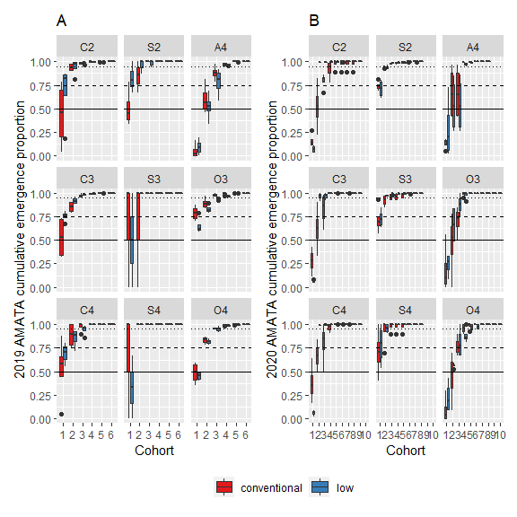

Figure 2: Data summary of cumulative emergence proportion of waterhemp in 2019 (A) and 2020 (B). The solid, dashed, and dotted lines indicate 50%, 75%, and 95% of total season emergence. The abbreviations on each section of panels A and B are crop identities, which are the combinations of the first letter in crop species names and the rotation in which it occurred (C2 - corn in the 2-year rotation, C3 - corn in the 3-year rotation, C4 - corn in the 4-year rotation, S2 - soybean in the 2-year rotation, S3 - soybean in the 3-year rotation, S4 - soybean in the 4-year rotation, O3 - oat in the 3-year rotation, O4 - oat in the 4-year rotation, and A4 - alfalfa in the 4-year rotation).

Table 3: 2019 and 2020 seedling emergence initiation in four crop environments (Julian date). Only the first seedling cohort was used as the response variable due to small sample sizes in the subsequent cohorts.

|  | 2019 | | | 2020 | | |
| --- | --- | --- | --- | --- | --- | --- |
| Crop | estimate | SE | df | estimate | SE | df |
| alfalfa | 154.0 | 1.3 | 61 | 163.0 | 0.1 | 61 |
| corn | 176.7 | 0.7 | 61 | 139.3 | 0.0 | 61 |
| oat | 150.0 | 0.9 | 61 | 141.0 | 0.1 | 61 |
| soybean | 189.0 | 0.7 | 61 | 163.0 | 0.0 | 61 |

Table 4: 2019 and 2020 seedling emergence timing (days) in four crop environments

|  | 2019 | | | | 2020 | | | |
| --- | --- | --- | --- | --- | --- | --- | --- | --- |
| Contrast | difference | SE | df | p | difference | SE | df | p |
| alfalfa - corn | -22.7 | 1.5 | 61 | <.0001 | 23.8 | 0.1 | 61 | <.0001 |
| alfalfa - oat | 4.0 | 1.6 | 61 | 0.0596 | 22.0 | 0.1 | 61 | <.0001 |
| alfalfa - soybean | -35.0 | 1.5 | 61 | <.0001 | 0.0 | 0.1 | 61 | 1.0000 |
| corn - oat | 26.7 | 1.2 | 61 | <.0001 | -1.8 | 0.1 | 61 | <.0001 |
| corn - soybean | -12.3 | 1.0 | 61 | <.0001 | -23.8 | 0.1 | 61 | <.0001 |
| oat - soybean | -39.0 | 1.2 | 61 | <.0001 | -22.0 | 0.1 | 61 | <.0001 |

Table 5: 2019 seedbank densities (seeds/m2) at the top and bottom soil strata

|  |  |  |  | Top stratum density | | Bottom stratum density | |
| --- | --- | --- | --- | --- | --- | --- | --- |
| Rotation | Crop ID | Corn weed management | df | mean | SE | mean | SE |
| 2-year | C2 | conventional | 51 | 8,231.9 | 5,655.5 | 5,422.1 | 1,679.3 |
| 2-year | C2 | low | 51 | 4,811.6 | 3,306.0 | 3,938.9 | 1,220.0 |
| 2-year | S2 | conventional | 51 | 604.6 | 416.0 | 1,297.9 | 402.2 |
| 2-year | S2 | low | 51 | 1,451.2 | 997.6 | 1,612.6 | 499.6 |
| 3-year | C3 | conventional | 51 | 1,851.6 | 1,272.6 | 6,361.6 | 1,970.2 |
| 3-year | C3 | low | 51 | 1,781.0 | 1,224.1 | 8,922.5 | 2,763.2 |
| 3-year | S3 | conventional | 51 | 73.8 | 51.4 | 1,615.5 | 500.5 |
| 3-year | S3 | low | 51 | 303.6 | 209.2 | 1,831.5 | 567.5 |
| 3-year | O3 | conventional | 51 | 6,682.3 | 4,591.0 | 5,921.9 | 1,834.1 |
| 3-year | O3 | low | 51 | 8,513.1 | 5,848.7 | 5,292.1 | 1,639.1 |
| 4-year | C4 | conventional | 51 | 90.0 | 62.5 | 1,052.1 | 326.1 |
| 4-year | C4 | low | 51 | 77.9 | 54.2 | 1,300.8 | 403.1 |
| 4-year | S4 | conventional | 51 | 231.8 | 159.9 | 2,554.0 | 791.2 |
| 4-year | S4 | low | 51 | 375.6 | 258.7 | 3,717.3 | 1,151.4 |
| 4-year | O4 | conventional | 51 | 10,201.1 | 7,008.2 | 5,209.5 | 1,613.5 |
| 4-year | O4 | low | 51 | 13,770.2 | 9,460.0 | 4,590.4 | 1,421.8 |
| 4-year | A4 | conventional | 51 | 5,777.9 | 3,969.8 | 2,790.2 | 864.3 |
| 4-year | A4 | low | 51 | 8,022.3 | 5,511.5 | 3,415.9 | 1,058.1 |

Table 8: Added control efficacy (with respect to the original control efficacy reflected by the unmanipulated seed production) averaged over 10000 rotational cycles (the 2-year rotation cycled over two years and ended at the soybean phase, the 3-year rotation cycled over three years and ended at the oat phase, and the 4-year rotation cycled over four years and ended at the alfalfa phase). All simulations started with a seed column of 10000 female seeds in the top 0 - 2 cm soil stratum and 0 female seeds in the bottom 2 - 20 cm soil stratum.

| Crop ID | Corn weed management | cohort 1 | cohort 2 | cohort 2 | cohort 4 | cohort 5 | cohort 6 |
| --- | --- | --- | --- | --- | --- | --- | --- |
| C2 | conventional | 1.00 | 0.99 | 0.99 | 0.00 | 0 | 0 |
| C2 | low | 1.00 | 0.99 | 0.98 | 0.00 | 0 | 0 |
| S2 | conventional | 1.00 | 1.00 | 1.00 | 0.00 | 0 | 0 |
| S2 | low | 1.00 | 1.00 | 1.00 | 0.00 | 0 | 0 |
| C3 | conventional | 1.00 | 1.00 | 0.99 | 0.00 | 0 | 0 |
| C3 | low | 0.93 | 0.96 | 0.59 | 0.00 | 0 | 0 |
| S3 | conventional | 1.00 | 1.00 | 1.00 | 1.00 | 1 | 1 |
| S3 | low | 1.00 | 1.00 | 0.99 | 0.00 | 0 | 0 |
| O3 | conventional | 0.00 | 0.00 | 0.00 | 0.00 | 0 | 0 |
| O3 | low | 0.00 | 0.00 | 0.00 | 0.00 | 0 | 0 |
| C4 | conventional | 1.00 | 1.00 | 1.00 | 0.00 | 0 | 0 |
| C4 | low | 1.00 | 0.99 | 0.97 | 0.00 | 0 | 0 |
| S4 | conventional | 1.00 | 1.00 | 1.00 | 0.77 | 0 | 0 |
| S4 | low | 1.00 | 1.00 | 1.00 | 1.00 | 1 | 0 |
| O4 | conventional | 0.00 | 0.00 | 0.00 | 0.00 | 0 | 0 |
| O4 | low | 0.00 | 0.00 | 0.00 | 0.00 | 0 | 0 |
| A4 | conventional | 0.00 | 0.00 | 0.00 | 0.00 | 0 | 0 |
| A4 | low | 0.00 | 0.00 | 0.00 | 0.00 | 0 | 0 |

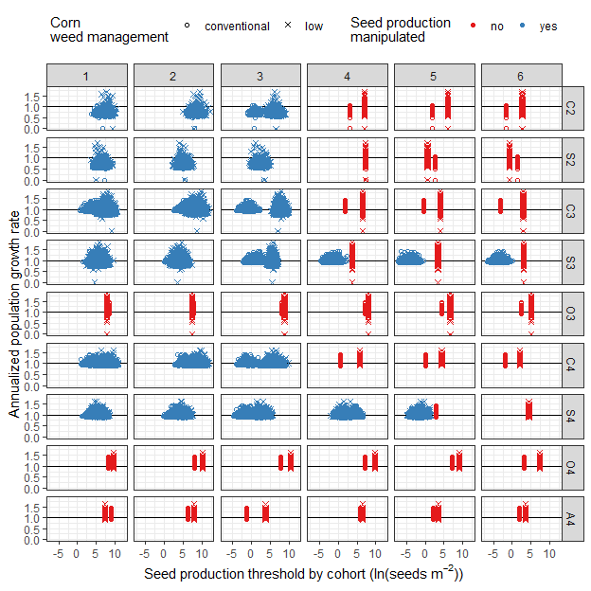

Figure 5: Cohort-based seed production threshold on natural logarithm scale for waterhemp population stabilization over 10000 rotational cycles (the 2-year rotation cycled over two years and ended at the soybean phase, the 3-year rotation cycled over three years and ended at the oat phase, and the 4-year rotation cycled over four years and ended at the alfalfa phase). All simulations started with a seed column of 10000 female seeds in the top 0 - 2 cm soil stratum and 0 female seeds in the bottom 2 - 20 cm soil stratum. It was expected that no waterhemp cohorts in any crop environments but only the cohorts 1 through 3 in corn and soybean were manipulated to find the seed production thresholds. However, additional control efficacy was needed in some crop phases outside of the expected group to meet annualized λ = 1. Annualized λ is the population growth rate of the rotation averaged over the number of crop phases. The dots colored blue are where control measures extended beyond waterhemp cohort 3 would be necessary. The relationships of aboveground mass and fecundity in Nguyen and Liebman (2022a) were used to estimate per-capita seed production threshold in each cohort. The black horizontal lines mark annualized λ = 1. The right-hand-side panel labels indicate the crop identities, which are the combinations of the first letter in crop species names and the rotation to which the crops belonged (C2, corn in the 2-year rotation; C3, corn in the 3-year rotation; C4, corn in the 4-year rotation; S2, soybean in the 2-year rotation; S3, soybean in the 3-year rotation; S4, soybean in the 4-year rotation; O3, oat in the 3-year rotation; O4, oat in the 4-year rotation; and A4, alfalfa in the 4-year rotation).

Table 9: Necessary control efficacy (with respect to seedling survival to maturity) averaged over 100 rotational cycles (the 2-year rotation cycled over two years and ended at the soybean phase, the 3-year rotation cycled over three years and ended at the oat phase, and the 4-year rotation cycled over four years and ended at the alfalfa phase). All simulations started with a seed column of 10000 female seeds in the top 0 - 2 cm soil stratum and 0 female seeds in the bottom 2 - 20 cm soil stratum.

| Crop ID | Corn weed management | cohort 1 | cohort 2 | cohort 2 | cohort 4 | cohort 5 | cohort 6 |
| --- | --- | --- | --- | --- | --- | --- | --- |
| C2 | conventional | 0.99 | 0.99 | 0.99 | 0.96 | 0.96 | 0.99 |
| C2 | low | 1.00 | 1.00 | 1.00 | 0.96 | 0.96 | 0.99 |
| S2 | conventional | 0.99 | 0.99 | 0.99 | 0.74 | 0.99 | 0.99 |
| S2 | low | 1.00 | 1.00 | 1.00 | 0.74 | 0.99 | 0.99 |
| C3 | conventional | 1.00 | 1.00 | 1.00 | 1.00 | 1.00 | 1.00 |
| C3 | low | 1.00 | 1.00 | 1.00 | 0.96 | 0.96 | 0.99 |
| S3 | conventional | 1.00 | 1.00 | 1.00 | 1.00 | 1.00 | 1.00 |
| S3 | low | 1.00 | 1.00 | 1.00 | 0.74 | 0.99 | 0.99 |
| O3 | conventional | 0.90 | 0.90 | 0.99 | 0.99 | 0.99 | 0.99 |
| O3 | low | 0.90 | 0.90 | 0.50 | 0.50 | 0.10 | 0.10 |
| C4 | conventional | 1.00 | 1.00 | 1.00 | 1.00 | 1.00 | 1.00 |
| C4 | low | 1.00 | 1.00 | 0.99 | 0.95 | 0.96 | 0.99 |
| S4 | conventional | 1.00 | 1.00 | 1.00 | 1.00 | 1.00 | 1.00 |
| S4 | low | 1.00 | 1.00 | 0.99 | 0.95 | 0.99 | 0.99 |
| O4 | conventional | 0.90 | 0.90 | 0.50 | 0.50 | 0.10 | 0.10 |
| O4 | low | 0.90 | 0.90 | 0.50 | 0.50 | 0.10 | 0.10 |
| A4 | conventional | 0.90 | 0.90 | 0.90 | 0.90 | 0.50 | 0.50 |
| A4 | low | 0.90 | 0.90 | 0.90 | 0.90 | 0.50 | 0.50 |

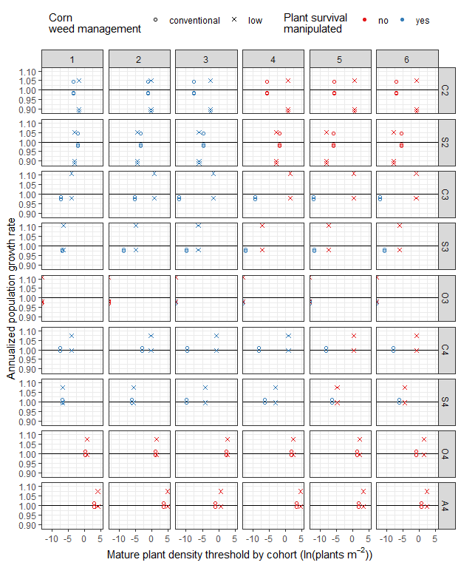

Figure 7: Cohort-based mature plant density thresholds on the natural logarithm scale for waterhemp population stabilization averaged over 100 rotational cycles (the 2-year rotation ended at the soybean phase, the 3-year rotation ended at the oat phase, and the 4-year rotation ended at the alfalfa phase). All simulations started with a seed column of 10000 female seeds in the top 0 - 2 cm soil stratum and 0 female seed in the bottom 2 - 20 cm soil stratum. The simulation applied improved control efficacy on waterhemp cohorts 1 through 3 in corn and soybean only. The relationships of aboveground mass and fecundity in Nguyen and Liebman (2022a) were used to estimate cohort-based fecundity. It was expected that no waterhemp cohorts in any crop environments but only the cohorts 1 through 3 in corn and soybean had their survival rates manipulated to find the mature plant density thresholds for which annualized λ = 1. Annualized λ is the population growth rate of the rotation averaged over the number of crop phases. However, additional control efficacy was needed in some crop phases outside of the expected groups to reduced the mature plant densities. The black horizontal lines mark λ= 1. The right-hand-side panel labels indicate the crop identities, which are the combinations of the first letter in crop species names and the rotation to which the crops belonged (C2, corn in the 2-year rotation; C3, corn in the 3-year rotation; C4, corn in the 4-year rotation; S2, soybean in the 2-year rotation; S3, soybean in the 3-year rotation; S4, soybean in the 4-year rotation; O3, oat in the 3-year rotation; O4, oat in the 4-year rotation; and A4, alfalfa in the 4-year rotation).

## Appendix

### A – Empirically measured data

#### Seed densities at the top and bottom soil strata

## ANOVA of Crop ID x Corn weed management effects on AMATA seedbank density at the 0-2 cm soil stratum  
AMATA_female_top_lm <- lm(log(AMATA_total_viable_density + 1) ~ Block +   
 Crop_ID * Corn_weed_management,   
 data = top_stratum_female)  
  
  
## ANOVA table of female seedbank density at the 0-2 cm soil stratum  
AMATA_female_top_emm_log <- emmeans(AMATA_female_top_lm,   
 c("Crop_ID" , "Corn_weed_management"))  
  
joint_tests(AMATA_female_top_emm_log )

## model term df1 df2 F.ratio p.value  
## Crop_ID 8 51 14.638 <.0001  
## Corn_weed_management 1 51 0.998 0.3225  
## Crop_ID:Corn_weed_management 8 51 0.343 0.9445

## ANOVA of Crop ID x Corn weed management effects on AMATA seedbank density at the 2-20 cm soil stratum  
AMATA_female_bottom_lm <- lm(log(AMATA_total_viable_density + 1) ~ Block +   
 Crop_ID * Corn_weed_management,   
 data = bottom_stratum_female)  
   
  
## ANOVA table of female seedbank density at the 2-20 cm soil stratum  
AMATA_female_bottom_emm_log <- emmeans(AMATA_female_bottom_lm, c("Crop_ID" , "Corn_weed_management"))  
  
joint_tests(AMATA_female_bottom_emm_log)

## model term df1 df2 F.ratio p.value  
## Crop_ID 8 51 8.812 <.0001  
## Corn_weed_management 1 51 0.482 0.4908  
## Crop_ID:Corn_weed_management 8 51 0.288 0.9669

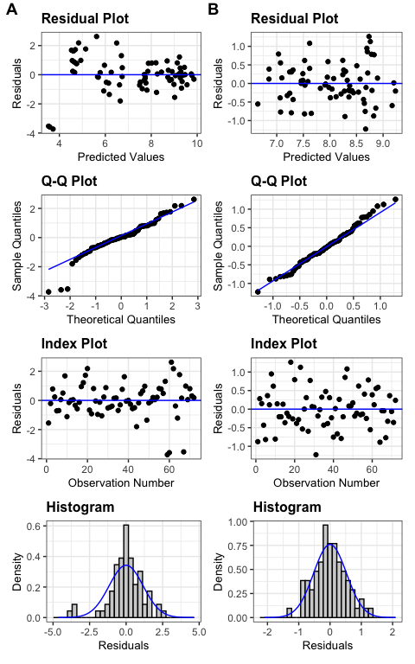

Figure A1: Diagnosis plots for the effects of crop identity and crop weed management on the seedbank densities at the top (A) and bottom (B) soil strata

#### Seedbank density from 2014 through 2019

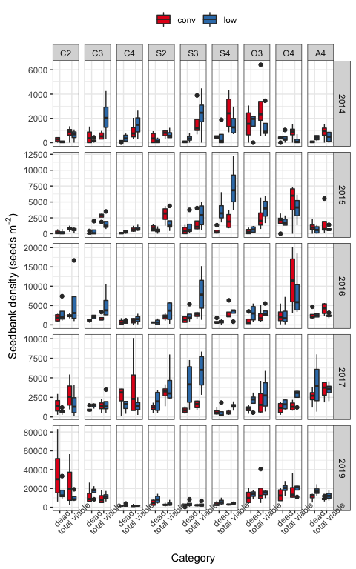

Figure A2: Dead and viable seedbank density from 2014 through 2019. 2018 seedbank density was not evaluated due to weather adversity.

#### Emergence pattern and timing in different crop environments

## Did crop identity and corn weed management affect waterhemp's emergence pattern in 2019?  
emerge_cohort_19_gls <- gls(log(eu_female_cohort_Density_begin+1) ~ Block +   
 Crop_ID*Corn_weed_management + Cohort +  
 Crop_ID:Cohort + Corn_weed_management:Cohort,  
 correlation=corCompSymm(form=~1 | bt),  
 weights=varIdent(form= ~1 | Cohort),  
data = density_emerge_19)  
  
 joint_tests(emerge_cohort_19_gls)

## model term df1 df2 F.ratio p.value  
## Block 3 68.42 2.793 0.0468  
## Crop_ID 8 54.23 222.641 <.0001  
## Corn_weed_management 1 54.23 0.518 0.4749  
## Cohort 5 75.61 438.355 <.0001  
## Crop_ID:Corn_weed_management 8 68.42 0.956 0.4772  
## Crop_ID:Cohort 40 75.61 46.683 <.0001  
## Corn_weed_management:Cohort 5 75.61 1.569 0.1790

## Did crop identity and corn weed management affect waterhemp's emergence pattern in 2020?  
#   
emerge_cohort_20_gls <- gls(log(cohort_female_Seedling_density +1) ~ Block +   
 Crop_ID*Corn_weed_management + Cohort +  
 Crop_ID:Cohort + Corn_weed_management:Cohort,  
 correlation=corCompSymm(form=~1 | bt),  
 weights=varIdent(form= ~1 | Cohort),  
data=cohort_emerge_20_first_six )  
  
 joint_tests(emerge_cohort_20_gls)

## model term df1 df2 F.ratio p.value  
## Block 3 65.97 2.376 0.0779  
## Crop_ID 8 57.25 9.890 <.0001  
## Corn_weed_management 1 57.25 13.732 0.0005  
## Cohort 5 66.34 40.266 <.0001  
## Crop_ID:Corn_weed_management 8 65.97 5.920 <.0001  
## Crop_ID:Cohort 40 66.34 11.498 <.0001  
## Corn_weed_management:Cohort 5 66.34 5.185 0.0004

## Did crop identity and corn weed management affect waterhemp's first emergence timing in 2019?  
Julian_cohort1_19_lm <- lm(Julian_day ~ Block +   
 Crop * Corn_weed_management,  
data = cohort1_2019)   
  
joint_tests(Julian_cohort1_19_lm)

## model term df1 df2 F.ratio p.value  
## Block 3 61 0.000 1.0000  
## Crop 3 61 458.187 <.0001  
## Corn_weed_management 1 61 0.000 1.0000  
## Crop:Corn_weed_management 3 61 0.000 1.0000

## Did crop identity and corn weed management affect waterhemp's first emergence timing in 2020?  
Julian_cohort1_20_lm <- lm(Julian_day ~ Block +   
 Crop*Corn_weed_management,  
 data=cohort1_2020)  
  
joint_tests(Julian_cohort1_20_lm )

## model term df1 df2 F.ratio p.value  
## Block 3 61 10.170 <.0001  
## Crop 3 61 64217.940 <.0001  
## Corn_weed_management 1 61 0.000 1.0000  
## Crop:Corn_weed_management 3 61 0.000 1.0000

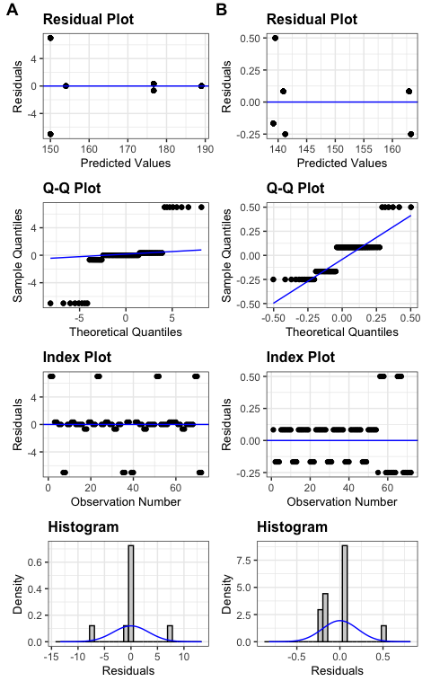

Figure A3: Diagnosis plots for the effects of crop identity and corn weed management on the seedbank densities at the top (A) and bottom (B) soil strata

#### 2019 female survival rate by cohort

Table A1: Point-estimates of 2019 seedling to maturity survival rates by cohort. Some zeroes are due to rounding.

|  |  | Cohort | | | | | |
| --- | --- | --- | --- | --- | --- | --- | --- |
| Crop ID | Corn weed management | 1 | 2 | 3 | 4 | 5 | 6 |
| C2 | conventional | 0.17 | 0.10 | 0.19 | 0.46 | 0.50 | 0.50 |
| C2 | low | 0.00 | 0.15 | 0.32 | 0.43 | 0.17 | 0.00 |
| S2 | conventional | 0.00 | 0.00 | 0.00 | 0.00 | 0.00 | 0.00 |
| S2 | low | 0.00 | 0.00 | 0.00 | 0.00 | 0.00 | 0.00 |
| C3 | conventional | 0.15 | 0.25 | 0.34 | 0.53 | 0.00 | 0.67 |
| C3 | low | 0.02 | 0.20 | 0.33 | 0.23 | 0.00 | 1.00 |
| S3 | conventional | 0.00 | 0.00 | 0.00 | 0.00 | 0.00 | 0.00 |
| S3 | low | 0.00 | 0.00 | 0.00 | 0.00 | 0.00 | 0.00 |
| O3 | conventional | 0.04 | 0.08 | 0.01 | 0.39 | 0.00 | 0.00 |
| O3 | low | 0.03 | 0.02 | 0.03 | 0.07 | 0.04 | 0.00 |
| C4 | conventional | 0.38 | 0.26 | 0.42 | 0.50 | 0.00 | 0.00 |
| C4 | low | 0.02 | 0.24 | 0.37 | 0.30 | 0.00 | 0.00 |
| S4 | conventional | 0.00 | 0.00 | 0.00 | 0.00 | 0.00 | 0.00 |
| S4 | low | 0.00 | 0.00 | 0.00 | 0.00 | 0.00 | 0.00 |
| O4 | conventional | 0.15 | 0.10 | 0.28 | 0.22 | 0.33 | 0.22 |
| O4 | low | 0.07 | 0.04 | 0.09 | 0.13 | 0.29 | 0.08 |
| A4 | conventional | 0.06 | 0.06 | 0.17 | 0.02 | 0.06 | 0.00 |
| A4 | low | 0.08 | 0.06 | 0.10 | 0.14 | 0.25 | 0.00 |

### 

### B - Matrix assembly

The structure of all periodic matrices used in the two control efficacy levels is listed below. All numbers are female-only. Each theoretical matrix for a sub-annual period is followed by the set of matrices used in that sub-annual period. The abbreviate row and column names are:  
- s_t: seed at the top stratum (0 - 2 cm),  
- s_b: seed at the bottom stratum (2 - 20 cm),  
- p_co_1 through p_co_6: plant cohort 1 through 6.

#### Published literature data

##### Pre-planting tillage induced vertical redistribution of seeds

The only non-zeroes section of the pre-planting tillage-induced vertical redistribution of seeds is $M_{s}$. $M_{s}$’s were resized from the raw data of Seed Chaser (Spokas et al., 2007), a simulation program that estimates vertical seed movement after various types of tillage: the proportion of seeds staying at their original soil stratum, $t_{11,s}$ and $t_{22,s}$, or move to another stratum, $t_{12,s}$ and $t_{21,s}$. The original matrices in Spokas et al. (2007) were resized to 2 x 2 by summing over all the elements within each of the four sections, i.e., top left 2 x 2, bottom left 18 x 2, top right 2 x 18, and 18x18, and divide each of the i x 2 summations by the summation of the 20 x 2 left section, and each of the i x 18 summations by the summation of the 20 x 2 right section.

No-till is represented by an identical matrix, $I$, after Cousens and Moss (1990). A field cultivator was applied before planting corn (C2, C3, and C4), soybean (S2, S3, and S4), and oat (O3 and O4). No-tillage was applied before alfalfa (A4) because alfalfa intercropped with oat in the 4-year rotation (O4) was kept overwinter and grown as a sole crop in the following year.

$$B_{t\left(s\right)}=\left[\begin{matrix}t_{11,s} & t_{21,s} & 0 & ... & ... & ... & ... & 0 \\ t_{12,s} & t_{22,s} & 0 & ... & ... & ... & ... & 0 \\ 0 & 0 & 0 & ... & ... & ... & ... & 0 \\ ... & ... & ... & ... & ... & ... & ... & ... \\ ... & ... & ... & ... & ... & ... & ... & ... \\ 0 & 0 & 0 & ... & ... & ... & ... & 0\end{matrix}\right]$$

The same pre-planting tillage regimes were applied in 2018 and 2019. The list of pre-planting tillage matrices is available at <https://github.com/hnguyen19/matrix-prospective/blob/master/2-Data/Clean/mean-pre-planting-tillage.RData>.

##### In-season survival of seeds and seedlings

The matrix $B_{s}$ is comprised of seed survival rates at the $M_{s}$ and plant survival rates at the $M_{p}$ sections, respectively.

$$B_{s}=\left[\begin{matrix}s_{s_{1}} & 0 & 0 & ... & ... & ... & ... & 0 \\ 0 & s_{s_{2}} & 0 & ... & ... & ... & ... & 0 \\ 0 & 0 & s_{p_{1}} & ... & ... & ... & ... & 0 \\ ... & ... & 0 & s_{p_{2}} & ... & ... & ... & 0 \\ ... & ... & ... & ... & ... & ... & ... & 0 \\ 0 & 0 & 0 & ... & ... & ... & 0 & s_{p_{6}}\end{matrix}\right]$$

The $M_{s}$ section’s diagonal ( $s_{s_{1}}$ and $s_{s_{2}}$) were filled with survival rates adapted from equations $o_{1}=y=98.9e^{-0.068x}\%$ and $o_{2}=y=99.5e^{-0.05x}\%$ (Figures 1 and 3, Sosnoskie et al., 2013) for the top and bottom layers. The values of x were assigned at 6 months for all crop environments. We settled at 6 months despite the complexity in tillage timing and method, light and humidity conditions, and granivores’ activities at individual crop environments for simplicity. In reality, the burial length can interact with any crop management activity and deliver different germination and emergence results.

The empirically measured data for seedling survival were deemed unrealistically (Appendix) low as compared to the literature, so Nordby and Hartzler's (2004) results were used for corn, and Hartzler et al. (2004)’s results were used for soybean crop environments. The seedling survival rates by cohort ($s_{p_{k}},k=\{1,...,6\}$) were assigned such that the earlier cohorts had a lower survival rate in the oat crop environment; and those in the alfalfa crop environment were evenly low in all cohorts. These estimated numbers were based on a suggestion that cool-season crop environments can inhibit warm-season weed species growth (Nguyen and Liebman, 2022b and citations given there).

The same summer survival rates were used in 2018 and 2019. The same summer survival rates were used in 2018 and 2019. The list of summer seed survival rate matrices is available at <https://github.com/hnguyen19/matrix-prospective/blob/master/2-Data/Clean/mean-summer-seed-survival-Sosnoskie.RData> and the list of seedling survival rate to maturity is available at <https://github.com/hnguyen19/matrix-prospective/blob/master/2-Data/Clean/mean-summer-seedling-survival-Hartzler.RData>

##### Post-harvest tillage induced vertical redistribution of seeds post-harvest tillage

The compilation of $B_{t\left(f\right)}$ was similar to that of $B_{t\left(s\right)}$. Chisel plowing was applied after corn was harvested in the C2, C3, and C4 treatments, no-till was applied after harvests in the S2, S3, S4, and O4 treatments, and moldboard plowing was applied at the end of the O3 and A4 phases.

$$B_{t\left(f\right)}=\left[\begin{matrix}t_{11,f} & t_{21,f} & 0 & ... & ... & ... & ... & 0 \\ t_{12,f} & t_{22,f} & 0 & ... & ... & ... & ... & 0 \\ 0 & 0 & 0 & ... & ... & ... & ... & 0 \\ ... & ... & ... & ... & ... & ... & ... & ... \\ ... & ... & ... & ... & ... & ... & ... & ... \\ 0 & 0 & 0 & ... & ... & ... & ... & 0\end{matrix}\right]$$

The same post-harvest tillage regimes were applied in 2018 and 2019. The list of pre-planting tillage matrices is available at <https://github.com/hnguyen19/matrix-prospective/blob/master/2-Data/Clean/mean-post-harvest-tillage.RData>

##### Overwinter survival

The compilation of matrix $B_{o}$ was similar to that of $B_{s}$, using equations $o_{1}=y=98.9e^{-0.068x}\%$ and $o_{2}=y=99.5e^{-0.05x}\%$ (Figures 1 and 3, Sosnoskie et al., 2013).

$$B_{o}=\left[\begin{matrix}o_{11} & 0 & 0 & ... & ... & ... & ... & 0 \\ 0 & o_{22} & 0 & ... & ... & ... & ... & 0 \\ 0 & 0 & 0 & ... & ... & ... & ... & 0 \\ ... & ... & ... & ... & ... & ... & ... & ... \\ ... & ... & ... & ... & ... & ... & ... & ... \\ 0 & 0 & 0 & ... & ... & ... & ... & 0\end{matrix}\right]$$

The same overwinter survival rates were used in 2018 and 2019. Some zero values were due to rounding. The list of overwinter seed survival matrices is available at <https://github.com/hnguyen19/matrix-prospective/blob/master/2-Data/Clean/mean-winter-seed-survival-Sosnoskie.RData>

#### Empirically measured data

##### Seedling recruitment

The emergence proportions calculated from step 5 here are positioned on the first column of the block $M_{s,p}$ in the matrix $B_{e}$. $d$ represents the proportion of non-emerging seeds.

$$B_{e}=\left[\begin{matrix}d=0.8 & 0 & 0 & ... & ... & ... & ... & 0 \\ 0 & 1 & 0 & ... & ... & ... & ... & 0 \\ e_{1} & 0 & 0 & ... & ... & ... & ... & 0 \\ ... & ... & ... & ... & ... & ... & ... & ... \\ e_{6} & 0 & 0 & ... & ... & ... & ... & 0\end{matrix}\right]$$

The raw proportion of seedling emergence from the top 0 – 2 cm soil seedbank stratum in each crop identity crossed with the corn weed management regime was calculated with the following steps:

1 - Estimate the 0 - 2 cm and 2 - 20 cm seedbank densities with the soil seedbank samples collected before post-harvest tillage. A seed column at a particular sub-annual period is comprised of the 0 - 2 cm and 2 - 20 cm soil stratum seed densities, $N_{h}=\left[s_{t},s_{b}\right]$.

From steps 2 through 4, the seed column in sub-period h, $N_{h}$, was transitioned from one period to the next with the general matrix multiplication of $N_{h+1}=B_{h}N_{h}$ by Caswell (2001).

2 - Estimate post-harvest tillage induced vertical seed redistribution with resized Seed Chaser (Spokas et al., 2007) chisel and moldboard plowing matrices, as detailed in the *Post-harvest tillage induced vertical seed movement*, to yield $N_{t\left(f\right)}$

3 - Adapt overwinter survival rates as previously explained in the *Overwinter survival section* and apply it on $N_{t\left(f\right)}$ to yield $N_{o}$. Corn weed management did not affect waterhemp’s first cohort emergence in the same crop environment, so the same value of $x_{s}$ was used for the same crop identity.

4 - Estimate pre-planting tillage-induced seed vertical redistribution with resized Seed Chaser (Spokas et al., 2007) field cultivator matrix, similar to step 2 to yield $N_{t\left(s\right)}$.

5 - Divide the seedling density in each cohort, $l_{k}$, by $s_{11,f}$, the top soil stratum seed density to yield $e_{k}$.

In a soil seedbank of 5 cm deep that was undisturbed mechanically in the first burial year and unexposed to herbicides throughout the experiment, 5% of the waterhemp seedlings emerged a year after seed burial (Buhler and Hartzler 2001). Annually, 23.5% +/- 16.6% sd of waterhemp seeds that were not treated with herbicides and undisturbed mechanically emerged from the top 1 cm soil layer (Schutte and Davis 2014). Mesotrione applied at 75 g ha-1 rate was 76% and 96% efficacious against *A retroflexus* L grown in corn that was susceptible and resistant to atrazine, respectively (Sutton et al. 2002). The Thiencarbazone-methyl + isoxaflutole mixture was 93.5% efficacious and mesotrione was 70.75% efficacious against *A. palmeri* grown in corn (Janak and Grichar 2016). Waterhemp control in soybean treated with pre-emergence, post-emergence, or sequential pre- and post-emergence herbicides (Jhala et al. 2017; Hay, Shoup, and Peterson 2019; Ferrier et al. 2022a, 2022b) was studied, but no information on seedling emergence as a proportion of the seedbank is available.

The resistance profile of the waterhemp populations at our experiment site was undetermined, but the raw estimation of seedling emergence proportion with respect to the top 0 - 2 cm soil seedbank density seems unrealistically low (Table A5). We combined the findings on other *Amaranthus* species from Sutton et al. (2002); Janak and Grichar (2016) for herbicide efficacy and from Buhler and Hartzler (2001) and Schutte and Davis (2014) for herbicide-unexposed germinants to assign emergence rates based on the crop-specific weed management (Table 1).

The same emergence successful rate was assumed the same in corn and soybean for the lack of available data in the soybean crop environment. The emergence successful rates in the oat/red clover intercrop, oat/alfalfa intercrop, and alfalfa sole crop were set at 50% of all germinated seeds to reflect a weaker potency of allelochemicals versus pre-emergence herbicides. With a uniform germination rate at 20% in all the crop identity crossed with corn weed management, the remaining seedbank density in the 0 - 2 cm soil stratum is calculated using the following equation:

$$N_{B_{e,11}}=\left(1-G\right)*N_{B_{st,11}}=\left(1-\left(E+D\right)\right)*N_{B_{st,11}}$$

where, $N_{B_{e,11}}$ 
 is the remaining seedbank density after seed germination

$N_{B_{st,11}}$ is the seed density in the top 0 - 2 cm soil stratum upon completion of pre-planting tillage,

$G$ is the proportion of germinated seeds,

$E$ is the proportion of germinated seeds that successfully emerge as seedlings, and

$d$ is the proportion of germinated seeds that were killed by weed control measures.

$d=1-G=0.8$ is filled in the [1,1] position of the seedling recruitment matrix ($B_{e}\left[1,1\right]$). The cohort-specific emergence rates ( $e_{1}$ through $e_{6}$) were adjusted from the raw data ( $\frac{p_{k}}{N_{B_{st,11}}}$ with $k=\{1,...,6\}$) to reflect 5% emergence success rate (equivalent to $E=0.01*N_{B_{st,11}}$) in crop environments that received pre-emergence herbicides (C2, C3 and C4 under conventional weed management and all the S2, S3, and S4 (Table 1, Nguyen and Liebman 2022b)), 100% emergence success rate (equivalent to $E=1*N_{B_{st,11}}$) in the crop environments that received post-emergence herbicides (C2, C3, and C4 under low herbicide weed management, (Table 1, Nguyen and Liebman 2022b)) and 50% emergence success rate (equivalent to $E=0.1*N_{B_{st,11}}$).

The same emergence rates were used in 2018 and 2019. Some zero values in the first column were due to rounding. The list of seedling recruitment matrices is available at <https://github.com/hnguyen19/matrix-prospective/blob/master/2-Data/Clean/mean-emergence-prop-adjusted.RData>

Table A4: Proportion of the first six cohorts of female seedlings in the total seedling numbers averaged over four replications.

| Crop ID | Corn weed management | Ffirst six cohorts emergence proportion |
| --- | --- | --- |
| C2 | conventional | 0.97 |
| C2 | low | 1.00 |
| S2 | conventional | 1.00 |
| S2 | low | 1.00 |
| C3 | conventional | 1.00 |
| C3 | low | 1.00 |
| S3 | conventional | 1.00 |
| S3 | low | 1.00 |
| O3 | conventional | 1.00 |
| O3 | low | 1.00 |
| C4 | conventional | 1.00 |
| C4 | low | 1.00 |
| S4 | conventional | 1.00 |
| S4 | low | 1.00 |
| O4 | conventional | 1.00 |
| O4 | low | 0.98 |
| A4 | conventional | 1.00 |
| A4 | low | 1.00 |

Table A5: Estimated seedling emergence proportion with respect to the top 0 - 2 cm soil stratum using stratified soil seedbank densities sampled in 2019 and seedling emergence densities sampled in 2020; and adjusted seedling emergence proportions for use in the modelling excercises. The seedbank densities in 2019 were vertically redistributed with two passes of tillage: post-harvest (fall 2019) and pre-planting (spring 2020). Between the two passes of tillage, overwinter seed survial rates were calculated using the equations provided in Figures 1 and 3 of Sosnoskie et al., 2013.

|  |  |  |  |  |  |  |  |  |  |
| --- | --- | --- | --- | --- | --- | --- | --- | --- | --- |
|  |  | Estimated total emergence proportion from | Assigned total emergence proportion from | Adjusted total emergence proportion of | | | | | |
| Crop ID | Corn weed management | 0 - 2 cm soil stratum | 0 - 2 cm soil stratum | cohort 1 | cohort 2 | cohort 3 | cohort 4 | cohort 5 | cohort 6 |
| C2 | conventional | 0.00242 | 0.01 | 0.00082 | 0.00913 | 0.00001 | 0.00001 | 0.00001 | 0.00001 |
| C2 | low | 0.01094 | 0.20 | 0.02715 | 0.13632 | 0.01282 | 0.00927 | 0.00739 | 0.00704 |
| S2 | conventional | 0.06368 | 0.01 | 0.00722 | 0.00182 | 0.00052 | 0.00020 | 0.00011 | 0.00014 |
| S2 | low | 0.02478 | 0.01 | 0.00773 | 0.00182 | 0.00039 | 0.00004 | 0.00001 | 0.00001 |
| C3 | conventional | 0.00731 | 0.01 | 0.00099 | 0.00881 | 0.00001 | 0.00016 | 0.00001 | 0.00001 |
| C3 | low | 0.02978 | 0.20 | 0.02927 | 0.12741 | 0.01207 | 0.01888 | 0.00619 | 0.00618 |
| S3 | conventional | 0.03737 | 0.01 | 0.00781 | 0.00156 | 0.00039 | 0.00003 | 0.00007 | 0.00015 |
| S3 | low | 0.02339 | 0.01 | 0.00793 | 0.00156 | 0.00036 | 0.00000 | 0.00004 | 0.00012 |
| O3 | conventional | 0.00301 | 0.10 | 0.02080 | 0.03809 | 0.02437 | 0.01551 | 0.00102 | 0.00021 |
| O3 | low | 0.00329 | 0.10 | 0.02055 | 0.03597 | 0.02374 | 0.01584 | 0.00291 | 0.00099 |
| C4 | conventional | 0.05870 | 0.01 | 0.00096 | 0.00900 | 0.00001 | 0.00001 | 0.00001 | 0.00001 |
| C4 | low | 0.19969 | 0.20 | 0.03000 | 0.13872 | 0.01025 | 0.00799 | 0.00663 | 0.00641 |
| S4 | conventional | 0.00104 | 0.01 | 0.00764 | 0.00155 | 0.00004 | 0.00026 | 0.00026 | 0.00026 |
| S4 | low | 0.00107 | 0.01 | 0.00590 | 0.00187 | 0.00087 | 0.00042 | 0.00042 | 0.00053 |
| O4 | conventional | 0.00091 | 0.10 | 0.01380 | 0.03899 | 0.02638 | 0.01512 | 0.00521 | 0.00050 |
| O4 | low | 0.00093 | 0.10 | 0.01432 | 0.03493 | 0.02461 | 0.01540 | 0.00729 | 0.00344 |
| A4 | conventional | 0.39258 | 0.10 | 0.01970 | 0.04429 | 0.00038 | 0.03357 | 0.00162 | 0.00045 |
| A4 | low | 0.35169 | 0.10 | 0.01964 | 0.04383 | 0.00065 | 0.03328 | 0.00187 | 0.00072 |

##### Plant fecundity

The plant fecundity matrix ($B_{f}$) had the $M_{s}$ block’s diagonal filled with 1’s and the first row of the $M_{p,s}$ filled with $f_{k},k=\{1,...,6\}$. The 1’s in the $M_{s}$ block’s diagonal are placeholders to carry the product from the previous matrices over.

$$B_{f}=\left[\begin{matrix}1 & 0 & f_{1} & f_{2} & ... & ... & ... & f_{6} \\ 0 & 1 & 0 & ... & ... & ... & ... & 0 \\ 0 & 0 & 0 & ... & ... & ... & ... & 0 \\ ... & ... & ... & ... & ... & ... & ... & 0 \\ ... & ... & ... & ... & ... & ... & ... & ... \\ 0 & 0 & 0 & ... & ... & ... & 0 & 0\end{matrix}\right]$$

Two scenarios of control efficacy, high/low that resulted in high/low plant fecundity, were used. In scenario 1, plant fecundity ($f_{k},k=\{1,...,6\}$) in each crop identity crossed with corn weed management was estimated from plant aboveground mass using eighteen equations from Nguyen and Liebman (2022a). In scenario 2, the plants were partitioned into six size-based bins, and their fecundity was summarized as $f_{k},k=\{1,...,6\}$ and filled in their relevant positions in the $B_{f}$ matrix by partitioning. Both practices in scenarios 1 and 2 were based on the assumption that plant size and fecundity decreased as emergence was delayed (Hartzler et al., 2004; Nordby and Hartzler, 2004).

Scenario 1: High control efficacy

The list of cohort-averaged fecundity matrices under high control efficacy is available at <https://github.com/hnguyen19/matrix-prospective/blob/master/2-Data/Clean/mean-fecundity-19-cohort.RData>

Scenario 2: Low control efficacy

The list of cohort-averaged fecundity matrices under low control efficacy is available at <https://github.com/hnguyen19/matrix-prospective/blob/master/2-Data/Clean/mean-fecundity-18-cohort.RData>

### C - Simulation

#### Seed production threshold

We pooled all the data points in Nguyen and Liebman (2022a) into one regression of ln(individual fecundity +1) against ln(individual aboveground mass + 0.005) and estimated twenty-four means of fecundity on natural logarithm scales using emmeans(model, ~ Biomass, at = list(Biomass = c(). The values in Biomass = c() were the means of 24 quantiles of individual plant size on the original scale (gram/individual).

Table A5: Mean on the original scale (M) and mean (m) and standard deviation (s) on natural logarithm scale estimation from a set of mean aboveground mass values. m and s were used to assign the mean and standard deviation values in the rlnorm function in the simulation.

| Aboveground mass | M | m | SE_ln_Seed | s |
| --- | --- | --- | --- | --- |
| 0.04 | 13.58 | 2.66 | 0.21 | 0.89 |
| 0.09 | 30.84 | 3.44 | 0.18 | 0.76 |
| 0.14 | 46.55 | 3.85 | 0.17 | 0.70 |
| 0.21 | 67.56 | 4.22 | 0.16 | 0.65 |
| 0.28 | 91.73 | 4.52 | 0.15 | 0.61 |
| 0.38 | 122.33 | 4.81 | 0.14 | 0.56 |
| 0.48 | 155.93 | 5.05 | 0.13 | 0.53 |
| 0.56 | 182.74 | 5.21 | 0.13 | 0.51 |
| 0.64 | 208.18 | 5.34 | 0.12 | 0.50 |
| 0.79 | 257.03 | 5.55 | 0.12 | 0.48 |
| 0.97 | 316.83 | 5.75 | 0.12 | 0.46 |
| 1.23 | 403.27 | 6.00 | 0.11 | 0.45 |
| 1.65 | 542.18 | 6.29 | 0.11 | 0.44 |
| 2.30 | 757.22 | 6.63 | 0.11 | 0.43 |
| 3.16 | 1,040.21 | 6.94 | 0.11 | 0.43 |
| 4.69 | 1,552.89 | 7.34 | 0.11 | 0.44 |
| 6.63 | 2,204.30 | 7.69 | 0.12 | 0.46 |
| 8.92 | 2,975.76 | 7.99 | 0.12 | 0.48 |
| 13.50 | 4,529.40 | 8.41 | 0.13 | 0.52 |
| 21.21 | 7,163.44 | 8.87 | 0.14 | 0.58 |
| 32.94 | 11,200.58 | 9.31 | 0.16 | 0.63 |
| 54.32 | 18,619.89 | 9.82 | 0.18 | 0.70 |
| 123.01 | 42,785.63 | 10.64 | 0.21 | 0.83 |
| 669.01 | 240,902.15 | 12.35 | 0.28 | 1.11 |

10000 iterations of the seed production threshold simulation were run per each rotation crossed with corn weed management regime. The full simulation algorithm is detailed at <https://github.com/hnguyen19/matrix-prospective/blob/master/4-Analysis/Q1-seed-production-allowance-rot.Rmd>.

#### Mature plant density threshold

100 iterations of the mature plant density threshold simulation were run per each rotation crossed with corn weed management regime. The full simulation algorithm is detailed at <https://github.com/hnguyen19/matrix-prospective/blob/master/4-Analysis/Q2-mature-density-allowance-rot.Rmd>.