Over all Pclass (Exclude CabinRoom=0) (200 rows)

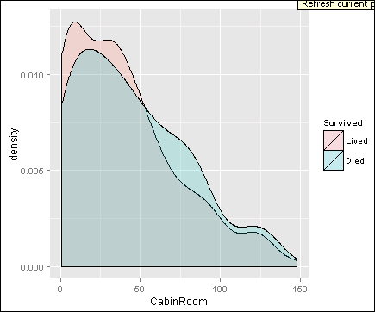

Pclass=1 (Exclude CabinRoom=0) (175 Rows)

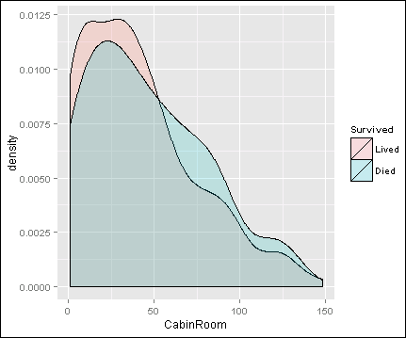

Pclass=2 (Exclude CabinRoom=0) (13 Rows)

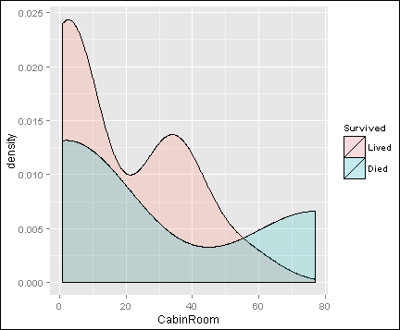

Pclass=3 (Exclude CabinRoom=0)(12 Rows)

