# Book query program:

This is a simple application that offers value-added services by combining information collected from two bookstores A and B, by using Java RMI.

How to run:

1. Restore the bookstore database

Our program works on the MySQL client with the password “cmsc5702”. So if your root password is not “cmsc5702”, then you need to either change it to “cmsc5702” or modify the DatabaseConnection.java file to make the program work.

Open a command window and start the MySQL client by typing:

mysql -uroot -pcmsc5702

At command prompt "mysql >", type the following sql commands to restore the StudentDB database:

source BookStores_DB.sql; exit;

1. In the console, compile the application by using:

javac *.java bookstore/*.java

1. Start the Bookstore A Server:

java -classpath mysql-connector-java-5.1.18.jar; RMIServer 1

1. Start the Bookstore B Server:

java -classpath mysql-connector-java-5.1.18.jar; RMIServer 2

1. Start the bookstore query application client:

java Client

Flow diagram:

BookStore B

BookStore A

RMI

RMI

Client

Client GUI:

You can either input the book name (can be keywords) or the book ID that you would like to search, e.g. harry potter:

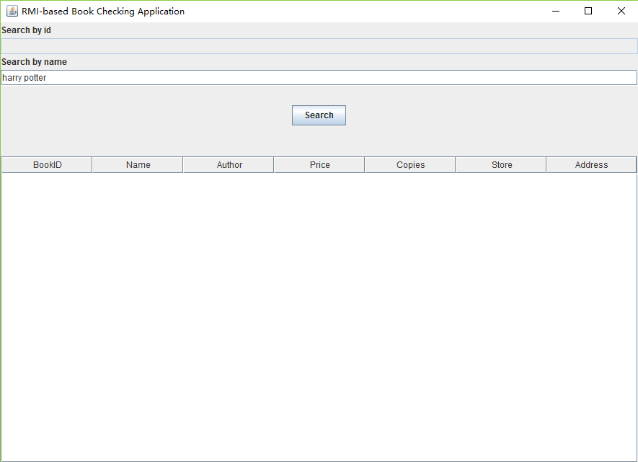

After you click the search button, the program will fetch all the related records from both bookstore A and B. Those information are including the book’s full name, author, price, how many copies available and the corresponding real store as well as its address:

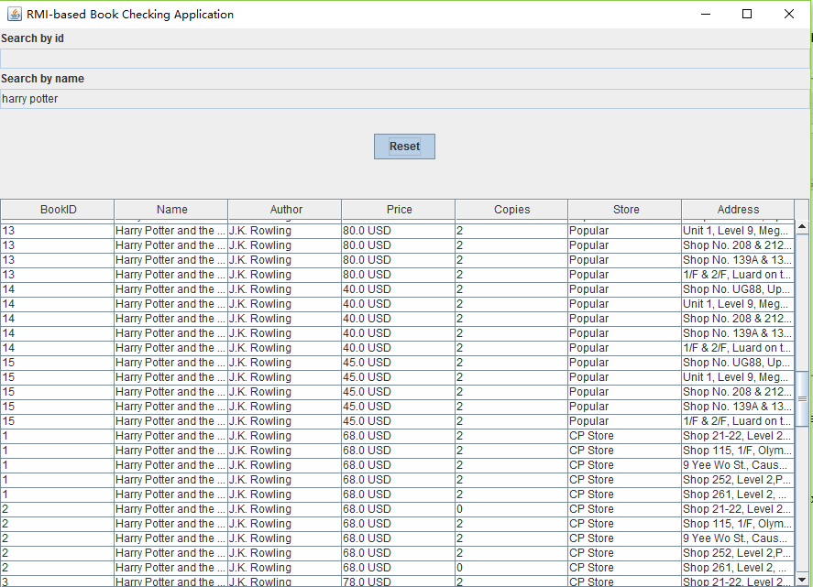

Think twice and you will know which store you should go to buy the book.