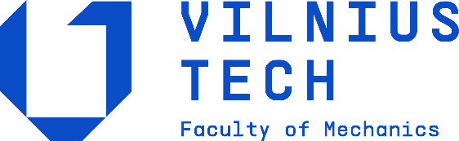

DEPARTMENT OF MECHATRONICS, ROBOTICS AND DIGITAL MANUFACTURING

Robots, Intelligent Automation (with Course Project)
(MERSB21502)

Course Project Report

Submitted by: Maksym Malyshkin,
Vladyslav Pavlenko, Mark Tretiak,
Vladyslav Hnitsa, Maxime Brunet

Evaluated by: Mantas Makulavičius

Vilnius, 2025
Table of contents

1. GENERAL INTRODUCTION 3
1.1 Introduction 3
1.2 Tasks 3
2.1 Task 3
2.2 Research 3
2.3 Task Breakdown for Edge Following 4
2.4 Research Analysis 5
3. PROJECT PIPELINE 6
3.1 Designing the pipeline 7
A) Industrial robot simulation platforms 7
B) Switching from Simulation to Real Industrial Robot 7
C) Object recognition, feature extraction, and data conversion 8
3.2 Tools and materials 9
A) Industrial robot simulation platform 9
B) Industrial robot 9
C) Sensors 10
3.3 Work description 10
4. CONCLUSION 22
5. TABLE OF REFERENCES……………………………………………………………………………………….22

- GENERAL INTRODUCTION
  - Introduction
The aim is to design and integrate a multi-sensor machine vision system with an industrial robot so it can detect objects, measure their properties, interpret their contours, and autonomously follow those contours through programmed motion in RoboDK.
  - Tasks
The individual steps of the task include the following:
- Analysis of existing projects and implementation.
- Design and structuring of the overall project system.
- Characterisation of industrial robot and software environment setup.
- Implementation of machine vision tools.
- Combination of real industrial robot and sensors (hardware), programing tools (software).
- Real-life implementation and testing at the laboratory.
- ANALYSIS OF EXISTING PROJECTS
  - Task
The first task: the preliminary analysis of the existing projects related to industrial robots, including 6 degrees of freedom (DOF) robot manipulators performing some object scanning and recognition tasks, implementing machine vision tools.
  - Research
A 6-Degrees-of-Freedom (6-DOF) industrial robot is a manipulator with six independent joint movements, which typically allow the tool to reach any position (x, y, z) and any orientation (Roll, Pitch, Yaw) within its workspace. This capability makes them highly versatile for complex tasks, emulating the human arm (What are degrees of freedom in robotics? Complete guide, n.d.).
Industrial robots are primarily programmed using vendor-specific, high-level robot programming languages. There are 3 ways of teaching the robot. Lead-Through Programming allows the operator to manually guide the robot through the required path, and the controller records the joint positions or end-effector poses. This is a common and intuitive method for simple, repetitive tasks. In case of the Offline Programming, the program is developed, simulated, and debugged on a separate computer using specialized software, like ABB RobotStudio, KUKA Sim Pro, FANUC ROBOGUIDE, etc. However, in case of our lab works, we mostly did Textual Programming, which means writing code directly in the robot's proprietary language. ABB, for example has RAPID, KUKA has KRL (KUKA Robot Language). These languages include commands for motion (MOVEJ for joint-to-joint, MOVEL for linear), I/O (Input/Output), and program logic (Wikipedia: Industrial Robot, n.d.).
Robot control relies on solving the Kinematics (the relationship between joint space and Cartesian space) and using a Controller to manage motor torques and currents to achieve the desired motion. Most industrial robots use a dedicated controller (e.g., ABB S4C, KUKA KRC) with a real-time operating kernel to ensure high-speed, repeatable control (Gemini, 2025). In order to ensure the accuracy of the robot, closed-loop control systems are used. Each control loop is a contiguous cycle that regulates system’s behavior, comparing it to desired state, and then making adjustments to minimize the error. Control Loops often involve a PID (Proportional-Integral-Derivative) controller for each joint to minimize the error between the desired joint position/velocity and the actual position/velocity. More advanced techniques like Computed Torque Control (CTC) or Adaptive Control are used for high-performance applications, sometimes implemented using techniques like Reinforcement Learning (RL) (Understanding PID Controllers in Robot Stability, 2025).
The most common implementation of industrial robots is Pick-and-Place - Moving objects between fixed or known locations. Welding, Painting, Material Handling are also standard. It is done by making the tool follow a predefined path or trajectory.
  - Task Breakdown for Edge Following
The proposed project to program a 6-DOF robot to follow an edge using machine vision can be conceptually split into the following sequential and interconnected parts:
- Robot Programming and Software Setup: Setting up the control environment, establishing communication, and defining basic robot motion.
- Sensor Integration and Calibration: Physically and logically connecting the machine vision sensor (camera) and calibrating its coordinate system relative to the robot's coordinate system (Hand-Eye Calibration).
- Object Recognition/Edge Detection: Developing the machine vision algorithm to process image data, detect the target object's edge, and extract its position and orientation in the camera's frame of reference.
- Kinematic Transformation and Control Strategy: Translating the visual data (edge position in camera coordinates) into robot movement commands (changes in joint angles or end-effector pose) in real-time to follow the edge.
- Program Combination and Execution: Integrating the vision-guided control loop into the main robot program to achieve real-time, adaptive edge following.
  - Research Analysis
Work area | Aim | Tools/technologies | Input/output variables | Results/  achievements | Reference
Warehouse Automation (Pick-and-Place) | Develop an efficient and precise control system for 6-DOF industrial manipulators using Reinforcement Learning (RL). | ABB IRB120 (6-DOF Manipulator), Deep Deterministic Policy Gradient (DDPG), Linear Quadratic Regulator (LQR) controller. | Input: Angular positions ($θ_{i}$); angular velocities ($\dot{θ_{i}}$), Output: Control torques/forces. | Achieved 28% improvement in positioning accuracy (mean error of 2.14 mm) and a 92.5% success rate in pick-and-place tasks. | (Kumar, Qiang Wang, Rizwan, Shaikh, & Liu, 2018)
Industrial Object Localization (Manipulation) | Localize the 6-DOF pose of textured objects for manipulation using a low-cost monocular camera. | Monocular Camera, ROS (Robot Operating System), SURF (Speeded Up Robust Features), PnP (Perspective-n-Point) algorithm. | Input: 2D image data (from camera), extracted SURF features and their coordinates. Output: 6-DOF object pose (position and orientation). | Demonstrated accurate object localization by combining 2D vision data with known robot kinematics for pick-and-place applications. | (Liu, Shang, & Cong, 2017)
General Robotic Guidance (Inspection/QC) | Review and compare machine vision techniques for robot guidance in industrial environments, particularly for high-accuracy tasks. | 3D Vision Sensors (Stereo Vision, Structured Light, ToF), Robot Control Systems, Optical Calibration Methods. | Input: 3D point clouds, image data. Output: Corrective motion commands to improve robot absolute accuracy. | Confirmed that machine vision can significantly improve the absolute accuracy of industrial robots for precise guidance and quality control (QC). | (Pérez, 2016)
After the analysis was completed, the table can be filled.
Across the three articles, a clear conclusion emerges: machine vision is essential for enabling robots to understand and interact with their environment, but the right technique depends heavily on the task and constraints. The first study shows how even simple colour-based vision can allow a 6-DoF robot to successfully pick up objects, proving that low-cost solutions can still achieve meaningful automation.
The second one highlights how combining robot kinematics with monocular vision dramatically improves 6-DoF localization accuracy, showing that smart sensor fusion can overcome the limits of a single camera.
The third one broadens the perspective by comparing many industrial vision methods—stereo cameras, structured light, Time-of-Flight, laser triangulation—and emphasizes that each technique has strengths and weaknesses, with no universally superior option.
These insights are directly useful for this project because they help guide which vision approach fits the robots, sensors, and object-recognition goals.
Kumar’s work shows the feasibility of simple detection methods if your objects and tasks are controlled, while Liu’s method suggests how you can combine camera data with robot kinematics in RoboDK to get more accurate positioning for contour following.
Finally, Pérez’s review gives you a structured understanding of different 3D sensing techniques, helping you justify your choice of sensor setup, explain its limitations, and design a pipeline that matches the industrial robot’s real-world needs.
Together, the three papers reinforce the idea that effective robot guidance is not about finding one perfect method, but about choosing and integrating the right tools for the specific environment and task you are solving.

- PROJECT PIPELINE
The second task: Description of the course project implementation and performance, the robot, sensors, software and additional equipment analysis, how they do work. The relevant information is provided in further subchapters.
  - Designing the pipeline

A) Industrial robot simulation platforms

There are many different robot simulation platforms, each having its own advantages and limitations. They let engineers design, program, and test robotic systems virtually, creating "digital twins" to optimize workflows, avoid collisions, and reduce downtime.

The most popular one, RoboDK, is cost-effective, has software for many different robot brands, and is great for offline programming (OLP) for tasks like pick-and-place, welding, and path optimization. It can also integrate Python, MATLAB, C++, and C# APIs in order to be able to program the robot from your own computer (RoboDK API for Python, 2025).
NVIDIA Isaac Sim is powerful for synthetic data generation, training AI models (perception, manipulation), and hardware-in-the-loop testing, using NVIDIA's GPU acceleration. It supports a wide range of robots with differential bases, form factors, and functions. These robots can be categorized as wheeled robots, holonomic robots, quadruped robots, robotic manipulators and aerial robots (drones). They can be found in the Content Browser in the Isaac Sim/Robots folder (Robot Assets, 2025).
Other industrial robot simulation platforms are vendor-specific, like ABB RobotStudio or KUKA Sim Pro. These platforms allow engineers to import CAD models of the robot, its tooling, peripheral equipment, and the workspace to create a highly accurate virtual environment. They replicate the robot's kinematics, dynamics, and controller logic.

B) Switching from Simulation to Real Industrial Robot
The process of transferring a validated program from the simulation environment to the physical industrial robot is a key step, called Deployment. Using tools like RoboDK with its Python API facilitates this by acting as a universal intermediary (Gemini, 2025).
The first step to do this is Simulation & Off-line Programming. The entire robot path is defined and verified for collision-free operation within the simulation environment. Using the Python script via the RoboDK API defines targets and movements using a universal high-level language.
Then, the program has to be generated. The universal OLP code must be translated into the specific native programming language (e.g., KRL, RAPID, KAREL) that the physical robot controller understands. RoboDK uses a specific Post Processor for the target robot (e.g., KUKA, ABB) to convert the Python/RoboDK API commands into the native program file.
After that the program has to be transferred to the robot using a USB Drive or Ethernet. After this, the program is s loaded into the robot controller's memory and run. A critical step is calibration. It is needed because the industrial robots are highly repeatable but not perfectly accurate; calibration brings commanded positions closer to actual physical positions.

C) Object recognition, feature extraction, and data conversion
Object Recognition is the process of identifying a known object (e.g., a sheet of material) within an image, and Feature Extraction is the step of isolating meaningful data points from the raw image. Object Recognition starts with Raw Data Acquisition. The program imports raw pixel data, RGB or Greyscale. Then, basic filtering is applied (e.g., Gaussian blur for noise reduction, Color Space Conversion from RGB to Grayscale for simpler processing) (Gemini, 2025).
Feature extraction works using Edge/Corner Detection with algorithms like Canny Edge Detection or Sobel Filter used to identify sharp intensity changes in the image, effectively highlighting the object's boundary (the edge). When more advanced features are needed, a Convolutional Neural Network (CNN) or a framework like YOLO (You Only Look Once) can be trained to recognize the object and output a bounding box or, more precisely, a mask of the desired edge segment (Feature Extraction in Image Processing: Techniques and Applications, n.d.). The result is usually a set of 2D pixel coordinates representing the detected edge points within the camera's image plane (Feature Extraction in Image Processing: Techniques and Applications, n.d.).
The 2D image coordinates must be converted into a 6-DOF coordinate frame (Position X, Y, Z, and Orientation A, B, C) that the robot controller can understand. This process relies on Calibration and Coordinate Transformation.
This continuous cycle of Feature Extraction, Data Conversion, and Motion Command forms the Visual Servo Loop necessary for adaptive edge following.

  - Tools and materials

A) Industrial robot simulation platform
The simulation platform used in this project is RoboDK. It is one of the most popular platforms of its type; however, like anything in this world, it has its own advantages and limitations.
The biggest advantage of RoboDK is its expansive library supporting over 50 robot manufacturers, allowing users to program, simulate, and switch between different robot brands using a single software interface. Furthermore, its powerful Python API allows for seamless integration of custom scripts, such as those used for advanced machine vision or complex calculations, directly into the robot control workflow, making it highly versatile for research and rapid application development. This interoperability significantly reduces the learning curve and capital expenditure associated with purchasing and mastering multiple vendor-specific software packages (RoboDK API for Python, 2025).
However, it still has its limitations. RoboDK is still in active development, with each passing month comes bug fixes, new implementations, and new additions to their robotics library. Many robots/cobots have not been fully implemented yet, and the same goes for many grippers/accessories. Although you can upload a model of the hardware, it takes time to have it be fully functional on the simulation (Herron, 2022).

B) Industrial robot
The industrial robot used in this project is YASKAWA Motoman HC10DTP. This 6 DOF collaborative robot enables operation with, or in close proximity to, human workers. Depending on risk assessment, this cobot can operate in collaborative mode at speeds up to 1,000 mm/s without extra safety features, saving space and lowering cost. Additionally, when properly equipped, this hybrid cobot can operate in non-collaborative mode at speeds up to 2,000 mm/s. Having a payload of 10 kg and a reach of 1200 mm horizontally and 2400 mm vertically, it is a great solution for Assembly, Machine Tending, Material Handling, Pick and Pack, and other applications (HC10DTP, n.d.) (HC10DTP: Collaborative Robot with Hand-Guided Teaching, n.d.).

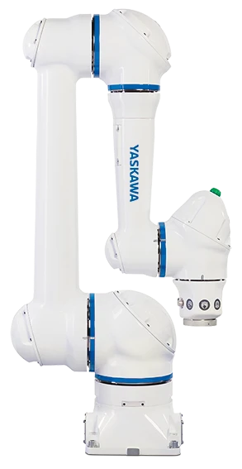
Figure 3.1 YASKAWA Motoman HC10DTP.

C) Sensors
There weren’t any sensors used in this project. The raw imagery was obtained using the camera, and the feature extraction was done using the Python algorithms, as explained in the next section of this report (Hnitsa, Pavlenko, Tretiak, Malyshkin, & Brunet, 2025).
  - Work description
Firstly, the Python code has to be written. The code includes: importing of the picture, transforming it to grayscale, using the Edge Detection Algorithm. Then, the program has to calculate the size of the object and import it to RoboDK. The program then has to generate the .JBI file with code converted to robot’s programming language (For YASKAWA robots, it is called INFORM (Yaskawa Motoman Robot Programming: How to Get Started, 2024)).

Before running the code, the picture has to be taken using the camera attached to the robot. In order to attach the camera, we need a camera holder and a broad board. The parts were designed using SOLIDWORKS. The screenshot of the models is below.

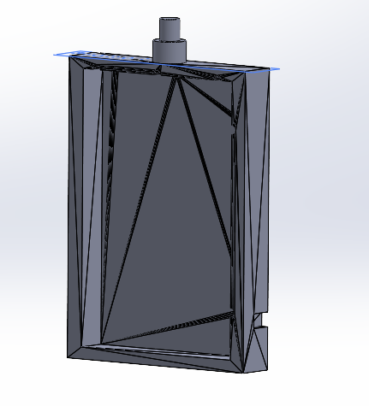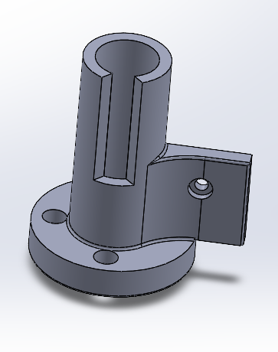
      - b)
Figure 3.2 Parts designed using SOLIDWORKS.
- Broad board b) Camera holder
Both parts then have to be combined into one using the Assembly feature in SOLIDWORKS. The model can then be 3D printed and used to attach the camera; however, this step is optional, since the picture can be taken using any kind of camera without attaching it to the robot.
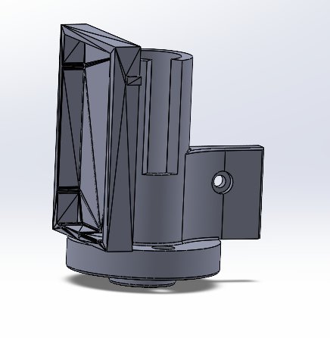
Figure 3.2 Part designed using SOLIDWORKS – Final model of the holder.

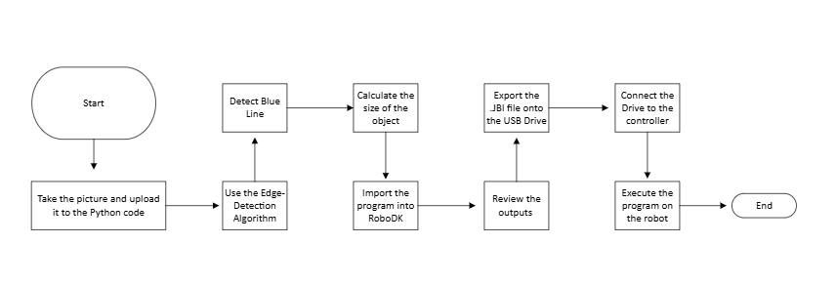
Figure 3.2 Project pipeline diagram.
In order to get this code working, the following libraries were utilized: OpenCV for image processing, NumPy for calculations, and RoboDK for import.
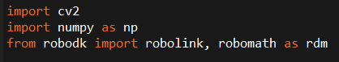
Figure 3.3 Python code – Importing libraries.
In the meantime, a picture of the object has to be made. The blue line, size of 120 mm was added to the bottom of the picture in order to simplify the calculations of the object size. Initially, the program was made without the line; however, the program couldn’t accurately measure the object size, which led to the impossibility to perfectly replicate the outline
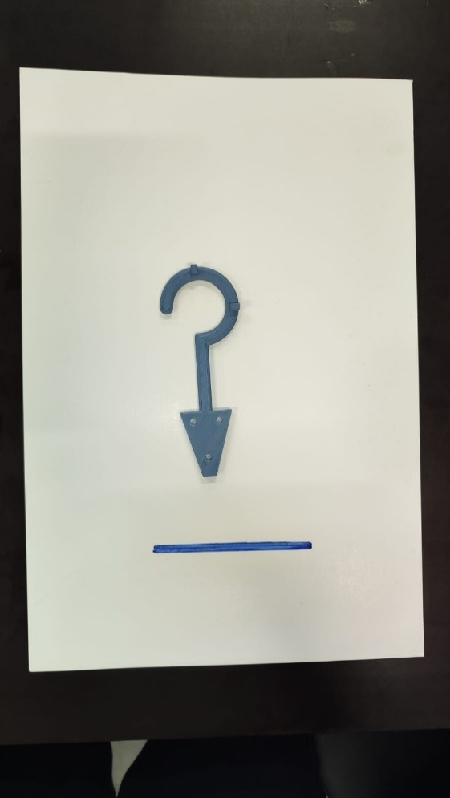
Figure 3.4 The picture used as input.
Variables have to be declared. Fallback parameters for width and height (120 and 260 mm, respectively) are included as a safety measure, in case the scale fails. Then, for hook contour simplifications, we set the point step to 1 to take every Nth point and set the minimal parameter for simplification. Afterwards, the HSV range and shape filters is set for blue color, to help the program detect the blue line. The directions have to be changed when the robot follows the trajectory, in order to make it work according to the workplace.
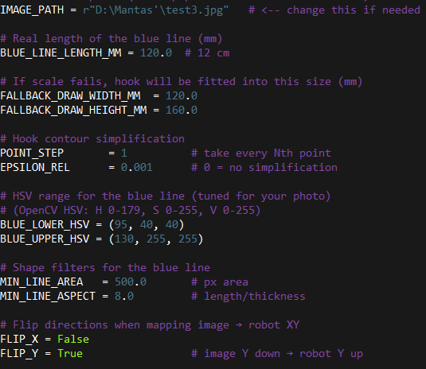
Figure 3.5 Python code – Variables definition.
The heights have to be edited to ensure the correct distance between the tool of the robot and the paper, relative to StartDraw. The speeds have to then be set. Afterwards, the variables for RoboDK have to be declared.
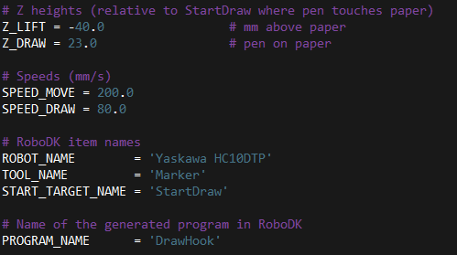
Figure 3.6 Python code – Variables definition.
Then, the functions have to be defined one by one. The `find_contours_compat` function ensures compatibility across OpenCV versions for `cv2.findContours()`, which can return either two values (contours, hierarchy) or three (image, contours, hierarchy). It checks the tuple length: if two, it unpacks directly; if three, it discards the redundant image and unpacks the others. This always extracts the correct contours and hierarchy, returning a consistent list of contours.
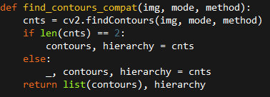
Figure 3.7 Python code – Function ‘find_contours_compat’.
This function detects an image and returns the region of interest (ROI). Firstly, it converts the image to grayscale and applies a Gaussian blur, then uses Otsu’s thresholding to create a binary image separating the paper from the background. Afterwards it ensures the paper is white (foreground) in the binary image by comparing intensity averages. Then it applies morphological operations (close, then open) to remove noise and fill small gaps in the paper’s outline. Finds contours, selecting the largest as the paper and returns the cropped ROI and its bounding box coordinates. If no paper is found, the entire image is returned as a fallback.
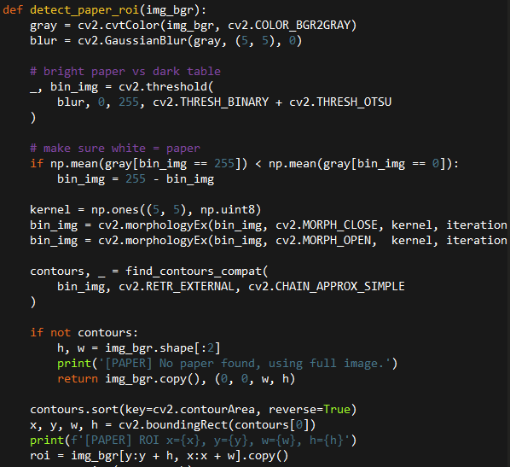
Figure 3.8 Python code – Function ‘detect_paper_roi’.
In the next step, the function detect_blue_line_scale identifies a pre-measured blue reference line in an image to calculate a scale. It converts the image to HSV and creates a mask for the blue color range. Morphological operations clean the mask before finding contours. It filters contours to find a suitable long, thin line near the bottom of the image based on area, aspect ratio, and position. The contour with the highest aspect ratio is selected as the reference line. Its pixel length is used to calculate a millimeters-per-pixel ratio (assuming a known real-world length), which is returned along with the contour and mask. If no suitable contour is found, it falls back to selecting the contour with the largest aspect ratio or returns no scale.

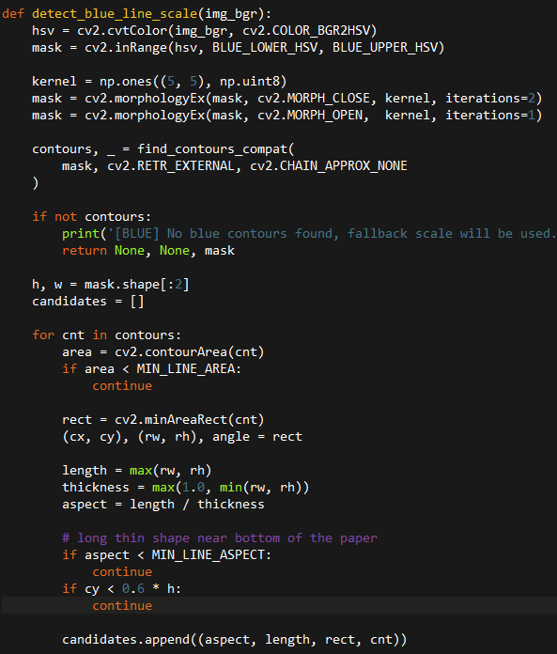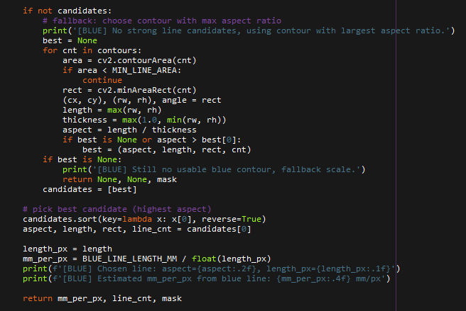
Figures 3.9-10 Python code – Function ‘detect_blue_line_scale’.
Then, `find_hook_contour` detects the main object (a hook) on a pre-cropped paper image. It converts the image to grayscale, applies blur, and uses Otsu's thresholding to create a binary image where the darker hook is white. After finding contours, it filters them to eliminate noise, the paper border, or other line-like shapes. The function prioritizes solid, moderately-sized contours. If no suitable contour passes the filters, it defaults to using the largest non-huge contour on the paper. Finally, the contour is simplified using polygon approximation and sub-sampled before being returned alongside the binary mask.
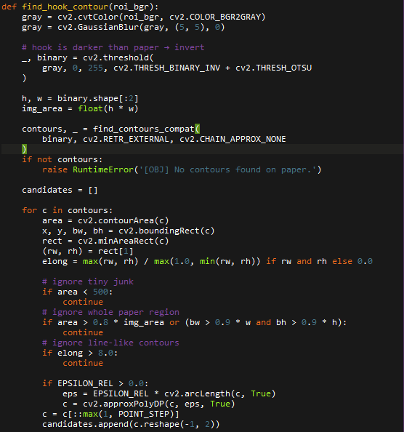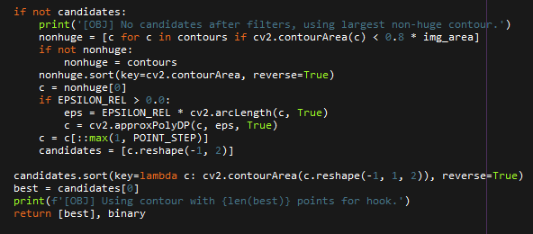
Figures 3.11-12 Python code – Function ‘find_hook_contour’.
‘preview_all’ generates and saves debug images and an interactive preview for visual verification of the detection process. It first saves the binary mask of the detected hook object as hook_binary_debug.png. If a blue mask exists, it is also saved as blue_mask_debug.png. It then creates a single visualization image by copying the original cropped region and drawing the detected hook contours in green and the reference blue line in blue. This preview is saved as contours_preview.png. In the end, it attempts to display all three images—the hook binary, blue mask, and final preview—in separate windows for immediate visual inspection, automatically closing them when a key is pressed.
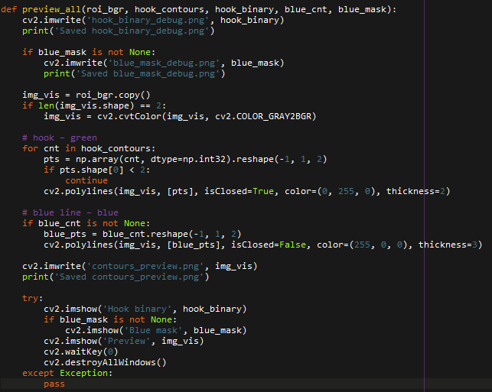
Figure 3.13 Python code – Function ‘preview_all’.
‘contours_px_to_mm’, takes the outline of the detected hook (in pixels) and converts it into real-world millimeter dimensions. First, it finds the overall bounding box of the hook to get its pixel width and height and center point. It then determines the conversion scale from pixels to millimeters. If a pre-calculated scale (from the blue reference line) is provided, it uses that. Otherwise, it uses a fallback scale based on standard paper size.
Using this scale, it reports the hook's approximate physical size. Finally, it transforms every point in the hook's outline from pixel coordinates into millimeter coordinates relative to the object's center, applying any specified X or Y axis flips. The result is a list of points ready for machining or drawing in real-world units.
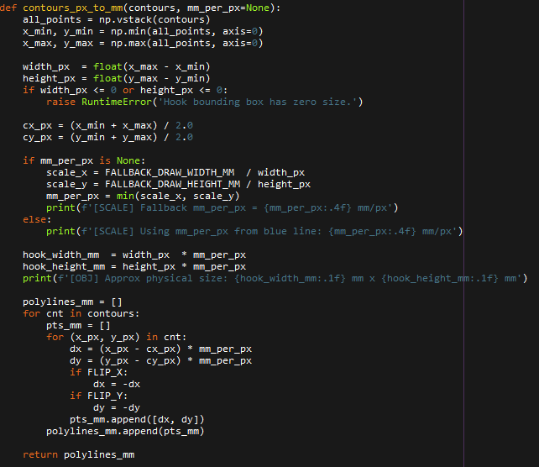
Figure 3.14 Python code – Function ‘contours_px_to_mm’.
‘draw_with_robot’, automates the process of converting the detected hook outline into a robot drawing program. It connects to RoboDK, a robot simulation and programming software, and prepares to generate instructions for a robotic arm. The function first locates the defined robot, tool, and pre-taught starting position on the paper within the RoboDK project. It then creates a new robot program with the correct tool and reference frame settings.
The robot is moved to a safe starting height above the paper. The function then processes the hook outline point by point. For each shape (contour), it first moves the robot to the start position with the pen lifted (Z_LIFT). It then lowers the pen to the drawing height (Z_DRAW) and moves along the contour line, drawing the shape. After completing a contour, it lifts the pen and moves to the next shape. The robot uses a slower speed for drawing and a faster speed for travel moves. Once the entire outline is traced, the robot returns to the safe starting position. In the end, the function prompts the user to generate the actual robot code from the simulation program.
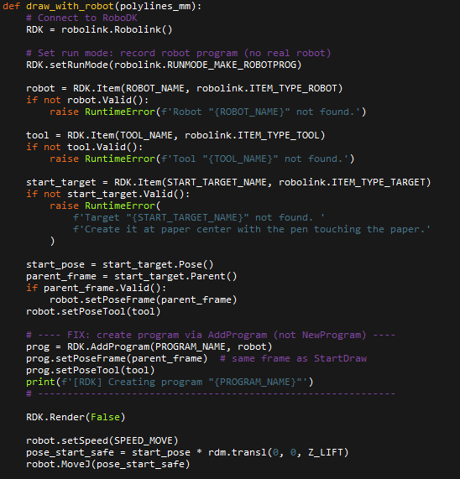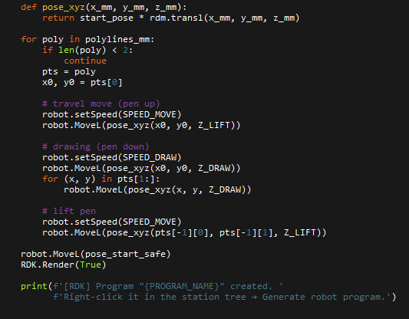
Figure 3.15-16 Python code – Function ‘draw_with_robot.
Finally, after all this, the ‘main’ function is added to launch everything.
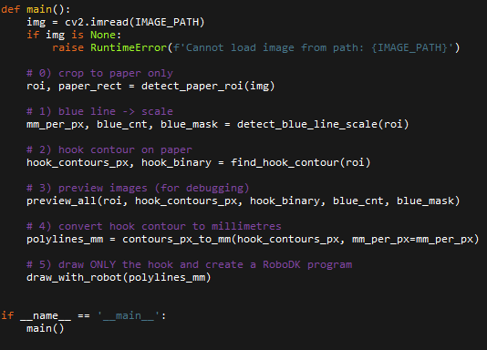
Figure 3.17 Python code – Function ‘main’.
When the code is launched, RoboDK opens. Once the code is launched inside the RoboDK, it gives three images as output: the binary image of the hook, the blue mask with outline of the blue line and the object, and the final preview of the processed image of the object.
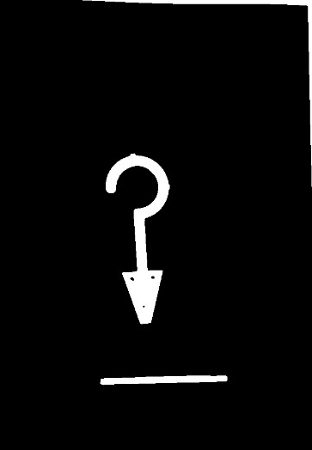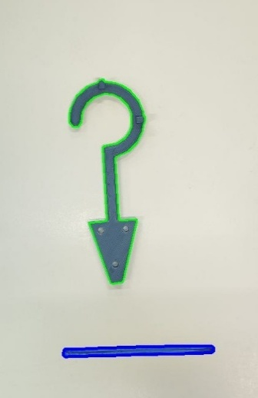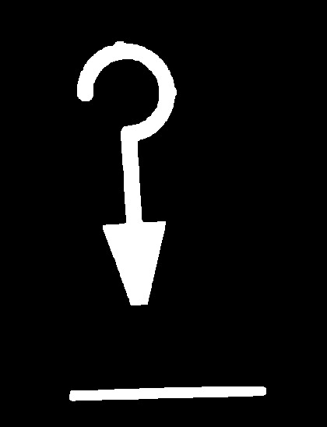
a) | b) | c)
Figure 3.18 Output Images: the hook binary, blue mask, and final preview.
Then, the program can be seen.
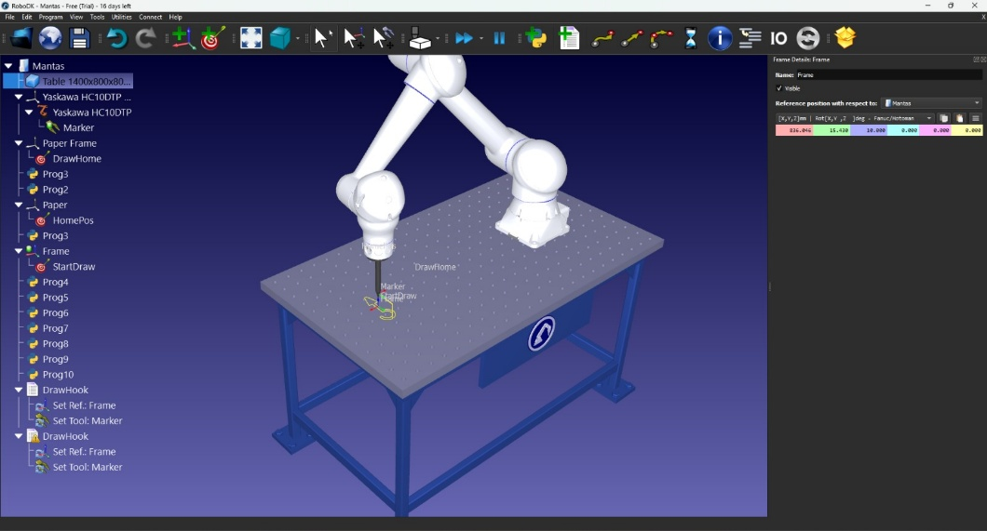
Figure 3.19 The outline of the object in RoboDK.
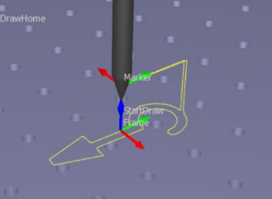
Figure 3.20 The more detailed outline of the object in RoboDK.
In the end, the program also generates the actual robot code from the simulation program. The code first defines each point using coordinates, and afterwards, using the MOVL function, draws the outline. When drawing the outline, the speed is set to 80, but when travelling, it is 200.
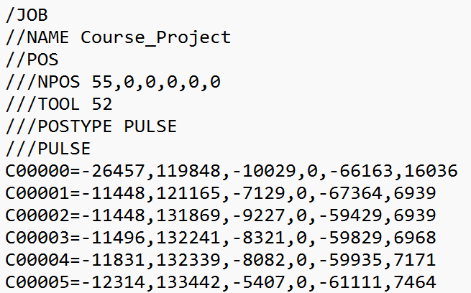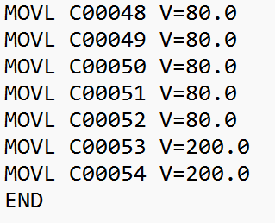
Figure 3.21 Output code file – points definition and outline drawing.
In order to launch the code on the robot and execute the program, this file has to be transferred onto the controller using the USB drive.
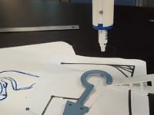
Figure 3.21 The successful program execution video.
As can be seen from the video, the robot successfully replicates the object’s outline and returns to the home position. That means that the task was completed as anticipated.

- CONCLUSION
This project combined robotics, computer vision, and software integration to develop a working system that can identify an object and convert its outline into actionable robot movements. By building a full pipeline, from collecting images, pulling out features, computing coordinate transform, and programming the robot, the team demonstrated that machine vision can stretch an industrial robot’s abilities beyond predetermined movements. The importance of accurate detection, calibration, and data manipulation was highlighted for reliable and reproducible results.
Throughout the process, various tools and technologies were combined, including Python-based vision algorithms, RoboDK simulation, and the Yaskawa HC10DTP robot. The project required careful testing, refinement, and troubleshooting to ensure that each stage, from detecting the blue reference line to generating the INFORM code, worked accurately. The successful integration proved that even without additional dedicated sensors, robust object recognition and contour tracking can be accomplished through well-designed software methods and a structured workflow.
The project demonstrated the practical value of intelligent automation in industrial settings. It provided hands-on experience with real robot programming, simulation-to-reality transfer, and vision-driven motion planning. The results confirm that machine vision can significantly expand the capabilities of a robot, enabling it to interpret its environment and perform dynamic tasks such as edge following. This experience not only fulfilled the course objectives but also laid a strong foundation for future developments in robotic perception and autonomous operation.

- TABLE OF REFERENCES

Feature Extraction in Image Processing: Techniques and Applications. (n.d.). Retrieved from geeksforgeeks: https://www.geeksforgeeks.org/computer-vision/feature-extraction-in-image-processing-techniques-and-applications/
Gemini. (2025). Retrieved from Google: https://gemini.google.com/
HC10DTP. (n.d.). Retrieved from YASKAWA: https://www.ru.yaskawa.eu.com/products/robots/collaborative/productdetail/product/hc10dtp_17024
HC10DTP: Collaborative Robot with Hand-Guided Teaching. (n.d.). Retrieved from MOTOMAN: https://www.motoman.com/en-us/products/robots/collaborative/hc-series/hc10dtp
Herron, Z. (2022). Qviro. Retrieved from RoboDK Reviews: https://qviro.com/product/robodk/robodk-robodk/reviews
Hnitsa, V., Pavlenko, V., Tretiak, M., Malyshkin, M., & Brunet, M. (2025). Robots, Intelligent Automation: Course Project Report. Vilnius: Vilnius Tech.
Kumar, V., Qiang Wang, W. M., Rizwan, S., Shaikh, S. M., & Liu, X. (2018). Computer vision based object grasping 6DoF robotic arm using picamera. Retrieved from IEEE Xplore: https://ieeexplore.ieee.org/document/8384653
Liu, K., Shang, W., & Cong, S. (2017, July). 6-DOF object localization by combining monocular vision and robot arm kinematics. Retrieved from ResearchGate: https://www.researchgate.net/publication/320122448_6-DOF_object_localization_by_combining_monocular_vision_and_robot_arm_kinematics
Pérez, L. (2016, March 5). Robot Guidance Using Machine Vision Techniques in Industrial Environments: A Comparative Review. Retrieved from MDPI: https://www.mdpi.com/1424-8220/16/3/335
RoboDK API for Python. (2025). Retrieved from RoboDK: https://robodk.com/doc/en/PythonAPI/index.html
Robot Assets. (2025). Retrieved from NVIDIA Isaac Sim Documentation: https://docs.isaacsim.omniverse.nvidia.com/5.0.0/assets/usd_assets_robots.html
Understanding PID Controllers in Robot Stability. (2025). Retrieved from AI-FutureSchool: https://www.ai-futureschool.com/en/mechatronics/pid-controllers-in-robotics-stability-1.php
What are degrees of freedom in robotics? Complete guide. (n.d.). Retrieved from Standard Bots: https://standardbots.com/blog/degrees-of-freedom
Wikipedia: Industrial Robot. (n.d.). Retrieved from Wikipedia: en.wikipedia.org/Industrial_Robot
Yaskawa Motoman Robot Programming: How to Get Started. (2024). Retrieved from Augmentus: https://www.augmentus.tech/blog/yaskawa-motoman-robot-programming/

