

REPORT
Course project

Author: Vladyslav Hnitsa
Course name: Databases

2025

This report documents the structure and behaviour of a relational database for a vehicle sales & service management system.
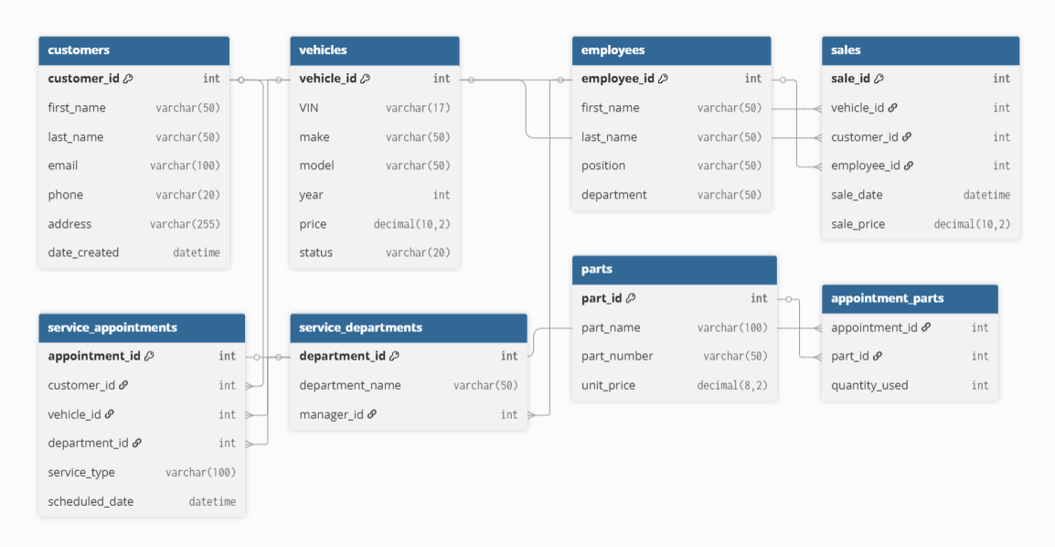
The database is visualized using https://dbdiagram.io/.
The database includes 8 tables: customers, vehicles, employees, sales, service appointments, service departments, parts, and appointments for parts. Each table contains a primary key.
Database Project Requirements
The objective of this project is to design, implement, and manipulate a relational database using Microsoft SQL Server (or other). Throughout the project, you will gain practical experience with database concepts and SQL operations. Your database should include the following components and functionalities:
1. Database Design
- Create a Database: Design and create a database for a small business or organisation, such as an online store, or school.
- Define Tables: Identify and create tables necessary to store the required data, including:
  - Primary Key: Ensure each table has an auto-incremented primary key (PK) to uniquely identify each record.
  - Foreign Key: Define foreign key (FK) constraints to establish relationships between tables.
  - Many-to-Many Relationships: Implement at least one many-to-many relationship using a junction table.
  - Indexes: Create indexes to optimise queries. Use both unique and non-unique indexes where appropriate.
  - Data Types: Use a variety of data types (e.g., int, varchar, datetime) in your tables as appropriate to your data.
2. Data Manipulation
- Insert Operations: Insert sample data into each table to adequately populate the database. Write scripts using multi-row inserts.
- Update Operations: Write queries to update existing data in the tables, demonstrate modifying specific fields.
- Delete Operations: Write queries to remove specific records from the tables, practice with both conditional deletions and full table truncations.
3. Data Retrieval and Queries
Write a minimum of three SQL SELECT statements that meet the following requirements:
- Utilise at least three aggregate functions, such as COUNT, SUM, AVG, etc.
- One of the SELECT statements should be structured to support pagination, using clauses like OFFSET, FETCH NEXT, TOP, etc.
- Demonstrate data aggregation by grouping the results based on one or more columns, using the GROUP BY clause.
- Implement the ORDER BY clause to sort the retrieved data in both ascending and descending order.
4. Table Joins
- Join Two Tables: Write queries to retrieve combined information from two related tables using INNER JOIN, LEFT JOIN, RIGHT JOIN, etc.
- Join Three Tables: Extend queries to incorporate data combining from three related tables, showcasing more complex relationships.
- Create a View: create a view which combines 3 different tables using JOIN.
5. Procedures/Functions/Triggers
Create at least one:
- SQL Stored procedure
- SQL function
- SQL trigger
- Manual transaction
6. Presentation
- Be prepared to demonstrate the implementation of the specified requirements, including the relevant SQL queries. Ensure that you are ready to explain not only how the requirements were implemented, but also the underlying concepts. For instance, if you utilised a Primary Key, you should be able to explain its purpose.
- Create a visual representation of the database schema using a tool of your choice.
- Upload all project files to a version control system, such as GitHub or an alternative platform.
- Present the database design, key features, and queries in a structured and detailed report or presentation.

- Database design
Tables and key columns:
customers
- customer_id INT IDENTITY(1,1) PRIMARY KEY
- first_name VARCHAR(50) NOT NULL
- last_name VARCHAR(50) NOT NULL
- email VARCHAR(100) NOT NULL UNIQUE
- phone VARCHAR(20)
- address VARCHAR(255)
- date_created DATETIME DEFAULT GETDATE()
vehicles
- vehicle_id INT IDENTITY(1,1) PRIMARY KEY
- VIN VARCHAR(17) NOT NULL UNIQUE
- make VARCHAR(50) NOT NULL
- model VARCHAR(50) NOT NULL
- year INT NOT NULL
- price DECIMAL(10,2) NOT NULL
- status VARCHAR(20) DEFAULT 'available' CHECK (status IN ('available', 'sold', 'reserved', 'maintenance'))
employees
- employee_id INT IDENTITY(1,1) PRIMARY KEY
- first_name VARCHAR(50) NOT NULL
- last_name VARCHAR(50) NOT NULL
- position VARCHAR(50) NOT NULL
- department VARCHAR(50) NOT NULL
service_departments
- department_id INT IDENTITY(1,1) PRIMARY KEY
- department_name VARCHAR(50) NOT NULL UNIQUE
- manager_id INT FOREIGN KEY REFERENCES employees(employee_id)
sales
- sale_id INT IDENTITY(1,1) PRIMARY KEY
- vehicle_id INT NOT NULL FOREIGN KEY REFERENCES vehicles(vehicle_id)
- customer_id INT NOT NULL FOREIGN KEY REFERENCES customers(customer_id)
- employee_id INT NOT NULL FOREIGN KEY REFERENCES employees(employee_id)
- sale_date DATETIME DEFAULT GETDATE()
- sale_price DECIMAL(10,2) NOT NULL
service_appointments
- appointment_id INT IDENTITY(1,1) PRIMARY KEY
- customer_id INT NOT NULL FOREIGN KEY REFERENCES customers(customer_id)
- vehicle_id INT NOT NULL FOREIGN KEY REFERENCES vehicles(vehicle_id)
- department_id INT NOT NULL FOREIGN KEY REFERENCES service_departments(department_id)
- service_type VARCHAR(100) NOT NULL
- scheduled_date DATETIME NOT NULL
parts
- part_id INT IDENTITY(1,1) PRIMARY KEY
- part_name VARCHAR(100) NOT NULL
- part_number VARCHAR(50) NOT NULL UNIQUE
- unit_price DECIMAL(8,2) NOT NULL
appointment_parts
- appointment_id INT NOT NULL FOREIGN KEY REFERENCES service_appointments(appointment_id)
- part_id INT NOT NULL FOREIGN KEY REFERENCES parts(part_id)
- quantity_used INT NOT NULL DEFAULT 1
- PRIMARY KEY (appointment_id, part_id)
- CONSTRAINT CHK_quantity_positive CHECK (quantity_used > 0)

- Database creation
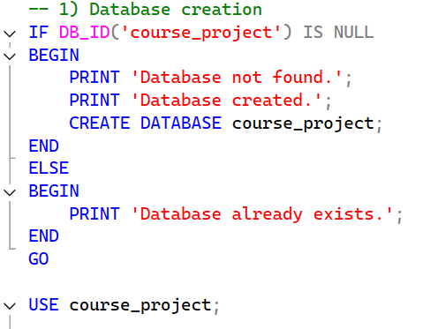
First of all, we have to create a database in our server or use one, if it already exists.
Then we create each table one by one.
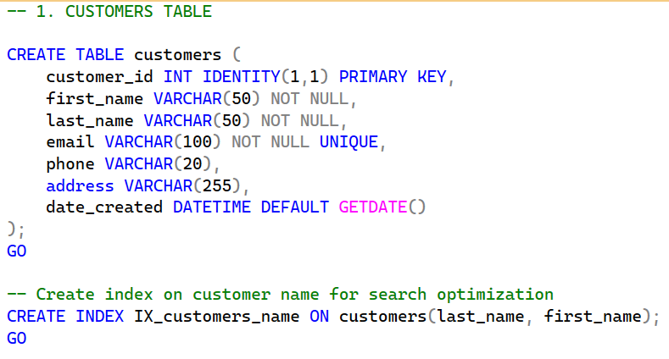
Also, we include indexes to improve query performance.
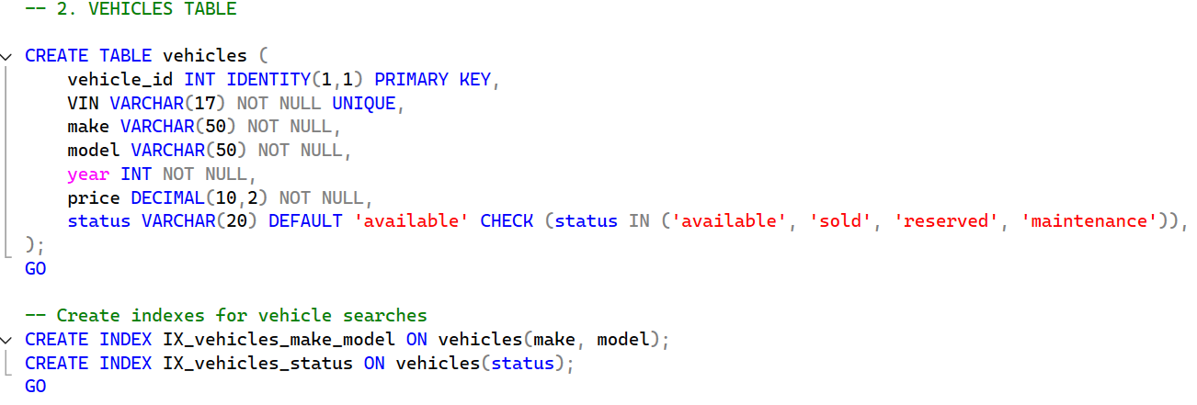
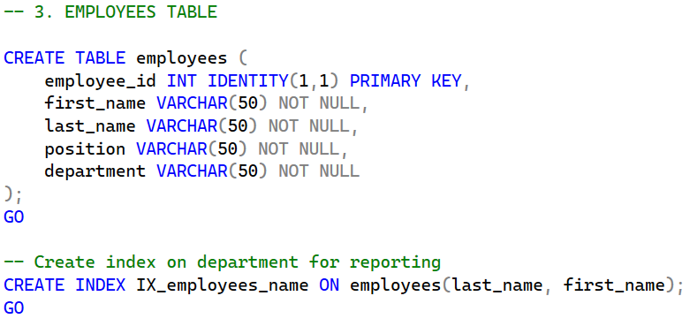
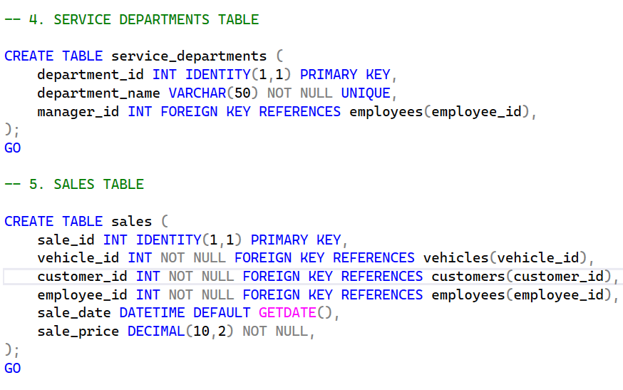
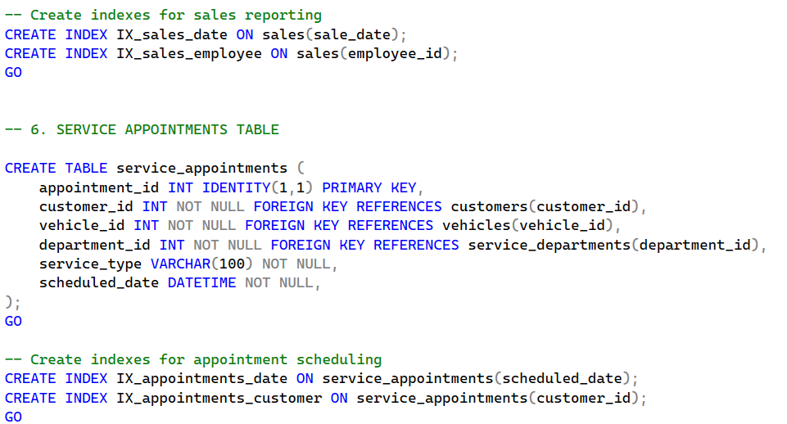
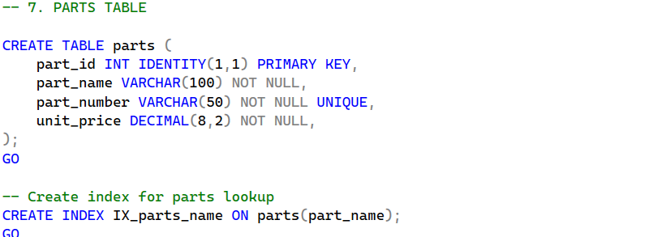
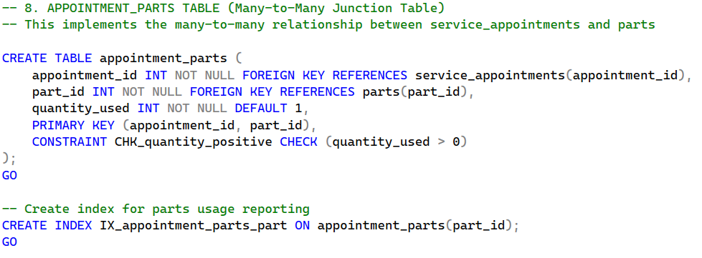
The Appointment Parts table implements a many-to-many relationship as required.

- Data manipulation
We insert sample data.
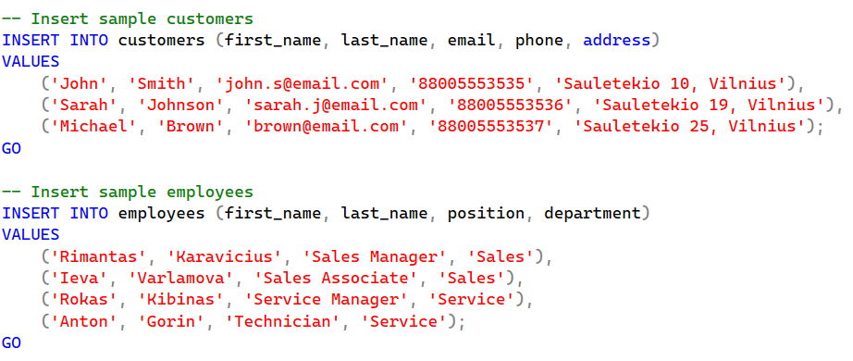
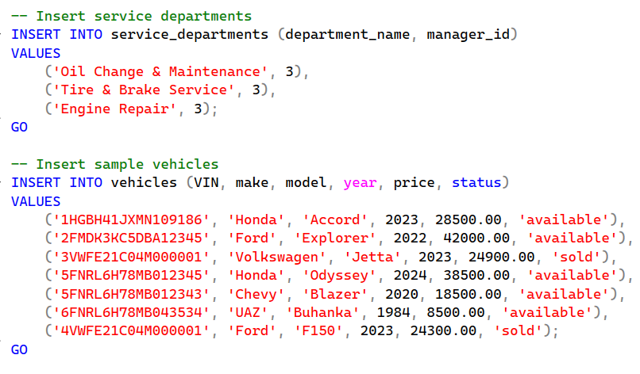
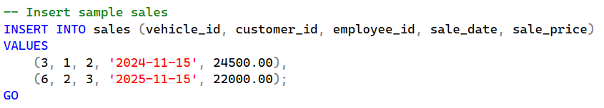
Using Update, we are able to update the status of the vehicle.
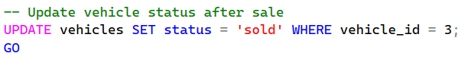

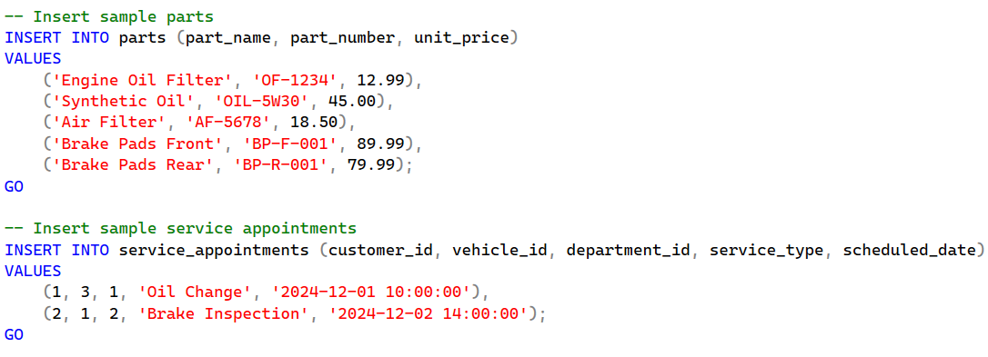
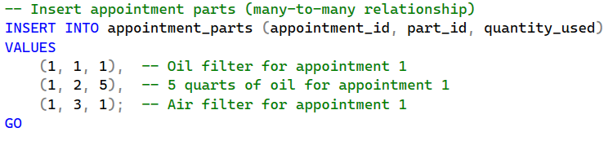
Using the following query, we are able to see all tables.
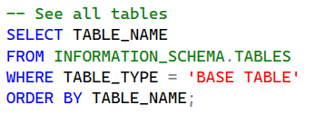
Using the following query, we can delete the appointments older than 1 year.
Using the Truncate Table, we can clean the data from the table without deleting the table.
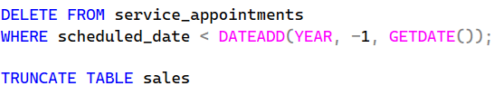
- Data retrieval
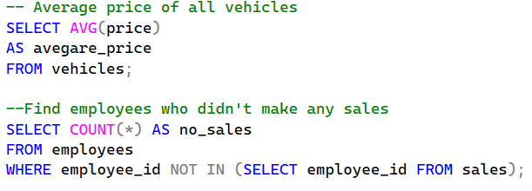
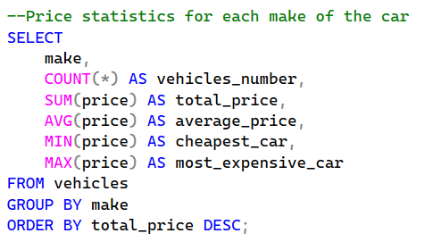
Those are some simple queries for data retrieval.
Using pagination, we are able to divide the needed information into pages. Editing the Offset parameter, we can set the starting row. Using Fetch Next, we can set the number of rows displayed.
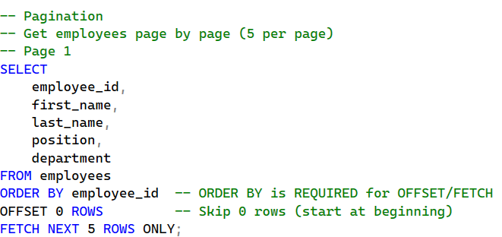
To see page 2, Offset needs to be changed to 5 in this case.
- Joins
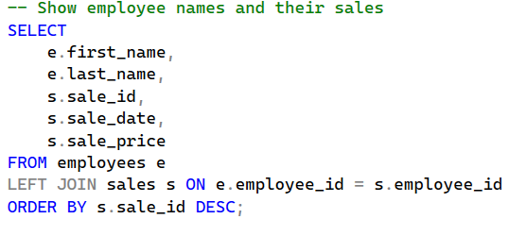
This is a query to show employee names and their sales.
Note: Left Join also allows us to see the employees who didn’t make any sales. In order to only see those that made sales we have to use Inner Join.
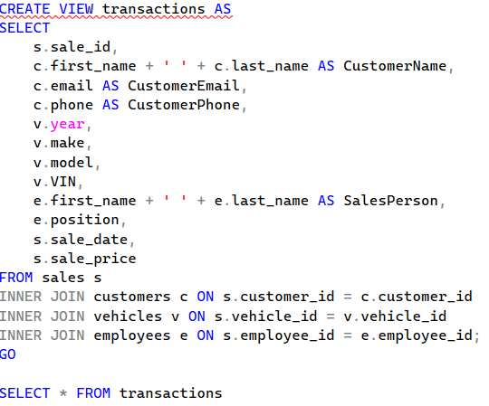
Using Create View, we are able to join 3 tables in such a way. It will show the detailed information about each transaction.
- Triggers/Stored Procedures
Then we have to create a stored procedure to add a new customer and return new customer id.
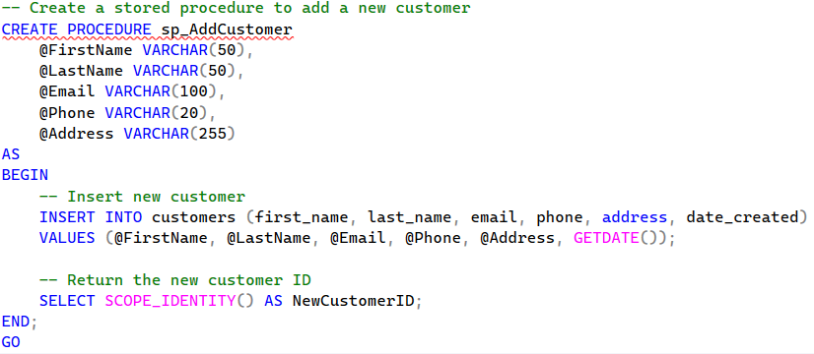
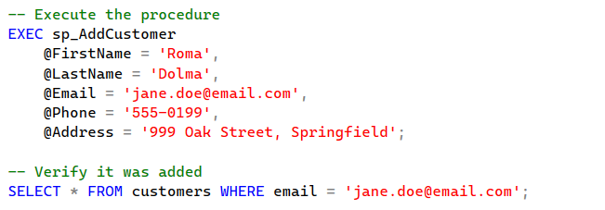
This is an example of the output:

Now, a trigger has to be created. This trigger sets the vehicle status in the vehicles table to sold, after it is sold.
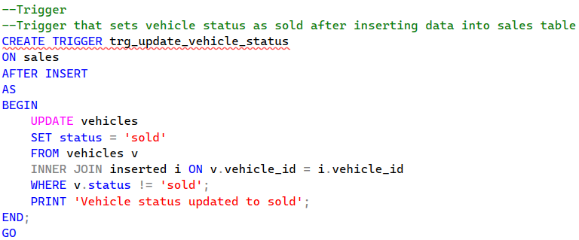

- Conclusion
The completed database project successfully establishes a structured, relational system for managing vehicle sales, service operations, customers, employees, and inventory. It demonstrates full CRUD functionality, reporting capabilities, and automated logic through views, stored procedures, and triggers. The implemented indexing strategy and constraints ensure data integrity, efficient querying, and reliable system performance. Overall, the project provides a strong, scalable foundation suitable for real-world dealership and service-center management needs.

