- 新增设备登记编号也需要验证唯一性
- 新增超级管理员（蔡勇军：18673317979。杨玉山：13874463309。张正胜：‭133 1960 6251‬）密码123456报密码错误
Request URL:http://118.24.171.48:8080/zbsjk/login
Request Method:POST
Status Code:400
Remote Address:118.24.171.48:8080
{"account":"13874463309","pwd":"123456","loginType":"guanli"}
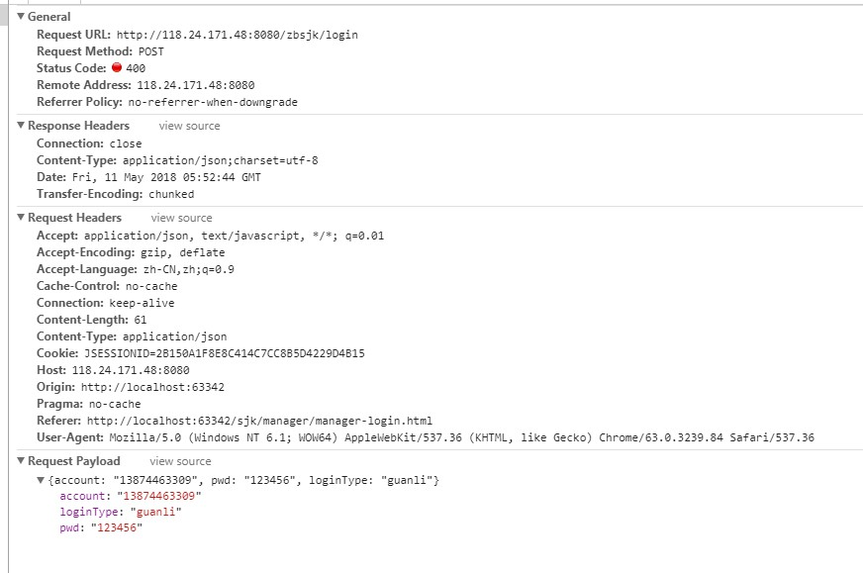
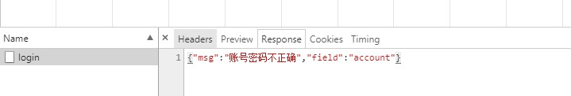

8新增考试
Request URL:http://118.24.171.48:8080/zbsjk/examination
Request Method:POST
Status Code:404
{"equipmentNumber":"湘H2JM98","userName":"周菊梅"}

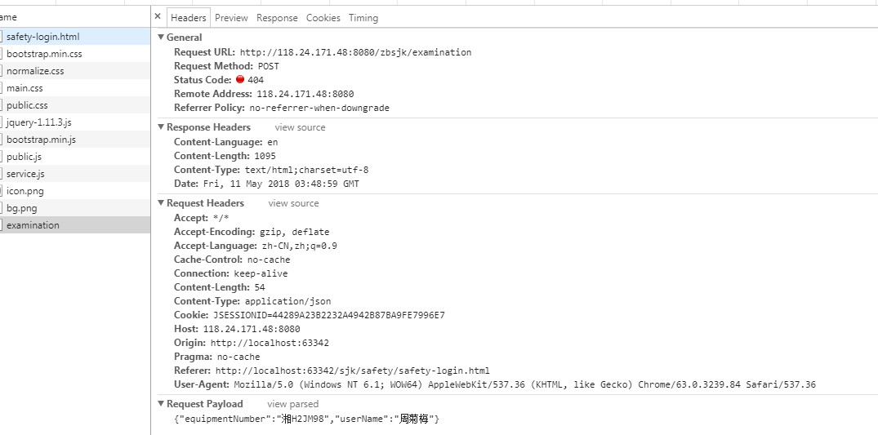
返回错误信息The origin server did not find a current representation for the target resource or is not willing to disclose that one exists.

9.超级管理员登录应急救援报无权限
Request URL:http://118.24.171.48:8080/zbsjk/login
Request Method:POST
Status Code:403
Remote Address:118.24.171.48:8080
{"pwd":"123456","account":"123456","loginType":"yingji"}
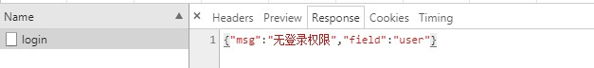
10.二维码扫描后