DSC640-T302 Data Presentation & Visualization (2261-1)
Weeks 11 Project Milestone 5
Linh Huynh

Childcare Price Analysis

Introduction
This project studies childcare prices in the United States to help parents understand how much childcare costs and how it has changed over time. The dataset includes prices for infants, toddlers, and preschoolers from different provider types between 2008 and 2018. The goal is not to predict future prices but to show clear patterns and trends in a simple way. The findings show that infant care is always the most expensive, family childcare homes are usually cheaper, and overall prices have gone up in the last decade. To explain these results clearly, three different mediums are used: charts and visuals, a short-written report, and an infographic. These mediums are made for parents and community groups who may not have a background in data. They are designed to make the information easy to see, read, and understand. Together, they tell one story: childcare in the U.S. is expensive, and the cost continues to rise, especially for families with infants.

Charts and Visuals
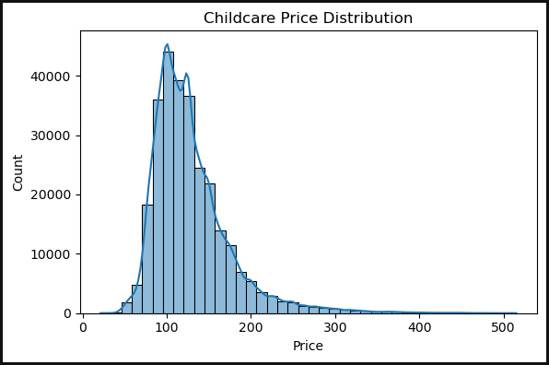

This chart shows how much parents usually pay for childcare. Most prices are between 100 dollars and 150 dollars, which means this is the common range for many families. A smaller number of places charge much more, sometimes over 300 dollars - 500 dollars, but these are less common. The curve line also shows that prices rise quickly up to about $120 and then slowly go down, meaning some centers are very expensive but not the majority. This tells us that while most families pay around the middle range, a few pay much higher costs depending on location or type of care.

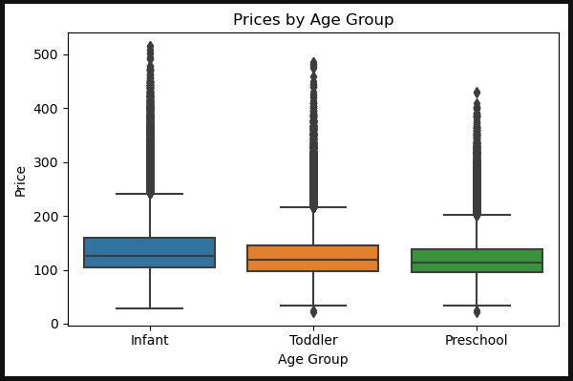

This chart compares childcare prices for infants, toddlers, and preschoolers. Infant care is usually the most expensive, with a higher middle price than the other groups. Toddler and preschool care cost a little less, and their typical prices look very similar to each other. Most families pay between 100 dollars and 150 dollars for all groups, but there are some places that charge much more, especially for infants. These very high prices are shown as the many dots above the boxes, meaning they are less common but still present.
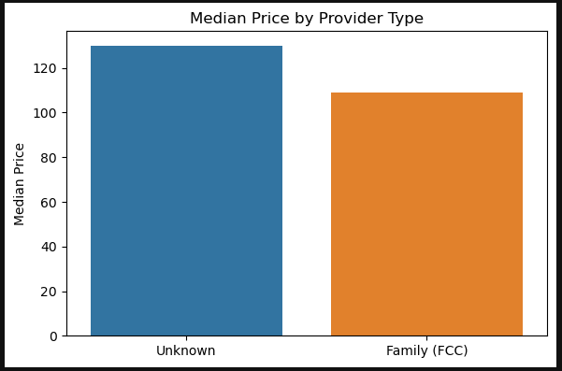

This chart compares the median childcare price by provider type. It shows that family childcare (FCC) has a lower median cost, around 110 dollars, while the group marked as unknown has a higher median price, about 130 dollars. This suggests that family-based providers are usually a bit cheaper than other types of care. However, since one group is labeled “unknown”, it may include centers or mixed providers that were not clearly identified, which could explain the higher price.
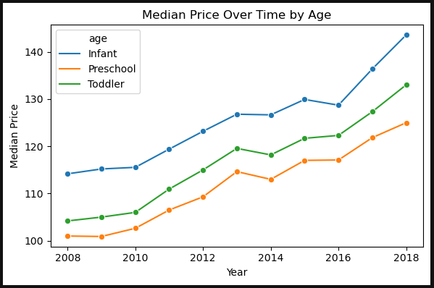

This chart shows how childcare prices have changed over time for infants, toddlers, and preschoolers. From 2008 dollars to 2018 dollars, prices have gone up for all age groups. Infant care is always the most expensive, starting around 115 dollars in 2008 and rising to more than 140 dollars by 2018. Toddler care is in the middle, while preschool is the cheapest, but both also increased steadily. The gap between infants and older children stays clear across all years. This means that childcare costs keep rising no matter the age, and families with infants usually face the highest costs.

Findings
The data shows that most childcare prices in the United States range between $100 and $150 per week. Some providers charge much higher prices, reaching up to $300 or even $500 per week, depending on their location and the type of care they offer.
Infant care is always the most expensive among all age groups. Toddler and preschool care cost less, but they still follow the same pattern of increasing prices over time. Family childcare homes (FCC) are usually more affordable, with an average cost of around $110 per week. Other provider types, especially those listed as “Unknown,” tend to be more expensive and may include center-based programs.
Between 2008 and 2018, childcare prices increased for all age groups. Infant care remained the most expensive each year, followed by toddler and preschool care. This trend shows that childcare is becoming less affordable for many families, and infant care continues to be the most difficult expense for parents to manage.

Infographic
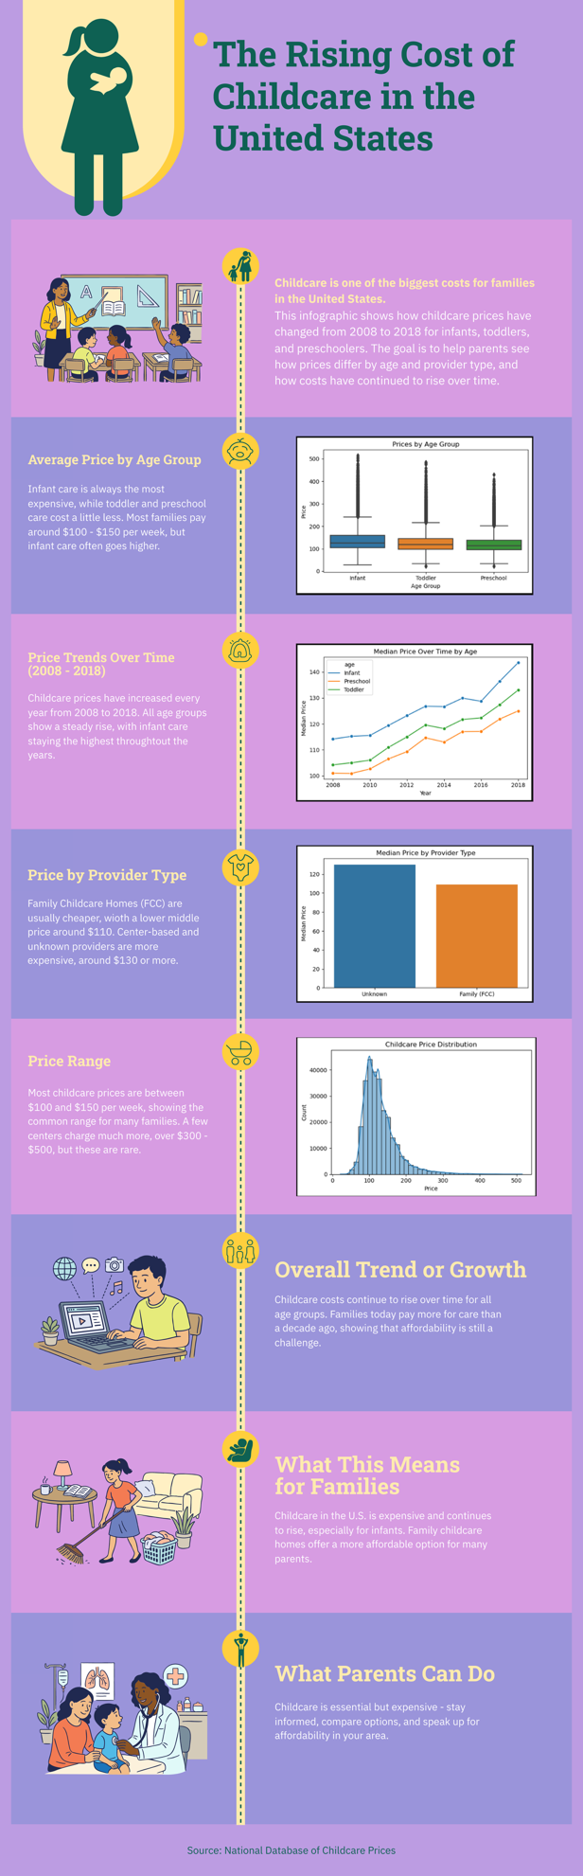
Design Narrative

The infographic “The Rising Cost of Childcare in the U.S.” was designed to present the findings from the childcare price analysis in a clear and simple way that parents can easily understand. I used Jupyter Notebook to create the charts and visuals because it allowed me to clean, analyze, and visualize the data using Python. The charts include bar charts, line charts, boxplots, and histograms to show different aspects of childcare prices such as price range, provider type, and changes over time. Each chart was exported and then used as a reference to design the final infographic in Piktochart.
Soft purple, green, yellow and pink colors were chosen to create a calm, friendly, and professional look that fits the topic of family and childcare. The vertical layout was used to guide the reader from the title and introduction at the top, through each visual finding in the middle, to the key takeaway and call to action at the bottom. Icons such as a baby, stroller, and family were included next to each section to make the information more visual and engaging. I used short sentences and simple wording, so the message is easy to read for parents and community groups. Spacing and sizing were carefully adjusted to make each section clear and balanced without overcrowding. Overall, the design communicates one strong message: childcare in the U.S. is expensive and continues to rise, especially for infants, while family childcare homes remain a more affordable option for many parents.

Ethical Considerations
Only basic data cleaning was done, and no information was removed or changed without explanation. The dataset was public and used for educational purposes, and it did not include any personal information, so it followed data privacy rules. The data was collected ethically and used only for learning. All charts were labeled correctly, scales were fair, and the information was presented honestly.

Lessons Learned
This project taught me that data visualization is more than just making charts; it is about clear communication. I learned how to use color, layout, and text to make data easy to understand for people who are not data experts. I also learned that ethical design means being clear, honest, and transparent about what the data shows and what it does not show.
If I do this project again, I will include state-level comparisons to show where childcare is most or least expensive. I would also adjust for inflation to show how much prices really changed over time.
The part I enjoyed the most was creating the infographic because it let me combine analysis and design. It was fun to turn numbers into a story that parents can easily understand and relate to.

Dataset : National Database of Childcare Prices

