Idempotence in HTTP methods:

PUT vs POST :

PUT : mainly used to update

POST: used to insert the data

Repeatable and non-repeatable methods:

GET , PUT and DELETE: are Repeatable methods. We can get the records, delete and update no of times we want. There is no impact on other data. Are idempotent methods.

Delete: if we delete a record and again we want to delete the same record then server will show record not exist, but nothing harm to other data.

POST: whenever we perform POST method new data will be added. So not repeatable method.

Idempotent method: property of certain operations that can be applied multiple times without changing the result beyond initial application.

B’z each idempotent methods can do duplicate request which won’t affects initial data.

**REST RESPONSES:**

When client made request, server send response for the corresponding request.

So sending request and receiving response should have **content type**  to know which format of data is sending and receiving.

Content-Type is present in Header.

**STATUS CODE:**

**200 OK -**

**201 CREATED – requested created**

**204 NO CONTENT – no data present**

**Redirection code:**

**302 – Found**

**304- not modified**

**307 – temporary redirect**

**4xx- Client Error codes:**

**400 – bad request**

**401- unauthorized**

**403 – forbidden (no access)**

**404 – not found**

**415 – unsupported media type**

**5xx server error code:**

**500 -internal server error**

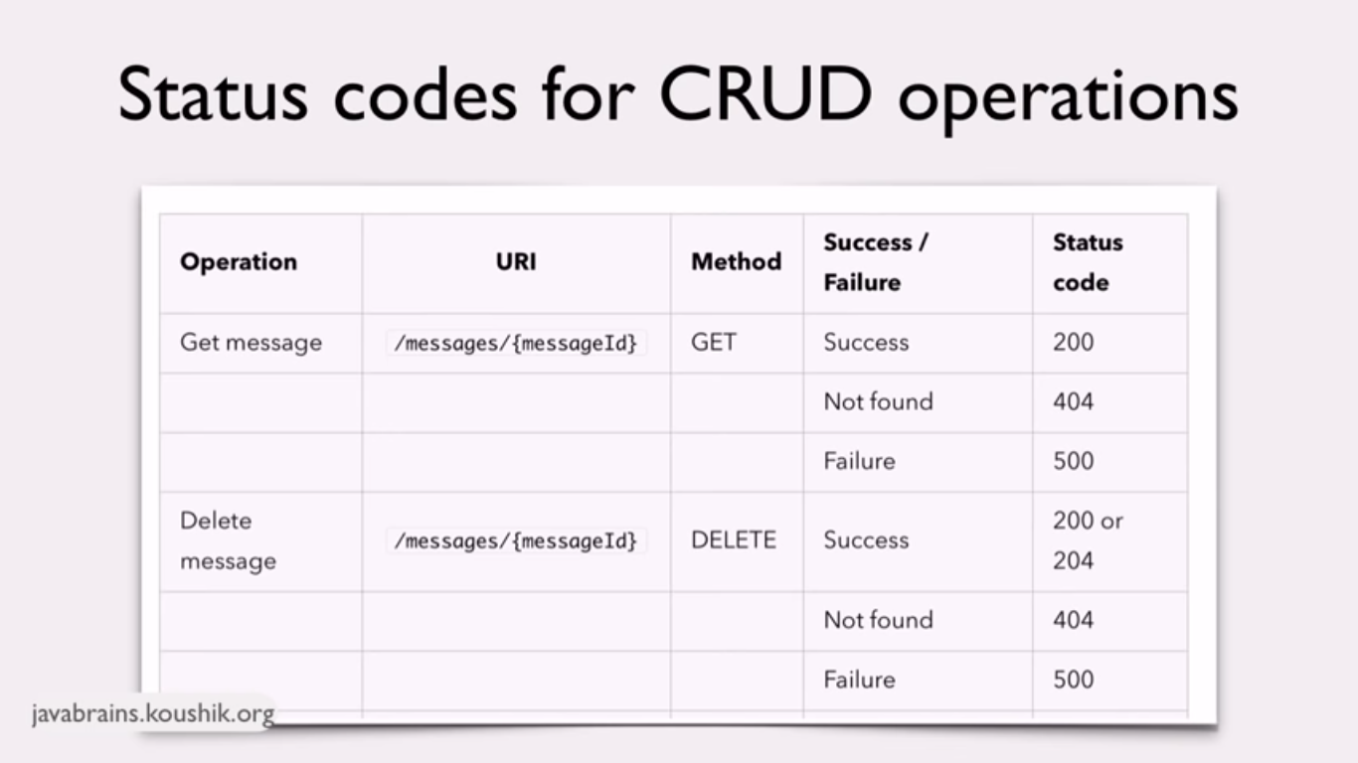

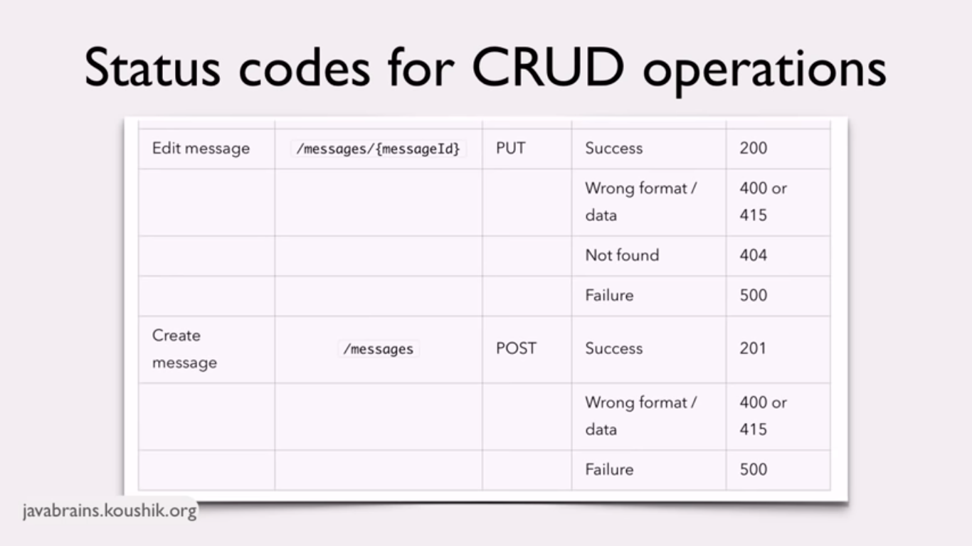

**HATEOAS -H**ypermedia **A**s **T**he Engine of Application State.

Is a way to provide Links to resources in the API response.

Hateoas is like when we request some data then server send that data with additional data such as links and other details. We can use that data if we needed.

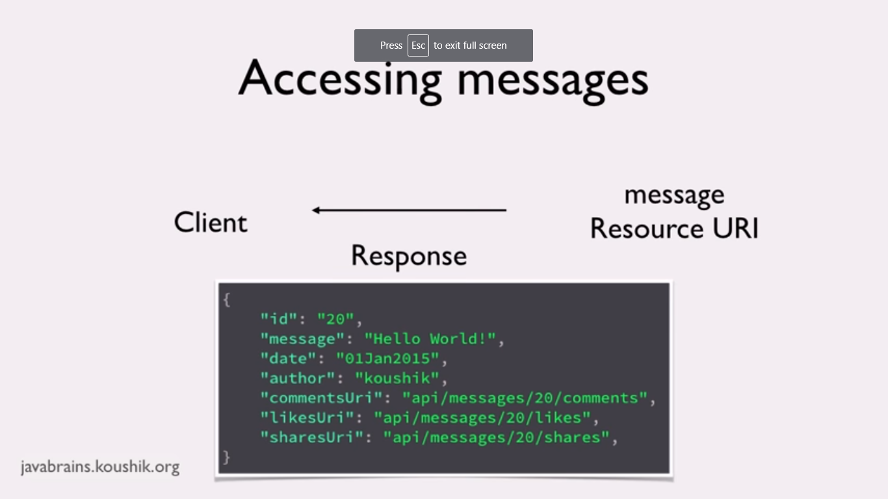

Rel Attribute indicates what is the relation with respect to the link.

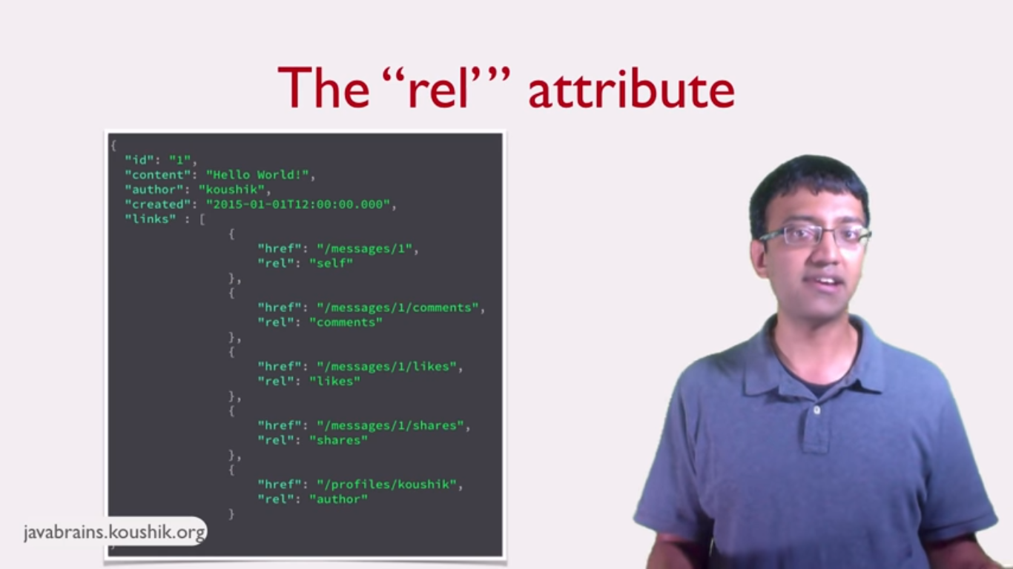

<https://www.iana.org/assignments/link-relations/link-relations.xml>

**RICHARDSON MATURITY MODEL:**

To know whether an api/service is completely restful or not we use Richardson model.

There are 4 level:

**Level -0 :** not RESTful API. Swamp of POX (plain old xml).

Eg: to create message format will be in xml.

<create-msg><msg-name>hi msg</msg-name><create-msg>

Here there is no http methods used.

**Level-1 : Resource URI’s –** using uri’s can get the bunch of data.

**Level -2 : HTTP methods –** api developed using https methods.

**Level -3 : hateoas –** api developed using hateoas.

JAX-RS:

Which is the API contains list of libraries such as jersey and other libraries to build rest application.

