

Dunkin Donuts Workplace Improvement Guide

**Table of Contents**

1. Introduction 3
2. The Guide 4
   1. Step-by-Step Training 5
      1. Dunkin Donuts Training 6
         1. Figure 1.1 7
         2. Figure 1.2 8
         3. Figure 1.3 9
      2. New Employee Training Form 10
      3. Current Employee Retraining Form 12
   2. Team Cooperation 14
      1. Seven Steps 14
      2. Benefits 16
      3. Dunkin Donuts Application 17
   3. Shift Organization 18
      1. Why is it good? 18
      2. How can the workplace benefit? 18
         1. Figure 2.1 19
      3. What practices can be improved? 20
         1. Figure 2.2 20
   4. Task Management 21
      1. Prioritizing 21
      2. Delegation 22
      3. Dunkin Donuts Task Lists 23
   5. Leadership Development 29
      1. What makes a good leader? 29
      2. How do we become strong leaders? 30
      3. Leading within Dunkin Donuts 30
         1. Figure 3.1 31
   6. Benefits of Modernization 33
      1. Why does Dunkin Donuts need to Modernize? 33
      2. What do the team members think? 34
         1. Figure 4.1 34
3. Conclusion 36
4. Works Cited 38

Introduction

There comes a time in every business where leadership may want to improve aspects of the company to enhance employee morale, productivity, or maintain standards. As business stand the test of time, they may come to see that current implementation of certain practices may no longer be beneficial to the company. Some companies may choose to ignore this observation and encourage no changes, but many will look for answers that will lead them towards maintaining their reputation.

Currently Dunkin Donuts in the Charger Union on the campus of The University of Alabama in Huntsville is looking to improve the quality of work by reviewing leadership, modifying existing practices, and encouraging the growth of employees. This is not to say that the business is lacking in the previous qualities, it simply implies they are looking to find better methods than those currently in use. The project will center its focus around the improvement of Dunkin Donuts. The project will focus on developing the skills of the workers, identifying strong leadership, analyzing ways to make the daily shift more productive, and why it is good to consider modifying the business practice.

The document contains data charts gathered from interviews with the team at the Dunkin Donuts in the Charger Union, and images of materials from there as well. Included throughout the document are developed forms and charts corresponding to each section that are meant for use in the workplace. By combining my knowledge of food service workplace practice, thorough research, and interviews, I will present ideas to help improve the way Dunkin Donuts operates.

I believe this project has the potential to help the business become more successful and be able to serve a higher volume of customers. The project intends to help employees grow their skills, so they may output better quality product in a quicker manner. It also focuses on encouraging leaders to guide employees in ways that can inspire the desire to be a stronger worker and will enforce an element of consistent performance. The project is guided to be an addition to the already existing training material; that meaning, the project will be a guide on how to utilize the resources the business is given efficiently. With these goals in mind, let us begin the journey to discover the ways in which the business can flourish.

The Guide



Step-by-Step Training

When a company starts to investigate methods for improvements, they usually start by training employees with new techniques and introduce new skills. Training is an essential element in any business. Training can be the difference in high performance and efficient work versus confused teams and lack of completed projects. For teams to work together to complete an assigned set of tasks, there must be some form of training for the team to understand concepts or instructions. The training must fit the following guidelines:

1. Stay focused on individual topics, it should not cover so much information that the employee feels overwhelmed.
2. It should follow an understood format that is used in each session.
3. Each session should present the material in the same manner and in the same order.
4. It should be engaging and informative, the employee should gain new knowledge or new skills from each session.

Effective employee training relies on the leader’s knowledge and understanding of the material. “Clear understanding of policies, job functions, goals and company philosophy lead to increased motivation, morale and productivity for employees, and higher profits for your business.”, this statement provided by Matt McKay helps to explain the importance of the above guidelines (Mckay). Training of employees should be geared towards creating common goals and practice within the workplace. Maintaining a common mindset in the workplace allows each person to understand the expectations, methods to work with, and other factors set forth by the leadership of the company.

There are many aspects that need to be considered before a training session is held. The company needs to establish a common set of goals, common practices within the workplace, and the goals to be reached. When the team understands what needs to be done and what the management expects out of everyone, then the team can provide results that meet the standards of the company. The first step to ensuring good training of future and current employees is to make sure that the trainer understands what the management is expecting them to cover with their sessions. Also, it is suggested that the training be done in short intervals with plenty of time to practice the skill once instruction has been given. If the company can agree on what needs to be taught, agree on how training will be conducted, have knowledgeable trainers, and schedule training properly they can expect to see well-trained employees (Mckay).

Dunkin Donuts Training

To help with organizing training for the company, below there are two forms that will allow the manager to ensure that training is completed and thorough. There is a New Employee Training Form and a Current Employee Retraining form below. Each form has a section for identifying the employee who is being retrained, who will be training the employee, and what sections of the workplace will be covered in the training. The forms will allow the employee to know what they will be learning and how long it will take them to complete training. The form for new employees is set up to allow five days of training with the sections broken apart by area in the workplace. This allows for instructions to be explained in detail, and the employee gets to have plenty of practice before moving on to a different area. The current employee form includes all the same information, but no time frame since this kind of training can be done quicker and in less time. There is a section on this form that allows for documentation of the time it took to complete the training. Documenting this information allows management to analyze employee performance and compare it to the amount of time spent learning a skill.

In the below figures, there are images of training materials that could be useful in teaching concepts and encouraging practice. In a Dunkin Donuts there are different kinds of provided training materials. There are booklets, flash cards, manuals, and more. Each piece of material provides details on certain beverages or food items. Encouraging employees to use these materials can have great benefits for the team. If everyone learns the correct way to prepare an item, it reduces the amount of confusion or variance in results that customers may experience. Customers want consistency in product and the best way to achieve this is by reaching for uniform knowledge. Encouraging the team to practice the same methods will keep customers coming back and satisfied by receiving the same item each visit. Training materials are easily accessible and have the potential to solve many discrepancies in how employees prepare products.

Overall, training is an important aspect to every workplace. The company should take time to create a complete plan for the execution of training and practice common communication with employees. Companies should not hesitate to think of requesting the retraining of employees since it can create uniform practice by encouraging employees to work in the same way. Therefore, consistency in practice and communication are key; it keeps the knowledge of the employees consistent. This keeps the company functioning in the same way, on the same level, and on the same schedule. Training can make a company stronger and create a better work environment for the employees. Thus, training is the driving force behind improving the way a company operates.

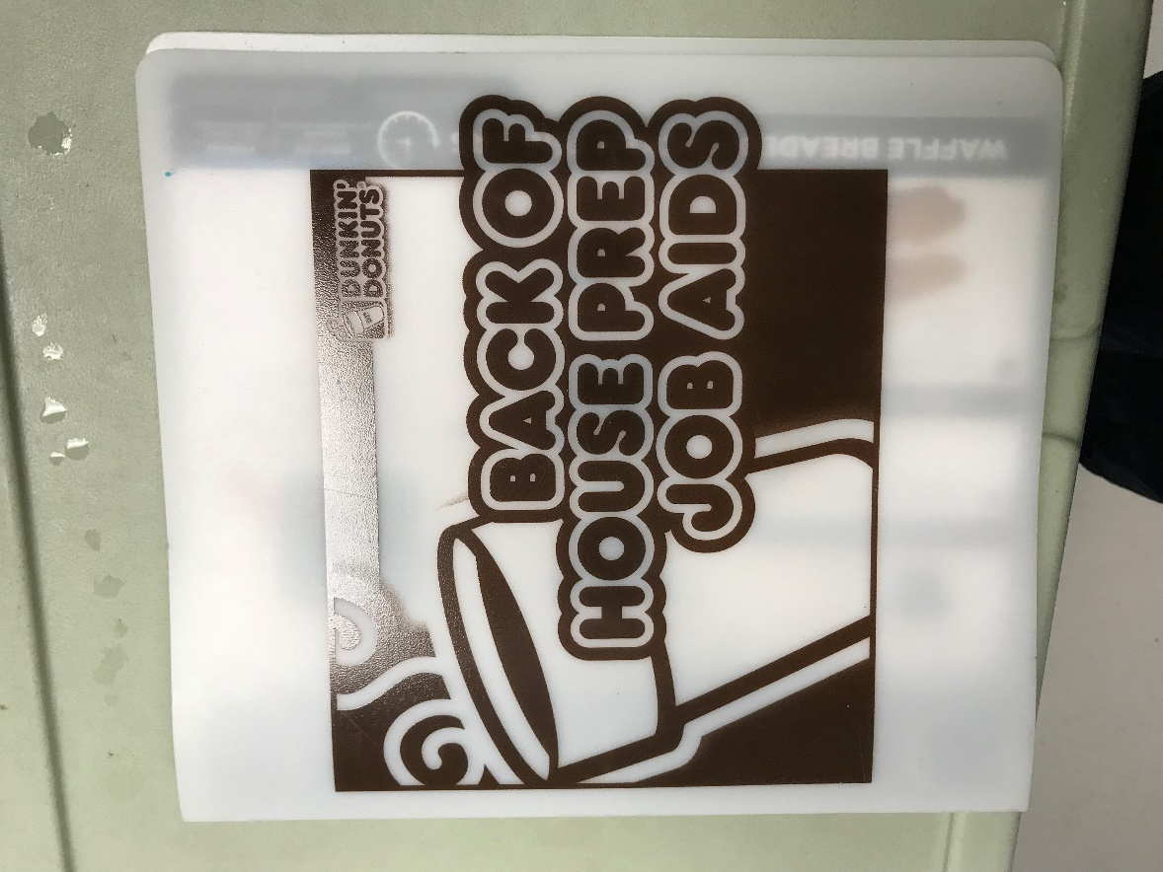

*Figure 1.1 BOH Prep Job Aids*

*This image is taken within the Dunkin Donuts in the Charger Union.*

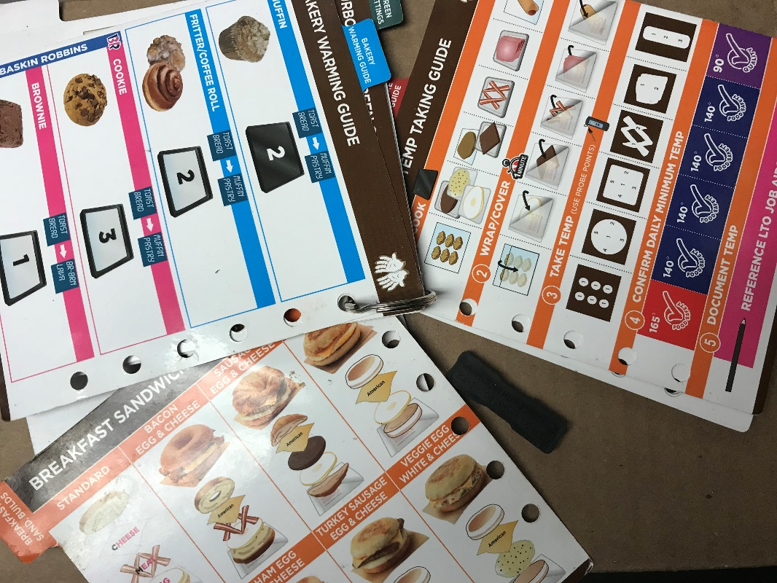

*Figure 1.2 Food Station Guides*

*This image is taken within the Dunkin Donuts in the Charger Union.*

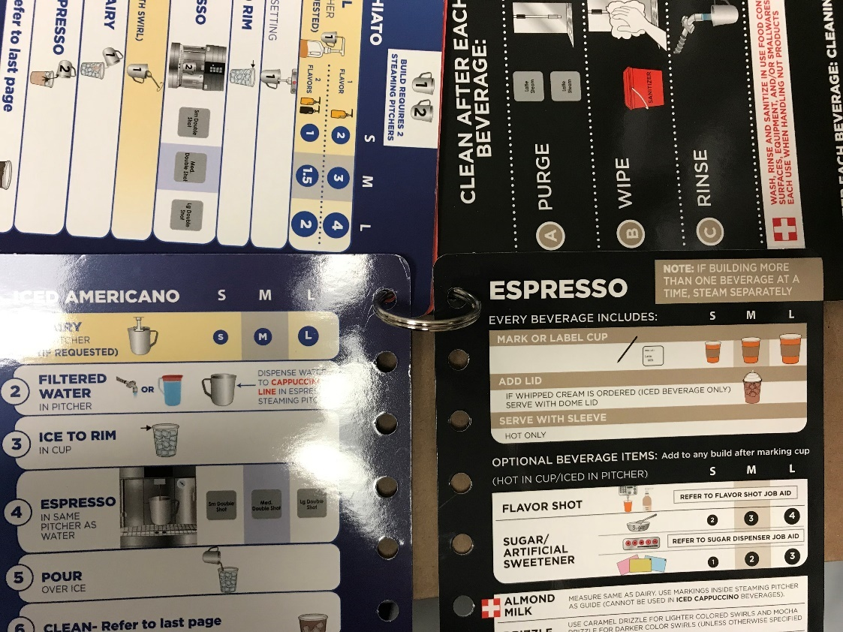

*Figure 1.3 Latte Machine Guides*

*This image is taken within the Dunkin Donuts in the Charger Union.*

New Employee Training Form

This schedule is to guide a new employee through learning each area of Dunkin Donuts. This form should be filled out and completed by each new employee. There will be five days of short shifts full of thorough training that will allow the employee to learn the new skills, practice, and feel comfortable in starting their new job. Please get a signature from your trainer when your training in the area is complete.

Name of Employee:

Dates for Training:

Trainer:

1. Day One (Enter shift time and date)
   1. Non-espresso Iced Beverages ____
      1. How to prepare the beverages when opening for the day
      2. Proper labeling of the beverages (on the cups and on food labels)
      3. How to break down the beverages when closing for the day
      4. Iced Tea
      5. Iced Coffee
      6. Cold Brew
2. Day Two (Enter shift time and date)
   1. Non- Espresso Hot Beverages ____
      1. How to prepare the beverages when opening for the day
      2. Proper labeling of the beverages (on the cups and on food labels)
      3. How to break down the beverages when closing for the day
      4. Hot Coffee
      5. Hot Chocolate/ Dunkaccino
      6. Vanilla Chai
      7. Hot Tea
3. Day Three (Enter shift time and date)
   1. Lattes, Cappuccinos, Macchiatos, Other Espresso Beverages ____
      1. How to prepare the beverages when opening for the day
      2. Proper labeling of the beverages (on the cups and on food labels)
      3. How to break down the beverages when closing for the day
      4. Espresso
      5. Latte
      6. Cappuccino
      7. Macchiato
      8. Americano
4. Day Four (Enter shift time and date)
   1. Coolatta Beverages ____
      1. How to prepare the beverages when opening for the day
      2. Proper labeling of the beverages (on the cups and on food labels)
      3. How to break down the beverages when closing for the day
      4. Frozen coffee and Frozen coffee with flavor
      5. Flavored Coolatta
      6. Frozen Vanilla Chai
5. Day Five (Enter shift time and date)
   1. Food Products ____
      1. How to prepare food area for opening shift
      2. How to properly label food in coolers
      3. How to properly cook food products
      4. How to properly build food items
      5. How to properly wrap and hand out food items
      6. How to clean the food area when closing the shift

Current Employee Retraining Form

This form should be filled out and completed for current employees going through retraining in order to grow as an employee. The trainer should sign each area that the current employee is being retrained in (not every section has to be completed for current employees). Please circle which section of training is being completed and have the trainer sign off for each section of training.

Name of Employee:

Date of Training:

Trainer:

1. Section One (Enter shift time and date)
   1. Non-espresso Iced Beverages ____
      1. How to prepare the beverages when opening for the day
      2. Proper labeling of the beverages (on the cups and on food labels)
      3. How to break down the beverages when closing for the day
      4. Iced Tea
      5. Iced Coffee
      6. Cold Brew
2. Section Two (Enter shift time and date)
   1. Non- Espresso Hot Beverages ____
      1. How to prepare the beverages when opening for the day
      2. Proper labeling of the beverages (on the cups and on food labels)
      3. How to break down the beverages when closing for the day
      4. Hot Coffee
      5. Hot Chocolate/ Dunkaccino
      6. Vanilla Chai
      7. Hot Tea
3. Section Three (Enter shift time and date)
   1. Lattes, Cappuccinos, Macchiatos, Other Espresso Beverages ____
      1. How to prepare the beverages when opening for the day
      2. Proper labeling of the beverages (on the cups and on food labels)
      3. How to break down the beverages when closing for the day
      4. Espresso
      5. Latte
      6. Cappuccino
      7. Macchiato
      8. Americano
4. Section Four (Enter shift time and date)
   1. Coolatta Beverages ____
      1. How to prepare the beverages when opening for the day
      2. Proper labeling of the beverages (on the cups and on food labels)
      3. How to break down the beverages when closing for the day
      4. Frozen coffee and Frozen coffee with flavor
      5. Flavored Coolatta
      6. Frozen Vanilla Chai
5. Section Five (Enter shift time and date)
   1. Food Products ____
      1. How to prepare food area for opening shift
      2. How to properly label food in coolers
      3. How to properly cook food products
      4. How to properly build food items
      5. How to properly wrap and hand out food items
      6. How to clean the food area when closing the shift

Team Cooperation

Team cooperation involves more than just keeping peace within the work environment, it has the power to change the way that work is done and how product is made. Good cooperation within a team can produce higher quality product, encourage more efficient work, and open communication between team members. When a team can get along and work well together the company can flourish and go beyond expectations. However, what can a company do when a team needs help with team building? This section will cover suggestions for guiding a team to become a stronger unit.

Seven Steps

According to Amanda Kelly with the LiquidPlanner Blog, there are seven steps to help improve team cooperation in the workplace. The LiquidPlanner Blog is a collection of articles written by business professionals for others in business to use. The site doubles as a blog and a resource for businesses to use to improve how their workplace functions with provided resources. The article written by Amanda Kelly goes into detail about the steps that can help with team building. The seven steps can be implemented in different business environments; so, let’s discuss the steps and how they can help a business.

* The first step is to “Aggregate and Adapt” which discusses how a good manager will bring together many pieces of information to formulate the best plan for a team, while also considering the teams’ needs. The section encourages meeting with team members and providing collected data on the topic so that the team can understand the plan. This method of open communication and keeping everyone in the same loop will help the management seem less far off from the team members. Encouraging interaction with the management and team will show the team members that their ideas are welcomed. When a team member feels valued they may take it upon themselves to work harder and grow in the company.
* The second step “Listen First”, builds off the first step. This section discusses how listening to employees before taking concrete action can create a plan best suited to the individual team. When working on building a team the management should listen to the requests of the employees. When ideas are brought together by the first step there can be some confusion and some ideas can be forgotten or lost in all the planning. The second step comes into play by encouraging more open communication. Communication has proven to be the122.. key factor in improving a business; if the management can listen to the employees and incorporate their ideas the employees may feel proud that they were able to help the company.
* “Energize” is the third step in building a stronger team. This section discusses how energizing the team to create positive feelings about change or a new project will inspire the team to work their best. This step can also be considered a result of the two previous steps. Incorporating team ideas and listening to the desires of the employees will help to boost morale in the workplace. This increase in morale will energize a team to provide the best results for the company so that their ideas may be considered more often, and they may take this time to grow in their career. When a team feels appreciated they can help the company grow. “A motivated, energized team is a project’s strongest asset.” (Kelly).
* The fourth and fifth steps are closely related, “Be Open” and “Be Transparent”. When the leaders of a company keep open minds and keep information out in the open, the team feels involved in the company instead of just feeling like a worker. These two concepts help employees feel that their presence in the company is valued and taken seriously. These steps are key to keeping the environment open and full of communication.
* “Have fun!” may seem like an unprofessional title for a section under team cooperation, but it is nonetheless an important factor in building a team. A workplace that contains no humor or lively happenings causes feelings of dreary routine or boredom. When a team can have some fun during their work it encourages joy in an environment sometimes thought to only focus on working with no play. Having fun at work can come in the form of small bits of humor in presentations, turning an assignment into a game, group lunches, or group outings sponsored by the company. Each business will use different methods, but the use of fun in the workplace will greatly increase morale since people enjoy smiling rather than feeling dull.
* “Transcend Insularity” sounds extremely complicated and full of deep meaning; however, it simply means to encourage group work. The act of encouraging group work will help to grow the social aspect of a company. When a workplace has good social interaction, all the above steps will be able to fall into place easier. While individual work can be beneficial to personal development, group work can spread ideas and offer more room to grow. A good balance of individual and group work can create the optimal work environment.

The overall analysis of the seven steps shows that an open environment, good communication, and an energized team will produce a high functioning business team. When these seven steps are utilized together the management can expect to see desired results and possibly more change that will help the company grow. A team that works well together outputs the best results, and this will encourage the business to continue to modify the way they operate (Kelly).

Benefits

When thinking about how to express the best ways to work towards team cooperation, there came the thought about if this subject is just a matter of opinion. While most of the previously discussed material involves the management coming up with their own forms of implementation, these methods are universally recognized as beneficial to companies. UC Berkley prepared a document that covers team building, business management, and more. The *Guide to Managing Human Resources* put together by distinguished faculty of UC Berkley and multiple institutions discusses how to best handle Human Resources in business.

The guide includes a specific section on team building with a subsection on ways to build a good team. They suggest remembering employee suggestions are valued, establishing goals, providing group work, coordinating open communication, combining information for the team to understand it all, and involving the team in each step of the way. All of these were also listed above when discussing the seven steps. This guide lists more specific details in each topic and also includes information on conflict resolution plus examples of results that team building can produce.

The following list is quoted directly from the guide:

Team building can lead to:

* Good communications with participants as team members and individuals
* Increased department productivity and creativity
* Team members motivated to achieve goals
* A climate of cooperation and collaborative problem-solving
* Higher levels of job satisfaction and commitment
* Higher levels of trust and support
* Diverse co-workers working well together
* Clear work objectives
* Better operating policies and procedures

Looking at this list of benefits of team building, it seems that—as discussed previously—teams have the potential to increase the productivity of a workplace. A team that works together as a unit has the potential to combine creative ideas, discover new material, produce more work collectively, and improve the morale of the business environment. So, if a company is looking to improve the environmental conditions or work done by their employees they should strongly consider what they can do to improve team work within their teams (Berkley).

Dunkin Donuts Application

Specifically, when talking about Dunkin Donuts, there are many steps that can be taken to improve the team work in the work area. One of the first steps is to create a common set of goals and desires for the teams, this will ensure all the leaders will encourage the team to go in the same direction. Once the goals are established, the company could encourage daily meetings between the leaders and team members where the days goals are discussed. This can also be a time where any issues can be addressed, and discussions of any previous problems can take place. Open communication will make team members more comfortable with addressing any issues they have in the workplace.

Once the team begins to feel more comfortable with the leaders and issues are being properly addressed, then the real team building can begin. There can be small sales competitions between day and night shifts, there can be small monthly rewards for improving as an employee or the most helpful employee. Along with encouraging improvement in working, management and leaders could boost morale by acknowledging a good job done when an employee completes a task assigned to them. Acknowledging someone’s hard work can make them feel as if they are succeeding and will make the environment more positive. In the long run, small changes over time can make a big difference in how the teams function together. When the teams are functioning as a unit the productivity of the business will increase, and the company will begin to grow; it all starts with helping the teams grow stronger.

Shift Organization

Why is it Good?

The term “organization” appears in businesses consistently, and for good reason. A good business knows that one of the most important influences on how they operate is how well they organize. Without organization businesses would not get much done and will often end up with unsatisfied customers.

Businesses are constantly searching for new ways to organize their work areas. Whether it is redesigning the cubicle or promoting a new way to assign employees to certain tasks, there are always ways to improve the functionality of a work environment. In a typical day at work, an employee may find themselves going through the same routine practices with different information or new topics. The reason for repetitive work is organization. If a company finds a solution to a problem that seems to output the most results, they will implement this as a new method for work in the entire company. One example is how some businesses are switching to more open concept work areas instead of cubicles for the individual. This change in organization comes from a development that perhaps encouraging socializing in the workplace increases productivity. Every business has its methods and each business is different. Keeping resources, people, documents, ideas, or goals organized helps the business grow by increasing product output or reputation. There are many ways and many benefits, it all depends on each companies needs plus the availability of resources to make it happen.

How Can the Workplace Benefit?

Organizing a shift has many benefits, some you can see immediately, and some stretch out into the future. Organizing a shift is the teams’ way of creating a plan that will output the best work for the day. The team may see themselves work faster, produce accurate results, develop new skills, and the day may go by quicker. The team members may not feel as anxious during rushes if everyone has a specific job to do, instead of everyone running around trying to figure out what needs to be done. This practice eliminates some errors in work; such as, miscommunication, the repeat making of orders, or a skipped step. When team members are not confused, they are more likely to make sure orders are correct and that each one gets made. There are many ways to organize shifts; you can include a calendar for who will perform a certain task on what day, a time table to schedule breaks, or a list of achievable goals for the day. Keeping the team focused on working hard and working together is the driving reason to organize a shift plan.

Organization goes beyond the people, it can include resources and how they are managed. The quickest way for a shift to become chaotic is for resources to run out and then not easily found. Dunkin Donuts provides small diagrams on how to organize shelves, racks, and drawers (refer to figure 2.1). Keeping resources organized and within quick reach, allows team members to feel prepared when the day gets busy. Stocking and prepping for the day are essential in making sure the workplace stays organized. If the team can work together to maintain stock and replenish materials when it is needed, the shift becomes easier for the team.

Combining team organization and resource organization presents a well-rounded shift. When the people can work at their best with the right amount of resources, that is when the workplace can truly function at its highest level. Maintaining organization can be difficult, especially during rushes, but it is key for keeping up with the demand and satisfying customers. Overall, reaching for optimal organization will help the business grow and help team members feel pride in how well their shift went (Williams).

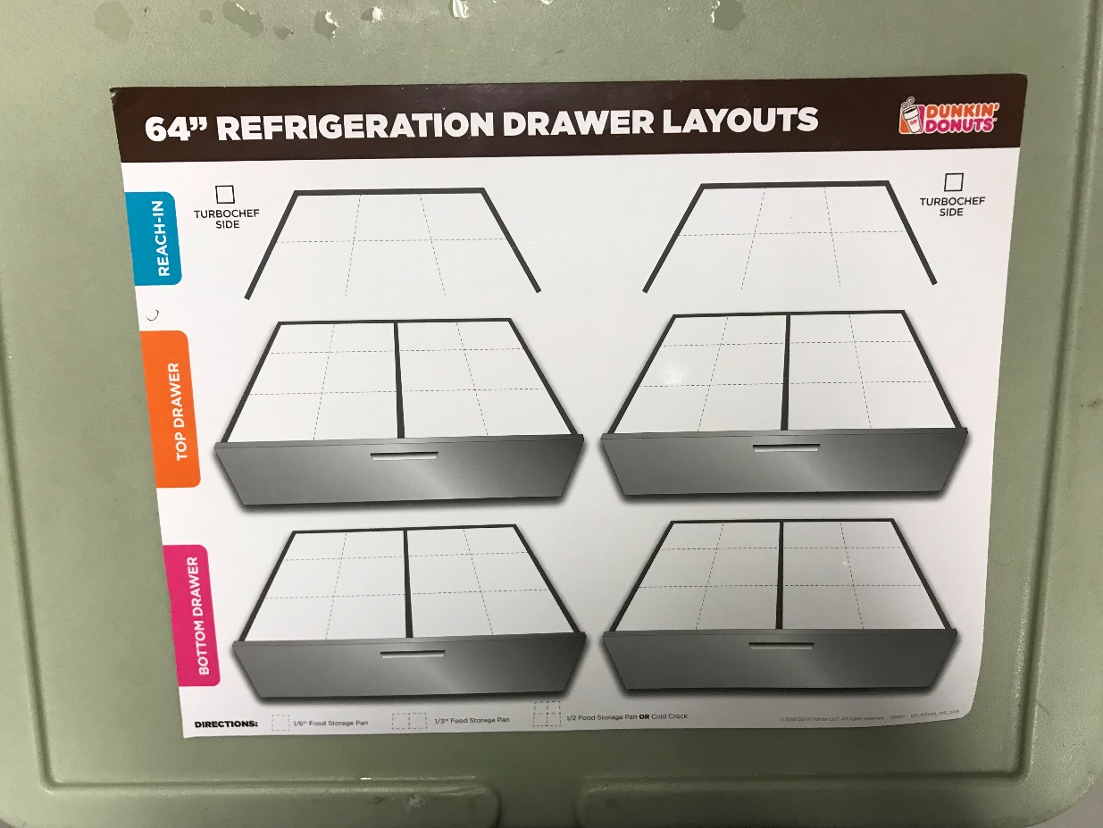

*Figure 2.1 Drawer Layouts*

*This image is taken within the Dunkin Donuts in the Charger Union.*

What Practices Can Be Improved?

Dunkin Donuts provides each workplace with a broad set of training and organization materials, from booklets to heavy manuals. When there is a new launch or promotion, even more material is sent out to each location. If there is so much material, why are there problems and how can they be fixed? The first question is an easy one to answer, time and ability to practice. Over time, some steps may seem unnecessary or may not be able to be put into practice at a specific location. Each area is different and needs to utilize its material in the best way they can. In the Charger Union Dunkin Donuts, there is a lack of space and sometimes a lack of employees on shift to fit the designed shift layout (refer to figure 2.2). However, utilizing this set-up is optimal during busy times and ensures that everyone knows what they are supposed to be doing.

So, Charger Union Dunkin Donuts can modify the layout to benefit them individually. For example, let’s say there are six employees on shift at a given time and the lead wants to assign a spot for each employee. There can be one cashier (spot 1 or 5), two people on beverages (spot 2 and 6), two people on the sandwich station (spot 3 and 7), and the last person can be the expeditor. The positions can change based on the number of employees behind the counter and what is needed specifically during that time. If the sandwich station is behind, someone from the beverage station may jump in to help them and vice versa. The key to keeping a shift organized is making sure that everyone has a primary position while understanding that the customers come first, making sure orders come out promptly and accurately.

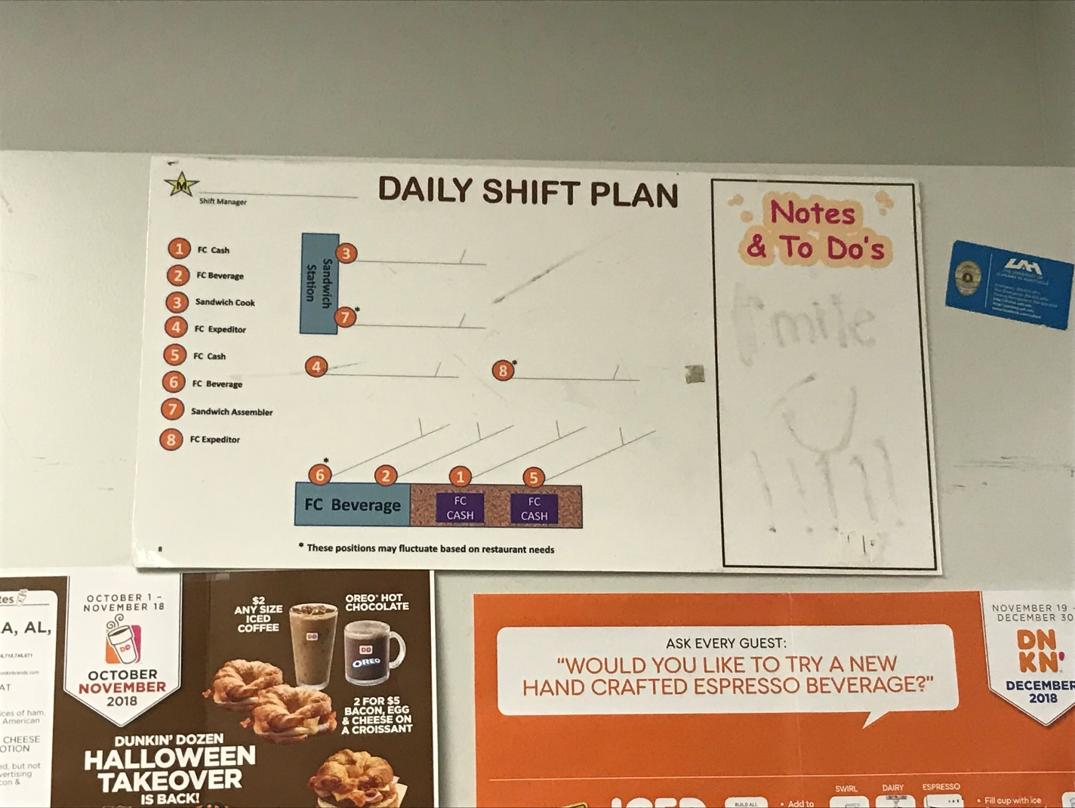

*Figure 2.2 Daily Shift Plan*

*This image is taken within the Dunkin Donuts in the Charger Union.*

Task Management

Another topic that is key to creating a more efficient workplace is ensuring that each employee knows how to handle multiple tasks at once. In every workplace in the business world, employees are expected to handle multiple tasks during a work day. It has become a skill expected by most employers since there is an increase expectation of output due to the growth of technology being used today. Employees are expected to produce more results and higher quality results. However, sometimes technology grows while employees are left trying to catch up. Learning how to manage tasks properly will assist employees in adjusting to new environments and outputting more product.

There are two topics to be covered in this section; prioritizing and delegation. In discussing these topics, the goal is to help employees grow their skills in task management. When employees invest in personal growth they help the company grow in the long run. At the end of this section there will be a series of tasks lists developed specifically for Dunkin Donuts. So, let’s begin by discussing the ways in which employees can develop their skills.

Prioritizing

What does it mean to prioritize? When an employee prioritizes a task above another they are helping themselves accomplish what is urgent, what is necessary, and what can be done the quickest. This is how an employee should organize their day, they start by doing what needs to be done by the earliest deadline. This ensures that urgent tasks are completed and out of the way so that deadlines are met. Next, an employee should focus on what is necessary and must be completed. In this area, an employee should complete easy tasks first and dedicate more time to the harder tasks. This will help the employee feel more accomplished since they will complete more tasks by eliminating easier ones then accomplishing the more difficult ones.

One of the best ways to help with task management is to develop lists for employees to follow. These can be checklists, emails, spreadsheets, etc. and they can be presented in different ways. A list should be formatted specifically for your environment. A good task list includes the task, when it needs to be done, who should do it, space to mark completion, and a place for approval that the task was indeed completed – signed by a leader. By utilizing lists in the workplace, it helps to remind employees or what needs to be done or what has already been completed. “Checklists can help us stay more organized by assuring we don't skip any steps in a process.” (Singer). Andy Singer discusses how lists will keep tasks organized and help the workplace function smoother. Overall, task lists are a good tool to use when trying to improve the workplace since they help to maintain organization.

Delegation

Delegation is a key element in achieving balanced task management. When a leader delegates certain tasks to employees it helps to get more tasks completed in a shorter amount of time. It also makes employees feel that their presence in the company matters more if they are trusted to complete certain tasks by their superiors. Delegating also encourages employees to keep working throughout the work day, often employees may find themselves without work to do if they have completed their tasks. Employees can be given tasks to complete if their leaders delegate properly. “When we are more comfortable that tasks will be done correctly, we delegate more...” (Singer). Overall, task management relies heavily on the practice of delegation along with prioritizing.

For delegation to work a leader must know the strengths of their employees. When the leader can give the appropriate task to the employee who can complete the task, they are guaranteed to get the best result. An employee should not be expected to complete a task without any prior knowledge of how to do it properly. This is where making sure that the task assigned is given to an employee who can complete it. Leaders should also trust their employees when they assign tasks. However, while employees should be trusted it is a good idea to verify that the employee does know how to complete their task. Sometimes people are confused or embarrassed to admit they do not know how to do something. When a leader verifies with a team member, this opens an opportunity for the employee to ask for help. Trusting employees with tasks and making sure they can complete the task reduces time spent monitoring or assisting employees (DeMers).

When managing tasks, it is important to recognize the work done by an employee. Feedback is essential to building the morale of the team. Team members work best when they feel their work is appreciated and that the leadership is proud of them. Task management is essential to creating a high-functioning workplace. Combining prioritizing, delegation, and feedback can ensure that task management becomes a natural process in the workplace. Encouraging team members to handle tasks properly and efficiently will help the company continue to grow. It starts by encouraging the leadership to implement prioritization and delegation. Once the leadership takes steps forward, the team members are sure to follow.

Opening Shift Task List

|  |  |  |  |  |  |  |  |
| --- | --- | --- | --- | --- | --- | --- | --- |
| Date: | M | T | W | Th | F | Sat | Sun |
| Turn on equipment |  |  |  |  |  |  |  |
| Set-up dishes and supplies for the day |  |  |  |  |  |  |  |
| Fill both ice bins |  |  |  |  |  |  |  |
| Bring up black containers from freezer (hash browns and chicken tenders) |  |  |  |  |  |  |  |
| Brew iced coffee, iced tea, and hot coffee |  |  |  |  |  |  |  |
| Stock cups, lids, coffee beans, hot chocolate powders, and hot tea bags |  |  |  |  |  |  |  |
| Stock all flavor and syrup bottles |  |  |  |  |  |  |  |
| Stock guest area with straws, condiments, napkins, etc.. |  |  |  |  |  |  |  |
| Label iced coffees and iced teas |  |  |  |  |  |  |  |
| Prep and label food products |  |  |  |  |  |  |  |
| Label and set-up doughnut racks |  |  |  |  |  |  |  |
| Wash used dishes |  |  |  |  |  |  |  |

Closing Shift Task List

|  |  |  |  |  |  |  |  |
| --- | --- | --- | --- | --- | --- | --- | --- |
| Date: | M | T | W | Th | F | Sat | Sun |
| Break down doughnut racks, throw away leftover doughnuts, and clean the racks |  |  |  |  |  |  |  |
| Throw away leftover croissants, bagels, or biscuits (English muffins, toast, and tortillas can be kept in coolers) |  |  |  |  |  |  |  |
| Break down dishes |  |  |  |  |  |  |  |
| Wash dishes |  |  |  |  |  |  |  |
| Wipe down counters and machines |  |  |  |  |  |  |  |
| Stock all areas |  |  |  |  |  |  |  |
| Stock drink cooler |  |  |  |  |  |  |  |
| Stock food coolers |  |  |  |  |  |  |  |
| Place napkin holder, condiment holders, and other guest access items in the back room |  |  |  |  |  |  |  |
| Sweep floors |  |  |  |  |  |  |  |
| Mop floors |  |  |  |  |  |  |  |
| Lock the back room |  |  |  |  |  |  |  |
| Lock up the drink cooler |  |  |  |  |  |  |  |
| Take black bins of hash browns and chicken tenders, bread/doughnut metal rack, and ice bins all to the back |  |  |  |  |  |  |  |
| Clean out cabinets |  |  |  |  |  |  |  |

Mid-Shift Task List

|  |  |  |  |  |  |  |  |
| --- | --- | --- | --- | --- | --- | --- | --- |
| Date: | M | T | W | Th | F | Sat | Sun |
| Complete Red Book Logs |  |  |  |  |  |  |  |
| Keep areas clean |  |  |  |  |  |  |  |
| Keep dishes washed |  |  |  |  |  |  |  |
| Keep areas stocked |  |  |  |  |  |  |  |
| Complete any assigned daily tasks |  |  |  |  |  |  |  |
| Work on weekly and monthly lists |  |  |  |  |  |  |  |
| Prep food items for the next day |  |  |  |  |  |  |  |
| Stock speed rack |  |  |  |  |  |  |  |
| Organize stock rooms |  |  |  |  |  |  |  |

Weekly Task List

|  |  |
| --- | --- |
|  | Week of: |
| Sweep under all cabinets and shelves |  |
| Pull out ovens and sweep/mop/wipe down behind them |  |
| Wipe surface of ovens |  |
| Clean food coolers thoroughly and make sure labels on containers are changed when new product is placed in them |  |
| Break apart and deep clean hot chocolate machine |  |
| Wipe behind and under all machines |  |
| Wipe out milk cooler under coolatta machine |  |
| Calibrate coolatta machine |  |
| Organize shelves under latte machine |  |
| Make sure milk/cream dispenser is cleaned EVERY 3 DAYS and is labeled when cleaned |  |

Monthly Task List

|  |  |
| --- | --- |
|  | Week of: |
| Wipe down ice bins, inside and out |  |
| Wipe down speed rack |  |
| Wipe out back cooler in back room |  |
| Wipe down all sinks |  |
| Organize shelves under the register |  |
| Wipe down walls, baseboards, shelves, and cabinets |  |

Leadership Development

The driving force behind every company is the leadership that guides the employees. The leadership in a company has the potential to make or break the business. Good leadership results in a good work force which outputs quality work from the employees. Choosing good leadership is extremely important. What makes a good leader? How does management decide who to hire? This section will discuss these two questions in depth to help lead the business towards choosing the best leaders.

What Makes a Good Leader?

First, the best place to start is investigating good qualities of leaders. The book *The Servant Leader: How to Build a Creative Team, Develop Great Morale, and Improve Bottom-Line Performance* is written by a Starbucks employee who was inspired to be a passionate leader in his company. The book discusses the characteristics of a leader, finding the right people to be leaders, and other aspects a company needs to consider when looking for someone to put in a leadership position.

The author James Autry states, “…my strong belief that leadership, or management if you prefer, approached properly, is a calling. Not just a job but a calling. Think about it. As a manager, much of the psychological, emotional, and financial well-being of other people is dependent on you and how well you create the circumstances and the environment in which they can do their jobs.” (Autry). This quote captures the very essence of what it takes to be a strong leader. Leaders are meant to be an example to the team and a guiding hand when things get tough. If a leader is negative or acts as if they would rather have any other job, the team members respond to that negativity and in turn become negative about their jobs themselves. Choosing leaders who are passionate and dedicated to their work shows companies who the good candidates are in the business.

In the end, one of the best qualities a leader can have is the ability to guide the team towards success. A leader should take their job seriously and use their position to better the business. A leader may also take the time to work on themselves, a leader is never done growing and developing. If a leader can successfully lead while also developing their own skills, they possess the qualities needed for strong leadership (Autry).

How Do We Become Strong Leaders?

“Building teams of leaders and leaders of teams…” (Conger and Benjamin), one of the strongest statements about developing leaders. To begin helping employees develop into leaders a business should start by identifying those with a built-up reputation with the team. When a person is credible and reliable they can be trusted to put forth the same character in their new position. When building a “team of leaders” a company must consider who they can entrust with ensuring that the goals of the company are met. They must also consider a mix of personalities, but not a mix of workplace manner. Mixing personalities within a team, especially leaders, encourages new ideas and different perspectives which is healthy for a workplace. However, when you get people together who work differently, and all believe that their ways are right, you risk having miscommunication between leaders which leads to miscommunication with team members. If a team can communicate and develop ideas together, then the team of leaders can advance the functionality of their team members.

“Widespread involvement is a necessity. All managers and employees must take ownership of a new vision and apply it to their daily decision.” (Conger and Benjamin). This quote explains a major element in leadership development. Not only should a leader be able to take charge and work well with other leaders, they must be able to include team members in new ideas or practices. A leader without the support of their team is like a king without his subjects. To truly lead, the leader needs to make sure they can guide the team to the best of their ability. If a team will not follow their leader, tension builds and the rift between leader and team becomes wider. If a team and its leader are too far apart, there cannot be sufficient communication or cooperation. Becoming a strong leader requires establishing good relations with all team members and being a guide instead of a boss (Conger and Benjamin).

Leading Within Dunkin Donuts

To better understand the needs of the Dunkin Donuts in the Charger Union, an interview was conducted with the team members and with the Retail Manager Mrs. Kim Mitchell. Conducting these interviews allows for a deeper insight into what the Dunkin Donuts team looks for in a leader. Interviewing the Team Members and Manager separately allows for different perspectives and shows how combining the two will allow management to find the best person for a leadership position.

Let’s start by discussing what the Retail Manager, Mrs. Kim Mitchell, looks for when she searches for leaders in her team. When asked what qualities she considers to be essential in a leader, she gave the following four examples:

A leader must…

* Be able to prioritize tasks properly.
* Ensure that all tasks are complete daily.
* Be an example for the team members.
* Handle resources properly.

Mrs. Mitchell emphasized how important it is that a leader sets a good example. She explained that when a leader works hard and encourages their team, the team will follow by example. She encourages leaders to build up their team and create positive environments (Mitchell).

The Team Member portion of this interview carries some of the same elements as the interview with Mrs. Mitchell. Below is a pie chart expressing the importance of each element. The elements were combined; such as if one team member said, “can communicate” and one said, “people skills”, they were combined into Communication Skills.

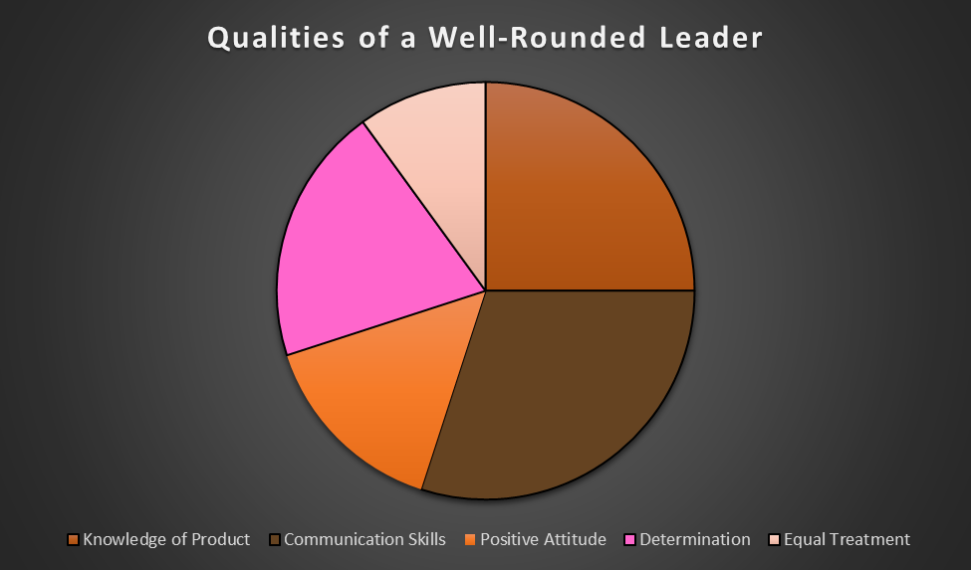

*Figure 3.1 Team Member Interview (part 1)*

According to this portion of the interview, team members choose good communication skills and knowledge of product to be their top choices of qualities in a leader. The team members want someone who can communicate with them and be a source of communication between them and management. They want someone who leads by making sure everyone understands and someone who explains concepts before expecting them to know it. They also expect their leaders to know the product of Dunkin Donuts and know all the procedures. The leader should be able to answer questions from customers, tell employees how to perform a certain task, and be able to identify any mistakes if they are made plus correct them (Team).

By looking at the interviews with the Team Members and Mrs. Mitchell, there are points of similarity and differences in their opinion on the qualities of a leader. The main similarity is that Mrs. Mitchell looks for someone who is a good example to the team and the team members want someone who embodies what they strive to be. When looking at the team member chart, each quality is something a team member wants to see in themselves. If the leader embodies these qualities and leads as an example, a team member may be inspired to grow in that quality or as a leader.

Benefits of Modernization

This whole project is based on the idea of modernizing the practices of Dunkin Donuts. Why is this necessary? How can modernizing the practices of a company improve the productivity? Will modernization truly benefit the country?

To answer these questions, we need to start by discussing why it is even necessary to have a set of common practices and why utilizing the handbooks are necessary. In a company there needs to be a set of boundaries and guidelines to make sure the goals are reached by employees. These principles need to be modified as goals change, policies change, or the company grows. Maintaining the business relies on keeping procedures up to date and enforcing the procedures in the workplace (Sanchez).

Besides legal basis, there are many other reasons to keep modifying workplace handbooks. As mentioned previously, competition has greatly increased. Not only are community businesses growing and expanding, but people now have access to world-wide markets as well. People can purchase products or services from around the world with just as much ease, if not more, as walking down the street to a local business. Technology plays a huge role in this new way of shopping, it also helps consumers by offering them access to reviews and suggesting the best businesses for the consumer. So, in order to keep up with these changes, a company must be willing to be flexible and encourage constant progression.

Reviewing and updating policies or procedures helps to keep the company moving forward with society. If technology or the law changes, the company needs to change with it and make sure their practices are legal and modern. This helps the company survive in an ever-growing and competitive world. If a company does not keep up with other companies, they risk losing business to other places. So, to keep the business performing well and bringing in a good amount of sales, the company needs to make sure it keeps up with the progression of the business model (Kovnov).

Why does Dunkin Donuts Need to Modernize?

Dunkin Donuts currently operates a busy location in the Charger Union on the campus of the University of Alabama in Huntsville. They bring in a large number of sales daily and cater to large groups of customers. While their practices are efficient and work fine currently, there is always room for improvement. They could benefit from revamping some aspects of the business; such as ensuring everyone receives the same training, organizing their shifts daily, encouraging team building, and promoting strong leaders. This is not to say Dunkin Donuts lacks any of the following, but there are areas that could use improvement.

Dunkin Donuts has the potential to create a workplace that increases productivity and creates a better work environment for its employees. In every business there is always room for improvement, no company is ever done growing. The company can increase its sales, have more enthusiastic employees, and output higher quality product from the business. Modernization has the potential to really help the business to continue to grow and compete with other eateries on campus.

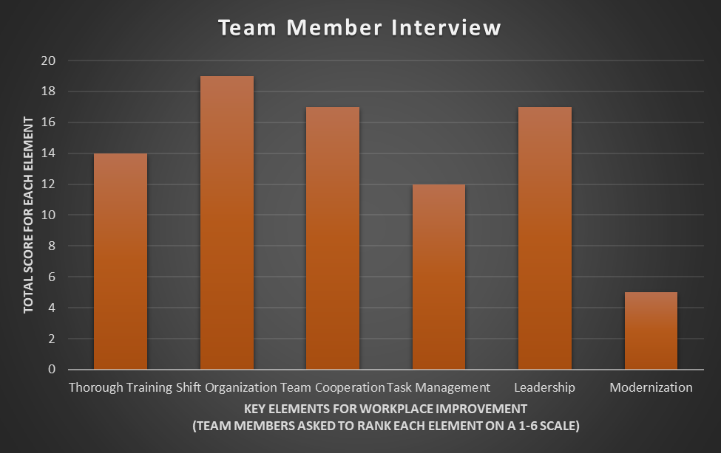What Do the Team Members Think?

*Figure 4.1 Team Member Interview (part 2)*

An interview was conducted with the team members of the Dunkin Donuts. The team was asked to rank the topics of this project on a scale from 1 to 6 based on each topics’ importance to them. The table was created by adding the point totals together; such as if someone gave organization a 2 and another person gave it a 4, then the total would be 6 (Team).

Based on this interview team members valued shift organization, leadership, team cooperation, and training as the top four elements that influence the workplace the most. This reflects areas in which the team would like to see some change. This project is meant to help provide suggestions for improving these areas in the Dunkin Donuts. As stated in previous sections of this project, the way that team members feel in the workplace drastically affects how the business works. Conducting this interview will allow management to focus on areas that the team members view as most important. Team members are the best source for discovering problems in the workplace. Management may see a decrease in sales, but team members may see a lack of resources or lack of team work. By taking the time to evaluate the problems from the teams’ perspective, management can create a holistic view of the problem and formulate the best solutions to the problem.

Conclusion

Modifications and improvements pave the way for a business to experience growth. While there are many areas in which businesses can focus their improvements, often it is better to focus on a select few to begin with. There are many benefits to modifying the business model and utilizing new materials.

Dunkin Donuts specifically can benefit from understanding the information in this project and putting it to use in the workplace. By focusing on the five elements—training, team cooperation, shift organization, task management, and leadership development—Dunkin Donuts will have the opportunity to evaluate current practices to determine how to best implement the information. The project provides lists, direct quotes, images, charts, and interviews all as evidence that taking the steps to improve is a positive action that will benefit all who experience the results.

The information provided in each section is meant to help the management and team formulate their own solutions that will work best in the actual work environment. The forms and lists provided throughout the project are intended to be templates or examples of what can help the work place function at higher efficiency. In the end, the project is a guide and not an official production of policies meant to be specifically put into the workplace immediately. The guide is meant to provide suggestions, examples, and tips for moving forward in developing ideas to help the business find solutions to problems. The goal is to provide assistance to management by presenting in depth research of topics and suggestions on how to utilize existing materials in new ways.

If the project is utilized in the way it is intended, it will give the company a unique opportunity to formulate the best solutions to many problems. It can also inspire any future problems to be addressed in the same way, thus creating a model to follow whenever a problem emerges. By researching solutions and combining those results with already existing practices, a business can truly grow without having to wipe their slate clean. Growth is learning from past experiences and building on top of those with new ideas. When a company accepts that their ways are outdated, and they then take the effort to improve them, that is when they can begin to flourish.

In concluding this project, a good quote about business growth comes to mind from a book on women in the workplace. “We cannot change what we are not aware of, and once we are aware, we cannot help but change.” (Sandberg). Growth begins with change and change begins by observing and observing begins by caring. For a business to grow its employees and management need to care for the place in which they work; without employees to support their company a business may never experience growth. The driving force behind the business is the employees; and if the business helps the employs, then the employs help the business. It becomes one big circle of reactions, and through this cycle a business can stand the test of time.

# Works Cited

Autry, James A. *The Servant Leader: How to Build a Creative Team, Develop Great Morale, and Improve Bottom-Line Performance*. Crown Publishing Group, 18 December 2007. 26 September 2018. <https://books.google.com/books?id=EAQPgsOVffMC&dq=how+to+discover+the+best+leader+in+a+team&lr=&source=gbs_navlinks_s>.

Berkley, UC. *Guide to Managing Human Resources: Interaction in the Workplace*. 2018. Web. 12 October 2018. <https://hr.berkeley.edu/hr-network/central-guide-managing-hr/managing-hr/interaction/team-building/steps>.

Conger, Jay A. and Beth Benjamin. "How Successful Companies Develop The Next Generation." *Building Leaders*. Prod. Inc. Altfeld. n.d. <http://www.altfeldinc.com/pdfs/building.pdf>.

DeMers, Jayson. *7 Strategies for Delegating and Getting More Done*. 7 May 2015. <https://www.inc.com/jayson-demers/7-strategies-to-delegate-better-and-get-more-done.html>.

Kelly, Amanda. *7 Steps to Improve Collaboration on Your Team*. 15 April 2014. <https://www.liquidplanner.com/blog/7-steps-improve-collaboration-team/>.

Kovnov, Alex. *How Continuous Improvement Can Benefit Your Business*. 17 May 2018. Kanbanize. Web. 17 October 2018. <https://kanbanize.com/blog/how-continuous-improvement-can-benefit-your-business/>.

Mckay, Matt. *Developing An Effective Employee Training Program*. 20 July 2017. <https://books.google.com/books?id=EAQPgsOVffMC&dq=how+to+discover+the+best+leader+in+a+team&lr=&source=gbs_navlinks_s>.

Mitchell, Kim. *Interview with Manager of Dunkin Donuts* Haley Michaels. 27 October 2018. In person.

Sanchez, Terri. *3 Reasons Why You Need to Update Your Employee Handbook*. n.d. <https://www.insperity.com/blog/3-reasons-why-you-need-to-update-your-employee-handbook/>.

Sandberg, Sheryl. *Lean In: Women, Work, and the Will to Lead*. New York City: Alfred A. Knopf, 2013. Web.

Singer, Andy. *Seven Management Benefits of Using A Checklist*. 23 June 2014. New England Business Media. Web. October 15 2018. <http://www.hartfordbusiness.com/article/20140623/PRINTEDITION/306199955/seven-management-benefits-of-using-a-checklist>.

Team, Charger Union Dunkin Donuts. *Team Member Interview* Haley Michaels. 20 October 2018. In person.

Williams, Carolyn. *Ways to Organize a Work Plan with a Team*. n.d. <https://work.chron.com/ways-organize-work-plan-team-5110.html>.