Numerical methods
Project 1
Kaverinskyi Eduard

In this paper we will compare the efficiency of Newtons and Multipoint algorithm in approximating the algebraic and non-algebraic functions
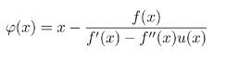
Multipoint method used:
Non-algebraic equation used:

