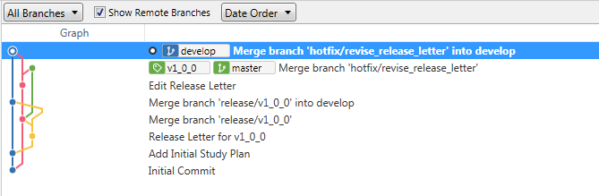

1. Initial Commit on [master], then create [develop] (by initializing Git Flow)
2. Add Initial Study Plan [develop], by using [feature/initial] on [develop]
3. Start [release/v1_0_0]  
   Release Letter for v1_0_0 on [release/v1_0_0]
4. Finish [release/v1_0_0]   
   Automatically, Merge branch [release/v1_0_0] into [mater]   
   Automatically, Merge branch [release/v1_0_0] into [develop]
5. Start [hotfix/revise_release_letter]  
   Edit Release Letter on [hotfix/revise_releaes_letter]
6. Finish [hotfix/revise_release_letter]   
   Automatically, Merge branch [hotfix/revise_release_letter] into [master] (tag is added manually)   
   Automatically, Merget branch [hotfix/revise_release_letter] into [develop]