BÀI GIẢI ĐẦY ĐỦ
Lab CCNA: VLSM – Inter-VLAN Routing – OSPF – Cisco ASA (Inside/Outside/DMZ)
Tài liệu này giải trọn vẹn tất cả yêu cầu trong “Kịch bản bài lab / Skills Exam”: bảng địa chỉ IP hoàn chỉnh, cấu hình chi tiết cho từng thiết bị (kể cả các switch Layer-2 và NAT/ACL nâng cao), cùng kết quả kiểm thử mong đợi
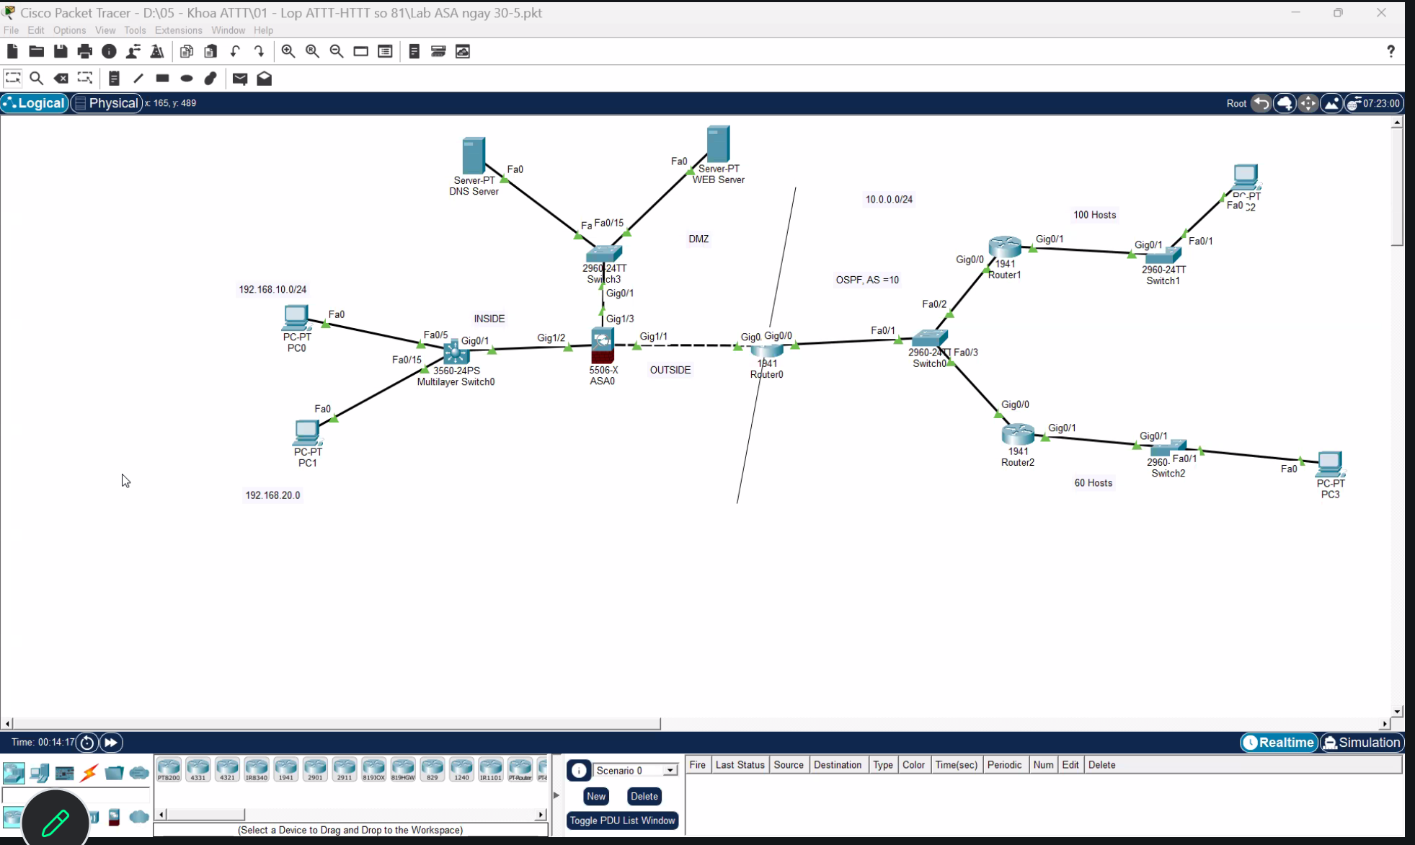.

1. BẢNG ĐỊA CHỈ IP HOÀN CHỈNH
Mạng con | Địa chỉ / Mask | Dải host dùng được | Gán cho
100 hosts (chi nhánh 1) | 10.0.0.0 /25 | 10.0.0.1 – 10.0.0.126 | Router1 Gig0/1 = .1 ; PC2 = .10
60 hosts (chi nhánh 2) | 10.0.0.128 /26 | 10.0.0.129 – 10.0.0.190 | Router2 Gig0/1 = .129 ; PC3 = .140
Transit OSPF 3 router | 10.0.0.192 /29 | 10.0.0.193 – 10.0.0.198 | R0 Fa0/1=.193; R1 Gig0/0=.194; R2 Gig0/0=.195
INSIDE VLAN10 (PC0) | 192.168.10.0 /24 | 192.168.10.2 – .254 | Gateway 192.168.10.1 (SVI MLS0); PC0 = .10
INSIDE VLAN20 (PC1) | 192.168.20.0 /24 | 192.168.20.2 – .254 | Gateway 192.168.20.1 (SVI MLS0); PC1 = .10
INSIDE transit (MLS0 ↔ ASA) | 192.168.1.0 /24 | 192.168.1.2 – .254 | MLS0 Gig0/1 = .2 ; ASA Gig1/2 (inside) = .1
DMZ | 172.16.3.0 /25 | 172.16.3.2 – .126 | ASA Gig1/3 (dmz) = .1 ; DNS = .10 ; WEB = .20
OUTSIDE (ASA ↔ Router0) | 100.0.0.0 /24 | 100.0.0.2 – .254 | ASA Gig1/1 (outside) = .100 ; Router0 Gig0/0 = .1

2. CẤU HÌNH CHI TIẾT TỪNG THIẾT BỊ

2.1. ASA0 (5506-X) — đầy đủ, gồm cả NAT/PAT và ACL publish Web Server
ciscoasa> enable
ciscoasa# configure terminal
ciscoasa(config)# hostname ASA0-FW
ASA0-FW(config)# domain-name company.local
ASA0-FW(config)# enable password Asa@2026
ASA0-FW(config)# banner motd ============================
ASA0-FW(config)# banner motd CANH BAO: Chi nguoi duoc uy quyen moi duoc truy cap
ASA0-FW(config)# banner motd ============================

! Mã hoá AES cho toàn bộ password lưu trong running-config
ASA0-FW(config)# key config-key password-encryption Asa@2026
ASA0-FW(config)# password encryption aes

! ----- 3 interface theo 3 mức security-level -----
ASA0-FW(config)# interface gigabitEthernet 1/2
ASA0-FW(config-if)# nameif inside
ASA0-FW(config-if)# security-level 100
ASA0-FW(config-if)# ip address 192.168.1.1 255.255.255.0
ASA0-FW(config-if)# no shutdown
ASA0-FW(config-if)# exit

ASA0-FW(config)# interface gigabitEthernet 1/1
ASA0-FW(config-if)# nameif outside
ASA0-FW(config-if)# security-level 0
ASA0-FW(config-if)# ip address 100.0.0.100 255.255.255.0
ASA0-FW(config-if)# no shutdown
ASA0-FW(config-if)# exit

ASA0-FW(config)# interface gigabitEthernet 1/3
ASA0-FW(config-if)# nameif dmz
ASA0-FW(config-if)# security-level 50
ASA0-FW(config-if)# ip address 172.16.3.1 255.255.255.128
ASA0-FW(config-if)# no shutdown
ASA0-FW(config-if)# exit

! ----- Định tuyến -----
ASA0-FW(config)# route outside 0.0.0.0 0.0.0.0 100.0.0.1
ASA0-FW(config)# route inside 192.168.10.0 255.255.255.0 192.168.1.2
ASA0-FW(config)# route inside 192.168.20.0 255.255.255.0 192.168.1.2

! ----- PAT: cho toàn bộ INSIDE ra Internet qua IP outside -----
ASA0-FW(config)# object network OBJ-INSIDE-ALL
ASA0-FW(config-network-object)# subnet 192.168.0.0 255.255.0.0
ASA0-FW(config-network-object)# nat (inside,outside) dynamic interface
ASA0-FW(config-network-object)# exit

! ----- Static NAT: publish WEB Server ra ngoài -----
ASA0-FW(config)# object network OBJ-WEBSERVER
ASA0-FW(config-network-object)# host 172.16.3.20
ASA0-FW(config-network-object)# nat (dmz,outside) static 100.0.0.20
ASA0-FW(config-network-object)# exit

! ----- ACL: chỉ cho phép HTTP/HTTPS/DNS từ ngoài vào DMZ -----
ASA0-FW(config)# access-list OUTSIDE-IN extended permit tcp any host 172.16.3.20 eq 80
ASA0-FW(config)# access-list OUTSIDE-IN extended permit tcp any host 172.16.3.20 eq 443
ASA0-FW(config)# access-list OUTSIDE-IN extended permit udp any host 172.16.3.10 eq 53
ASA0-FW(config)# access-list OUTSIDE-IN extended deny ip any any log
ASA0-FW(config)# access-group OUTSIDE-IN in interface outside

! ----- Telnet quản trị (chỉ từ INSIDE) -----
ASA0-FW(config)# password cisco
ASA0-FW(config)# telnet 192.168.1.0 255.255.255.0 inside
ASA0-FW(config)# telnet timeout 3

! ----- SSH quản trị (chỉ từ INSIDE) -----
ASA0-FW(config)# username admin password Asa@2026
ASA0-FW(config)# aaa authentication ssh console LOCAL
ASA0-FW(config)# crypto key generate rsa modulus 2048
ASA0-FW(config)# ssh 192.168.1.0 255.255.255.0 inside
ASA0-FW(config)# ssh version 2
ASA0-FW(config)# ssh timeout 5

! ----- NTP -----
ASA0-FW(config)# ntp authenticate
ASA0-FW(config)# ntp trusted-key 1
ASA0-FW(config)# ntp authentication-key 1 md5 Asa@2026
ASA0-FW(config)# ntp server 192.168.1.2

! ----- DHCP cho VLAN10 (PC0) -----
ASA0-FW(config)# dhcpd address 192.168.10.10-192.168.10.200 inside
ASA0-FW(config)# dhcpd dns 8.8.8.8 8.8.4.4 inside
ASA0-FW(config)# dhcpd lease 1800
ASA0-FW(config)# dhcpd enable inside

ASA0-FW(config)# exit
ASA0-FW# write memory

2.2. Multilayer Switch0 (3560-24PS)
Switch> enable
Switch# configure terminal
Switch(config)# hostname MLS0
MLS0(config)# vlan 10
MLS0(config-vlan)# name INSIDE_PC0
MLS0(config-vlan)# exit
MLS0(config)# vlan 20
MLS0(config-vlan)# name INSIDE_PC1
MLS0(config-vlan)# exit

MLS0(config)# interface fa0/5
MLS0(config-if)# switchport mode access
MLS0(config-if)# switchport access vlan 10
MLS0(config-if)# exit

MLS0(config)# interface fa0/15
MLS0(config-if)# switchport mode access
MLS0(config-if)# switchport access vlan 20
MLS0(config-if)# exit

MLS0(config)# ip routing
MLS0(config)# interface vlan 10
MLS0(config-if)# ip address 192.168.10.1 255.255.255.0
MLS0(config-if)# no shutdown
MLS0(config-if)# exit

MLS0(config)# interface vlan 20
MLS0(config-if)# ip address 192.168.20.1 255.255.255.0
MLS0(config-if)# no shutdown
MLS0(config-if)# exit

! Cổng nối ASA0 chuyển thành routed port (Layer 3)
MLS0(config)# interface gigabitEthernet0/1
MLS0(config-if)# no switchport
MLS0(config-if)# ip address 192.168.1.2 255.255.255.0
MLS0(config-if)# no shutdown
MLS0(config-if)# exit

! Default route toàn bộ traffic ra ngoài đi qua ASA inside
MLS0(config)# ip route 0.0.0.0 0.0.0.0 192.168.1.1
MLS0(config)# exit
MLS0# write memory

2.3. Router0 (R0) — biên giáp ASA + OSPF area 0
Router> enable
Router# configure terminal
Router(config)# hostname R0
R0(config)# enable secret Router@2026
R0(config)# service password-encryption
R0(config)# line console 0
R0(config-line)# password Console@123
R0(config-line)# login
R0(config-line)# exit
R0(config)# line vty 0 4
R0(config-line)# password Vty@123
R0(config-line)# login
R0(config-line)# exit

R0(config)# interface gigabitEthernet0/0
R0(config-if)# ip address 100.0.0.1 255.255.255.0
R0(config-if)# no shutdown
R0(config-if)# exit

R0(config)# interface fastEthernet0/1
R0(config-if)# ip address 10.0.0.193 255.255.255.248
R0(config-if)# no shutdown
R0(config-if)# exit

R0(config)# router ospf 10
R0(config-router)# network 10.0.0.192 0.0.0.7 area 0
R0(config-router)# passive-interface gigabitEthernet0/0
R0(config-router)# default-information originate
R0(config-router)# exit

R0(config)# ip route 0.0.0.0 0.0.0.0 100.0.0.100
R0(config)# exit
R0# write memory

2.4. Router1 (R1) — chi nhánh 100 hosts
Router(config)# hostname R1
R1(config)# enable secret Router@2026
R1(config)# service password-encryption

R1(config)# interface gigabitEthernet0/0
R1(config-if)# ip address 10.0.0.194 255.255.255.248
R1(config-if)# no shutdown
R1(config-if)# exit

R1(config)# interface gigabitEthernet0/1
R1(config-if)# ip address 10.0.0.1 255.255.255.128
R1(config-if)# no shutdown
R1(config-if)# exit

R1(config)# router ospf 10
R1(config-router)# network 10.0.0.192 0.0.0.7 area 0
R1(config-router)# network 10.0.0.0 0.0.0.127 area 0
R1(config-router)# exit
R1(config)# exit
R1# write memory

2.5. Router2 (R2) — chi nhánh 60 hosts
Router(config)# hostname R2
R2(config)# enable secret Router@2026
R2(config)# service password-encryption

R2(config)# interface gigabitEthernet0/0
R2(config-if)# ip address 10.0.0.195 255.255.255.248
R2(config-if)# no shutdown
R2(config-if)# exit

R2(config)# interface gigabitEthernet0/1
R2(config-if)# ip address 10.0.0.129 255.255.255.192
R2(config-if)# no shutdown
R2(config-if)# exit

R2(config)# router ospf 10
R2(config-router)# network 10.0.0.192 0.0.0.7 area 0
R2(config-router)# network 10.0.0.128 0.0.0.63 area 0
R2(config-router)# exit
R2(config)# exit
R2# write memory

2.6. Switch0 (2960-24TT) — transit OSPF, đấu 3 router
Switch(config)# hostname SW0
SW0(config)# interface vlan 1
SW0(config-if)# ip address 10.0.0.196 255.255.255.248
SW0(config-if)# no shutdown
SW0(config-if)# exit
SW0(config)# ip default-gateway 10.0.0.193
! Fa0/1 (Router0), Fa0/2 (Router1), Gi0/1 (Router2) giữ nguyên VLAN 1, mode access

2.7. Switch1 (2960-24TT) — LAN chi nhánh 100 hosts (PC2)
Switch(config)# hostname SW1
SW1(config)# interface vlan 1
SW1(config-if)# ip address 10.0.0.2 255.255.255.128
SW1(config-if)# no shutdown
SW1(config-if)# exit
SW1(config)# ip default-gateway 10.0.0.1
SW1(config)# interface fastEthernet0/1
SW1(config-if)# switchport mode access

2.8. Switch2 (2960-) — LAN chi nhánh 60 hosts (PC3)
Switch(config)# hostname SW2
SW2(config)# interface vlan 1
SW2(config-if)# ip address 10.0.0.130 255.255.255.192
SW2(config-if)# no shutdown
SW2(config-if)# exit
SW2(config)# ip default-gateway 10.0.0.129
SW2(config)# interface fastEthernet0/1
SW2(config-if)# switchport mode access

2.9. Switch3 (2960-24TT) — DMZ (DNS Server, WEB Server)
Switch(config)# hostname SW3
SW3(config)# interface vlan 1
SW3(config-if)# ip address 172.16.3.2 255.255.255.128
SW3(config-if)# no shutdown
SW3(config-if)# exit
SW3(config)# ip default-gateway 172.16.3.1
SW3(config)# interface range fastEthernet0/1-2
SW3(config-if-range)# switchport mode access

2.10. Cấu hình IP tĩnh trên các PC / Server (Desktop > IP Configuration)
Thiết bị | IP Address | Subnet Mask | Default Gateway | DNS
PC0 | 192.168.10.10 | 255.255.255.0 | 192.168.10.1 | 172.16.3.10
PC1 | 192.168.20.10 | 255.255.255.0 | 192.168.20.1 | 172.16.3.10
PC2 | 10.0.0.10 | 255.255.255.128 | 10.0.0.1 | 172.16.3.10
PC3 | 10.0.0.140 | 255.255.255.192 | 10.0.0.129 | 172.16.3.10
DNS Server | 172.16.3.10 | 255.255.255.128 | 172.16.3.1 | 127.0.0.1
WEB Server | 172.16.3.20 | 255.255.255.128 | 172.16.3.1 | 172.16.3.10

3. KẾT QUẢ KIỂM THỬ MONG ĐỢI (Verification)

3.1. Trên ASA0
ASA0-FW# show nameif
Interface Name Security
GigabitEthernet1/1 outside 0
GigabitEthernet1/2 inside 100
GigabitEthernet1/3 dmz 50

ASA0-FW# show route
S* 0.0.0.0 0.0.0.0 [1/0] via 100.0.0.1, outside
S 192.168.10.0 255.255.255.0 [1/0] via 192.168.1.2, inside
S 192.168.20.0 255.255.255.0 [1/0] via 192.168.1.2, inside
C 192.168.1.0 255.255.255.0 is directly connected, inside
C 172.16.3.0 255.255.255.128 is directly connected, dmz
C 100.0.0.0 255.255.255.0 is directly connected, outside

3.2. Trên Router0/1/2 — OSPF hội tụ
R1# show ip ospf neighbor
Neighbor ID Pri State Dead Time Address Interface
0.0.0.193 1 FULL/DR 00:00:38 10.0.0.193 GigabitEthernet0/0
0.0.0.195 1 FULL/BDR 00:00:33 10.0.0.195 GigabitEthernet0/0

R1# show ip route ospf
O 10.0.0.128/26 [110/2] via 10.0.0.193, GigabitEthernet0/0
O*E2 0.0.0.0/0 [110/1] via 10.0.0.193, GigabitEthernet0/0

3.3. Kịch bản ping kỳ vọng
- PC0 (192.168.10.10) ↔ PC1 (192.168.20.10): OK — đi qua SVI của MLS0 (inter-VLAN routing).
- PC0/PC1 → DNS/WEB Server (172.16.3.x): OK — ASA cho phép inside → dmz theo security-level (100 > 50).
- PC2 (10.0.0.10) ↔ PC3 (10.0.0.140): OK — định tuyến qua OSPF, 2-hop qua Switch0.
- Từ OUTSIDE (giả lập PC ngoài) → PC0/PC1: FAIL (đúng thiết kế) — ASA chặn traffic khởi tạo từ vùng thấp vào vùng cao hơn.
- Từ OUTSIDE → WEB Server qua địa chỉ NAT 100.0.0.20 cổng 80: OK — do có static NAT + ACL OUTSIDE-IN cho phép.
- Từ OUTSIDE → DNS Server cổng khác 53 hoặc → WEB Server cổng khác 80/443: FAIL — bị access-list mặc định deny.
- PC INSIDE mở trình duyệt tới WEB Server DMZ (172.16.3.20 hoặc qua tên miền nếu cấu hình DNS record) → hiển thị trang web thành công.

Toàn bộ địa chỉ, mật khẩu (Asa@2026, Router@2026...) chỉ mang tính minh hoạ cho bài lab — khi áp dụng thực tế cần đổi theo chính sách mật khẩu của tổ chức.

