MSR-test-Instance-1: 18.206.154.55 & MSR-test-Instance-2: 3.83.22.181

Apache web server is installed as a Docker conatianer in MSR-test-instace1 and accessible from browser

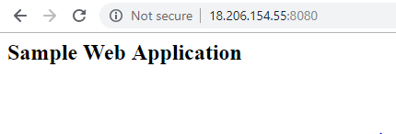

CouchDB futon installed as a Docker container in MSR-test-instance2 and accessible from browser

