Chatbot Assistant System using Python

- Background/ Problem Statement

The recent decade has witnessed a significant boom in Technology. Technology has become more user-friendly and accessible over the years. This improvement in accessibility has led to dramatic growth in the number of users. Providing individual technical support to each and every customer could often prove to be hectic and tedious.
This Chatbot Assistant is developed to help customers get technical help for their queries. Moreover, the user-friendly design of this project improves accessibility for users. As the number of users within a system grows, their queries and issues will also inadvertently increase. Tackling each and every query personally could prove to be expensive, time-consuming and inefficient.
This Chatbot Assistant aims to streamline the process of providing technical help by automating the process. Instead of waiting for their issues to be resolved by a representative, users can directly approach the chatbot for help and get the answers to their questions. Moreover, the easy-to-use nature of this system improves accessibility for the customers.

- Working of the Project

Considering the anomalies in the existing system computerization of the whole activity is being suggested after the initial analysis. The web application is developed using Django Framework with Python as a programming language. In this project, there is one major module which is the user module.

The user has to register their account using their basic details and then they can log in with their username and create a password. Lo gin to the system using username and password. After logging in, the user can chat with the chatbot and edit its personal details.

The user can ask the chatbot about solving technical issues or doing setups likewise the chatbot will send the respective link that is clickable and can redirect the user to the particular page. This Project is developed using the Django Framework with Python as the programming language. The front-end involves Html, CSS, and JavaScript

- Advantages

- It is easy to maintain.
- It is user-friendly.
- The system will provide answers to their technical queries instantly.
- It saves time and the issues are resolved in less time.

- System Description
The system comprises 1 major module with its sub-modules as follows:

- USER:

- Register
- The user can register by creating a username and password.
- Login
- The user can access the system using valid credentials.
- Chat Window
- The user can chat with the chatbot for technical help.
- Edit User Details
- The user can edit their details.

- Project Life Cycle

The waterfall model is a classical model used in the system development life cycle to create a system with a linear and sequential approach. It is termed a waterfall because the model develops systematically from one phase to another in a downward fashion. The waterfall approach does not define the process to go back to the previous phase to handle changes in requirements. The waterfall approach is the earliest approach that was used for software development.

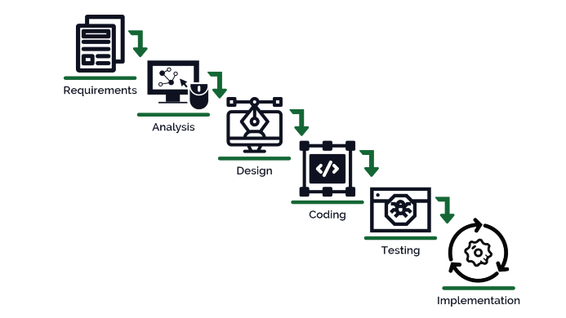

- System Requirements

- Hardware Requirement

- Laptop or PC
- Windows 7 or higher
- I3 processor system or higher
- 4 GB RAM or higher
- 100 GB ROM or higher

- Software Requirement

- Laptop or PC
- Python
- Sublime Text Editor
- XAMP Server

- Limitation/Disadvantages
- Chatbots have the same answer for a query.
- They can’t make decisions.
- They have zero research skills.

- Application – This application helps in the process of providing technical help by automating the process.

- Reference
- https://ieeexplore.ieee.org/document/9322667
- http://ieeexplore.ieee.org/document/8304128/
- http://ieeexplore.ieee.org/document/8541320
- https://ieeexplore.ieee.org/iel7/9445209/9445272/09445316.pdf
- https://ieeexplore.ieee.org/document/944531

