**Our POC website which accepts Voice command for navigation.**

Just to demonstrate the Idea we have made a website with three tabs and accepting voice commands to navigate to these tabs.

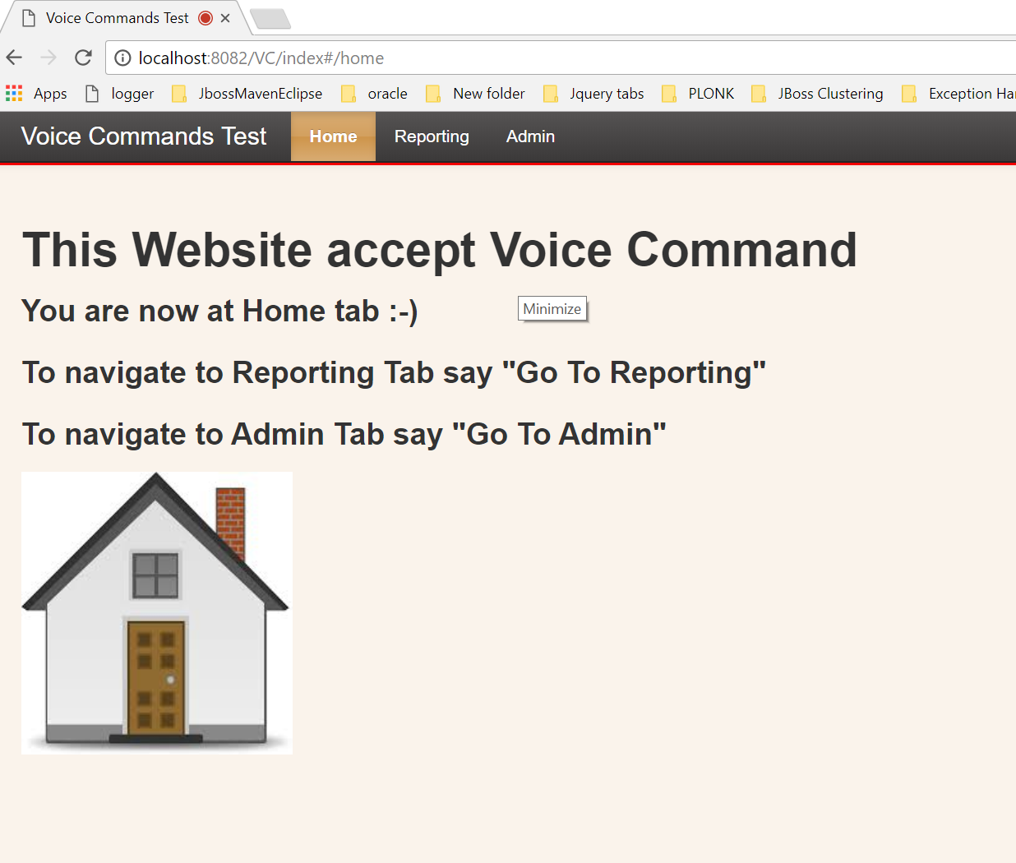

For a website which is accessing the microphone, chrome shows the below symbol

