“**Internal Dropbox with Sharing**”

**Problem statement**:

Nothing is useful unless we put it to use. Hence we have identified one common problem that we face in our companies and as a part of this project we propose a solution for the same.

Generally in any company we do not have any shared drives to share files across the Department/Vertical which at times is required, plus admins rights are not given so that we can create shared folders, plus at times network restrictions come in play.

Hence an “Internal Dropbox with Filesharing” web application. (HTTP packets are not bounded by network rules).

After Logging in, user can see two tabs.

**1)      My Files:**

Here all the files uploaded by the logged in user will be listed.

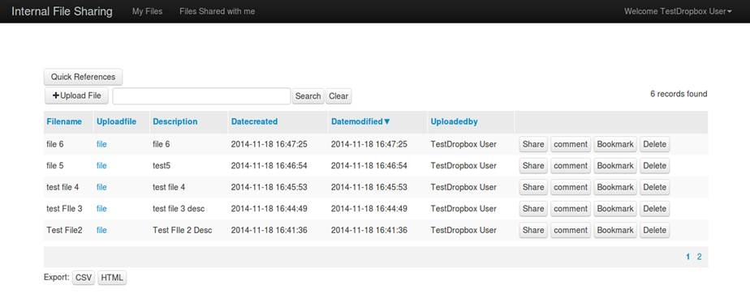

Features:

a)    User can share the file uploaded by him to any other registered user, the other user will receive an alert email, informing that a file is shared with him/her.

b)    The owner** of file plus the other users with whom the file is shared can post comments for that specific uploaded file.

c)    The user can bookmark  files for quick references(files uploaded by him plus files shared with him by other users)

d)    The Owner of the file can download/delete the uploaded file.

(Owner of the file **: user who has uploaded the file)

Uploading the file:

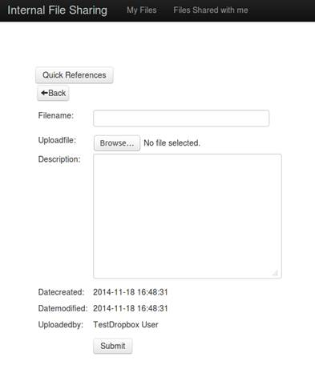

Posting Comments for a specific file:

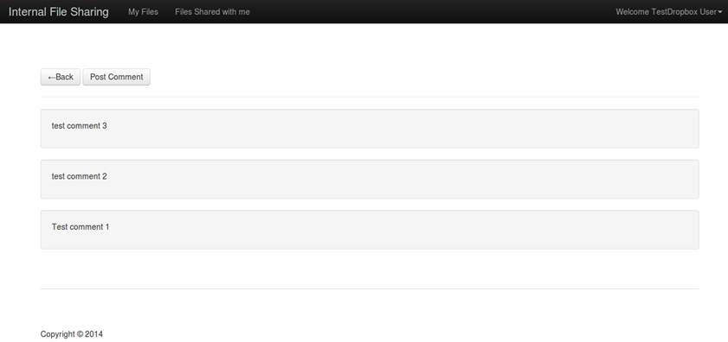

Bookmark Slider, listing all bookmarked file(on click of “Quick reference” button):

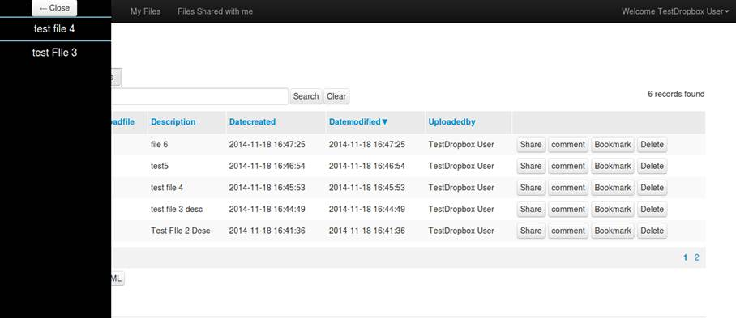

**2)      Files Shared with me Tab**

This tab will list the files which are shared by other users with the logged in user.

Features:

a) User can download the shared file.

b) User can post comment for shared file

c) User can bookmark any shared file.

Files shared (by other user with logged in user)

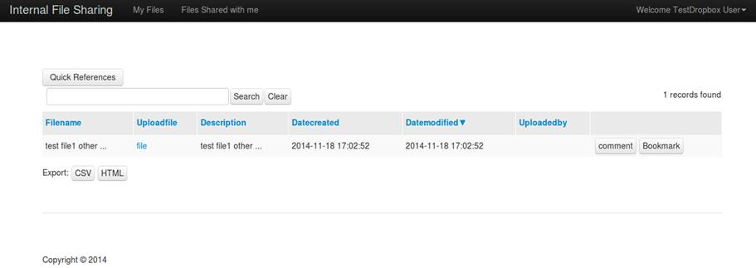

Going one step further, incase if “Internal Dropbox with Sharing” site uses the same authentication as any other internal websites, then employing SSO we can embed its URL, and users can seamlessly access their “Dropbox” from multiple other internal sites.

I am still working on this feature and presently trying to implement SSO using 3rd party authentication like yahoo, Gmail, Facebook.

SSO using third party authentication:

