To do:
cable management. add the new blue sleeve: done
install new zlim: done
set the z homing command to be z zeroing
install PSU switches
update distances to be accurate for each axis: done
consider writing all power low after 4 hours of no input. :done

To do round 2:
locktite on the screws
expoxy the drag chain connections
solder on switches
supports for the overhead festoon

For hunter:
queuing and lag
button
update interrupt branding for the screen P1. blue gradient

User's guide

Light instructions:
Turning on:
- Ensure the arduino is plugged into the computer and has been flashed with the claw_controller ino file.
- Switch on the 12V and 6V power supply connections (note doing this before step 1 can fry the arduino which is $35 and 30 minutes of wiring so please try not to). The order of 12V vs 6V doesn't matter.
- Launch the agent server (uv run uvicorn agent.app:app --reload) and open it in the browser at http://127.0.0.1:8000/
- Tell the program to "home Z"
- Game is ready to go. Available commands include
  - Move forward / Move backward by __ feet/inches/centimeters/... (if no value specified, will move a few inches and prompt for more)
  - Move left / Move right by ...
  - Drop the claw / raise the claw
  - Bring me the parrot: Drops the claw, closes it, retracts, moves to front left corner, and opens the claw
  - Home: Moves to the front left corner
Note that entering a new command before the agent has finished responding to the previous one won't be recognized or recorded, so wait until the agent returns to idle.
- When done, please switch off the power supplies. The motors have a holding current, so keeping them on indefinitely will degrade them and waste energy.

Detailed instructions:
The claw machine runs on an arduino uno with a cnc motor shield on top. This motor shield has 4 A4998 stepper motor drivers and manages all the electrical PWM signals the steppers and servo see. There are 4 stepper motors: 2 motors which run parallel along the 'x' axis and which run on the drivers labelled X and A on the CNC shield. There is a single stepper for the 'y' axis which runs on the Y driver and a stepper to turn a spool to raise and lower the height of the claw. This runs on Z. A 12V power supply provides main power to the CNC shield and all the motors

A servo runs off the CNC shield too. It gets power from a separate 6V power supply but has a ground and signal connection on the CNC shield.

When done, please switch off the power supplies. The motors have a holding current, so keeping them on indefinitely will degrade them, waste energy, and lead them to heat up. The cnc shield will auto shut off if it gets above a certain temperature, but it's better to be safe with this.

Troubleshooting
- Either the X or A motor appears to lag behind the other OR machine makes a grinding noise and stalls while moving in X.
  - Likely the GT2 timing belt connectors are loose from the stepper spoke. This is a small barrel shaped piece on the motor spoke and touching the belt drive. Each of them has 2 m2 screws which need to be tight to ensure it moves with the motor spoke. Try tightening.
  - Less likely: the belt drive has become loose. If you can depress it more than 1-2 cm with a finger, it may need to be re-tightened. You can do this at the end by unscrewing the clamping acrylic block and resetting it tighter.
  - Less likely, the motor itself has an issue. There are potentiometers on the cnc shield which can be used to rebalance current, but it's very delicate. Contact Ben at (415) 418 8884 to ask him to fix.
- X/A motor makes a temporary grinding sound and the claw doesn't move as far as you asked it to.
  - Ask the machine to go to home. It is possible the motors have come out of phase with each other. The homing sequence has an automatic re-leveling process which should fix this. A grinding sound is a sign of an issue, but it's not causing immediate damage.
  - Check the blue overhead cables haven't become tangled on the white arduino base
- The Z isn't stopping at the top
  - Re-run the Z zeroing sequence. It is possible that the stepper wasn't properly engaged the first time
  - It should be ruled out by software, but it may be possible for the spool to rotate so much that the blue rope begins winding onto it in the opposite direction. This could lead to a bypass of the previously set home. This shouldn't happen, so contact Ben if you're seeing strange Z behaviors
- Motors aren't stopping after hitting limit switch
  - Check connections are secure on the limit switch outputs and on the arduino shield inputs (can very lightly tug to feel if they are solid).
- Frame feels unstable
  - Tighten the screws in the small silver triangular pieces at the inner corners of the gantry frame

Component library

Belt tension end pieces  Limit switches | 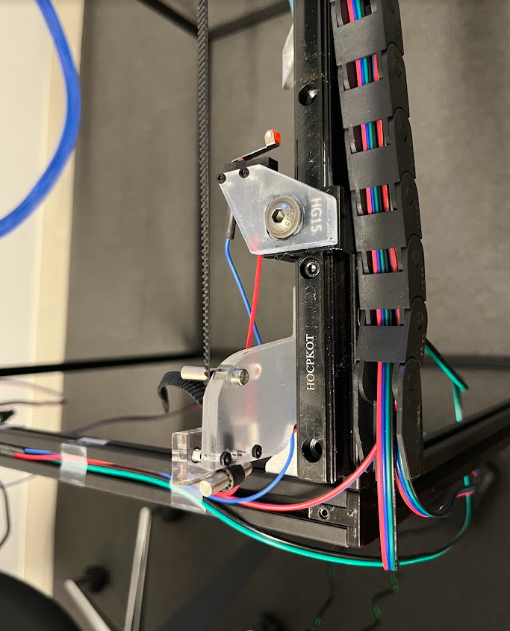
GT2 timing belt connectors  X/A motors  Y motor | 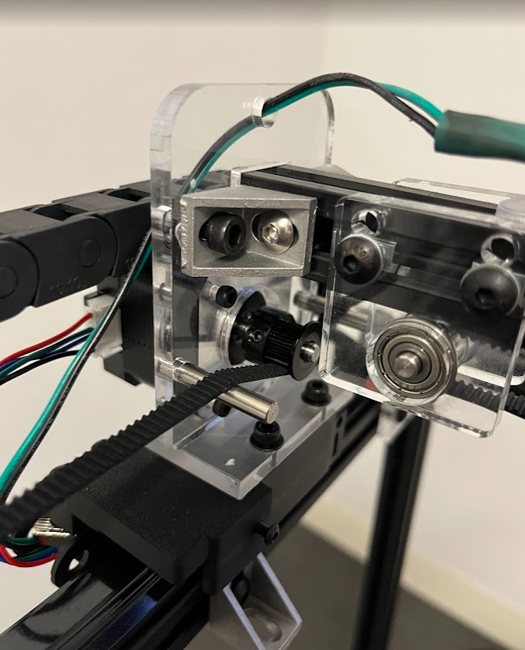  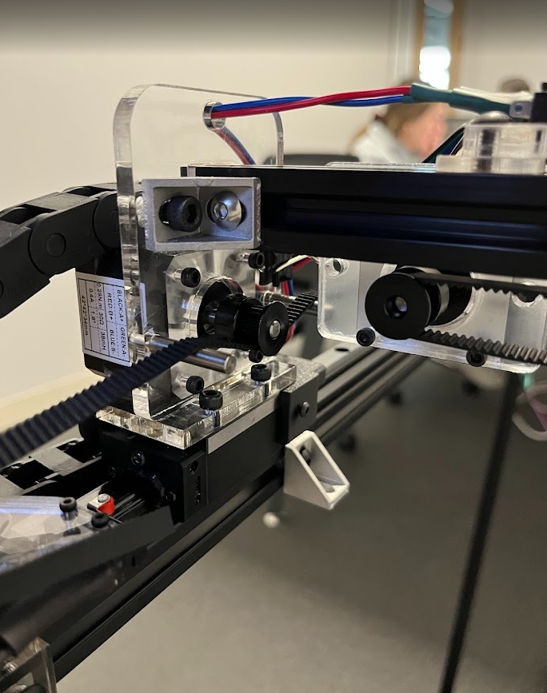
Z motor | 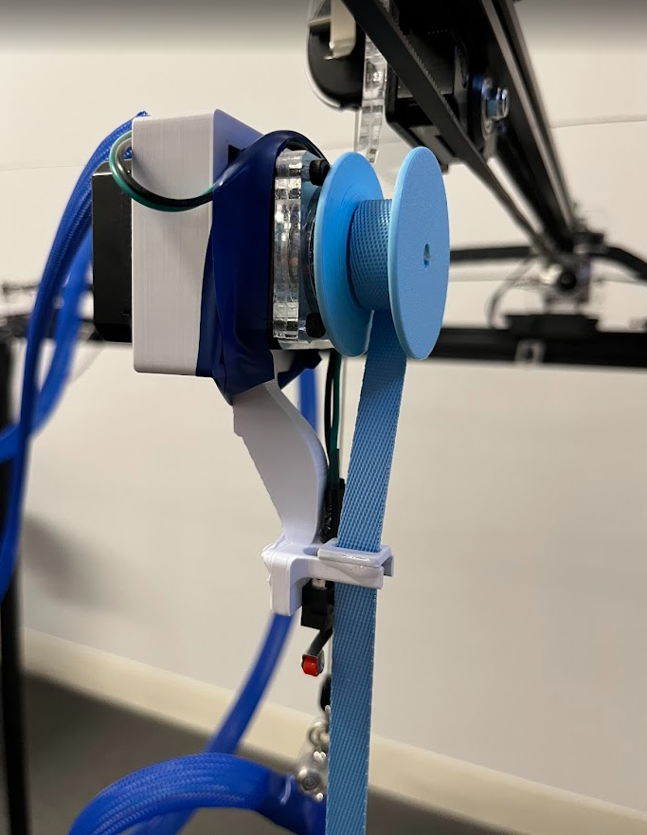
Claw servo

Circuit information

The pin details can be found in the arduino .ino file, but a few pictures are included here for reference in case something gets unplugged.
