SE LAB GROUP ASSIGNMENT 1 REPORT TEMPLATE
Software Engineering | Smart Ticketing System (Ticket Vendor Machine) | Sem 1_2627 | Template for the file 524H0168_DangHieuMinh_524H0161_PhamCongQuocHuy_524H0166_NguyenTrongHoangLinh_524H0200_HuaNguyenThanhTrong_524H0199_LeHoangTri.docx
Marking of this report
No. | Task | Marks | Section in this report
1 | Clarification Q&A (Excel) | 5 | 2.1
2 | Requirements Specification | 15 | 2.2
3 | Use Case Modeling | 10 | 3.1
4 | Activity Diagrams | 10 | 3.2
5 | Detailed System Modeling: "Buy a Ticket" | 15 | 3.3
6 | UI/UX Design | 5 | 4.1
7 | Architectural Design | 10 | 4.2, 4.3
8 | Visual Studio Engineering (Model-to-Code) | 10 | 5.1
9 | GitHub & AI Tooling (Copilot) | 10 | 5.2
10 | Demo Application (C# and MSSQL) | 10 | 5.3
Total |  | 100 | Weight: 20% of QT2 (plus 1 bonus point towards the Final Project for exceptional work)

How to use this template
- Keep all titles and numbering. Replace every blue [bracketed placeholder] with your own content, and delete all grey "Guidance" paragraphs, unused figure frames and this instruction page before you submit.
- Keep the headings as real Word headings (the navigation pane must work). Update the table of contents before submitting (right-click, Update Field).
- Group of 3 to 5 students. Section 7 must list the % contribution of each member (total 100%) and must match your readme.txt.
- Submit [YourID]_[YourStudentName].docx, readme.txt (GitHub link and other links such as Figma and database script instructions) and the % contribution of each member. All final artifacts are also uploaded to the shared GitHub repository.
- The report must also address the content of "LabGroupAssignment1.pdf". Use the checklist in section 6 to show where each item is covered.
- Keep your diagrams consistent with each other: the rubric rewards diagrams that are syntactically correct, logically sound and aligned. Use the consistency table in section 3.4.
- The workbook A1_Team_Workbook (Q&A, requirements, prompt log, commit log, progress log) is your working record and the source for several tables here.

Smart Ticketing System
Ticket Vendor Machine (TVM)
Software Engineering Lab Group Assignment 1 – Sem 1_2627
Group The Five Super Brothers
1. 524H0168 : Dang Hieu Minh
2. 524H0161 : Pham Cong Quoc Huy
3. 524H0166 : Nguyen Trong Hoang Linh
4. 524H0200: Hua Nguyen Thanh Trong
5. 524H0199 : Le Hoang Tri

GitHub repository | Figma / other link | Date submitted
https://github.com/hnttrong/SmartTicketingSystem-TVM | https://www.figma.com/design/chjKyWaJin2KMWQ9iaUzuP/TVM?node-id=0-1&t=icsEXm35cFjpr6e4-1 | 30/10/2026

Table of Contents
Table of Contents 4
1. Introduction 6
1.1 Purpose and Scope 6
1.2 Problem Statement in Our Own Words 6
1.3 Team and Roles 6
2. Phase 1: Requirements Engineering (20 marks) 7
2.1 Clarification Q&A (5 marks) 7
2.2 Requirements Specification (15 marks) 7
2.2.1 Functional Requirements 7
2.2.2 Non-Functional Requirements 7
2.2.3 Domain Requirements 8
3. Phase 2: UML Modeling & System Design (35 marks) 9
3.1 Use Case Modeling (10 marks) 9
3.1.1 Use Case Diagram 9
3.1.2 Actors and Use Case List 9
3.1.3 Use Case Descriptions 9
3.2 Activity Diagrams (10 marks) 10
3.2.1 Passenger Buys a Ticket at the TVM 10
3.2.2 Communication with External Payment Gateways 10
3.3 Detailed System Modeling: Main Use Case "Buy a Ticket" (15 marks) 10
3.3.1 Sequence Diagram 10
3.3.2 State Chart Diagram 10
3.3.3 Class Diagram (Domain Model) 10
3.4 Model Consistency Check 10
4. Phase 3: UI/UX & Architecture (15 marks) 12
4.1 UI/UX Design (5 marks) 12
4.2 Architectural Design (10 marks) 12
4.2.1 Architecture Diagram 12
4.2.2 Deployment Diagram 12
5. Phase 4: Implementation, Tooling & Demo (30 marks) 13
5.1 Visual Studio Engineering: Model-to-Code (10 marks) 13
5.1.1 Forward Engineering (Model to Code) 13
5.1.2 Backward Engineering (Code to Model) 13
5.1.3 Code Map 13
5.2 GitHub & AI Tooling (10 marks) 13
5.2.1 Source Control 13
5.2.2 AI Assistance: Copilot Prompt Documentation 14
5.2.3 Reflection on AI Use 14
5.3 Demo Application (10 marks) 14
6. Checklist for "LabGroupAssignment1.pdf" 16
7. Contribution of Each Member 16
8. Conclusion and Lessons Learnt 16
References 16
Appendix 17
Appendix A: readme.txt 17
Appendix B: Full-size Diagrams 17

1. Introduction

1.1 Purpose and Scope
This report documents the analysis, design, implementation and tooling of the Ticket Vendor Machine (TVM), the self-service ticket kiosk of the Smart Ticketing System, for SE Lab Group Assignment 1. It covers requirements engineering, UML modeling, the user interface and architecture, a C# and MSSQL prototype of the main use case "Buy a Ticket", and the Visual Studio, GitHub and Copilot work behind them.
In scope: single-journey Bus and MRT tickets sold at the TVM, payment by credit card, bank QR code and digital wallet, ticket printing, failure handling, refunds and basic machine monitoring. Out of scope: ticket validation at gates, a passenger mobile app, return, day-pass, stored-value and concession tickets, and a connection to live payment gateways (the demo uses a mock gateway).

1.2 Problem Statement in Our Own Words
A transport operator wants passengers to buy bus and MRT tickets without a counter. At the TVM the passenger presses Start, picks a destination from a menu, chooses how to pay and receives a paper ticket with a barcode. There are three payment modes: a credit card (inserted or tapped), a QR code linked to a bank, and a digital wallet, where the TVM shows a QR code that the passenger scans with a phone. A ticket is issued only after the payment has been validated.
The brief is deliberately incomplete. It does not say which tickets and fares exist, how long a passenger has to pay, what happens when a card is declined or a QR code expires, how a payment that succeeds without a printed ticket is refunded, what to do when the printer or the network fails, how the payment providers connect, how card data is protected, or what "fast" and "reliable" mean in numbers.
We listed 25 such ambiguities in nine areas, wrote an assumed answer for each (section 2.1) and turned them into 25 functional, 12 non-functional and 8 domain requirements (section 2.2). The assumed answers are our own choices and would have to be confirmed by the real stakeholders.

1.3 Team and Roles
No. | Name | Student ID | Main responsibilities
1 | Dang Hieu Minh | 524H0168 | Requirements and report integration: Clarification Q&A, requirements specification, sections 1, 2, 6, 7 and 8, final report
2 | Pham Cong Quoc Huy | 524H0161 | Use case modeling and activity diagrams
3 | Nguyen Trong Hoang Linh | 524H0166 | Sequence, state chart and class diagrams; architecture diagram
4 | Hua Nguyen Thanh Trong | 524H0200 | Visual Studio engineering, GitHub repository, Copilot prompt documentation, readme.txt
5 | Le Hoang Tri | 524H0199 | UI/UX Touchscreen Mockups (4.1); UML Deployment Diagram (4.2.2); C# .NET 8 WinForms & MSSQL Demo Application (5.3)

2. Phase 1: Requirements Engineering (20 marks)

2.1 Clarification Q&A (5 marks)
We wrote 25 questions in nine areas (ticket and fares, payment, failure handling, hardware, security, performance and reliability, users and accessibility, integration, other). The table shows the 12 most important ones with the assumed answer we designed against. The full list is in the workbook, sheet "Clarification Q&A".
ID | Question to the stakeholder | Assumed answer | Why it matters | Requirement ID
Q01 | Which transport modes and ticket types must the TVM sell: single-journey only, or also return, day-pass and stored-value tickets? | Bus and MRT single-journey tickets only. Return, day-pass and stored-value tickets are out of scope for this release. | Bounds the scope. The Ticket class keeps a mode and a type attribute so new types can be added later. | FR2, FR3
Q02 | Is the fare a fixed price per origin-destination pair or distance/zone based, and who maintains the fare table? | Fixed price per origin-destination pair (origin = the station where the TVM stands), in whole VND. The authority maintains one Fare table on the central server and each TVM synchronises it every 15 minutes. | Fare and Destination become database entities. The TVM never hard-codes prices. | FR2, FR4, DR1
Q03 | Can a passenger buy several tickets in one transaction, and for different destinations? | Yes: 1 to 5 tickets of the same destination and type per transaction. Different destinations need separate transactions. | Transaction gets a quantity. Total = fare × quantity, printing loops over the tickets and each ticket needs its own barcode. | FR3, FR5, FR16
Q04 | Are concession fares offered, and which price applies if the fare changes while a passenger is in the middle of a transaction? | Full fare only, because a TVM cannot verify eligibility. The fare shown at order confirmation is locked for that transaction and a new fare applies from the next one. | Avoids price disputes. The Transaction stores a fare snapshot. | FR4
Q05 | Which card schemes and entry methods must be supported (Visa, Mastercard, JCB; chip insert, contactless tap, magnetic stripe)? | Visa, Mastercard and JCB credit cards by chip insert or contactless tap. Magnetic stripe is not supported. | Decides the card-reader hardware, EMV rules and the PaymentGateway interface. | FR6, FR7, DR2
Q06 | How do the bank QR and the wallet QR differ for the passenger and for the system? | Bank QR: an interbank VietQR code scanned in any banking app, confirmed by the bank. Wallet QR: a provider-specific dynamic QR (Momo, ZaloPay, VNPay) scanned in that wallet app, confirmed by a callback. Both are one-time codes bound to the amount. | Two payment types with different standards and confirmation channels behind one PaymentGateway interface. Gives separate use cases. | FR8, FR9, DR3
Q07 | How long is a QR code valid, and how long may the machine wait for a payment result? | A QR code is valid for 120 seconds, shown with a countdown, and can be regenerated at most twice per transaction. A card authorization waits at most 30 seconds. | Defines the Awaiting payment state, its timeout transition and a response-time limit. | FR8, FR9, FR13, NFR3
Q08 | What happens when the card is declined or expired, and how many attempts are allowed? | A generic "payment declined" message is shown. The passenger has 3 attempts or may switch to another payment mode, then the transaction is cancelled. No ticket and no charge. | Adds the decline branch to the activity and sequence diagrams and a retry counter to Transaction. | FR12
Q09 | Can the passenger cancel at any step, and what happens to money already taken? | Cancel is available on every screen until payment is confirmed. Cancelling while waiting for payment voids the authorization or invalidates the QR code and nothing is charged. After confirmation the sale is final and the ticket is printed. | Adds a Cancelled state to the state chart and a cancel branch to the activity diagram. | FR11
Q10 | If payment is confirmed but the ticket cannot be printed, who refunds, how, and how fast? | The TVM retries printing once, then refunds automatically to the original card, bank account or wallet and shows a refund reference. The refund request is sent within 60 seconds. The operator is alerted if a refund is still open after 24 hours. | "Paid but no ticket" is the worst failure. It drives a refund flow, a Refund pending status and a reliability NFR. | FR18, NFR6, DR8
Q11 | What should the system do with a payment that arrives late? | No ticket is issued once the transaction has expired or been cancelled. The system refunds the late payment automatically and logs it as a late payment. | Closes the race between callback and timeout. The status must be checked before any ticket is issued. | FR14, NFR6
Q12 | After how long without touch input should the TVM reset, and what about money already paid? | On the selection screens, after 60 seconds without touch a 10-second warning is shown, then the session is cancelled and the TVM returns to Start. While waiting for payment the QR and card timeouts apply instead. A confirmed payment is always completed. | Prevents a blocked machine and defines the timeout transitions in the state chart. | FR21
Q13 | What should happen when the printer fails or paper runs out, before and after a payment? | The TVM checks the printer before accepting any payment. If it is not ready or paper is almost out, the TVM goes Out of service for sales. A fault after payment follows the refund rule in Q10. | Adds a pre-condition to Buy a Ticket, an Out of service state and a link between printer status and sales. | FR17, FR18, FR22
Q14 | At what paper level must staff be warned, how, and how fast? | A warning goes to the operator console at 50 tickets or fewer and sales stop at fewer than 10 tickets. Alerts for printer error, lost connectivity and gateway failure arrive within 60 seconds. The TVM sends a status heartbeat every 60 seconds. | Gives measurable thresholds for the monitoring use case. | FR17, FR23
Q15 | What must the ticket show, which barcode type is used and how long is the ticket valid? | Ticket ID, mode, origin, destination, fare, date and time, validity and a Code 128 barcode encoding a unique 16-digit ticket number with a check digit. Valid for one journey within 24 hours of issue. | Defines the Ticket attributes, the print layout and the contract with the gate readers. | FR15, FR16, DR4
Q16 | May the TVM or our database store card data, and which security standard applies? | No. A certified reader sends card data to the gateway. The system keeps only a gateway token, the card scheme and the last 4 digits. PCI DSS and EMV rules apply and no other personal data is collected. | Reduces PCI scope and data risk. Payment stores masked data only. | NFR9, DR2, DR5
Q17 | How are payment results delivered, and how does the system know they are genuine and not repeated? | The gateway sends a signed callback over HTTPS with the transaction reference and amount. The system verifies signature, amount and reference and ignores duplicate callbacks. | Protects against forged "paid" messages and double ticket issue. | FR10, FR20, NFR10
Q18 | Who may enter maintenance mode and how are they identified? | Only authorised staff with a staff card and PIN. Every maintenance access is logged with staff ID and time. | Adds a Maintenance staff actor and an access-control step to the maintenance use case. | FR24
Q19 | What response times does a passenger expect for the menu, the QR code, the card result and the ticket print? | Menu within 1 s of pressing Start, QR code within 3 s of choosing the mode, card result within 10 s, first ticket printed within 5 s of payment confirmation, each measured at a stated percentile. | The rubric asks for measurable response times. These limits become NFR1 to NFR4. | NFR1, NFR2, NFR3, NFR4
Q20 | What service availability and transaction success rate does the operator require? | Sales available 99.5% of operating hours (05:00 to 23:00) per month, and at least 99.5% of confirmed payments end with a printed ticket. | Gives quantified reliability limits for NFR5 and NFR8. | NFR5, NFR8
Q21 | Should the TVM sell offline, and what happens after a power cut during a transaction? | No offline sales: without a connection to the server or gateway the TVM goes Out of service. After a restart it recovers the last transaction from local storage and completes or refunds it within 2 minutes. | Avoids offline fraud. Requires a persisted transaction state. | FR22, NFR7
Q22 | Which languages must be supported and what accessibility features are required? | Vietnamese and English, switchable at any time before payment. Touch buttons at least 15 mm x 15 mm, text at least 18 pt, a high-contrast mode, audio guidance through a headphone jack, and controls placed 0.9 to 1.2 m above the floor for wheelchair users. A first-time passenger should buy one ticket in 90 seconds or less (median), with at least 90% succeeding without help. | Sets design constraints for the UI screens and a usability NFR. | FR1, NFR11, DR7
Q23 | Do we integrate each provider separately or through one aggregator, and how are settlements reconciled? | One payment service with a common PaymentGateway interface and one adapter per provider (Momo, VNPay, ZaloPay, card acquirer). Each provider offers a sandbox and a daily settlement file. | Adapter structure for the design and a settlement feed for reconciliation. | FR10, FR25, NFR2
Q24 | How many TVMs will run and do they share one central server? | Up to 50 TVMs share one central application and database server, with a peak of 200 transactions per minute in total. | Sizing for the capacity NFR. The deployment diagram shows one central server. | FR23, NFR12
Q25 | What must be logged, for how long, and what daily reports does Finance need? | Log every transaction including failures and cancellations and keep records 10 years (to be confirmed by Finance). A daily reconciliation report by payment mode is compared with the settlement files. | Needed for audit and disputes. Drives the Transaction table. | FR19, FR25, DR6
Hidden complexities we uncovered
- Paid but no ticket. Asking what happens when money is taken and the printer fails (Q10, Q13) gave us an automatic refund flow: FR18, NFR6 and DR8, and a Refund pending status.
- Race between timeout and callback. A QR payment can complete after the code expired (Q07, Q11, Q17). This produced FR13, FR14, FR20 and NFR10: late payments are refunded, duplicate callbacks are ignored.
- Two different QR paths. Bank QR and wallet QR are confirmed through different channels and standards (Q06), so they are separate use cases (UC03, UC04) with their own format rule (DR3).
- No offline sales. Answering Q21 meant the TVM goes Out of service without a connection (FR22) and must recover an unfinished transaction after a power cut (NFR7).
- Fares and quantity. Q02, Q03 and Q04 led to a fare table on the server, 1 to 5 tickets per purchase with one barcode each (FR3, FR4, FR16) and a fare locked for the whole transaction.

2.2 Requirements Specification (15 marks)

2.2.1 Functional Requirements
25 functional requirements. Use case IDs (UC01 to UC08) follow the use case list in section 3.1.2. Source shows the Q&A question each requirement comes from.
ID | Requirement ("The system shall…") | Priority | Use case | Source (Q&A)
FR1 | The system shall show a Start screen with a Start button and a language selector (Vietnamese or English) whenever the TVM is idle and in service. | Medium | UC01 | Q22
FR2 | The system shall, when the passenger presses Start, display a menu of destinations grouped by transport mode (Bus, MRT), each with its single-journey fare in VND. | High | UC01 | Q01, Q02
FR3 | The system shall let the passenger choose one destination and a quantity of 1 to 5 tickets of the same type. | High | UC01 | Q01, Q03
FR4 | The system shall calculate the total price as full fare × quantity, using the fare effective when the passenger confirms the selection, and keep that fare fixed for the whole transaction. Fare updates shall reach each TVM at least every 15 minutes. | High | UC01 | Q02, Q04
FR5 | The system shall show an order summary (destination, quantity, total) and require the passenger to confirm it before payment starts. | Medium | UC01 | Q03
FR6 | The system shall offer the payment modes Credit Card, Bank QR Code and Digital Wallet and hide any mode that is currently unavailable. | High | UC01 | Q05
FR7 | The system shall, for Credit Card payment, prompt the passenger to insert or tap the card, read it through the card reader and send an authorization request for the total to the payment gateway. | High | UC02 | Q05
FR8 | The system shall, for Bank QR payment, generate a unique one-time QR code containing the amount and the transaction reference and display it with a countdown timer. | High | UC03 | Q06, Q07
FR9 | The system shall, for Digital Wallet payment, generate a unique one-time QR code for the selected wallet (Momo, ZaloPay or VNPay) and display it with a countdown timer. | High | UC04 | Q06, Q07
FR10 | The system shall accept a payment result (a direct response for card, a callback for QR and wallet) only after verifying its signature, amount and transaction reference. | High | UC02, UC03, UC04 | Q17, Q23
FR11 | The system shall allow the passenger to cancel on any screen until payment is confirmed, voiding the authorization or invalidating the QR code without any charge. | High | UC06 | Q09
FR12 | The system shall, when a card payment is declined, show a generic decline message and allow up to 3 attempts or a change of payment mode before cancelling the transaction. | High | UC02 | Q08
FR13 | The system shall expire a QR code after 120 seconds, show a timeout message, invalidate the code and offer to regenerate it (at most twice per transaction) or to cancel. | High | UC03, UC04 | Q07
FR14 | The system shall not issue a ticket for a payment that arrives after the transaction expired or was cancelled, and shall refund that payment automatically. | Medium | UC06 | Q11
FR15 | The system shall print the ticket only after payment is confirmed, showing ticket ID, transport mode, origin, destination, fare, date and time, validity and a barcode. | High | UC05 | Q15
FR16 | The system shall print one ticket per purchased unit, each with a unique barcode number. | High | UC05 | Q03, Q15
FR17 | The system shall check the printer status and paper level before accepting a payment and shall not start a sale when the printer is not ready or fewer than 10 tickets of paper remain. | High | UC05, UC07 | Q13, Q14
FR18 | The system shall, when payment is confirmed but printing fails, retry printing once and, if it still fails, refund the payment automatically to the original payment method and show a refund reference. | High | UC05, UC06 | Q10, Q13
FR19 | The system shall record every transaction, including failed, cancelled, timed-out and refunded ones, with a unique ID, timestamps, items, amount, payment mode, status and gateway reference. | High | UC01 | Q25
FR20 | The system shall issue tickets at most once per confirmed payment and shall ignore duplicate gateway callbacks for the same transaction. | High | UC01 | Q17
FR21 | The system shall cancel a transaction and return to the Start screen after 60 seconds without touch input on the selection screens, showing a 10-second warning first. | Medium | UC06 | Q12
FR22 | The system shall show an Out of service screen and block new sales when the printer, the connection to the central server or all payment modes are unavailable. | High | UC08 | Q13, Q21
FR23 | The system shall send alerts to the operator console for low paper (50 tickets or fewer), printer errors, lost connectivity and gateway failures. | Medium | UC08 | Q14, Q24
FR24 | The system shall let authorised maintenance staff enter a maintenance mode with a staff card and PIN to refill paper, run a test print and view the machine status, and shall log every access. | Medium | UC07 | Q18
FR25 | The system shall produce a daily reconciliation report by payment mode and status, compare it with the gateway settlement files and flag any mismatch. | Medium | UC08 | Q23, Q25

2.2.2 Non-Functional Requirements
12 non-functional requirements. Each has a number, a unit, a condition and a measurement method. Reliability and response time, the critical focus of the assignment, have 3 and 4 requirements. All figures are assumptions traced to the Q&A (workbook sheet "Requirements", column Source).
ID | Category | Measurable requirement | Measurement method | Related FR
NFR1 | Response time | The system shall display the destination menu within 1 second of the passenger pressing Start in at least 95% of cases. | TVM logs the two timestamps. Analyse 1,000 transactions in the test environment. | FR1, FR2
NFR2 | Response time | The system shall display the QR code within 3 seconds after the passenger chooses Bank QR or Digital Wallet in at least 95% of cases (gateway latency of 1 second or less assumed). | Timestamps logged by the TVM. Analyse 500 attempts against the gateway sandbox. | FR8, FR9
NFR3 | Response time | The system shall show the result of a card authorization within 10 seconds of the card being read in at least 95% of cases, and shall treat the attempt as failed after 30 seconds. | Timestamps logged by the TVM. Analyse 1,000 card transactions against the sandbox acquirer, including 50 forced timeouts. | FR7, FR12
NFR4 | Response time | The system shall finish printing the first ticket within 5 seconds of payment confirmation, and each further ticket within 3 seconds, in at least 99% of cases. | Timestamps logged by the TVM. Analyse 1,000 transactions, of which 200 with 5 tickets. | FR15, FR16
NFR5 | Reliability | At least 99.5% of confirmed payments shall end with all purchased tickets printed on the first attempt or after the one automatic retry. | Count transaction statuses in the database over 10,000 transactions. In testing, run 1,000 sales with random printer faults. | FR15, FR18, FR19, FR20
NFR6 | Reliability | For every confirmed payment that ends without a ticket, the system shall submit a refund request within 60 seconds, and no refund shall stay open for more than 24 hours without being escalated to the operator. | Fault-injection test (printer jam, 50 runs) and a daily query for Refund pending transactions older than 24 hours. | FR14, FR18
NFR7 | Reliability | After a power loss or restart the TVM shall resolve any transaction that was in progress (complete it or refund it) within 2 minutes of starting, without losing a transaction record. | Cut power 50 times at different transaction states and check the database and the TVM log after restart. | FR19, FR22
NFR8 | Availability | The sales function of each TVM shall be available at least 99.5% of the operating hours (05:00 to 23:00) in a calendar month, not counting planned maintenance. | TVM sends a heartbeat to the monitoring server every 60 seconds. Compute availability from the heartbeat log. | FR22, FR23
NFR9 | Security | The system shall never store or log a full card number, expiry date or security code. Only a gateway token, the card scheme and the last 4 digits may be kept. | Code review plus an automatic scan of the database and log files with a card-number pattern after 200 test transactions. | FR7, FR19
NFR10 | Security | The system shall reject and log every gateway callback with an invalid signature, a wrong amount or an unknown transaction reference. | Send 100 forged and replayed callbacks to the callback endpoint and run unit tests of the verification code. | FR10, FR20
NFR11 | Usability | A first-time passenger shall buy one ticket in 90 seconds or less (median) and at least 90% of first-time passengers shall succeed without help. Touch buttons shall be at least 15 mm × 15 mm and text at least 18 pt. | Usability test with at least 10 people on the prototype, with a stopwatch and an observer. Check sizes against the wireframes. | FR1 to FR6
NFR12 | Capacity | The central server shall support 50 TVMs at a peak of 200 transactions per minute in total while still meeting the response-time limits NFR1 to NFR4. | Load test with 50 simulated TVMs against the application server and database. | FR19, FR23

2.2.3 Domain Requirements
8 domain requirements coming from fare, payment, ticket, data and accessibility rules.
ID | Domain requirement | Domain / source | Related FR / NFR
DR1 | All prices shall be in Vietnamese dong (VND), as whole amounts without decimals, and shall equal the fare approved by the transport authority for the origin-destination pair. | Domain / source: Transport authority fare schedule (assumed, Q02) | FR2, FR4
DR2 | Card payments shall be processed through a PCI DSS compliant gateway and an EMV certified chip and contactless reader. | Domain / source: PCI DSS; EMV (EMVCo) | FR7, NFR9
DR3 | Bank QR codes shall follow the VietQR (EMV QR Code) format and wallet QR codes shall follow the format defined by each wallet provider. | Domain / source: NAPAS VietQR; EMVCo QR Code specification; Momo, ZaloPay and VNPay developer documentation | FR8, FR9
DR4 | Ticket barcodes shall use Code 128 encoding a unique 16-digit ticket number with a check digit. A ticket is valid for one journey within 24 hours of issue. | Domain / source: ISO/IEC 15417 (Code 128); transport authority ticket rules (assumed, Q15) | FR15, FR16
DR5 | The system shall collect only the personal data needed to complete a payment and shall not store passenger identity or card details. | Domain / source: Vietnam Decree 13/2023/ND-CP on personal data protection | FR19, NFR9
DR6 | Transaction, refund and reconciliation records shall be kept for at least 10 years (period assumed, to be confirmed by Finance). | Domain / source: Accounting and audit practice (assumed, Q25) | FR19, FR25
DR7 | The TVM shall offer accessible interaction: audio guidance through a headphone jack, a high-contrast mode, and controls placed 0.9 to 1.2 m above the floor. | Domain / source: Vietnam Law on Persons with Disabilities (2010); WCAG 2.1 as guidance | FR1, NFR11
DR8 | A refund shall always return to the original payment method (card, bank account or wallet) and never be paid in cash. | Domain / source: Card scheme and wallet provider refund rules | FR14, FR18, NFR6

3. Phase 2: UML Modeling & System Design (35 marks)

3.1 Use Case Modeling (10 marks)

3.1.1 Use Case Diagram
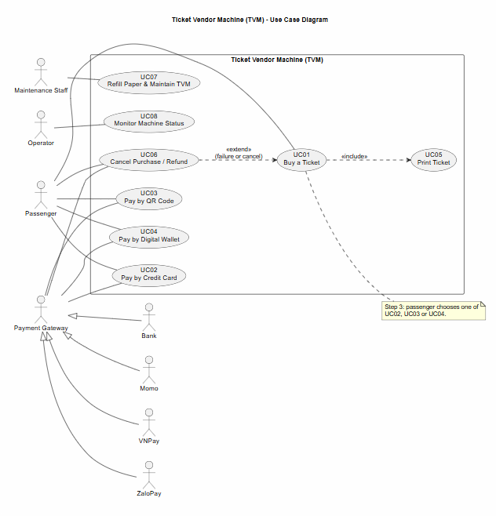
Figure 3.1.1: Use case diagram of the TVM (UC01 to UC08).

3.1.2 Actors and Use Case List
ID | Use case | Primary actor | Short description
UC01 | Buy a Ticket | Passenger | Passenger selects destination and payment method, pays, and receives a printed ticket.
UC02 | Pay by Credit Card | Passenger | Passenger taps or inserts a bank card; the TVM authorizes the payment through the payment gateway.
UC03 | Pay by QR Code | Passenger | Passenger scans a QR code with a banking app and confirms; the gateway sends a signed callback.
UC04 | Pay by Digital Wallet | Passenger | Passenger pays with Momo, VNPay or ZaloPay by scanning a one-time wallet QR code.
UC05 | Print Ticket | none, included in UC01 | The TVM prints the ticket after payment is confirmed. Included in UC01.
UC06 | Cancel Purchase / Refund | Passenger (cancel) or TVM (refund) | Cancels an unpaid transaction, or refunds a paid transaction when printing fails. Extends UC01.
UC07 | Refill Paper & Maintain TVM | Maintenance Staff | Staff refills paper, checks components, and returns the TVM to service.
UC08 | Monitor Machine Status | Operator | Operator watches machine status and alerts, dispatches maintenance, and reviews reconciliation results.

3.1.3 Use Case Descriptions
UC01: Buy a Ticket
Item | Content
Use case ID and name | UC01 – Buy a Ticket
Primary actor / secondary actors | Passenger (primary) / Payment Gateway (secondary)
Related requirements | FR1, FR2, FR3, FR4, FR5, FR6, FR10, FR12, FR15, FR16, FR17, FR18, FR19, FR20, FR21, FR23, FR25  NFR1, NFR5, NFR7, NFR11, NFR12  DR1, DR5, DR7
Pre-conditions | TVM is in service: printer ready with at least 10 tickets of paper (FR17).
Trigger | Passenger presses Start on the idle screen (FR1).
Main flow | 1) Passenger presses Start; TVM shows the destination menu within 1 s (FR2, NFR1).  2) Passenger chooses a destination and 1 to 5 tickets; TVM shows the total and an order summary (FR3, FR4, FR5).  3) Passenger confirms the summary and chooses a payment mode; TVM opens the payment screen for UC02, UC03 or UC04 (FR6).  4) Payment completes; TVM verifies the signed result (FR10).  5) TVM calls UC05 to print one ticket per unit (FR15, FR16).  6) TVM shows completion and records the transaction (FR19, FR20).  7) Passenger takes the tickets and leaves.
Alternate flows | A1: After a failed attempt, the passenger changes the payment mode and returns to step 3 (FR12).
Exception flows | E1: Payment declined – UC02 applies: generic message, up to 3 attempts or a change of mode, then cancel (FR12).  E2: No touch input for 60 s on a selection screen – 10 s warning, then cancel and return to Start (FR21).  E3: Printing fails after payment – UC05 retries once, then UC06 refunds and UC08 is alerted (FR18, FR23).  E4: Connection to the gateway lost – transaction is pending and goes to reconciliation (FR25).
Post-conditions | Success: tickets are printed and the transaction is recorded.  Failure or cancel: nothing is charged, or the full amount is refunded; the transaction is recorded with its status (FR19).
UC02: Pay by Credit Card
Item | Content
Use case ID and name | UC02 – Pay by Credit Card
Primary actor / secondary actors | Passenger (primary) / Bank via Payment Gateway (secondary)
Related requirements | FR6, FR7, FR10, FR12, FR23  NFR3, NFR9  DR2
Pre-conditions | UC01 has selected the destination, quantity and total.
Trigger | Passenger chooses Credit Card in UC01 (FR6).
Main flow | 1) Passenger inserts or taps the card; TVM reads it through the EMV reader (FR7, DR2).  2) TVM sends an authorization request for the total to the payment gateway (FR7).  3) Bank responds; TVM receives the result within 10 s in 95% of cases (NFR3).  4) TVM verifies the signed result (FR10) and returns it to UC01.  5) Passenger removes the card when prompted.
Alternate flows | A1: Card asks for a PIN – passenger enters it before step 2 completes.
Exception flows | E1: Declined – generic decline message; up to 3 attempts or a change of mode, then cancel (FR12).  E2: No response within 30 s – attempt is treated as failed, authorization is cancelled, passenger may retry (NFR3).  E3: Card stuck in the reader – TVM alerts UC08 and shows staff contact instructions (FR23).
Post-conditions | Success: approval is recorded. Only a gateway token, card scheme and last 4 digits are kept (NFR9).  Failure: transaction is recorded with status Failed (FR19); nothing is charged.
UC03: Pay by QR Code
Item | Content
Use case ID and name | UC03 – Pay by QR Code
Primary actor / secondary actors | Passenger (primary) / Payment Gateway (secondary)
Related requirements | FR6, FR8, FR10, FR13, FR14, FR23, FR25  NFR2, NFR10  DR3
Pre-conditions | UC01 has selected the total. The payment gateway is available.
Trigger | Passenger chooses Bank QR in UC01 (FR6).
Main flow | 1) TVM requests a one-time VietQR code for the amount and transaction reference (FR8, DR3).  2) Gateway returns the QR code.  3) TVM shows the QR code within 3 s, with a 120 s countdown (FR8, NFR2).  4) Passenger scans it in a banking app and confirms.  5) Gateway sends a signed callback to the TVM.  6) TVM verifies the signature, amount and reference (FR10, NFR10) and returns the result to UC01.
Alternate flows | A1: Passenger switches to another payment mode before scanning.
Exception flows | E1: QR expires after 120 s – code is invalidated; TVM offers regeneration (at most 2 times) or cancel (FR13).  E2: Callback has an invalid signature, wrong amount or unknown reference – it is rejected, logged and UC08 is alerted (NFR10, FR23).  E3: No callback after payment – TVM queries the status; if still unclear, the transaction goes to reconciliation (FR25).  E4: Payment arrives after the QR expired or was cancelled – no ticket is issued and the payment is refunded automatically (FR14).
Post-conditions | Success: transaction has a gateway reference and is confirmed.  Timeout or failure: transaction is recorded as Expired, Cancelled or Failed (FR19); no ticket is issued.
UC04: Pay by Digital Wallet
Item | Content
Use case ID and name | UC04 – Pay by Digital Wallet
Primary actor / secondary actors | Passenger (primary) / Momo, ZaloPay, VNPay (secondary)
Related requirements | FR6, FR9, FR10, FR13, FR14, FR23, FR25  NFR2, NFR10  DR3
Pre-conditions | UC01 has selected the total. The chosen wallet is operating.
Trigger | Passenger chooses a digital wallet in UC01 (FR6).
Main flow | 1) TVM requests a one-time QR code for the selected wallet (FR9, DR3).  2) TVM shows the QR code within 3 s, with a 120 s countdown (NFR2).  3) Passenger scans it in the wallet app and confirms.  4) Wallet sends a signed callback to the TVM.  5) TVM verifies the callback (FR10, NFR10) and returns the result to UC01.
Alternate flows | A1: Passenger switches to another payment mode before scanning (as in UC03 A1).
Exception flows | E1: QR expires after 120 s – regeneration (at most 2 times) or cancel (FR13).  E2: Invalid callback – rejected, logged and UC08 is alerted (NFR10, FR23).  E3: No callback after payment – status query; if still unclear, reconciliation (FR25).  E4: Late payment – no ticket is issued and the payment is refunded automatically (FR14).
Post-conditions | Success: transaction is confirmed with the wallet's reference.  Failure: transaction is recorded as Failed or Cancelled (FR19); no ticket is issued.
UC05: Print Ticket
Item | Content
Use case ID and name | UC05 – Print Ticket
Primary actor / secondary actors | none, included in UC01 / none
Related requirements | FR15, FR16, FR17, FR18  NFR4  DR4
Pre-conditions | Payment is confirmed. Printer is ready with at least 10 tickets of paper (FR17).
Trigger | UC01 calls UC05 after payment is confirmed (FR15).
Main flow | 1) TVM sends a print job for each ticket: mode, origin, destination, fare, date and time, validity and a Code 128 barcode with a unique 16-digit number and check digit (FR15, FR16, DR4).  2) Printer prints the first ticket within 5 s of confirmation and each further ticket within 3 s (NFR4).  3) TVM confirms the print and records the ticket status.
Alternate flows | A1: Multi-ticket purchase (up to 5) – tickets are printed one by one, each with its own barcode (FR16).
Exception flows | E1: Printer error (out of paper, jam) – TVM retries once (FR18); if it still fails, UC06 refunds and UC08 is alerted (FR18, FR23).  E2: Printer connection lost – TVM retries once, then follows E1.
Post-conditions | Success: all tickets are printed and the transaction is complete.  Error: the payment is refunded (UC06).
UC06: Cancel Purchase / Refund
Item | Content
Use case ID and name | UC06 – Cancel Purchase / Refund
Primary actor / secondary actors | Passenger (cancel) or TVM (automatic refund) / Payment Gateway (secondary)
Related requirements | FR11, FR14, FR18, FR19, FR21  NFR6  DR8
Pre-conditions | A transaction is pending (not yet confirmed), or has been paid without a ticket being issued.
Trigger | Passenger presses Cancel (FR11); UC05 fails after one retry (FR18); 60 s without touch (FR21); late payment (FR14).
Main flow | 1) TVM decides whether to cancel or refund.  2) TVM sends the cancel request (void the authorization or invalidate the QR) or the refund request to the gateway within 60 s (NFR6).  3) Gateway confirms.  4) TVM shows a message with the refund reference; the refund goes to the original payment method (DR8).
Alternate flows | A1: Only part of the transaction failed – partial refund is issued.
Exception flows | E1: Gateway cannot confirm the refund – transaction goes to the reconciliation queue and UC08 is alerted; any refund open for more than 24 h is escalated (NFR6).  E2: Passenger cancels while entering card details – transaction is cancelled at once and no payment request is sent (FR11).
Post-conditions | Money is refunded or the transaction is cancelled.  Status is recorded in the transaction log (FR19).
UC07: Refill Paper & Maintain TVM
Item | Content
Use case ID and name | UC07 – Refill Paper & Maintain TVM
Primary actor / secondary actors | Maintenance Staff (primary) / none
Related requirements | FR17, FR23, FR24  NFR8
Pre-conditions | Staff holds an authorised staff card and PIN (FR24).
Trigger | Low-paper warning (50 tickets or fewer, FR23) or scheduled maintenance.
Main flow | 1) Staff inserts the staff card and enters the PIN (FR24).  2) TVM enters maintenance mode and stops sales.  3) Staff refills the paper, runs a test print and checks the machine status.  4) Staff confirms; TVM returns to service only when the printer is ready and at least 10 tickets of paper remain (FR17).
Alternate flows | A1: Staff only refills paper, without a full check.
Exception flows | E1: Staff card or PIN is invalid – access is denied and the attempt is logged (FR24).  Rule: every maintenance access is logged with staff ID and time (FR24).
Post-conditions | TVM is in service, or is marked as needing repair.  Access and maintenance log is updated.
UC08: Monitor Machine Status
Item | Content
Use case ID and name | UC08 – Monitor Machine Status
Primary actor / secondary actors | Operator (primary) / none (reconciliation uses gateway settlement files)
Related requirements | FR22, FR23, FR25  NFR8  DR6
Pre-conditions | TVM is connected to the central monitoring server.
Trigger | Machine status changes or an alert is raised, or the daily reconciliation time arrives.
Main flow | 1) TVM sends a heartbeat every 60 s (NFR8).  2) TVM shows Out of service and blocks sales when the printer, the server connection or all payment modes are unavailable (FR22).  3) Operator receives alerts for low paper, printer errors, lost connection and gateway failure within 60 s (FR23).  4) Operator dispatches maintenance (UC07).  5) System produces the daily reconciliation report by payment mode and status and compares it with the gateway settlement files (FR25).
Alternate flows | A1: Operator views the error history of one machine.
Exception flows | E1: No heartbeat within the 60 s interval (NFR8) – alert is raised to the Operator.  E2: Reconciliation mismatch – transaction is flagged for manual checking (FR25).
Post-conditions | Machine status is updated.  Records are kept for at least 10 years (DR6).

3.2 Activity Diagrams (10 marks)

3.2.1 Passenger Buys a Ticket at the TVM

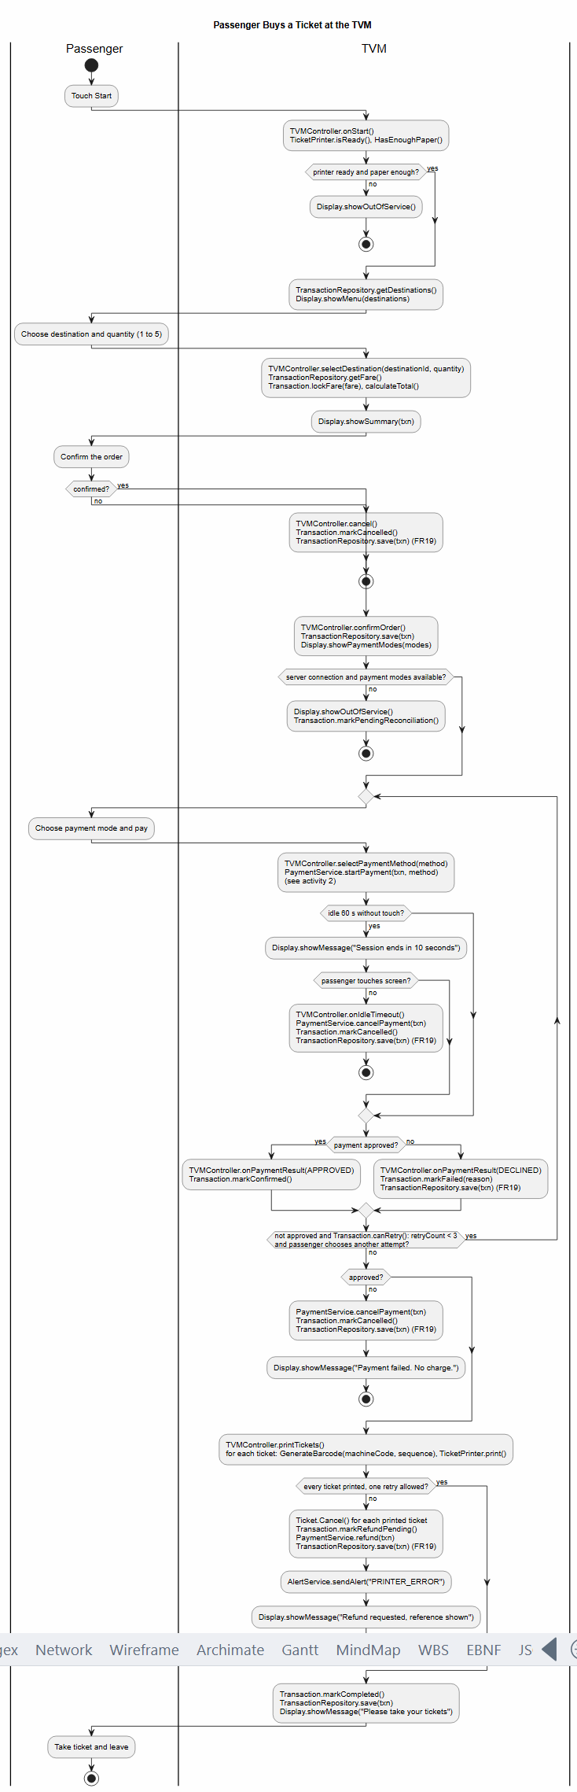

Figure 3.2.1: Activity diagram, passenger buys a ticket at the TVM.

3.2.2 Communication with External Payment Gateways
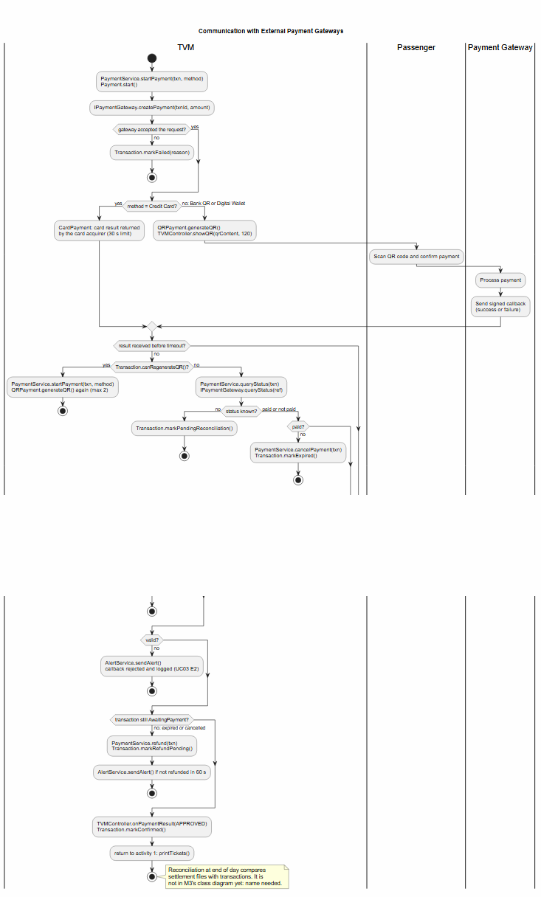
Figure 3.2.2: Activity diagram, communication with external payment gateways.

3.3 Detailed System Modeling: Main Use Case "Buy a Ticket" (15 marks)

3.3.1 Sequence Diagram 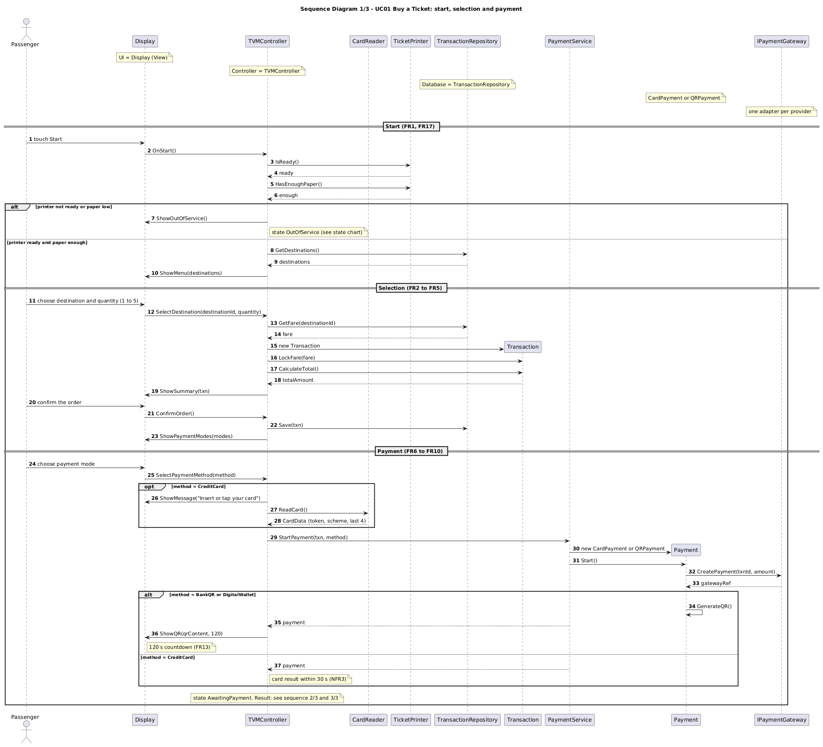
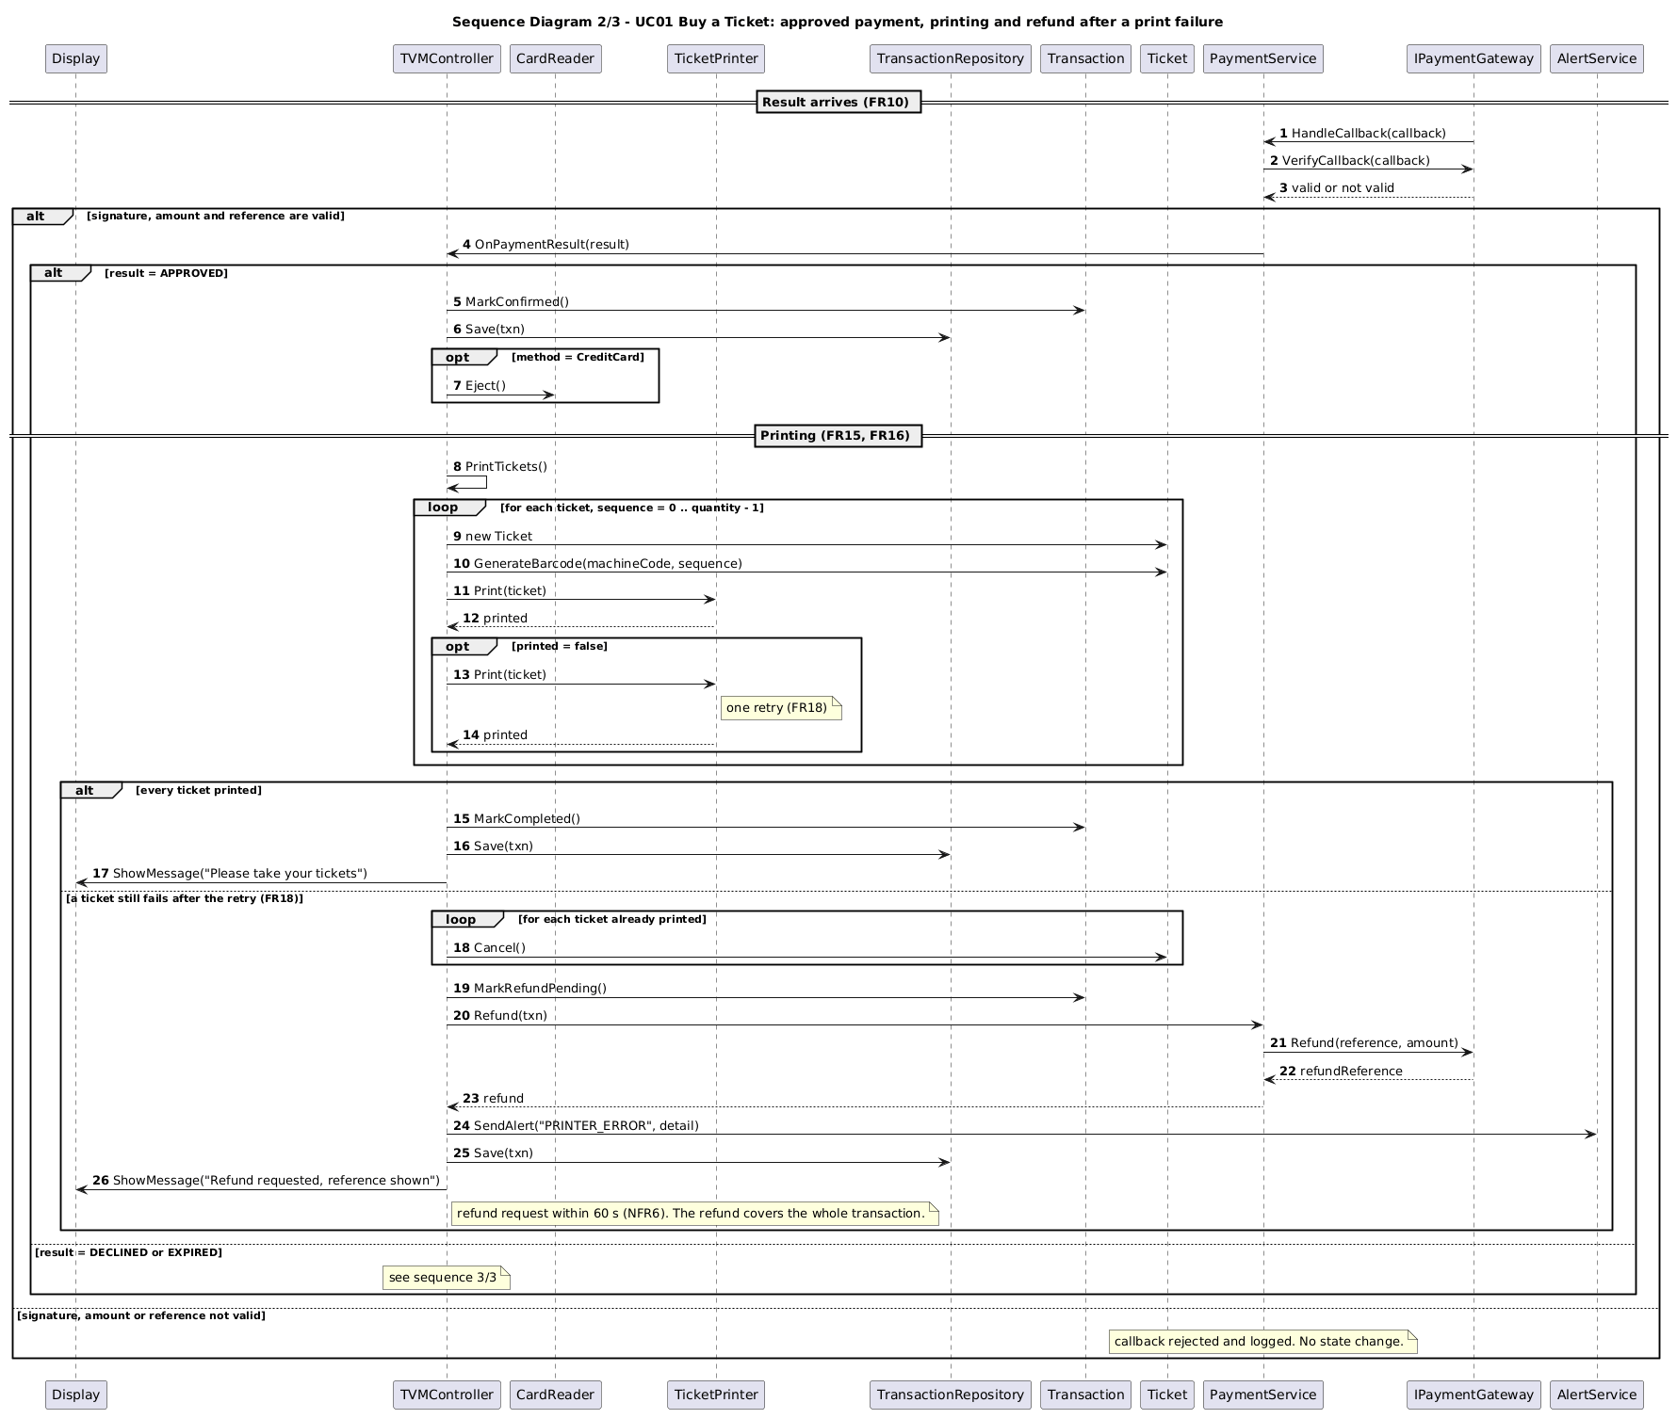
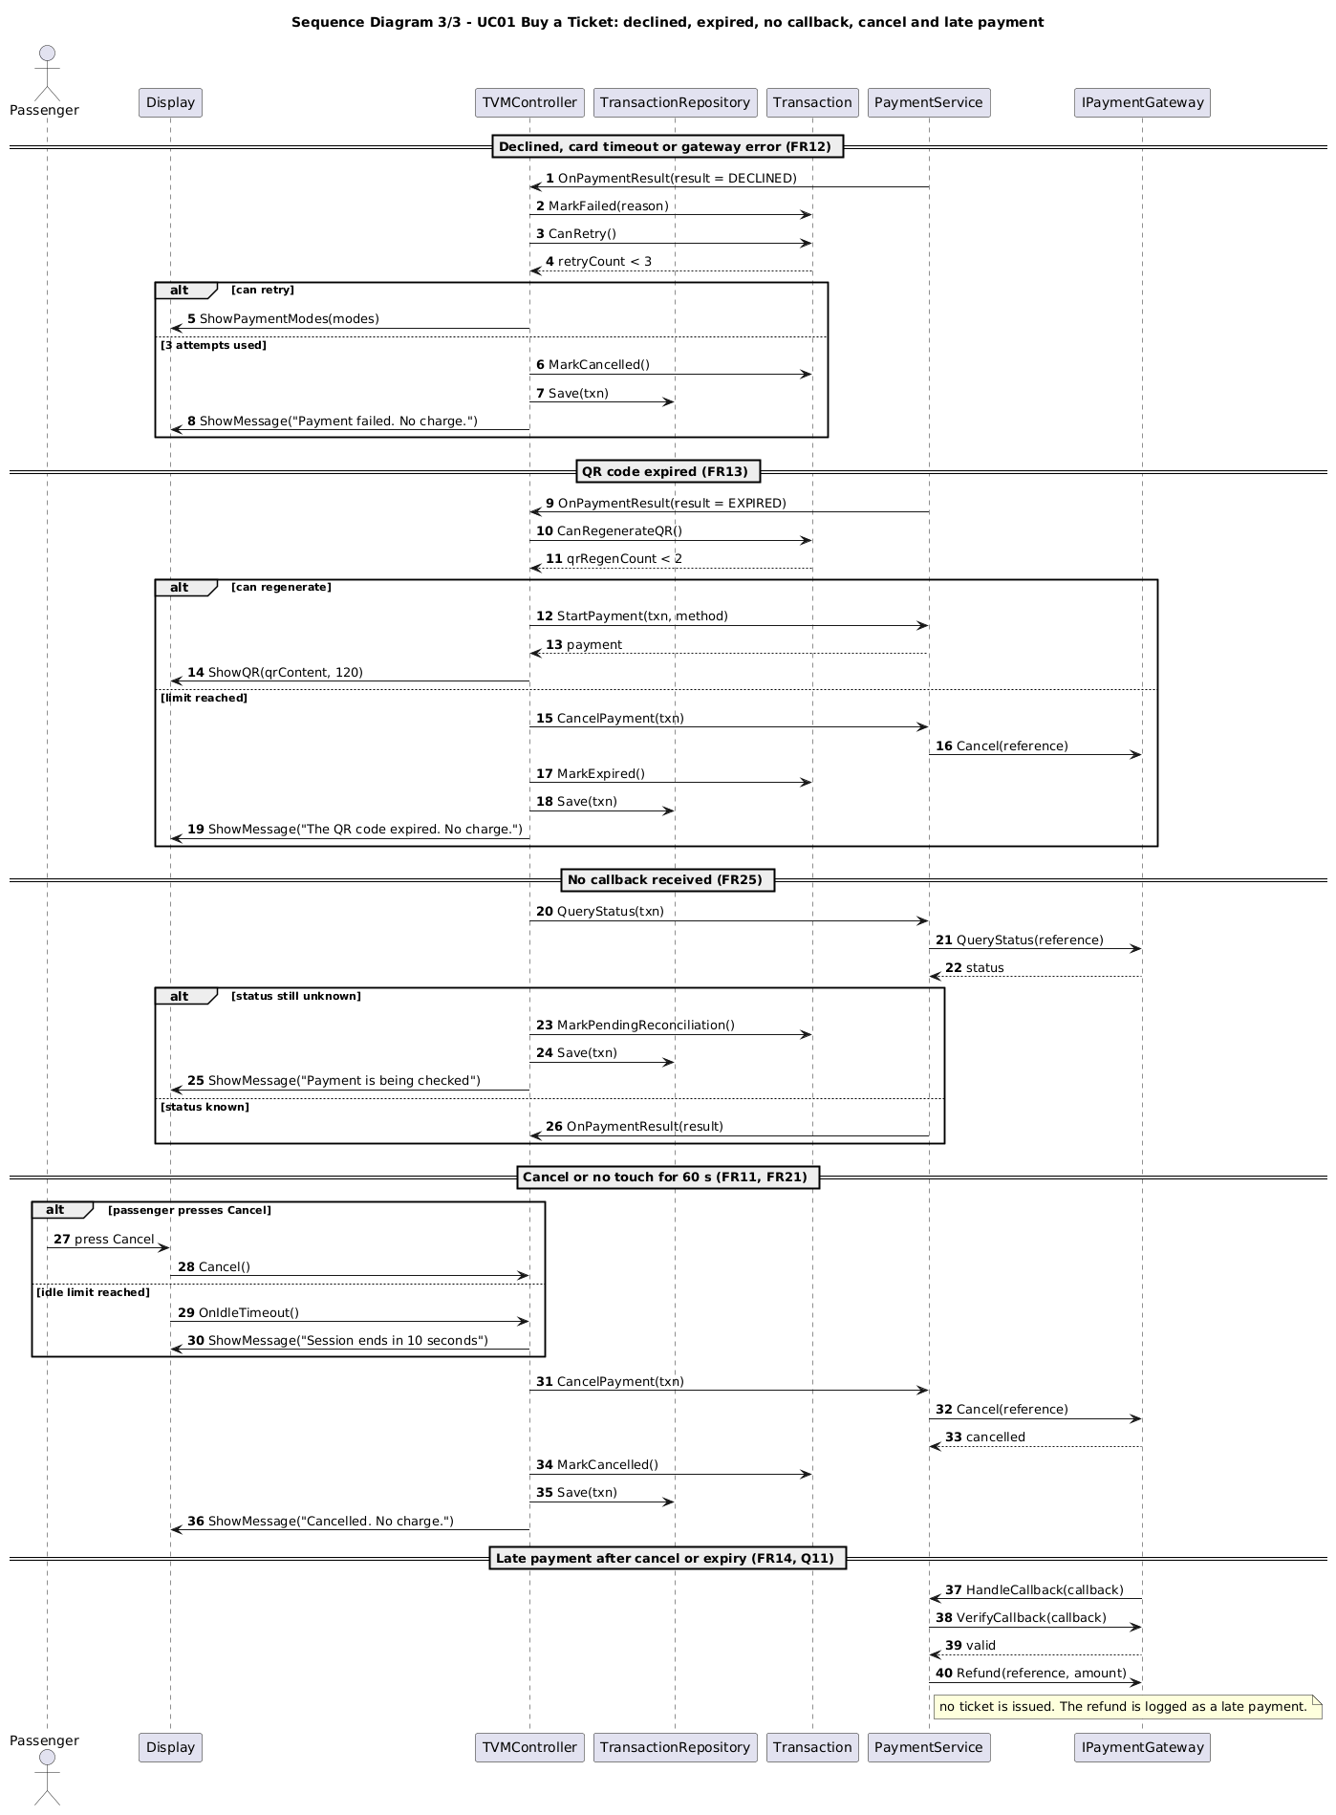

3.3.2 State Chart Diagram
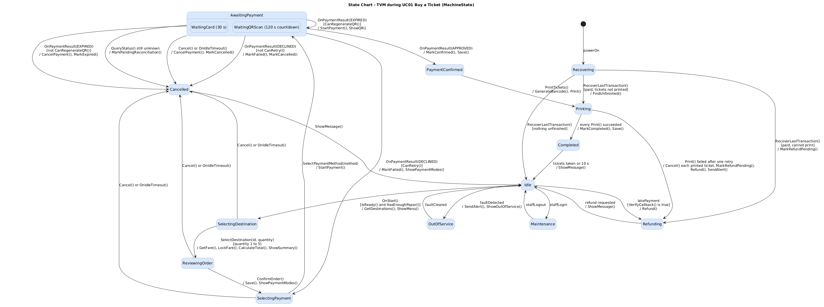

3.3.3 Class Diagram (Domain Model)
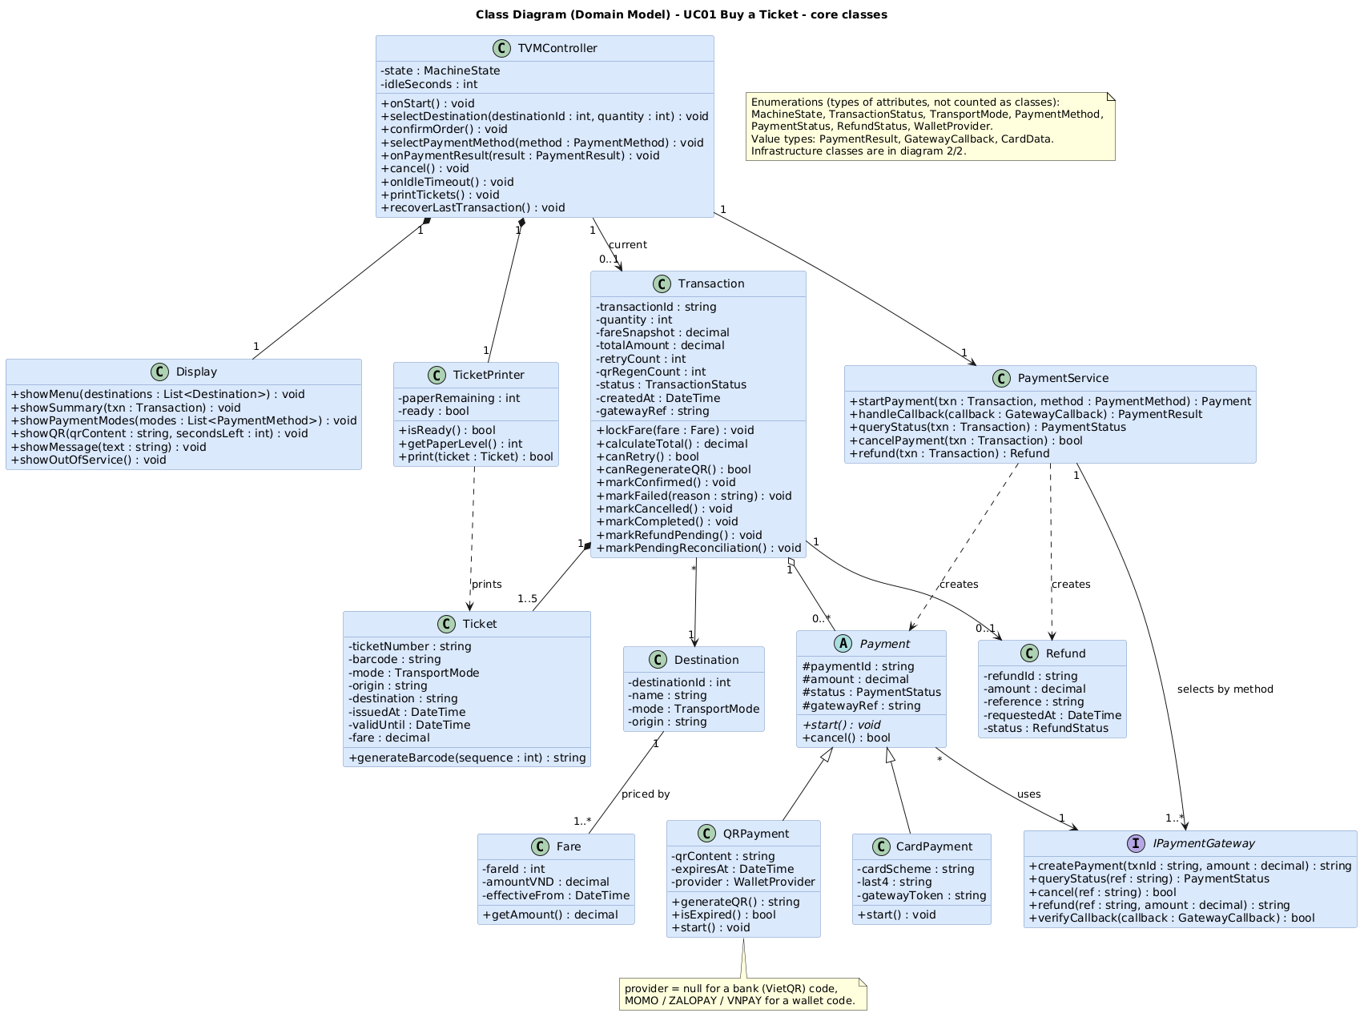
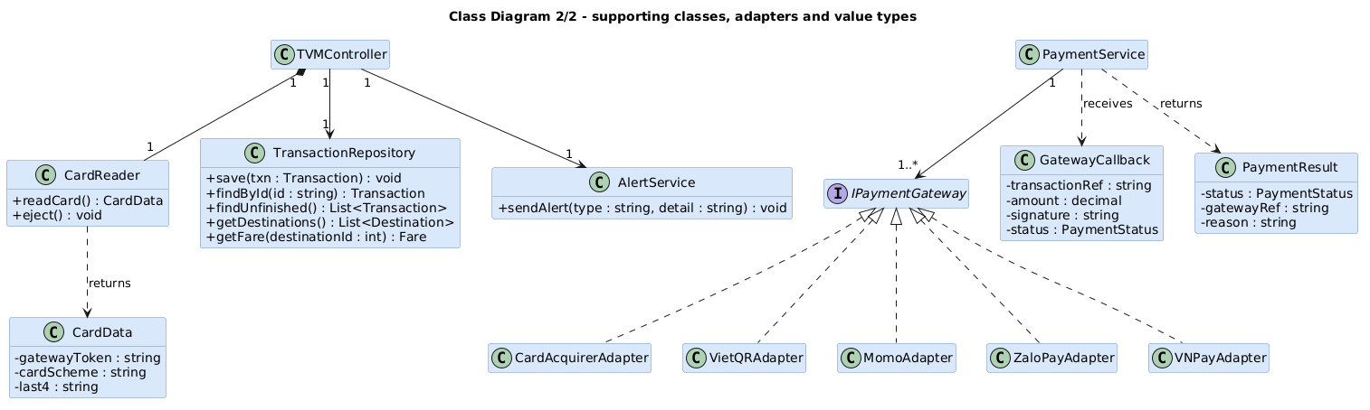
Class | Key attributes | Key methods | Relationships
TVMController | state : MachineState, idleSeconds | onStart(), selectDestination(), confirmOrder(), selectPaymentMethod(), onPaymentResult(), cancel(), onIdleTimeout(), printTickets(), recoverLastTransaction() | Composes Display and TicketPrinter; uses PaymentService; 0..1 current Transaction
Display | none | showMenu(), showSummary(), showPaymentModes(), showQR(), showMessage(), showOutOfService() | Composed by TVMController
TicketPrinter | paperRemaining, ready | isReady(), getPaperLevel(), print() | Composed by TVMController; prints Ticket
Destination | destinationId, name, mode, origin | none | 1 to 1..* Fare; referenced by many Transaction
Fare | fareId, amountVND, effectiveFrom | getAmount() | Many to 1 Destination
Transaction | transactionId, quantity (1..5), fareSnapshot, totalAmount, retryCount, qrRegenCount, status, createdAt, gatewayRef | lockFare(), calculateTotal(), canRetry(), canRegenerateQR(), markConfirmed(), markFailed(), markCancelled(), markCompleted(), markRefundPending(), markPendingReconciliation() | Many to 1 Destination; 1 to 0..* Payment (aggregation); 1 to 1..5 Ticket (composition); 1 to 0..1 Refund
Ticket | ticketNumber (16 digits), barcode (Code 128), mode, origin, destination, issuedAt, validUntil, fare | generateBarcode(sequence) | Part of Transaction; printed by TicketPrinter
Refund | refundId, amount, reference, requestedAt, status | none | 0..1 per Transaction; created by PaymentService
PaymentService | none | startPayment(), handleCallback(), queryStatus(), cancelPayment(), refund() | Selects 1..* IPaymentGateway by payment mode; creates Payment and Refund
Payment (abstract) | paymentId, amount, status, gatewayRef | start(), cancel() | Generalised by CardPayment and QRPayment; uses 1 IPaymentGateway
CardPayment | cardScheme, last4, gatewayToken | start() | Extends Payment
QRPayment | qrContent, expiresAt (120 s), provider (null = bank QR, else wallet) | generateQR(), isExpired(), start() | Extends Payment
IPaymentGateway (interface) | none | createPayment(), queryStatus(), cancel(), refund(), verifyCallback() | Realised by CardAcquirerAdapter, VietQRAdapter, MomoAdapter, ZaloPayAdapter, VNPayAdapter
Supporting classes (diagram 2/2) | CardReader, TransactionRepository, AlertService; value types CardData, GatewayCallback, PaymentResult | readCard(), eject(); save(), findById(), findUnfinished(), getDestinations(), getFare(); sendAlert() | Used by TVMController and PaymentService

3.4 Model Consistency Check
Consistency check | Diagrams involved | Done
Every use case in the diagram has a description, and every description is in the diagram | Use case diagram / descriptions | x
Every step of the main flow appears in the activity diagram | Descriptions / activity | x
Objects and messages in the sequence diagram exist as classes and methods in the class diagram | Sequence / class | x
State names and transitions match the events in the sequence diagram | State chart / sequence | x
Payment gateway steps match between the two activity diagrams and the sequence diagram | Activity / sequence | x
Requirement IDs are cited in the use cases | Requirements / use cases | x
The class diagram matches the C# code generated in 5.1 | Class / code | x

4. Phase 3: UI/UX & Architecture (15 marks)

4.1 UI/UX Design (5 marks)
Screen | Name / purpose | Linked use case step | Tool and link
S01 | Home / Start — Idle welcome screen showing station status (Bus & MRT), bilingual EN/VI toggle, High-Contrast switch, and large 'Touch to Start' CTA. | UC01 Pre-condition & Step 1: Passenger presses Start -> TVMController.onStart() checks TicketPrinter.isReady(). | Figma: https://www.figma.com/design/chjKyWaJin2KMWQ9iaUzuP/TVM| HTML: ui/tvm_glassmorphism_mockups.html#S01
S02 | Destination & Quantity Menu — 4x3 touchscreen station grid (HCMC Metro Line 1 [MRT] & Feeder [BUS], FR15) + ticket quantity stepper (1–5, FR3) and live FareSnapshot total (FR4). | UC01 Step 2: Passenger selects destination & quantity -> TVMController.selectDestination(id, qty) & confirmOrder(). | Figma: https://www.figma.com/design/chjKyWaJin2KMWQ9iaUzuP/TVM| HTML: ui/tvm_glassmorphism_mockups.html#S02
S03 | Payment Mode Selection — 3 large touch cards: Credit/Debit Card (EMV/NFC), Bank QR (VietQR Napas 247), or Digital Wallet (MoMo / ZaloPay / VNPay). | UC01 Step 3: Passenger selects PaymentMethod -> TVMController.selectPaymentMethod(method). | Figma: https://www.figma.com/design/chjKyWaJin2KMWQ9iaUzuP/TVM| HTML: ui/tvm_glassmorphism_mockups.html#S03
S04a | Card Payment Processing — Prompts passenger to tap NFC or insert EMV chip card on CardReader with live countdown timer and Cancel button. | UC01 Step 4a (Card Branch): CardPayment.start() via CardAcquirerAdapter; awaits Approved/Declined token response. | Figma: https://www.figma.com/design/chjKyWaJin2KMWQ9iaUzuP/TVM| HTML: ui/tvm_glassmorphism_mockups.html#S04a
S04b | QR / Digital Wallet Payment — Displays dynamic QR code (QRPayment.generateQR(), provider=null for VietQR or Momo/ZaloPay/VNPay) with 120s countdown (FR13). | UC01 Step 4b (QR/Wallet Branch): Awaits signed GatewayCallback webhook verified via IPaymentGateway.verifyCallback() (FR10). | Figma: https://www.figma.com/design/chjKyWaJin2KMWQ9iaUzuP/TVM| HTML: ui/tvm_glassmorphism_mockups.html#S04b
S05a | Ticket Issued (Success) — Renders printed paper ticket preview with 16-digit Luhn TicketNumber & 1D Barcode (DR4, FR16), 24h validity, and dispenser prompt. | UC01 Steps 5–6 (Main Post-condition): TVMController.printTickets() -> Transaction.markCompleted(). | Figma: https://www.figma.com/design/chjKyWaJin2KMWQ9iaUzuP/TVM| HTML: ui/tvm_glassmorphism_mockups.html#S05a
S05b | Payment Declined — Error alert when issuer/wallet rejects payment; displays explicit green banner ('NOT CHARGED — 0 VND') and retry option (up to 3 attempts, FR12). | UC01 Exception E1 (Card/Wallet Declined): Transaction.markFailed(); passenger may retry if canRetry() or cancel. | Figma: https://www.figma.com/design/chjKyWaJin2KMWQ9iaUzuP/TVM| HTML: ui/tvm_glassmorphism_mockups.html#S05b
S06 | Cancel Confirmation — Modal confirmation preventing accidental mid-flow exit, stating clearly that cancelling now deducts 0 VND. | UC01 Exception E3 (User Cancel): TVMController.cancel() -> PaymentService.cancelPayment() & Transaction.markCancelled(). | Figma: https://www.figma.com/design/chjKyWaJin2KMWQ9iaUzuP/TVM| HTML: ui/tvm_glassmorphism_mockups.html#S06
S07 | Payment Timeout — Shown when 120s QR/payment timer reaches 00:00 without callback; warns not to scan expired QR and states charge/auto-refund policy. | UC01 Exception E2 (Gateway/QR Timeout): QRPayment.isExpired() (FR13); allows regenerateQR() (<=2) or return to S01. | Figma: https://www.figma.com/design/chjKyWaJin2KMWQ9iaUzuP/TVM| HTML: ui/tvm_glassmorphism_mockups.html#S07
S08 | Machine Out of Service — Full-screen hardware/DB lock screen when printer is out of paper or DB is unreachable, displaying explicit charge/auto-refund banner & hotline. | UC01 Exception E4/E5 (Printer Fault / Out of Service): MachineState.OutOfService + AlertService.sendAlert(); Refund if post-charge. | Figma: https://www.figma.com/design/chjKyWaJin2KMWQ9iaUzuP/TVM | HTML: ui/tvm_glassmorphism_mockups.html#S08
Touchscreen Mockups & Implemented Glassmorphism Screens (1280×800 Landscape, S01–S08):
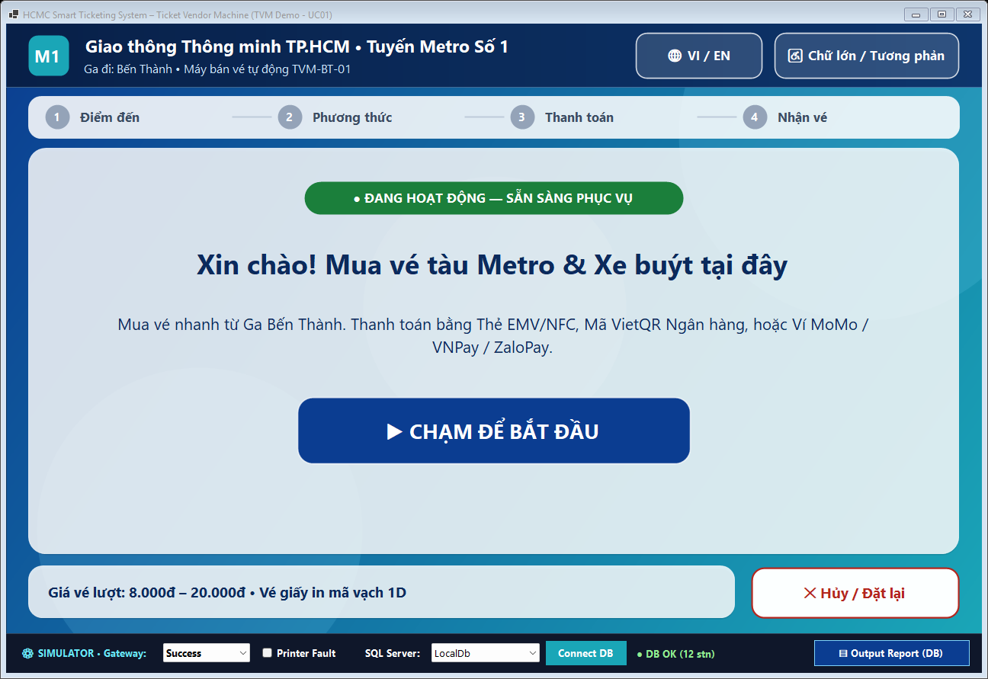  S01: Home / Start Screen (1280×800) | 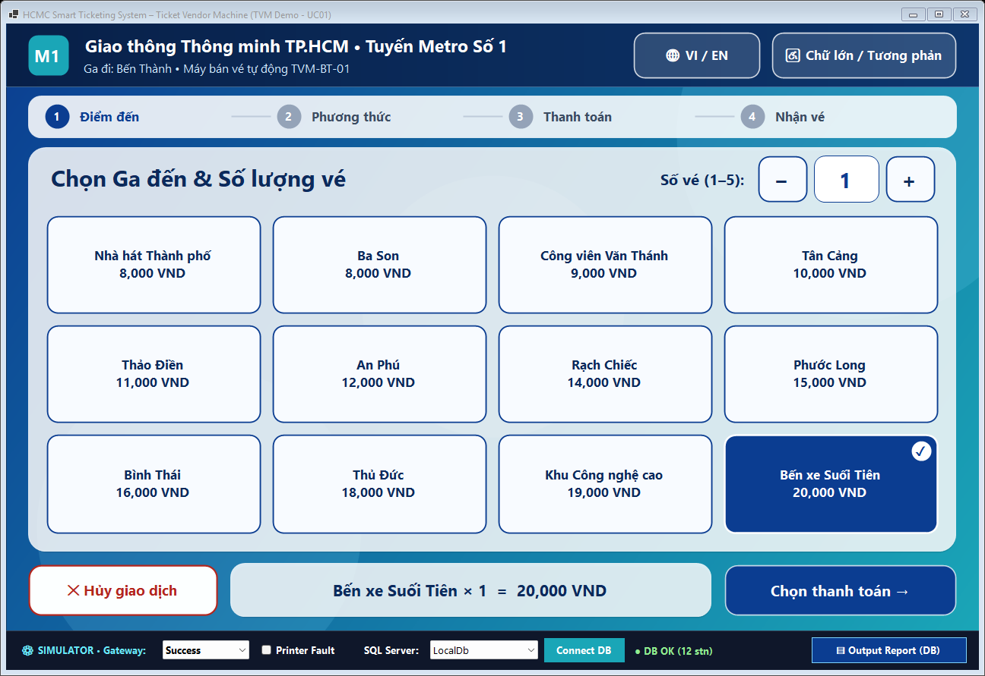  S02: Destination & Quantity Menu (1–5 Tickets)
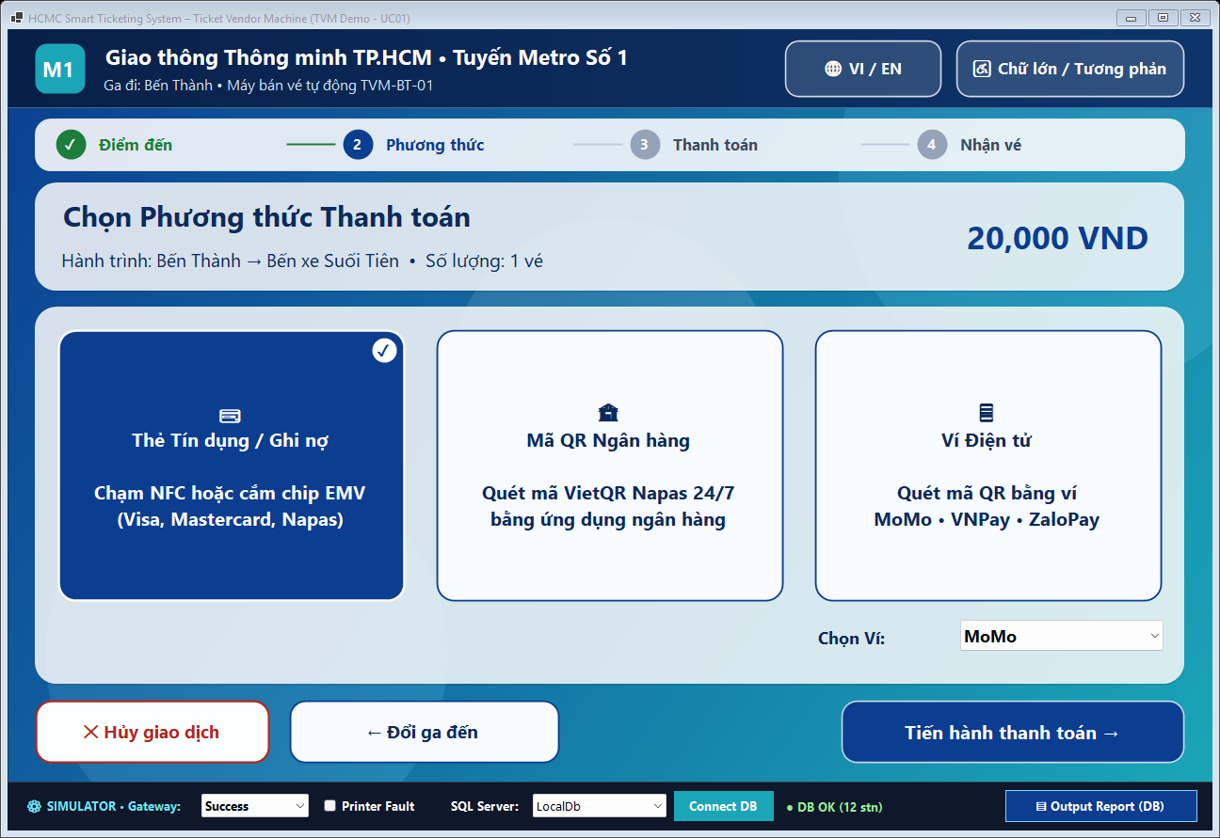  S03: Payment Mode Selection (Card / VietQR / Wallet) | 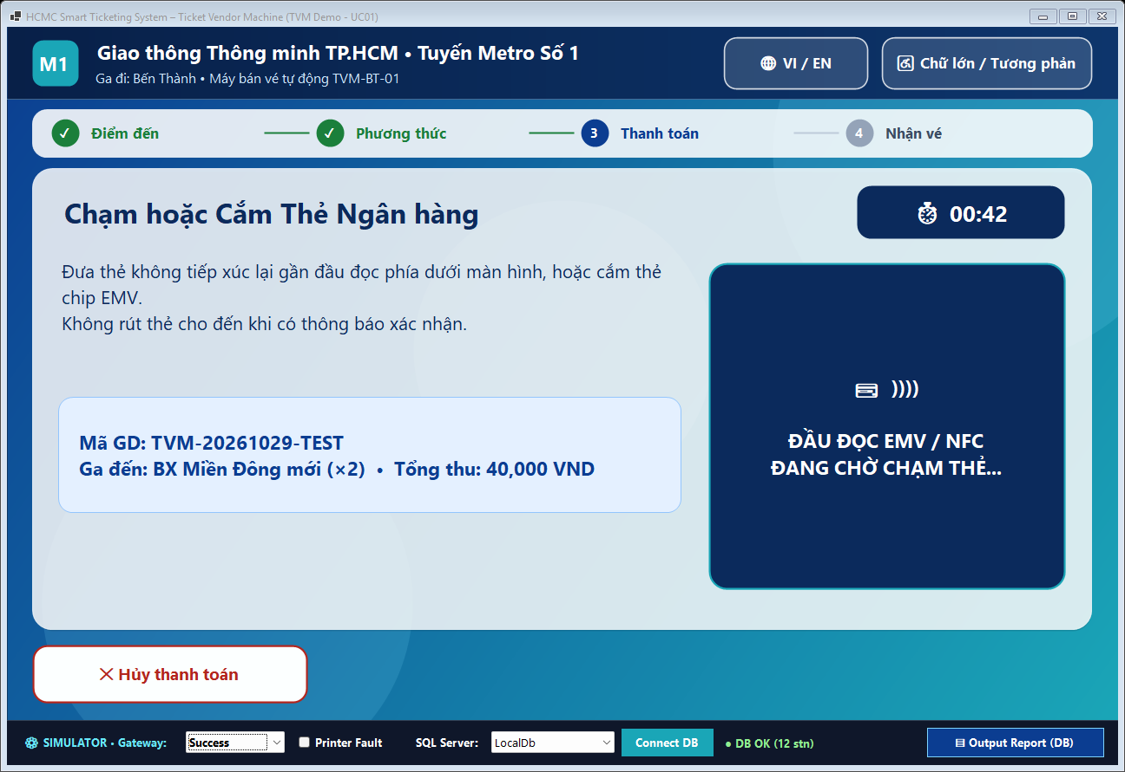  S04a: EMV / NFC Card Payment Screen
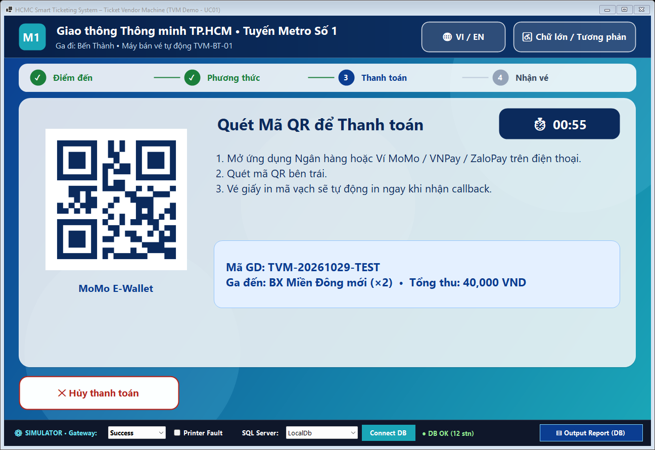  S04b: Dynamic VietQR / Wallet Payment (Countdown) | 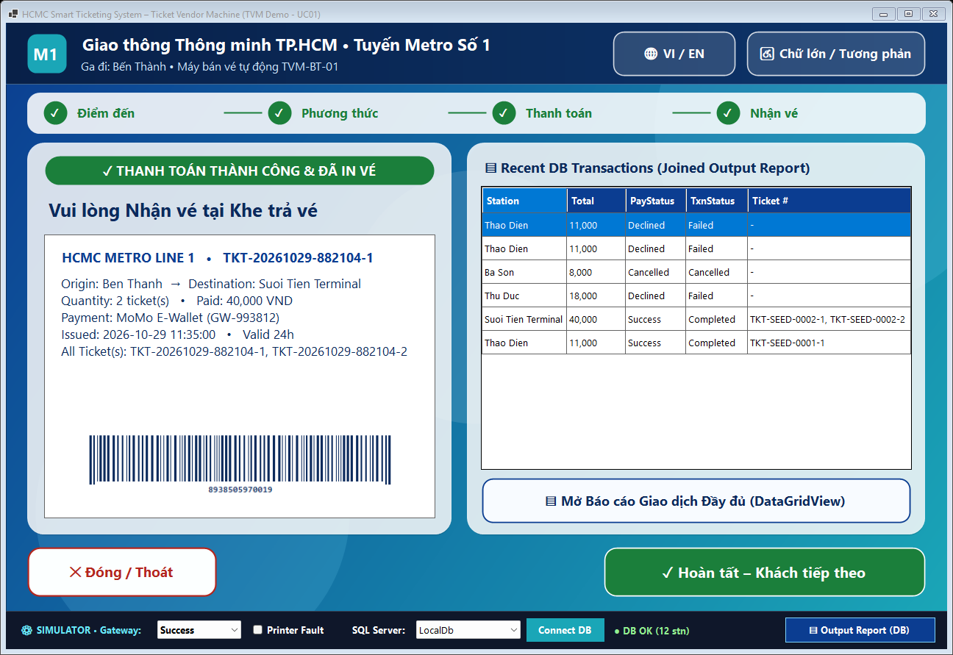  S05a: Ticket Issued with 1D Barcode & DB Summary
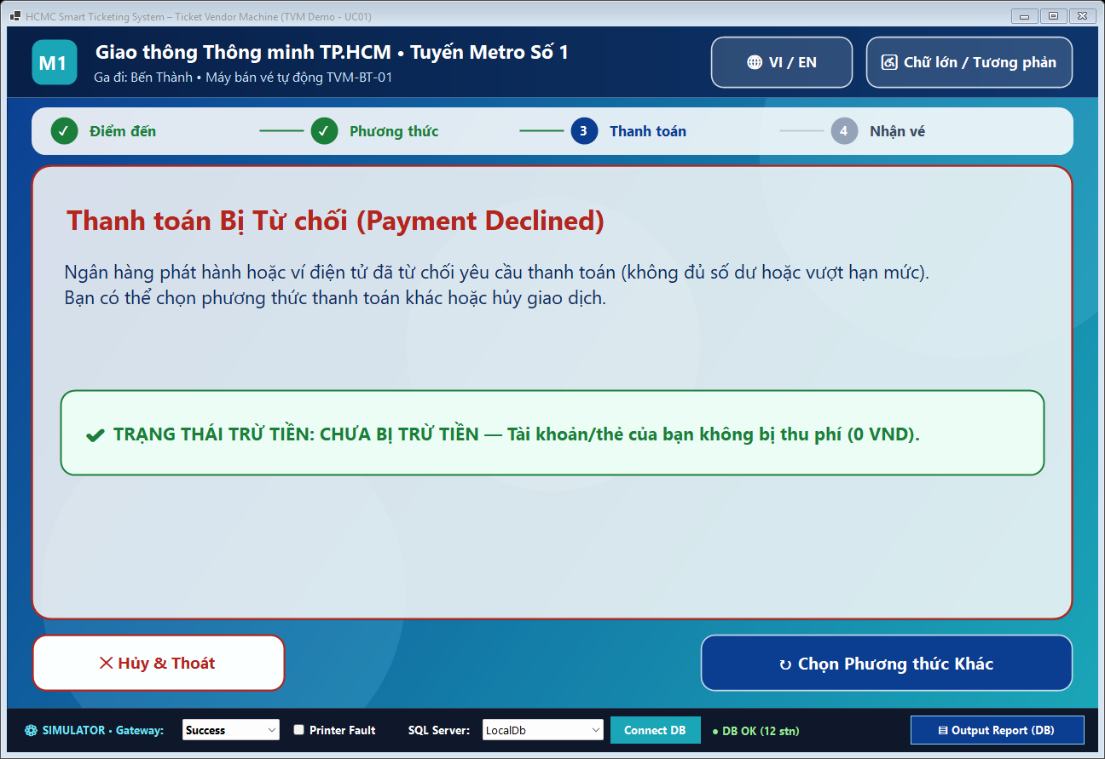  S05b: Payment Declined (Explicit Not-Charged Notice) | 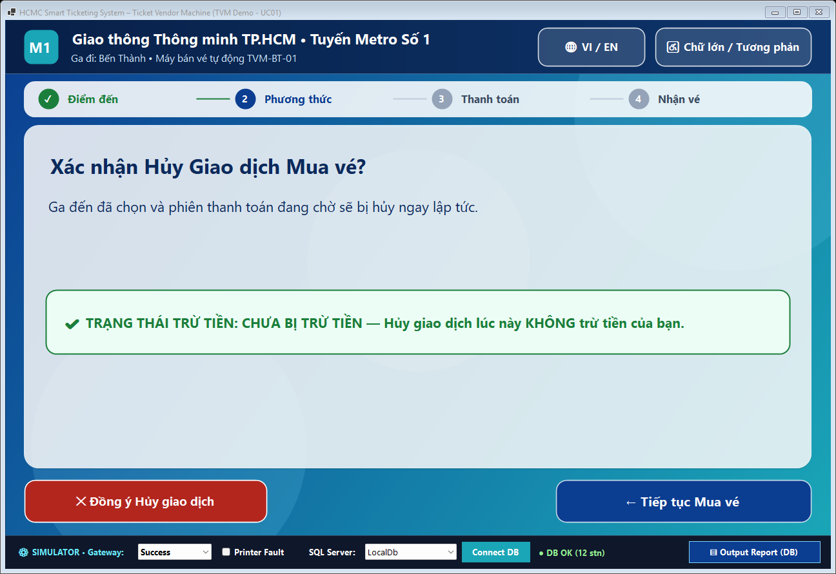  S06: Cancel Confirmation Dialog
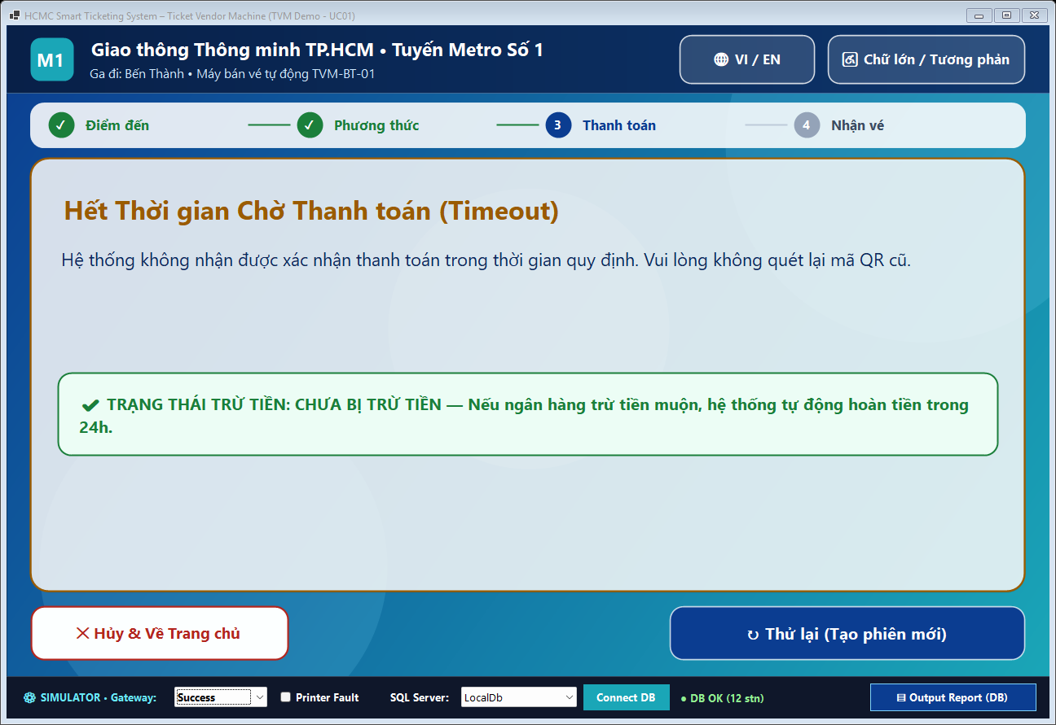  S07: Payment Session Timeout Screen | 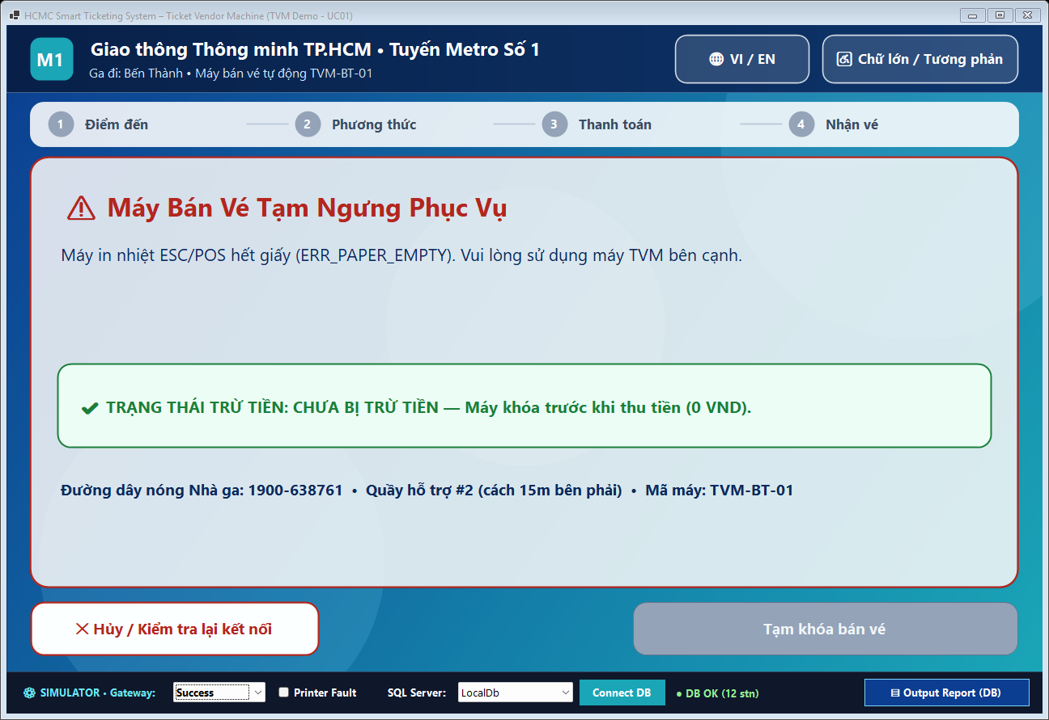  S08: Machine Out of Service / Hardware Lock
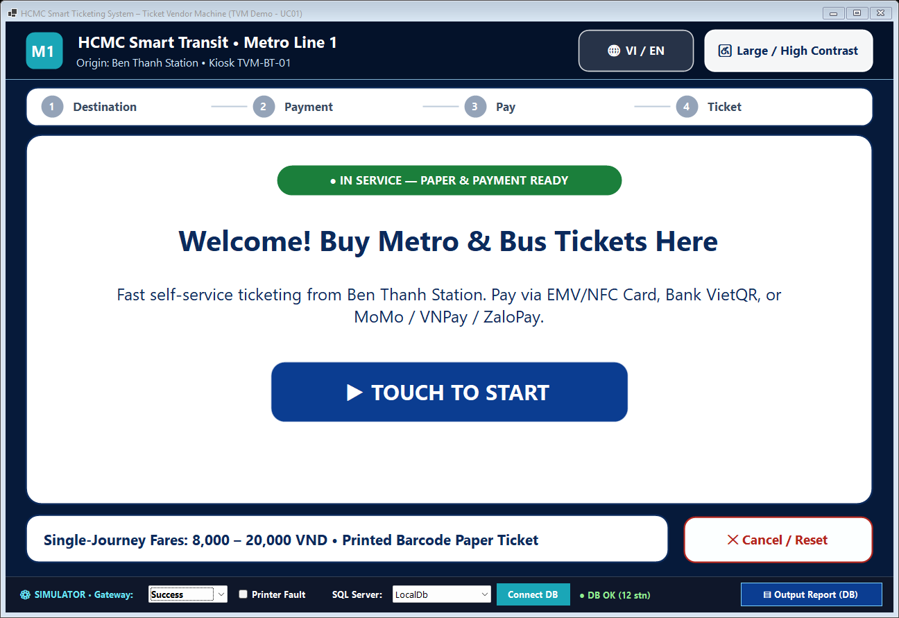
Accessibility Mode: English + High-Contrast / Large Text

Design Tokens Summary: Ambient gradient #0B3D91 -> #1AA6B7; Frosted Glass Surface rgba(255,255,255,0.68) with backdrop-filter: blur(20px), 1 px border rgba(255,255,255,0.42), radius 22 px, shadow 0 8px 32px rgba(0,0,0,0.18); Primary Navy Text #0B2A5C (contrast 9.4:1 >= WCAG AA 4.5:1); Solid Primary CTA #0B3D91; Success #1B7F3B; Error/Cancel #B3261E; Touch Target height >= 64 px; Body 24 px / Heading 40–48 px (Segoe UI / Inter).
Design Rationale: The TVM interface is tailored for rapid commuter throughput in brightly lit public metro and bus stations. All interactive buttons enforce a >= 64 px height and >= 12 px gutter to prevent finger mis-taps, paired with a persistent 4-step progress bar (Destination -> Method -> Pay -> Ticket), bilingual EN/VI switch, and one-tap High-Contrast / Large-Text accessibility mode (disabling translucency into solid #000000/#FFD600 contrast). Crucially, the glassmorphism aesthetic is restricted strictly to structural cards over a soft ocean-teal gradient, while primary action buttons remain solid opaque fills for unmistakable affordance and >9:1 legibility. Every exception screen (S05b, S06, S07, S08) prominently states whether the passenger was charged, eliminating payment anxiety at unattended kiosks.

4.2 Architectural Design (10 marks)

4.2.1 Architecture Diagram
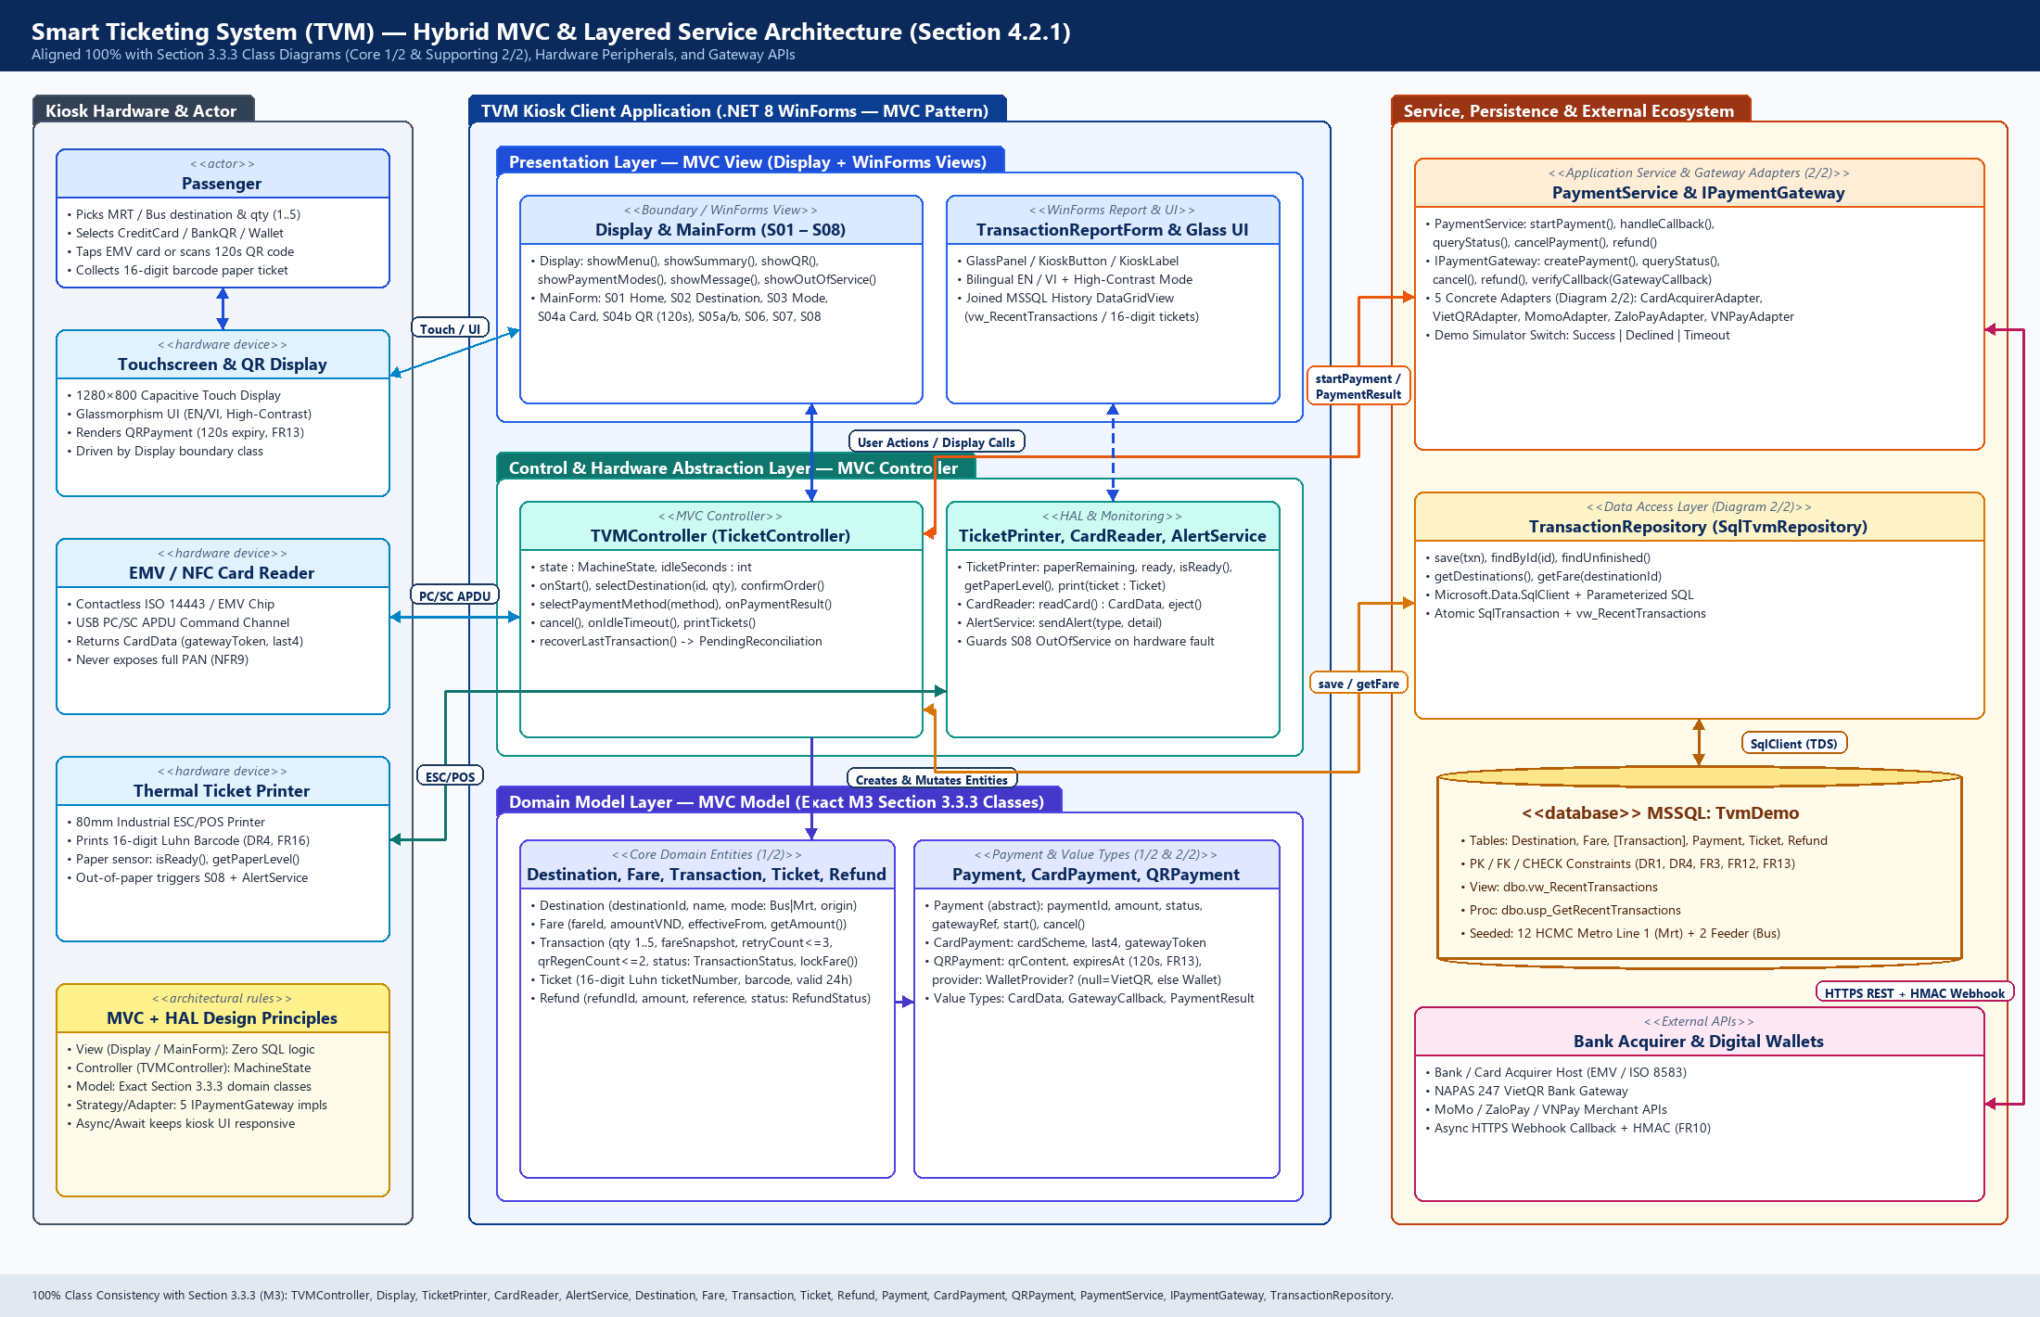
Figure 4.2.1: Hybrid MVC & Layered Service Architecture Aligned with Section 3.3.3 Class Diagrams
The Smart Ticketing TVM adopts a Hybrid Model-View-Controller (MVC) + Layered Service & Hardware Abstraction Architecture that maps 1-to-1 to the Section 3.3.3 Class Diagrams (Core 1/2 & Supporting 2/2):
1. Presentation Layer (MVC View): Implemented by the Display boundary class bound to WinForms MainForm (screens S01–S08) and TransactionReportForm. The View renders station menus, dynamic QR codes, and 120s countdown timers, forwarding user touch gestures to TVMController while containing zero SQL queries or gateway cryptographic secrets.
2. Control & Hardware Abstraction Layer (MVC Controller + HAL): TVMController manages MachineState transitions (Idle -> SelectingDestination -> ReviewingOrder -> SelectingPayment -> AwaitingPayment -> PaymentConfirmed -> Printing -> Completed, plus OutOfService and Recovering) while composing TicketPrinter (ESC/POS), CardReader (PC/SC APDU returning tokenized CardData), and AlertService.
3. Domain Model Layer (MVC Model): Encapsulates pure transport-domain rules shared across all diagrams: Destination (TransportMode: Bus | Mrt, FR15), Fare (whole VND, DR1), Transaction (1..5 tickets FR3, locked FareSnapshot FR4, retryCount <= 3 FR12, qrRegenCount <= 2 FR13), Ticket (16-digit Luhn barcode DR4/FR16), Refund, and abstract Payment extended by CardPayment and QRPayment.
4. Service, Gateway Adapter & Persistence Layer: PaymentService selects the appropriate IPaymentGateway adapter (CardAcquirerAdapter, VietQRAdapter, MomoAdapter, ZaloPayAdapter, or VNPayAdapter) via the Strategy/Adapter pattern, enabling simulated classroom testing (Success/Declined/Timeout) without altering controller or UI code. TransactionRepository isolates parameterized Microsoft.Data.SqlClient persistence against SQL Server (TvmDemo).

4.2.2 Deployment Diagram
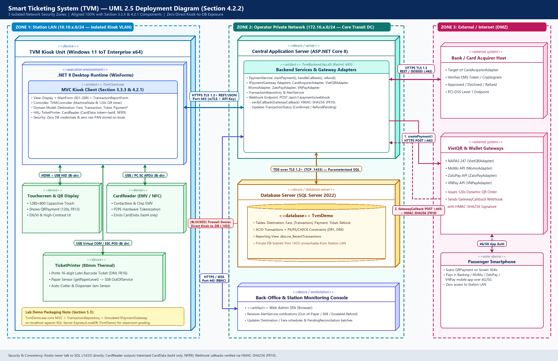
Figure 4.2.2: 3-Zone UML 2.5 Deployment Diagram Showing Hardware Nodes, Network Boundaries, and Protocols
Node / component | Description | Connection (protocol, direction)
TVM Kiosk Unit & Peripherals  (Station LAN 10.10.x.0/24) | Industrial Windows 11 IoT Enterprise x64 kiosk running .NET 8 TvmClient.exe (Display/MainForm S01–S08, TVMController, local Domain Model) connected inside a locked steel enclosure to: (1) 1280×800 Capacitive Touchscreen & QR Display, (2) EMV/NFC CardReader, and (3) 80mm ESC/POS Thermal TicketPrinter. | • Touchscreen: HDMI + USB HID (Bi-directional, local)  • CardReader: USB / PC-SC APDU (Bi-directional, tokenized CardData)  • TicketPrinter: USB Virtual COM / ESC-POS (Bi-directional paper status)  • To App Server: Outbound HTTPS TLS 1.2+ REST/JSON (:443, mTLS)
Central Application Server  (Operator Private Network) | ASP.NET Core 8 backend (TvmBackend.Api.dll on Kestrel :443) hosting PaymentService, AlertService, TransactionRepository, the 5 IPaymentGateway adapters, and the public-DMZ reverse-proxied Webhook endpoint (/api/v1/payments/webhook). | • From TVM Kiosks: Inbound HTTPS TLS 1.2+ REST/JSON (:443)  • To Database Server: Outbound TDS over TLS 1.2+ (TCP :1433)  • To External Gateways: Outbound HTTPS TLS 1.3 REST (:443)  • From Gateways: Inbound Async HTTPS POST Webhook (:443, HMAC-SHA256)
Database Server  (Isolated DB Subnet) | Microsoft SQL Server 2022 hosting relational database TvmDemo (Destination, Fare, [Transaction], Payment, Ticket, Refund, vw_RecentTransactions) with ACID transactions and daily backups. | • From Central Application Server ONLY: Inbound TDS over TLS 1.2+ (TCP :1433).  • Direct access from Station LAN or Internet strictly blocked by firewall.
Back-Office & Monitoring Console  (Operator Private Network) | Station operator workstation running Web Admin SPA to monitor live TVM heartbeats, AlertService out-of-paper/S08 alarms, Fare schedules, and PendingReconciliation batches. | • To Central Application Server: Outbound HTTPS REST & Secure WebSocket WSS (:443, RBAC authenticated).
Bank / Card Acquirer Host  (External / Internet) | External PCI-DSS Level 1 financial switch (Visa / Mastercard / NAPAS) targeted by CardAcquirerAdapter to authorize EMV cryptograms and process reversals/refunds. | • From Application Server: Synchronous HTTPS TLS 1.3 REST / ISO 8583 gateway (:443, Bi-directional request/response).
VietQR & Digital Wallet Gateways  (External / Internet) | External NAPAS 247 Bank QR (VietQRAdapter) and MoMo, ZaloPay, VNPay merchant APIs generating 120s dynamic QR orders and pushing payment notifications after smartphone authorization. | • Order Creation: Inbound HTTPS POST (:443) from App Server  • Payment Confirmation: Outbound Async HTTPS POST Webhook (:443) to /api/v1/payments/webhook with X-Signature HMAC-SHA256 (FR10).
Deployment & Security Reasoning: Placing TVM kiosks in public metro stations exposes them to physical tampering; therefore, the architecture enforces three strict network security boundaries (Station LAN, Operator Private Network, and External Internet). First, TVM kiosks never communicate with SQL Server (port 1433) directly and hold zero database credentials—all persistence flows through the Central Application Server over mTLS-authenticated HTTPS (:443). Second, in compliance with PCI-DSS and NFR9, the EMV/NFC CardReader performs hardware-level P2PE tokenization and outputs only a non-sensitive GatewayToken and Last4 digits (CardData), ensuring raw PAN/CVV data is never stored in memory, logs, or TvmDemo tables. Third, because passenger smartphones authorize Bank QR and Wallet payments over public 4G/5G networks, external gateways notify the backend asynchronously via HTTPS webhooks; IPaymentGateway.verifyCallback() validates the HMAC-SHA256 signature, timestamp window, exact VND amount, and idempotency key (FR10) before TVMController dispenses any paper ticket. (Note: For offline classroom grading in Section 5.3, TvmDemo.exe packages the MVC layers, SqlTvmRepository, and simulated gateway switch on localhost against SQL Server Express/LocalDB.)

5. Phase 4: Implementation, Tooling & Demo (30 marks)

5.1 Visual Studio Engineering: Model-to-Code (10 marks)

5.1.1 Forward Engineering (Model to Code)
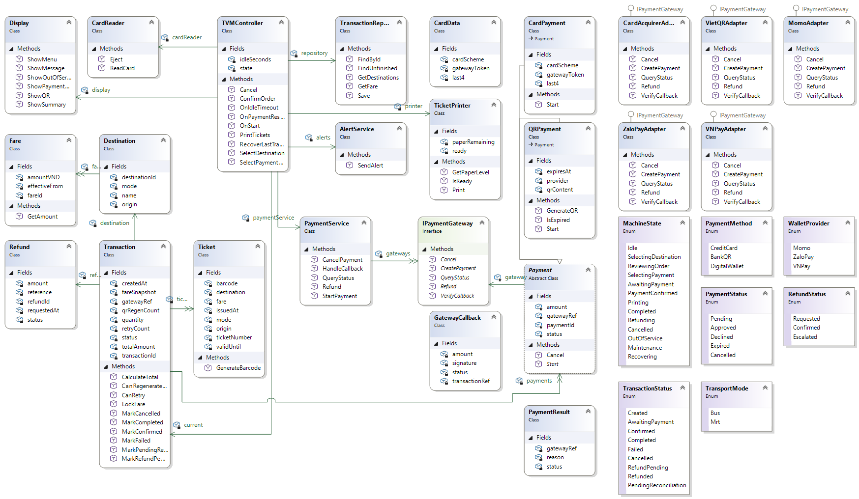
- Created a C# Class Library project targeting .NET Framework 4.8.1 in Visual Studio 2026.
- Added the TVM_Core.cd class diagram using Class Designer.
- Recreated the classes, fields, methods, enumerations, interfaces, and relationships based on Section 3.3.3.
- Visual Studio generated the corresponding C# skeleton files from the model.
- Built the project successfully. Most method bodies retain NotImplementedException for later implementation.

5.1.2 Backward Engineering (Code to Model)
No. | Manual code change | File / class | How it was reflected in the model
1 | Added LastFailureReason and updated MarkFailed to record the failure reason, increment the retry count, and set the transaction status to Failed. | Transaction.cs / Transaction | The LastFailureReason property appeared in the class diagram. The existing MarkFailed method remained visible.
2 | Added IsValid(DateTime checkedAt) to check whether a ticket is within its validity period. | Ticket.cs / Ticket | The IsValid method appeared in the class diagram.
3 | Added HasEnoughPaper(int quantity) to check paper capacity, assuming one paper unit per ticket. | TicketPrinter.cs / TicketPrinter | The HasEnoughPaper method appeared in the class diagram.
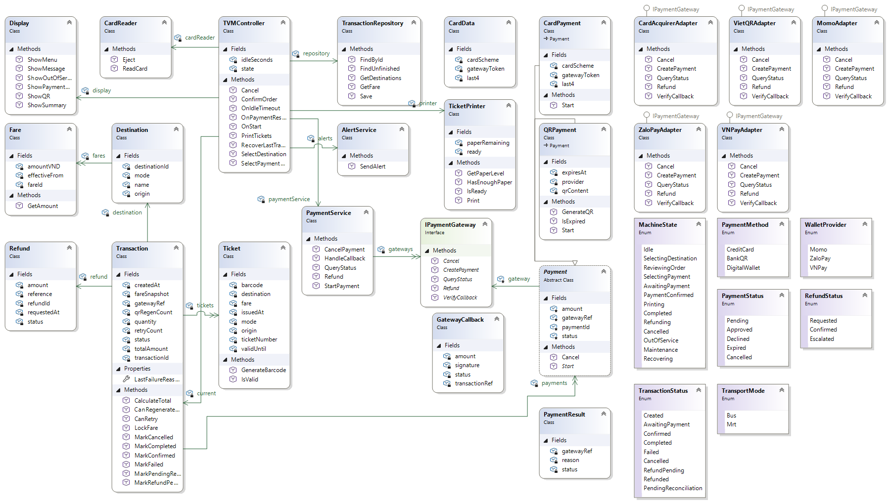
Figure 1: Updated Class Designer model after manual code changes.

5.1.3 Code Map
[ Visual Studio Code Map ]
[What the code map shows and what you learned]

5.2 GitHub & AI Tooling (10 marks)

5.2.1 Source Control
Item | Your answer
Repository link | https://github.com/hnttrong/SmartTicketingSystem-TVM
Branches (names and purpose) | main: shared integration branch.  feature/m4-vs-engineering: Class Designer model, C# skeleton, and code-to-model changes.
Number of commits and pull requests | Hua Nguyen Thanh Trong: 1 commit (09c8f34) and 1 pull request (#1).

Member | Commits | Pull requests | Main contributions
[Student Name 1] ([M1_ID]) | [ ] | [ ] | [ ]
[Student Name 2] ([M2_ID]) | [ ] | [ ] | [ ]
Nguyen Trong Hoang Linh 524H0166 | 2 | 1 | Section 3.3.3 Class Diagrams (Core 1/2 & Supporting 2/2), Forward-Engineered TVM.cs Skeleton, Section 4.2.1 Architecture
Hua Nguyen Thanh Trong 524H0200 | 1 | 1 | Recreated the class model in Visual Studio Class Designer, generated C# skeletons, demonstrated code-to-model updates, and set up the GitHub repository.
Le Hoang Tri 524H0199 | 5 | 2 | Section 4.1 Glassmorphism UI Mockups (S01–S08), Section 4.2.2 UML Deployment Diagram, db/TvmDemo_Setup.sql & Section 5.3 .NET 8 WinForms Demo

5.2.2 AI Assistance: Copilot Prompt Documentation
No. | Member | Prompt | How the AI helped | Used? (kept / changed / rejected) | How we validated it
1 | Hua Nguyen Thanh Trong | Review the C# skeleton against the supplied class diagrams. Identify mismatched field types, method parameters, inheritance, and interface implementations. | Identified inconsistencies between the model and code and suggested corrections. | Changed | Compared each correction with the class diagrams and rebuilt the project.
2 | Hua Nguyen Thanh Trong | Suggest three small code changes to demonstrate code-to-model synchronization in Visual Studio Class Designer. Use the Transaction, Ticket, and TicketPrinter classes. | Suggested a failure-reason property, a ticket-validity method, and a paper-capacity method. | Kept and adapted | Reviewed the code, built the project, and checked that the new members appeared in Class Designer
3 | Le Hoang Tri (524H0199) | Generate an HTML5/CSS3 1280x800 touchscreen prototype for 10 TVM screens (S01–S08) using glassmorphism cards (backdrop-filter: blur(20px)), EN/VI switch, >=64px touch targets, 120s QR timer (FR13), and charge-status banners. | Scaffolded CSS design tokens, 10 screen layouts, 4-step progress bar, and bilingual EN/VI dictionary. | Changed | Increased card opacity to 0.68 and text to #0B2A5C to pass WCAG AA >= 4.5:1 contrast; verified 1-to-1 mapping against UC01 steps.
4 | Le Hoang Tri (524H0199) | Write PlantUML for a Smart Ticketing TVM deployment diagram with 3 network zones and protocols aligned with Section 3.3.3 classes (TVMController, PaymentService, 5 IPaymentGateway adapters, TransactionRepository). | Generated PlantUML deployment nodes, artifacts, and protocol links. | Changed | Synchronized all component names with M3's class diagrams and removed direct kiosk-to-DB path so only App Server reaches port 1433.
5 | Le Hoang Tri (524H0199) | Create an idempotent T-SQL script for TvmDemo matching M3's domain model: Destination (Bus/Mrt), Fare (DR1), [Transaction] (FareSnapshot FR4), Payment (last4 NFR9, 120s QR FR13), Ticket (16-digit Luhn DR4), and Refund. | Produced DDL tables, PK/FK/CHECK constraints, 12 Bus+MRT stations, and reporting view. | Changed | Escaped [Transaction], saved with UTF-8 BOM for Vietnamese NVARCHAR names, and verified all 5 queries on LocalDB & SQLEXPRESS.
6 | Le Hoang Tri (524H0199) | Integrate M3's SmartTicketing.TVM C# skeleton (TVM.cs) with .NET 8 WinForms (S01–S08), async simulated IPaymentGateway (Success/Declined/Timeout), 16-digit Luhn barcode rendering, and parameterized SqlClient CRUD. | Implemented async purchase workflow, CancellationToken countdown, and DataGridView report. | Changed | Wrapped payment + ticket creation in atomic SqlTransaction, fixed High-DPI & glass rendering, and verified 0 build warnings/errors.

5.2.3 Reflection on AI Use
AI helped us review the C# skeleton against the class diagrams and suggest small changes for code-to-model synchronization. We checked the suggestions against the supplied model, corrected mismatched types and method parameters, and built the project successfully. We also verified that the added members appeared in Class Designer. However, a successful build does not confirm that the business logic works correctly. Functional testing will be required when the application is implemented.

5.3 Demo Application (10 marks)
Item | Your answer
Technology and versions | • Framework & Language: C# 12 on .NET 8.0 Windows Forms (net8.0-windows, PerMonitorV2 High-DPI)  • IDE: Microsoft Visual Studio 2022 (v17.8+)  • Database: Microsoft SQL Server 2022 Express / LocalDB + Microsoft.Data.SqlClient 5.2.2  • Architecture: MVC + Repository + Strategy/Adapter integrating M3's SmartTicketing.TVM skeleton (TVM_M3_Model.cs)
Database script location and how to run it | • Script path: db/TvmDemo_Setup.sql (idempotent UTF-8 BOM script creating TvmDemo, 6 tables, constraints, 10 MRT + 2 Bus destinations, and vw_RecentTransactions).  • Run via CLI: sqlcmd -S "(localdb)\MSSQLLocalDB" -E -f 65001 -i db/TvmDemo_Setup.sql -C (or open in SSMS and press F5).  • Connection strings in src/TvmDemo/appsettings.json (switchable live on bottom Simulator Bar):  - LocalDb: Server=(localdb)\MSSQLLocalDB;Database=TvmDemo;Integrated Security=True;TrustServerCertificate=True;  - SqlExpress: Server=.\SQLEXPRESS;Database=TvmDemo;Integrated Security=True;TrustServerCertificate=True;  - Localhost: Server=localhost;Database=TvmDemo;Integrated Security=True;TrustServerCertificate=True;
How to run the application | 1. Execute db/TvmDemo_Setup.sql once on LocalDB or SQLEXPRESS.  2. Open src/TvmDemo.sln in Visual Studio 2022 and press F5 (or run: dotnet run --project src/TvmDemo/TvmDemo.csproj).  3. Use the bottom Instructor Simulator Bar to switch Gateway Result (Success / Declined / Timeout), toggle Printer Fault, switch SQL Server profile, or open the full Output Report (DataGridView).
Video demo link (optional) | [Optional video demo link]
Input form

Input Step 1 (S02): Select Station & Ticket Quantity (1–5) | Input Step 2 (S03): Choose Card, Bank VietQR, or Wallet
Payment Step (S04a): Async EMV/NFC Card Tap | Payment Step (S04b): Dynamic QR + Countdown + Cancel

Output report or success screen

Figure 5.3a: Output Screen (S05a) — Issued Paper Ticket with 1D Barcode & Joined MSSQL Recent Transactions DataGridView
Exception Handling (S05b): Card/Wallet Declined — Not Charged | Exception Handling (S08): Out of Service / DB or Printer Fault

Test scenarios
No. | Scenario | Input | Expected result | Result
1 | Successful Card Purchase (UC01 Main Flow) | Station: Bến xe Suối Tiên [MRT] (20,000 VND), Qty: 2, Mode: Credit Card, Simulator: Success | Async card authorization succeeds without UI freeze; 2 unique 16-digit Luhn tickets printed on S05a; dbo.[Transaction].Status = 'Completed', dbo.Payment.Status = 'Approved'; row appears in Output Report. | [Pass/Fail after run]
2 | Successful Wallet / VietQR Purchase (UC01 QR Flow) | Station: Thảo Điền [MRT] (11,000 VND), Qty: 1, Mode: Digital Wallet (MoMo), Simulator: Success | S04b renders dynamic QR with 02:00 (120s, FR13) countdown; simulated callback approves payment; 1 barcode ticket issued on S05a; DB records QRPayment (WalletProvider='Momo', Status='Approved') & Completed transaction. | [Pass/Fail after run]
3 | Card / Wallet Payment Declined (Exception E1) | Station: BX Chợ Lớn [BUS] (6,000 VND), Qty: 1, Mode: Credit Card, Simulator: Declined | Transitions to S05b Payment Declined with green banner 'NOT CHARGED — 0 VND'; dbo.[Transaction].Status = 'Failed' (RetryCount + 1), dbo.Payment.Status = 'Declined', 0 tickets inserted. | [Pass/Fail after run]
4 | QR / Gateway Timeout (Exception E2) | Station: Thủ Đức [MRT] (18,000 VND), Qty: 1, Mode: Bank QR (VietQR), Simulator: Timeout (or timer hits 00:00) | Transitions to S07 Payment Timeout stating passenger was not charged and warning against scanning expired QR; dbo.[Transaction].Status = 'Failed', dbo.Payment.Status = 'Expired', 0 tickets issued. | [Pass/Fail after run]
5 | Passenger Cancels Mid-Payment (Exception E3) | Start any purchase -> reach S03 or S04b -> press '✕ Cancel' -> press 'Yes, Cancel Purchase' on S06 | In-flight CancellationToken cancels async wait immediately; dbo.[Transaction].Status = 'Cancelled', dbo.Payment.Status = 'Cancelled'; returns cleanly to S01 Idle. | [Pass/Fail after run]
6 | Thermal Printer Fault / Out of Paper (Exception E4) | Tick 'Printer Fault' on Simulator Bar -> complete payment with Simulator: Success | TicketPrinter detects fault; transitions to S08 Out of Service displaying auto-refund notice & transaction reference; transaction recorded as Failed/RefundPending without crashing. | [Pass/Fail after run]
7 | SQL Server Unavailable (Exception E5 / DB Error) | Switch SQL Server dropdown on Simulator Bar to 'InvalidDbTest' -> click 'Connect DB' | SqlException caught cleanly within 2s timeout; transitions to S08 Out of Service with clear diagnostic message and 'NOT CHARGED (0 VND)' banner; UI remains responsive. | [Pass/Fail after run]
Known limitations
• Simulated Payment Gateways: CardAcquirerAdapter, VietQRAdapter, MomoAdapter, ZaloPayAdapter, and VNPayAdapter use an in-memory simulator switch (Success / Declined / Timeout) with 1.8s async latency rather than live merchant credentials.
• Simulated Financial Reversal: When a post-payment printer fault occurs, Refund records are created in memory/DB without triggering real interbank settlement.
• No Offline Store-and-Forward Queue: If SQL Server is unreachable, the kiosk safely locks into S08 Out of Service rather than caching encrypted offline transactions.
• Classroom Localhost Database Connection: For self-contained lab evaluation, TvmDemo.exe connects directly to local SQL Server Express/LocalDB via SqlClient instead of routing through a separate remote ASP.NET Core mTLS API server.
• Simulated Thermal Hardware: Barcode and QR codes are rendered via GDI+ bitmaps on screen rather than driving a physical USB ESC/POS thermal printer or PC/SC smartcard reader.

6. Checklist for "LabGroup_QT2_Assignment1.pdf"
No. | Item from LabGroupAssignment1.pdf | Where addressed in this report | Done
1 | Business context: three payment modes (credit card, bank QR code, digital wallet) and the passenger flow Start, destination menu, card insert or tap, ticket issued, and wallet QR flow | Sections 1.2, 3.1.3, 3.2.1 | x
2 | Phase 1, tasks 1 and 2: Clarification Q&A (Excel) and Requirements Specification with exact reliability and response-time expectations | Sections 2.1 and 2.2 (NFR1 to NFR7) | x
3 | Phase 2, tasks 3 to 5: use case diagram and descriptions, two activity diagrams, sequence, state chart and class diagrams | Sections 3.1, 3.2, 3.3 | x
4 | Phase 3, tasks 6 and 7: UI/UX wireframes, architecture diagram and deployment diagram | Sections 4.1, 4.2 | x
5 | Phase 4, tasks 8 to 10: Visual Studio forward and backward engineering and Code Map; GitHub history and Copilot documentation; C# and MSSQL demo | Sections 5.1, 5.2, 5.3 | [ ]
6 | Submission: [524H0199]_[Le Hoang Tri].docx with diagrams, requirements, AI prompt documentation and screenshots | This report | x
7 | Submission: readme.txt with the GitHub link and other links (Figma, database script instructions) | Appendix A | x
8 | Submission: % contribution of each member; all final artifacts in the shared GitHub repository | Section 7, Section 5.2.1 | x

7. Contribution of Each Member
Member | Student ID | Work products and tasks | % contribution
Dang Hieu Minh | 524H0168 | Clarification Q&A, requirements specification, team workbook, sections 1, 2, 6, 7 and 8, report assembly | 20%
Pham Cong Quoc Huy | 524H0161 | Use case diagram and descriptions, two activity diagrams | 20%
Nguyen Trong Hoang Linh | 524H0166 | Sequence, state chart and class diagrams, architecture diagram | 20%
Hua Nguyen Thanh Trong | 524H0200 | Visual Studio engineering, GitHub repository, Copilot documentation, readme.txt | 20%
Le Hoang Tri | 524H0199 | Phase 3 Section 4.1 Touchscreen UI/UX Mockups (S01–S08) & Section 4.2.2 UML Deployment Diagram; Phase 4 Section 5.3 C# .NET 8 WinForms & MSSQL Demo Application | 20%
Total |  |  | 100%

8. Conclusion and Lessons Learnt
Achievements. The team analysed the TVM brief, found 25 ambiguities, and specified 45 requirements (25 functional, 12 non-functional, 8 domain) with measurable reliability and response-time limits. We then modelled the main use case "Buy a Ticket" with a use case diagram of eight use cases, two activity diagrams, a three-part sequence diagram, a state chart and a two-part class diagram, and designed ten touchscreen screens, a layered MVC architecture and a three-zone deployment diagram. In Visual Studio we rebuilt the class model in Class Designer, generated the C# skeleton and showed three manual code changes reflected back into the model; the project is hosted on GitHub with a feature branch and pull requests. A C# .NET 8 and SQL Server prototype implements the purchase flow with an input form and an output report.
Limitations. The assumed answers were not confirmed with real stakeholders. Payment gateways are mocked, so the response-time and reliability limits are targets and were not measured on real hardware or with live providers. Offline sales, concession fares and return tickets are out of scope. In the demo, the payment gateways and the ticket printer are simulated, refunds are only recorded in the database, there is no offline queue when SQL Server is unreachable, and barcodes and QR codes are drawn on screen instead of on a physical printer.
Lessons learnt. Dang Hieu Minh (524H0168): Writing the Q&A before the requirements made the requirements easier to trace: nearly every number in section 2.2 points back to a question, and the hard cases (a payment arriving after the timeout, money taken without a ticket) only appeared when we asked "what if" about each step.
Pham Cong Quoc Huy (524H0161): Writing the use case descriptions with exception flows (declined card, expired QR, printer fault) showed which branches the activity diagrams had to cover, and citing a requirement ID in every step kept the use cases traceable to section 2.2.
Nguyen Trong Hoang Linh (524H0166) & Le Hoang Tri (524H0199): Sharing a single canonical domain vocabulary early (TVMController, Transaction, QRPayment with 120s expiry, 16-digit Luhn TicketNumber, and 5 IPaymentGateway adapters) allowed our UML Class Diagrams (3.3.3), MVC & Deployment Architecture (4.2), T-SQL constraints, and C# .NET 8 WinForms demo (5.3) to integrate with zero naming drift. Implementing async/await with CancellationTokenSource and atomic SqlTransaction blocks also proved essential on a kiosk touchscreen so gateway timeouts, user cancellations, and printer faults never freeze the UI or leave ambiguous charge states.
Hua Nguyen Thanh Trong (524H0200): Class Designer made it easy to check the code against the model and to see manual changes reflected back in the diagram, and Copilot helped find mismatched types and parameters. A successful build does not prove that the business logic is correct, so generated code still needs functional testing.

References
1. I. Sommerville, Software Engineering, 10th ed., Pearson, 2016.
2. Object Management Group, Unified Modeling Language (UML) Specification, version 2.5.1, 2017.
3. ISO/IEC 25010:2011, Systems and software engineering: Systems and software quality models.
4. PCI Security Standards Council, Payment Card Industry Data Security Standard (PCI DSS), v4.0.
5. EMVCo, EMV chip and contactless specifications, and EMV QR Code Specification for Payment Systems (emvco.com).
6. NAPAS, VietQR interbank QR payment (napas.com.vn); developer documentation of Momo, ZaloPay and VNPay (callback and signature verification).
7. ISO/IEC 15417, Information technology: Code 128 bar code symbology specification.
8. Government of Vietnam, Decree 13/2023/ND-CP on personal data protection; Law on Persons with Disabilities, 2010.
9. P.T.K. Trung, SE Lab Group Assignment 1: Smart Ticketing System, TDTU, Sem 1_2627 (course notes and assignment sheet).
10. Microsoft, “Design, visualize, and refactor with Class Designer,” Microsoft Learn. [Online]. Available: https://learn.microsoft.com/en-us/visualstudio/ide/class-designer/designing-and-viewing-classes-and-types. [Accessed: Oct. 31, 2026].
11. GitHub, “About pull requests,” GitHub Docs. [Online]. Available: https://docs.github.com/en/pull-requests/get-started/about-pull-requests. [Accessed: Oct. 31, 2026].
12. Figma design: https://www.figma.com/design/chjKyWaJin2KMWQ9iaUzuP/TVM
13. Microsoft Corporation. SQL Server Management Studio (SSMS). Microsoft Learn. https://learn.microsoft.com/sql/ssms/download-sql-server-management-studio-ssms

Appendix

Appendix A: readme.txt

SMART TICKETING SYSTEM – TVM

Software Engineering Lab Group Assignment 1 – Sem 1_2627

GITHUB

https://github.com/hnttrong/SmartTicketingSystem-TVM

FIGMA PROTOTYPE

https://www.figma.com/design/chjKyWaJin2KMWQ9iaUzuP/TVM

REQUIREMENTS

- Windows

- Microsoft Visual Studio 2022 (v17.8 or later) with the ".NET desktop development" workload

- .NET 8 SDK (C# 12, net8.0-windows, Windows Forms)

- Microsoft SQL Server 2022 Express or LocalDB

- SQL Server Management Studio (optional; sqlcmd can be used instead)

- Microsoft.Data.SqlClient 5.2.2 (restored automatically by NuGet)

DATABASE SETUP

1. Open SQL Server Management Studio and connect with Windows Authentication.

2. Open db/TvmDemo_Setup.sql and press F5.

3. Confirm that the TvmDemo database has been created.

CONNECTION STRING

Default profile is LocalDb: Server=(localdb)\MSSQLLocalDB;Database=TvmDemo;Integrated Security=True;TrustServerCertificate=True;

If you use SQL Server Express instead, select the SqlExpress profile on the Simulator Bar or edit src/TvmDemo/appsettings.json.

RUN THE DEMO

1. Run db/TvmDemo_Setup.sql once on LocalDB or SQLEXPRESS (see DATABASE SETUP).

2. Open src/TvmDemo.sln in Visual Studio 2022 and press F5

(or run: dotnet run --project src/TvmDemo/TvmDemo.csproj).

3. On the Simulator Bar, select the database profile and click Connect DB. Confirm that DB OK appears.

4. Buy a ticket: S01 Start -> S02 destination and quantity (1-5) -> S03 payment mode -> S04a card / S04b QR -> S05a ticket issued.

SIMULATION (Instructor Simulator Bar)

- Gateway Result: Success (payment approved, tickets generated), Declined (payment rejected, no ticket), Timeout (payment expires, no ticket).

- Printer Fault: tick to simulate a printer fault after payment (S08 Out of Service, refund record created).

- SQL Server profile: switch the database connection (an invalid profile shows S08 Out of Service).

- Output Report (DB): DataGridView with the saved transactions and tickets.

KNOWN LIMITATIONS

- Payment gateways (CardAcquirerAdapter, VietQRAdapter, MomoAdapter, ZaloPayAdapter, VNPayAdapter) are simulated in memory with about 1.8 s of async latency; no live merchant credentials are used.

- Refunds are recorded in memory/DB only; no real interbank settlement.

- No offline store-and-forward queue: if SQL Server is unreachable the kiosk locks into S08 Out of Service.

- The demo connects directly to local SQL Server Express/LocalDB through SqlClient (no separate ASP.NET Core API server).

- Barcode and QR codes are drawn on screen (GDI+); no physical thermal printer or card reader is driven.

- The Class Designer skeleton (Visual Studio, section 5.1) targets .NET Framework 4.8.1; the runnable demo targets .NET 8.

TEAM CONTRIBUTIONS

Student ID | Full Name | Contribution (%) | Main Tasks

524H0168 | Dang Hieu Minh | 20% | Requirements and report integration: Clarification Q&A, requirements specification, sections 1, 2, 6, 7 and 8, final report

524H0161 | Pham Cong Quoc Huy | 20% | Use case modeling and activity diagrams

524H0166 | Nguyen Trong Hoang Linh | 20% | Sequence, state chart and class diagrams; architecture diagram

524H0200 | Hua Nguyen Thanh Trong | 20% | Visual Studio engineering, GitHub repository, Copilot prompt documentation, readme.txt

524H0199 | Le Hoang Tri | 20% | UI/UX touchscreen mockups (4.1); UML deployment diagram (4.2.2); C# .NET 8 WinForms and MSSQL demo (5.3)

Total: 100%

Appendix B: Full-size Diagrams
[Full-size use case, activity, sequence, state, class, architecture and deployment diagrams]

