SE LAB GROUP ASSIGNMENT 1 REPORT TEMPLATE
Software Engineering | Smart Ticketing System (Ticket Vendor Machine) | Sem 1_2627 | Template for the file [YourID]_[YourStudentName].docx
Marking of this report
No. | Task | Marks | Section in this report
1 | Clarification Q&A (Excel) | 5 | 2.1
2 | Requirements Specification | 15 | 2.2
3 | Use Case Modeling | 10 | 3.1
4 | Activity Diagrams | 10 | 3.2
5 | Detailed System Modeling: "Buy a Ticket" | 15 | 3.3
6 | UI/UX Design | 5 | 4.1
7 | Architectural Design | 10 | 4.2, 4.3
8 | Visual Studio Engineering (Model-to-Code) | 10 | 5.1
9 | GitHub & AI Tooling (Copilot) | 10 | 5.2
10 | Demo Application (C# and MSSQL) | 10 | 5.3
Total |  | 100 | Weight: 20% of QT2 (plus 1 bonus point towards the Final Project for exceptional work)

How to use this template
- Keep all titles and numbering. Replace every blue [bracketed placeholder] with your own content, and delete all grey "Guidance" paragraphs, unused figure frames and this instruction page before you submit.
- Keep the headings as real Word headings (the navigation pane must work). Update the table of contents before submitting (right-click, Update Field).
- Group of 3 to 5 students. Section 7 must list the % contribution of each member (total 100%) and must match your readme.txt.
- Submit [YourID]_[YourStudentName].docx, readme.txt (GitHub link and other links such as Figma and database script instructions) and the % contribution of each member. All final artifacts are also uploaded to the shared GitHub repository.
- The report must also address the content of "LabGroupAssignment1.pdf". Use the checklist in section 6 to show where each item is covered.
- Keep your diagrams consistent with each other: the rubric rewards diagrams that are syntactically correct, logically sound and aligned. Use the consistency table in section 3.4.
- The workbook A1_Team_Workbook (Q&A, requirements, prompt log, commit log, progress log) is your working record and the source for several tables here.

Smart Ticketing System
Ticket Vendor Machine (TVM)
Software Engineering Lab Group Assignment 1 – Sem 1_2627
Group [XX]
1. [StudentID1] : [Student Name 1]
2. [StudentID2] : [Student Name 2]
3. [StudentID3] : [Student Name 3]
4. [StudentID4] : [Student Name 4]
5. [524H0199] : [Student Name 5]

GitHub repository | Figma | Date submitted
[link] | [https://www.figma.com/design/chjKyWaJin2KMWQ9iaUzuP/TVM?node-id=0-1&t=icsEXm35cFjpr6e4-1] | [date]

Table of Contents
Table of Contents 4
1. Introduction 6
1.1 Purpose and Scope 6
1.2 Problem Statement in Our Own Words 6
1.3 Team and Roles 6
2. Phase 1: Requirements Engineering (20 marks) 7
2.1 Clarification Q&A (5 marks) 7
2.2 Requirements Specification (15 marks) 7
2.2.1 Functional Requirements 7
2.2.2 Non-Functional Requirements 7
2.2.3 Domain Requirements 8
3. Phase 2: UML Modeling & System Design (35 marks) 9
3.1 Use Case Modeling (10 marks) 9
3.1.1 Use Case Diagram 9
3.1.2 Actors and Use Case List 9
3.1.3 Use Case Descriptions 9
3.2 Activity Diagrams (10 marks) 10
3.2.1 Passenger Buys a Ticket at the TVM 10
3.2.2 Communication with External Payment Gateways 10
3.3 Detailed System Modeling: Main Use Case "Buy a Ticket" (15 marks) 10
3.3.1 Sequence Diagram 10
3.3.2 State Chart Diagram 10
3.3.3 Class Diagram (Domain Model) 10
3.4 Model Consistency Check 10
4. Phase 3: UI/UX & Architecture (15 marks) 12
4.1 UI/UX Design (5 marks) 12
4.2 Architectural Design (10 marks) 12
4.2.1 Architecture Diagram 12
4.2.2 Deployment Diagram 12
5. Phase 4: Implementation, Tooling & Demo (30 marks) 13
5.1 Visual Studio Engineering: Model-to-Code (10 marks) 13
5.1.1 Forward Engineering (Model to Code) 13
5.1.2 Backward Engineering (Code to Model) 13
5.1.3 Code Map 13
5.2 GitHub & AI Tooling (10 marks) 13
5.2.1 Source Control 13
5.2.2 AI Assistance: Copilot Prompt Documentation 14
5.2.3 Reflection on AI Use 14
5.3 Demo Application (10 marks) 14
6. Checklist for "LabGroupAssignment1.pdf" 16
7. Contribution of Each Member 16
8. Conclusion and Lessons Learnt 16
References 16
Appendix 17
Appendix A: readme.txt 17
Appendix B: Full-size Diagrams 17

1. Introduction

1.1 Purpose and Scope
Guidance (delete before submitting): Two or three sentences: what the report covers, which system (the Ticket Vendor Machine within the Smart Ticketing System) and what is in and out of scope.
[Purpose and scope]

1.2 Problem Statement in Our Own Words
Guidance (delete before submitting): Summarize the business context: ticket types, payment modes (Credit Card, QR Code linked to a banking system, Digital Wallet), the passenger interaction, and the ambiguities you found. Do not copy the assignment text.
[Problem statement]

1.3 Team and Roles
No. | Name | Student ID | Main responsibilities
1 | [ ] | [ ] | [ ]
2 | [ ] | [ ] | [ ]
3 | [ ] | [ ] | [ ]
4 | [ ] | [ ] | [ ]
5 | [Student Name 5] | [524H0199] | UI/UX Touchscreen Mockups (4.1); UML Deployment Diagram (4.2.2); C# .NET 8 WinForms & MSSQL Demo Application (5.3)

2. Phase 1: Requirements Engineering (20 marks)

2.1 Clarification Q&A (5 marks)
Guidance (delete before submitting): Identify the ambiguities in the problem statement. List the clarifying questions you would ask the stakeholders and give logical, assumed answers to base your design on. Put the full list in the Excel workbook (sheet "Clarification Q&A") and show the most important ones here. Look for hidden complexity: payment timeouts, card or QR failure, refunds, cancellation, ticket types and fares, printer or paper out, offline operation, multiple machines, security.
ID | Question to the stakeholder | Assumed answer | Why it matters | Requirement ID
Q01 | [ ] | [ ] | [ ] | [FR/NFR ]
Q02 | [ ] | [ ] | [ ] | [ ]
…
Hidden complexities we uncovered
[Three to five points where the Q&A changed the requirements]

2.2 Requirements Specification (15 marks)
Guidance (delete before submitting): A formal set of Functional, Non-Functional and Domain requirements for the TVM. Every requirement has an ID and is testable. The workbook sheet "Requirements" is the working copy.

2.2.1 Functional Requirements
ID | Requirement ("The system shall…") | Priority | Use case | Source (Q&A)
FR1 | [ ] | [ ] | [UC ] | [Q ]
FR2 | [ ] | [ ] | [UC ] | [ ]
…

2.2.2 Non-Functional Requirements
Guidance (delete before submitting): Critical focus: reliability and response time. Write exact, measurable expectations (a number, a unit, a condition and how you will measure it). "Fast response" is not acceptable. Example of the format: "The system shall display the destination menu within 1 second of pressing Start in 95% of cases, measured over 1,000 transactions." Add other categories where they matter (security, availability, usability, capacity, maintainability).
ID | Category | Measurable requirement | Measurement method | Related FR
NFR1 | Reliability | [ ] | [ ] | [ ]
NFR2 | Reliability | [ ] | [ ] | [ ]
NFR3 | Response time | [ ] | [ ] | [ ]
NFR4 | Response time | [ ] | [ ] | [ ]
NFR5 | [Security] | [ ] | [ ] | [ ]
…

2.2.3 Domain Requirements
Guidance (delete before submitting): Rules that come from the transport and payment domain rather than from the user: for example fare rules, payment standards and bank or wallet rules, ticket and barcode format, data retention, regulatory or accessibility rules.
ID | Domain requirement | Domain / source | Related FR / NFR
DR1 | [ ] | [ ] | [ ]
DR2 | [ ] | [ ] | [ ]
…

3. Phase 2: UML Modeling & System Design (35 marks)

3.1 Use Case Modeling (10 marks)

3.1.1 Use Case Diagram
Guidance (delete before submitting): Actors (passenger, payment gateways, maintenance staff, etc.), the system boundary, and include or extend relationships where they make sense.
[ Use case diagram ]

3.1.2 Actors and Use Case List
ID | Use case | Primary actor | Short description
UC01 | [ ] | [ ] | [ ]
UC02 | [ ] | [ ] | [ ]
UC03 | [ ] | [ ] | [ ]
UC04 | [ ] | [ ] | [ ]
UC05 | [ ] | [ ] | [ ]

3.1.3 Use Case Descriptions
Guidance (delete before submitting): One description for each use case in the list above. Copy the table below for every use case. Cite the requirement IDs.
UC01: [Use case name]
Item | Content
Use case ID and name | [ ]
Primary actor / secondary actors | [ ]
Related requirements | [FR ] [NFR ]
Pre-conditions | [ ]
Trigger | [ ]
Main flow | [Step-by-step: actor action / system response]
Alternate flows | [ ]
Exception flows | [ ] (card declined, QR timeout, printer error, …)
Post-conditions | [ ]
UC02: [Use case name]
Guidance (delete before submitting): Use the same table. Repeat for UC04, UC05 and any further use case.
UC03: [Use case name]
Guidance (delete before submitting): Use the same table.

3.2 Activity Diagrams (10 marks)

3.2.1 Passenger Buys a Ticket at the TVM
Guidance (delete before submitting): The step-by-step process, similar to an ATM flow: Start, destination menu, payment mode, card tap or insert, QR Code, validation, ticket printing. Show decisions, failures, cancellation and timeouts. Use swim lanes (Passenger, TVM) where helpful.
[ Activity diagram: buy a ticket ]

3.2.2 Communication with External Payment Gateways
Guidance (delete before submitting): A separate activity diagram showing the communication and integration between your system and the external payment gateways (for example Momo, VNPay, ZaloPay): request, redirect or QR, callback, verification, timeout, failure and reconciliation.
[ Activity diagram: payment gateway integration ]

3.3 Detailed System Modeling: Main Use Case "Buy a Ticket" (15 marks)

3.3.1 Sequence Diagram
Guidance (delete before submitting): Object interactions over time: passenger, UI, controller, payment service, gateway, ticket printer and database. Use the same names as in your class diagram.
[ Sequence diagram: Buy a Ticket ]

3.3.2 State Chart Diagram
Guidance (delete before submitting): The states the TVM goes through during the transaction (for example Idle, Selecting destination, Awaiting payment, Payment confirmed, Printing, Out of service), with events, guards and actions.
[ State chart diagram ]

3.3.3 Class Diagram (Domain Model)
Guidance (delete before submitting): Core domain classes with attributes, methods, relationships and multiplicities.
[ Class diagram ]
Class | Key attributes | Key methods | Relationships
[ ] | [ ] | [ ] | [ ]
[ ] | [ ] | [ ] | [ ]
…

3.4 Model Consistency Check
Guidance (delete before submitting): The rubric rewards diagrams that are aligned with each other. Tick each check after you verify it.
Consistency check | Diagrams involved | Done
Every use case in the diagram has a description, and every description is in the diagram | Use case diagram / descriptions | [ ]
Every step of the main flow appears in the activity diagram | Descriptions / activity | [ ]
Objects and messages in the sequence diagram exist as classes and methods in the class diagram | Sequence / class | [ ]
State names and transitions match the events in the sequence diagram | State chart / sequence | [ ]
Payment gateway steps match between the two activity diagrams and the sequence diagram | Activity / sequence | [ ]
Requirement IDs are cited in the use cases | Requirements / use cases | [ ]
The class diagram matches the C# code generated in 5.1 | Class / code | [ ]

4. Phase 3: UI/UX & Architecture (15 marks)

4.1 UI/UX Design (5 marks)
Guidance (delete before submitting): Wireframes or mockups of the TVM screens, designed with Balsamiq, Figma or a similar tool. Make them modern and intuitive for a touchscreen kiosk (large buttons, clear language, accessibility). Link each screen to a step of the main use case.
Screen | Name / purpose | Linked use case step | Tool and link
S01 | Home / Start — Idle welcome screen showing station status (Bus & MRT), bilingual EN/VI toggle, High-Contrast switch, and large 'Touch to Start' CTA. | UC01 Pre-condition & Step 1: Passenger presses Start -> TVMController.onStart() checks TicketPrinter.isReady(). | Figma: [Figma link] | HTML: ui/tvm_glassmorphism_mockups.html#S01
S02 | Destination & Quantity Menu — 4x3 touchscreen station grid (HCMC Metro Line 1 [MRT] & Feeder [BUS], FR15) + ticket quantity stepper (1–5, FR3) and live FareSnapshot total (FR4). | UC01 Step 2: Passenger selects destination & quantity -> TVMController.selectDestination(id, qty) & confirmOrder(). | Figma: [Figma link] | HTML: ui/tvm_glassmorphism_mockups.html#S02
S03 | Payment Mode Selection — 3 large touch cards: Credit/Debit Card (EMV/NFC), Bank QR (VietQR Napas 247), or Digital Wallet (MoMo / ZaloPay / VNPay). | UC01 Step 3: Passenger selects PaymentMethod -> TVMController.selectPaymentMethod(method). | Figma: [Figma link] | HTML: ui/tvm_glassmorphism_mockups.html#S03
S04a | Card Payment Processing — Prompts passenger to tap NFC or insert EMV chip card on CardReader with live countdown timer and Cancel button. | UC01 Step 4a (Card Branch): CardPayment.start() via CardAcquirerAdapter; awaits Approved/Declined token response. | Figma: [Figma link] | HTML: ui/tvm_glassmorphism_mockups.html#S04a
S04b | QR / Digital Wallet Payment — Displays dynamic QR code (QRPayment.generateQR(), provider=null for VietQR or Momo/ZaloPay/VNPay) with 120s countdown (FR13). | UC01 Step 4b (QR/Wallet Branch): Awaits signed GatewayCallback webhook verified via IPaymentGateway.verifyCallback() (FR10). | Figma: [Figma link] | HTML: ui/tvm_glassmorphism_mockups.html#S04b
S05a | Ticket Issued (Success) — Renders printed paper ticket preview with 16-digit Luhn TicketNumber & 1D Barcode (DR4, FR16), 24h validity, and dispenser prompt. | UC01 Steps 5–6 (Main Post-condition): TVMController.printTickets() -> Transaction.markCompleted(). | Figma: [Figma link] | HTML: ui/tvm_glassmorphism_mockups.html#S05a
S05b | Payment Declined — Error alert when issuer/wallet rejects payment; displays explicit green banner ('NOT CHARGED — 0 VND') and retry option (up to 3 attempts, FR12). | UC01 Exception E1 (Card/Wallet Declined): Transaction.markFailed(); passenger may retry if canRetry() or cancel. | Figma: [Figma link] | HTML: ui/tvm_glassmorphism_mockups.html#S05b
S06 | Cancel Confirmation — Modal confirmation preventing accidental mid-flow exit, stating clearly that cancelling now deducts 0 VND. | UC01 Exception E3 (User Cancel): TVMController.cancel() -> PaymentService.cancelPayment() & Transaction.markCancelled(). | Figma: [Figma link] | HTML: ui/tvm_glassmorphism_mockups.html#S06
S07 | Payment Timeout — Shown when 120s QR/payment timer reaches 00:00 without callback; warns not to scan expired QR and states charge/auto-refund policy. | UC01 Exception E2 (Gateway/QR Timeout): QRPayment.isExpired() (FR13); allows regenerateQR() (<=2) or return to S01. | Figma: [Figma link] | HTML: ui/tvm_glassmorphism_mockups.html#S07
S08 | Machine Out of Service — Full-screen hardware/DB lock screen when printer is out of paper or DB is unreachable, displaying explicit charge/auto-refund banner & hotline. | UC01 Exception E4/E5 (Printer Fault / Out of Service): MachineState.OutOfService + AlertService.sendAlert(); Refund if post-charge. | Figma: [Figma link] | HTML: ui/tvm_glassmorphism_mockups.html#S08
Touchscreen Mockups & Implemented Glassmorphism Screens (1280×800 Landscape, S01–S08):
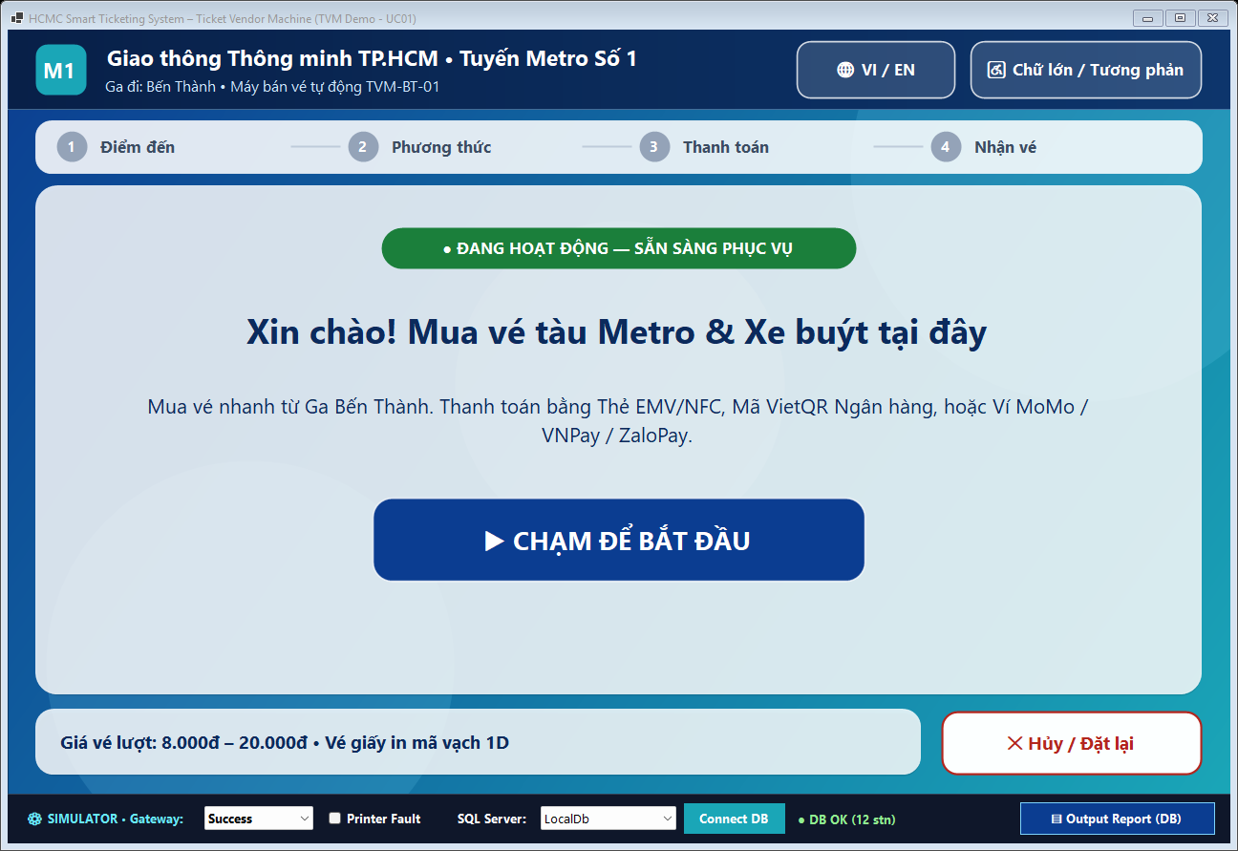  S01: Home / Start Screen (1280×800) | 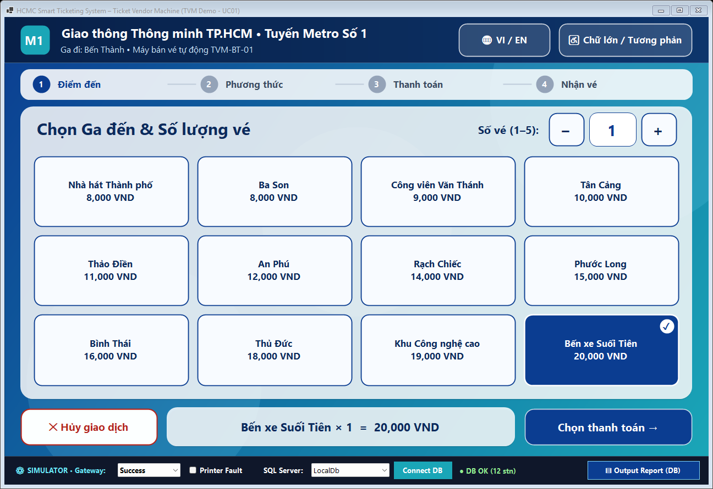  S02: Destination & Quantity Menu (1–5 Tickets)
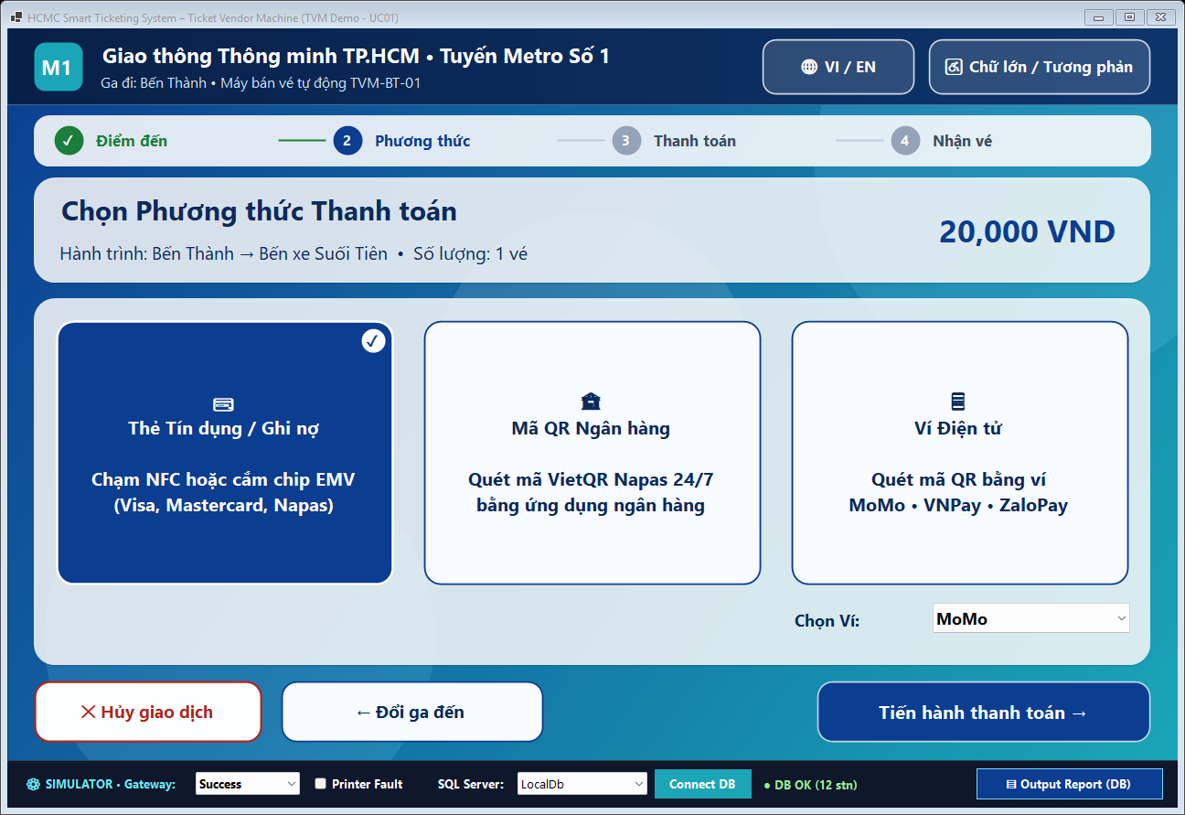  S03: Payment Mode Selection (Card / VietQR / Wallet) | 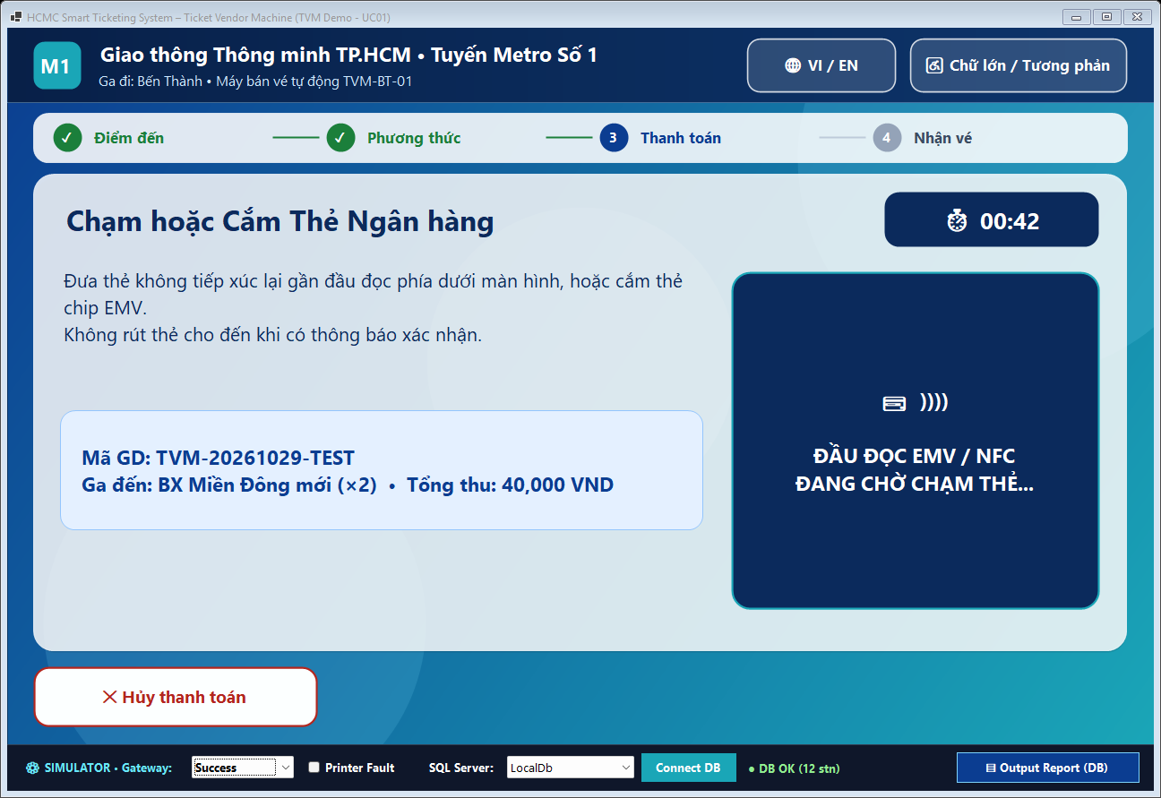  S04a: EMV / NFC Card Payment Screen
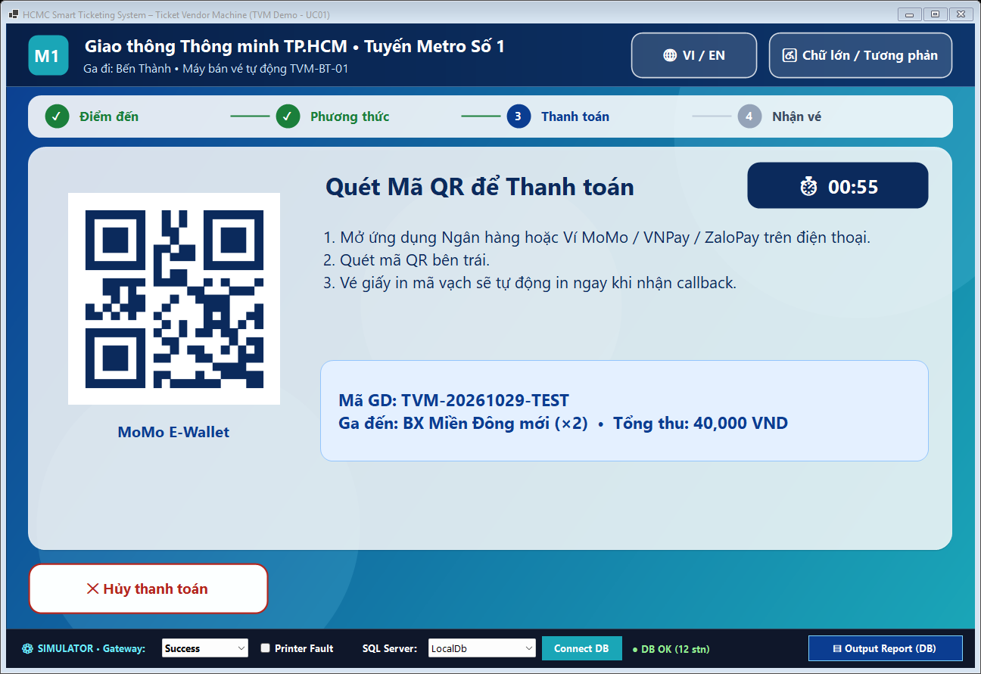  S04b: Dynamic VietQR / Wallet Payment (Countdown) | 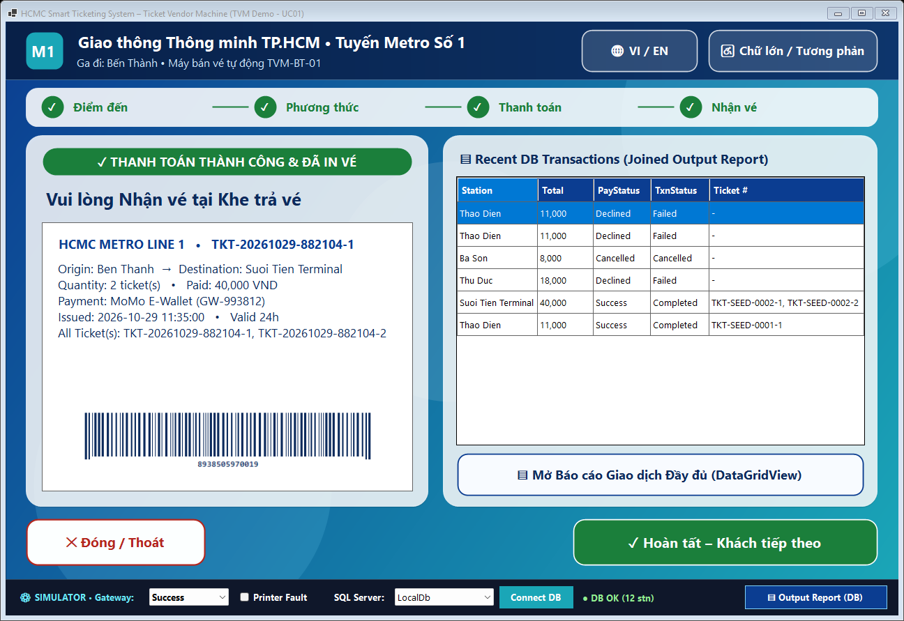  S05a: Ticket Issued with 1D Barcode & DB Summary
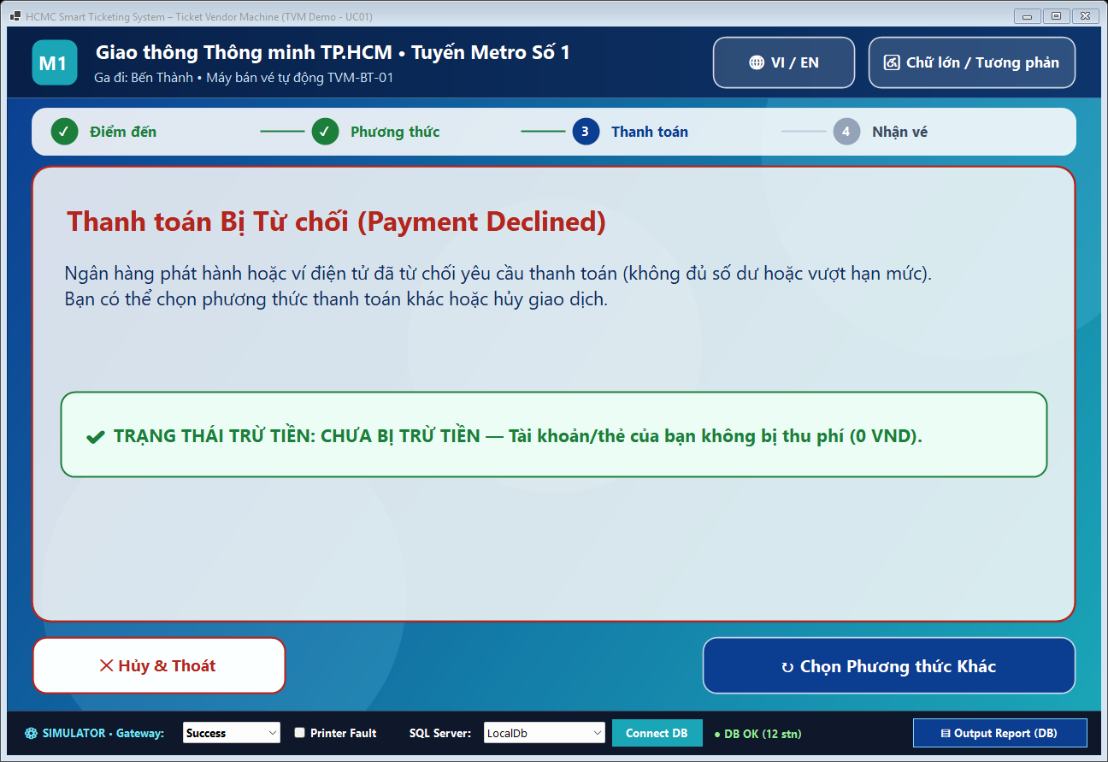  S05b: Payment Declined (Explicit Not-Charged Notice) | 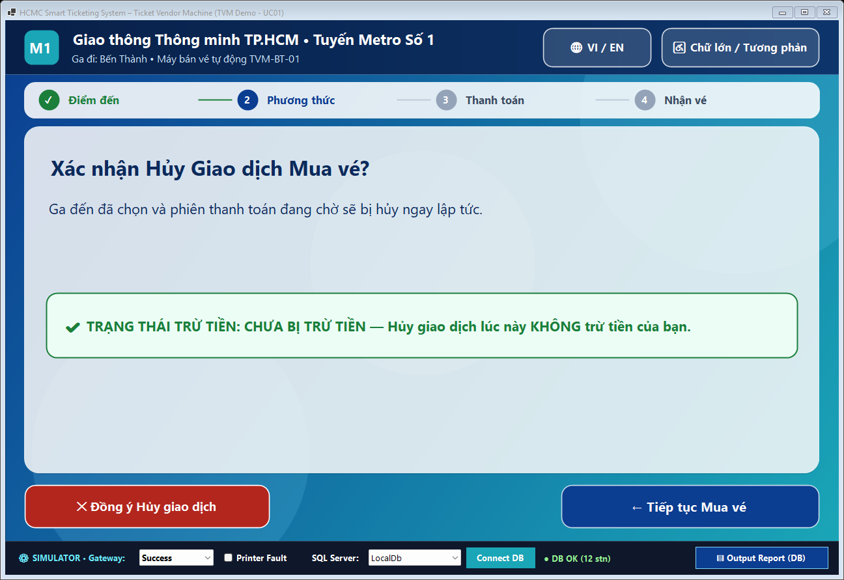  S06: Cancel Confirmation Dialog
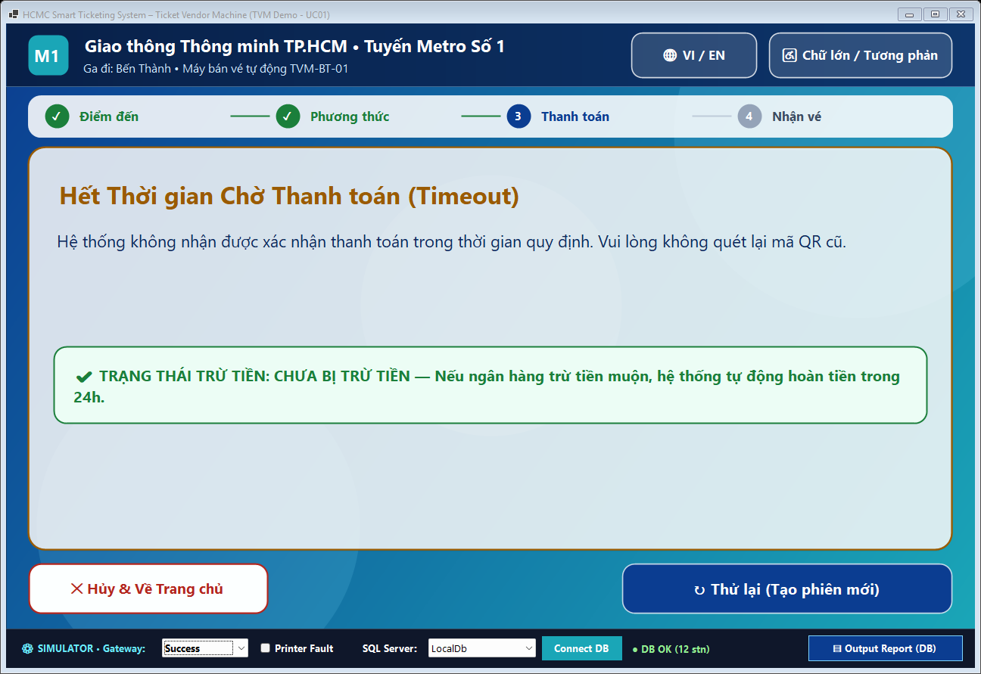  S07: Payment Session Timeout Screen | 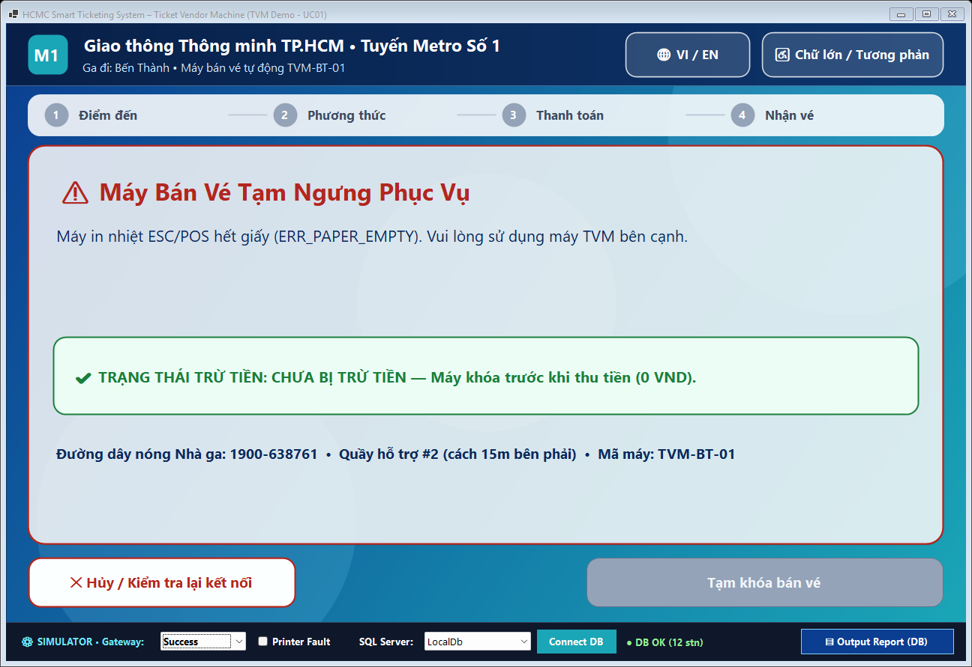  S08: Machine Out of Service / Hardware Lock
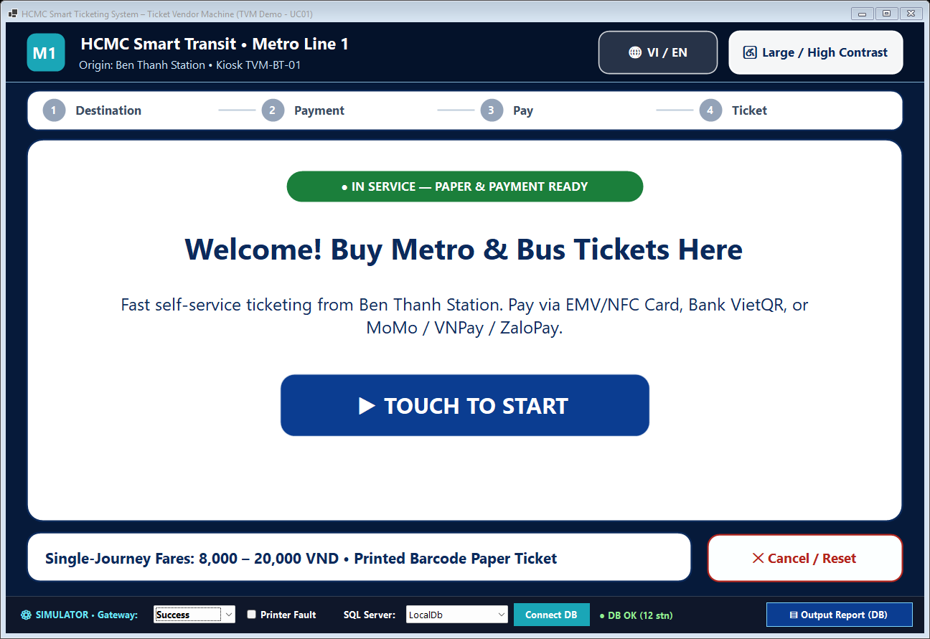
Accessibility Mode: English + High-Contrast / Large Text

Design Tokens Summary: Ambient gradient #0B3D91 -> #1AA6B7; Frosted Glass Surface rgba(255,255,255,0.68) with backdrop-filter: blur(20px), 1 px border rgba(255,255,255,0.42), radius 22 px, shadow 0 8px 32px rgba(0,0,0,0.18); Primary Navy Text #0B2A5C (contrast 9.4:1 >= WCAG AA 4.5:1); Solid Primary CTA #0B3D91; Success #1B7F3B; Error/Cancel #B3261E; Touch Target height >= 64 px; Body 24 px / Heading 40–48 px (Segoe UI / Inter).
Design Rationale: The TVM interface is tailored for rapid commuter throughput in brightly lit public metro and bus stations. All interactive buttons enforce a >= 64 px height and >= 12 px gutter to prevent finger mis-taps, paired with a persistent 4-step progress bar (Destination -> Method -> Pay -> Ticket), bilingual EN/VI switch, and one-tap High-Contrast / Large-Text accessibility mode (disabling translucency into solid #000000/#FFD600 contrast). Crucially, the glassmorphism aesthetic is restricted strictly to structural cards over a soft ocean-teal gradient, while primary action buttons remain solid opaque fills for unmistakable affordance and >9:1 legibility. Every exception screen (S05b, S06, S07, S08) prominently states whether the passenger was charged, eliminating payment anxiety at unattended kiosks.

4.2 Architectural Design (10 marks)

4.2.1 Architecture Diagram
Guidance (delete before submitting): A System-in-a-box or MVC architecture diagram. The architecture must be logical, modular and suitable for the hardware. Explain what each part does and why you chose it.

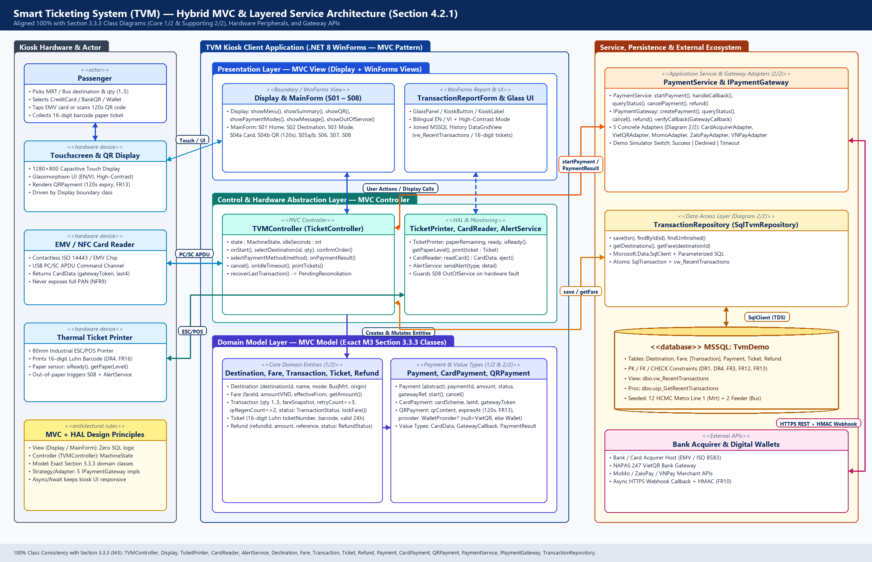
Figure 4.2.1: Hybrid MVC & Layered Service Architecture Aligned with Section 3.3.3 Class Diagrams
The Smart Ticketing TVM adopts a Hybrid Model-View-Controller (MVC) + Layered Service & Hardware Abstraction Architecture that maps 1-to-1 to the Section 3.3.3 Class Diagrams (Core 1/2 & Supporting 2/2):
1. Presentation Layer (MVC View): Implemented by the Display boundary class bound to WinForms MainForm (screens S01–S08) and TransactionReportForm. The View renders station menus, dynamic QR codes, and 120s countdown timers, forwarding user touch gestures to TVMController while containing zero SQL queries or gateway cryptographic secrets.
2. Control & Hardware Abstraction Layer (MVC Controller + HAL): TVMController manages MachineState transitions (Idle -> SelectingDestination -> ReviewingOrder -> SelectingPayment -> AwaitingPayment -> PaymentConfirmed -> Printing -> Completed, plus OutOfService and Recovering) while composing TicketPrinter (ESC/POS), CardReader (PC/SC APDU returning tokenized CardData), and AlertService.
3. Domain Model Layer (MVC Model): Encapsulates pure transport-domain rules shared across all diagrams: Destination (TransportMode: Bus | Mrt, FR15), Fare (whole VND, DR1), Transaction (1..5 tickets FR3, locked FareSnapshot FR4, retryCount <= 3 FR12, qrRegenCount <= 2 FR13), Ticket (16-digit Luhn barcode DR4/FR16), Refund, and abstract Payment extended by CardPayment and QRPayment.
4. Service, Gateway Adapter & Persistence Layer: PaymentService selects the appropriate IPaymentGateway adapter (CardAcquirerAdapter, VietQRAdapter, MomoAdapter, ZaloPayAdapter, or VNPayAdapter) via the Strategy/Adapter pattern, enabling simulated classroom testing (Success/Declined/Timeout) without altering controller or UI code. TransactionRepository isolates parameterized Microsoft.Data.SqlClient persistence against SQL Server (TvmDemo).

4.2.2 Deployment Diagram
Guidance (delete before submitting): How the TVM hardware (touchscreen, card reader, QR display, printer), servers and external APIs (payment gateways) connect. Show nodes, protocols and the network boundary.

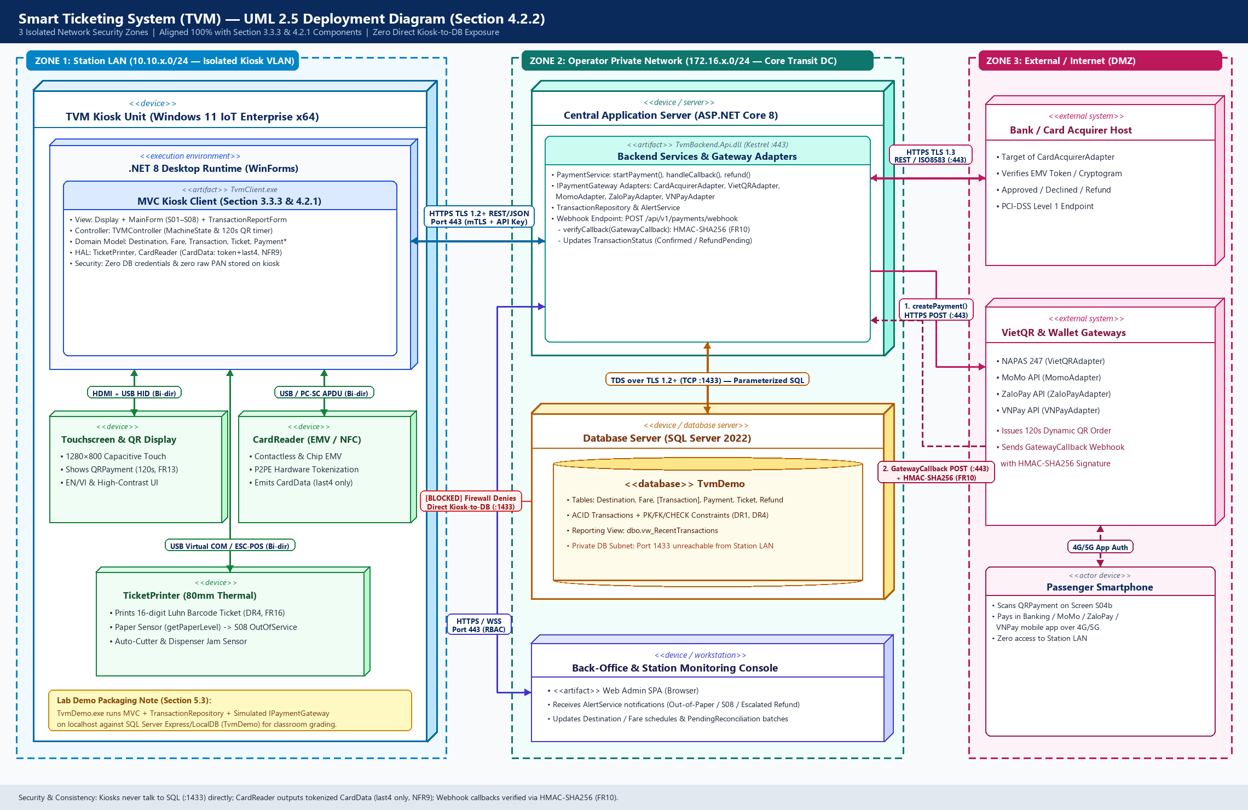
Figure 4.2.2: 3-Zone UML 2.5 Deployment Diagram Showing Hardware Nodes, Network Boundaries, and Protocols
Node / component | Description | Connection (protocol, direction)
TVM Kiosk Unit & Peripherals  (Station LAN 10.10.x.0/24) | Industrial Windows 11 IoT Enterprise x64 kiosk running .NET 8 TvmClient.exe (Display/MainForm S01–S08, TVMController, local Domain Model) connected inside a locked steel enclosure to: (1) 1280×800 Capacitive Touchscreen & QR Display, (2) EMV/NFC CardReader, and (3) 80mm ESC/POS Thermal TicketPrinter. | • Touchscreen: HDMI + USB HID (Bi-directional, local)  • CardReader: USB / PC-SC APDU (Bi-directional, tokenized CardData)  • TicketPrinter: USB Virtual COM / ESC-POS (Bi-directional paper status)  • To App Server: Outbound HTTPS TLS 1.2+ REST/JSON (:443, mTLS)
Central Application Server  (Operator Private Network) | ASP.NET Core 8 backend (TvmBackend.Api.dll on Kestrel :443) hosting PaymentService, AlertService, TransactionRepository, the 5 IPaymentGateway adapters, and the public-DMZ reverse-proxied Webhook endpoint (/api/v1/payments/webhook). | • From TVM Kiosks: Inbound HTTPS TLS 1.2+ REST/JSON (:443)  • To Database Server: Outbound TDS over TLS 1.2+ (TCP :1433)  • To External Gateways: Outbound HTTPS TLS 1.3 REST (:443)  • From Gateways: Inbound Async HTTPS POST Webhook (:443, HMAC-SHA256)
Database Server  (Isolated DB Subnet) | Microsoft SQL Server 2022 hosting relational database TvmDemo (Destination, Fare, [Transaction], Payment, Ticket, Refund, vw_RecentTransactions) with ACID transactions and daily backups. | • From Central Application Server ONLY: Inbound TDS over TLS 1.2+ (TCP :1433).  • Direct access from Station LAN or Internet strictly blocked by firewall.
Back-Office & Monitoring Console  (Operator Private Network) | Station operator workstation running Web Admin SPA to monitor live TVM heartbeats, AlertService out-of-paper/S08 alarms, Fare schedules, and PendingReconciliation batches. | • To Central Application Server: Outbound HTTPS REST & Secure WebSocket WSS (:443, RBAC authenticated).
Bank / Card Acquirer Host  (External / Internet) | External PCI-DSS Level 1 financial switch (Visa / Mastercard / NAPAS) targeted by CardAcquirerAdapter to authorize EMV cryptograms and process reversals/refunds. | • From Application Server: Synchronous HTTPS TLS 1.3 REST / ISO 8583 gateway (:443, Bi-directional request/response).
VietQR & Digital Wallet Gateways  (External / Internet) | External NAPAS 247 Bank QR (VietQRAdapter) and MoMo, ZaloPay, VNPay merchant APIs generating 120s dynamic QR orders and pushing payment notifications after smartphone authorization. | • Order Creation: Inbound HTTPS POST (:443) from App Server  • Payment Confirmation: Outbound Async HTTPS POST Webhook (:443) to /api/v1/payments/webhook with X-Signature HMAC-SHA256 (FR10).
Deployment & Security Reasoning: Placing TVM kiosks in public metro stations exposes them to physical tampering; therefore, the architecture enforces three strict network security boundaries (Station LAN, Operator Private Network, and External Internet). First, TVM kiosks never communicate with SQL Server (port 1433) directly and hold zero database credentials—all persistence flows through the Central Application Server over mTLS-authenticated HTTPS (:443). Second, in compliance with PCI-DSS and NFR9, the EMV/NFC CardReader performs hardware-level P2PE tokenization and outputs only a non-sensitive GatewayToken and Last4 digits (CardData), ensuring raw PAN/CVV data is never stored in memory, logs, or TvmDemo tables. Third, because passenger smartphones authorize Bank QR and Wallet payments over public 4G/5G networks, external gateways notify the backend asynchronously via HTTPS webhooks; IPaymentGateway.verifyCallback() validates the HMAC-SHA256 signature, timestamp window, exact VND amount, and idempotency key (FR10) before TVMController dispenses any paper ticket. (Note: For offline classroom grading in Section 5.3, TvmDemo.exe packages the MVC layers, SqlTvmRepository, and simulated gateway switch on localhost against SQL Server Express/LocalDB.)

5. Phase 4: Implementation, Tooling & Demo (30 marks)

5.1 Visual Studio Engineering: Model-to-Code (10 marks)

5.1.1 Forward Engineering (Model to Code)
Guidance (delete before submitting): Show how you generated the initial C# code skeletons from your class diagrams in Visual Studio. Include screenshots of the model and of the generated classes.
[ Class diagram in Visual Studio and the generated C# skeleton ]
[Steps taken and what was generated]

5.1.2 Backward Engineering (Code to Model)
Guidance (delete before submitting): List the manual code changes you made and show how they were reflected back into the UML model.
No. | Manual code change | File / class | How it was reflected in the model
1 | [ ] | [ ] | [ ]
2 | [ ] | [ ] | [ ]
…
[ Updated model after reverse engineering ]

5.1.3 Code Map
Guidance (delete before submitting): Generate a Code Map in Visual Studio and explain the relationships and architecture it shows.
[ Visual Studio Code Map ]
[What the code map shows and what you learned]

5.2 GitHub & AI Tooling (10 marks)

5.2.1 Source Control
Guidance (delete before submitting): The repository must show a committed history that proves active collaboration among all members.
Item | Your answer
Repository link | [ ]
Branches (names and purpose) | [ ]
Number of commits and pull requests | [ ]

Member | Commits | Pull requests | Main contributions
[Student Name 1] ([M1_ID]) | [ ] | [ ] | [ ]
[Student Name 2] ([M2_ID]) | [ ] | [ ] | [ ]
[Student Name 3] ([M3_ID]) | 2 | 1 | Section 3.3.3 Class Diagrams (Core 1/2 & Supporting 2/2), Forward-Engineered TVM.cs Skeleton, Section 4.2.1 Architecture
[Student Name 4] ([M4_ID]) | [ ] | [ ] | [ ]
[Student Name 5] ([524H0199]) | 5 | 2 | Section 4.1 Glassmorphism UI Mockups (S01–S08), Section 4.2.2 UML Deployment Diagram, db/TvmDemo_Setup.sql & Section 5.3 .NET 8 WinForms Demo

5.2.2 AI Assistance: Copilot Prompt Documentation
Guidance (delete before submitting): Document the prompts you used with GitHub Copilot (or a similar AI tool), how it helped (boilerplate or complex logic), and how you validated the AI-generated code. The workbook sheet "AI Prompt Log" is the full log; show the most important ones here.
No. | Member | Prompt | How the AI helped | Used? (kept / changed / rejected) | How we validated it
1 | [M1/M2/M4] | [ ] | [ ] | [ ] | [ ]
2 | [M1/M2/M4] | [ ] | [ ] | [ ] | [ ]
3 | M5 ([524H0199]) | Generate an HTML5/CSS3 1280x800 touchscreen prototype for 10 TVM screens (S01–S08) using glassmorphism cards (backdrop-filter: blur(20px)), EN/VI switch, >=64px touch targets, 120s QR timer (FR13), and charge-status banners. | Scaffolded CSS design tokens, 10 screen layouts, 4-step progress bar, and bilingual EN/VI dictionary. | Changed | Increased card opacity to 0.68 and text to #0B2A5C to pass WCAG AA >= 4.5:1 contrast; verified 1-to-1 mapping against UC01 steps.
4 | M5 ([524H0199]) | Write PlantUML for a Smart Ticketing TVM deployment diagram with 3 network zones and protocols aligned with Section 3.3.3 classes (TVMController, PaymentService, 5 IPaymentGateway adapters, TransactionRepository). | Generated PlantUML deployment nodes, artifacts, and protocol links. | Changed | Synchronized all component names with M3's class diagrams and removed direct kiosk-to-DB path so only App Server reaches port 1433.
5 | M5 ([524H0199]) | Create an idempotent T-SQL script for TvmDemo matching M3's domain model: Destination (Bus/Mrt), Fare (DR1), [Transaction] (FareSnapshot FR4), Payment (last4 NFR9, 120s QR FR13), Ticket (16-digit Luhn DR4), and Refund. | Produced DDL tables, PK/FK/CHECK constraints, 12 Bus+MRT stations, and reporting view. | Changed | Escaped [Transaction], saved with UTF-8 BOM for Vietnamese NVARCHAR names, and verified all 5 queries on LocalDB & SQLEXPRESS.
6 | M5 ([524H0199]) | Integrate M3's SmartTicketing.TVM C# skeleton (TVM.cs) with .NET 8 WinForms (S01–S08), async simulated IPaymentGateway (Success/Declined/Timeout), 16-digit Luhn barcode rendering, and parameterized SqlClient CRUD. | Implemented async purchase workflow, CancellationToken countdown, and DataGridView report. | Changed | Wrapped payment + ticket creation in atomic SqlTransaction, fixed High-DPI & glass rendering, and verified 0 build warnings/errors.

5.2.3 Reflection on AI Use
[What worked, what did not, errors found in AI output, and what you would do differently]

5.3 Demo Application (10 marks)
Guidance (delete before submitting): A functional prototype of the main use case using Visual Programming C# and MSSQL, with an input form and an output report (or success screen).
Item | Your answer
Technology and versions | • Framework & Language: C# 12 on .NET 8.0 Windows Forms (net8.0-windows, PerMonitorV2 High-DPI)  • IDE: Microsoft Visual Studio 2022 (v17.8+)  • Database: Microsoft SQL Server 2022 Express / LocalDB + Microsoft.Data.SqlClient 5.2.2  • Architecture: MVC + Repository + Strategy/Adapter integrating M3's SmartTicketing.TVM skeleton (TVM_M3_Model.cs)
Database script location and how to run it | • Script path: db/TvmDemo_Setup.sql (idempotent UTF-8 BOM script creating TvmDemo, 6 tables, constraints, 10 MRT + 2 Bus destinations, and vw_RecentTransactions).  • Run via CLI: sqlcmd -S "(localdb)\MSSQLLocalDB" -E -f 65001 -i db/TvmDemo_Setup.sql -C (or open in SSMS and press F5).  • Connection strings in src/TvmDemo/appsettings.json (switchable live on bottom Simulator Bar):  - LocalDb: Server=(localdb)\MSSQLLocalDB;Database=TvmDemo;Integrated Security=True;TrustServerCertificate=True;  - SqlExpress: Server=.\SQLEXPRESS;Database=TvmDemo;Integrated Security=True;TrustServerCertificate=True;  - Localhost: Server=localhost;Database=TvmDemo;Integrated Security=True;TrustServerCertificate=True;
How to run the application | 1. Execute db/TvmDemo_Setup.sql once on LocalDB or SQLEXPRESS.  2. Open src/TvmDemo.sln in Visual Studio 2022 and press F5 (or run: dotnet run --project src/TvmDemo/TvmDemo.csproj).  3. Use the bottom Instructor Simulator Bar to switch Gateway Result (Success / Declined / Timeout), toggle Printer Fault, switch SQL Server profile, or open the full Output Report (DataGridView).
Video demo link (optional) | [Optional video demo link]
Input form

Input Step 1 (S02): Select Station & Ticket Quantity (1–5) | Input Step 2 (S03): Choose Card, Bank VietQR, or Wallet
Payment Step (S04a): Async EMV/NFC Card Tap | Payment Step (S04b): Dynamic QR + Countdown + Cancel

Output report or success screen

Figure 5.3a: Output Screen (S05a) — Issued Paper Ticket with 1D Barcode & Joined MSSQL Recent Transactions DataGridView
Exception Handling (S05b): Card/Wallet Declined — Not Charged | Exception Handling (S08): Out of Service / DB or Printer Fault

Test scenarios
No. | Scenario | Input | Expected result | Result
1 | Successful Card Purchase (UC01 Main Flow) | Station: Bến xe Suối Tiên [MRT] (20,000 VND), Qty: 2, Mode: Credit Card, Simulator: Success | Async card authorization succeeds without UI freeze; 2 unique 16-digit Luhn tickets printed on S05a; dbo.[Transaction].Status = 'Completed', dbo.Payment.Status = 'Approved'; row appears in Output Report. | [Pass/Fail after run]
2 | Successful Wallet / VietQR Purchase (UC01 QR Flow) | Station: Thảo Điền [MRT] (11,000 VND), Qty: 1, Mode: Digital Wallet (MoMo), Simulator: Success | S04b renders dynamic QR with 02:00 (120s, FR13) countdown; simulated callback approves payment; 1 barcode ticket issued on S05a; DB records QRPayment (WalletProvider='Momo', Status='Approved') & Completed transaction. | [Pass/Fail after run]
3 | Card / Wallet Payment Declined (Exception E1) | Station: BX Chợ Lớn [BUS] (6,000 VND), Qty: 1, Mode: Credit Card, Simulator: Declined | Transitions to S05b Payment Declined with green banner 'NOT CHARGED — 0 VND'; dbo.[Transaction].Status = 'Failed' (RetryCount + 1), dbo.Payment.Status = 'Declined', 0 tickets inserted. | [Pass/Fail after run]
4 | QR / Gateway Timeout (Exception E2) | Station: Thủ Đức [MRT] (18,000 VND), Qty: 1, Mode: Bank QR (VietQR), Simulator: Timeout (or timer hits 00:00) | Transitions to S07 Payment Timeout stating passenger was not charged and warning against scanning expired QR; dbo.[Transaction].Status = 'Failed', dbo.Payment.Status = 'Expired', 0 tickets issued. | [Pass/Fail after run]
5 | Passenger Cancels Mid-Payment (Exception E3) | Start any purchase -> reach S03 or S04b -> press '✕ Cancel' -> press 'Yes, Cancel Purchase' on S06 | In-flight CancellationToken cancels async wait immediately; dbo.[Transaction].Status = 'Cancelled', dbo.Payment.Status = 'Cancelled'; returns cleanly to S01 Idle. | [Pass/Fail after run]
6 | Thermal Printer Fault / Out of Paper (Exception E4) | Tick 'Printer Fault' on Simulator Bar -> complete payment with Simulator: Success | TicketPrinter detects fault; transitions to S08 Out of Service displaying auto-refund notice & transaction reference; transaction recorded as Failed/RefundPending without crashing. | [Pass/Fail after run]
7 | SQL Server Unavailable (Exception E5 / DB Error) | Switch SQL Server dropdown on Simulator Bar to 'InvalidDbTest' -> click 'Connect DB' | SqlException caught cleanly within 2s timeout; transitions to S08 Out of Service with clear diagnostic message and 'NOT CHARGED (0 VND)' banner; UI remains responsive. | [Pass/Fail after run]
Known limitations
• Simulated Payment Gateways: CardAcquirerAdapter, VietQRAdapter, MomoAdapter, ZaloPayAdapter, and VNPayAdapter use an in-memory simulator switch (Success / Declined / Timeout) with 1.8s async latency rather than live merchant credentials.
• Simulated Financial Reversal: When a post-payment printer fault occurs, Refund records are created in memory/DB without triggering real interbank settlement.
• No Offline Store-and-Forward Queue: If SQL Server is unreachable, the kiosk safely locks into S08 Out of Service rather than caching encrypted offline transactions.
• Classroom Localhost Database Connection: For self-contained lab evaluation, TvmDemo.exe connects directly to local SQL Server Express/LocalDB via SqlClient instead of routing through a separate remote ASP.NET Core mTLS API server.
• Simulated Thermal Hardware: Barcode and QR codes are rendered via GDI+ bitmaps on screen rather than driving a physical USB ESC/POS thermal printer or PC/SC smartcard reader.

6. Checklist for "LabGroup_QT2_Assignment1.pdf"
Guidance (delete before submitting): The submission must address the content of LabGroupAssignment1.pdf (initial context and submission guidelines). List each item of that document, where this report covers it, and tick it.
No. | Item from LabGroupAssignment1.pdf | Where addressed in this report | Done
1 | [ ] | [Section ] | [ ]
2 | [ ] | [Section ] | [ ]
3 | [ ] | [Section ] | [ ]
4 | [ ] | [Section ] | [ ]
5 | [ ] | [Section ] | [ ]
6 | [ ] | [Section ] | [ ]
7 | [ ] | [Section ] | [ ]
8 | [ ] | [Section ] | [ ]

7. Contribution of Each Member
Guidance (delete before submitting): The % contribution of each member must total 100% and match readme.txt.
Member | Student ID | Work products and tasks | % contribution
[ ] | [ ] | [ ] | [ ]
[ ] | [ ] | [ ] | [ ]
[ ] | [ ] | [ ] | [ ]
[ ] | [ ] | [ ] | [ ]
[Student Name 5] | [524H0199] | Phase 3 Section 4.1 Touchscreen UI/UX Mockups (S01–S08) & Section 4.2.2 UML Deployment Diagram; Phase 4 Section 5.3 C# .NET 8 WinForms & MSSQL Demo Application | 20%
Total |  |  | 100%

8. Conclusion and Lessons Learnt
[Overall team conclusion and lessons learnt from M1, M2, and M4 to be merged here before final submission.]
• Lessons Learnt — Member 3 ([M3_ID]) & Member 5 ([524H0199]): Sharing a single canonical domain vocabulary early (TVMController, Transaction, QRPayment with 120s expiry, 16-digit Luhn TicketNumber, and 5 IPaymentGateway adapters) allowed our UML Class Diagrams (3.3.3), MVC & Deployment Architecture (4.2), T-SQL constraints, and C# .NET 8 WinForms demo (5.3) to integrate with zero naming drift. Implementing async/await with CancellationTokenSource and atomic SqlTransaction blocks also proved essential on a kiosk touchscreen so gateway timeouts, user cancellations, and printer faults never freeze the UI or leave ambiguous charge states.

References
1. [Course notes, textbook, tool documentation, links]

Appendix

Appendix A: readme.txt
[Paste the contents of readme.txt: GitHub link, Figma link, database script instructions, % contribution]

Appendix B: Full-size Diagrams
[Full-size use case, activity, sequence, state, class, architecture and deployment diagrams]

