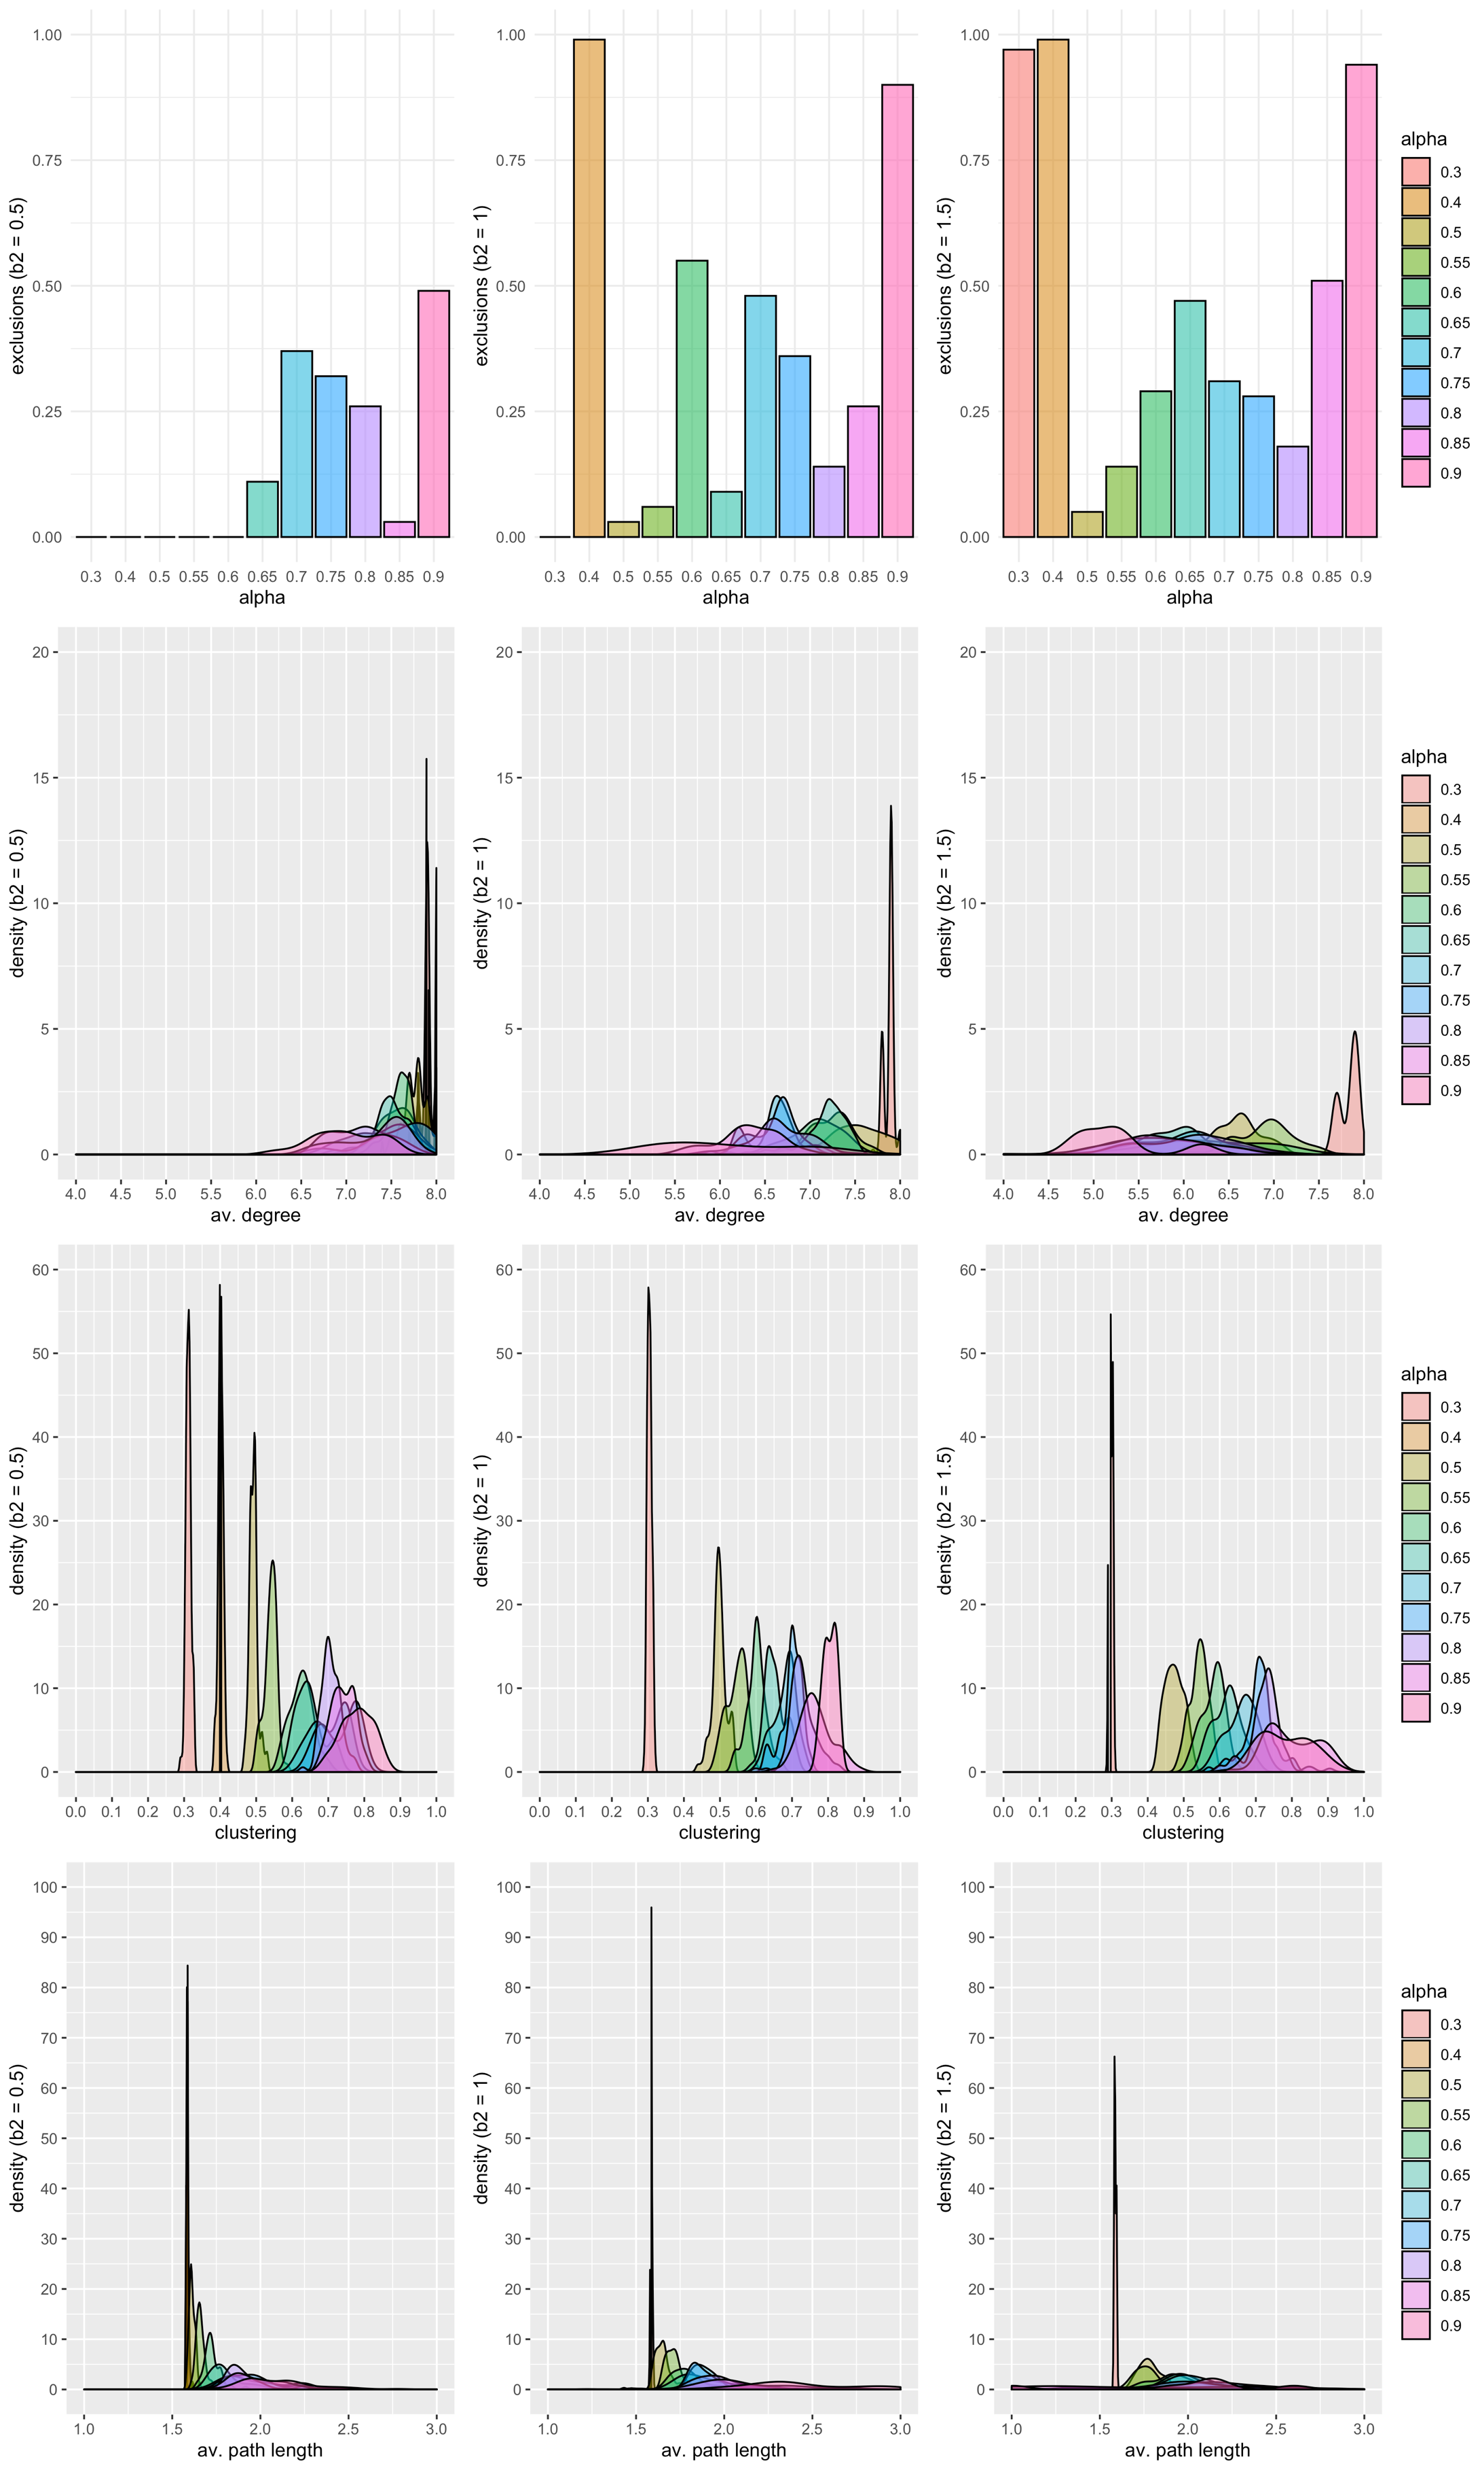­­­­

**b2 = 1.5**

**b2 = 1.0**

**b2 = 0.5**

**Finding b2 and upper bound for α for 3 conditions (RND, SWw, SWs)**

**Settings**

b1 = 1.0

c1 = 0.1

c2 = 0.05

b2 = {0.5, 1.0, 1.5}

α = {0.30, 0.40, 0.50, 0.55, 0.60, 0.65, 0.70 0.75, 0.80, 0.85, 0.90}

N = 20

ι = empty

φ = 0.4

**Finding α for 3 conditions (RND, SWw, SWs)**

**Settings**

b1 = 1.0

c1 = 0.1

c2 = 0.05

b2 = 0.5

α = {0.15, 0.25, 0.50, 0.75, 0.85}

N = 20

ι = empty

φ = 0.4

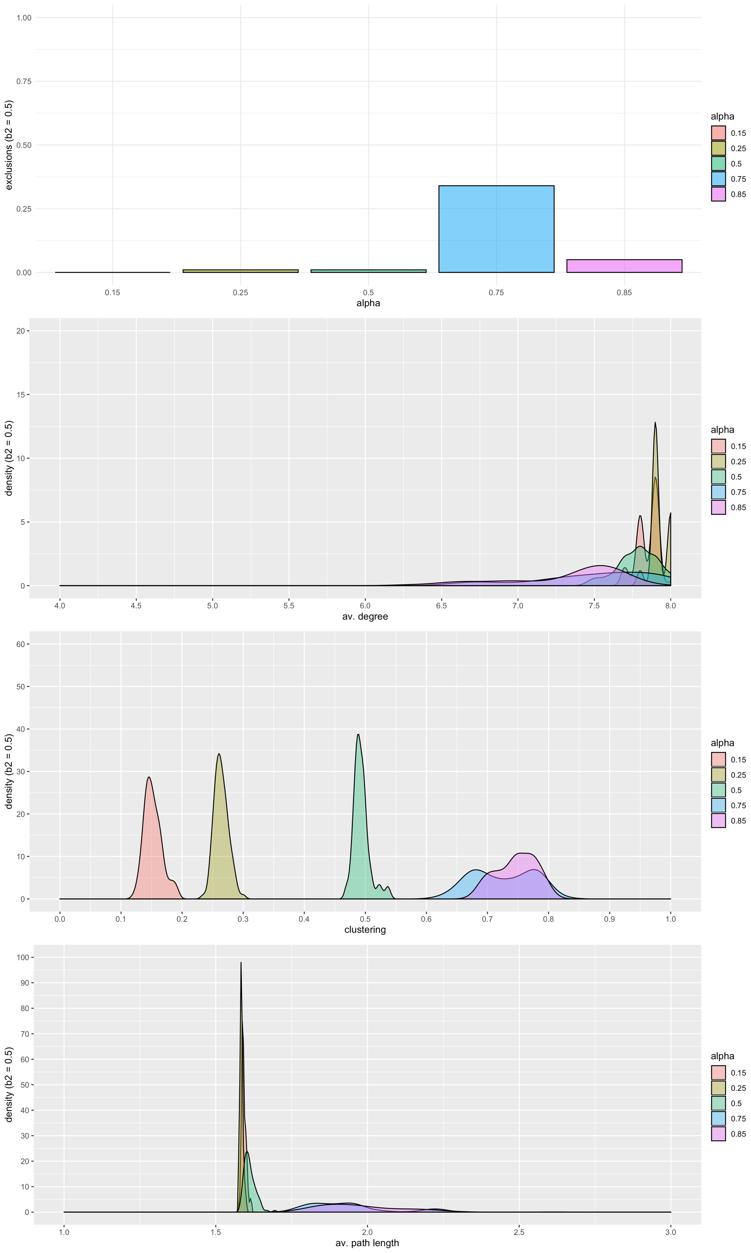

**Comparison of conditions (RND, SWw, SWs) over network sizes**

**N = 20**

**N = 40**

**N = 80**

**Settings**

b1 = 1.0

c1 = 0.1

c2 = 0.05

b2 = 0.5

α = {0.15, 0.50, 0.85}

N = {20, 40, 80}

ι = empty

φ = 0.4

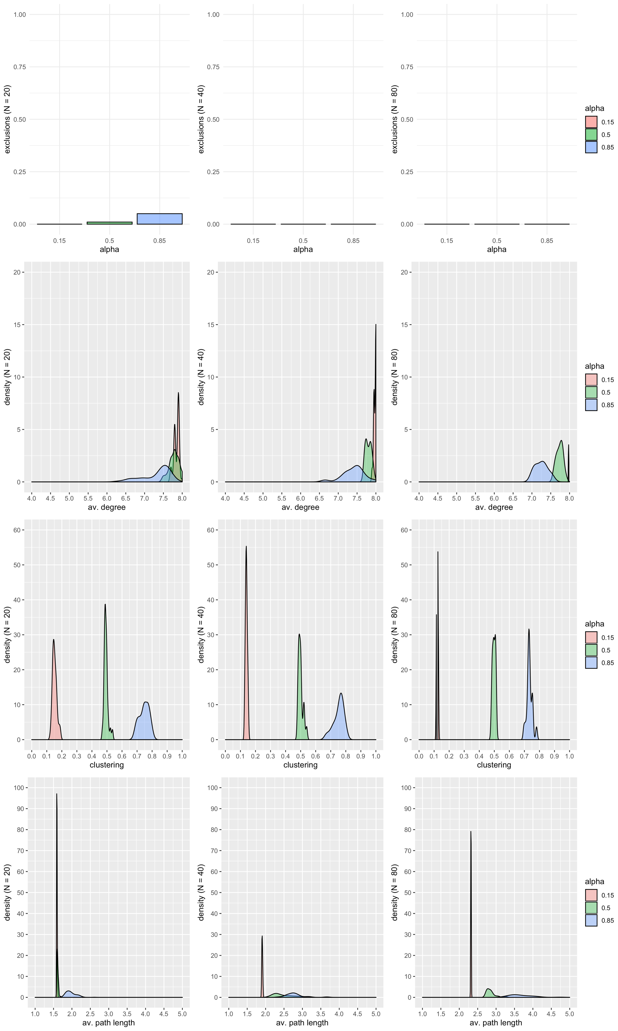

**Comparison of conditions (RND, SWw, SWs) over network sizes (rescaled)**

**N = 20**

**N = 40**

**N = 80**

**Settings**

b1 = 1.0

c1 = 0.1

c2 = 0.05

b2 = 0.5

α = {0.15, 0.50, 0.85}

N = {20, 40, 80}

ι = empty

φ = 0.4

