Full Name: Huynh Nguyen Van Khanh
Student ID: 314561007

Assignment #3 Report

Research Questions
This study aims to investigate the following research questions:
- How does the design of the reward function influence the performance and behavior of a reinforcement learning agent?
- Can heuristic reward schemes improve the learning efficiency of reinforcement learning agents?
- How does the learning process vary across different Atari tasks?
- How does frame skipping influence the learning performance and outcome of reinforcement learning agents?
- How does the replay buffer size affect the reinforcement learning process? Is the required buffer size the same throughout all stages of training, or does it vary depending on the training stage?

Used methods

Methodology and algorithms
- Deep Q-Network (DQN): Learns action values from stacked Atari frames using a convolutional neural network.
- Experience Replay: Stores transitions in a replay buffer and samples mini-batches during training to improve learning stability.
- Target Network: Uses a periodically updated target model to compute more stable Q-learning targets.
- Epsilon-Greedy Exploration: Selects random actions early in training, then gradually favors learned actions.

Tools
- Coding agent: Codex
- Writing assistant: ChatGPT

Experiments

Pong (Atari)

Task introduction
Pong is a simple table tennis simulation where the player controls a paddle and attempts to hit the ball past the opponent to score points.

Baseline
The baseline agent is designed to learn directly from visual game frames and estimate the expected value of each possible action. Its architecture follows the classic DQN design: Atari frames are first preprocessed and stacked to provide recent visual context, then passed through a convolutional neural network to extract features. The network finally outputs Q-values, which are used to select actions.
During training, the policy network is continuously updated, while the target network is updated periodically to keep the learning targets more stable. The replay buffer stores past experiences and samples them randomly during training, helping reduce the strong correlation between consecutive game frames.
The agent uses an epsilon-greedy strategy for action selection. At the beginning of training, it often takes random actions to explore the environment. As training progresses, the exploration rate gradually decreases, and the agent increasingly chooses the action with the highest predicted Q-value.
The reward function is simple: the agent receives +1 when it scores and -1 when it misses.

Replay buffer size
Replay buffer size controls how many past game experiences the agent stores and samples from during training, which affects learning stability, diversity of samples, and how quickly the agent adapts to new strategies in Pong.
In this experiment, I keep all settings the same but change the replay buffer size from 10K to 20K to observe how it affects the RL agent’s learning process in Pong. I also test whether increasing the buffer size later in training, after 1.2M timesteps, changes the agent’s behavior and learning stability.

Heuristic shaped-reward function
The heuristic shaped-reward agent was trained using the same settings as the baseline agent, except that it uses a modified reward function. In this version, the agent receives +4 for scoring, -2 for missing the ball, +1 for hitting the paddle, and an additional distance-based penalty ranging from 0 to -1 when it misses. This means that if the paddle is farther away from the ball when it misses, the penalty becomes larger.
The rationale behind this reward design is that, before the agent can learn to score, it first needs to learn how to hit the ball with the paddle. Therefore, the shaped reward encourages the agent to move the paddle closer to the ball and successfully return it. The distance-based penalty follows the same idea: even when the agent misses, it is encouraged to keep the paddle as close to the ball as possible.
A higher reward is given for scoring to ensure that the agent does not only learn to keep returning the ball back and forth but also learns to play aggressively and aim for actual points.

Breakout (Atari)

Task introduction
In the Breakout, the player controls a horizontal paddle at the bottom of the screen and uses it to bounce a ball upward to destroy rows of bricks placed at the top of the screen. The objective is to break as many bricks as possible without letting the ball fall below the paddle. As the game progresses, the ball speed increases, making the gameplay more challenging and requiring faster reactions and more precise paddle control.

Baseline
The baseline agent uses a standard DQN agent trained on the Atari Breakout environment. The input state is composed of four stacked grayscale frames resized to 84×84, allowing the agent to capture object movement such as the ball’s direction and speed. The network follows the typical Atari DQN architecture with three convolutional layers, a fully connected layer, and an output layer that predicts one Q-value for each possible action.
The baseline uses the original Breakout reward signal with reward clipping. Positive rewards are clipped to +1, zero rewards remain 0, and negative rewards are clipped to -1. No additional heuristic reward shaping is applied, meaning the agent learns only from the standard environment feedback.
For training, the agent uses epsilon-greedy exploration, experience replay, and a separate target network. The model is trained for 600,000 agent steps with a learning rate of 0.0001, batch size of 32, discount factor of 0.99, and target network updates every 1,000 steps. The baseline setting uses a frame skip of 4, where each selected action is repeated for four game frames.
- Heuristic shaped reward function
The main objective of this experiment is to investigate whether heuristic reward engineering can accelerate learning and improve agent behavior compared to the standard sparse Atari reward. Instead of relying only on the original game score, the agent receives additional intermediate rewards based on important in-game events.
The rules of Breakout are very similar to those of Pong, as both games require the player to control a paddle to interact with a moving ball. However, the objective of Pong is to score points against an opponent, while the objective of Breakout is to destroy as many bricks as possible.
Hence, the shaped reward function used in Breakout is also similar to the shaped reward function used in Pong. In both games, the reward design encourages the agent to move the paddle as close to the ball as possible. The agent receives a positive reward when the ball successfully hits the paddle, while a penalty is applied based on the distance between the paddle and the ball when the agent misses the ball.
The custom reward function consists of three components:
- Destroying a brick: +2
- Successfully hitting the paddle with the ball: +1
- Missing the ball: penalty ranging from 0 to -1 depending on the distance between the paddle and the ball
- Frame skipping
This experiment compares three settings: frame skip 2, frame skip 4, and frame skip 8.
All training settings and the DQN architecture are kept the same, while only the frame-skip value is changed. This allows the experiment to isolate how action repetition affects learning speed, control precision, training stability, and final game performance.
Frame skip 4 is treated as the baseline because it is the standard setting used in many Atari DQN experiments

Observations

Pong baseline learning curve
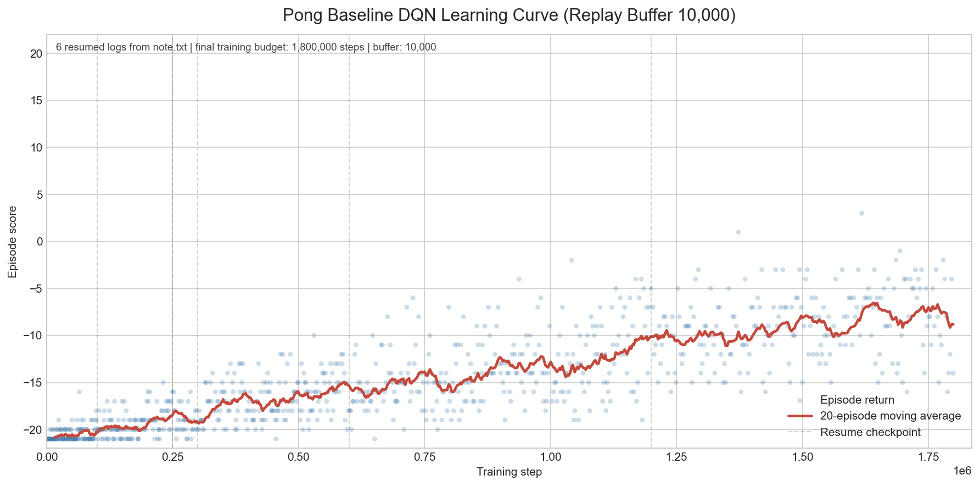
Figure 1. Pong baseline learning curve
From the above figure, we can observe that the return values are mostly clustered around low scores during the early training stages, indicating that the agent initially struggles to learn an effective policy. As training progresses, the return values begin to vary more widely, suggesting that the agent starts exploring more successful behaviors and occasionally achieves higher scores.

The role of replay buffer size (Pong)
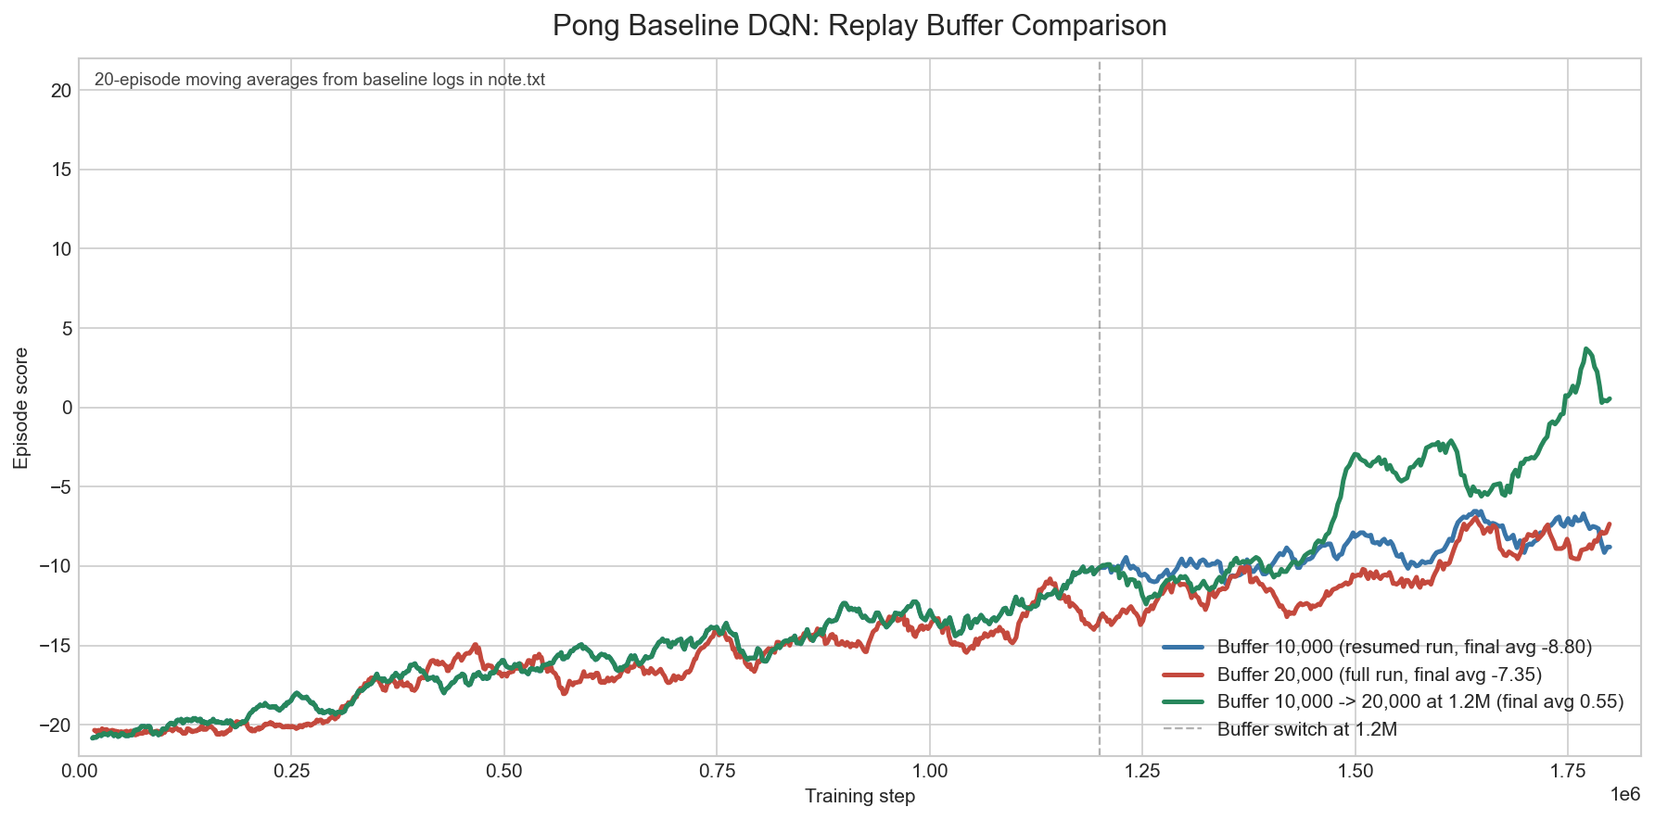
Figure 2. Replay buffer size comparison
The experiment yields interesting results. There is not much difference between the learning curves of the baseline agents trained with 10K and 20K replay buffers throughout the training process. However, the agent that is first trained with a 10K buffer and then switched to a 20K buffer shows a sharper improvement in the later timesteps.
This can happen because buffer size does not only affect how much experience is stored, but also what kind of experience the agent samples during each training stage.
A possible explanation is:
When the agent is trained with a 10K replay buffer, the buffer contains more recent experiences. This can help the agent adapt faster in the early stage because it mainly learns from the latest policy behavior. In contrast, a 20K buffer stores more old experiences, so the training samples are more diverse but may include many outdated transitions, making the learning curve similar or slightly slower.
However, when the agent is first trained with 10K and then switched to 20K, it may benefit from both effects. In the early stage, the smaller buffer helps the agent learn quickly from recent useful experiences. Later, increasing the buffer size allows the agent to keep more diverse and higher-quality experiences collected after it has already learned a better policy. As a result, the agent may sample from a richer set of useful transitions, which can lead to a sharper improvement in later timesteps.

Pong heuristic shaped-reward function results
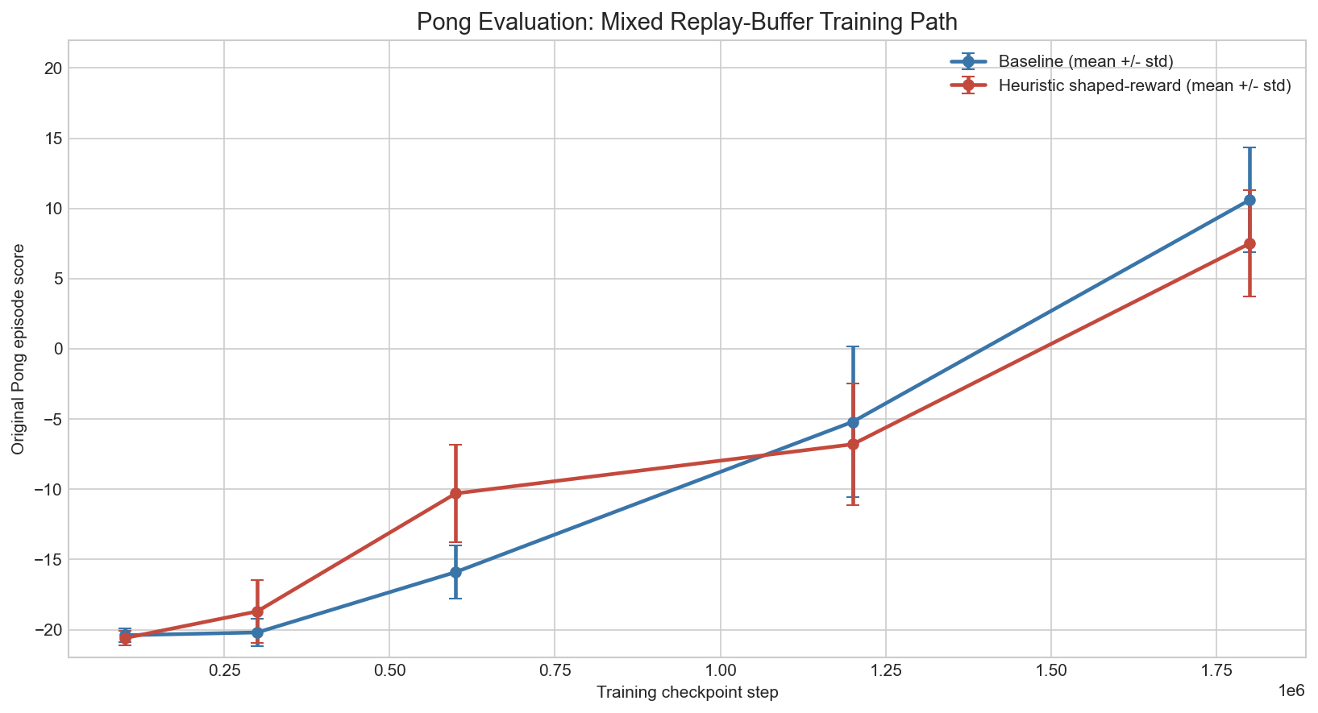
Figure 3. Comparison between baseline and reward heuristic shaped-reward agent
From the graph, we can see that the heuristic shaped-reward agent learns faster during the initial training stage (before 1M timesteps). However, the heuristic shaped-reward agent also shows a wider standard deviation range compared to the baseline agent, indicating a more unstable learning process.
This suggests that the heuristic shaped-reward function helps the agent learn common and basic gameplay patterns more quickly, allowing faster early improvement. However, because the reward function is more heavily shaped, the agent may become biased toward specific behaviors, leading to higher variance and reduced training stability.
After around 1M timesteps, the baseline agent surpasses the shaped-reward agent. One possible explanation is that the standard reward function encourages more stable long-term optimization, while the heuristic reward may eventually limit the agent’s ability to learn the optimal policy.

Breakout heuristic shaped-reward
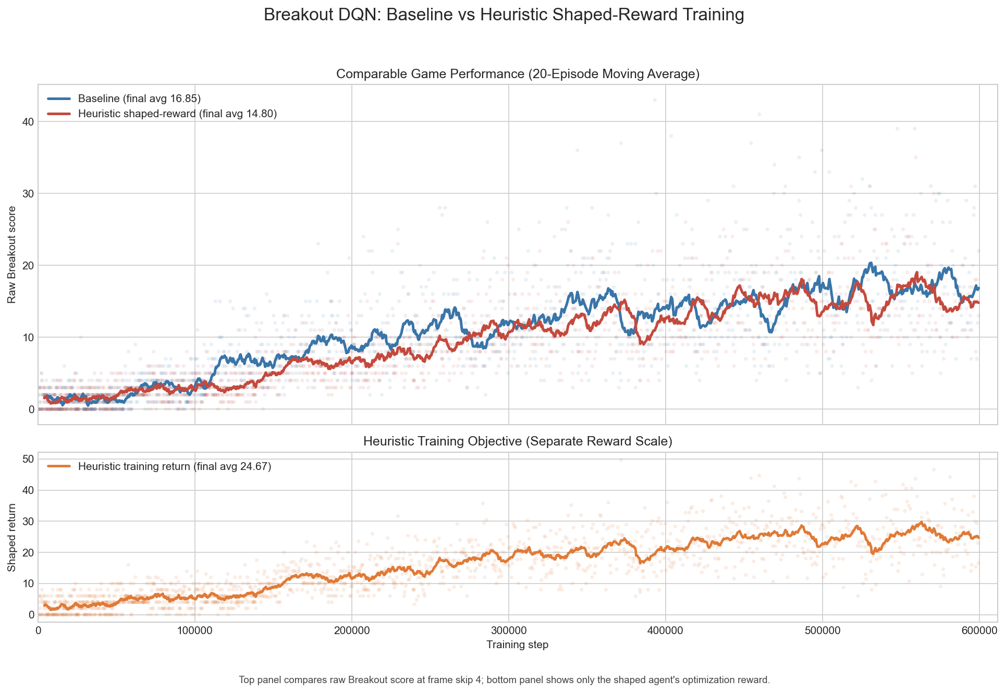
Figure 4. Learning curve of Breakout baseline and heuristic shaped-reward agent

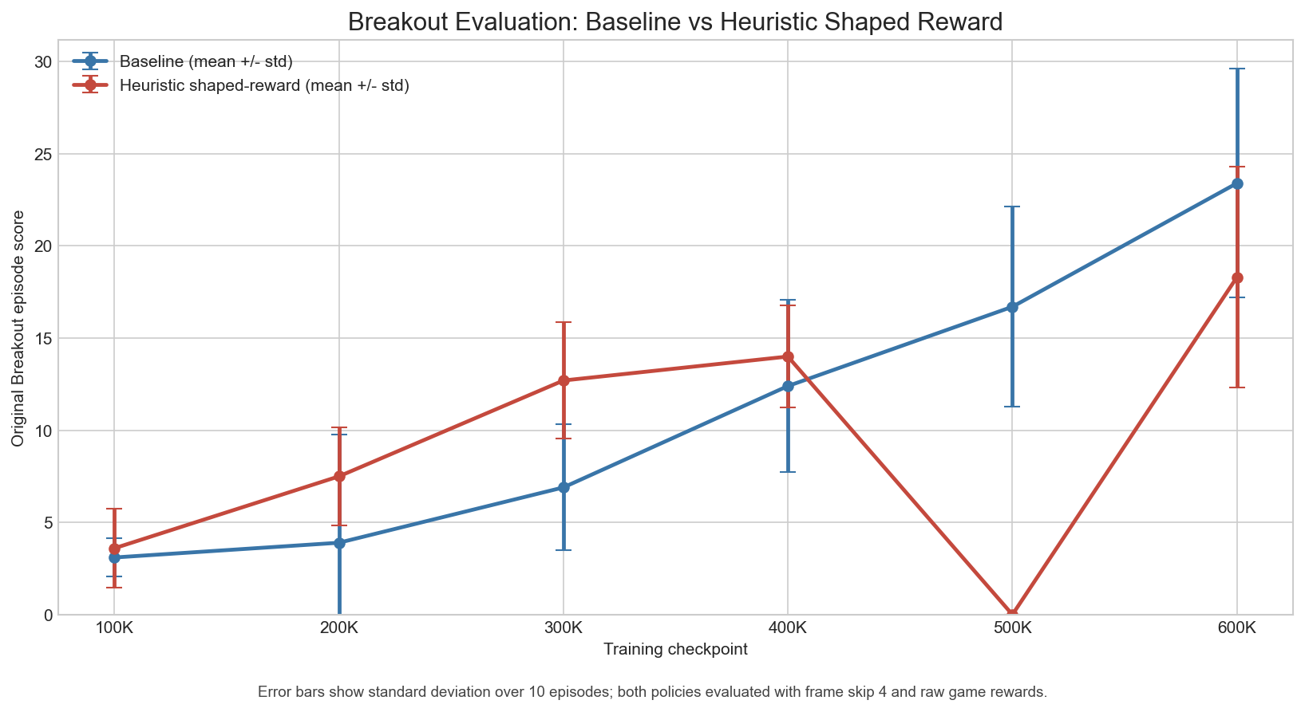
Figure 5. Evaluation results of both agents
The observation on Breakout task shaped-reward agent is similar to the observation on Pong. The shaped-reward agent learning faster at first, but in latter timesteps the baseline agent become better. But different from the case of Pong, in Breakout, both agent have very high standard deviation range.

Breakout frame skipping
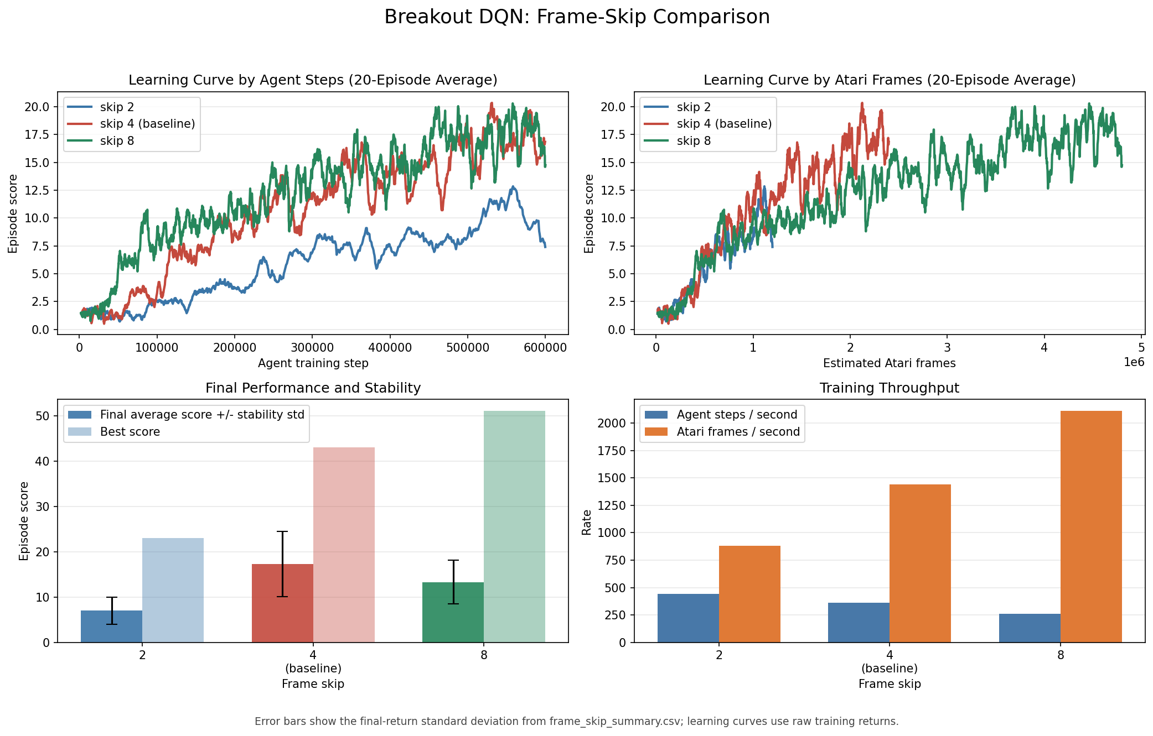
Figure 6. Frame-skip Comparison
Looking at Figure 2, we can see that the agent trained with a frame skip of 2 achieved the worst performance in terms of episode score per agent step. The agents trained with frame skip values of 4 and 8 achieved comparable overall results. Although the agent using frame skip 8 performed better during the early training stages, the agent with frame skip 4 gradually caught up during later timesteps, around step 200,000, after which both models produced similar performance.
However, despite achieving lower overall scores, the agent trained with frame skip 2 appeared to have a more stable training process. This can be observed from its lower standard deviation in the final average score compared to the other two agents. Therefore, while the learning process was slower, the policy updates seemed more consistent and stable over time.
The agent trained with frame skip 8 achieved the highest best episode score among all settings. Nevertheless, its average performance was less efficient and less stable compared to the frame skip 4 agent, which provided a better balance between learning speed and overall consistency.
When using a lower frame skip, such as 2, the agent is able to make decisions more frequently, resulting in finer control and faster reactions to ball movement. However, this also reduces Atari-frame throughput because the model must perform more forward passes and learning updates. In contrast, higher frame skip values allow the environment to process more Atari frames in less real-world time by repeating the same action for multiple frames. As shown in the figure, higher frame skip increases frame throughput, while lower frame skip allows the agent to perform more decision steps per second and maintain more precise control over gameplay.
In other words, a higher frame skip allows the agent to process more Atari frames in the same amount of real-world training time, meaning the agent can observe more gameplay examples during training. However, because the same action is repeated for multiple frames, the agent may miss short timing windows or fast movements that require precise reactions.
On the other hand, a lower frame skip allows the agent to make more granular and precise decisions because it can react more frequently to changes in the environment. However, this also slows down the overall learning process since the model must perform more forward passes and training updates for the same number of Atari frames.

Discussion
Through these experiments, we can see that reward shaping can help the agent learn faster, but the learning stability also depends heavily on the design of the reward function. In this case, the heuristic shaped-reward function helps the agent learn basic gameplay patterns more quickly, but it also makes the training process less stable.
There are multiple ways to improve an RL agent’s performance. One approach is frame preprocessing, such as frame skipping. Frame skipping can help the agent learn faster by reducing redundant observations, but it also introduces a trade-off because the agent may miss short-term details. Therefore, the best choice depends on the specific algorithm and task.
I also explored the effect of replay buffer size. The results suggest that replay buffer size may affect the agent differently at different stages of training. In this report, I tested whether changing the replay buffer size midway through training can hurt or benefit the agent. In this case, increasing the replay buffer size later in training improved the agent’s performance. However, whether this result generalizes to other tasks or settings still requires further validation.
Overall, these experiments show that training a reinforcement learning agent does not only depend on the algorithm and environment. Other factors are also important, such as how the agent observes the environment, how observations are preprocessed, how much past experience the agent can remember, and how much exploration the agent is encouraged to perform.

References
- Pong implementation using DQN: https://github.com/mmuppidi/DQN-Atari-Pong
- Breakout implementation using DQN: https://github.com/virajbhartiya/Atari-Breakout-DeepQ

