Manasseh A. Ortsin
Edward Bouchet
2/3/2026

PART A

Question 1

- The UK in 2017

The population pyramid referring to the UK in 2017 (shown in figure 2) shows how factors such as lower birth rates, higher access to healthcare, etc, makes it a constrictive population pyramid. There are lower, similar rates for males and females aged 0-24, meaning that birth rates are lower due to later marriage and higher living costs seen in the UK, as well as women tending to focus on career advances, education, and choosing to give birth later in life. The constrictive graph shows how life expectancy is high (79.4 years for males and 83.1 years for females), which also means an aging population.

SOURCES:
https://www.ons.gov.uk/peoplepopulationandcommunity/birthsdeathsandmarriages/lifeexpectancies/bulletins/nationallifetablesunitedkingdom/2017to2019

- Tanzania in 2017

The population pyramid of Tanzania in 2017 shows extremely high birth rates, but low life expectancy, with only 0.2% of the population (both male and female) living to see the age range of 85-89 years. This is an expansive population pyramid, and shows how the lack of family planning, access to higher education in the continent of Africa, and early marriage/birth causes the young population to skyrocket, and demands high attention and focus on healthcare, schools, and jobs to improve the living quality of the population.

c) The UK in 2055

The UK in 2055 shows a stationary population pyramid, a more balanced form than its 2017 counterpart, and includes larger groups of higher ages. The pyramid is more balanced throughout each age group, and even lower birth rates as well as shrinking work-aged population are prevalent. The implications of this suggest a possible strain on healthcare infrastructure and social infrastructure as well as a greater dependency ratio.

d) Tanzania in 2055

The population pyramid in 2055 Tanzania shows a less expansive population pyramid, which suggests an improved life expectancy, and a slower pace of population growth. The population pyramid implies a large opportunity for economic growth due to a large, young workforce, and shows a need for more education and jobs to utilize and educate the workforce at hand.

Question 2

A - 2017 UK

2017 uk would be in stage four of the demographic transition model, as the population pyramid displays low birth and death rates, as well as stable population growth.

B - 2017 Tanzania

2017 Tanzania falls under a country inside stage 2 of the demographic transition model, with very high birth rates, falling death rate, as well as rapid population growth.

C - 2055 UK

2055 uk falls under stage four (transitioning to stage 5 of the demographic transition model), with birth and death rates both low, a stable population, and an aging population as well.

D - 2055 Tanzania

2055 Tanzania is in stage 3 of the demographic transition model; it has a falling birth rate and a low death rate, which causes growth to round off and slow down. This shows a transition from 2017 to smaller family sizes, lower fertility rates, and improved healthcare / standards of living, as well as improved family planning.

Question 3

A comparison between the population pyramids of the UK and those of Tanzania show how improved healthcare, access to education, and better family planning cause higher life expectancies and more stable population demographics. In expansive population pyramids (such as Tanzania in 2017 and 2055), we see a booming young population whilst observing lower life expectancies. In contrast, for the constrictive (2017) and stationary (2055) population pyramids for the UK, we see that improved access to healthcare and education drives fertility rates lower, as well as lower birth rates (due to the fact that women tend to focus on their careers and give birth later in life, when older), and better family planning shapes a more controlled population.

Question 4

The government of the UK would have to enact policies that improve and strengthen the infrastructure regarding healthcare to accommodate for higher life expectancies and a stable, aging population.
PART B

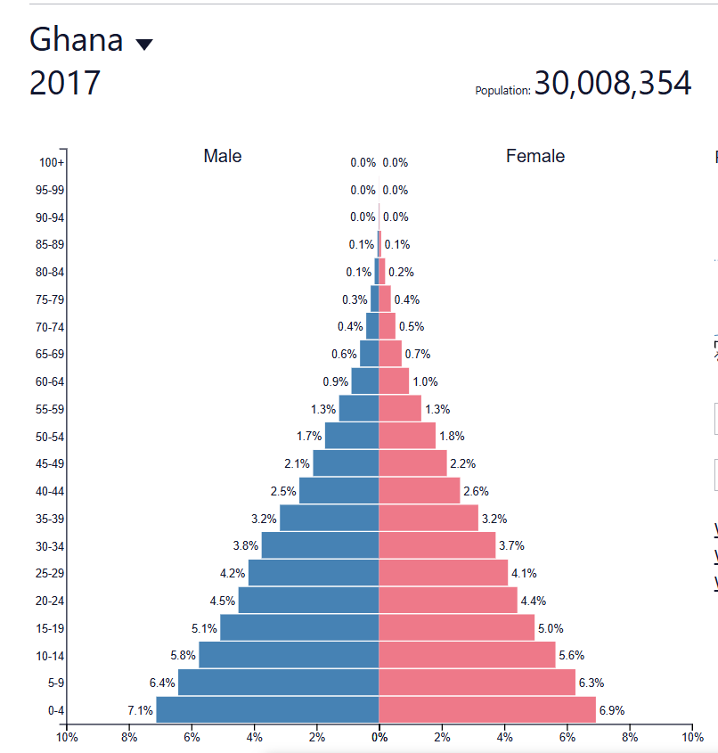
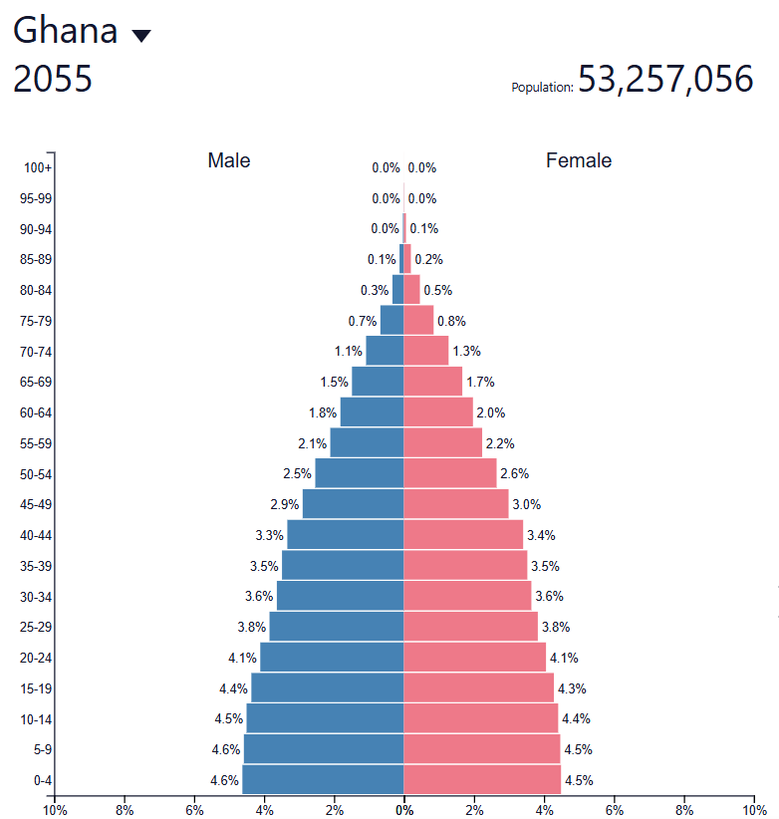
SOURCE: https://www.populationpyramid.net/

Question 1

- Ghana in 2017

The population pyramid of Ghana in 2017 displays the characteristics of a highly expansive population pyramid, causing a high growth in youth population as compared to the older population, with lower life expectancies.

- Ghana in 2055

The population pyramid of 2055 Ghana shows a transition from a more expansive pyramid to a constrictive one.

Question 2

A - 2017 Ghana

The population pyramid of Ghana in 2017 aligns with stage 2 of the demographic transition model. The wide base of younger ages shows high birth rates and a growing population, lower life expectancy, and a rapid population growth.

B - 2055 Ghana

The population pyramid of Ghana in 2055 shows stage 3 of the demographic transition model, as there is a narrower base and slower population growth. A wider array of older ages shows higher life expectancy and more people seeing adulthood.

Question 3

The population pyramid of Ghana in 2017 shows higher fertility rates as well as a higher dependency ratio and less of a stable adult population relative to the youthful population of the country, but in contrast, the population pyramid of Ghana in 2055 shows that the healthcare standard and infrastructure has improved, ushering more of the youth into adulthood and the workforce.

Question 4

The government would have to adjust and improve upon the healthcare infrastructure as well as the general infrastructure of the country to tailor to economic strain and possible strain on healthcare and amenities to ensure a more balanced, less expansive population pyramid.

