**Industrial Project Report On**

**Full Stack Web Development.**

## **Submitted By:** **Submitted** **to:**

Name: Hanish Thakur

vinash

210213006

A

## Roll No: 20011303007

## Semester: 8th

Course: Btech (CSE)

**Department of Computer Science & Engineering**

**Himalayan Group of Professional Institutions**

**Kala Amb, HP (173030)**

**Session 2023-2024**

**Declaration**

I, Hanish Thakur, hereby declare that I have successfully completed a comprehensive six-month industrial training program in full-stack web development. This training, conducted from 15/01/24 to 29/04/24, has equipped me with the essential skills and knowledge required to excel in the field of web development.

Throughout the duration of this training, I have diligently engaged in various modules covering both front-end and back-end development technologies. I have acquired proficiency in HTML, CSS, JavaScript, as well as popular frameworks and libraries such as React.js, bootstrap, and Express.js for front-end development. Additionally, I have gained expertise in server-side scripting languages like Node.js, along with database management systems including MongoDB, MySQL, and Cloudinary for back-end development.

I have actively participated in practical exercises, projects, and real-world scenarios, which have provided me with invaluable hands-on experience in designing, developing, and deploying dynamic web applications. Moreover, I have demonstrated my ability to collaborate effectively within a team environment, communicate technical concepts clearly, and adapt to evolving technologies and industry practices.

I am confident that the knowledge and skills acquired during this industrial training program have prepared me to contribute meaningfully to the web development domain. I express my gratitude to Apna College for providing me with this invaluable learning opportunity and to all the instructors and mentors who have guided and supported me throughout this journey.

Signature: ______________________________

Hanish Thakur

**Certificate of completion**



**Acknowledgement**

I would like to express my sincere gratitude to Apna College for providing me with the opportunity to undergo industrial training in full stack web development. This training program has been invaluable in enhancing my skills, knowledge, and understanding of web development technologies and frameworks.

I am deeply thankful to Shradha Khapra, our esteemed instructor, for guiding and mentoring me throughout the training program. Their expertise, patience, and dedication have been instrumental in shaping my learning experience and helping me acquire practical skills in web development.

This industrial training experience at Apna College has been truly enriching and rewarding, and I am confident that the knowledge and skills gained will significantly contribute to my future endeavors in the field of web development.

Thank you once again to everyone at Apna College for their support, guidance, and encouragement throughout this training journey.

Hanish Thakur

**Abstract**

This industrial training report provides an in-depth exploration of full stack web development, a comprehensive approach to building dynamic and interactive web applications. Conducted through Apna College, the training program offered a hands-on learning experience covering various aspects of web development, including frontend and backend technologies, frameworks, libraries, and best practices.

The report begins with an introduction to web development, highlighting the diverse facets of frontend development, backend development, database management, and server configuration. It delves into the process of web development, outlining the stages from planning and design to development, testing, deployment, and maintenance.

Key topics covered include HTML, CSS, and JavaScript for frontend development, Node.js and Express.js for server-side development, and Bootstrap for frontend design. The report explores the functionalities, benefits, and applications of these technologies and frameworks in full-stack web development.

Additionally, hardware and software requirements for web development are discussed, providing insights into the tools, equipment, and resources needed to support the development process effectively.

Overall, this industrial training report serves as a comprehensive guide to full stack web development, offering valuable insights and practical knowledge gained through hands-on experience at Apna College.

**Table of contents**

|  |  |  |
| --- | --- | --- |
| S. No. | Topics | Page No. |
| 1. | Introduction to Full Stack Web Development.   * 1. Web Development: An overview   2. Several Aspects of Web Development   3. Process of Web Development   4. Hardware Requirements   5. Software Requirements | 9-12 |
| 2. | HTML: The Backbone of Web Development  2.1 Introduction to HTML  2.2 Basic Structure of HTML Document  2.3 Common HTML Elements  2.4 Attributes and Semantic HTML  2.5 Forms and Input Elements  2.6 Accessibility and Best Practices | 13-14 |
| 3. | Cascading Style Sheets (CSS): Elevating Web Design  3.1 Introduction to CSS  3.2 Basic Structure of CSS  3.3 Selectors  3.4 Properties and Values  3.5 Box Model  3.6 Responsive Design and Media Queries  3.7 CSS Frameworks and Preprocessors | 15-17 |
| 4. | JavaScript: The Dynamic Heart of Web Development  4.1 Introduction to JavaScript  4.2 Basic Syntax and Structure  4.3 Datatypes and Variables  4.4 Functions and Scope  4.5 DOM Manipulation  4.6 Event Handling  4.7 Asynchronous Programming | 18-20 |
| 5. | Exploring Essential Libraries for Web Development  5.1 Node.js: Empowering Server-Side Development  5.2 React.js: Transforming Client-Side Development | 21-23 |
| 6. | Exploring Essential Frameworks for Web Development  6.1 Express.js: Streamlining Server-Side Development  6.2 Bootstrap: Enhancing Frontend Development | 24-26 |
| 7. | Snapshots of Project (Result) | 27-30 |
|  | Conclusion | 31 |
|  | Reference | 32 |
|  | Links to Access final Project & its files | 33 |

**List of Figures**

|  |  |  |
| --- | --- | --- |
| S. No. | Topics | Page No. |
| 1. | Simple Css Rule | 15 |
| 2. | Css Example | 15 |
| 3. | JS Example | 18 |
| 4. | Data Types and Variables | 19 |
| 5. | DOM Example | 19 |
| 6. | Event Handling Example | 20 |
| 7. | Async Programming Example | 20 |
| 8. | Snapshots of Project | 27-30 |

1. **Introduction to Full Stack Web Development**

In today's digital age, the internet serves as a cornerstone for communication, commerce, and information dissemination. As businesses strive to establish a strong online presence and individuals seek seamless digital experiences, the demand for web development expertise continues to soar. Full stack web development, in particular, emerges as a comprehensive approach to building dynamic and interactive web applications that cater to the diverse needs of users and businesses alike.

**1.1 Web Development: An Overview**

Web development encompasses a broad spectrum of disciplines and technologies aimed at creating websites and web applications that are accessible, functional, and visually appealing. It involves several aspects, including frontend development, backend development, database management, and server configuration, each playing a crucial role in the overall development process.

**1.2 Several Aspects of Web Development**

**- Frontend Development:** Frontend development focuses on building the user interface and user experience (UI/UX) of a website or web application. It involves the use of HTML, CSS, and JavaScript to create interactive and visually engaging interfaces that users interact with directly in their web browsers.

**- Backend Development:** Backend development deals with the server-side logic and functionality of a web application. It includes tasks such as handling user authentication, processing data, interacting with databases, and serving content to the frontend. Backend technologies may include programming languages like Python, Ruby, Java, or JavaScript (Node.js), as well as frameworks like Django, Rails, Spring Boot, or Express.js.

**- Database Management**: Database management involves designing, implementing, and maintaining databases to store and manage application data effectively. It includes tasks such as database modeling, querying, indexing, and optimizing database performance. Popular database systems used in web development include MySQL, PostgreSQL, MongoDB, and SQLite.

**- Server Configuration:** Server configuration involves setting up and configuring web servers, application servers, and other server-side components to host and deploy web applications. It includes tasks such as server provisioning, security configuration, performance optimization, and load balancing to ensure reliable and scalable application hosting.

**1.3 Process of Web Development**

The process of web development typically follows a series of stages, including planning, design, development, testing, deployment, and maintenance. Each stage involves specific tasks and activities aimed at ensuring the successful creation and delivery of a high-quality web application that meets the requirements and expectations of stakeholders.

**- Planning:** In the planning stage, project goals, requirements, and objectives are identified, and a project roadmap is developed. This includes defining the target audience, determining project scope, setting timelines, and allocating resources.

**- Design:** The design stage involves creating wireframes, mockups, and prototypes to visualize the layout, structure, and design of the web application. Design considerations include user experience, branding, accessibility, and responsiveness across different devices and screen sizes.

**- Development:** The development stage involves writing code to implement the functionality and features outlined in the project specifications. Frontend developers work on building the user interface and client-side logic, while backend developers focus on implementing server-side logic, APIs, and database interactions.

**- Testing:** The testing stage involves validating and verifying the functionality, performance, and usability of the web application. This includes various testing methods such as unit testing, integration testing, regression testing, and user acceptance testing to identify and resolve issues and bugs.

**- Deployment:** The deployment stage involves deploying the web application to a production environment and making it accessible to users. This includes tasks such as server setup, configuration, data migration, and continuous integration and deployment (CI/CD) to automate the deployment process and ensure smooth rollout of updates and changes.

**- Maintenance:** The maintenance stage involves monitoring, optimizing, and updating the web application to ensure its ongoing performance, security, and reliability. This includes tasks such as monitoring server health, applying security patches, fixing bugs, and implementing new features and enhancements based on user feedback and evolving requirements.

**1.4 Hardware Requirements**

Hardware requirements for full stack web development can vary depending on the size and complexity of the project, as well as the specific technologies and tools used. However, some common hardware requirements may include:

**- Computer:** A modern computer or laptop with sufficient processing power, memory (RAM), and storage capacity to support web development tools and IDEs, as well as run web servers and databases locally for testing and development purposes.

**- Display:** A high-resolution display with adequate screen real estate to accommodate multiple windows, tabs, and applications used in the development workflow, such as code editors, web browsers, and design tools.

**- Peripherals:** Input devices such as keyboards, mice, and trackpads, as well as external monitors, printers, and other peripherals that enhance productivity and ergonomics during the development process.

**1.5 Software Requirements**

Software requirements for full stack web development typically include a combination of development tools, programming languages, frameworks, libraries, and databases. Some common software requirements may include:

**- Code Editor:** A code editor or integrated development environment (IDE) for writing, editing, and debugging code. Popular code editors for web development include Visual Studio Code, Sublime Text, Atom, and JetBrains WebStorm.

**- Web Browser:** Web browsers for testing and debugging web applications across different browsers and platforms. Commonly used web browsers for web development include Google Chrome, Mozilla Firefox, Safari, and Microsoft Edge.

**- Version Control System:** Version control systems like Git for managing and tracking changes to code repositories. Git provides features for collaboration, branching, merging, and version history tracking, making it essential for team-based development workflows.

**- Web Server:** Web servers like Apache, Nginx, or development servers included with backend frameworks (e.g., Django's development server, Express.js) for hosting and testing web applications locally.

**- Database Management System:** Database management systems (DBMS) like MySQL, PostgreSQL, MongoDB, or SQLite for storing, querying, and managing application data. Developers may also use database administration tools for database modeling, querying, and administration tasks.

**- Frameworks and Libraries:** Frameworks and libraries specific to frontend and backend development, such as React.js, Angular, Vue.js, Express.js, Django, Flask, Ruby on Rails, or Spring Boot, depending on the project requirements and technology stack preferences.

1. **HTML: The Backbone of Web Development**

HTML, or Hypertext Markup Language, serves as the backbone of every web page on the internet. It provides the structure and semantics necessary for displaying content in web browsers. In this section, we will delve into the fundamentals of HTML, its key components, and its role in full-stack web development.

**2.1 Introduction to HTML:**

HTML is a markup language that uses a system of tags to structure content on a web page. These tags define the various elements such as headings, paragraphs, images, links, and more. HTML documents are comprised of a hierarchy of these elements, forming the structure of the webpage.

**2.2 Basic Structure of an HTML Document:**

Every HTML document begins with a `<!DOCTYPE html>` declaration, which tells the browser the version of HTML being used. Following this declaration is the `<html>` tag, enclosing the entire document. Inside the `<html>` tag, there are two main sections: the `<head>` and the `<body>`.

- The `<head>` section contains meta-information about the document, such as the page title, character encoding, CSS stylesheets, and JavaScript files. It does not directly contribute to the visible content of the page.

- The `<body>` section contains the actual content of the webpage, including text, images, links, forms, and other elements that users interact with.

**2.3 Common HTML Elements:**

**- `<h1>` to `<h6>`:** Heading elements, ranging from the largest (h1) to the smallest (h6).

**- `<p>`:** Paragraph element for text content.

**- `<a>`:** Anchor element used for creating hyperlinks.

**- `<img>`:** Image element for displaying images on the webpage.

**- `<div>` and `<span>`:** Container elements for grouping and styling content.

**- `<ul>`, `<ol>`, and `<li>`:** Elements for creating unordered and ordered lists.

**- `<table>`, `<tr>`, `<th>`, and `<td>`:** Elements for creating tables to display tabular data.

**2.4 Attributes and Semantic HTML:**

HTML elements can have attributes that provide additional information about them. For example, the `<a>` element has an `href` attribute that specifies the URL of the link. Attributes are key-value pairs written within the opening tag of an element.

Semantic HTML refers to using elements that convey the meaning of their content more accurately. For instance, instead of using a `<div>` element to create a section of content, one might use the `<section>` element, which semantically represents a thematic grouping of content.

**2.5 Forms and Input Elements:**

HTML provides a set of elements for creating forms to collect user input. These include `<form>`, `<input>`, `<textarea>`, `<select>`, `<button>`, and more. Forms are essential for interactive web applications, enabling users to submit data to servers for processing.

**2.6 Accessibility and Best Practices:**

Creating accessible websites is crucial for ensuring that everyone, including users with disabilities, can access and interact with the content. HTML provides several features and attributes, such as alt text for images (`alt="..."`), semantic elements (`<header>`, `<nav>`, `<main>`, `<footer>`), and ARIA roles, to improve accessibility.

1. **Cascading Style Sheets (CSS): Elevating Web Design**

CSS, an acronym for Cascading Style Sheets, is a cornerstone technology of the World Wide Web alongside HTML and JavaScript. It provides web developers with the power to control the presentation and layout of web pages, enabling them to create visually appealing and responsive designs. In this section, we will explore the fundamentals of CSS, its key features, and its role in full-stack web development.

**3.1 Introduction to CSS:**

CSS is a style sheet language used for describing the presentation of a document written in HTML. It allows developers to specify the visual appearance of elements on a webpage, including their layout, colors, fonts, and more. By separating content from presentation, CSS promotes clean and maintainable code, making it an indispensable tool for web designers and developers.

**3.2 Basic Structure of CSS:**

CSS rulesets consist of two main components: selectors and declarations. A selector identifies the HTML element(s) to which the style should be applied, while declarations define the specific styles to be applied to those elements.

A simple CSS rule looks like this:

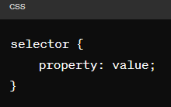

Fig. 1: Simple CSS rule

For example:

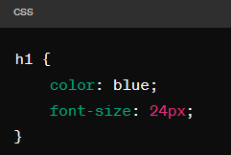

Fig. 2: CSS example

**3.3 Selectors:**

CSS selectors allow developers to target specific HTML elements based on various criteria, such as element type, class, ID, or attribute. Common selectors include:

**- Element selectors:** Target all instances of a specific HTML element.

**- Class selectors:** Target elements with a specific class attribute.

**- ID selectors:** Target a single element with a specific ID attribute.

**- Attribute selectors:** Target elements with specific attribute values.

**3.4 Properties and Values:**

CSS properties define the visual characteristics of HTML elements, such as color, size, position, and spacing. Each property accepts one or more values that dictate how the style should be applied. Some common properties include:

**- `color`:** Specifies the text color.

**- `font-size`:** Sets the size of the font.

**- `margin`, `padding`:** Controls spacing around elements.

**- `background-color`:** Defines the background color of an element.

**- `width`, `height`:** Determines the dimensions of an element.

**3.5 Box Model:**

The CSS box model describes the layout and spacing of elements on a webpage. It consists of four main components: content, padding, border, and margin. Understanding the box model is essential for creating well-structured and visually appealing layouts in CSS.

**3.6 Responsive Design and Media Queries:**

With the proliferation of mobile devices, responsive design has become a critical aspect of modern web development. CSS offers features such as media queries, which allow developers to apply different styles based on the characteristics of the device, such as screen size, orientation, and resolution.

**3.7 CSS Frameworks and Preprocessors:**

CSS frameworks like Bootstrap and Foundation provide pre-designed components and stylesheets to streamline the development process and ensure consistency across projects. Additionally, CSS preprocessors like Sass and Less extend the capabilities of CSS by introducing features such as variables, mixins, and nested rules, further enhancing productivity and code maintainability.

1. **JavaScript: The Dynamic Heart of Web Development**

JavaScript (JS) is a versatile programming language that powers the dynamic behavior and interactivity of modern web applications. As an integral part of the web development stack, JavaScript enables developers to create dynamic content, handle user interactions, and build responsive and engaging web experiences. In this section, we will explore the fundamentals of JavaScript, its key features, and its role in full-stack web development.

**4.1 Introduction to JavaScript:**

JavaScript is a high-level, interpreted programming language primarily used for client-side web development. It allows developers to add interactivity, manipulate DOM elements, and respond to user actions in web browsers. JavaScript is also increasingly used for server-side development (Node.js) and building cross-platform mobile applications (React Native, Ionic).

**4.2 Basic Syntax and Structure:**

JavaScript syntax is similar to other programming languages like Java and C, making it relatively easy to learn for developers familiar with those languages. Here's a basic example of JavaScript code:

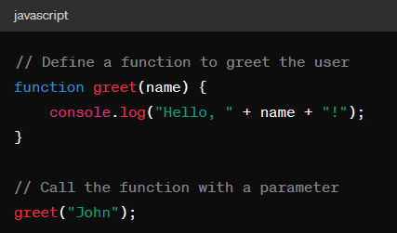

Fig. 3: JS Example

JavaScript statements are typically terminated with a semicolon (;), although it's not always required. Comments can be added using `//` for single-line comments or `/* */` for multi-line comments.

**4.3 Data Types and Variables:**

JavaScript supports various data types, including numbers, strings, booleans, objects, arrays, and functions. Variables in JavaScript are declared using the `var`, `let`, or `const` keywords. `var` is function-scoped, `let` is block-scoped, and `const` declares a constant variable.

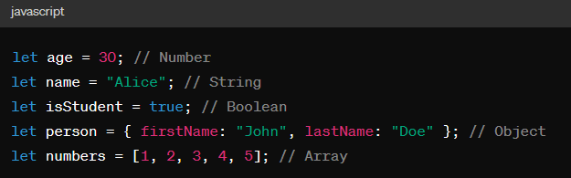

Fig. 4: Data Types and Variables

**4.4 Functions and Scope:**

Functions in JavaScript are first-class citizens, meaning they can be assigned to variables, passed as arguments to other functions, and returned from functions. JavaScript has function scope, meaning variables declared inside a function are local to that function. However, ES6 introduced block-scoped variables with `let` and `const`.

**4.5 DOM Manipulation:**

The Document Object Model (DOM) is a programming interface that represents the structure of HTML documents as a tree of objects. JavaScript can manipulate the DOM to dynamically update the content, structure, and style of web pages based on user actions or other events.

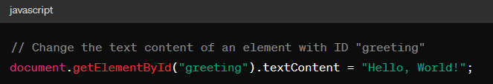

Fig. 5: DOM Example

**4.6 Event Handling:**

JavaScript enables developers to respond to user actions, such as clicks, key presses, and mouse movements, through event handling. Event listeners can be attached to DOM elements to execute code when a specific event occurs.

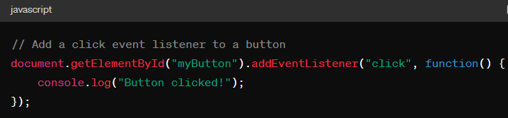

Fig. 6: Event Handling Example

**4.7 Asynchronous Programming:**

JavaScript is single-threaded and asynchronous, meaning it can execute only one piece of code at a time but can handle multiple tasks concurrently using callbacks, promises, and async/await syntax. Asynchronous programming is essential for tasks like fetching data from servers and handling user input without blocking the main thread.

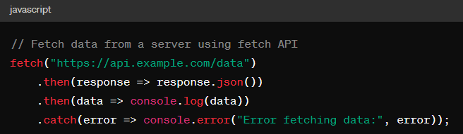

Fig. 7: Async Programming Example

1. **Exploring Essential Libraries for Web Development**

In the dynamic landscape of web development, leveraging libraries and frameworks is crucial for building robust and efficient applications. Libraries like Node.js and React.js have revolutionized the way developers approach server-side and client-side development, respectively. In this section, we will delve into the functionalities, benefits, and applications of these essential libraries in full-stack web development.

**5.1 Node.js: Empowering Server-Side Development**

Node.js is a JavaScript runtime built on Chrome's V8 JavaScript engine, enabling developers to run JavaScript code on the server-side. It provides a non-blocking, event-driven architecture that allows handling multiple concurrent connections efficiently. Node.js has become immensely popular for building scalable and high-performance server-side applications, APIs, and microservices.

**5.1.1 Key Features of Node.js:**

* **Asynchronous I/O:** Node.js employs non-blocking I/O operations, allowing it to handle a large number of concurrent connections without blocking the execution thread. This asynchronous programming model enhances performance and scalability, making Node.js well-suited for building real-time applications.
* **CommonJS Modules:** Node.js uses the CommonJS module system for organizing and structuring code. Modules encapsulate reusable code and can be easily imported and exported using `require()` and `module.exports`, facilitating code modularity and reusability.
* **Package Management with npm:** Node.js comes with npm (Node Package Manager), the largest ecosystem of open-source libraries and tools for JavaScript development. npm allows developers to install, manage, and share packages and dependencies effortlessly, accelerating the development process and reducing code duplication.

**5.1.2 Applications of Node.js:**

* **Web Servers:** Node.js is commonly used for building web servers due to its lightweight and efficient nature. Frameworks like Express.js provide a minimalist and flexible environment for creating web applications and APIs.

* **Real-Time Applications:** Node.js excels at handling real-time, event-driven applications such as chat applications, online gaming platforms, and collaboration tools, where instant communication and data synchronization are essential.
* **Microservices Architecture:** Node.js is well-suited for implementing microservices architecture, where applications are broken down into smaller, independent services that communicate with each other through APIs. Node.js' lightweight footprint and scalability make it an ideal choice for microservices-based architectures.

**5.2 React.js: Transforming Client-Side Development**

React.js is a powerful JavaScript library for building user interfaces, developed by Facebook. It follows a component-based architecture, where UI elements are encapsulated into reusable and composable components. React.js promotes a declarative and efficient programming paradigm, enabling developers to create dynamic and interactive user interfaces with ease.

**5.2.1 Key Features of React.js:**

* **Component-Based Architecture:** React.js encourages breaking down user interfaces into reusable components, each responsible for a specific piece of functionality. This modular approach enhances code reusability, maintainability, and scalability, allowing developers to build complex UIs efficiently.
* **Virtual DOM:** React.js utilizes a virtual DOM (Document Object Model) to efficiently update and render UI components. Instead of directly manipulating the DOM, React.js compares the virtual DOM with the actual DOM and updates only the necessary parts, resulting in faster rendering and improved performance.
* **JSX (JavaScript XML):** React.js introduces JSX, a syntax extension that allows embedding HTML-like code directly within JavaScript. JSX makes it easier to write and visualize UI components, enhancing code readability and maintainability.

**5.2.2 Applications of React.js:**

* **Single-Page Applications (SPAs):** React.js is widely used for building SPAs, where the entire application runs in a single web page, offering a seamless and fluid user experience. Frameworks like Next.js and Gatsby.js extend the capabilities of React.js for building server-rendered and statically-generated SPAs.
* **Dynamic User Interfaces:** React.js excels at building dynamic and interactive user interfaces with complex state management and data binding requirements. Its component-based architecture and unidirectional data flow make it suitable for complex UI workflows and data-driven applications.
* **Cross-Platform Development:** React.js can be used for building cross-platform mobile applications using frameworks like React Native. React Native allows developers to leverage their existing React.js skills to build native mobile apps for iOS and Android platforms, offering a consistent user experience across devices.

1. **Exploring Essential Frameworks for Web Development**

Frameworks play a crucial role in web development by providing developers with pre-built components, tools, and structures to streamline the development process and build scalable and responsive web applications. In this section, we will delve into two essential frameworks: Express.js for server-side development and Bootstrap for frontend development, exploring their functionalities, benefits, and applications in full-stack web development.

**6.1 Express.js: Streamlining Server-Side Development**

Express.js is a minimalist and flexible web application framework for Node.js, designed to build web applications and APIs quickly and easily. It provides a robust set of features for routing, middleware, template engines, and error handling, allowing developers to focus on building functionality rather than reinventing the wheel.

**6.1.1 Key Features of Express.js:**

* **Routing:** Express.js simplifies the process of defining routes for handling HTTP requests. Developers can define route handlers for different HTTP methods and URL patterns, making it easy to organize and manage application logic.
* **Middleware:** Express.js middleware functions allow developers to modify request and response objects, execute additional logic, and terminate request-response cycles. Middleware functions can be used for tasks such as authentication, logging, error handling, and request processing.
* **Template Engines:** Express.js supports various template engines like Pug, EJS, and Handlebars for generating dynamic HTML content. Template engines enable developers to generate HTML dynamically by injecting data into templates, facilitating the creation of dynamic web pages and views.

**6.1.2Applications of Express.js:**

* **Web Servers:** Express.js is commonly used for building web servers and APIs due to its lightweight and efficient nature. Developers can quickly set up routes, middleware, and error handling to create robust and scalable web applications.
* **RESTful APIs:** Express.js is well-suited for building RESTful APIs that follow the principles of Representational State Transfer (REST). Its simple and intuitive routing system, along with middleware support, makes it easy to define API endpoints and handle HTTP requests.
* **Microservices Architecture:** Express.js is often used in microservices architectures, where applications are broken down into smaller, independent services. Each microservice built with Express.js can handle specific functionality and communicate with other services via APIs, facilitating the development of scalable and distributed systems.

**6.2 Bootstrap: Enhancing Frontend Development**

Bootstrap is a popular open-source CSS framework developed by Twitter, designed to create responsive and mobile-first web applications. It provides a comprehensive collection of CSS classes, components, and utilities for building modern and visually appealing user interfaces with minimal effort.

**6.2.1 Key Features of Bootstrap:**

* **Responsive Design:** Bootstrap offers a responsive grid system and utility classes that allow developers to create layouts that adapt to different screen sizes and devices. This ensures that web applications built with Bootstrap look and function seamlessly across desktops, tablets, and smartphones.
* **Pre-styled Components:** Bootstrap includes a wide range of pre-styled components such as buttons, forms, navigation bars, cards, and modals. These components can be easily customized and combined to create complex user interfaces without writing custom CSS from scratch.
* **Extensibility:** Bootstrap is highly extensible and customizable, allowing developers to tailor the framework to their specific needs. They can override default styles, create custom themes, and add third-party plugins and extensions to enhance the functionality and appearance of their web applications.

**6.2.2 Applications of Bootstrap:**

* **Rapid Prototyping:** Bootstrap is widely used for rapid prototyping and development of web applications. Its pre-styled components and responsive grid system enable developers to quickly create functional prototypes and iterate on designs without spending time on CSS styling.
* **Cross-Browser Compatibility:** Bootstrap helps ensure cross-browser compatibility by providing consistent styles and layouts across different web browsers. This eliminates the need for extensive browser testing and ensures a consistent user experience for all users, regardless of their browser preferences.
* **Frontend Framework Integration:** Bootstrap can be seamlessly integrated with frontend frameworks like React.js, Angular, and Vue.js. Framework-specific libraries and components are available to simplify the integration process and leverage the benefits of both Bootstrap and the respective frontend framework.

1. **Snapshots of Project (Result)**

* [WanderInn (majorproject-bpl2.onrender.com)](https://majorproject-bpl2.onrender.com/listings)

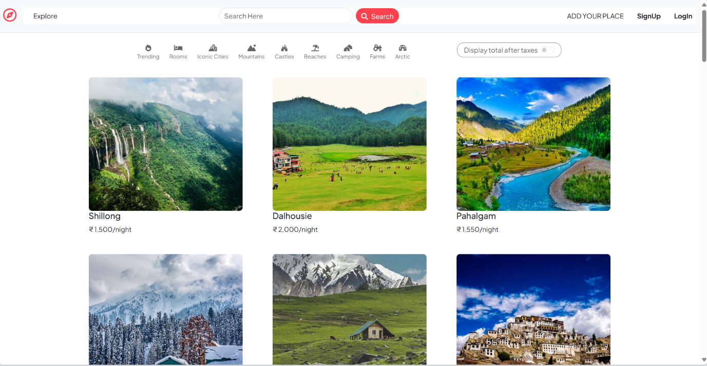

Fig. 7.1: Front page

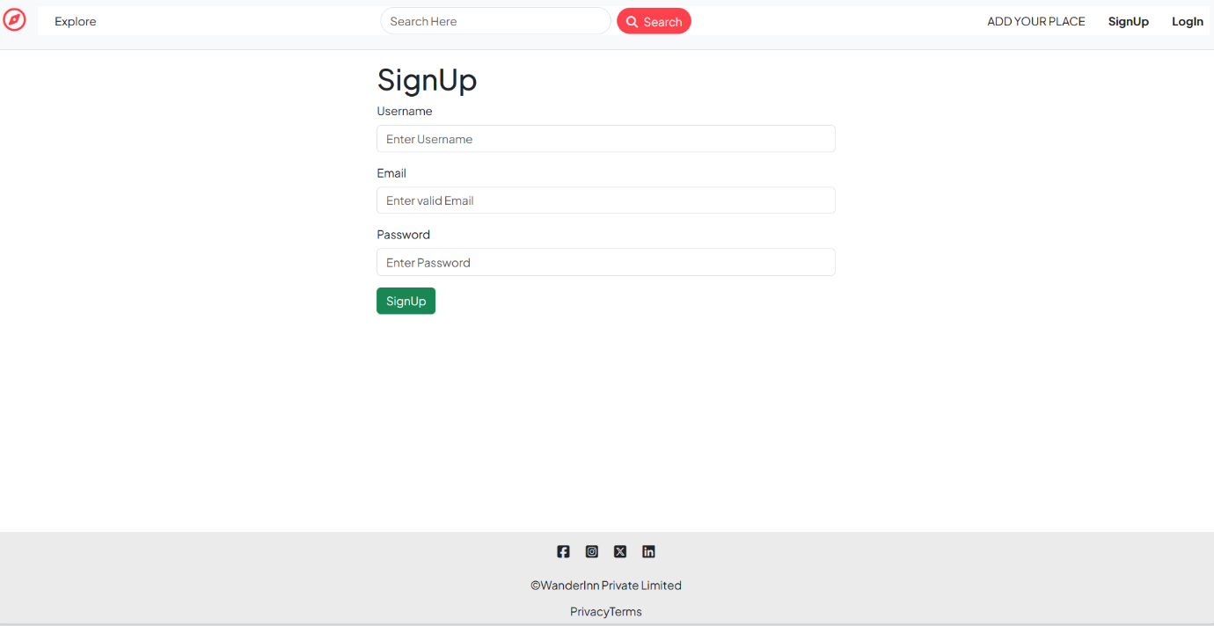

Fig. 7.2 Signup page

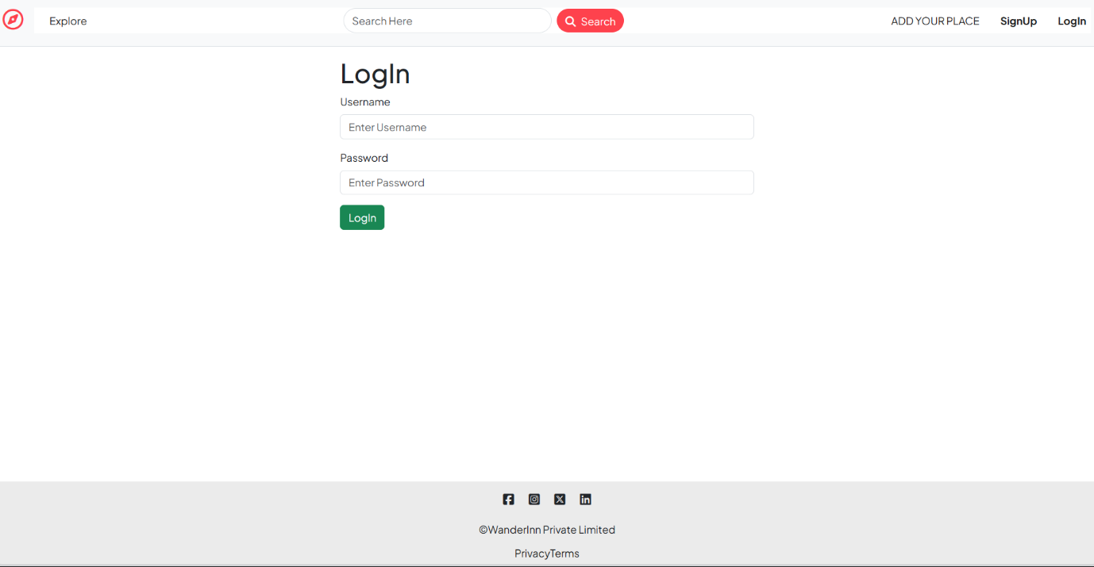

Fig. 7.3: Login page

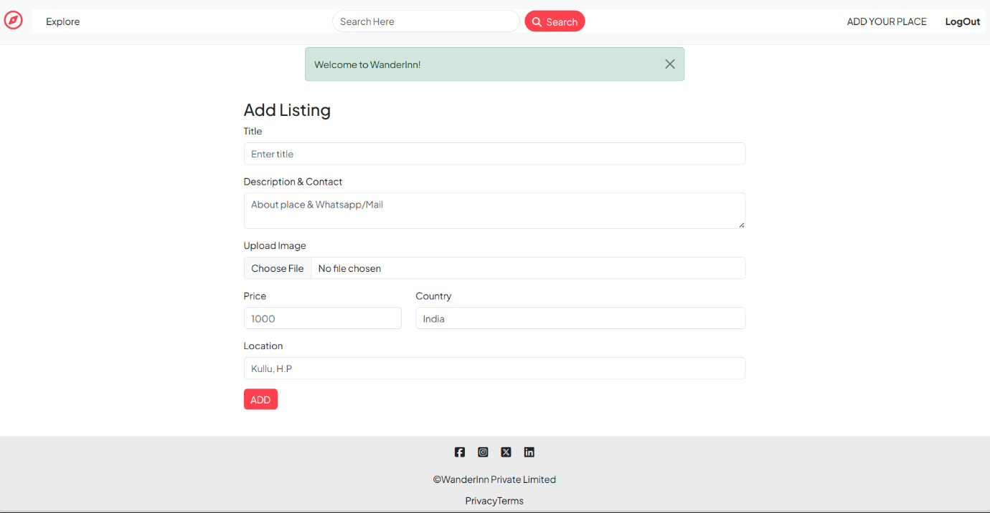

Fig. 7.4: Add Listing page

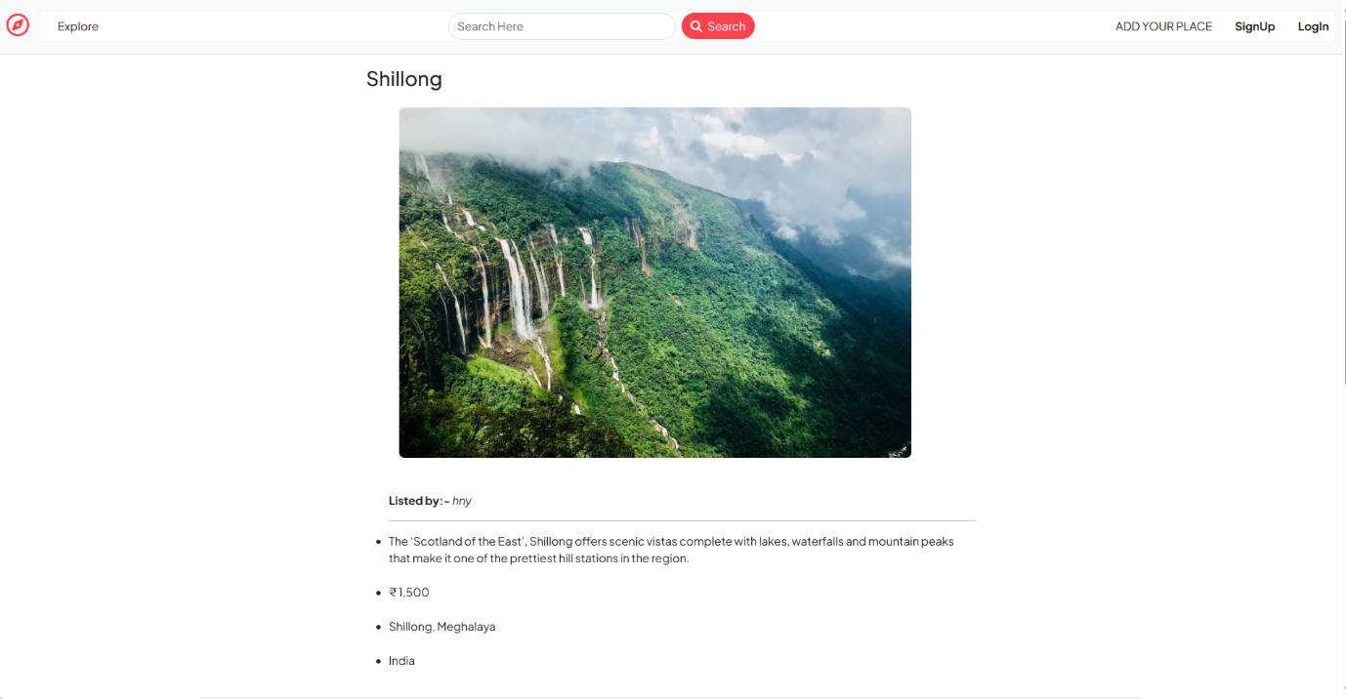

Fig. 7.5: View Listing page

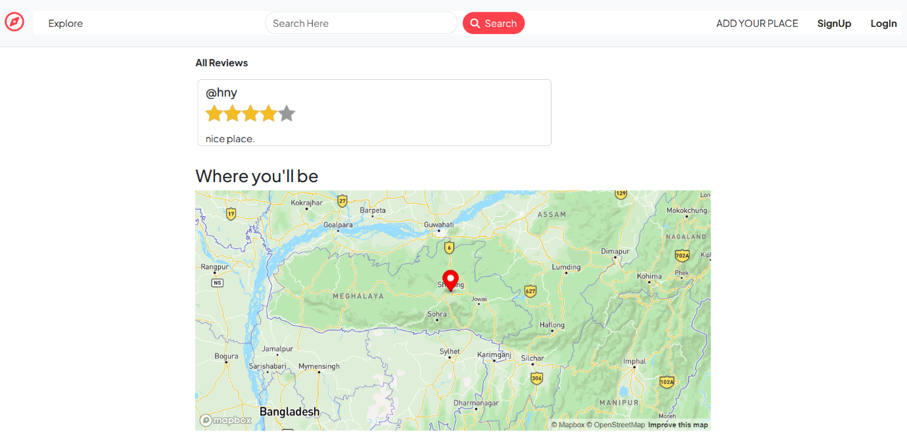

Fig. 7.6: Review & Map

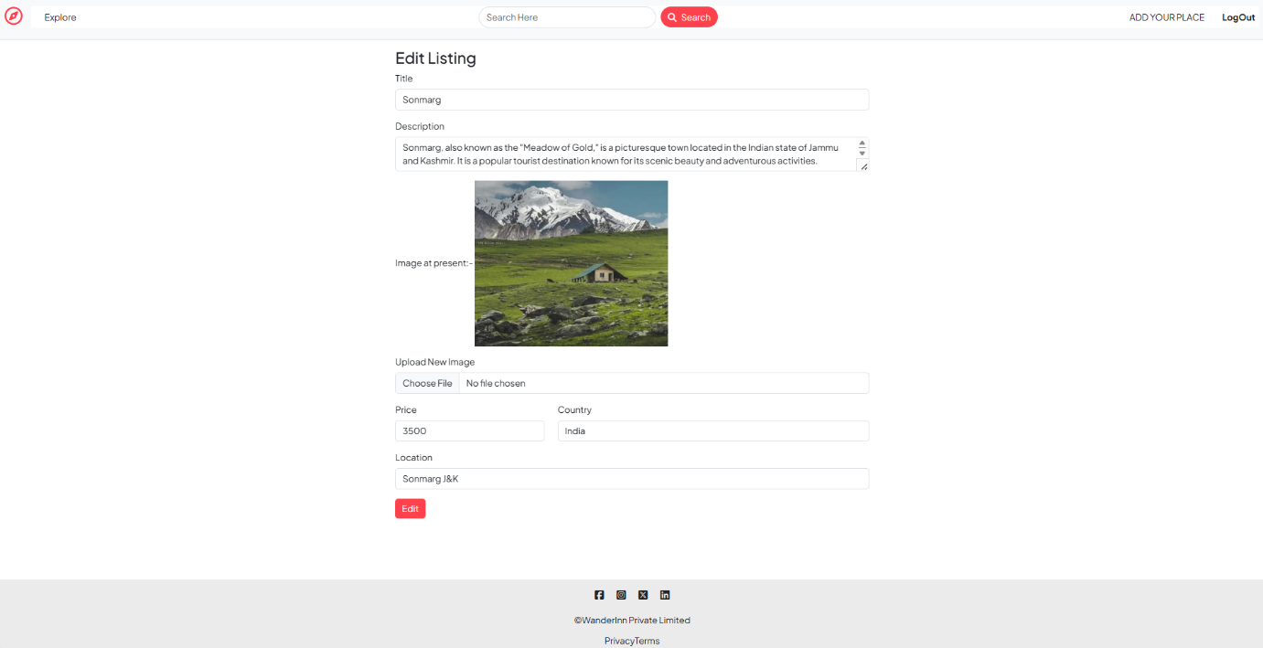

Fig. 7.7: Edit Listing page

**Conclusion**

In the realm of full-stack web development, the amalgamation of libraries, frameworks, and technologies plays a pivotal role in shaping the landscape of modern web applications. From server-side to client-side development, each component contributes to the creation of robust, scalable, and user-centric web experiences.

Frameworks like Express.js and Bootstrap serve as the backbone of web development, offering streamlined solutions for server-side and frontend development, respectively. Express.js simplifies server-side development with its minimalist architecture and powerful features, enabling the creation of scalable APIs and microservices. On the other hand, Bootstrap empowers frontend developers with a comprehensive collection of pre-styled components and responsive design features, facilitating the creation of visually appealing and cross-browser compatible user interfaces.

By leveraging libraries like Node.js and React.js, developers can harness the power of JavaScript across the entire web development stack. Node.js enables server-side JavaScript execution, facilitating asynchronous I/O operations and enhancing performance in real-time applications. Meanwhile, React.js revolutionizes client-side development with its component-based architecture and declarative programming paradigm, enabling the creation of dynamic and interactive user interfaces.

In conclusion, the synergy between libraries, frameworks, and technologies is essential for building innovative and impactful web applications in the full-stack web development landscape. By embracing the capabilities of these tools and incorporating best practices, developers can deliver seamless and engaging web experiences that meet the evolving needs of users and businesses in today's digital age.

**Reference**

[1] Mozilla Developer Network. "HTML: Hypertext Markup Language." https://developer.mozilla.org/en-US/docs/Web/HTML

[2] W3Schools. "CSS Tutorial." https://www.w3schools.com/css/

[3] JavaScript.info. "JavaScript Tutorial." https://javascript.info/

[4] Node.js Foundation. "Node.js Documentation." https://nodejs.org/en/docs/

[5] Express.js. "Express.js Guide." https://expressjs.com/en/guide/

[6] Bootstrap. "Bootstrap Documentation."https://getbootstrap.com/docs/5.1/getting-started/introduction/

[7] GitHub. "Visual Studio Code Repository." https://github.com/microsoft/vscode

**Links to Access final Project & its files**

* [WanderInn (majorproject-bpl2.onrender.com)](https://majorproject-bpl2.onrender.com/listings)
* https://github.com/hnytkr/MAJORPROJECT