|  |  |
| --- | --- |
| Bullying Across Victoria’s Schools  Narrative visualization report | Tutor  Yalong Yang  Mohammadhossein Sharifkazemi  28702557 |

Table of Contents

Introduction 2

Motivation 2

Audience 2

Design 3

FDS – Sheet 1 3

FDS – Sheet 2, 3, 4 3

FDS – Sheet 5 4

Implementation 5

Overall structure 5

Slide 1 5

Slide 2 6

Slide 3 7

Slide 4 8

User Guide 9

Conclusion 12

References 13

Appendix 14

1.1 Sheet 1 14

1.2 Sheet 2 15

1.3 Sheet 3 16

1.4 Sheet 4 17

1.5 Sheet 5 18

# Introduction

Bullying at schools is not a new phenomenon and happens everywhere in the world. There are number of known reasons that children get bullied at schools. It might be because of their physical, personality, gender differences; or just being in the wrong place in the wrong time.

In this project we use **VCAMS children who are bullied** dataset provided by department of education and training. It is compulsory for all students across Victoria to take the student Attitude to school (AtoS) survey at end of each term. In this survey there is a question about whether a student has been bullied in this term and those answers have been anonymised and collected. The data has been presented with the granularity of local area government (LGA) in Victoria which we refer to council from now on to avoid confusion.

Bullying rate that has been used extensively throughout this project which is the ratio of people who answered positive for getting bullied in the survey over the total of participation of the survey.

The Data collection started at 2006 and extends until 2018. Collectively 2,322,661 people have took the survey over the past 13 years and 462,570 of them have reported of getting bullied at schools.

​“Bullying is about a wrong choice the bully makes, not some perceived defect in the target. The responsibility for bullying always falls on the bully's shoulders, [not the victim's](https://www.verywellfamily.com/myths-about-victims-of-bullying-460781)”.  
Nonetheless, this project is aiming to raise awareness in this matter.

## Motivation

Bullying is never a onetime incident. It is the mean action of a person or group of people from a point of power towards others that cause emotional, verbal and physical pain. The emotional pains and struggle can last for many years or even a lifetime. These actions can resent a kid from going to school and disrupt his/her academic path. A close member of my family got bullied in school and had to carry the pain for many years before speaking up and seeking for help. This project motivates me to shed some light about the type victims or locations (councils) that are more prone to get bullied. If there are any interesting findings that can raise awareness for myself and my friends that would be beneficial. I might have a child going to Victoria’s school in future and this project might come handy.

## Audience

The audience of this presentation is general public to raise the awareness around the subject however the people listed below would benefit the most:

* + Family with children want to settle in Victoria
  + Parents whose children have suffered
  + Decision makers in Victoria Education System

# Design

The visualization design process implemented a five design sheet methodology. The sheets are sketched by hand and are available in appendix 1.   
  
According to Tamara Munzner’s Data visualization framework, the **what**, **why** and **how** of visualization need to be clear. The **what** part already has been discussed in the introduction which is in tabular format.

## FDS – Sheet 1

In this section, it was attempted to come up with as many mini-ideas for graphs and interactions to answer the following questions:

* How the trend of bullying is changing yearly and where it is headed for primary and secondary grades?
* Which category or type of children are more prone to get bullied at school?
* What are the negative consequences of getting bullied at schools?
* Which areas of Victoria are good or bad to go to school in terms of ranking according to the VCAMS dataset?

For more detail please refer to appendix 1.1

## FDS – Sheet 2, 3, 4

In this section, the ideas that were generated and filtered in the previous section used as a foundation to come up with 3 different layout design for the same topic. So far it is clear that for each visualization **what** kind of data needs to be visualized. Below is a list of **why(s)** for this data visualization project:   
In slide 1, the comparison of bullying rate between primary and secondary grade over period of time.  
In slide 2, the breakdown and comparison of different groups of victims. User should be able to filter based on year.

In slide 3, the relationship between connected to school and Bullying indicator for all the councils.

In slide 4, Representation of best/worst areas of Victoria in terms of bullying.

As a result, in sheet 2 the following graphs were considered for slide 1-4 respectively:

*Multi-line chart, pie chart, scatter plot and choropleth map.*

For more details please refer to appendix 1.2

In the sheet 3 the following graphs were considered for slide 1, 2 and 4 respectively:

*Population pyramid, horizontal stacked bar chart and bubble chart.*

For more details please refer to appendix 1.3

In sheet 4 the following graphs were considered for slide 1-4 respectively:

Lollipop chart, spider chart, grouped bar chart and bubble chart map.

For more details please refer to appendix 1.4

In the next section, the charts that made the final design and reasoning behind them is discussed.

## FDS – Sheet 5

The final design elements chosen for narrative visualization are listed below:

* **Genre**: Slide show with interactions
* **Structure**: Single page visualizations with linked elements. “Martini glass structure” is also considered to introduce visual elements once at a time and have a drill down format where user can interact with full data set.

For slide 1 the multi-line graph is chosen as it is the best fit to show the trend (changes) of two variables over the time. If the number of variables were more than two other options such as lollipop or parallel coordinates chart were also a good option

For slide 2, the stacked bar chart is been chosen for the final design. The stacked bar charts are better to show the proportion compared to multiple pie charts. The spider chart was also discarded as the number of variants are not fixed and changes per year due to limitation of data. This section should also include a query search for each year to filter the breakdown of categories and a sort functionality to sort the stacked bars based on the name or their numerical values.

For slide 3, Scatter plot fits the criteria of showing relationship between two dimensional data. The third variable which is the council name would be provided with tooltip as opposed to colours to keep the graph clean and without distraction (there are over +40 councils and assigning a colour to each of them would be a bad design).

For slide 4, The bubble chart map were chosen to show the location of areas that are good and bad in terms of bullying and the bubble size would represent the magnitude of their ranking. However during implementation some obstacles were faced and had to change the decision to simple bubble chart. In the implementation part the obstacles are discussed.

For more information please refer to *appendix 1.5*

# Implementation

## Overall structure

The layout and structure of slideshow has been designed and implemented with **HTML**, **CSS** and **bootstrap v4**. As a result the webpage is responsive and smooth to work with. The colour of slideshows and font (sans-serif) has been kept the same for consistency.

The **font awesome icons** have been used for the navigation buttons on top-right corner.

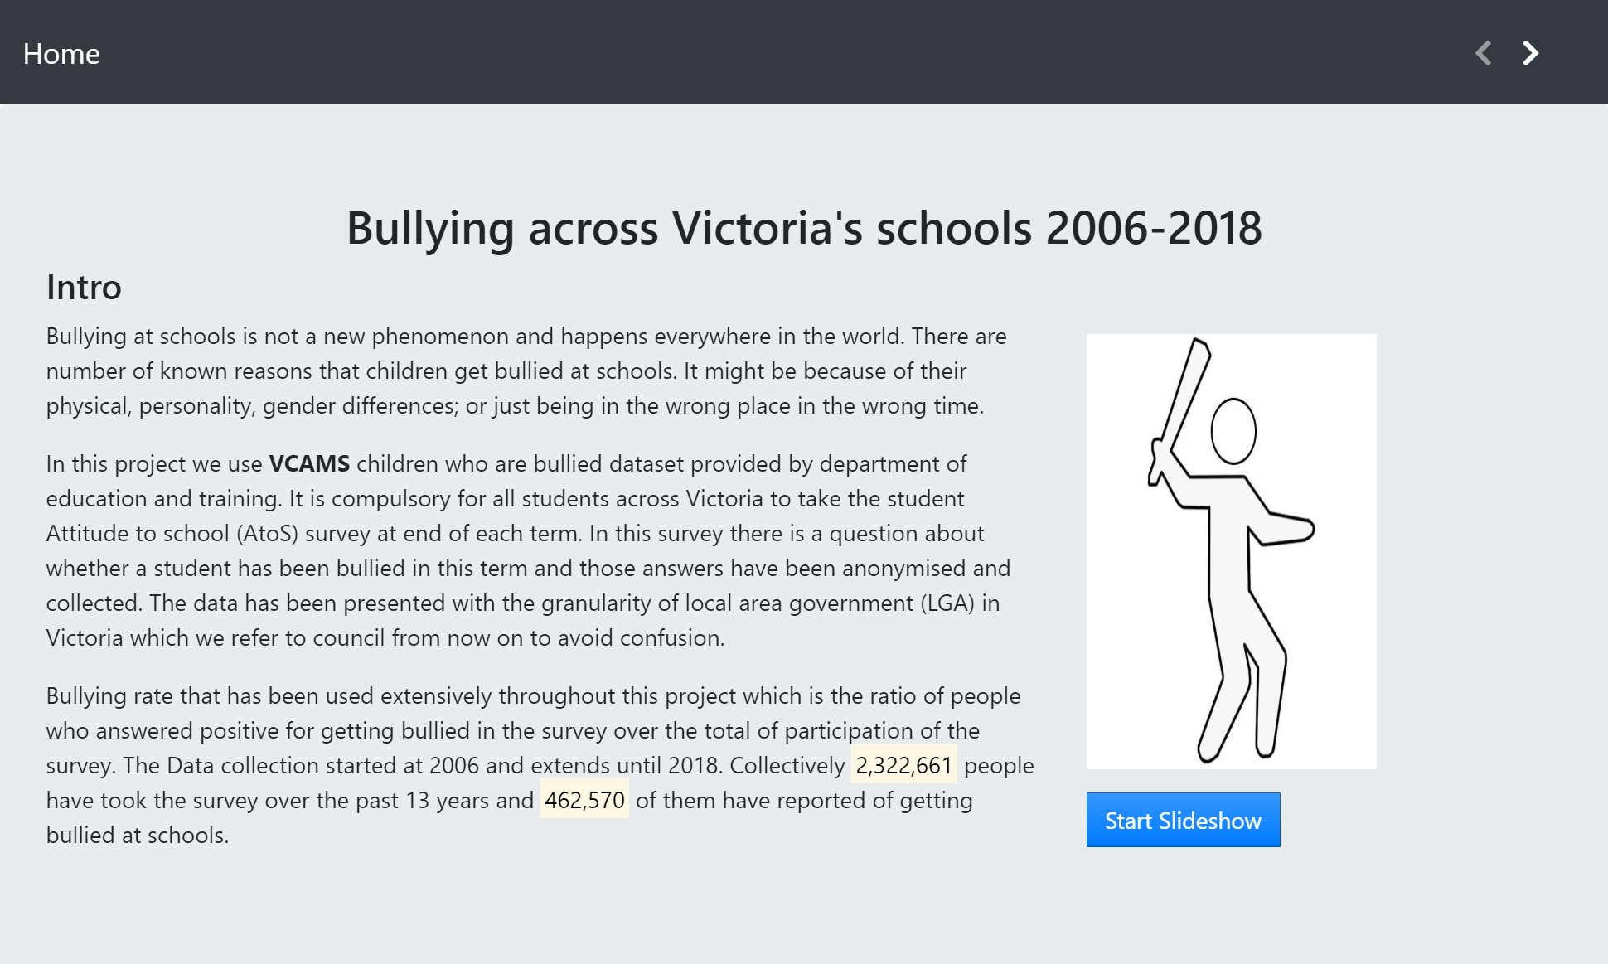

**D3.js v5** library has been used for the visualizations on slide 1, 2, 3 and 4. On the next sections the implementation of each chart and the part of d3.js library that were used will be discussed in details.

## Slide 1

In this slide, a multi-line chart has been implemented. The data has been loaded into d3 using the snippet below:

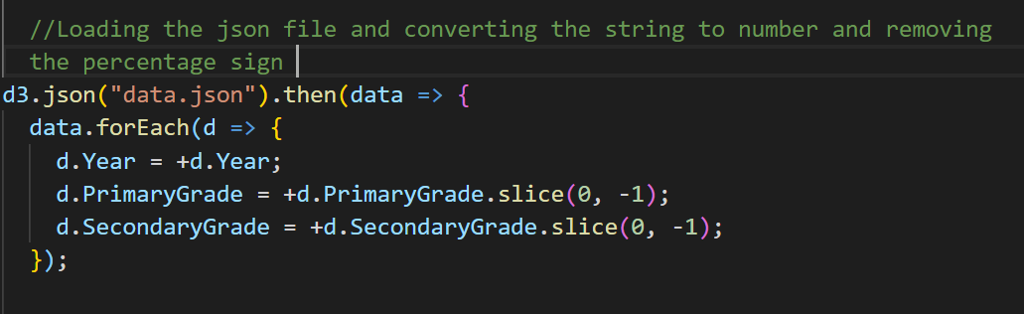

After defining the margins, width and height of graph. **D3.scaleLinear()** is used to define the scale for variables ( normalization) . For this method a domain(input) and range(output) can be defined. In this specific slide, we have set the range of scale to to the width and height of graph for x and y axis.

Then a line object is created for each line in the chart and binding the data from json file to it.

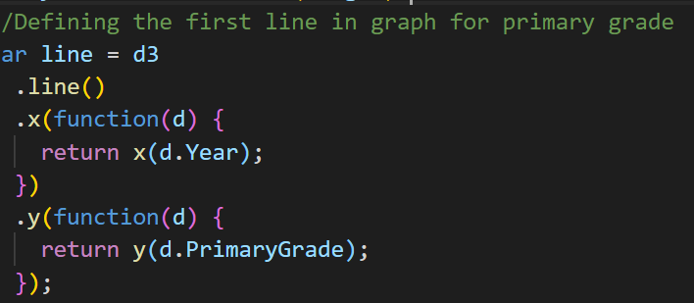

Each line object created by d3.line() needs to be appended individually to the SVG as a path.

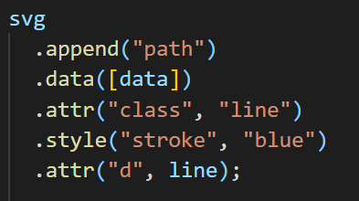

## Slide 2

In this slide a histogram is implemented representing the total bullying over the years(combining grades) and after clicking on each year a stacked bar chart with interaction controls would appear.

The histogram is implemented using the **d3.histogram()**  and data has loaded like slide 1. Then we create the bins of histogram using the snippet code below:

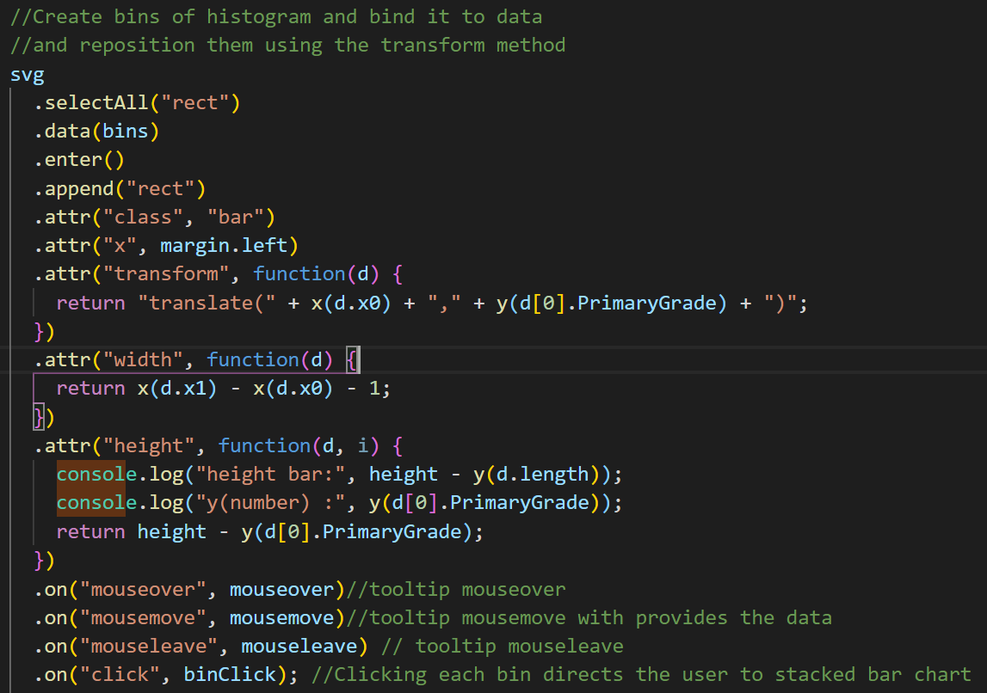

After creating the stacked bar chart, a function is defined to update the stacked bar chart whenever the dropdown for year is pressed.

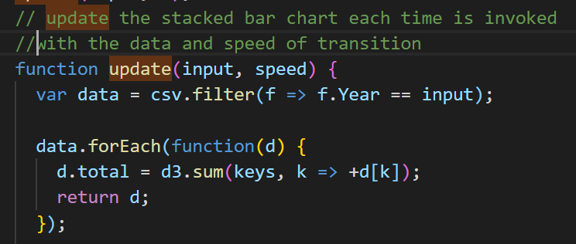

The colours of stacked bar chart uses d3.scaleOrdinal() to bind each section of each bar with a colour. The colour gray was chosen for not getting bullied throughout the bars so the user pays attention to the bullied part which also indicated with a numerical representation.

The sort checkbox, sort the bars based on their numerical value (max-> min) and unchecking them returns it to the default mode (the order of data in the file).

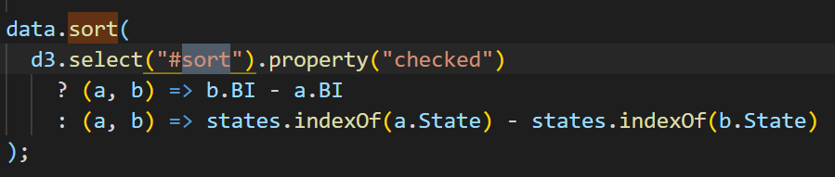

## Slide 3

In this slide, a scatter plot is implemented. The graph with margins and scales have been defined like previous slides. We add the code below to handle the extremes outside the domain and find the min and max for scale of each axis

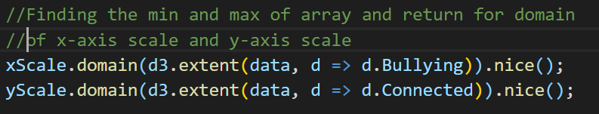

After plotting the axis, the dots(circles) representing the councils with active tooltip are created with the snippet below:

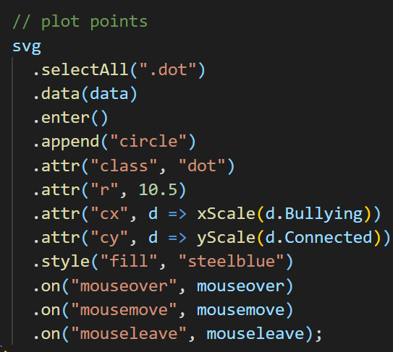

## Slide 4

Initially it was planned to visualize this slide with a map with topojson and leaflet.js. However the geojson file that I find on the Victoria opendata site did not match my representation of data values(granularity of area boundaries were provided at LGA level only). As the range of areas are from cities to rural areas and shrines for this projectIn addition to that the limited technical skills of myself was another obstacle to find a work-around. For these reasons I decided to change the bubble chart map to just bubble chart.

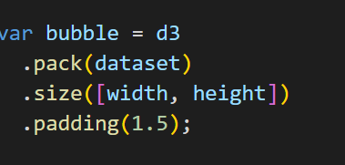In this slide, a bubble chart is implemented. Firstly, the size and margins are defined and a variable colour is bind to categories using the **d3.scaleOrdinal()**. Then d3.pack() is used to define a circle packing layout. It provides a node and root hierarchy.

As it is a hierarchy, the nodes of children need to a list with value of children in dataset as well. The nodes sum and sort needs to be defined to have a scale for the size and the order to place the nodes.

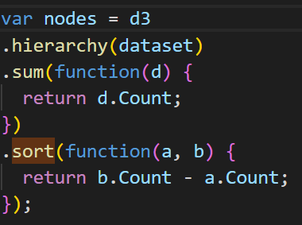

Finally create the nodes using the data and appending circles as the shape of node.

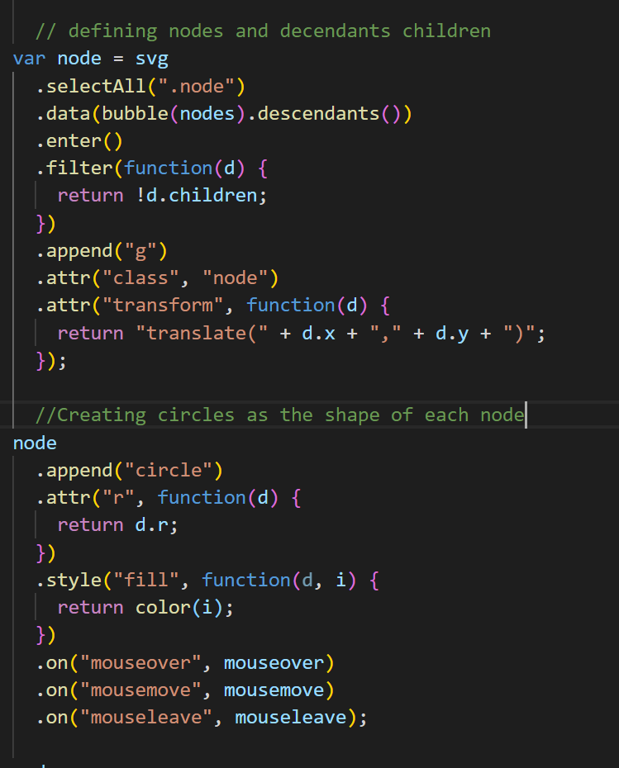

# User Guide

Please open the index.html file in your desired browser. (Chrome, Firefox and Edge browser have been tested and are compatible with this project.)

The first slide that you would see is the introduction and by clicking the blue button or the navigation arrow the slideshow would be started as it is shown in the picture below:

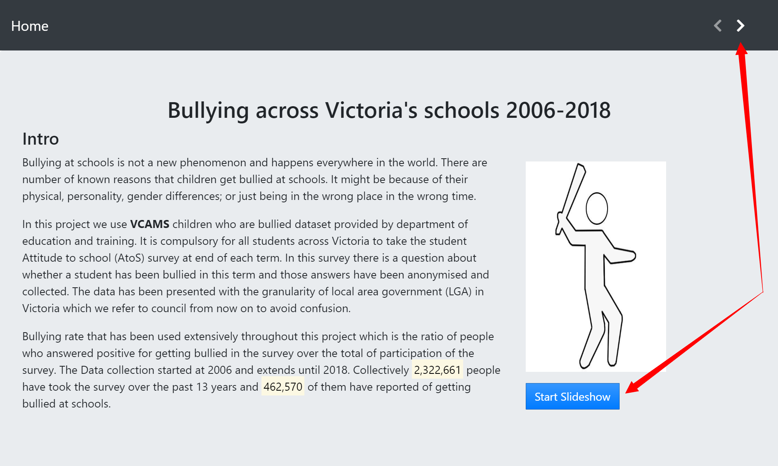

In the first slide, you see a multi-line chart. By hovering the mouse over the black dots the tooltip would appear.

The facts are toggled links. By clicking on each of them an arrow pointing to graph would appear that links to the text of fact. By pressing the button again the fact text and arrow pointer would disappear.

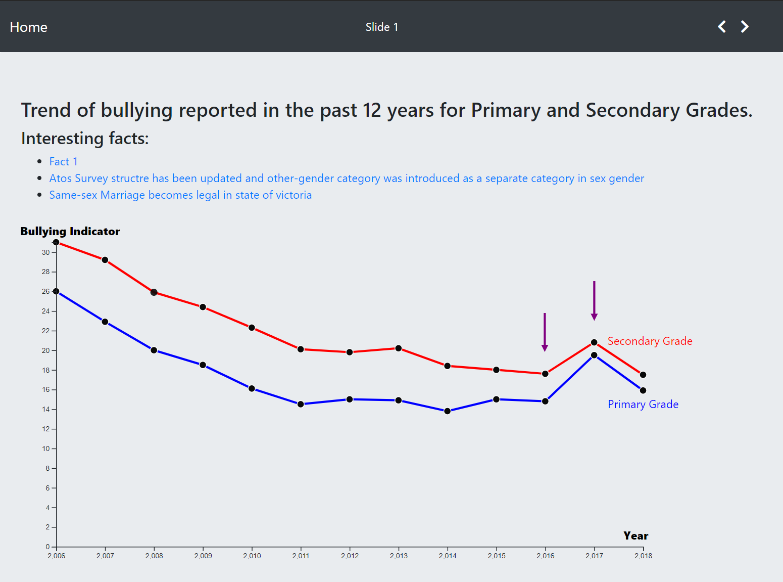

By clicking on the right hand side button of navigation bar, it would take you to slide 2 where you would see a histogram. The same mechanism as slide 1, you can reveal the facts and the year related to it by clicking on the highlighted toggle links.

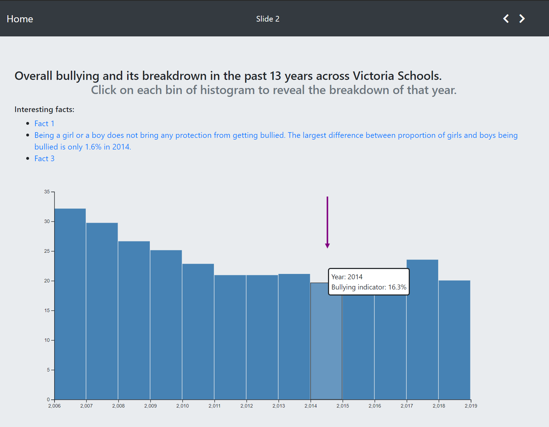

The bins of histogram are clickable. By clicking on each of them the location of your page would be shifted to the multi stacked bar representing the breakdown of bullying in different category for that year.

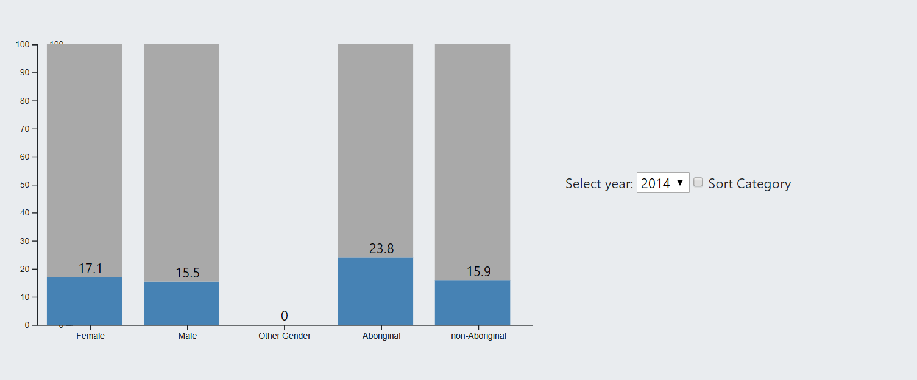

After clicking on the right hand side navigation button, it would take you to slide 3 where you see a scatter plot representing the relationship between bullying and feeling connected to schools. By hovering over each of the circles, a tooltip containing the information of council would appear. 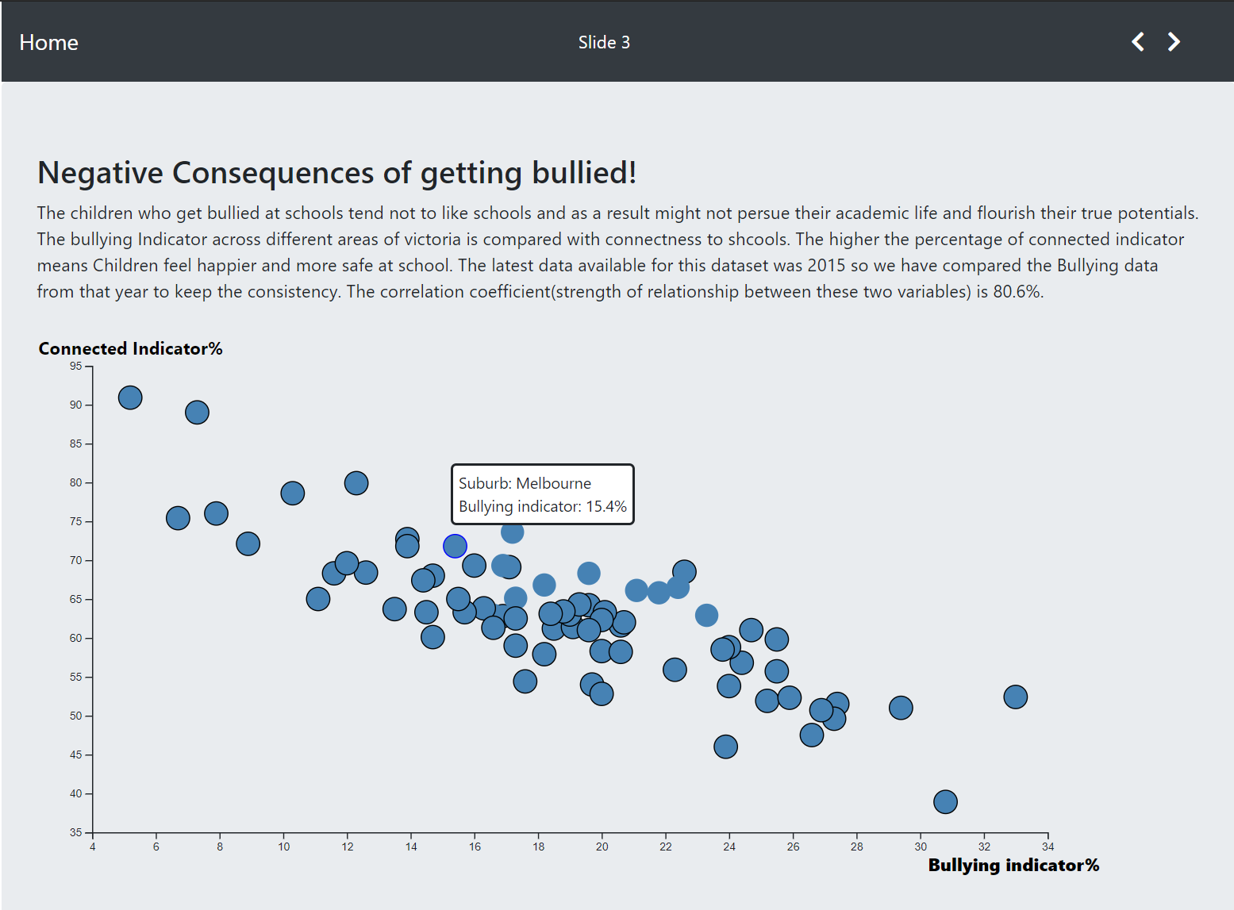

Press the navigation button to take you to slide 4 where you would see a bubble chart. The worst and best areas of victoria are grouped together and by hovering over each of them a tooltip with extra information would appear.

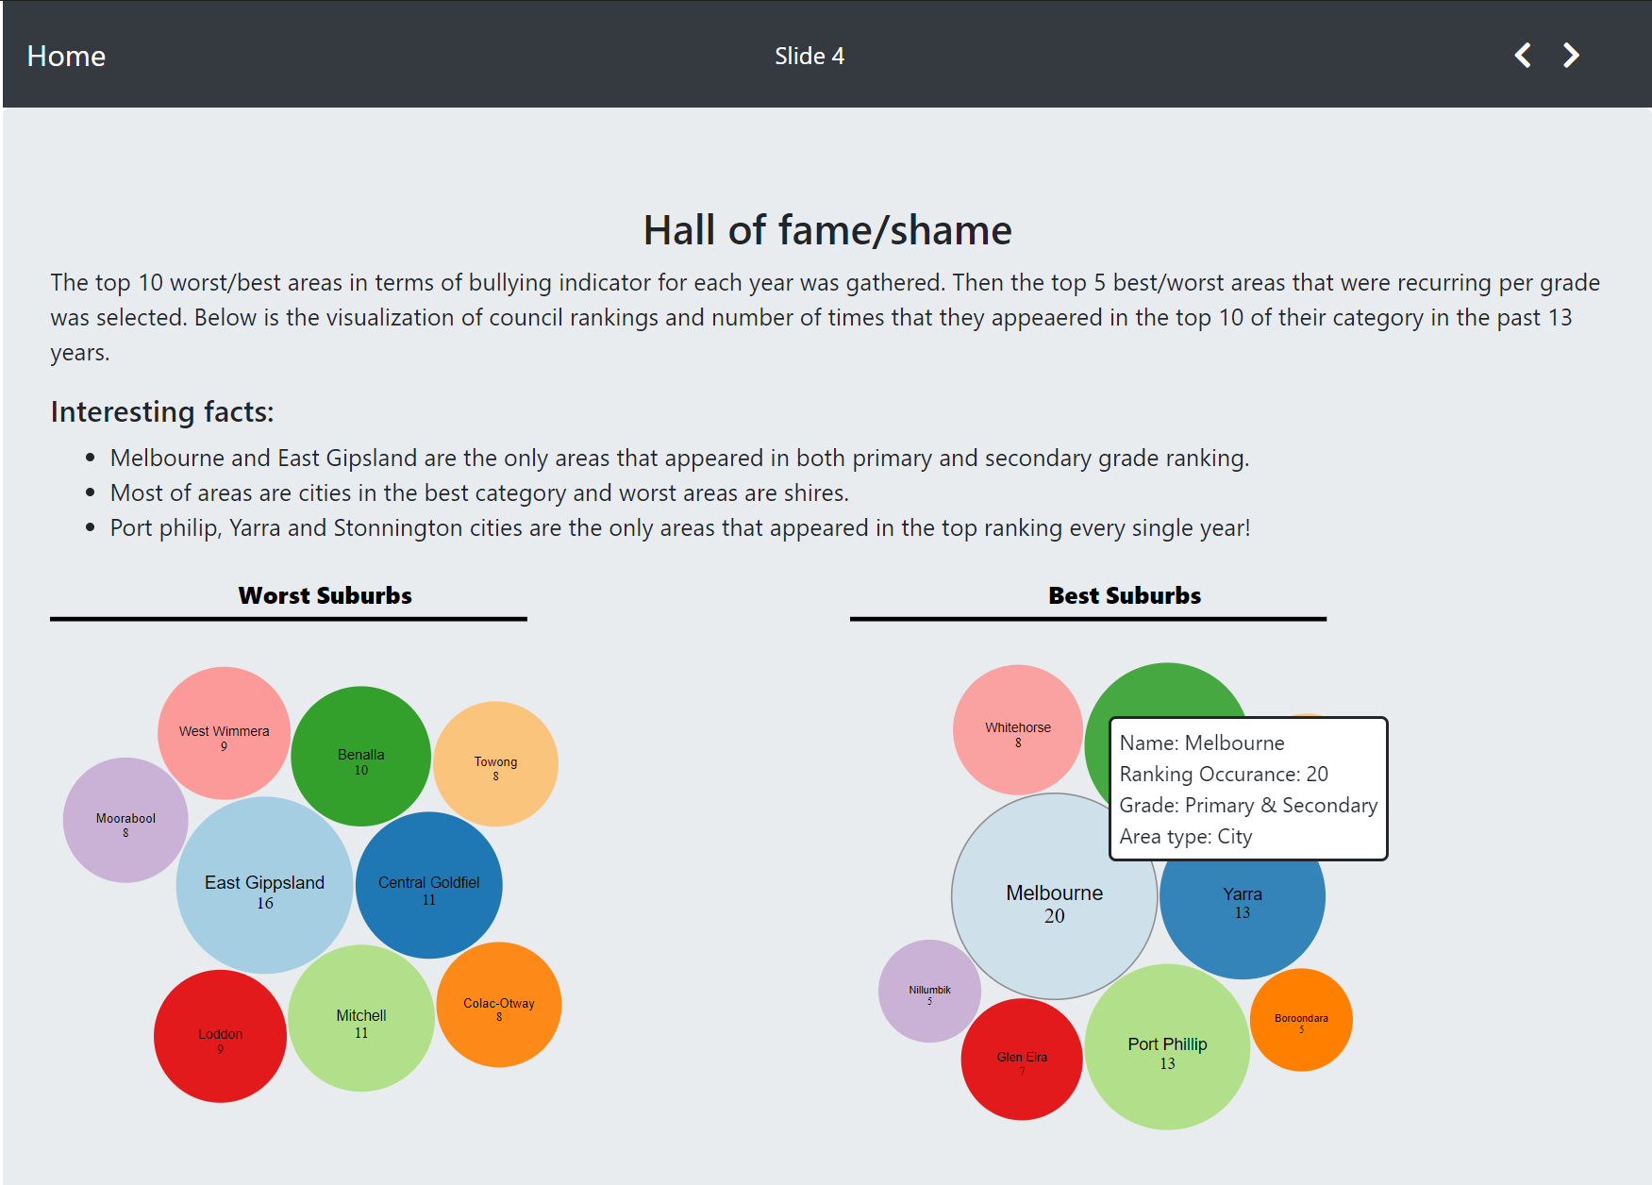

# Conclusion

Working with d3.js has been a challenging task. The learning curve is very steep and I have only scratched the surface. However without doing this project I would never have found out about the power of this framework. I can continue working on my skills to be able to implement advanced parts like plotting a map or using the simulation module of d3.js for my future projects. I also had to re-learn JavaScript!

I learned a lot about SVG elements and came up with many ways to manipulate the DOM and also come up with a way to link the textual facts to the sections of visualizations.(very proud of my trick)

I am very thrilled that I had the opportunity to work on a project from scratch without mimicking the dazzling projects available online. I am planning to continue working on this project and publish my findings in the hope that can make a difference. If the fate of even 1 child is changed I would be ecstatic.

# References

1. Interactive Data visualization book by Scott Murray
2. <https://bl.ocks.org/jiankuang/93dba6fac49222458b3b35e7c233bace>
3. <https://bl.ocks.org/d3noob/4db972df5d7efc7d611255d1cc6f3c4f>
4. <http://bl.ocks.org/KatiRG/5f168b5c884b1f9c36a5>
5. <https://bl.ocks.org/mbostock/1134768>

# Appendix

## Sheet 1

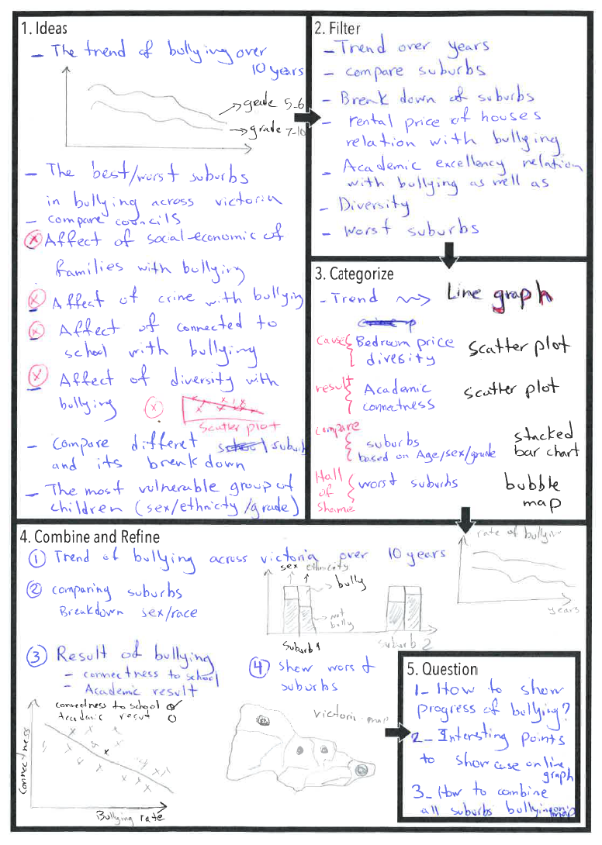

## Sheet 2

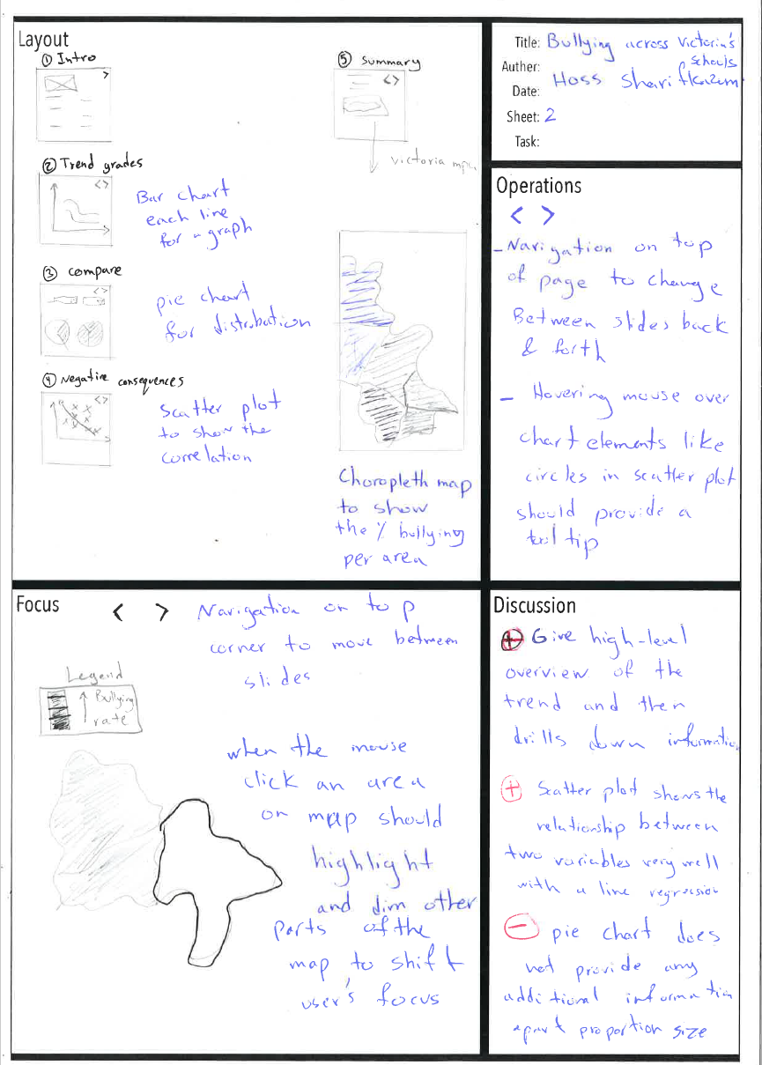

## Sheet 3

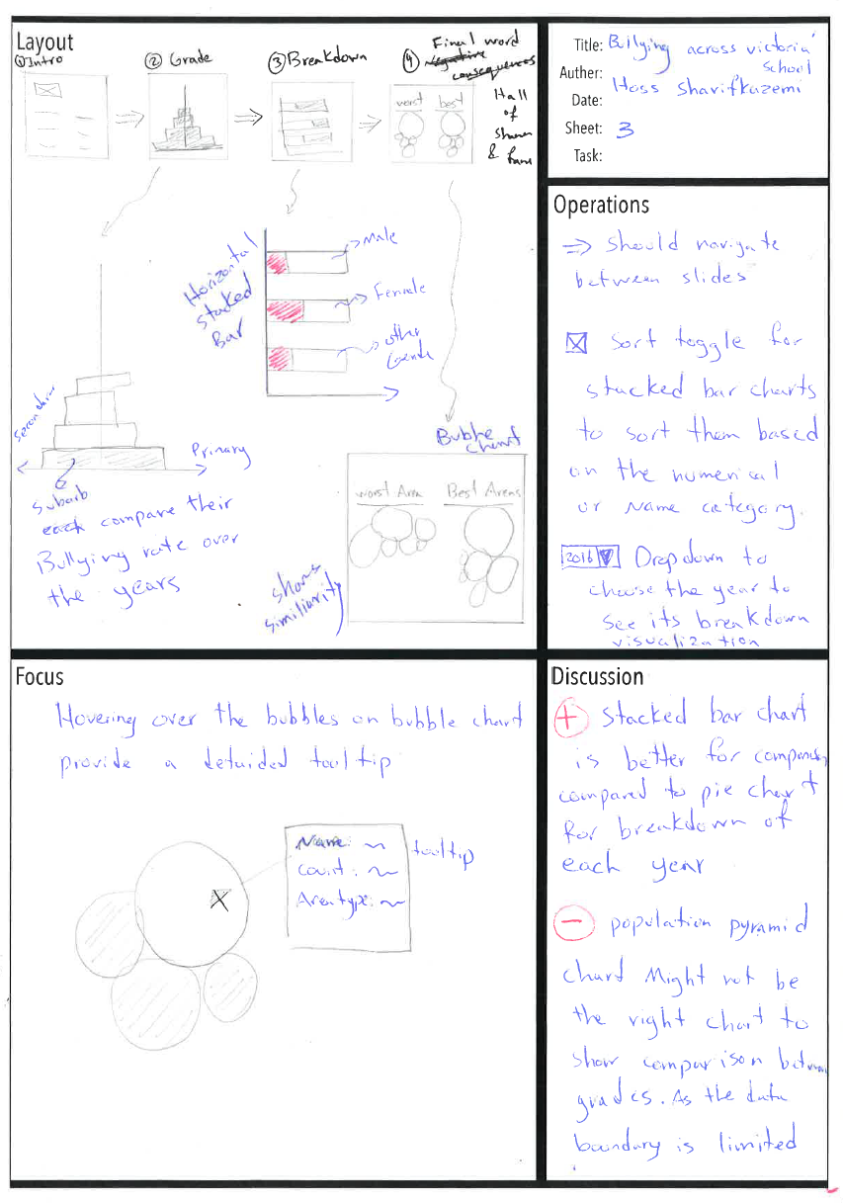

## Sheet 4

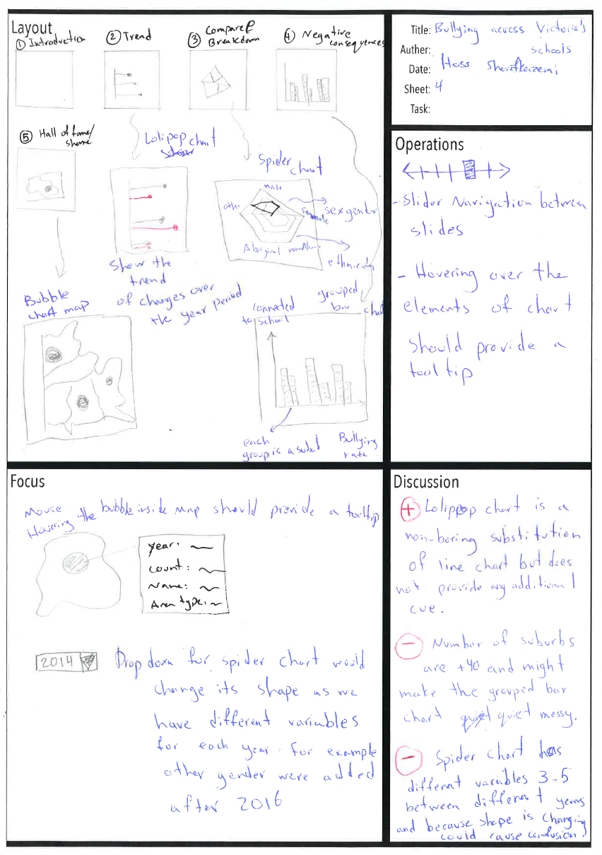

## 1.5 Sheet 5

# 