AskMeAnswerMe

Vision Document

Version <1.0>

Revision History

| **Date** | **Version** | **Description** | **Author** |
| --- | --- | --- | --- |
| 7/11/2022 | 1.0 | Initial release | Từ Khai Hoài, Lâm Hiền Toàn, Nguyễn Việt Hùng, Thái Võ Đức Trọng, Nguyễn Đình Quốc |
| 25/11/2022 | 2.0 |  | Từ Khai Hoài, Lâm Hiền Toàn, Nguyễn Việt Hùng, Thái Võ Đức Trọng, Nguyễn Đình Quốc |
|  |  |  |  |
|  |  |  |  |

Table of Contents

**1. Introduction** **4**

**2. Positioning** **4**

2.1 Problem Statement 4

2.2 Product Position Statement 4

**3. User Descriptions** **5**

3.1 User Persona 5

3.2 User Environment 6

3.3 Alternatives and Competition 6

**4. Product Features** **6**

**5. Non-Functional Requirements** **7**

Vision (Small Project)

# Introduction

The purpose of this document is to collect, analyze, and define high-level needs and features of AMAM. It focuses on the capabilities needed by the stakeholders and the target users, and **why** these needs exist. The details of how AMAM fulfills these needs are detailed in the use-case and supplementary specifications.

# Positioning

## Problem Statement

| The problem of | When a user has a question to ask, he/she doesn’t know who knows clearly about the domain of the question to ask or where to find the answer |
| --- | --- |
| affects | anyone who has a question but can not find someone suitable to ask. In this case, we will suppose the majority of users is student and office worker. |
| the impact of which is | everyone can easily get an answer for their question and the others who have similar or related questions can benefit from this, too. |
| a successful solution would be | a forum where everyone with a question can connect together and help others answer their questions, which will be a win-win situation. |

## Product Position Statement

| For | everyone (suppose the majority of users are students and office workers.) |
| --- | --- |
| Who | has some questions to ask |
| The (product name) | AMAM (AskMeAnswerMe) |
| That | allow users to ask any questions and others can help them answer |
| Unlike | Stackoverflow, which only allow to ask questions about code |
| Our product | allow users to ask any questions about any topics |

# User Descriptions

## User Persona

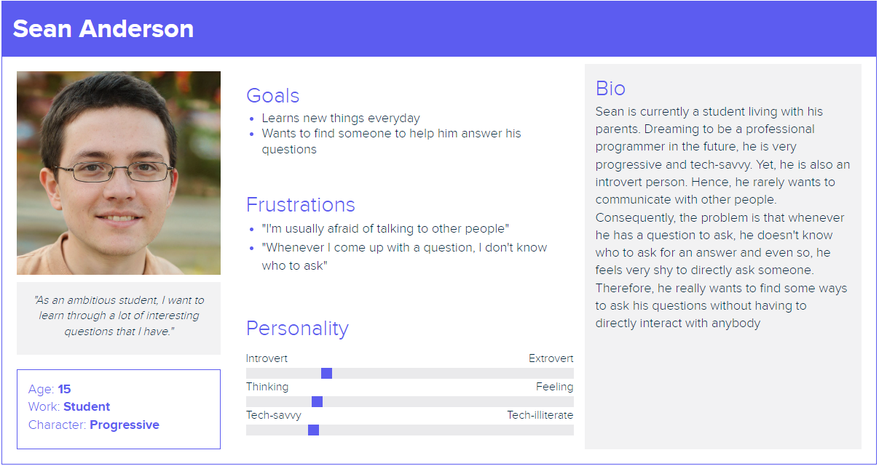

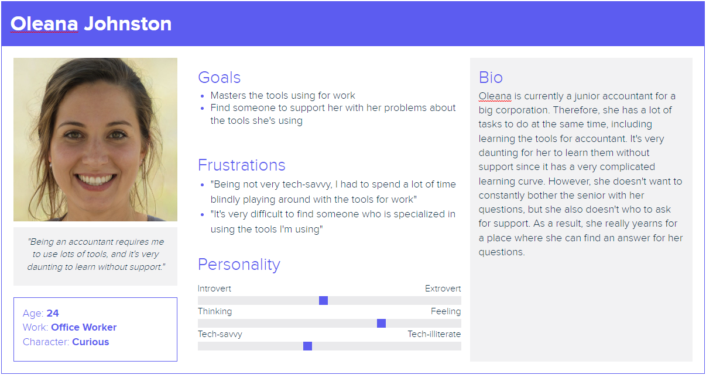

## User Environment

Environment: Web

When and Where:

* Whenever they have a question to ask (usually when studying, working, etc.).
* At school, office,… with their laptop or mobile phone

## Alternatives and Competition

|  | **Strengths** | **Weaknesses** |
| --- | --- | --- |
| **Stackover** | * Use as guest * Can evaluate which question/answer is good or bad based on the total vote | * Not UI friendly * Can only ask questions about coding |
| **Quora** | * Can ask a variety of questions * Can evaluate which answer is good or bad based on the total vote | * Not UI friendly * Can not search by categories |

# Product Features

| No. | Feature | Description | Priority |
| --- | --- | --- | --- |
| 1 | Post the question | Allow users to post any question regarding predefined categories such as Marketing, Mathematics, Technology,etc | High |
| 2 | Write comments on a specific post or other comments | In every post, a user using the official mode (opposite to the guess mode) can write comments on a particular post and can revert to any other comments. In the guess mode, users can not do this. | High |
| 3 | Upvote or downvote a specific post or comment | Users can upvote or downvote a specific post or a comment (official mode). With the guess mode, users can not do this. | High |
| 4 | Search a specific post by the title or the category | User can search a specific post by the title or the category | High |
| 5 | Sort the searched results by the number of views or votes or comments | User can sort the searched results by the number of views or votes or comments in the ascending or descending order | Medium |
| 6 | Show the list of posts that users have seen before | Everytime a user views a specific post, this post will be saved into the history, which is similar to Video History in Youtube. | Medium |
| 7 | Recommend users the related post | Everytime a user visits a specific post, the system will recommend that user with the related posts with the recommendation system. | Low |
| 8 | Allow each user to follow other users | A user can follow other users to get notified of their posts. | Medium |
| 9 | Notification | Users can get notified of the upvote/downvote, comments on their post, or get notified when people they follow post a new post. | Low |
| 10 | Monthly report a statical graph of users’ data | On the monthly basis, users can get the dashboard statistically reporting about the number of view, comments, or the upvote/downvotes. | Low |

# Non-Functional Requirements

**5.1. Applicable standards:**

None

**5.2. System Requirements:**

Any web browsers in life and stable internet connection

**5.3. Performance Requirements:**

The system shall support up to 1000 users simultaneously against the central database at any given time.

The system shall provide access to the database with the latency no more than 10 seconds.

The system shall be fault tolerant meaning that the data of the user can be kept intact even though the database server gets damaged.

The availability shall be favored over the consistency meaning that users do not need to wait for all transactions within the database to finish ( the consistency shall be still present eventually).

**5.4. Environment Requirements:**

The application should function the same in different web browsers and different versions of a web browser