Widows Bay visual reference guide

Scene and character atlas from the music video
4 October 2026
This companion to the textual video reference contains 24 images generated from captured video frames. Eleven reconstruct scenes; twelve study the band, film characters and creatures; one develops lyric-based objects. Each page identifies its input frames and places source imagery below the generated reference.
Captured source frames and built-in imagegen reconstructions. Generated images complete blurred or occluded details and are not exact film stills. Story motifs are inferred from song captions, with frames used only for style.
The reconstructions clarify the handmade stage aesthetic: cream-grey photographic texture, selective teal, pink, gold and red tint, theatrical costumes and artificial marine creatures. Generated faces, hidden details and additional views are interpretations. Names and narrative relationships remain unconfirmed unless explicitly supported by the video.
Source video: https://www.youtube.com/watch?v=7zoGfdN4dgE
Use the adjacent HTML gallery for full-resolution comparisons and prompts. The source captures retain the player seek overlay. Its accumulated plus-number is a UI artefact; the timestamp in the filename and caption identifies the selected frame.

Palace ceremony
Generated reconstruction from video frames. Hidden details, faces and any added views are interpretive completions.
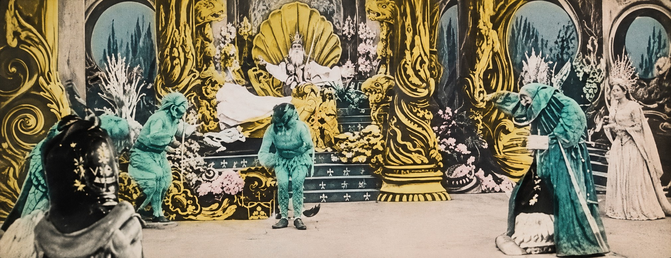
Generated reference • Inputs 0:10, 0:20
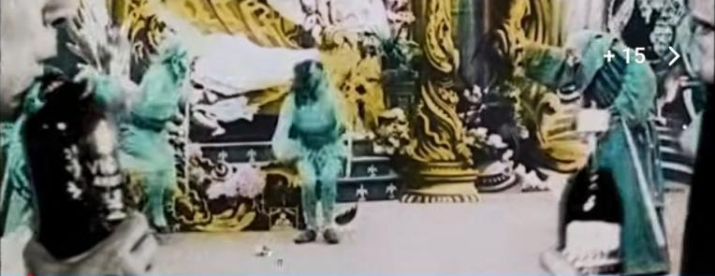
Source frame 0:10
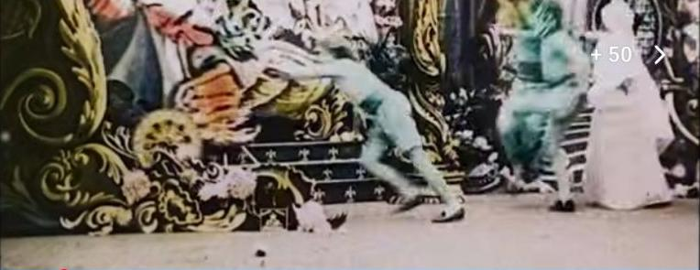
Source frame 0:20

Voyage and deck travellers
Generated reconstruction from video frames. Hidden details, faces and any added views are interpretive completions.
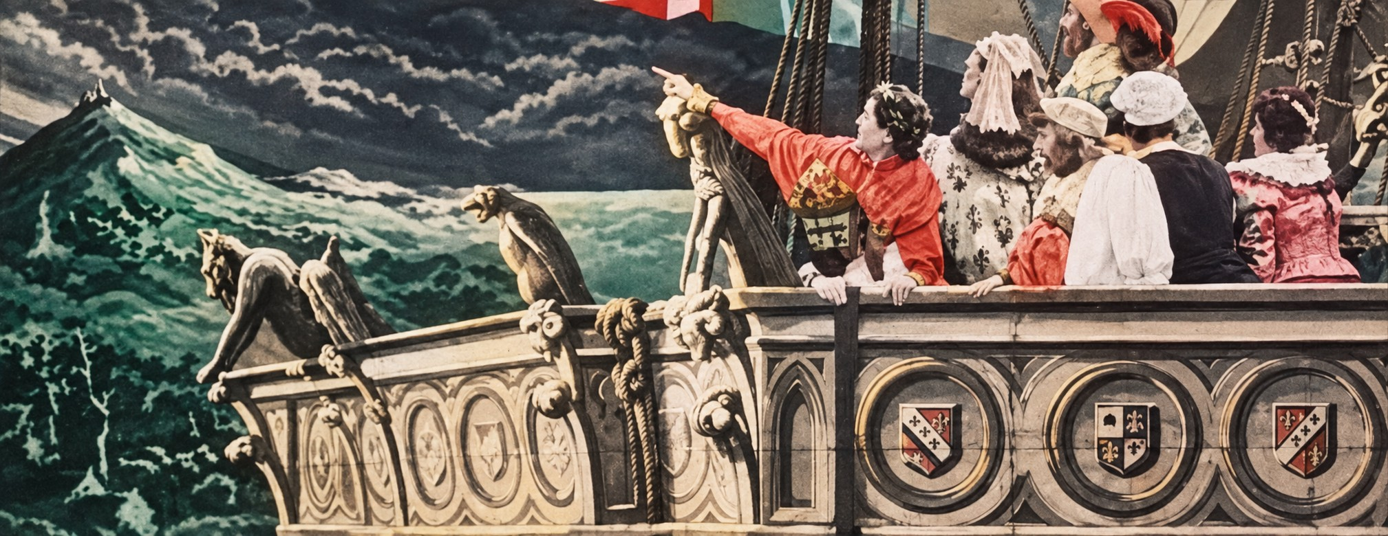
Generated reference • Inputs 0:25, 0:30, 0:35
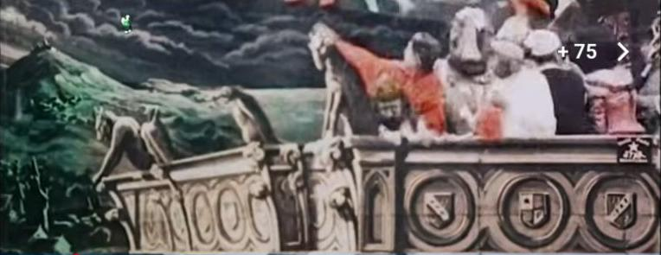
Source frame 0:25
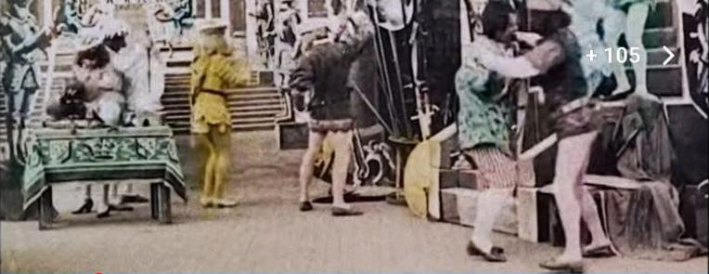
Source frame 0:30

Band at the harbour
Generated reconstruction from video frames. Hidden details, faces and any added views are interpretive completions.
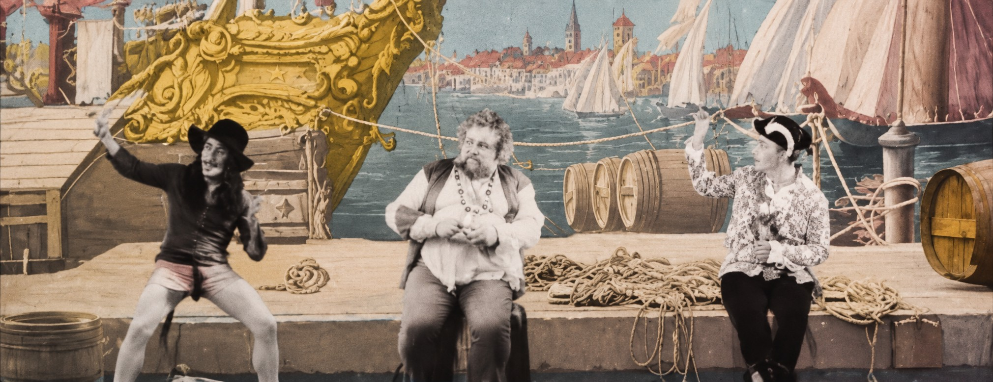
Generated reference • Inputs 0:40, 0:45
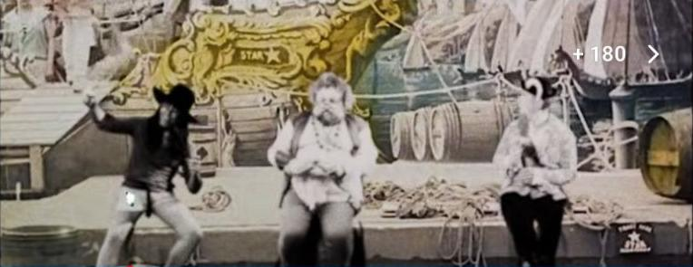
Source frame 0:40
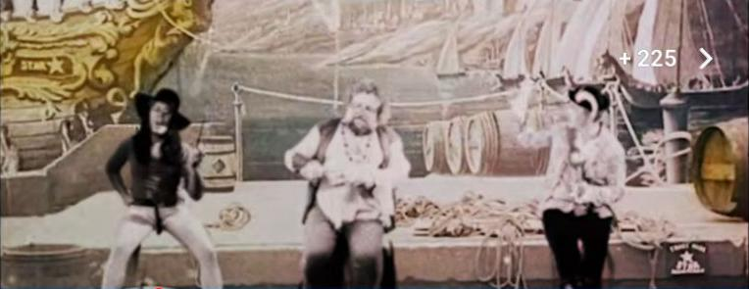
Source frame 0:45

Storm and shipwreck water
Generated reconstruction from video frames. Hidden details, faces and any added views are interpretive completions.
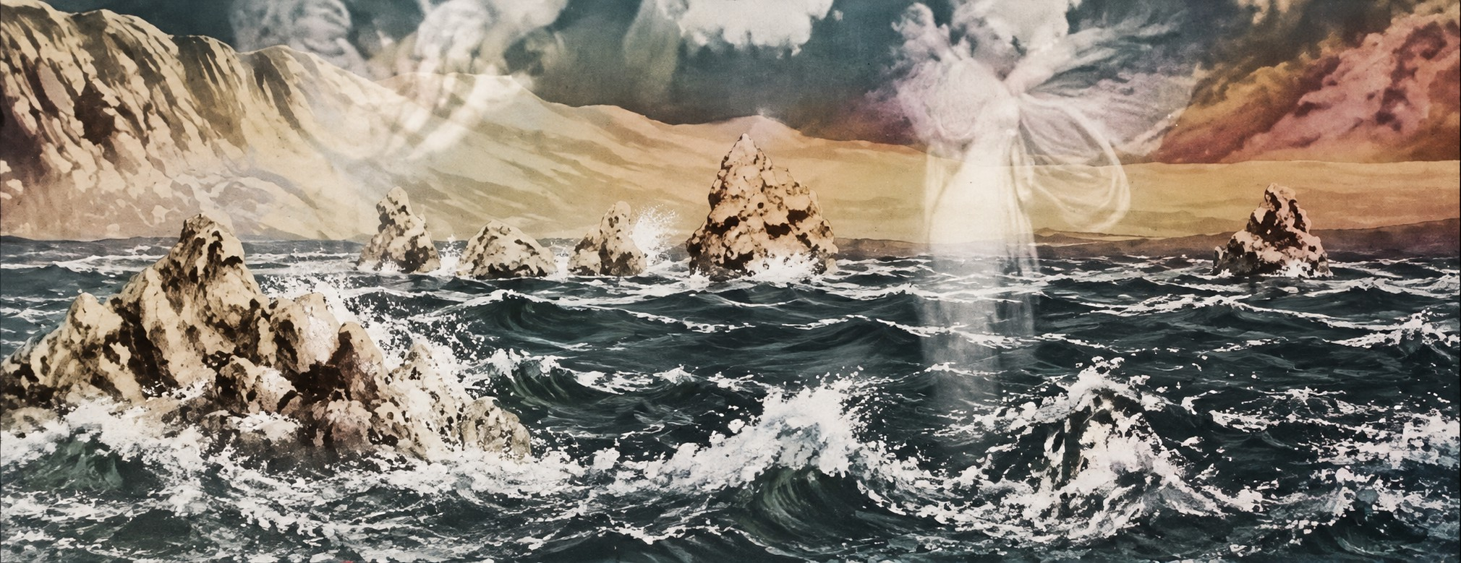
Generated reference • Inputs 0:50, 0:55, 1:00
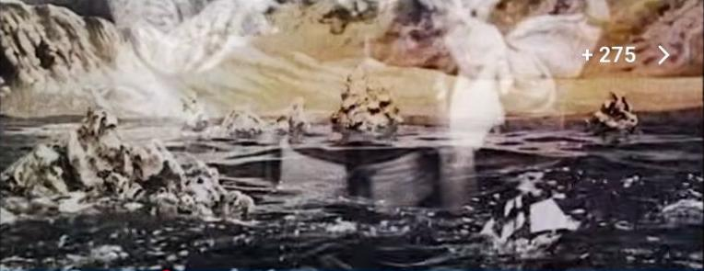
Source frame 0:50
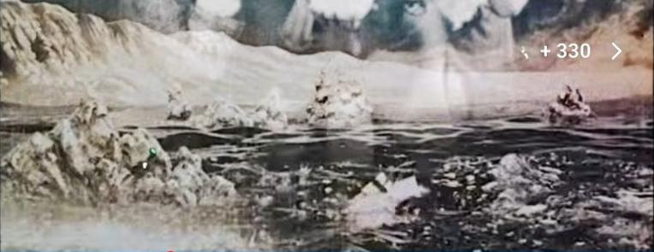
Source frame 0:55

Undersea arrival
Generated reconstruction from video frames. Hidden details, faces and any added views are interpretive completions.
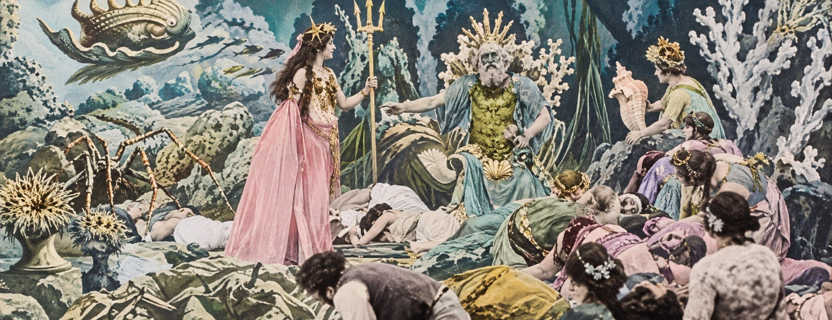
Generated reference • Inputs 1:05, 1:10, 1:25
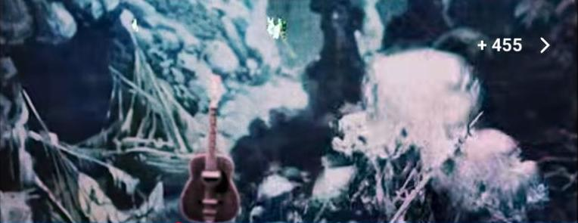
Source frame 1:05
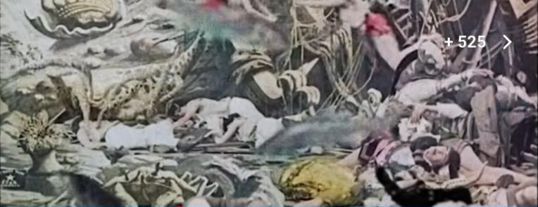
Source frame 1:10

Grotto and magical vessel
Generated reconstruction from video frames. Hidden details, faces and any added views are interpretive completions.
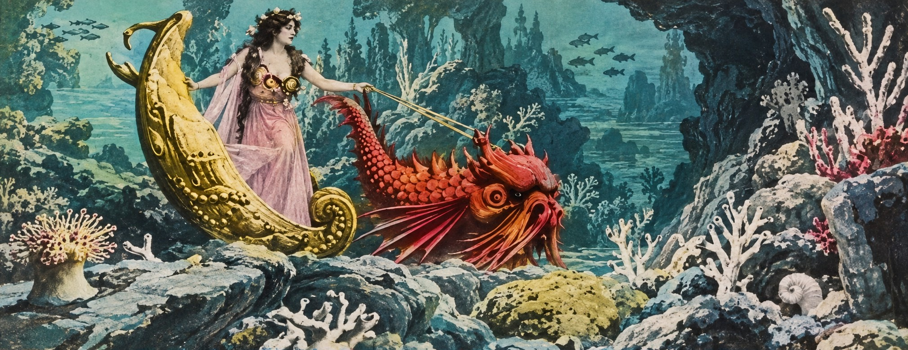
Generated reference • Inputs 1:20, 1:35, 1:45
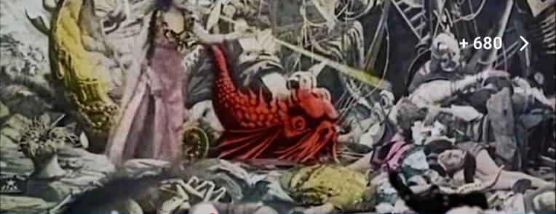
Source frame 1:20
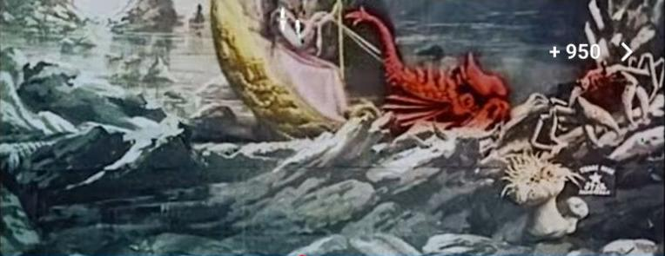
Source frame 1:35

Underwater court and whale
Generated reconstruction from video frames. Hidden details, faces and any added views are interpretive completions.
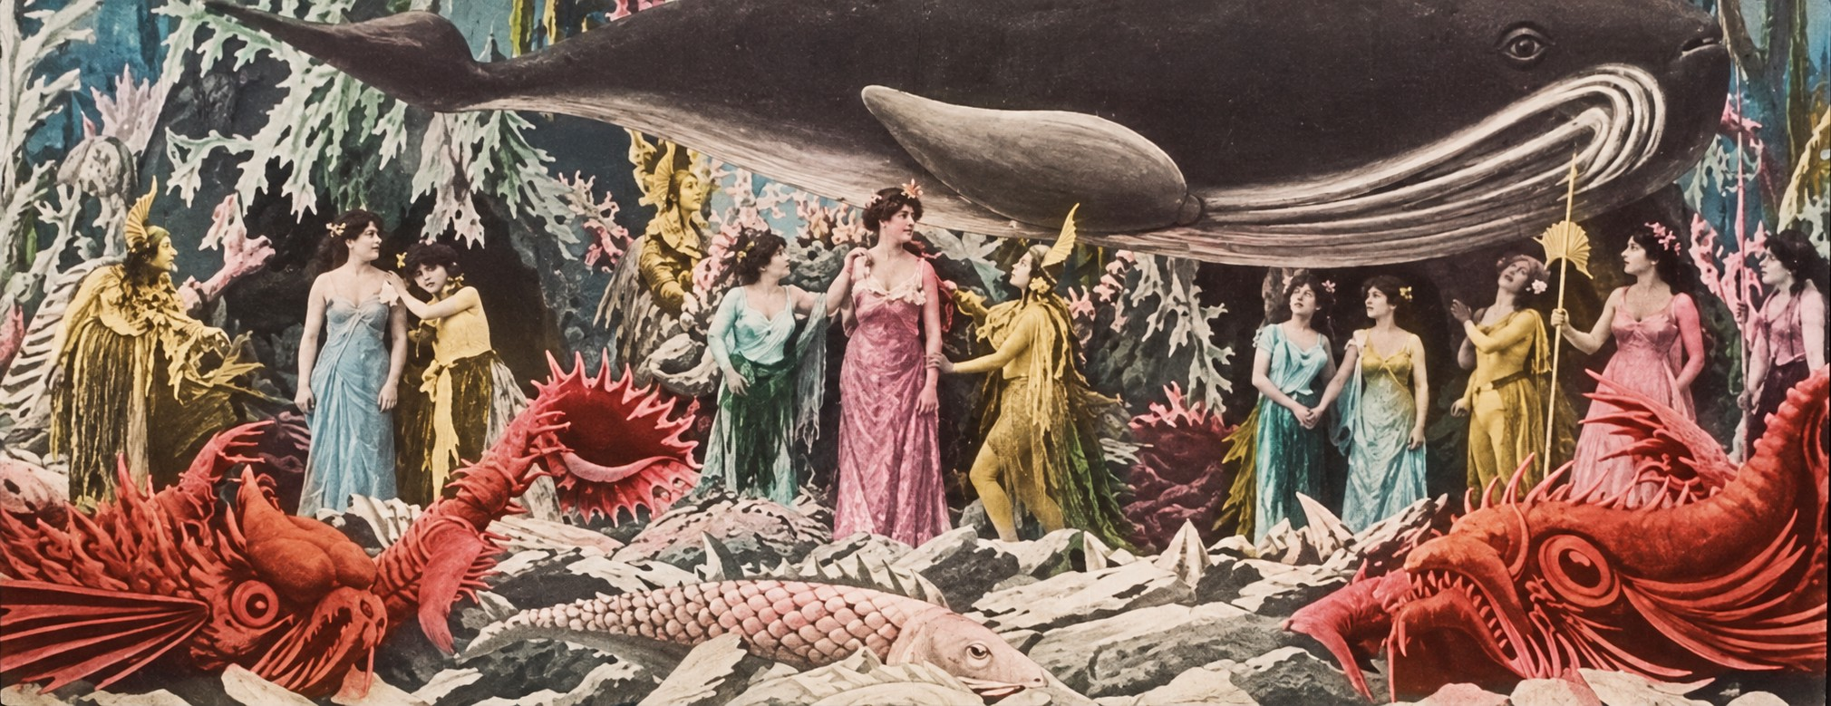
Generated reference • Inputs 1:55, 2:10, 2:25
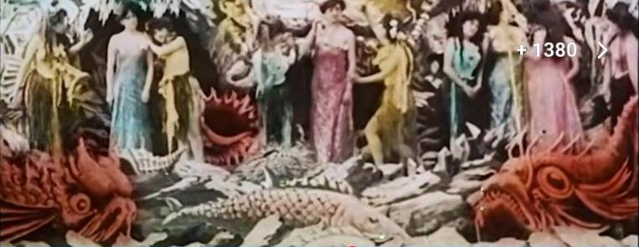
Source frame 1:55
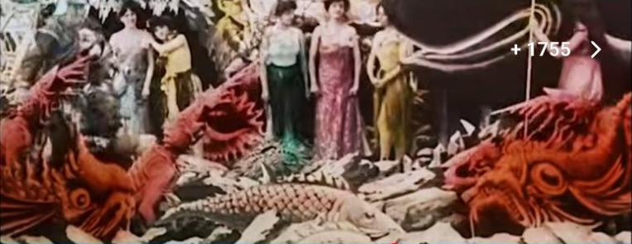
Source frame 2:10

Whale at the rocky shore
Generated reconstruction from video frames. Hidden details, faces and any added views are interpretive completions.
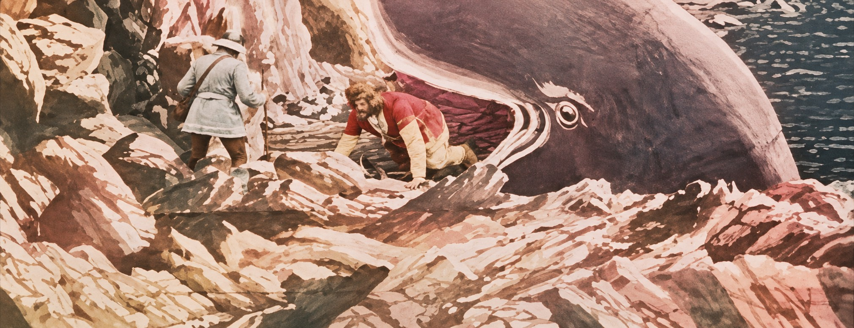
Generated reference • Inputs 2:30, 2:35, 2:40
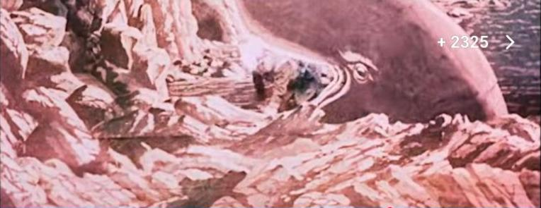
Source frame 2:30
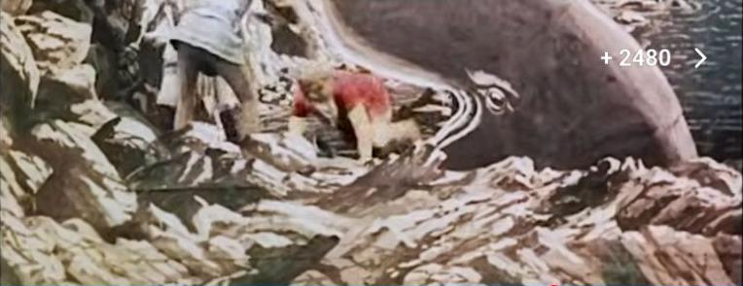
Source frame 2:35

Cliff and band collage
Generated reconstruction from video frames. Hidden details, faces and any added views are interpretive completions.
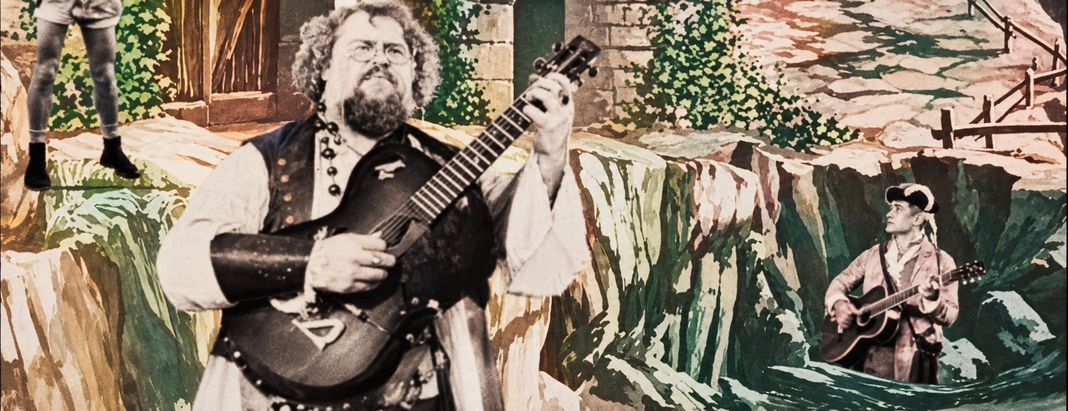
Generated reference • Inputs 2:50, 3:00, 3:05
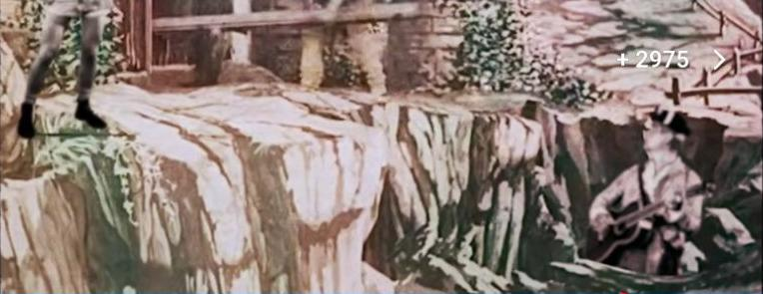
Source frame 2:50
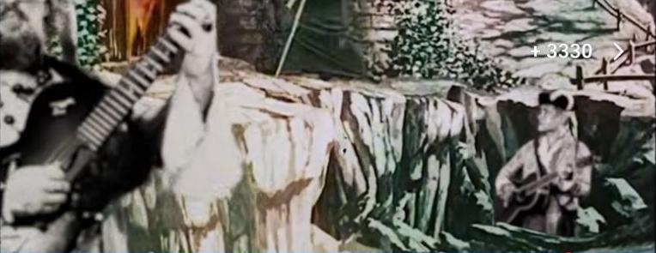
Source frame 3:00

Collapse and rescue
Generated reconstruction from video frames. Hidden details, faces and any added views are interpretive completions.
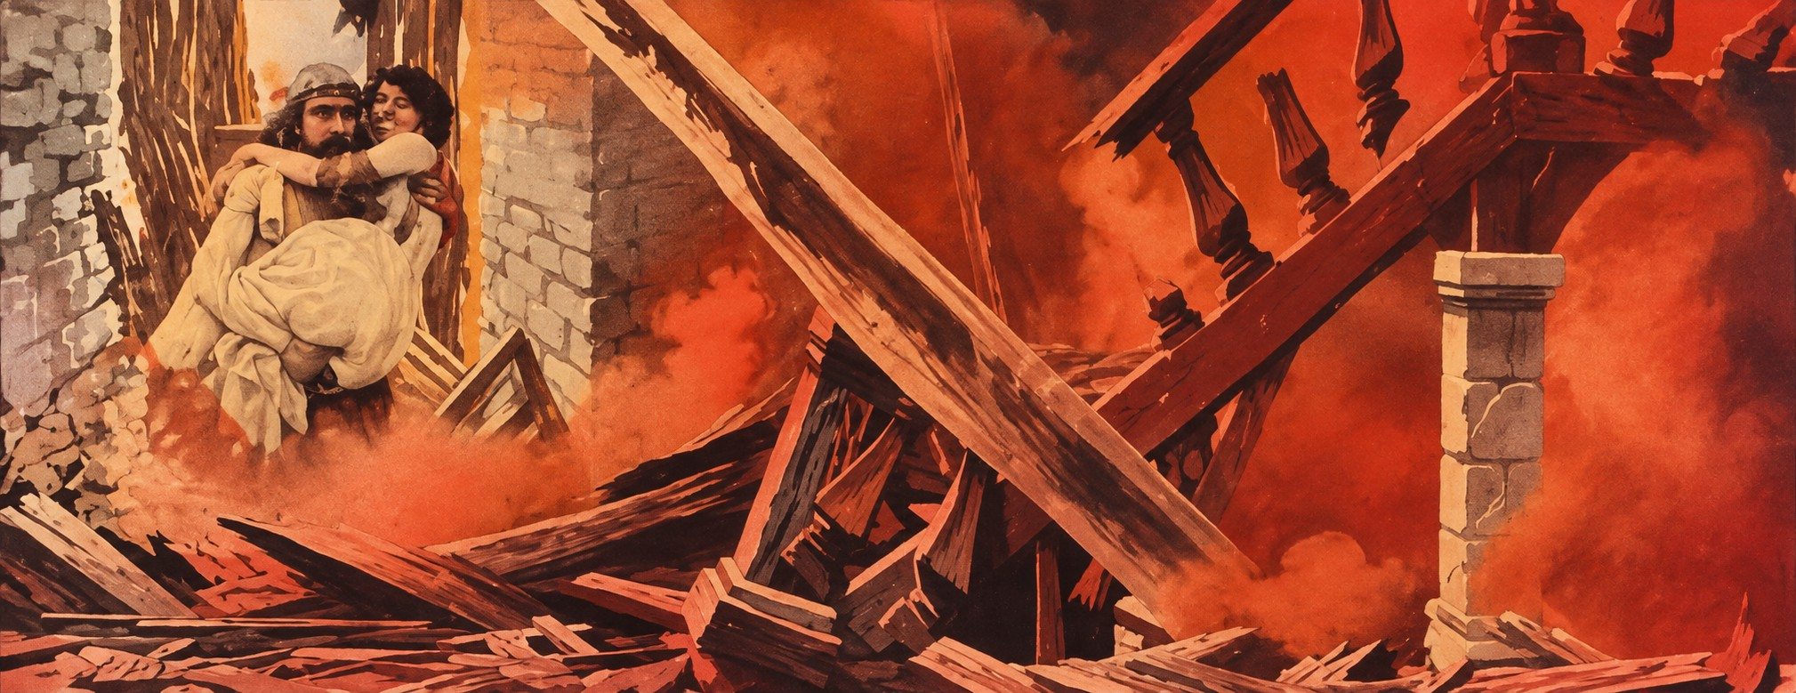
Generated reference • Inputs 3:10, 3:15
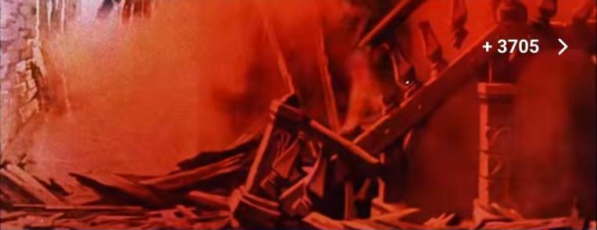
Source frame 3:10
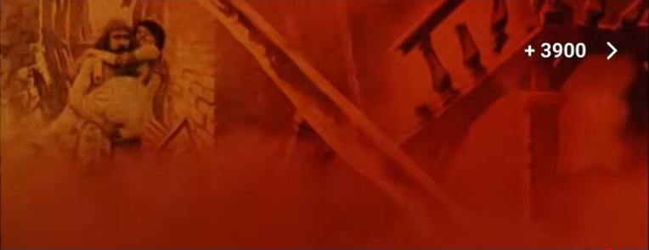
Source frame 3:15

Final fantasy pageant
The final tableau around 3:20 adds a fantasy pageant before the closing card; the layered appearance may be a dissolve.
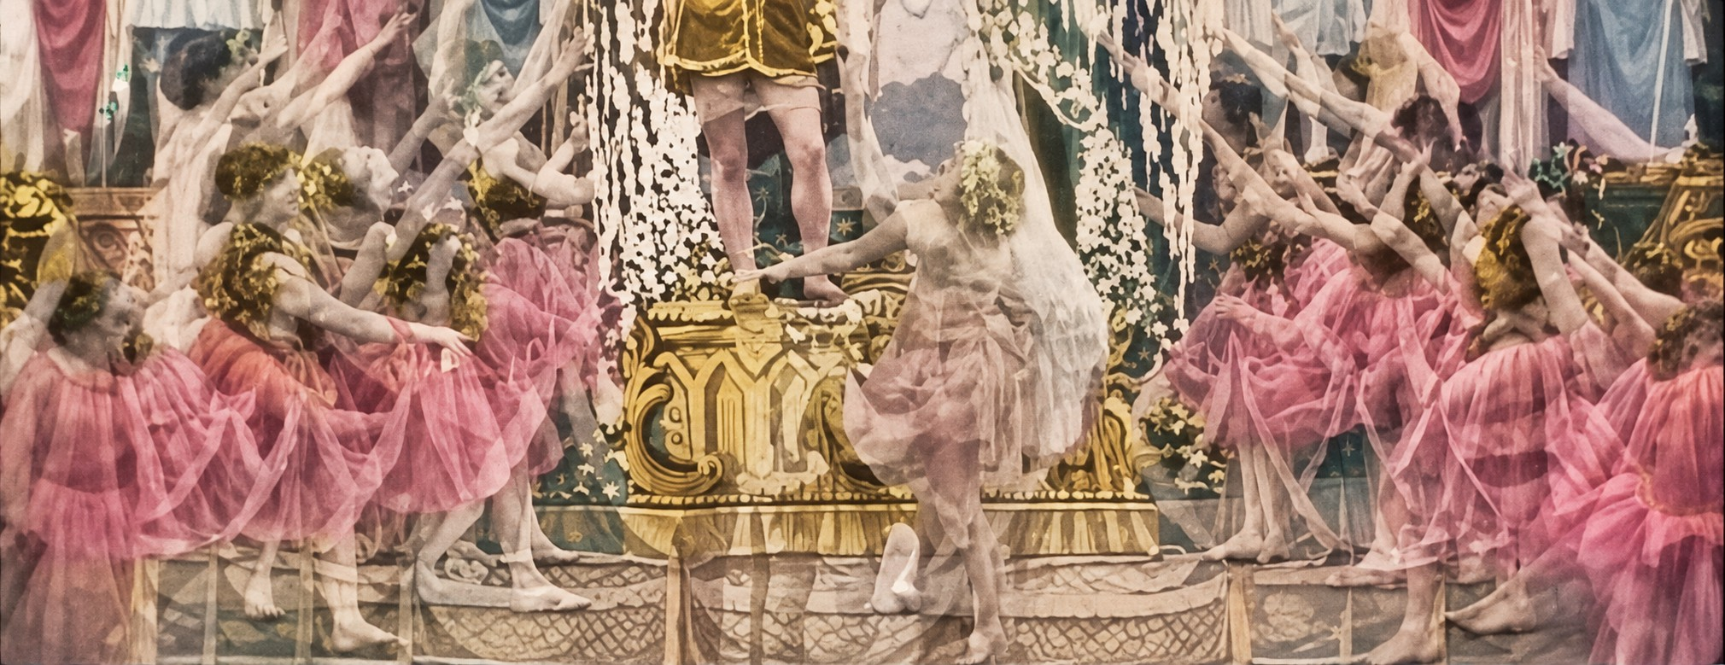
Generated reference • Inputs 3:20, 0:10
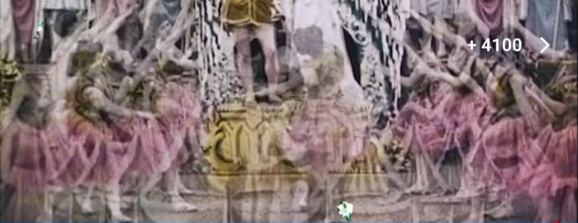
Source frame 3:20
Source frame 0:10

Band member in dark hat
Generated reconstruction from video frames. Hidden details, faces and any added views are interpretive completions.
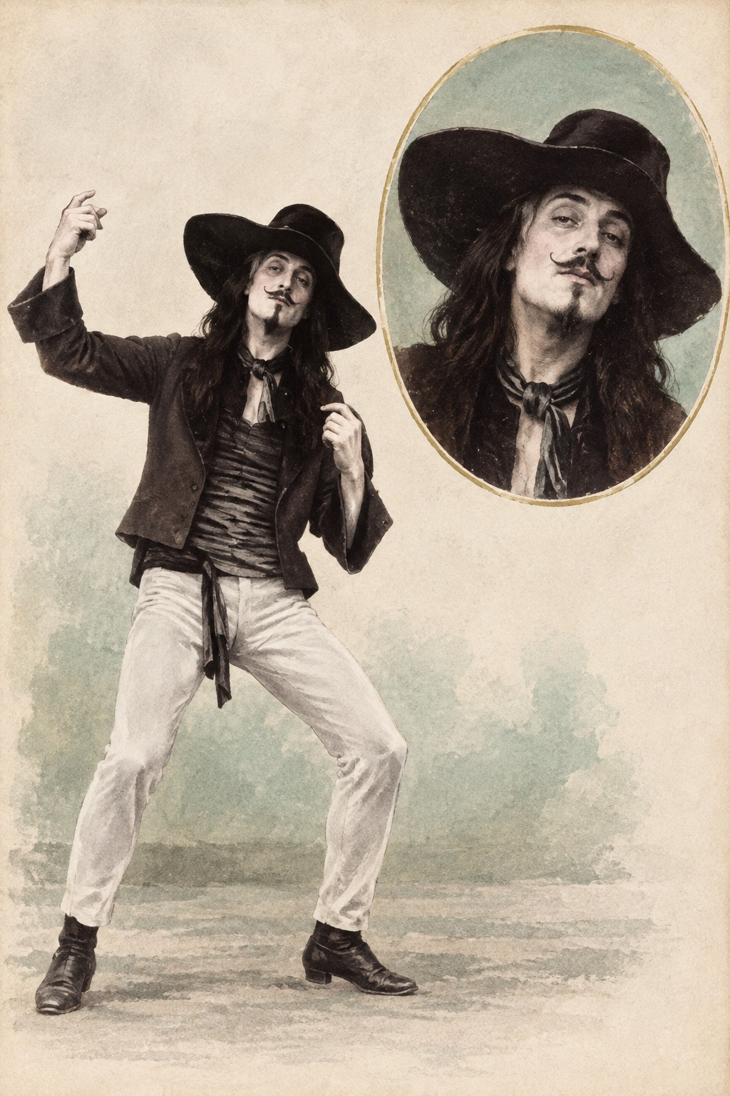
Generated reference • Inputs 0:15, 0:40, 0:45
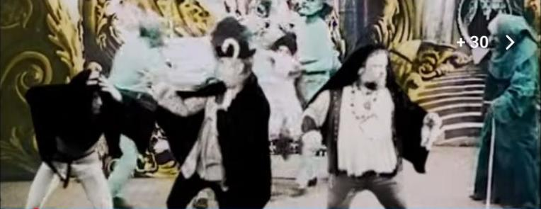
Source frame 0:15
Source frame 0:40

Band member with beard
Generated reconstruction from video frames. Hidden details, faces and any added views are interpretive completions.
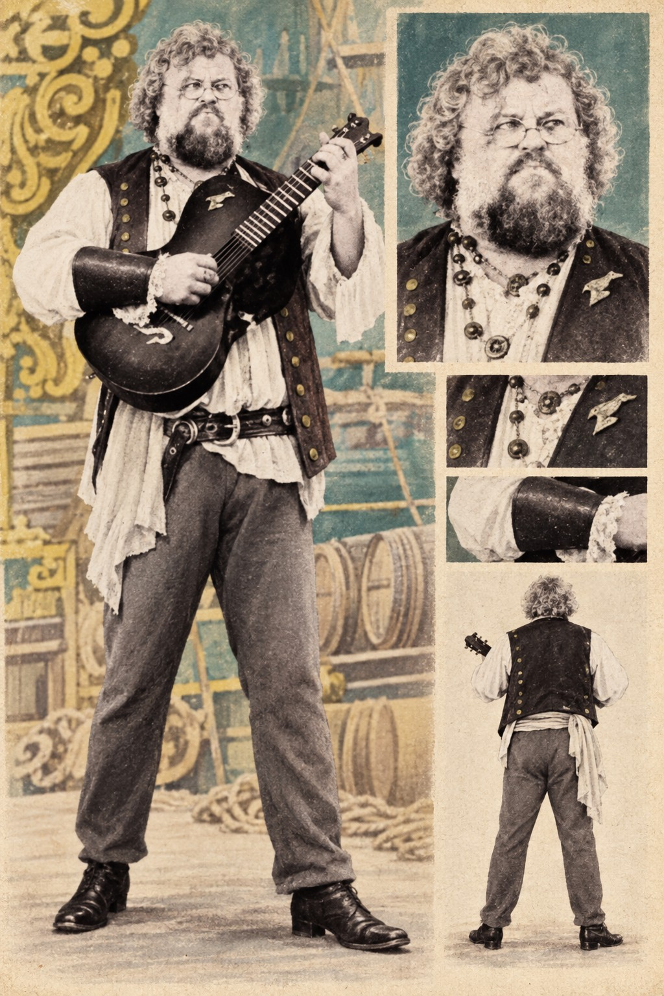
Generated reference • Inputs 0:15, 0:40, 3:05
Source frame 0:15
Source frame 0:40

Band member in curved hat
Generated reconstruction from video frames. Hidden details, faces and any added views are interpretive completions.
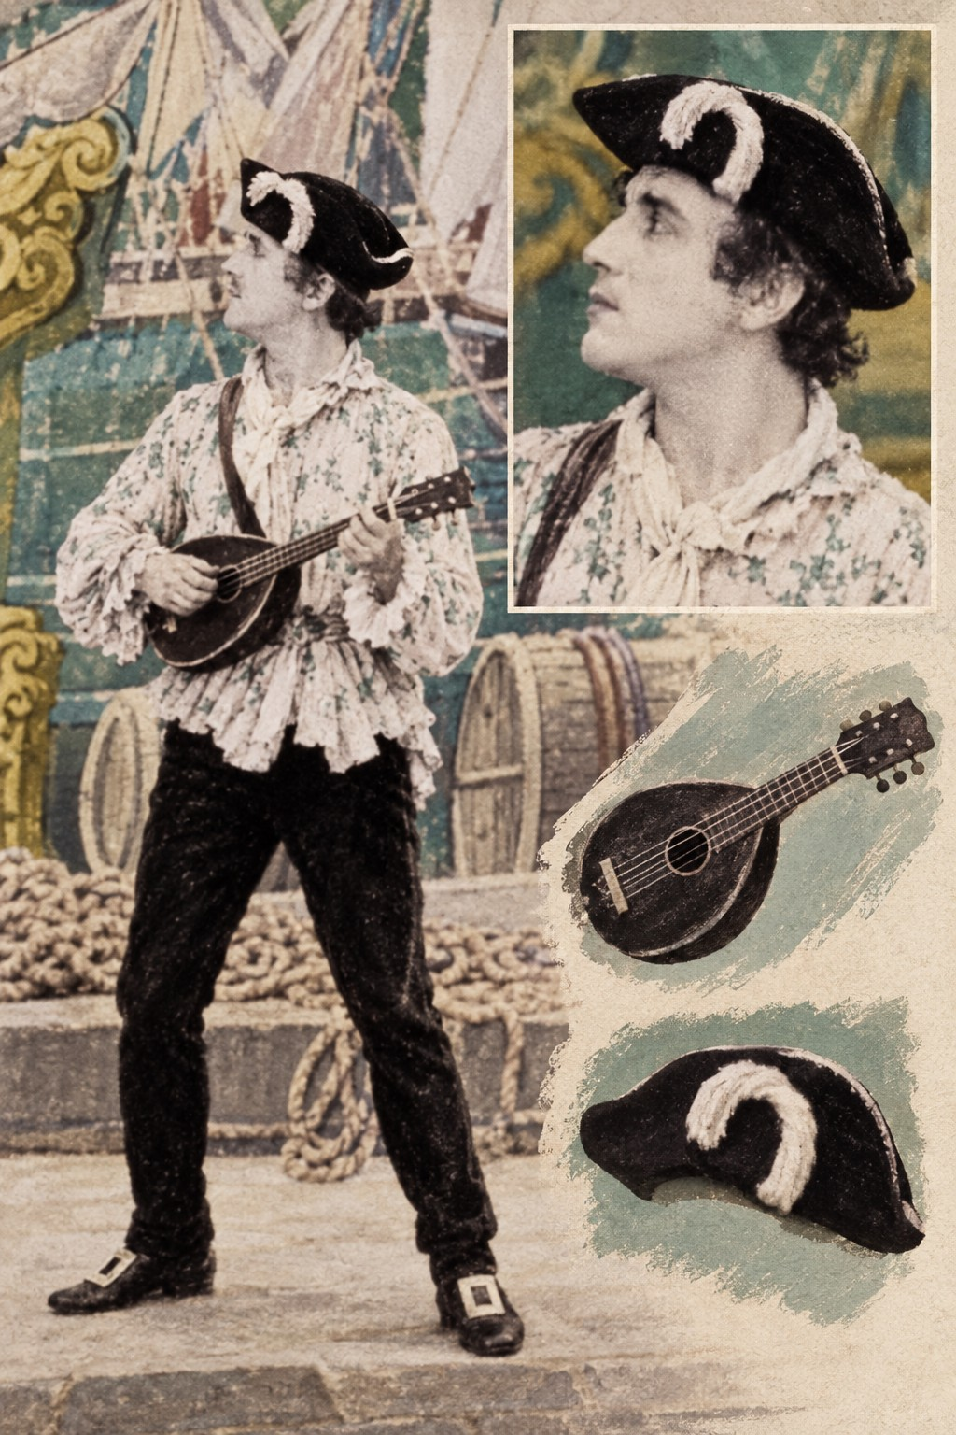
Generated reference • Inputs 0:15, 0:40, 2:55
Source frame 0:15
Source frame 0:40

Palace figures and courtiers
Royal-looking figures and courtiers. Names and precise narrative roles are unconfirmed.
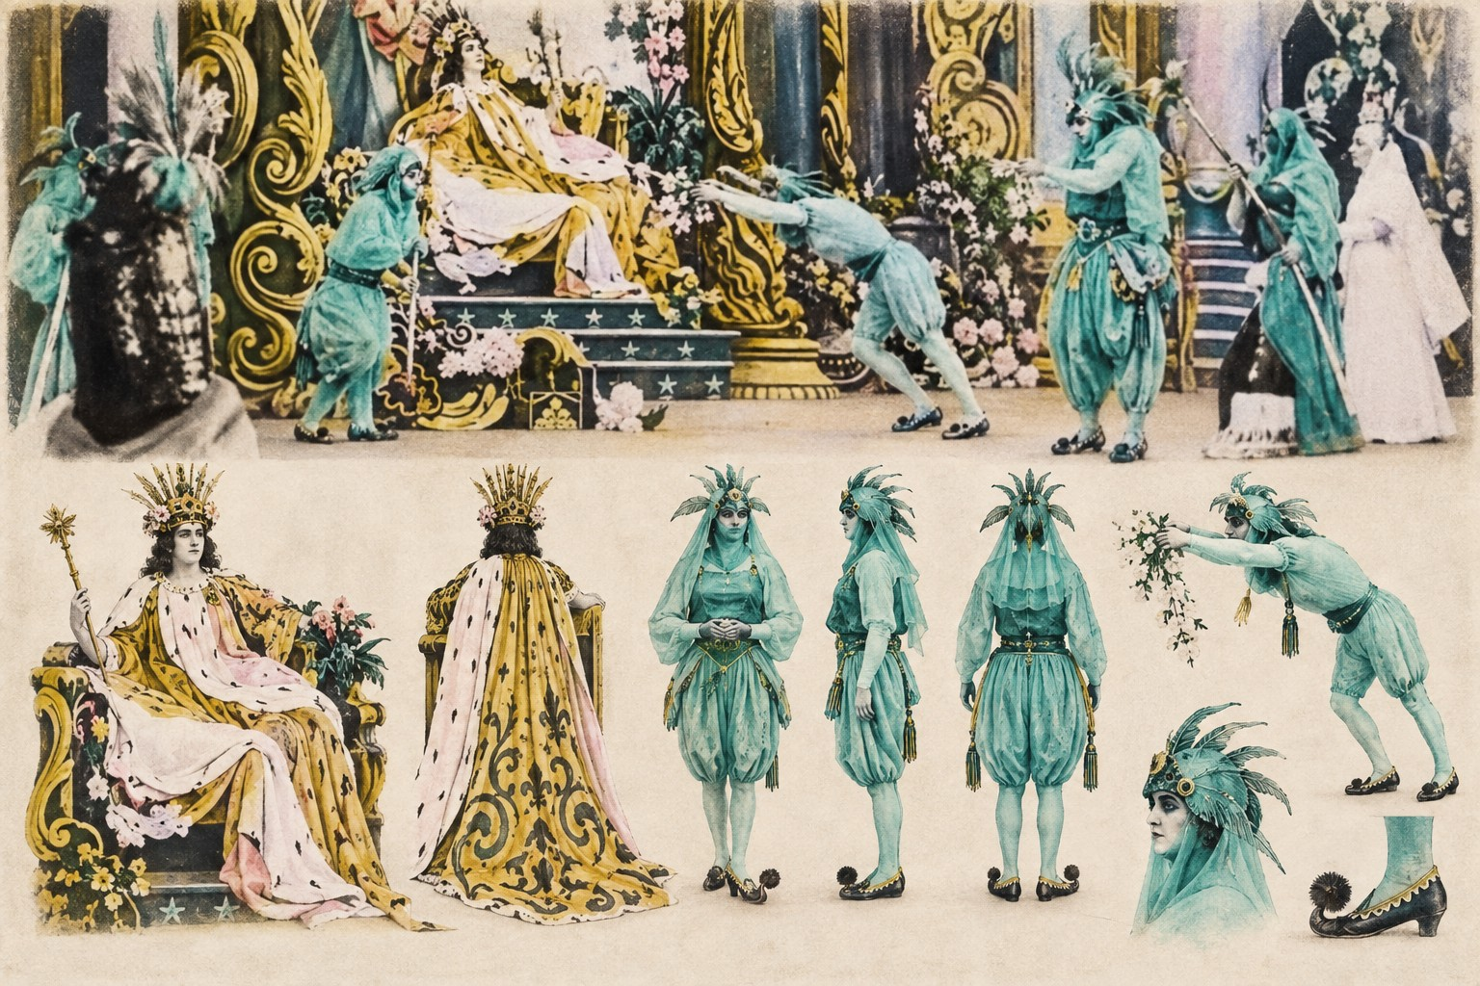
Generated reference • Inputs 0:10, 0:20
Source frame 0:10
Source frame 0:20

Costumed deck travellers
Generated reconstruction from video frames. Hidden details, faces and any added views are interpretive completions.
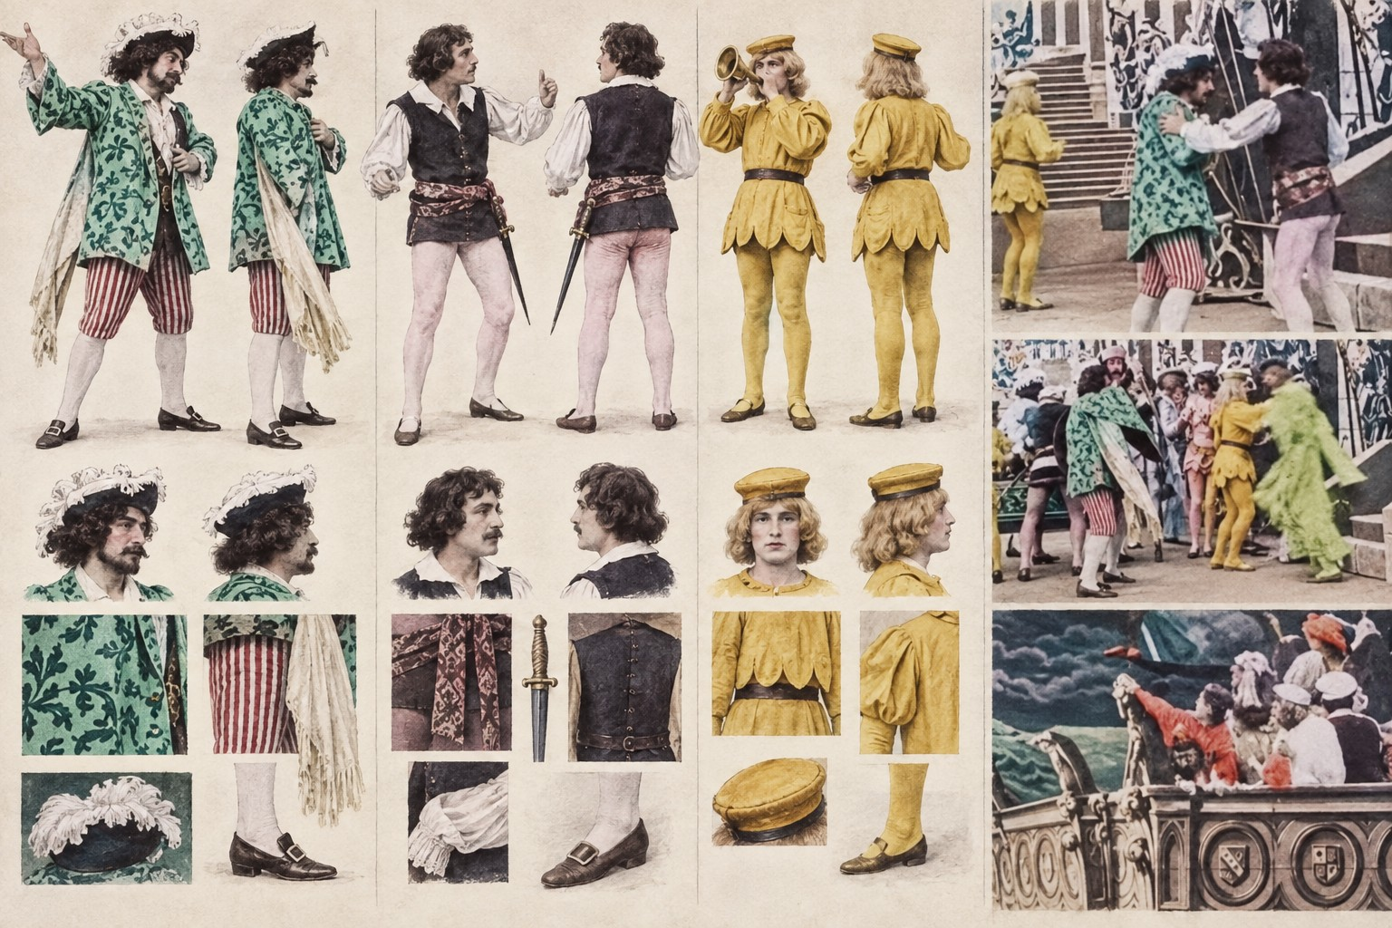
Generated reference • Inputs 0:30, 0:35, 0:25
Source frame 0:30
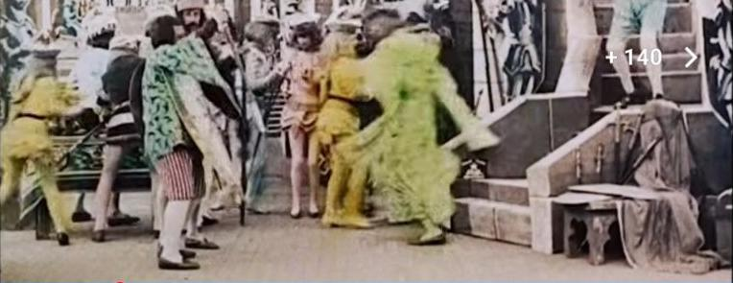
Source frame 0:35

Pink-robed magical figure
Magical figure is a descriptive label. Identification as the lyric’s sea witch is unconfirmed.
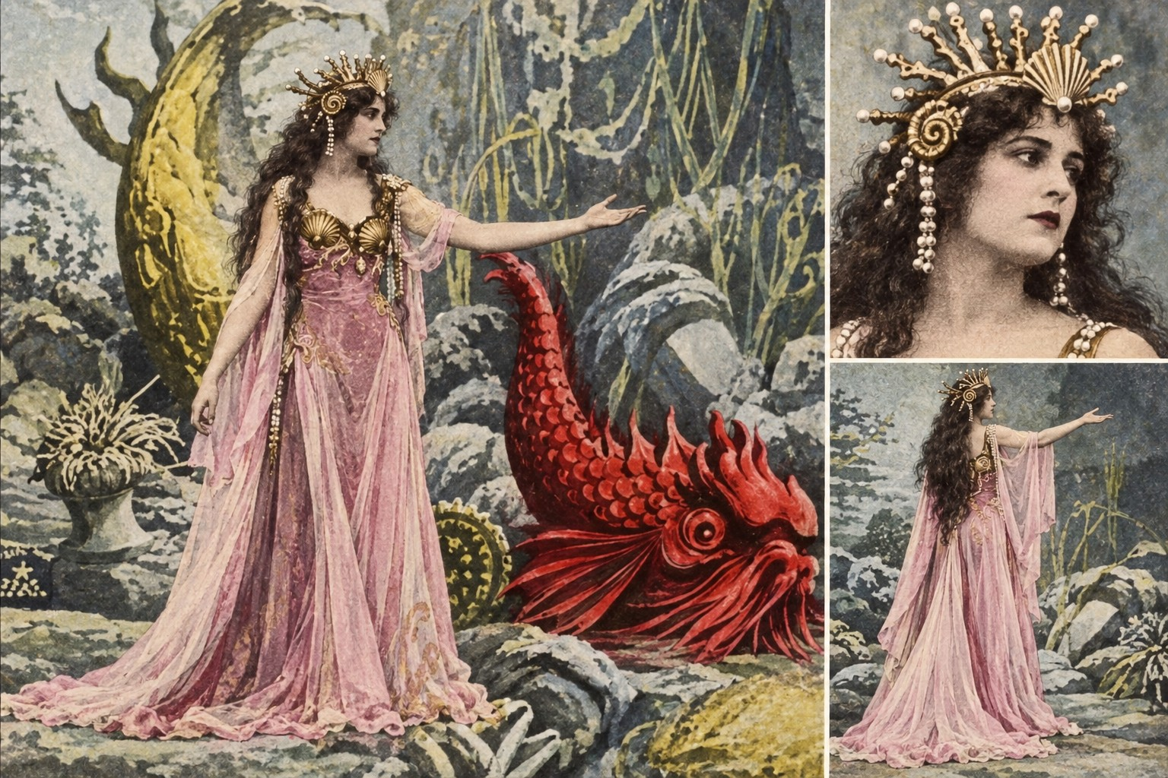
Generated reference • Inputs 1:20, 1:35, 1:25
Source frame 1:20
Source frame 1:35

Undersea women and attendants
Generated reconstruction from video frames. Hidden details, faces and any added views are interpretive completions.
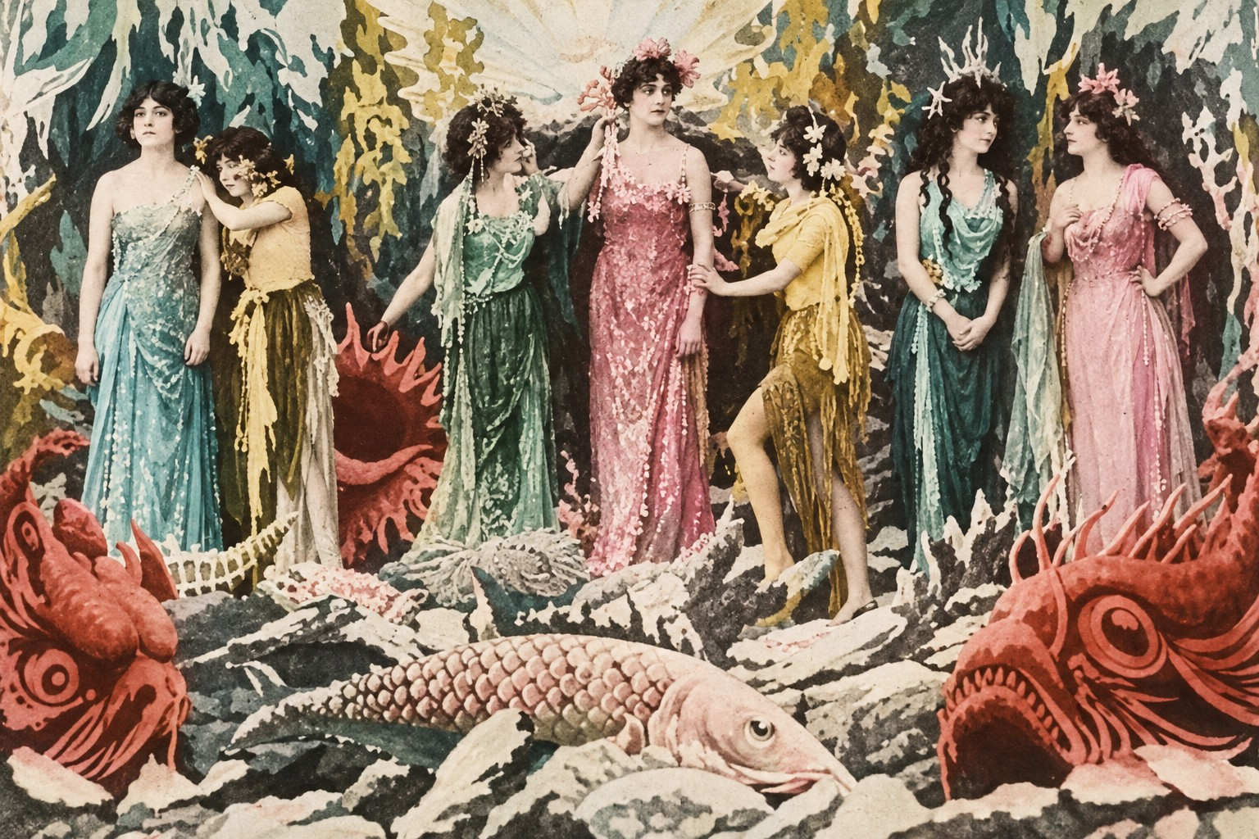
Generated reference • Inputs 1:55, 2:00, 2:05
Source frame 1:55
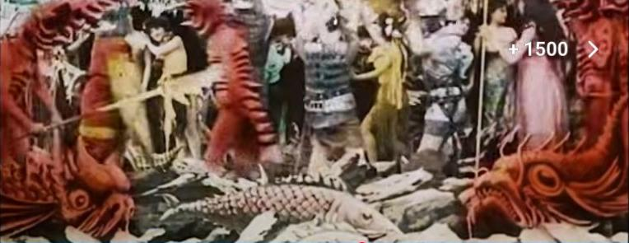
Source frame 2:00

Crowned undersea figure
Crowned undersea figure. The frames establish costume and placement, not a name or divine status.
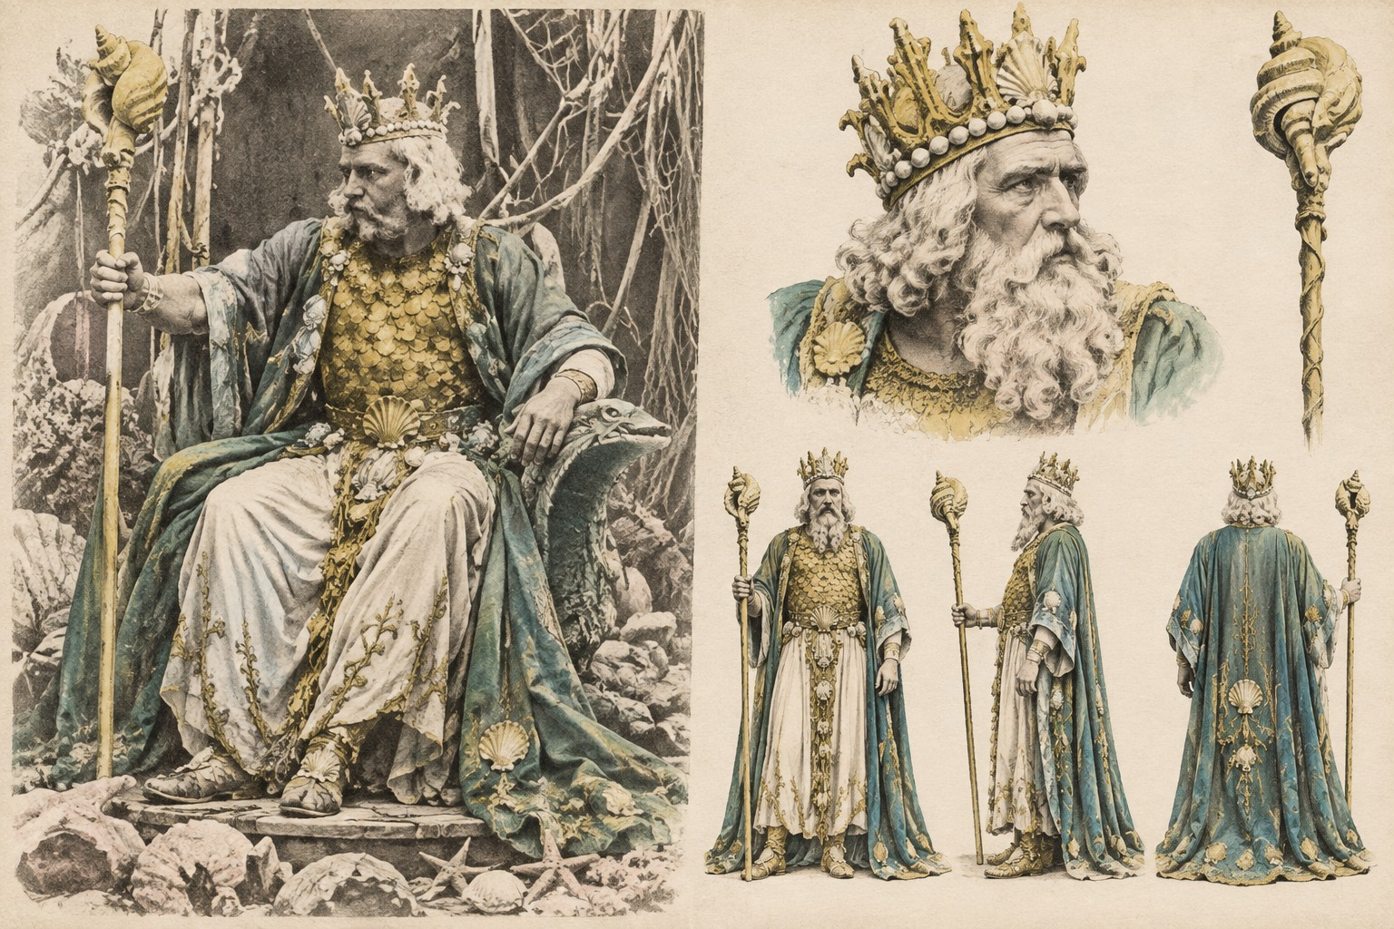
Generated reference • Inputs 1:10, 1:20, 1:25
Source frame 1:10
Source frame 1:20

Rescuer and carried woman
Observed carrying pose. Other supplied frames inform the costume style without proving character identity.
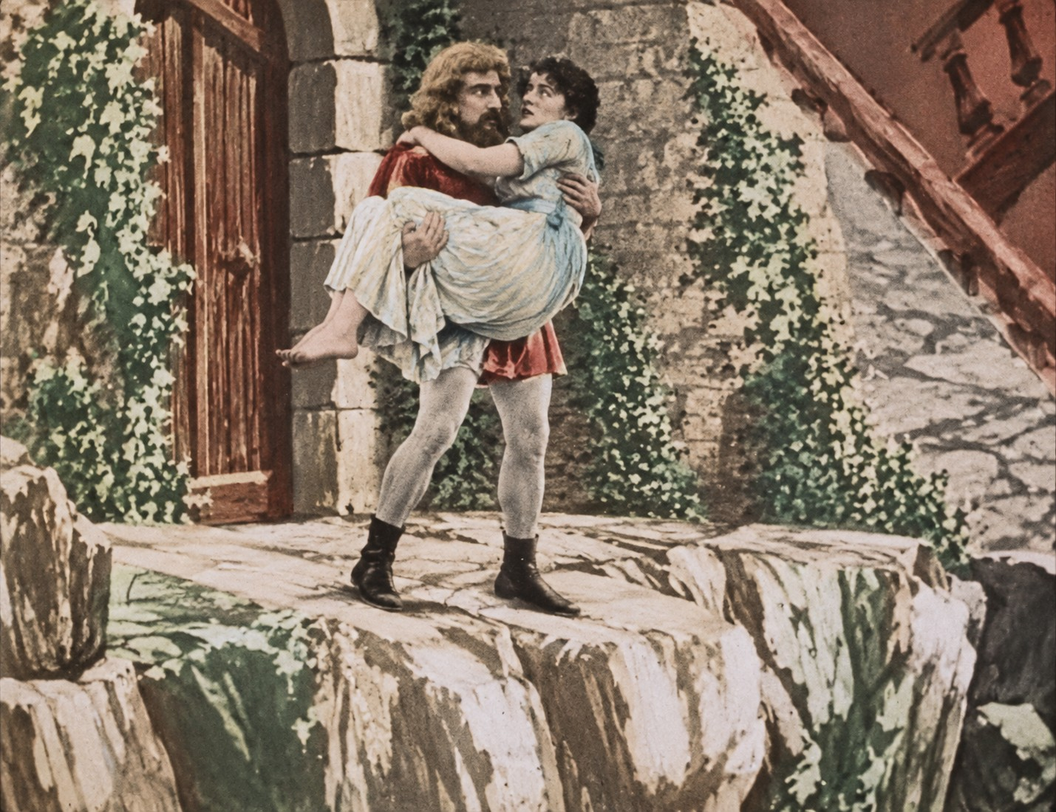
Generated reference • Inputs 3:15, 2:45, 2:35
Source frame 3:15
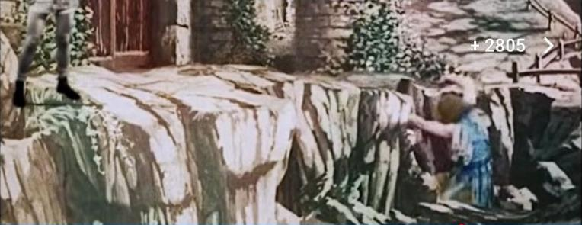
Source frame 2:45

Red marine dragon
Generated reconstruction from video frames. Hidden details, faces and any added views are interpretive completions.
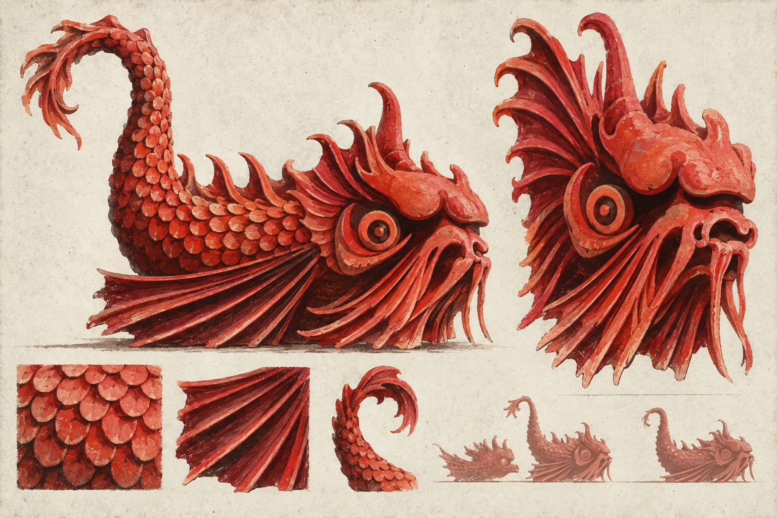
Generated reference • Inputs 1:15, 1:20, 1:55
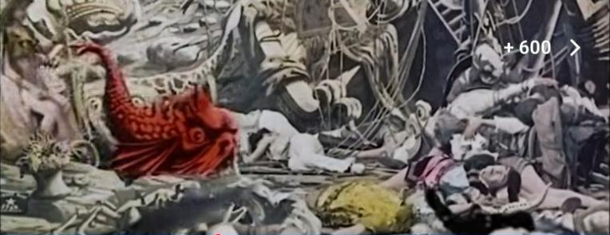
Source frame 1:15
Source frame 1:20

Giant prop whale
Generated reconstruction from video frames. Hidden details, faces and any added views are interpretive completions.
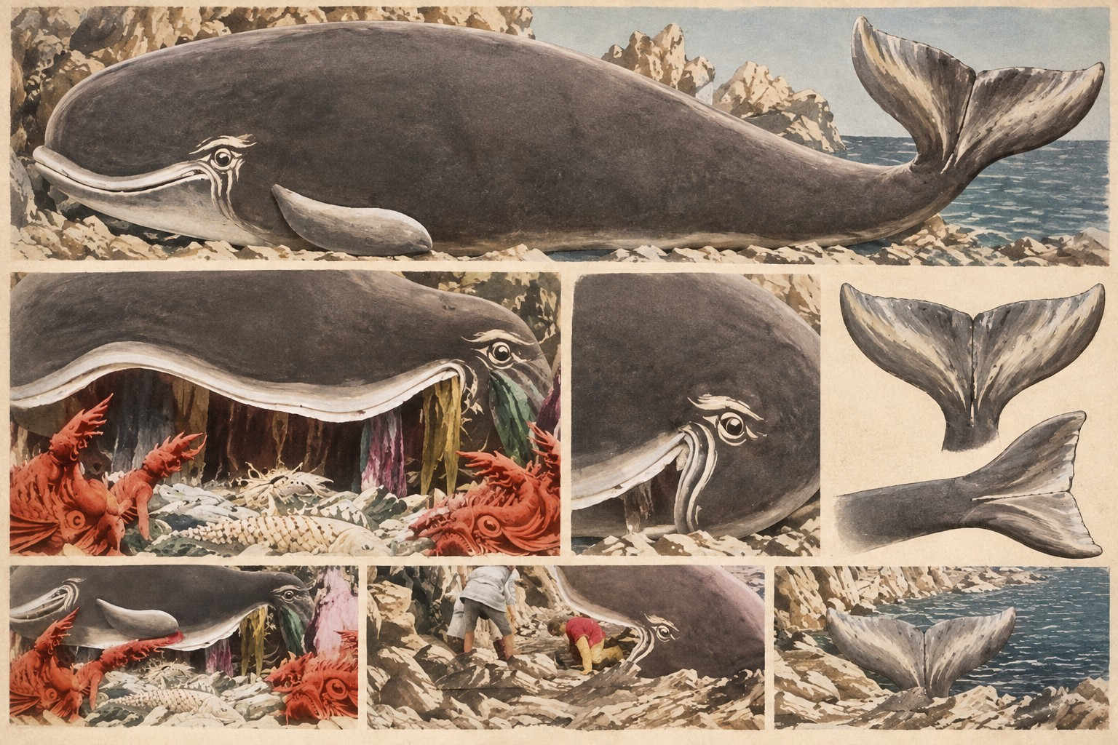
Generated reference • Inputs 2:25, 2:30, 2:35, 2:40
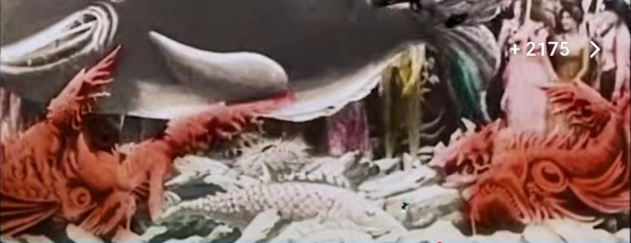
Source frame 2:25
Source frame 2:30

Grotto fish and marine ornaments
Generated reconstruction from video frames. Hidden details, faces and any added views are interpretive completions.
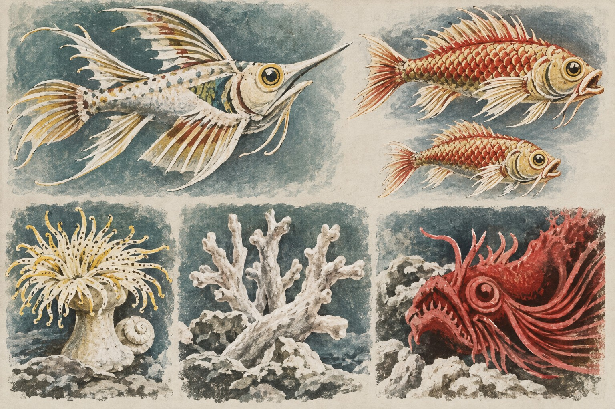
Generated reference • Inputs 1:10, 1:40, 1:45, 1:55
Source frame 1:10
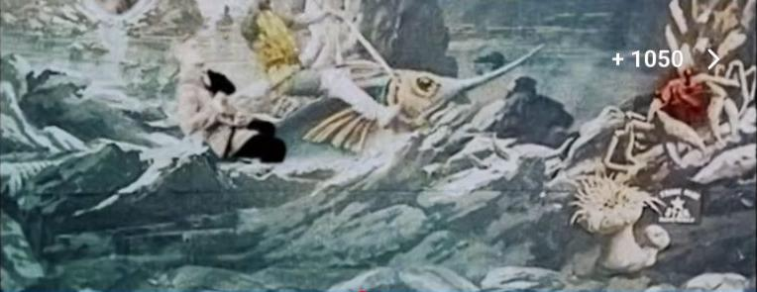
Source frame 1:40

Pearls tea and flowers
Interpretive adaptation objects from the song’s captions. Frames supply style only; these are not claimed film props.
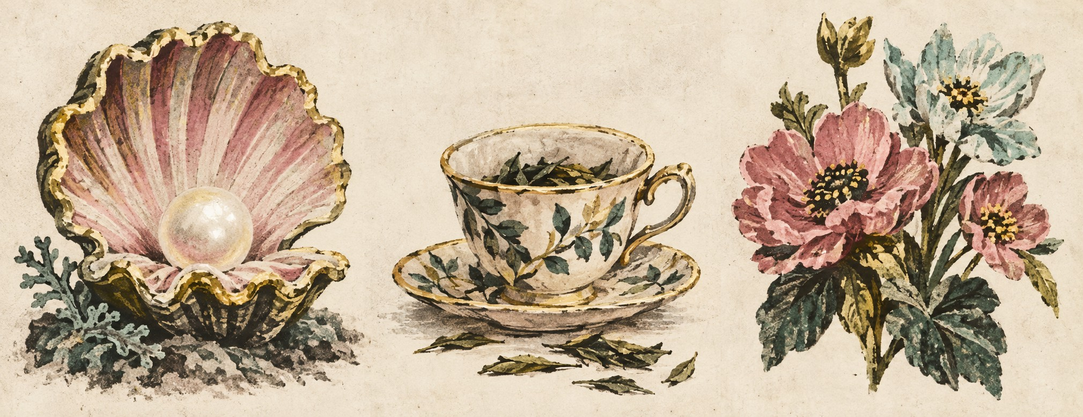
Generated reference • Inputs 1:20, 1:55
Source frame 1:20
Source frame 1:55

