1. **Total discount price by year**

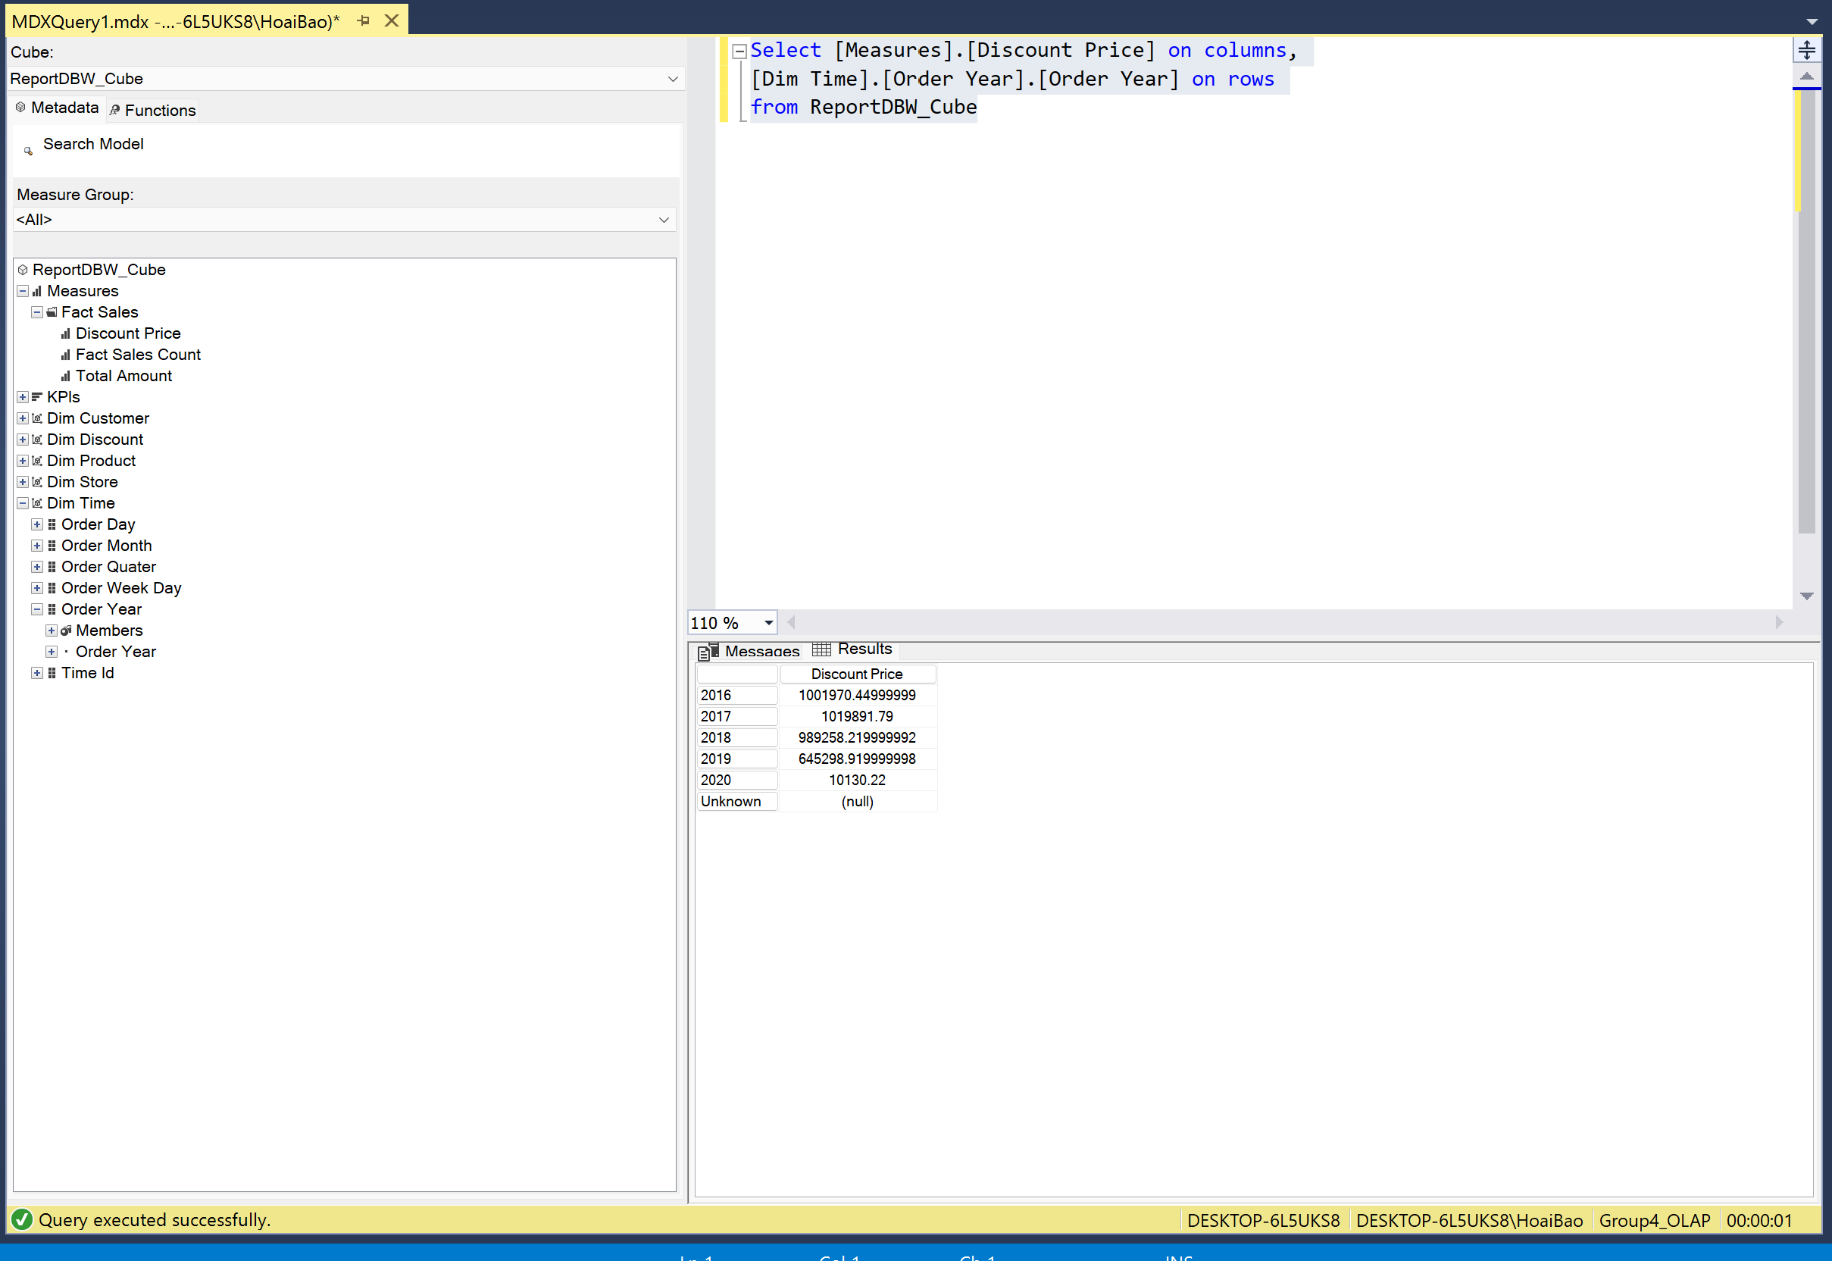

1. **Total discount price by brand name**

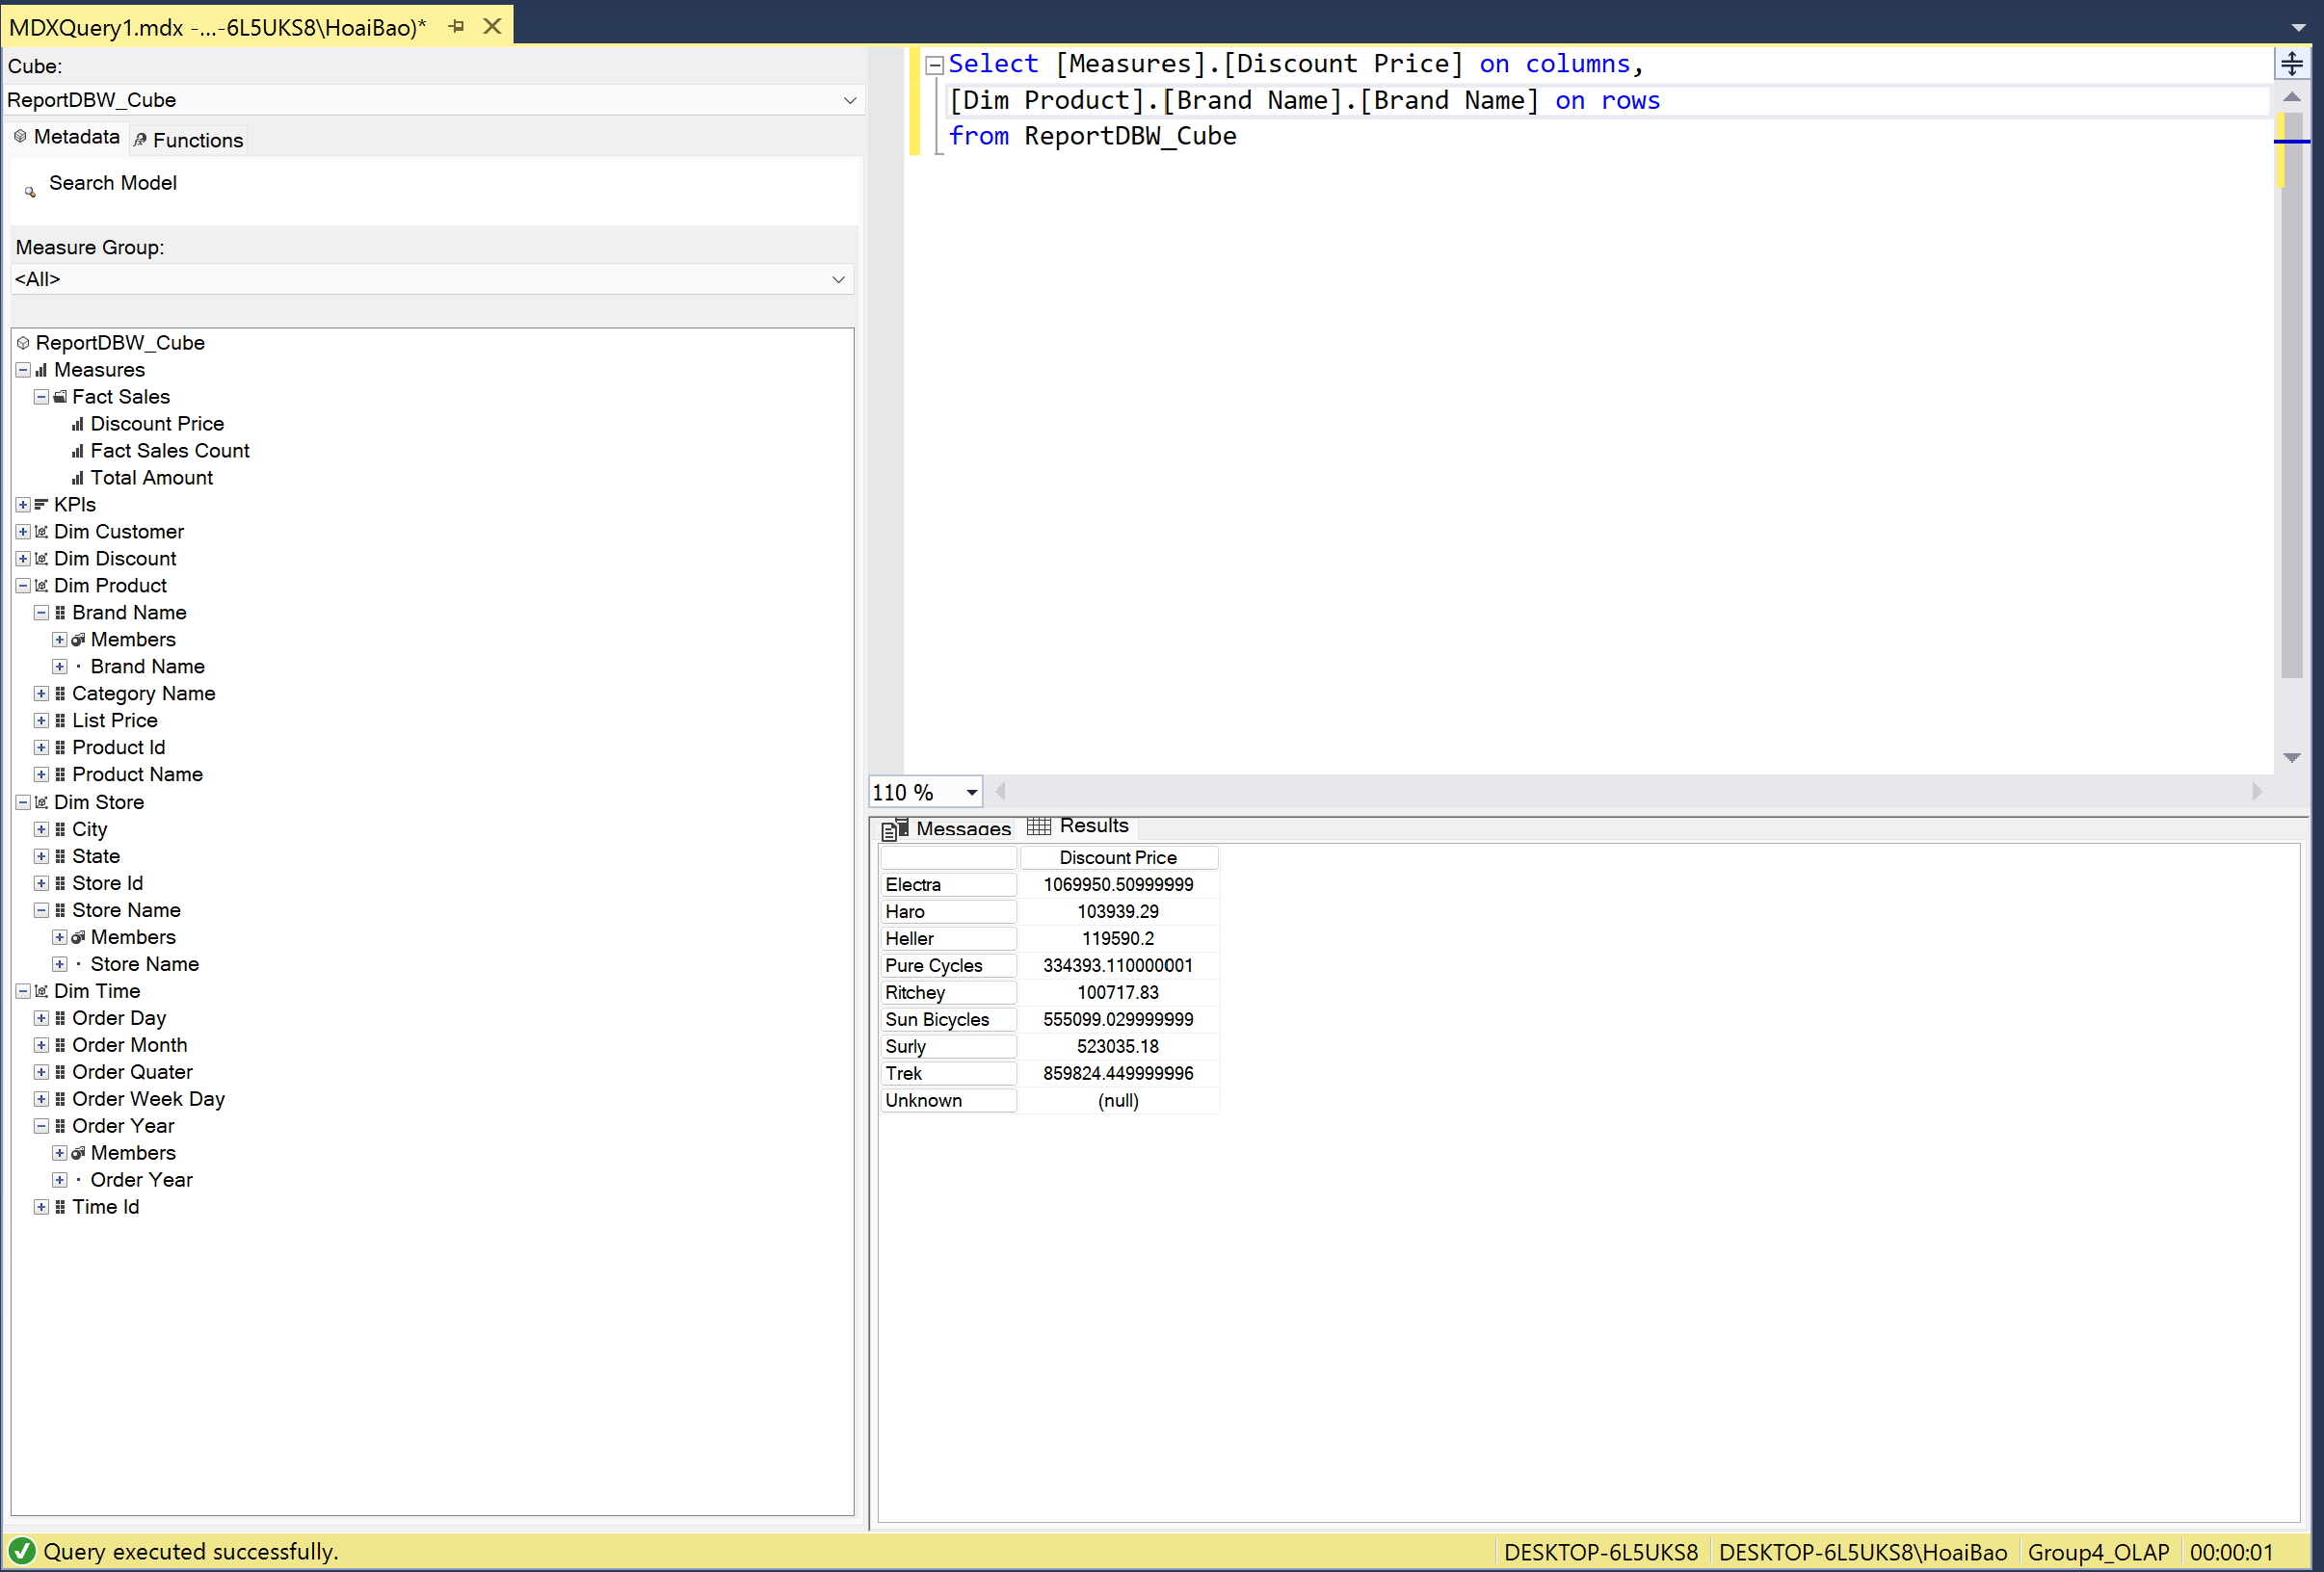

1. **Total sales price by brand name**

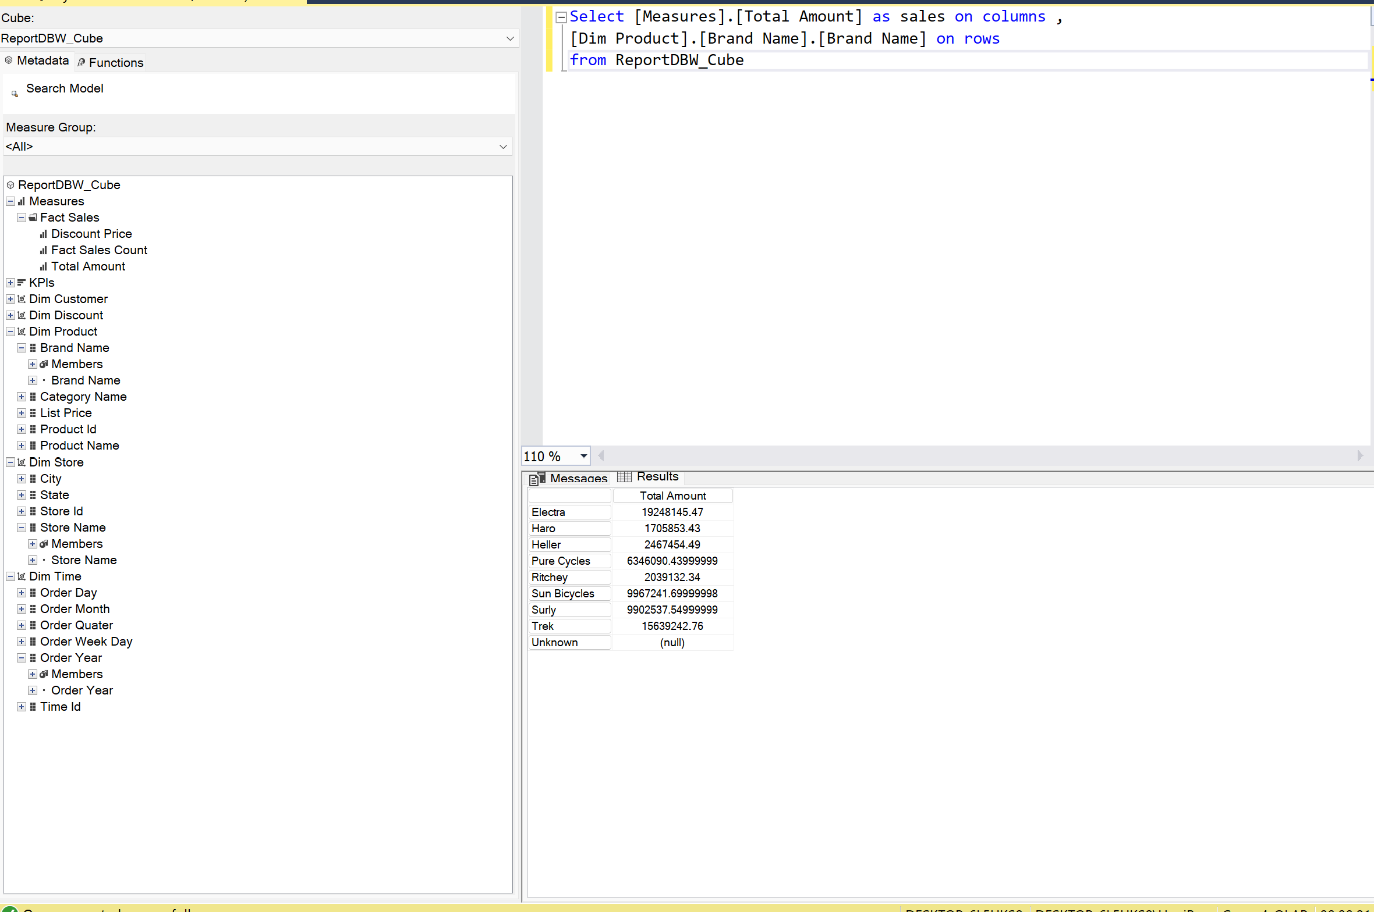

1. **Total sales price by store**

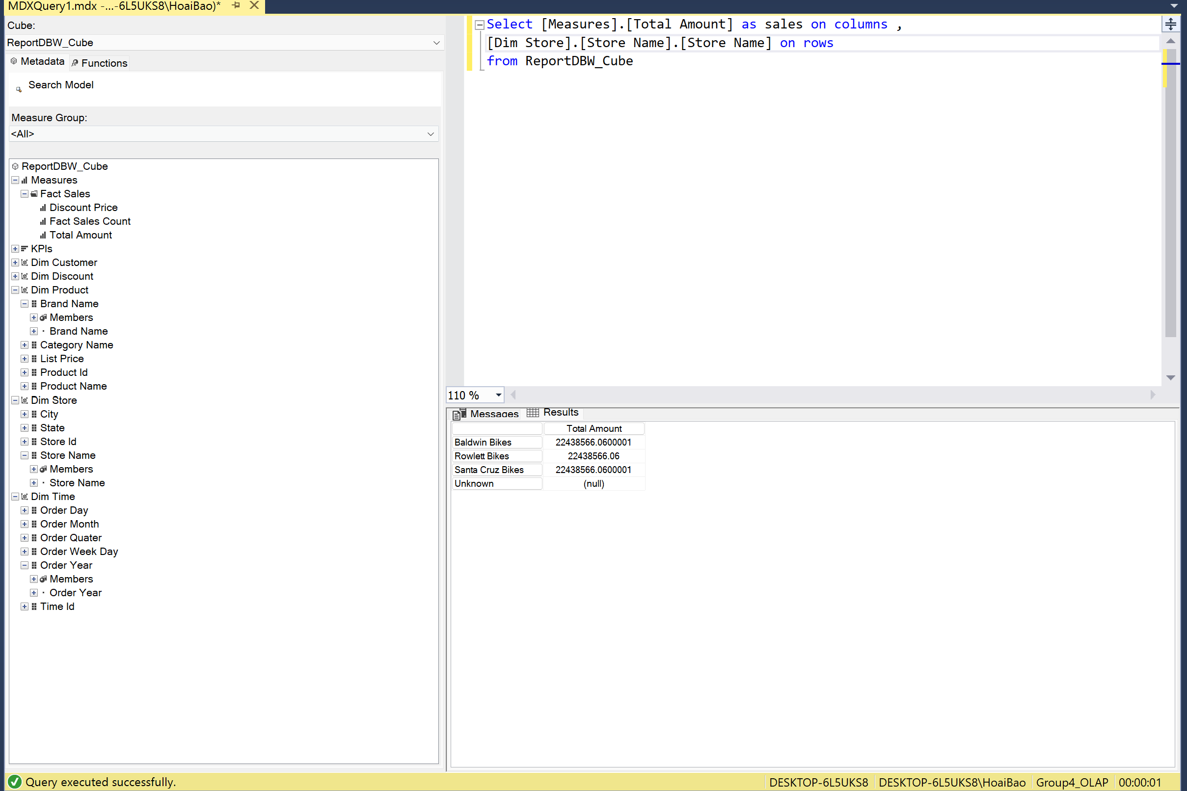

1. **Total orders by quarter**

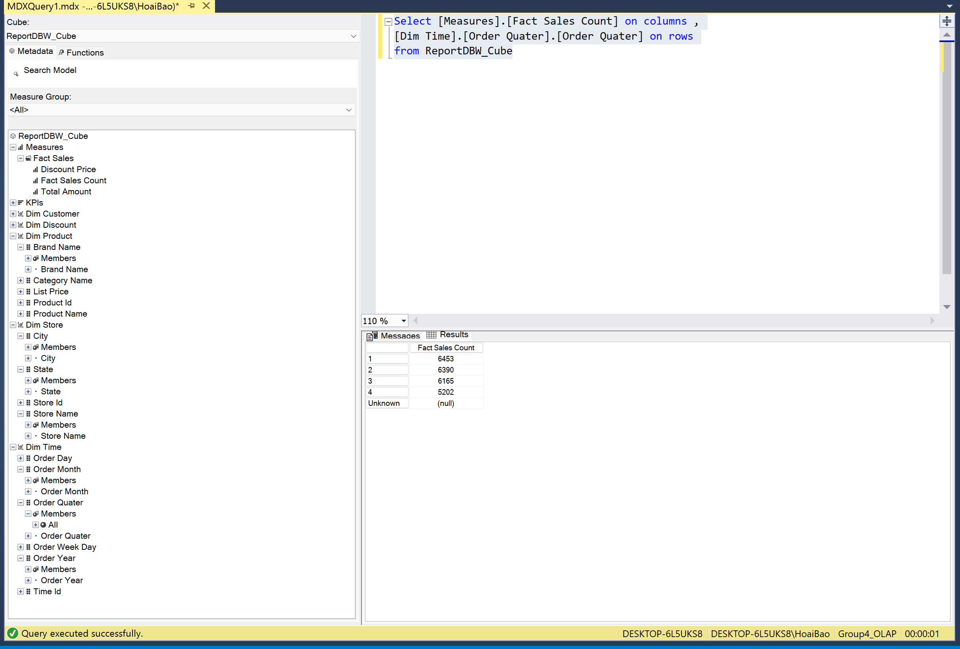

1. **Total Sales price by quarter**

